Yarrow Stalk, I Ching

you should use three 8-sided dice (d8)
Each d8 should have the following numbers engraved on its faces:
- Three faces with the number 2 (representing Yin)
- Five faces with the number 3 (representing Yang)

Instead of Western numerals, use the Trigram symbols or the actual Chinese characters for Yin (陰) and Yang (陽).

How to Roll and Read
You will roll all three dice together six times to build your hexagram from the bottom up.
For each roll, add the three numbers together. The sum determines the line type:
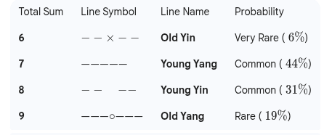

- Paint the 3s in Gold or Red (Active/Yang).
- Paint the 2s in Black or Silver (Passive/Yin).

