MaintEnhance
Home maintenance management
Training Guide for Executors
Entering work requests, doing work orders, and viewing everything else
Covers app version 2.6.1 · Issued October 1, 2026
Screenshots were taken from the application with sample data (the Maple Street Home household). Your own data, names and colours will differ.

Contents
How to use this guide
Your role: Executor
Key ideas
Getting started
Signing in
Forgot your password?
Choosing your own password (first sign-in)
My account: email and password
The user menu: Account settings and Sign out
The version number and the change log
Email digests: what, how often and when
The app layout: menu, top bar and page area
More info (i) buttons
Help: the training guide inside the app
Dashboard
Dashboard
Work Requests
Work Requests: the inbox
Submitting a work request (form)
Work Orders
Work Orders: the board
Creating a work order
Work order detail
Checklists and readings
Completing a work order: the completion comment
Comments on a work order
Viewing a PM Base template
The closed work-order archive
Schedule
Schedule
Locations, Assets and Bill of Materials
Locations: the location hierarchy
Assets and Bill of Materials
Adding or editing a BOM item
QR label
Vendors, Parts and Budget
Vendors and service providers
Parts Catalogue
Budget and cost tracking
Tools and settings
Tools (executor tools)
Scheduling and time keeping (optional)
Labour assignment
Entering hours worked when you complete a work order
Workforce schedule
Glossary
Quick reference: permissions by role

How to use this guide
This guide explains every screen and pop-up window you can use. Each screen has a page with a picture, a short description of the process, and a numbered list that explains every field, button, card and area in the picture.
- Red numbered circles in a picture match the numbered entries beside or below it.
- Red outlines show the area or field the number refers to.
- Fields marked with a red asterisk (*) on the screen are required.
Typical routine
- Check the Dashboard for overdue and upcoming work.
- Open Work Orders (your own name is selected in the Executor filter) and work through your jobs.
- Complete jobs with a comment (and your hours, if asked); tick checklist items as you go.
- Report anything new with Submit request — include a photo and a Required by date.
- Adjust part quantities when you use or restock something.
If you get stuck, the small “i” beside each page title opens a short help note, and your Owner can answer questions about your household’s setup.

Your role: Executor
As an Executor you are the person who notices problems and does the work. You can see everything in the app except the administrative areas, you can report problems, and you can create and work through work orders. Managers and Owners make the planning decisions and verify the work.
What you can do
- View the Dashboard, Locations, Assets & BOM, Work Requests, Work Orders, Schedule, Vendors, Parts Catalogue and Budget.
- Submit work requests, and edit your own requests until a manager has decided them.
- Create new work orders (for example an urgent, unplanned job).
- On a work order: move it between Active, Scheduled and Completed, tick checklist steps, record readings, and add comments.
- Adjust the quantity on hand of a part when you use or restock it.
- Add, edit and remove Bill of Materials items on an asset.
- Change your own email address and password.
- Use the Help tab to open this guide at any time, and the small (i) buttons for a short explanation of any card or window.
- If your Owner has switched on scheduling: see Labour assignment and the Workforce schedule, and record the hours you worked when you complete a work order.
What you cannot do
- Change the dates, cost, vendor, priority, executor or parts of an existing work order.
- Close a work order (only managers and owners verify and close).
- Review requests: convert, merge, ask for information or decline.
- Add or edit locations, assets, vendors or catalogue parts, or delete records.
- See Purchasing or Alarms — these menu items are hidden from you. On the Tools and settings page you see only the executor tools (your colour, your hours, and shift templates are not editable by you).

Key ideas

The life of a job: from request to closed work order
- Someone notices a problem and submits a Work Request (status Submitted).
- A manager or owner reviews it. They may ask for more information (Under Review), decline it (Declined), merge it into a work order that already exists (Merged), or convert it (Approved).
- Converting creates a Work Order. A work order with no date is Active. Giving it a scheduled date makes it Scheduled and puts it on the Schedule calendar.
- The executor does the work, ticking any checklist, and marks the work order Completed, adding a short comment about how it went. Parts used are deducted from stock.
- A manager or owner checks the work and marks it Closed. Closed work orders stay in the archive as the permanent history of the asset.

Work-order statuses
Status | Meaning
Active | Open and not yet booked for a date.
Scheduled | Has a scheduled date. Setting a date moves a work order here automatically; clearing it moves it back to Active.
Completed | The work is done. Moving a Scheduled work order to Completed requires a comment. Parts attached are deducted from stock.
Closed | Verified by a manager or owner. Recent closed work shows in the Closed column; everything is in the archive.

Work-order types
Type | Meaning
PM | A single preventive-maintenance job — usually generated automatically by a PM Base, for example “Replace furnace filter”.
PM Base | A template that generates PM jobs on a repeating schedule. It is never worked itself; it appears in the “PM Base templates” area under the board.
Benchmark | A reference job whose procedure and cost are saved so later jobs can start from it.
Corrective | A planned repair of something that has broken or is wearing out.
Unplanned | An urgent, unexpected job created directly, without waiting for a request to be reviewed.

Preventive maintenance (PM) jobs
Much of the work you will do is preventive maintenance (PM): small, regular jobs that stop big failures — changing a filter, testing a smoke alarm, servicing the mower.
These jobs are not created one by one. A manager sets up a PM Base, which is a template saying what the job is and when it repeats. Each time one job is completed the app creates the next one for you, so the board always shows the job that is next due.
A PM job may carry a checklist. Work through it in order and record any readings. If a reading is outside the expected range an alarm is raised for the managers automatically.
You do not need to do anything to the template itself. Just complete the PM jobs that appear.

Getting started

Signing in
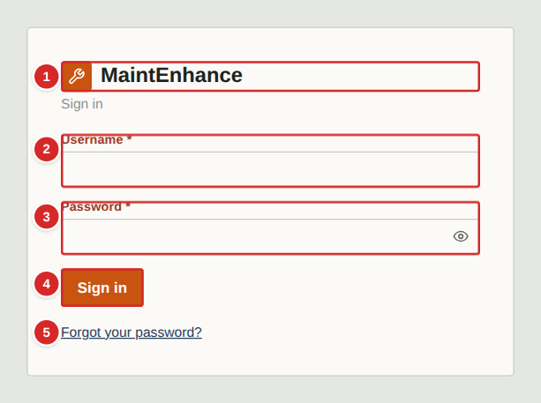
Open the address your Owner gave you in any web browser (on a phone, tablet or computer). You will see the sign-in screen. Your Owner creates your account and tells you your username and a temporary password.
What to do
1. Type your username and password exactly as given (the password is case-sensitive).
2. Select Sign in.
3. If your Owner gave you a temporary password, the next screen asks you to choose your own (see “Changing your password”).
4. Stay signed in on your own devices — the app keeps you signed in for about 30 days. Always use the sign-out button on a shared computer.
Numbered items in the picture
# | Field / area | What it is and how to use it
1 | Name and logo | Shows the name and logo your Owner has chosen for the household, with a one-line description below it.
2 | Username | Your personal username. Ask your Owner if you are unsure; it is not your email address.
3 | Password | Your password. Characters are hidden as you type; select the eye button at the right of the box to show or hide them (handy on a phone).
4 | Sign in | Signs you in. A message in red appears below the fields if the details are wrong. After several wrong attempts in a row the app makes you wait a few minutes before trying again.
5 | Forgot your password? | Appears only when your Owner has set up email for the app. It lets you reset your own password by email (see the next page).

Forgot your password?
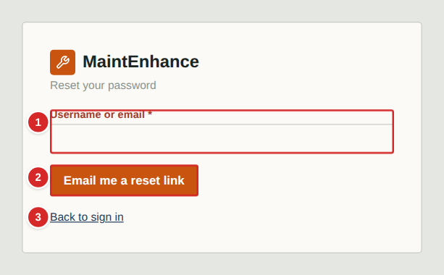
If your Owner has set up email for the app, you can reset your own password. This only works if your account has an email address on it (you or your Owner can add one — see “My account”). If the link does not appear on the sign-in screen, ask your Owner to give you a temporary password instead.
What to do
1. On the sign-in screen select “Forgot your password?”.
2. Type your username or the email address on your account and select “Email me a reset link”.
3. The app always shows the same confirmation, whether or not an account matched, so nobody can use it to find out who has an account.
4. Open the email and select the link. It works once and expires after one hour.
5. Type your new password twice (at least 8 characters) and select “Set new password”, then sign in.
Numbered items in the picture
# | Field / area | What it is and how to use it
1 | Username or email | Either your username or the email address saved on your account.
2 | Email me a reset link | Sends a single-use reset link. The link is valid for one hour. Too many requests in a short time are refused.
3 | Back to sign in | Returns to the sign-in screen without sending anything.

Choosing your own password (first sign-in)
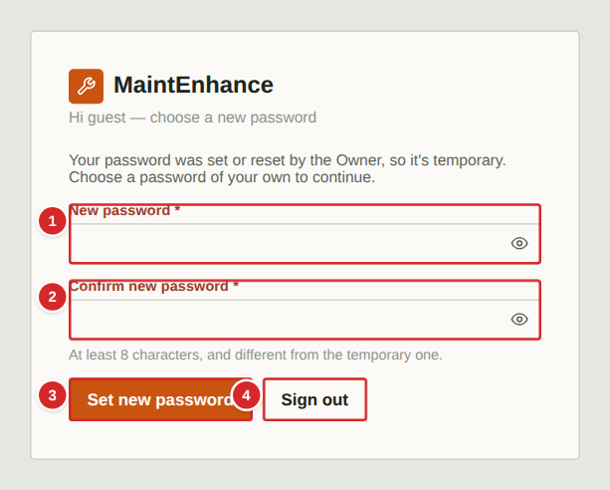
When an Owner creates your account, or resets your password, the password you were given is temporary. After you sign in with it, this screen appears and nothing else in the app is available until you choose your own password. The restriction is enforced by the server too, so it cannot be skipped.
What to do
1. Sign in with the temporary password.
2. Choose a new password of at least 8 characters that is different from the temporary one, and type it twice.
3. Select “Set new password”. You are taken straight into the app. Any other devices where you were signed in are signed out.
Numbered items in the picture
# | Field / area | What it is and how to use it
1 | New password | Your new password: at least 8 characters, and different from the temporary one. Use something only you know.
2 | Confirm new password | Type the new password again. The two must match. Each password box has an eye button to show or hide what you typed.
3 | Set new password | Saves the new password and opens the app.
4 | Sign out | Leaves without changing the password. You will be asked again the next time you sign in.

My account: email and password
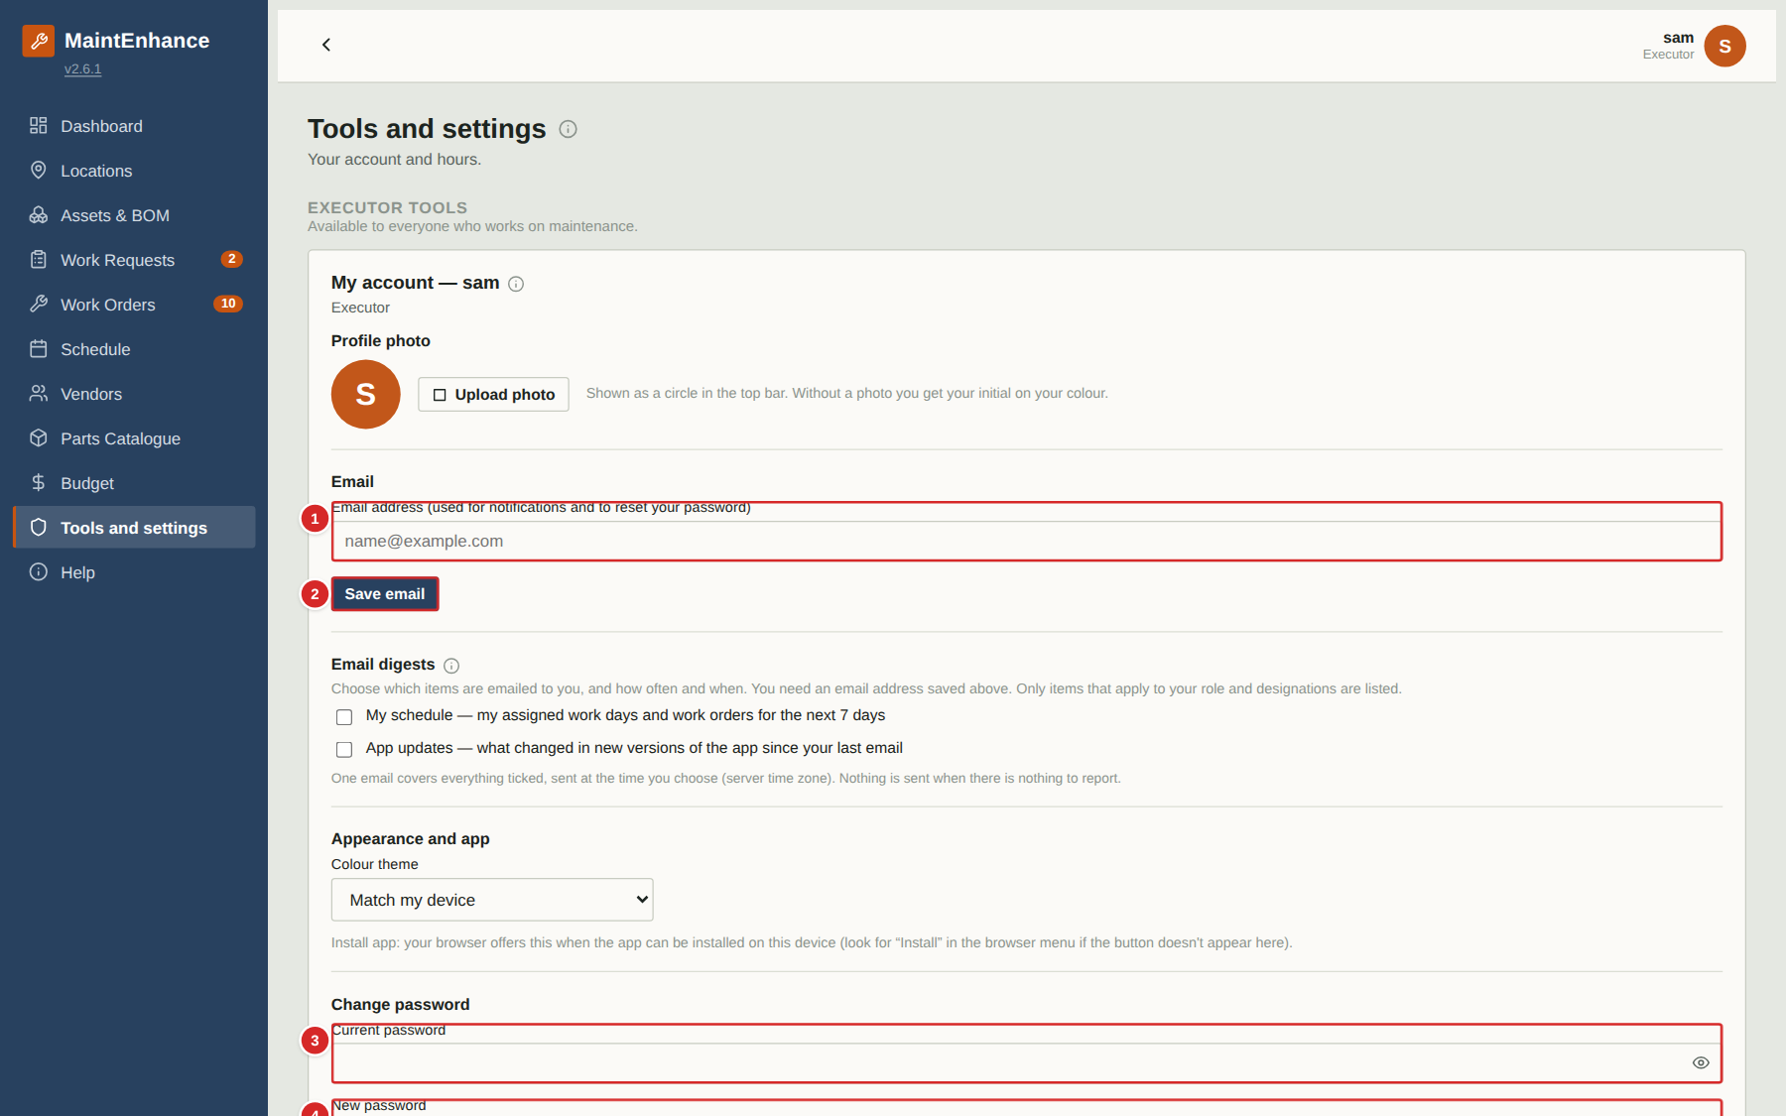
Open the user menu (your picture or initial at the top right), choose Account settings, and use the My account card to change your own email address or password. Your email address is used for reset links and, if your Owner has turned notifications on for you, for the daily digest.
What to do
1. Select your avatar at the top right, then Account settings (Tools and settings opens at My account).
2. To change your email, type it in the Email box and select “Save email”. Each email address can only belong to one account.
3. To change your password, type your current password, then the new one twice, and select “Change password”.
4. Changing your password signs you out on all your other devices; this device stays signed in.
Numbered items in the picture
# | Field / area | What it is and how to use it
1 | Email address | Where reset links and notification emails are sent. Leave it blank if you do not want email.
2 | Save email | Saves the email address. A confirmation or an error (for example, address already used) appears beside the button.
3 | Current password | Your existing password, to confirm it is you.
4 | New password | At least 8 characters and different from the current one.
5 | Confirm new password | Type the new password again.
6 | Change password | Saves the new password and signs out your other devices.

The user menu: Account settings and Sign out
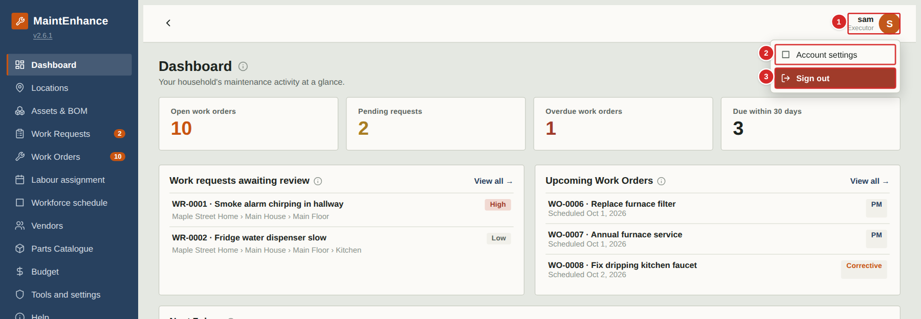
Your picture (or your initial on your colour) sits at the top right. Selecting it opens a small menu. Account settings opens Tools and settings at your account card; the red Sign out leaves the app.
What to do
1. Select your picture at the top right.
2. Choose Account settings to change your photo, email, password, theme and digests.
3. Choose Sign out when you are finished on a shared device.
Numbered items in the picture
# | Field / area | What it is and how to use it
1 | Your picture | Profile photo, or your initial on your colour. Opens the menu.
2 | Account settings | Opens Tools and settings at My account.
3 | Sign out | Ends your session on this device.

The version number and the change log
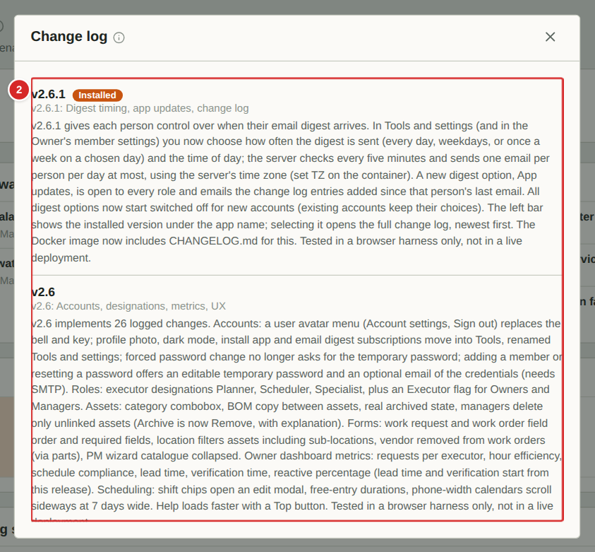
The installed version of the app is shown under the app name at the top of the menu. Selecting it opens the change log: every version, newest first, with a plain description of what changed. The version you are running is marked Installed.
What to do
1. Select the version number under the app name.
2. Scroll to read what changed in each version.
3. Close the window with the X.
Numbered items in the picture
# | Field / area | What it is and how to use it
1 | Version number | Select it to open the change log.
2 | Change log | Newest version first. Each entry says what changed.

Email digests: what, how often and when
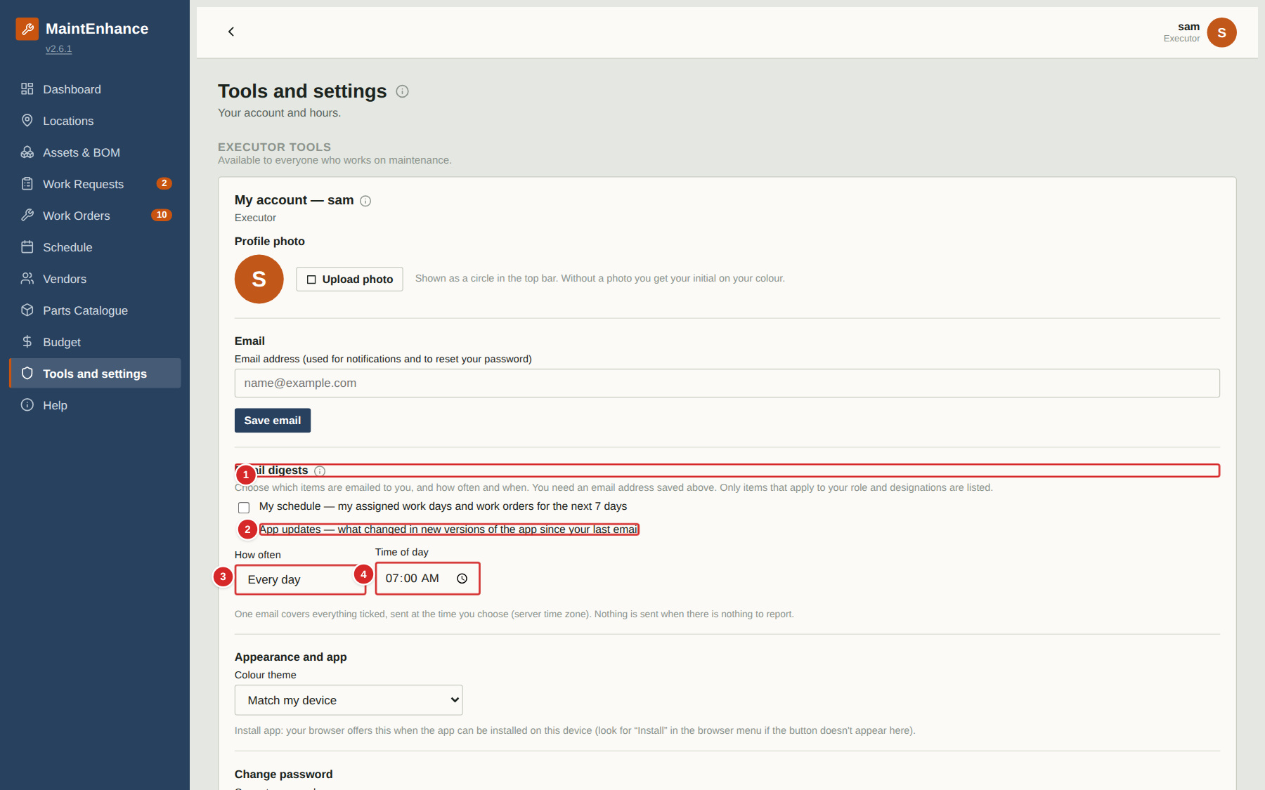
In Tools and settings, My account, tick the items you want emailed to you. Then choose how often (every day, weekdays or once a week) and the time of day. One email covers everything you ticked and is only sent when there is something to report. All options start switched off. App updates is open to everyone and lists what changed in the app since your last email.
What to do
1. Open your avatar menu and choose Account settings.
2. Tick the digest items you want.
3. Choose How often (and the day, for weekly) and the Time of day.
4. Make sure your email address is saved above; your Owner must have set up email on the server.
Numbered items in the picture
# | Field / area | What it is and how to use it
1 | Email digests | Everything here is off until you tick it.
2 | App updates | Emails the change log entries added since your last email.
3 | How often | Every day, weekdays, or once a week on a day you pick.
4 | Time of day | When the email is sent, in the server's time zone.

The app layout: menu, top bar and page area
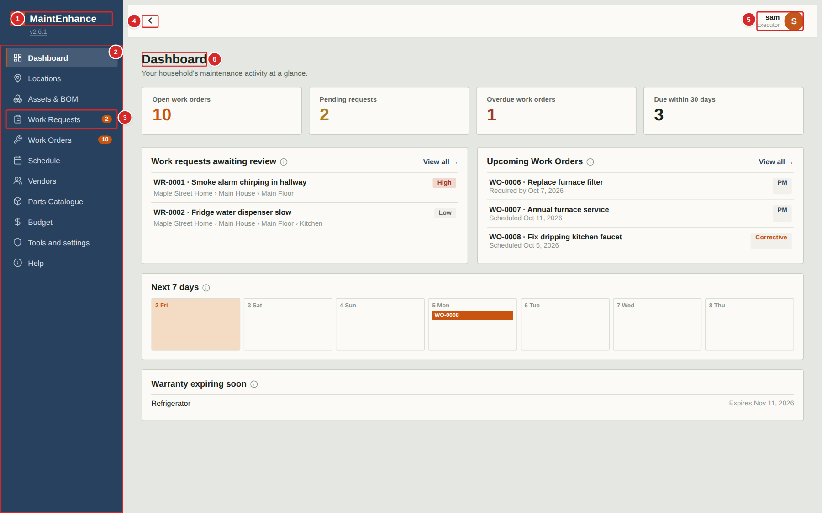
Every screen shares the same layout. The menu on the left switches between areas of the app, the top bar holds your personal controls, and the large area to the right shows the page you chose. Executors see every area except the purchasing list, and alarms, which are for managers and owners. Tools shows you your own tools only, and Help opens this guide.
What to do
1. Select a menu item to open that area. The current area is highlighted.
2. The small orange numbers beside Work Requests and Work Orders count requests waiting for review and work orders that are still open.
3. On a phone the menu is hidden: select the menu button at the top left to open it, and select any item to close it again.
4. Use the arrow button at the top left to collapse the menu on a large screen and give the page more room.
Numbered items in the picture
# | Field / area | What it is and how to use it
1 | Name and logo | The household name and logo, set by your Owner.
2 | Menu | One entry per area of the app. Select an entry to open it. Your role decides which entries appear.
3 | Count badges | Orange counters: requests that still need a decision, and work orders that are not yet Closed.
4 | Collapse / menu button | Hides or shows the menu.
5 | Signed-in user | Shows who is signed in and your role. Select it to open a small menu with Account settings and a red Sign out.
6 | Page title | The name of the page you are on. The small “i” beside it opens a short help note about the page.

More info (i) buttons
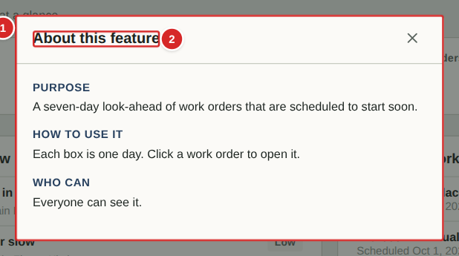
Small round “i” buttons appear beside page titles, card headings and pop-up window titles throughout the app. Selecting one opens a short note explaining what that part of the app is for, how to use it and who is allowed to use it. Nothing changes when you open one.
What to do
1. Look for the small “i” beside a title.
2. Select it to open the note.
3. Read the Purpose, How to use it and Who can sections, then close the window with the X.
Numbered items in the picture
# | Field / area | What it is and how to use it
1 | The note | Purpose: what the feature is for. How to use it: the steps. Who can: which roles can use it.
2 | Title | Always “About this feature” for card and pop-up notes; page notes are titled “About” and the page name.

Help: the training guide inside the app
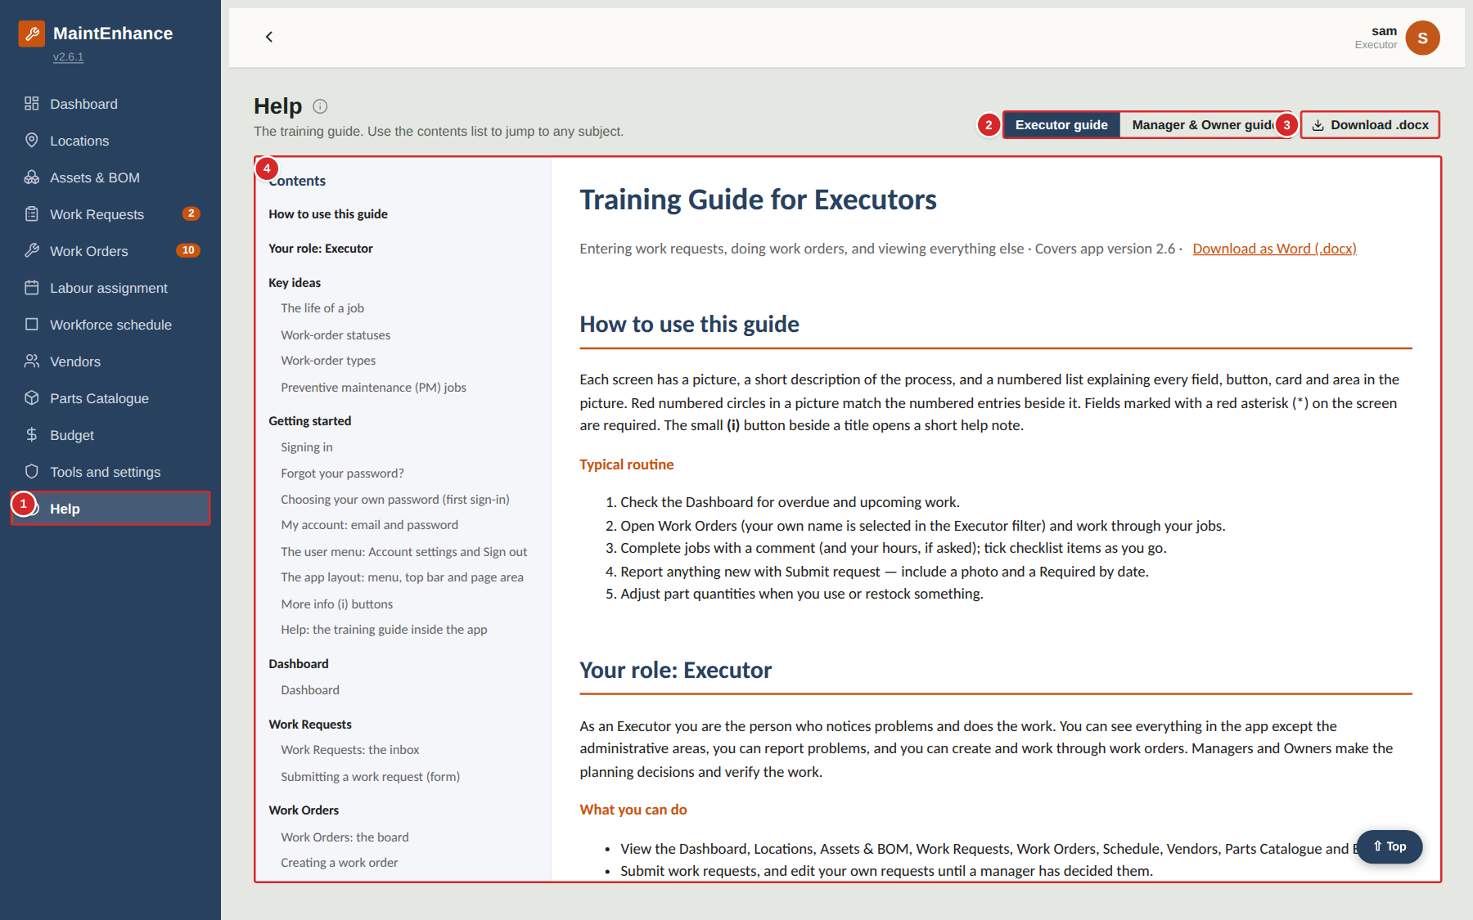
The Help item at the bottom of the menu opens this training guide inside the app. A contents list at the top links to every subject; selecting a title jumps straight to it. Use it when you want to remind yourself how a screen works.
What to do
1. Select Help in the menu.
2. Choose the guide for your role. You can read the other guide too.
3. Select a subject in the Contents list to jump to it, or scroll.
4. Select “Download .docx” to get the Word version to print or share.
Numbered items in the picture
# | Field / area | What it is and how to use it
1 | Help menu item | Opens this page. It is available to everyone.
2 | Guide selector | Switches between the Executor guide and the Manager & Owner guide.
3 | Download .docx | Downloads the Word version of the guide that is showing.
4 | The guide | The training guide itself. Its contents list is at the top and each entry is a link.

Dashboard

Dashboard
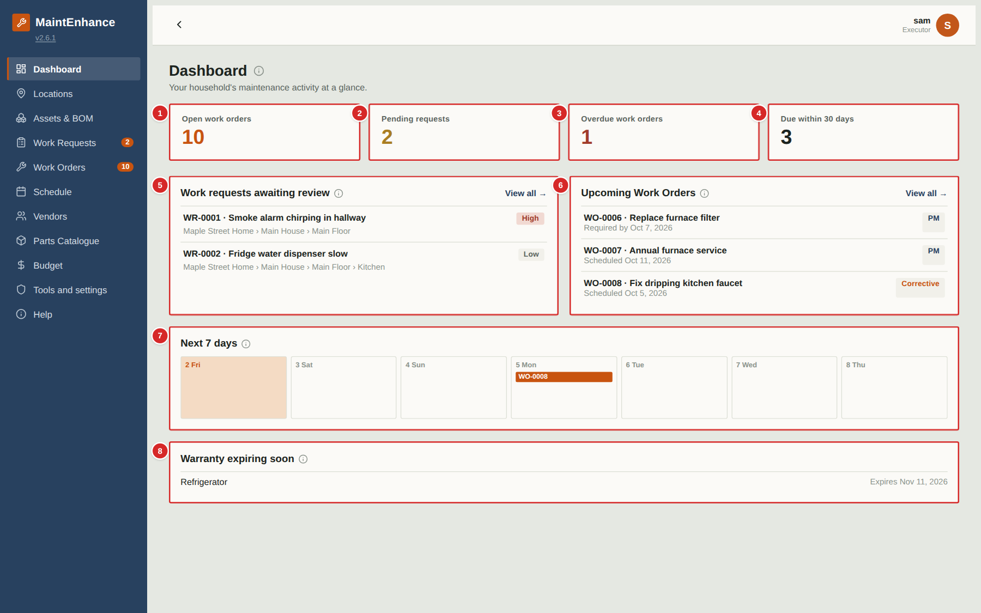
The Dashboard is the first page after you sign in. It answers “what needs attention?” at a glance. Everything on it is a live summary of the other pages — selecting a card or a row takes you to the matching list or record.
What to do
1. Look at the four counters at the top for the overall picture.
2. Select a counter to jump to the matching list (for example Overdue work orders opens the Work Orders board filtered to overdue items).
3. Use the Next 7 days strip to see what is scheduled this week. Select a work-order tag to open it.
4. Check Warranty expiring soon so that a claim can be raised before cover ends.
Numbered items in the picture
# | Field / area | What it is and how to use it
1 | Open work orders | How many work orders are not yet Closed (Active, Scheduled or Completed). Select it to open the Work Orders board.
2 | Pending requests | Work requests that are Submitted or Under Review and still waiting for a decision.
3 | Overdue work orders | Work orders whose required-by date has passed and that are not yet Completed or Closed. Shown in red when above zero.
4 | Due within 30 days | Open work orders due in the next 30 days.
5 | Work requests awaiting review | The latest requests that still need a decision, with number, title, location and priority. “View all” opens the Work Requests page.
6 | Upcoming Work Orders | The next open work orders by date, each with its type tag (PM, Corrective, Unplanned …) and either its scheduled or required-by date.
7 | Next 7 days | One box per day for the coming week. Today is highlighted; scheduled work orders appear as small tags in their day.
8 | Warranty expiring soon | Assets whose warranty ends in the next few months, with the expiry date. Plan repairs or claims before the date.

Work Requests

Work Requests: the inbox
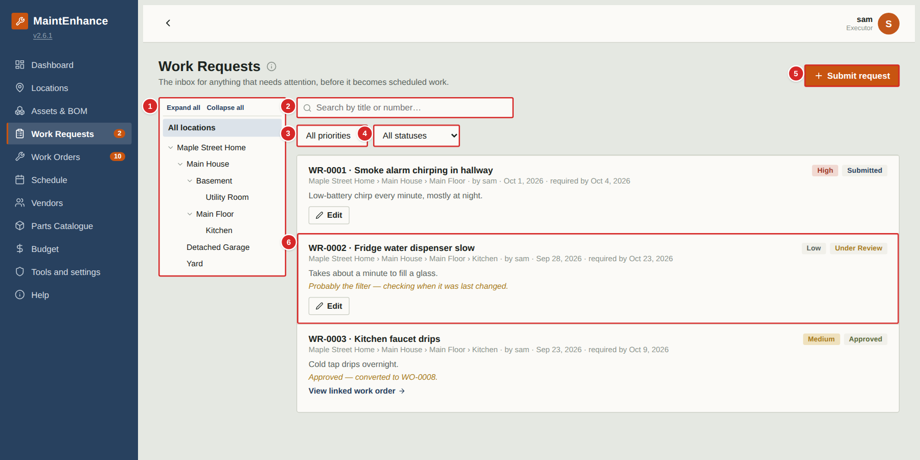
A work request is a note that something needs attention — a leak, a broken light, a strange noise. Anyone can raise one. A manager or owner then reviews it and either turns it into a work order, merges it into an existing one, asks for more information, or declines it. This page is the inbox of all requests and where each one stands.
What to do
1. Select “Submit request” to report a new problem (see the next page).
2. Use the location tree, the search box and the two filters to find a request.
3. Read the status tag on the right of each card to see where the request stands: Submitted (not yet looked at), Under Review (a manager has asked a question or is deciding), Approved (converted to a work order), Declined, or Merged.
4. Select Edit on one of your own requests that has not been decided yet to correct it or answer a question from the reviewer.
5. When a request has been approved, select “View linked work order” to follow the work.
Numbered items in the picture
# | Field / area | What it is and how to use it
1 | Location tree | Narrow the list to one place. Selecting a room also shows requests for the things inside it. “Expand all / Collapse all” opens or closes the branches.
2 | Search | Finds requests by words in the title or by number, for example “WR-0002”.
3 | Priority filter | Show only Low, Medium, High or Critical requests.
4 | Status filter | Show only requests with a given status.
5 | Submit request | Opens the form for a new request. Available to every role except Guest.
6 | Request card | One card per request: number and title, location path, who raised it and when, the date it is needed by, the description, and any reply from the reviewer (in italics). The tags at the top right show priority and status.

Submitting a work request (form)
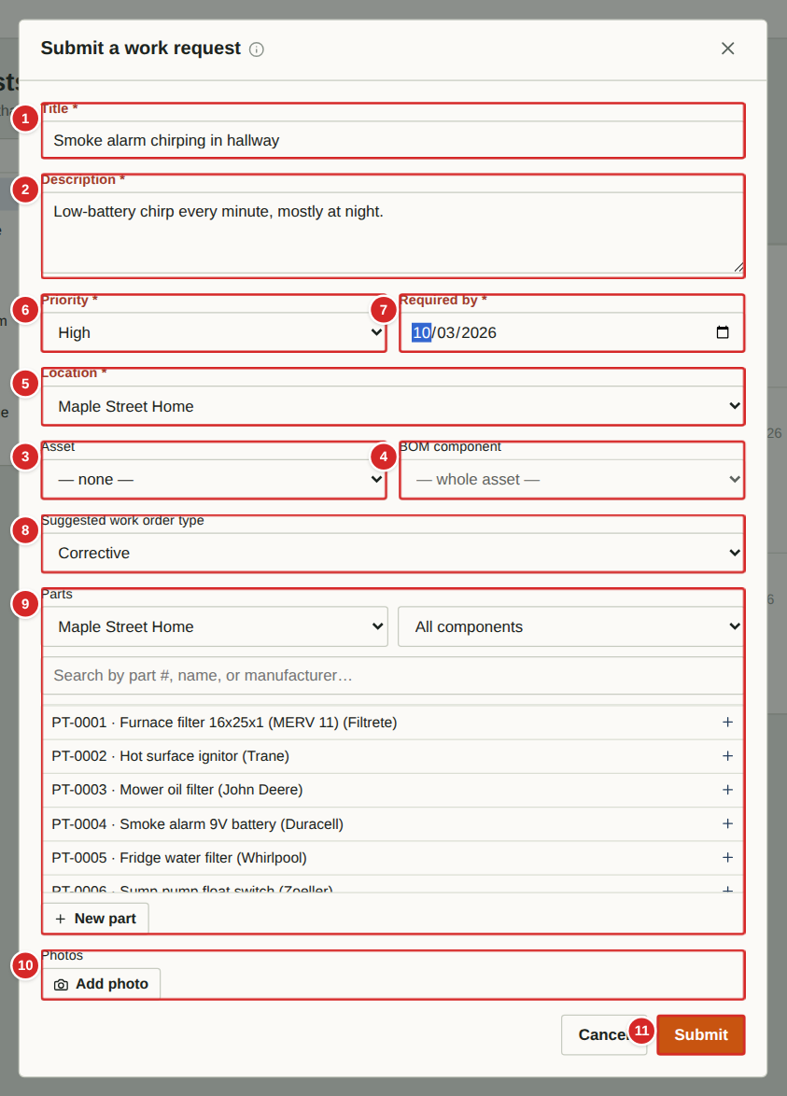 | Use this form whenever something needs attention. Give enough detail that someone who has not seen the problem can understand it. Fields marked with a red asterisk are required. You can edit your own request later, until a manager has decided it.  What to do  1. On the Work Requests page select “Submit request”.  2. Type a short Title that names the problem and where it is (for example “Kitchen tap dripping”).  3. Choose the Location. If the problem is on a specific asset or one of its components, also pick the Asset and the BOM component — this links the request to that item’s history.  4. Set the Priority and the date it is Required by. Pick the date you honestly need it fixed by; managers use it to plan.  5. Optionally suggest a work-order type and any Parts you think will be needed, and attach up to five photos.  6. Select Submit. The request appears in the inbox with the status Submitted. If you are offline the app keeps it on your device and sends it as soon as you are back online.  Numbered items in the picture  1 Title * — A short name for the problem. It becomes the work order title if the request is approved.  2 Description — What you saw, heard or smelled; when it happens; anything you have already tried.  3 Asset — Optional. The equipment concerned (furnace, fridge, mower …). Choosing one links the request to that asset’s history.  4 BOM component — Optional. A part inside the chosen asset (for example the burner of the furnace). Appears once an asset with components is chosen.  5 Location * — Where the problem is. Required. If you chose an asset the location is filled in from it.  6 Priority — Low, Medium, High or Critical. Use High or Critical only for safety issues or loss of an essential service.  7 Required by * — The date by which it needs to be fixed. Required.  8 Suggested work order type — Your suggestion for how the request should be handled: Corrective (fix something broken), PM, PM Base or Benchmark. The reviewer makes the final choice.  9 Parts — Optional. Pick parts from the Parts Catalogue that the job will probably need, with quantities. “New part” adds a catalogue entry on the spot.  10 Photos — Optional. Add up to five photos from the camera or gallery. Photos are shrunk automatically before upload.  11 Submit / Cancel — Submit sends the request. Cancel closes the form; if you typed anything the app asks whether to discard it.

Work Orders

Work Orders: the board
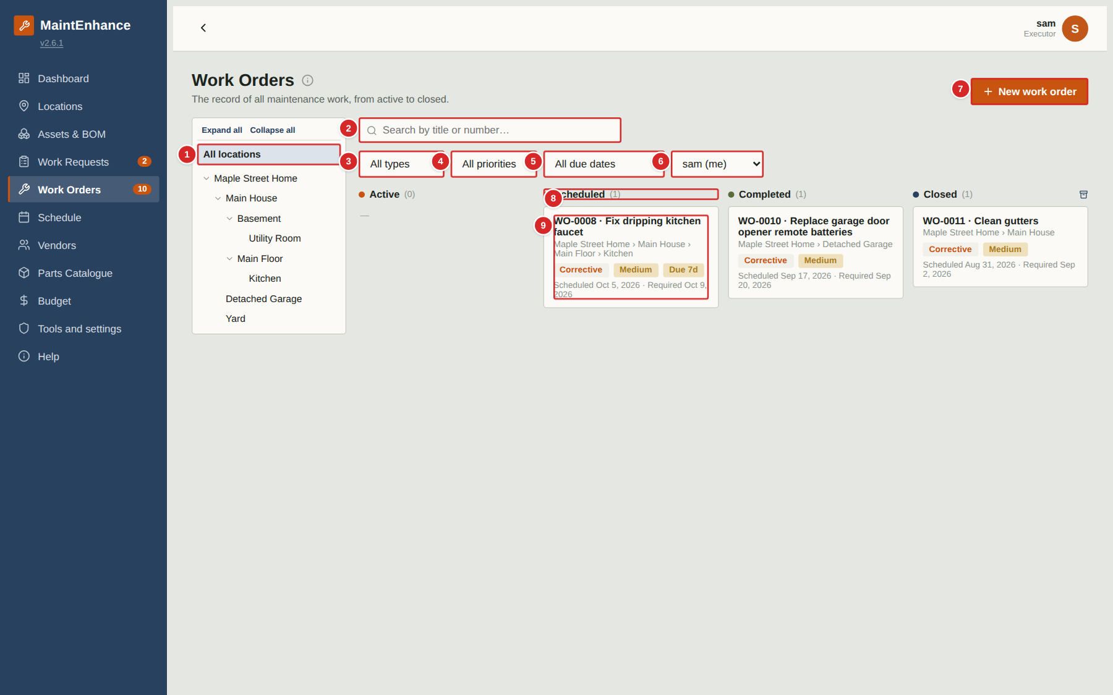
A work order is a job to be done: who, what, where, by when and with which parts. The board shows every work order in four columns that follow its life: Active (open, not yet booked), Scheduled (has a scheduled date), Completed (done, awaiting verification) and Closed (verified by a manager or owner). Cards move between columns when their status changes.
What to do
1. Use the location tree, search and filters to narrow the board. As an Executor the Executor filter starts on your own name so you see the jobs assigned to you; choose “All executors” to see everyone’s.
2. Select a card to open the work order (see “Work order detail”).
3. Select “New work order” to create one (see “Creating a work order”).
4. The archive button at the top of the Closed column lists work orders closed more than 30 days ago.
5. Scroll down (with the Executor filter set to All executors) to see the PM Base templates (see “Viewing a PM Base template”).
Numbered items in the picture
# | Field / area | What it is and how to use it
1 | Location tree | Show only work orders at one place and everything inside it.
2 | Search | Find a work order by words in the title or by number, for example “WO-0008”.
3 | Type filter | PM, PM Base, Benchmark, Corrective or Unplanned.
4 | Priority filter | Low, Medium, High or Critical.
5 | Due-date filter | Overdue, due within 7 days, 30 days and so on.
6 | Executor filter | The person the work is assigned to. Executors start with their own name selected.
7 | New work order | Opens the creation form.
8 | Column headers | Active, Scheduled, Completed and Closed, each with the number of cards. Managers and owners also get a tick-box on each header to select every card in the column (used by Auto schedule).
9 | Work order card | Number and title, location, type / priority / “Due 7d” tags, and the scheduled and required-by dates. Select it to open.

Creating a work order
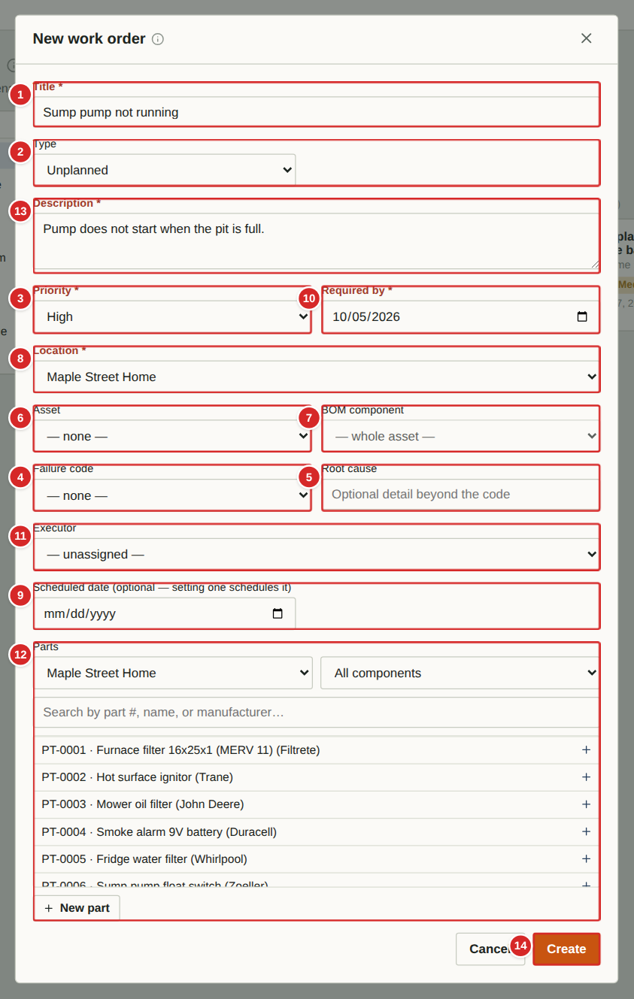 | Create a work order directly when you already know what needs doing — for example an urgent job that cannot wait for a request to be reviewed. (A request, once approved, becomes a work order automatically.) Fields marked with an asterisk are required. The fields shown change a little with the Type you choose.  What to do  1. On the Work Orders page select “New work order”.  2. Type a Title and choose the Type (see “Key ideas”). New work orders default to Unplanned for an unexpected job.  3. Choose the Location, and if relevant the Asset and BOM component. Set Priority and the Required by date.  4. Optionally pick a Vendor and an Executor (the person who will do the work), attach Parts from the catalogue, and add a Description.  5. Select Create. With no scheduled date the work order starts in the Active column; entering a scheduled date makes it Scheduled.  Note: Work order types: PM — a single preventive-maintenance job (usually generated for you by a PM Base). PM Base — a repeating template, not a job itself. Benchmark — a reference job whose procedure you want to reuse. Corrective — a planned repair. Unplanned — an unexpected or emergency job.  Numbered items in the picture  1 Title * — A short name for the job.  2 Type — PM, PM Base, Benchmark, Corrective or Unplanned. Choosing PM Base replaces the date fields with repeat-schedule fields.  3 Priority — Low, Medium, High or Critical.  4 Failure code — Corrective and Unplanned only. A standard category for why it failed (for example Wear), for later analysis.  5 Root cause — Corrective and Unplanned only. Free text for the underlying reason, beyond the code.  6 Asset — The equipment the job is on. Optional but recommended — it feeds the asset’s work-order history.  7 BOM component — A component inside the asset (for example “Burner”).  8 Location * — Where the job is. Filled in from the asset when you choose one.  9 Scheduled date (optional) — Entering a date schedules the work order: it moves to the Scheduled column and appears on the calendar.  10 Required by * — The deadline. Required for every type except PM Base.  11 Executor — The household member responsible. Their Work Orders filter and the Schedule will show the job.  12 Parts — Parts from the catalogue with quantities. They are deducted from stock when the work order is Completed, and shortages show on the Purchasing list.  13 Description — Details, instructions or access notes.  14 Create / Cancel — Create saves the work order. Cancel closes the form (the app asks first if you typed something).

Work order detail
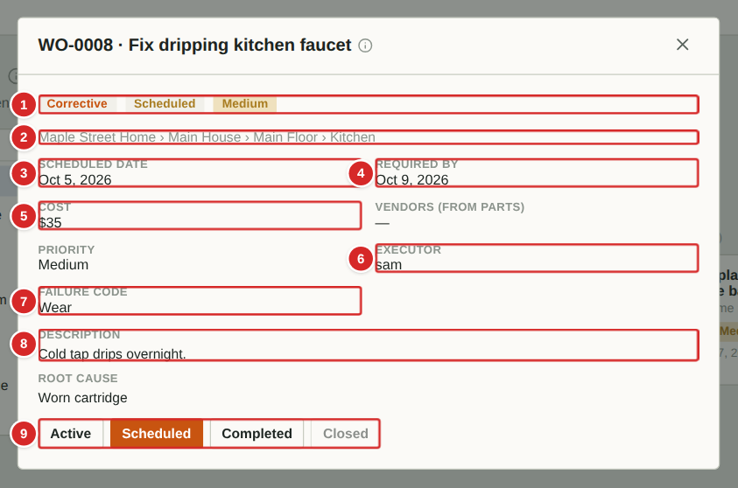
Selecting a card opens the work order. As an Executor you can read everything on it, move it between Active, Scheduled and Completed, tick checklist items, record readings and add comments. You cannot change dates, costs, assignments or parts, and you cannot Close a work order — a manager or owner verifies and closes the work.
What to do
1. Open a card from the board.
2. Read the details: what, where, when, and any parts or notes.
3. When the job is done, select Completed. If it was Scheduled, the app asks for a short comment on how it went (see the next page).
4. If a checklist is shown, tick off each step and enter any readings as you go.
5. If something here is wrong (a wrong date, say), tell a manager or add a comment, or submit a work request.
Numbered items in the picture
# | Field / area | What it is and how to use it
1 | Tags | Type (Corrective), status (Scheduled) and priority (Medium).
2 | Location path | Where the work is.
3 | Scheduled date | The day the work is planned for.
4 | Required by | The deadline.
5 | Cost / Vendor | What has been spent and who the contractor is, if any. Read-only for executors.
6 | Priority / Executor | How urgent the job is and who it is assigned to.
7 | Failure code / Root cause | Why the equipment failed, where recorded (corrective and unplanned jobs).
8 | Description | What needs doing.
9 | Status buttons | Move the work order: Active, Scheduled, Completed. “Closed” is greyed out for executors — only managers and owners can close.

Checklists and readings
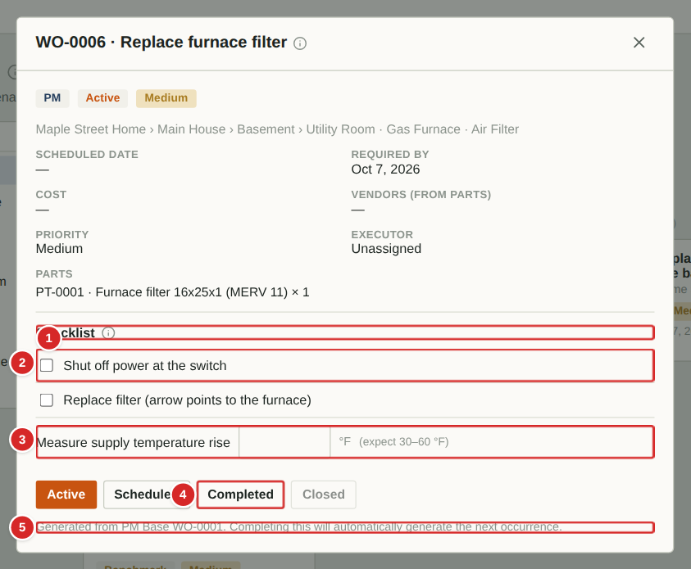
Preventive-maintenance (PM) work orders generated from a PM Base carry the checklist defined on that PM Base. Work through it in order. Some steps ask for a measurement instead of a tick. If a measurement falls outside the expected range, the app raises an alarm so a manager sees it.
What to do
1. Open the PM work order.
2. Tick each checklist step as you complete it. The ticks are saved straight away.
3. For a reading step, type the measured number. The unit and the expected range are shown beside the box.
4. If the reading is outside the range, an alarm is raised automatically for the managers; keep going and add a comment describing what you saw.
5. When every step is done, select Completed. If it was Scheduled you will be asked for a comment; completing generates the next occurrence of the PM automatically.
Numbered items in the picture
# | Field / area | What it is and how to use it
1 | Checklist heading | The steps for this job. Their order is the order to do them in.
2 | Tick step | Tick when the step is done.
3 | Reading step | Type the measured value. The unit (°F) and the expected range (30–60 °F) are shown to the right. A value outside the range raises an alarm.
4 | Completed | Marks the job done once the checklist is finished.
5 | Generated-from note | Shows which PM Base created this work order and what happens when you complete it.

Completing a work order: the completion comment
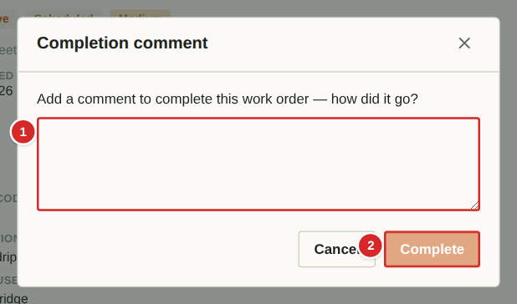
When a Scheduled work order is moved to Completed, the app asks how it went. This comment becomes part of the work order’s permanent history and helps whoever does the job next time. The work order cannot be completed without it.
What to do
1. On the work order select Completed.
2. Describe what was done, anything unexpected, and anything to improve next time (for example “Replaced the cartridge; needed a 3/4 inch wrench”).
3. Select Complete. The work order moves to the Completed column, parts used are deducted from stock, and the date is recorded.
4. A manager or owner reviews the work and then Closes it.
Numbered items in the picture
# | Field / area | What it is and how to use it
1 | Comment | Required. Say how the job went and what to improve.
2 | Complete / Cancel | Complete records the comment and finishes the work order. Cancel leaves it as it was.

Comments on a work order
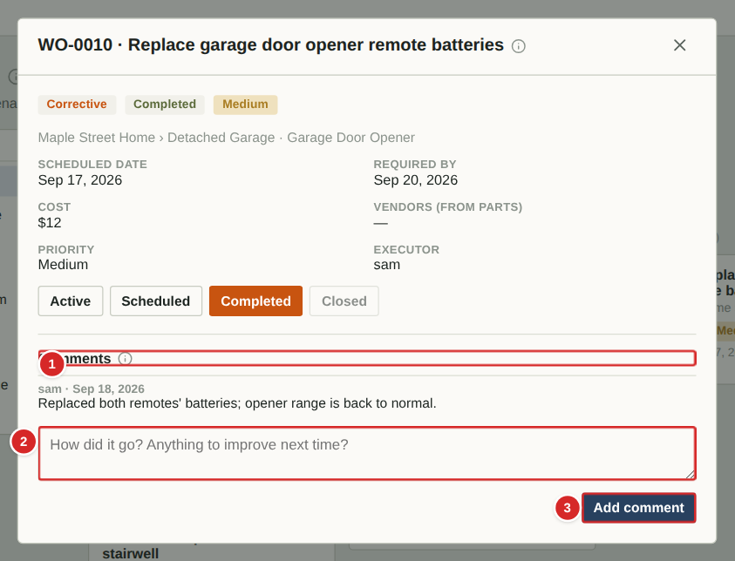
Once a work order is Completed or Closed — or any time it has comments — a Comments area appears at the bottom. It keeps a dated, signed history of what happened. Executors, managers and owners can add comments; guests can only read them.
What to do
1. Scroll to the Comments area at the bottom of the work order.
2. Read earlier comments (author and date above each).
3. Type your note in the box and select Add comment. Comments cannot be edited or deleted afterwards, so write them carefully.
Numbered items in the picture
# | Field / area | What it is and how to use it
1 | Comments heading | Everything said about this job, oldest first.
2 | New comment box | Type a note about how it went.
3 | Add comment | Saves the comment with your name and today’s date.

Viewing a PM Base template
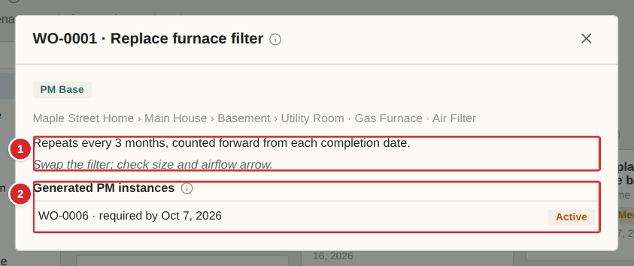
Executors can open PM Base templates to see how often a job repeats and which jobs have been generated from it, but cannot change them. To work a generated job, open it from the board (or from the list at the bottom of this window).
What to do
1. Find the PM Base under “PM Base templates” (set the Executor filter to All executors if it is hidden).
2. Read the repeat rule and the standby note, if any.
3. Select a generated job in the list to open it.
Numbered items in the picture
# | Field / area | What it is and how to use it
1 | Repeat rule | In words: how the next job is timed.
2 | Generated PM instances | Jobs created from this template, with number, due date and status. Select one to open it.

The closed work-order archive
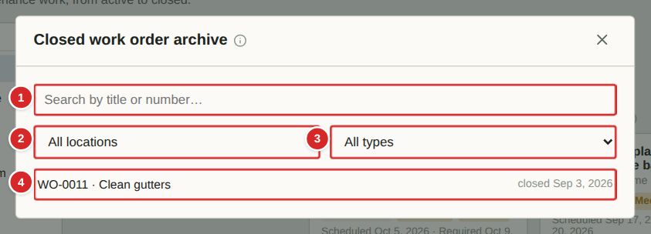
The Closed column of the board only shows recently closed work. The archive lists every closed work order, newest first, so you can look up what was done, when and for how much.
What to do
1. On the board select the archive button at the right end of the Closed column header.
2. Search by title or number and filter by location and type.
3. Select a row to open the work order.
Numbered items in the picture
# | Field / area | What it is and how to use it
1 | Search | Title or number.
2 | Location filter | Only work closed at one place and everything inside it.
3 | Type filter | PM, Benchmark, Corrective or Unplanned.
4 | Closed work order | Number, title and date it was closed. Select it to open.

Schedule

Schedule
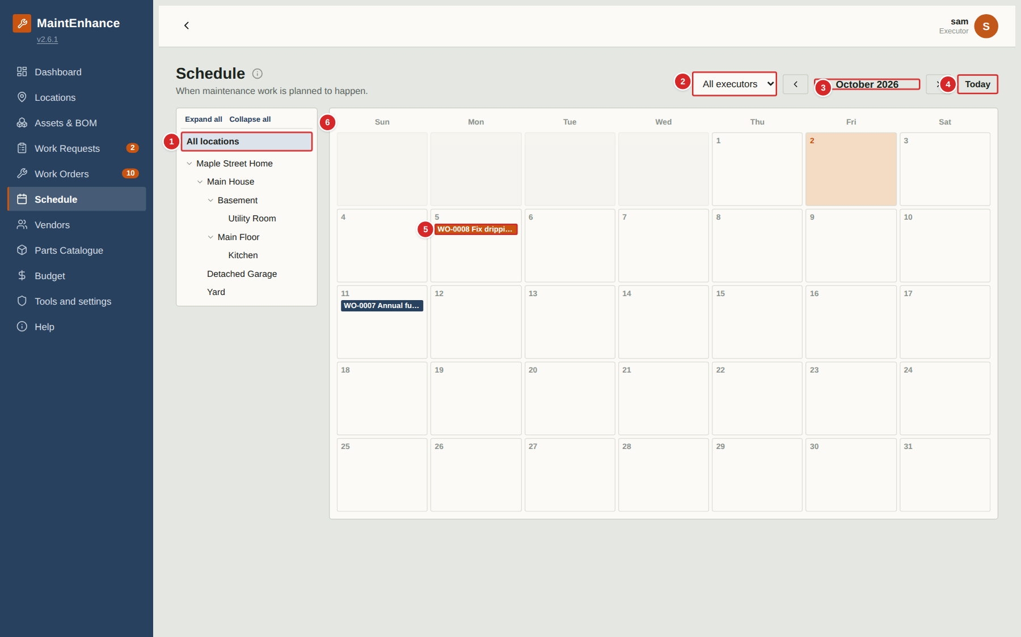
The Schedule is a monthly calendar of every work order that has a scheduled date. Use it to see what is planned for which day and to spot busy weeks.
What to do
1. Use the arrows beside the month name to move between months; “Today” jumps back to the current month.
2. Narrow the calendar with the location tree or the executor filter. Executors start on their own name; choose “All executors” to see everyone’s work.
3. Select a work-order tag in a day to open the work order. Colours follow the work-order type.
4. To change a date, open the work order (managers and owners only).
Numbered items in the picture
# | Field / area | What it is and how to use it
1 | Location tree | Show only work at one place and everything inside it.
2 | Executor filter | Show one person’s work, or everyone’s.
3 | Month and arrows | The month on show; the arrows on either side step back and forward.
4 | Today | Returns to the current month.
5 | Scheduled work order | A tag on the scheduled day. Select it to open the work order.
6 | Calendar header | Days of the week. Today’s box is highlighted.

Locations, Assets and Bill of Materials

Locations: the location hierarchy
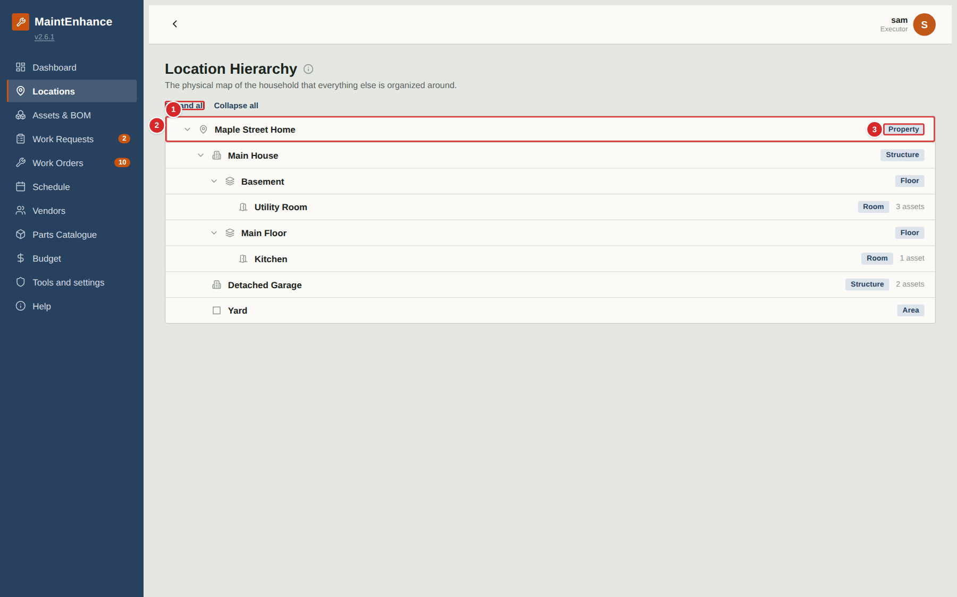
Locations map your home: a property contains buildings, which contain floors, rooms and so on. Everything else in the app — assets, work requests, work orders — is attached to a location, and the tree on many pages filters by it. You can browse the tree; managers and owners maintain it.
What to do
1. Expand a branch with the small arrow, or use Expand all / Collapse all.
2. Read the tag on each row (Property, Structure, Floor, Room, Area) and the count of assets in that location.
3. To report a problem at a location, use Work Requests — the location is chosen on the form.
Numbered items in the picture
# | Field / area | What it is and how to use it
1 | Expand all / Collapse all | Opens or closes every branch of the tree.
2 | Location row | Name, with an arrow to open or close its children. The tag on the right shows its level; “3 assets” counts the assets located there.
3 | Level tag | Property, Structure, Floor, Room or Area. Your Owner can rename the levels in the Tools and settings page.

Assets and Bill of Materials
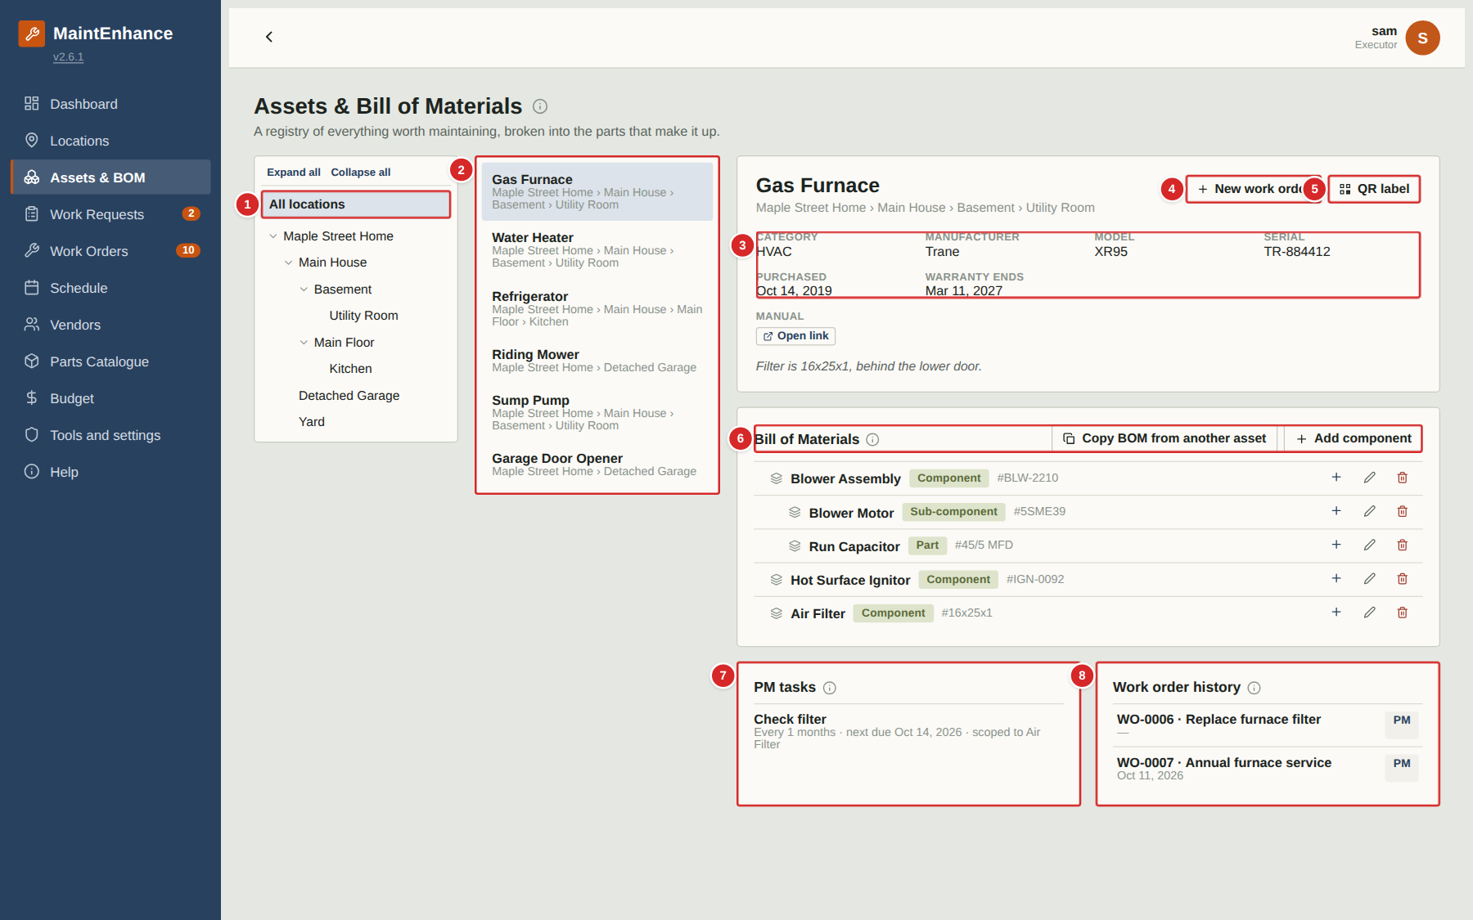
An asset is anything in the home worth maintaining — a furnace, a fridge, a mower. The Bill of Materials (BOM) breaks an asset into the components and parts it is made of, so that work and spare parts can be tied to the exact piece. This page also shows the preventive-maintenance tasks and the full work-order history of the selected asset.
What to do
1. Pick a location in the tree, then an asset from the list.
2. Read the details panel for model, serial number and warranty.
3. Browse the Bill of Materials: each row is a component, sub-component or part with its part number. As an Executor you can add, edit and remove BOM items to keep them accurate (+, pencil and bin on each row).
4. Check “PM tasks” for the recurring jobs attached to this asset and “Work order history” for everything done to it. Select a work order to open it.
5. Select “New work order” to log work against this asset, or “QR label” to print its label.
Numbered items in the picture
# | Field / area | What it is and how to use it
1 | Location tree | Filters the asset list to one place and everything inside it.
2 | Asset list | Every asset in the chosen location. Select one to see its details on the right.
3 | Asset details | Category, manufacturer, model, serial number, purchase date, warranty end date, a link to the manual, and notes.
4 | New work order | Creates a work order already linked to this asset.
5 | QR label | Shows a printable label with a QR code. Scanning it with a phone opens this asset directly. Available on assets marked as major.
6 | Bill of Materials | Indented tree of components. Each row shows a name, a tag (Component, Sub-component, Part) and its part number. Executors can use Add component, + (add child), pencil (edit) and bin (remove).
7 | PM tasks | Recurring maintenance (PM Bases) attached to this asset, with its repeat rule and next due date.
8 | Work order history | Every work order for the asset, newest first, with its type and date.

Adding or editing a BOM item
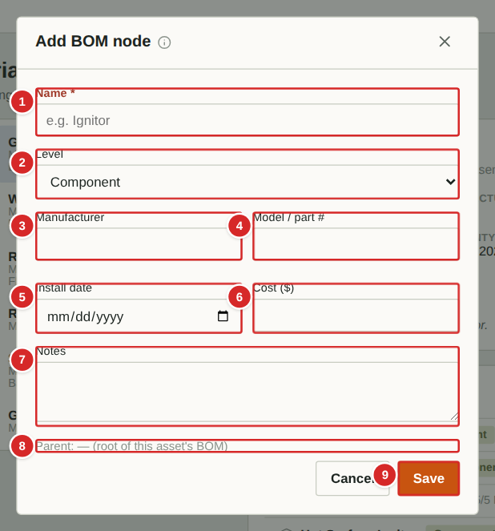 | Each row of the Bill of Materials is a component, sub-component or part of the asset. Keeping it accurate lets work orders and parts point at the exact piece (for example “Blower motor”) rather than just “furnace”. Executors, managers and owners can edit the BOM.  What to do  1. On the asset select “Add component” for a top-level item, or the + on a row to add something inside it. The Parent line shows where it will go.  2. Enter the Name and choose its Level (Component, Sub-component or Part).  3. Add the manufacturer, model / part number and install date so it can be re-ordered later.  4. Select Save. The pencil edits a row; the bin removes it.  Numbered items in the picture  1 Name * — What the component is called (for example “Blower Motor”).  2 Level — Component, Sub-component or Part.  3 Manufacturer — Maker of this item.  4 Model / part # — Model or part number, used when re-ordering.  5 Install date — When this item was fitted or last replaced.  6 Cost ($) — What it cost.  7 Notes — Anything useful, such as size or position.  8 Parent — Where in the tree the new item will sit.  9 Save / Cancel — Save stores the item.

QR label
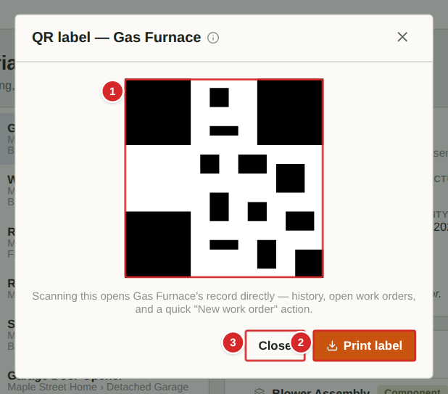
A QR label links a physical item to its record. Stick it on the equipment; anyone who scans it with a phone camera is taken straight to that asset in the app (after signing in), where they can read its details, see its history and start a work order.
What to do
1. Select the asset, then “QR label”.
2. Select “Print label” to print it, then cut out and stick it on the equipment.
3. To use it, scan the code with a phone camera and open the link.
Numbered items in the picture
# | Field / area | What it is and how to use it
1 | QR code | Scan to open this asset. The asset’s name is printed under it.
2 | Print label | Prints the label.
3 | Close | Closes the window.

Vendors, Parts and Budget

Vendors and service providers
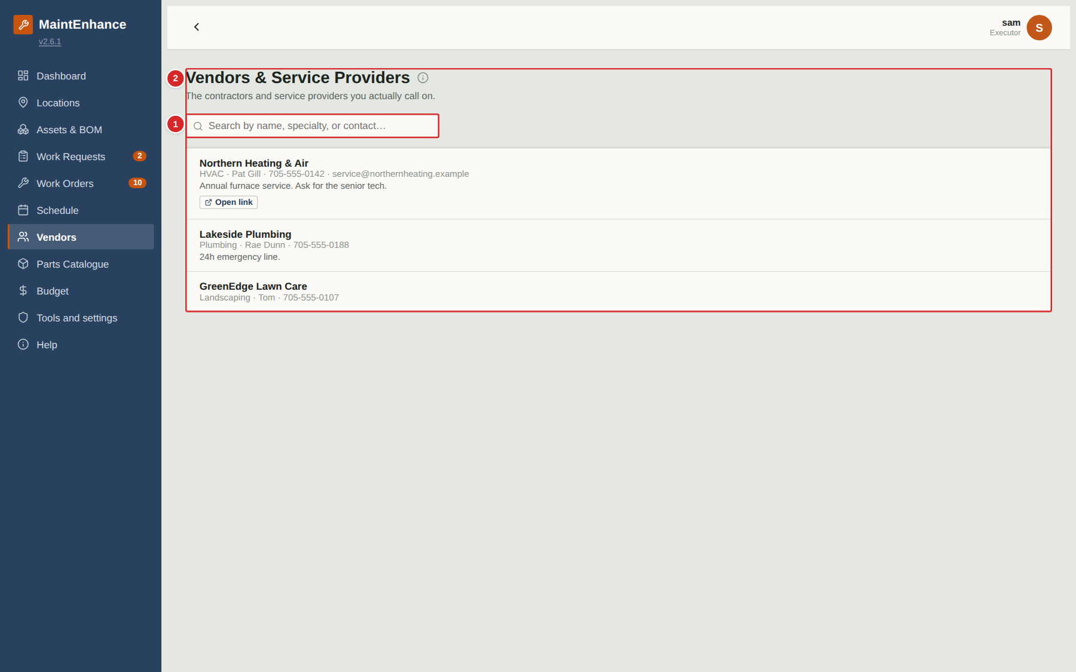
Vendors are the contractors and service providers you call on, kept in one place instead of scattered across texts and receipts. A vendor can be chosen on any work order. Executors can look up contact details here.
What to do
1. Use the search box to find a vendor by name, specialty or contact.
2. Read the row: name, specialty, contact person and phone/email, notes, and a link to the website if one is saved.
3. Select “Open link” to visit the vendor’s website.
Numbered items in the picture
# | Field / area | What it is and how to use it
1 | Search | Finds vendors by name, specialty or contact.
2 | Vendor row | Name, then specialty · contact person · phone · email, and notes such as “24h emergency line”. “Open link” opens the website.

Parts Catalogue
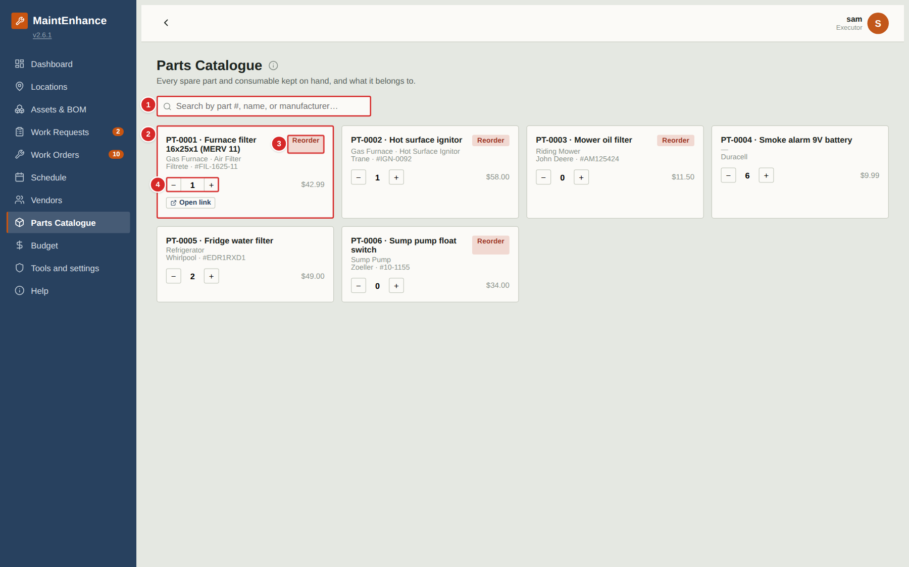
The Parts Catalogue is the master list of spare parts and consumables the household keeps, with part numbers, costs and how many are on hand. Parts are attached to work orders and requests from this list. Everyone can look parts up and adjust the quantity on hand when they use or restock one.
What to do
1. Search by part number, name or manufacturer.
2. Each card shows the part number and name, what it belongs to, the manufacturer’s part number, the price and the quantity in stock.
3. A red “Reorder” tag means the quantity is at or below the reorder level.
4. Use − and + to adjust the quantity on hand when you use a part or restock.
5. “Open link” goes to the supplier’s page for the part.
Numbered items in the picture
# | Field / area | What it is and how to use it
1 | Search | Finds parts by number, name or manufacturer.
2 | Part card | Part number and name; the asset/component it belongs to; manufacturer and manufacturer’s part number; unit cost; “Open link” to the supplier’s page.
3 | Reorder tag | Quantity on hand is at or below the reorder level. These parts also appear on the Purchasing list when needed by open work.
4 | Quantity − / + | Subtract or add one to the quantity on hand. The number between the buttons is the current stock.

Budget and cost tracking
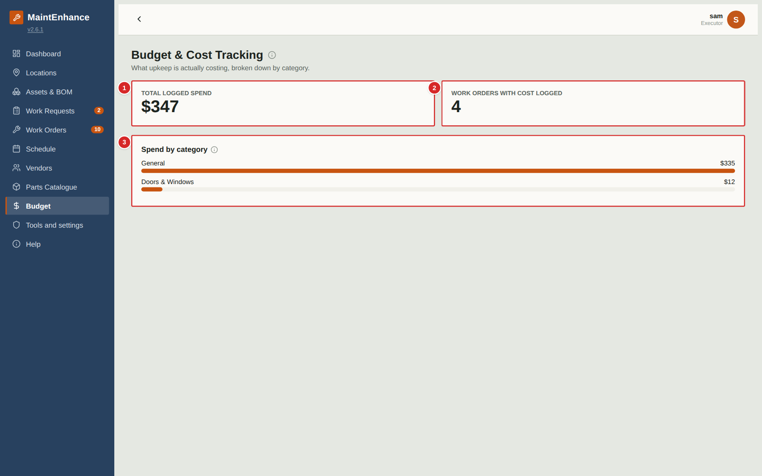
The Budget page shows what upkeep is actually costing, calculated from the costs recorded on work orders. There is nothing to type here — enter a cost on a work order and this page updates by itself.
What to do
1. Read “Total logged spend” for the overall figure and “Work orders with cost logged” for how many jobs it covers.
2. Look at “Spend by category” to see which kinds of asset cost the most: each bar is a category, longer meaning more spend.
3. To change a figure, correct the cost on the work order (managers and owners).
Numbered items in the picture
# | Field / area | What it is and how to use it
1 | Total logged spend | Sum of all costs entered on work orders.
2 | Work orders with cost logged | How many work orders have a cost entered.
3 | Spend by category | One bar per asset category with its total. Work orders without an asset are grouped as “General”.

Tools and settings

Tools (executor tools)
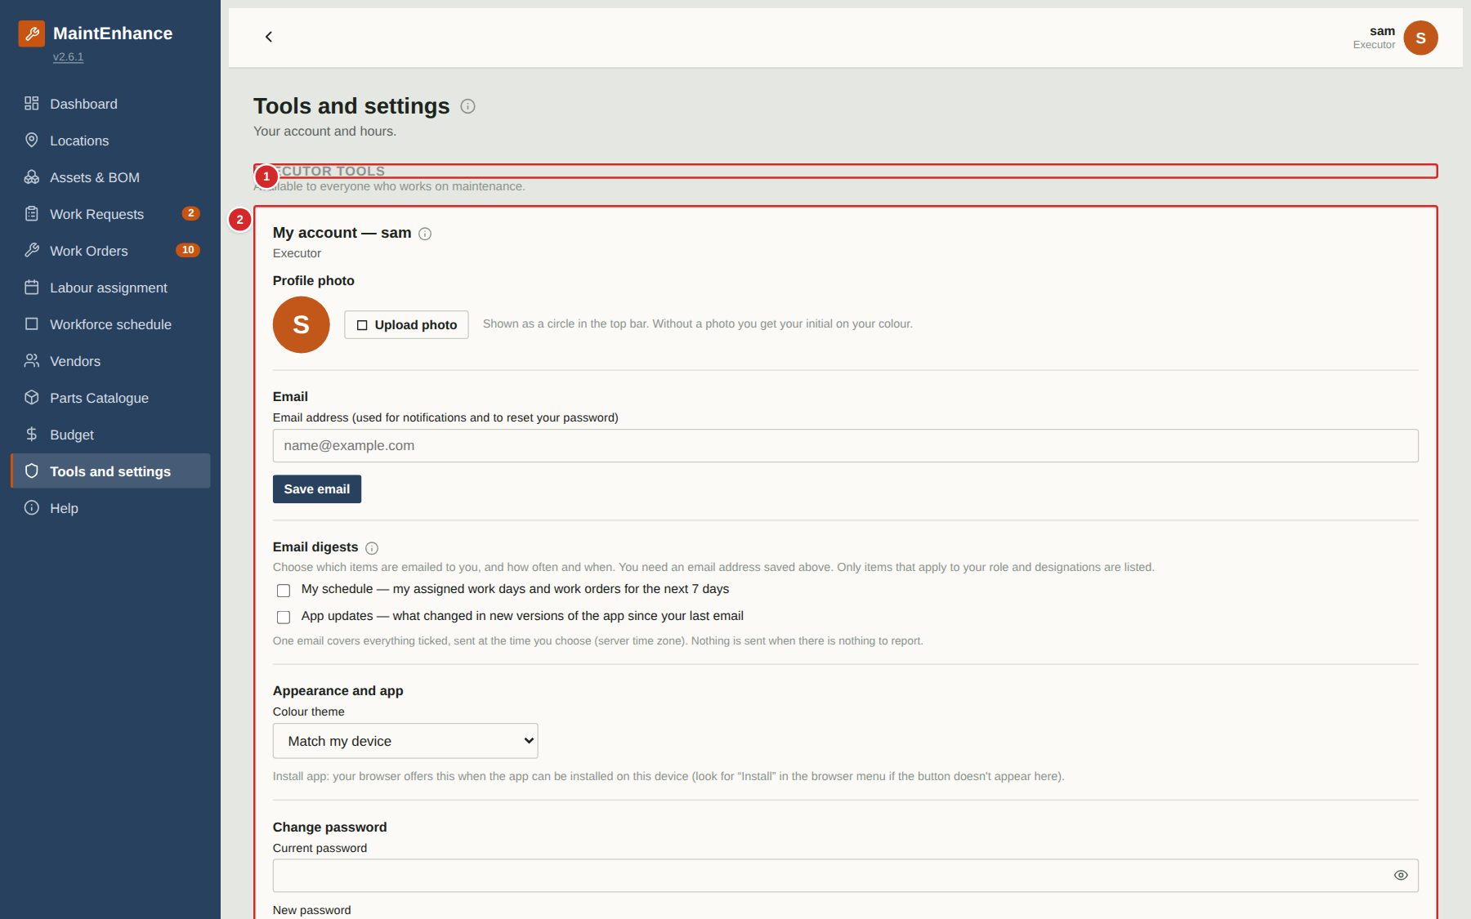
The Tools and settings tab collects the settings and reports that belong to you. As an Executor you see two cards: My account and, when your Owner has turned on time keeping, My hours. Managers and Owners see more cards on the same page.
What to do
1. Open Tools and settings from the menu.
2. Use the My account card to change your photo, email, password, theme and email digests.
3. Check My hours to see the hours you have logged.
Numbered items in the picture
# | Field / area | What it is and how to use it
1 | Section heading | Groups the tools available to everyone who works on maintenance.
2 | My account | Photo, email, digest subscriptions, theme, password and sign out.
3 | My hours | Your hours: the last 7 days, last 30 days and all time, plus your recent entries. Hours are added when you complete a work order.

Scheduling and time keeping (optional)

How scheduling and time keeping work
Three optional switches
Your Owner can switch on three optional features in Tools > Features: Execution-based scheduling (labour assignment and hours worked), Workforce scheduling (who works when) and Hourly assignment (a 30-minute grid inside each day). Hourly needs the other two. With all three off the app looks and behaves as in earlier versions.
Labour assignment
The Schedule page becomes Labour assignment. Drag a work order onto a day (or an hour) to schedule it, and drag a person’s name onto a work order to assign them. A day that is short of people for the crew required is flagged as under-staffed.
Workforce schedule
A calendar of who is working when. Drag a person onto a week or a day, then choose a shift template or enter a one-time shift. When you edit a shift enter any two of start, duration and end and the third is calculated. An end time earlier than the start means an overnight shift, shown on the day it starts. Each day header shows first start, last end and any gap in coverage (in red).
Hours worked
When an executor completes a work order they are asked how many hours they worked. Hours appear on the work order, in Tools > My hours and, for managers, in Tools > Hours worked.
Touch screens
On a tablet or phone, tap a work order card or a person’s name to pick it up (it is highlighted and a banner shows what you are holding), then tap the day, person’s day, week box or hour slot where it should go. Tap Cancel or the held card again to put it down, or Open to see the work order.

Labour assignment
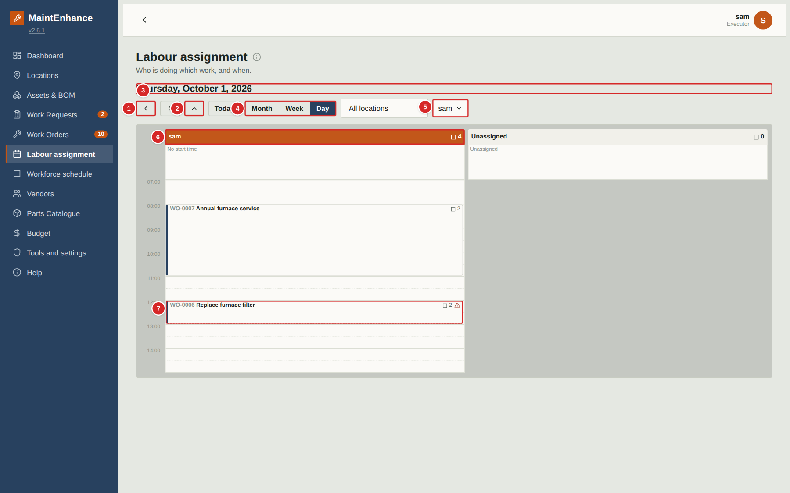
When your Owner turns on execution-based scheduling, the Schedule menu item is renamed Labour assignment. It shows who is doing which work and when. You can view it; managers do the assigning. It starts filtered to you. Use the Month, Week and Day buttons to change the view.
What to do
1. Open Labour assignment. Use the arrows to move between days (or weeks or months) and Today to come back.
2. Select Week or Month for a wider view, or the up arrow to go up one level.
3. Select a work order card to open it.
4. Check your column header for your total scheduled hours that day.
Numbered items in the picture
# | Field / area | What it is and how to use it
1 | Back and forward arrows | Move one day, week or month at a time depending on the view.
2 | Up arrow | Goes up one level: Day to Week to Month.
3 | Title | The day, week or month on show.
4 | Month / Week / Day | Jumps directly to a view.
5 | Executor filter | Choose one or several people. You start on yourself.
6 | Column header | Person's name and the total estimated hours scheduled to them that day.
7 | Work order card | Number and title, the number of people needed (person icon) and the estimated hours each (clock icon). A dashed red outline and “Short” means fewer people are assigned than needed.

Entering hours worked when you complete a work order
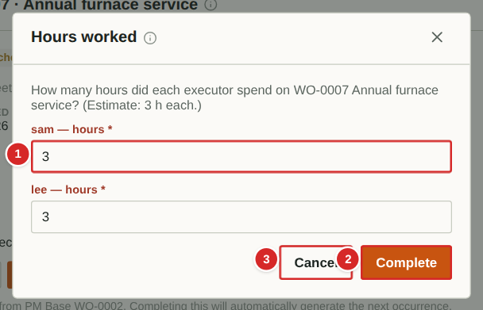
With execution-based scheduling on, moving a work order to Completed also asks how many hours each executor worked. This is how time keeping works: the hours are saved on the work order and counted in My hours and the managers' reports.
What to do
1. Open the work order and select Completed (a comment is asked for first when it was Scheduled).
2. Enter the hours worked for each executor listed. The estimate is pre-filled as a starting point.
3. Select Complete.
Numbered items in the picture
# | Field / area | What it is and how to use it
1 | Hours for each executor | Hours worked by that person, more than 0. Quarter hours are fine (1.25).
2 | Complete | Saves the hours and completes the work order.
3 | Cancel | Stops without completing; nothing is saved.

Workforce schedule
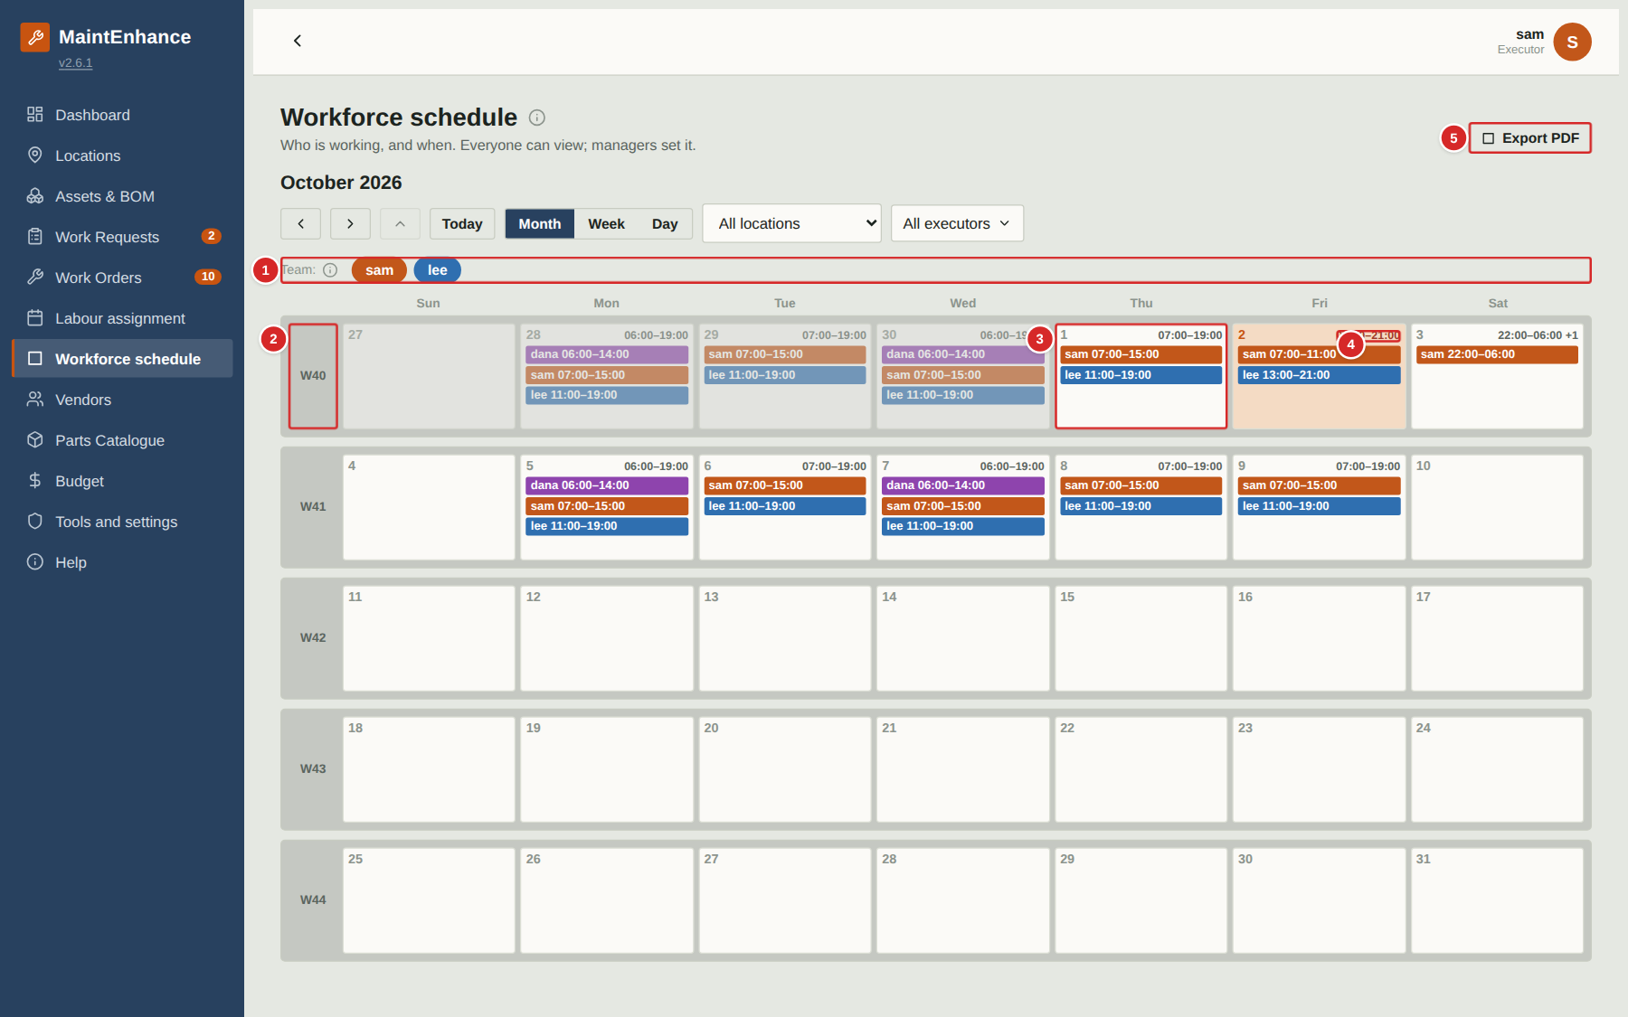
When workforce scheduling is on, the Workforce schedule shows when each person is working. Everyone can view it; managers set it. Use it to see who is on shift on a given day.
What to do
1. Open Workforce schedule. Use the Month, Week and Day buttons and the arrows to move around.
2. Select a day number to open that day, or a week number to open that week.
3. Look at the times at the top of each day: if they are red, hover over them to see the period when nobody is working.
4. Select Export PDF to print or save the schedule for the team.
Numbered items in the picture
# | Field / area | What it is and how to use it
1 | Team | One coloured card per person, in their own colour.
2 | Week number | Select it to open that week.
3 | A day | The shifts for that day: name and times. Select the day number to open the day view.
4 | Day hours (red = gap) | First start and last end of the day. Red text means some time between them has nobody working; hover to see when.
5 | Export PDF | Opens a printable page of what is on screen; choose Save as PDF in the print window.

Quick reference: permissions by role
Capability | Guest | Executor | Manager | Owner
View all pages (except admin pages) | Yes | Yes | Yes | Yes
Submit work requests; edit your own while pending | No | Yes | Yes | Yes
Review requests (convert, merge, ask, decline) | No | No | Yes | Yes
Create work orders | No | Yes | Yes | Yes
Change work-order status (not Closed); add comments; checklists | No | Yes | Yes | Yes
Edit work-order fields (dates, cost, vendor, executor, parts) | No | No | Yes | Yes
Close work orders | No | No | Yes | Yes
Create PM Bases and Benchmarks; Auto schedule | No | No | Yes | Yes
Edit locations and assets; run PM wizard | No | No | Yes | Yes
Edit Bill of Materials | No | Yes | Yes | Yes
Edit vendors and catalogue parts | No | No | Yes | Yes
Adjust part quantity on hand | No | Yes | Yes | Yes
Purchasing list and Alarms | No | No | Yes | Yes
Delete records | No | No | Own only | Any
Tools: executor tools (colour, my hours) | No | Yes | Yes | Yes
Tools: manager tools (shift templates, hours worked, executor colours) | No | No | Yes | Yes
Tools: owner tools (members, branding, features, backup …) | No | No | No | Yes
Labour assignment and Workforce schedule (when enabled) | View | View; record own hours | Edit | Edit
Help tab and (i) info buttons | Yes | Yes | Yes | Yes

Glossary
Term | Meaning
Active / Scheduled / Completed / Closed | The four stages of a work order. See Key ideas.
Alarm | An alert that needs attention: from a sensor (Home Assistant), an out-of-range checklist reading, or entered by hand. Managers and owners handle alarms.
Archive | The list of all Closed work orders, reached from the Closed column.
Asset | A piece of equipment or an item worth maintaining (furnace, fridge, mower).
Benchmark | A saved reference procedure and cost for a kind of job, copied onto new Corrective work orders.
BOM (Bill of Materials) | The tree of components, sub-components and parts that make up an asset.
Checklist | The steps on a PM work order; steps may be ticks, readings, photos or pass/fail.
Climate zone | A setting on the property (Very Cold … Marine) that scales the starter PM catalogue.
Corrective | A work order type: a planned repair.
Executor | Role (and a field on a work order): the person who does the work.
Fixed / Non-fixed | PM modes. Fixed repeats on the same calendar date(s) each year; Non-fixed repeats a set interval after the last completion.
Location | A place in the household tree: property, structure, floor, room, area. The words are configurable.
Meter | A usage counter on an asset (hours, kilometres) used by meter-based PM.
PM / PM Base | Preventive maintenance: a PM is one job; a PM Base is the repeating template that generates them.
Priority | Low, Medium, High or Critical.
QR label | A printable label whose QR code opens the asset’s record.
Required by | The deadline for a request or work order. Work past it is flagged Overdue.
Reorder level | The stock level at or below which a part is flagged Reorder.
Crew required | How many people a work order needs at the same time. Used by the planning calendars to flag an under-staffed day.
Estimated hours | How long a work order is expected to take per person. Used for hourly scheduling and to compare with hours worked.
Executor colour | The colour each executor is shown in on the planning calendars.
Hours worked | Time recorded against a work order by an executor when it is completed; totals appear in Tools.
Info button (i) | A small round button beside a title that opens a short explanation: what the area is for, how to use it and who can.
Overnight shift | A shift whose end time is earlier than its start time. It ends the next day but is always shown on the day it starts.
Shift template | A saved daily or weekly shift pattern that can be dropped onto a person and a day or week on the Workforce schedule.
Standby | A pause on a PM Base, by hand or outside a yearly window.
Work request | A report that something needs attention, awaiting review by a manager or owner.
Work order | A job to be done, with who, what, where, when, parts and cost.

