MaintEnhance
Home maintenance management
Training Guide for Managers and Owners
Reviewing, planning and administering the maintenance programme
Covers app version 2.7 · Issued October 1, 2026
Screenshots were taken from the application with sample data (the Maple Street Home household). Your own data, names and colours will differ.

Contents
How to use this guide
Your role: Manager or Owner
Key ideas
Getting started
First-time setup: creating the Owner account
Signing in
Forgot your password?
Choosing your own password (first sign-in)
My account: email and password
The user menu: Account settings and Sign out
The version number and the change log
Email digests: what, how often and when
The app layout: menu, top bar and page area
More info (i) buttons
Help: the training guide inside the app
Dashboard
Dashboard
Work Requests
Work Requests: the inbox
Submitting a work request (form)
Reviewing a request: Convert to work order
Reviewing a request: Merge into existing
Reviewing a request: Request more info
Reviewing a request: Decline
Work Orders
Work Orders: the board
Creating a work order
Build with AI: a work order
Build with AI: a PM program
Work order detail (managers and owners)
Completing a work order: the completion comment
Comments on a work order
The closed work-order archive
Auto schedule
PM Bases and Benchmarks
Creating a PM Base: calendar, repeating on a frequency
PM Base: Fixed dates every year
PM Base: Meter (usage-based)
PM Base: Seasonal
PM Base: Standby and yearly windows
Viewing and editing a PM Base
Benchmarks: saving a procedure that worked
Benchmarks: starting a job from one
Schedule
Schedule
Locations, Assets and Bill of Materials
Locations: the location hierarchy
Adding or editing a location
PM setup wizard
PM setup wizard: choosing the maintenance
Assets and Bill of Materials
Removing an asset
Adding or editing an asset
Adding or editing a BOM item
QR label
Logging a meter reading
Vendors, Parts and Budget
Vendors and service providers
Adding or editing a vendor
Parts Catalogue
Adding or editing a part
Budget and cost tracking
Purchasing
Purchasing list
Adding a part to buy
Alarms
Alarms
Alarms: webhook and sensor setup
Creating an alarm by hand
Alarm actions: create a work request
Alarm actions: link to a work order
Alarm actions: acknowledge as false
Tools and settings
Tools and settings: what you see by role
Tools and settings: Executor colours
Tools and settings: Shift templates
Shift templates: a daily template
Shift templates: a weekly template
Tools and settings: Hours worked (all executors)
Tools and settings: owner administration
Tools and settings: Members
Tools and settings: a member’s email and notification settings
Tools and settings: resetting a password
Tools and settings: Branding and terminology
Tools and settings: Features
Tools and settings: Backup and bulk edit
Tools and settings: PM Wizard starter catalogue
Tools and settings: adding or editing a catalogue entry
Tools and settings: Delete a work order or request
Scheduling and time keeping (optional)
Labour assignment: month view
Editing or deleting a shift
Labour assignment: week view
Labour assignment: day view
Labour assignment: hourly day view
Work orders: executors, estimate and crew
Hours worked prompt
Workforce schedule: month view
Workforce schedule: week view
Workforce schedule: day view
Scheduling a person: choosing a template
Scheduling a person: a one-time schedule
Glossary
Quick reference: permissions by role

How to use this guide
This guide explains every screen and pop-up window you can use. Each screen has a page with a picture, a short description of the process, and a numbered list that explains every field, button, card and area in the picture.
- Red numbered circles in a picture match the numbered entries beside or below it.
- Red outlines show the area or field the number refers to.
- Fields marked with a red asterisk (*) on the screen are required.
Typical routine
- Dashboard: check overdue work and requests awaiting review.
- Work Requests: review each new request — Convert, Merge, Request more info or Decline.
- Work Orders: assign executors and dates; use Auto schedule for new Active jobs. If scheduling is enabled, use Labour assignment to drag jobs onto days, and check the Workforce schedule for gaps.
- Alarms (if enabled): clear the open queue.
- Close Completed work orders after checking them.
- Purchasing: order parts for upcoming jobs; update stock on the Parts page.
- Monthly: review Budget, warranty warnings and PM Bases on standby.
If you get stuck, the small “i” beside each page title opens a short help note, and your Owner can answer questions about your household’s setup.

Your role: Manager or Owner
Managers and Owners run the maintenance programme: they review requests, plan and schedule work, keep the records of locations, assets, vendors and parts accurate, and verify and close finished work. Owners also administer the app itself. Everything in this guide applies to both roles unless it is marked “Owner only”.
What you can do
- Everything an Executor can do.
- Review work requests: edit, convert to a work order, merge into an existing one, ask for more information, or decline.
- Edit every field of a work order, schedule work, assign executors, attach parts, log costs, and Close work orders.
- Create and maintain PM Bases (repeating maintenance), checklist templates and Benchmarks.
- Add, edit and archive locations and assets; run the PM setup wizard; edit Bill of Materials; log meter readings.
- Add and edit vendors and catalogue parts; use the Purchasing list.
- Work the Alarms page: create, link, convert and acknowledge alarms.
- Owners only: the Owner tools section of the Tools and settings page — members and roles, branding and terminology, features, backups and import, the PM wizard catalogue, and permanent deletion tools.
What you cannot do
- Managers do not see the Owner tools section of the Tools and settings page, and cannot reveal or regenerate the alarm webhook key.
- Managers can delete only records they created themselves; Owners can delete any record.

Key ideas

The life of a job: from request to closed work order
- Someone notices a problem and submits a Work Request (status Submitted).
- A manager or owner reviews it. They may ask for more information (Under Review), decline it (Declined), merge it into a work order that already exists (Merged), or convert it (Approved).
- Converting creates a Work Order. A work order with no date is Active. Giving it a scheduled date makes it Scheduled and puts it on the Schedule calendar.
- The executor does the work, ticking any checklist, and marks the work order Completed, adding a short comment about how it went. Parts used are deducted from stock.
- A manager or owner checks the work and marks it Closed. Closed work orders stay in the archive as the permanent history of the asset.

Work-order statuses
Status | Meaning
Active | Open and not yet booked for a date.
Scheduled | Has a scheduled date. Setting a date moves a work order here automatically; clearing it moves it back to Active.
Completed | The work is done. Moving a Scheduled work order to Completed requires a comment. Parts attached are deducted from stock.
Closed | Verified by a manager or owner. Recent closed work shows in the Closed column; everything is in the archive.

Work-order types
Type | Meaning
PM | A single preventive-maintenance job — usually generated automatically by a PM Base, for example “Replace furnace filter”.
PM Base | A template that generates PM jobs on a repeating schedule. It is never worked itself; it appears in the “PM Base templates” area under the board.
Benchmark | A reference job whose procedure and cost are saved so later jobs can start from it.
Corrective | A planned repair of something that has broken or is wearing out.
Unplanned | An urgent, unexpected job created directly, without waiting for a request to be reviewed.

Getting started

First-time setup: creating the Owner account
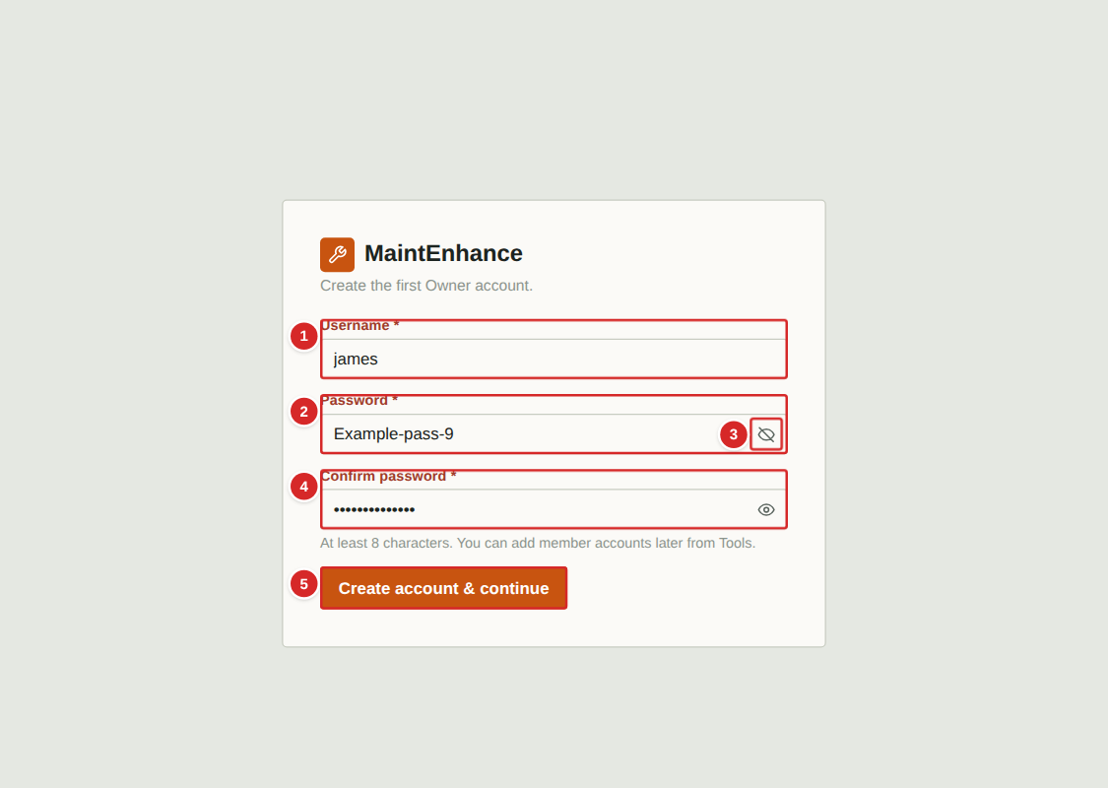
The very first time the app is opened on a new installation there are no accounts yet, so it shows this screen instead of the sign-in screen. Whoever completes it becomes the Owner, the only role that can add members, change branding and settings, and manage backups. Choose the username and password carefully and keep the password somewhere safe: if it is lost, an Owner reset needs access to the server.
What to do
1. Type the username you want for the Owner account.
2. Type a password of at least 8 characters. Select the eye button to see what you typed.
3. Type the same password again in Confirm password. The two must match, or the app asks you to correct them.
4. Select “Create account & continue”. You are signed in as the Owner and can add the rest of the household from Tools.
Numbered items in the picture
# | Field / area | What it is and how to use it
1 | Username | The Owner’s username. It is not an email address.
2 | Password | At least 8 characters. Characters are hidden as you type.
3 | Show / hide password (eye) | Shows or hides what you typed in that box, so typing mistakes are easy to spot.
4 | Confirm password | Type the password again. Both boxes must match before the account is created.
5 | Create account & continue | Creates the Owner account and opens the app.

Signing in
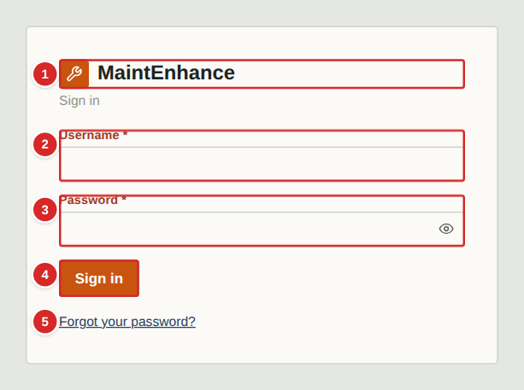
Open the address your Owner gave you in any web browser (on a phone, tablet or computer). You will see the sign-in screen. Your Owner creates your account and tells you your username and a temporary password.
What to do
1. Type your username and password exactly as given (the password is case-sensitive).
2. Select Sign in.
3. If your Owner gave you a temporary password, the next screen asks you to choose your own (see “Changing your password”).
4. Stay signed in on your own devices — the app keeps you signed in for about 30 days. Always use the sign-out button on a shared computer.
Numbered items in the picture
# | Field / area | What it is and how to use it
1 | Name and logo | Shows the name and logo your Owner has chosen for the household, with a one-line description below it.
2 | Username | Your personal username. Ask your Owner if you are unsure; it is not your email address.
3 | Password | Your password. Characters are hidden as you type; select the eye button at the right of the box to show or hide them (handy on a phone).
4 | Sign in | Signs you in. A message in red appears below the fields if the details are wrong. After several wrong attempts in a row the app makes you wait a few minutes before trying again.
5 | Forgot your password? | Appears only when your Owner has set up email for the app. It lets you reset your own password by email (see the next page).

Forgot your password?
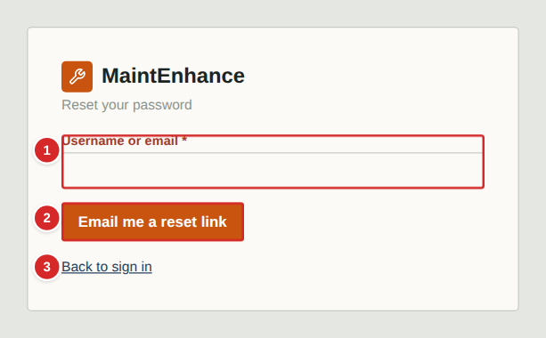
If your Owner has set up email for the app, you can reset your own password. This only works if your account has an email address on it (you or your Owner can add one — see “My account”). If the link does not appear on the sign-in screen, ask your Owner to give you a temporary password instead.
What to do
1. On the sign-in screen select “Forgot your password?”.
2. Type your username or the email address on your account and select “Email me a reset link”.
3. The app always shows the same confirmation, whether or not an account matched, so nobody can use it to find out who has an account.
4. Open the email and select the link. It works once and expires after one hour.
5. Type your new password twice (at least 8 characters) and select “Set new password”, then sign in.
Numbered items in the picture
# | Field / area | What it is and how to use it
1 | Username or email | Either your username or the email address saved on your account.
2 | Email me a reset link | Sends a single-use reset link. The link is valid for one hour. Too many requests in a short time are refused.
3 | Back to sign in | Returns to the sign-in screen without sending anything.

Choosing your own password (first sign-in)
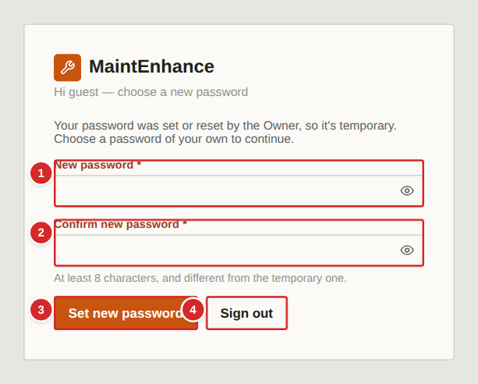
When an Owner creates your account, or resets your password, the password you were given is temporary. After you sign in with it, this screen appears and nothing else in the app is available until you choose your own password. The restriction is enforced by the server too, so it cannot be skipped.
What to do
1. Sign in with the temporary password.
2. Choose a new password of at least 8 characters that is different from the temporary one, and type it twice.
3. Select “Set new password”. You are taken straight into the app. Any other devices where you were signed in are signed out.
Numbered items in the picture
# | Field / area | What it is and how to use it
1 | New password | Your new password: at least 8 characters, and different from the temporary one. Use something only you know.
2 | Confirm new password | Type the new password again. The two must match. Each password box has an eye button to show or hide what you typed.
3 | Set new password | Saves the new password and opens the app.
4 | Sign out | Leaves without changing the password. You will be asked again the next time you sign in.

My account: email and password
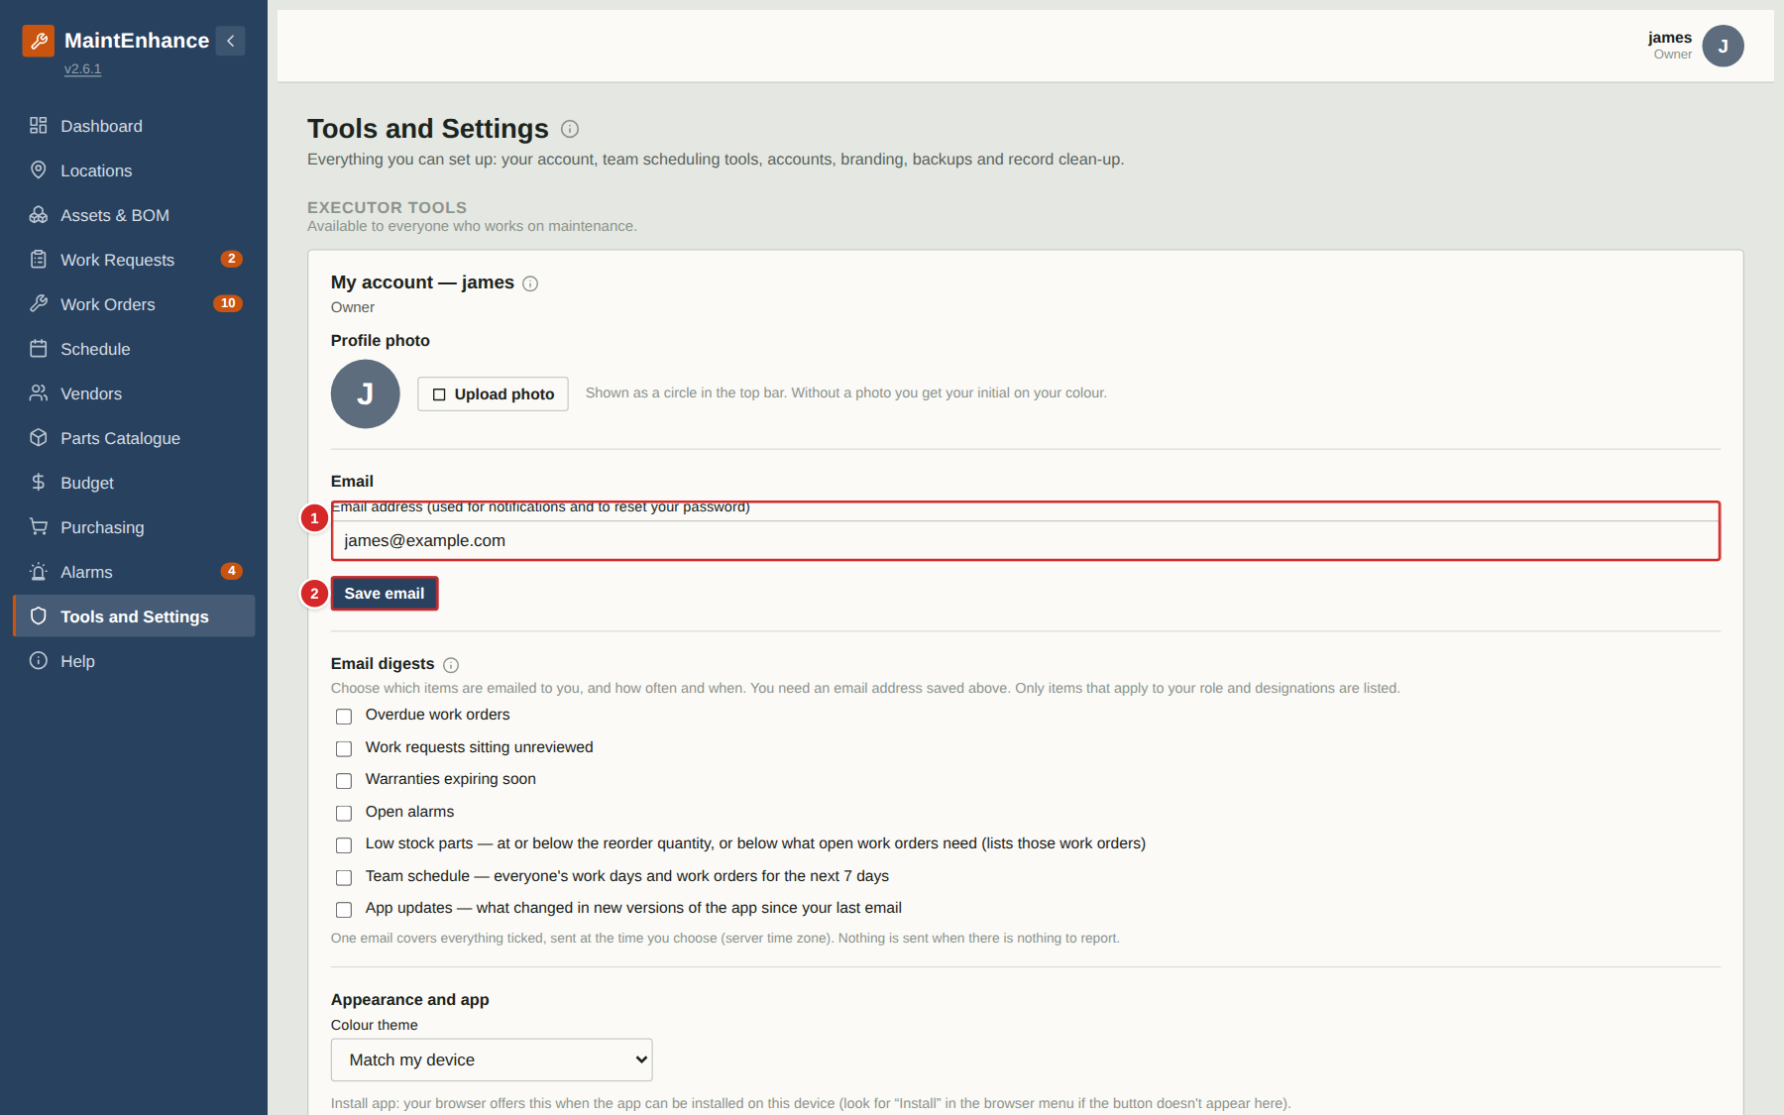
Open the user menu (your picture or initial at the top right), choose Account settings, and use the My account card to change your own email address or password. Your email address is used for reset links and, if your Owner has turned notifications on for you, for the daily digest.
What to do
1. Select your avatar at the top right, then Account settings (Tools and settings opens at My account).
2. To change your email, type it in the Email box and select “Save email”. Each email address can only belong to one account.
3. To change your password, type your current password, then the new one twice, and select “Change password”.
4. Changing your password signs you out on all your other devices; this device stays signed in.
Numbered items in the picture
# | Field / area | What it is and how to use it
1 | Email address | Where reset links and notification emails are sent. Leave it blank if you do not want email.
2 | Save email | Saves the email address. A confirmation or an error (for example, address already used) appears beside the button.
3 | Current password | Your existing password, to confirm it is you.
4 | New password | At least 8 characters and different from the current one.
5 | Confirm new password | Type the new password again.
6 | Change password | Saves the new password and signs out your other devices.

The user menu: Account settings and Sign out
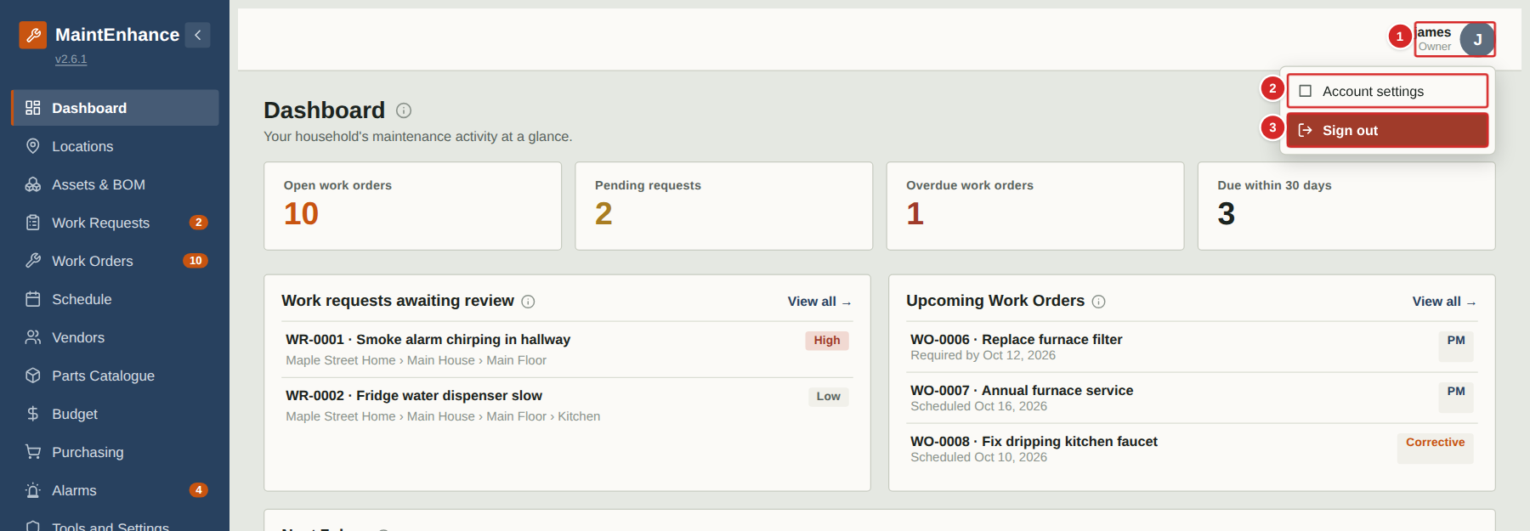
Your picture (or your initial on your colour) sits at the top right. Selecting it opens a small menu. Account settings opens Tools and settings at your account card; the red Sign out leaves the app.
What to do
1. Select your picture at the top right.
2. Choose Account settings to change your photo, email, password, theme and digests.
3. Choose Sign out when you are finished on a shared device.
Numbered items in the picture
# | Field / area | What it is and how to use it
1 | Your picture | Profile photo, or your initial on your colour. Opens the menu.
2 | Account settings | Opens Tools and settings at My account.
3 | Sign out | Ends your session on this device.

The version number and the change log
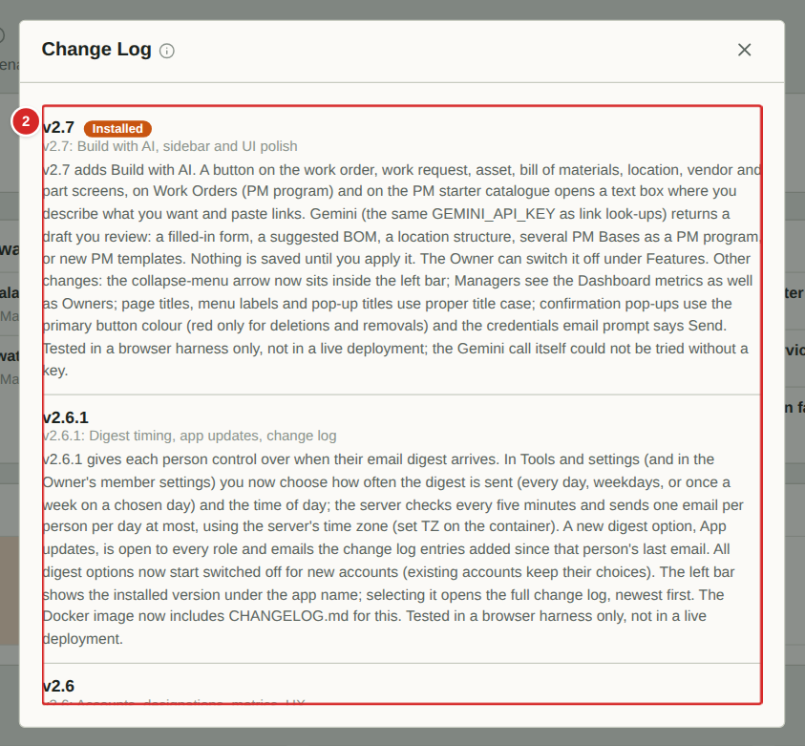
The installed version of the app is shown under the app name at the top of the menu. Selecting it opens the change log: every version, newest first, with a plain description of what changed. The version you are running is marked Installed.
What to do
1. Select the version number under the app name.
2. Scroll to read what changed in each version.
3. Close the window with the X.
Numbered items in the picture
# | Field / area | What it is and how to use it
1 | Version number | Select it to open the change log.
2 | Change log | Newest version first. Each entry says what changed.

Email digests: what, how often and when
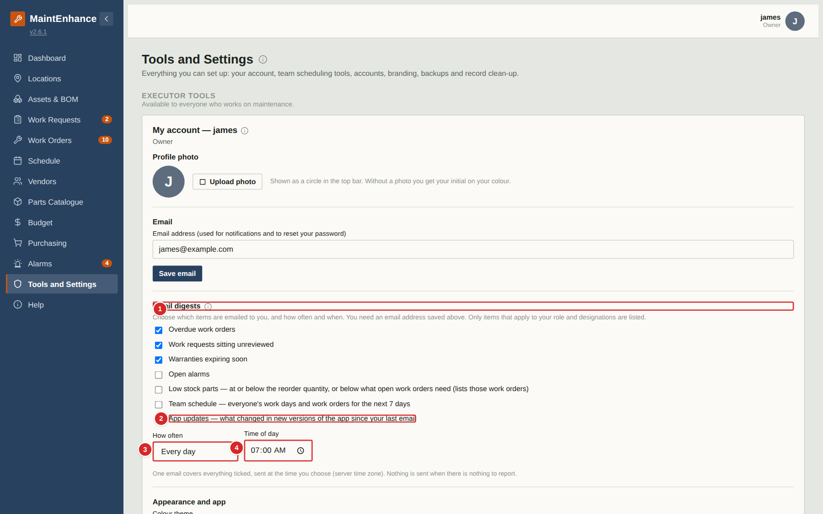
In Tools and settings, My account, tick the items you want emailed to you. Then choose how often (every day, weekdays or once a week) and the time of day. One email covers everything you ticked and is only sent when there is something to report. All options start switched off. App updates is open to everyone and lists what changed in the app since your last email.
What to do
1. Open your avatar menu and choose Account settings.
2. Tick the digest items you want.
3. Choose How often (and the day, for weekly) and the Time of day.
4. Make sure your email address is saved above; your Owner must have set up email on the server.
Numbered items in the picture
# | Field / area | What it is and how to use it
1 | Email digests | Everything here is off until you tick it.
2 | App updates | Emails the change log entries added since your last email.
3 | How often | Every day, weekdays, or once a week on a day you pick.
4 | Time of day | When the email is sent, in the server's time zone.

The app layout: menu, top bar and page area
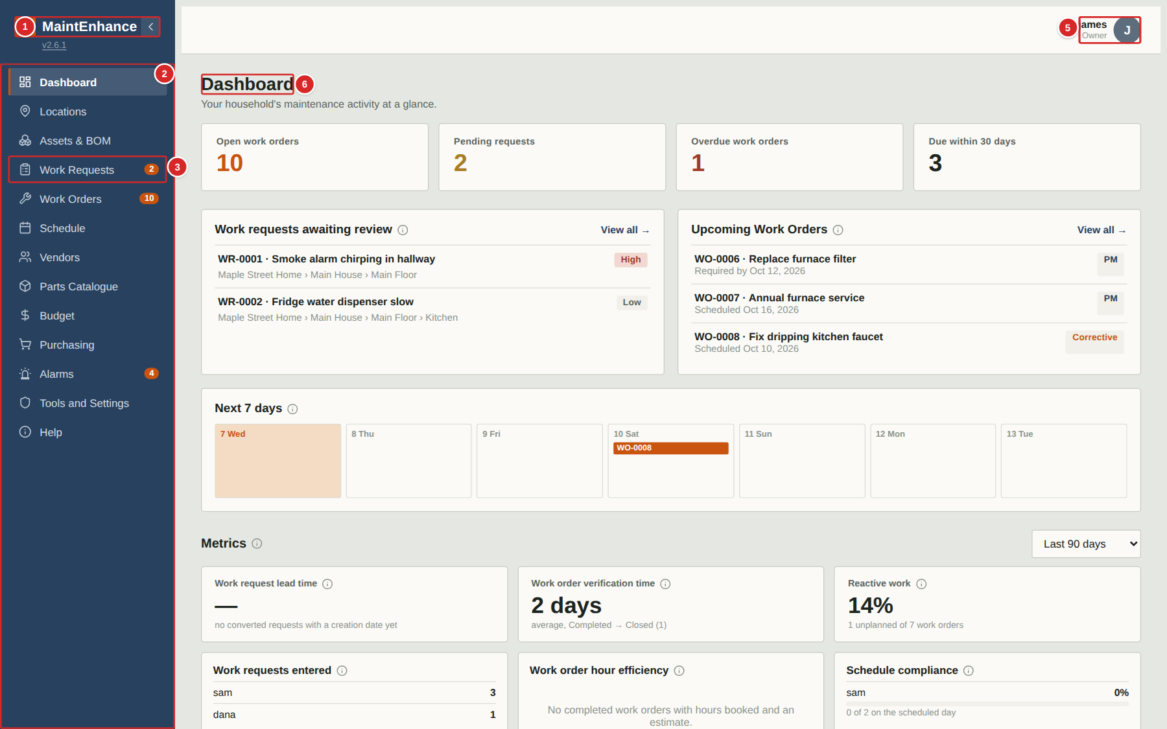
Every screen shares the same layout. The menu on the left switches between areas of the app, the top bar holds your personal controls, and the large area to the right shows the page you chose. As a Manager or Owner you see every menu item your role allows: Purchasing and Alarms are shown to managers and owners only, and Tools is shown to every signed-in member except Guests (its cards depend on your role). When your Owner has switched on the optional scheduling features the menu also shows Labour assignment and Workforce schedule. Help, at the bottom, opens this guide.
What to do
1. Select a menu item to open that area. The current area is highlighted.
2. The small orange numbers beside Work Requests and Work Orders count requests waiting for review and work orders that are still open.
3. On a phone the menu is hidden: select the menu button at the top left to open it, and select any item to close it again.
4. Use the arrow button at the top left to collapse the menu on a large screen and give the page more room.
Numbered items in the picture
# | Field / area | What it is and how to use it
1 | Name and logo | The household name and logo, set by your Owner.
2 | Menu | One entry per area of the app. Select an entry to open it. Your role decides which entries appear.
3 | Count badges | Orange counters: requests that still need a decision, and work orders that are not yet Closed.
4 | Collapse / menu button | Hides or shows the menu.
5 | Signed-in user | Shows who is signed in and your role. Select it to open a small menu with Account settings and a red Sign out.
6 | Page title | The name of the page you are on. The small “i” beside it opens a short help note about the page.

More info (i) buttons
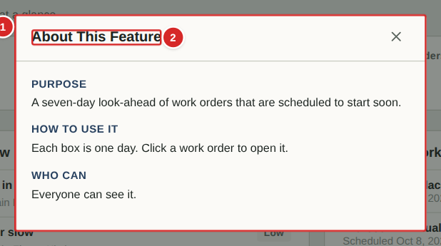
Small round “i” buttons appear beside page titles, card headings and pop-up window titles throughout the app. Selecting one opens a short note explaining what that part of the app is for, how to use it and who is allowed to use it. Nothing changes when you open one.
What to do
1. Look for the small “i” beside a title.
2. Select it to open the note.
3. Read the Purpose, How to use it and Who can sections, then close the window with the X.
Numbered items in the picture
# | Field / area | What it is and how to use it
1 | The note | Purpose: what the feature is for. How to use it: the steps. Who can: which roles can use it.
2 | Title | Always “About this feature” for card and pop-up notes; page notes are titled “About” and the page name.

Help: the training guide inside the app
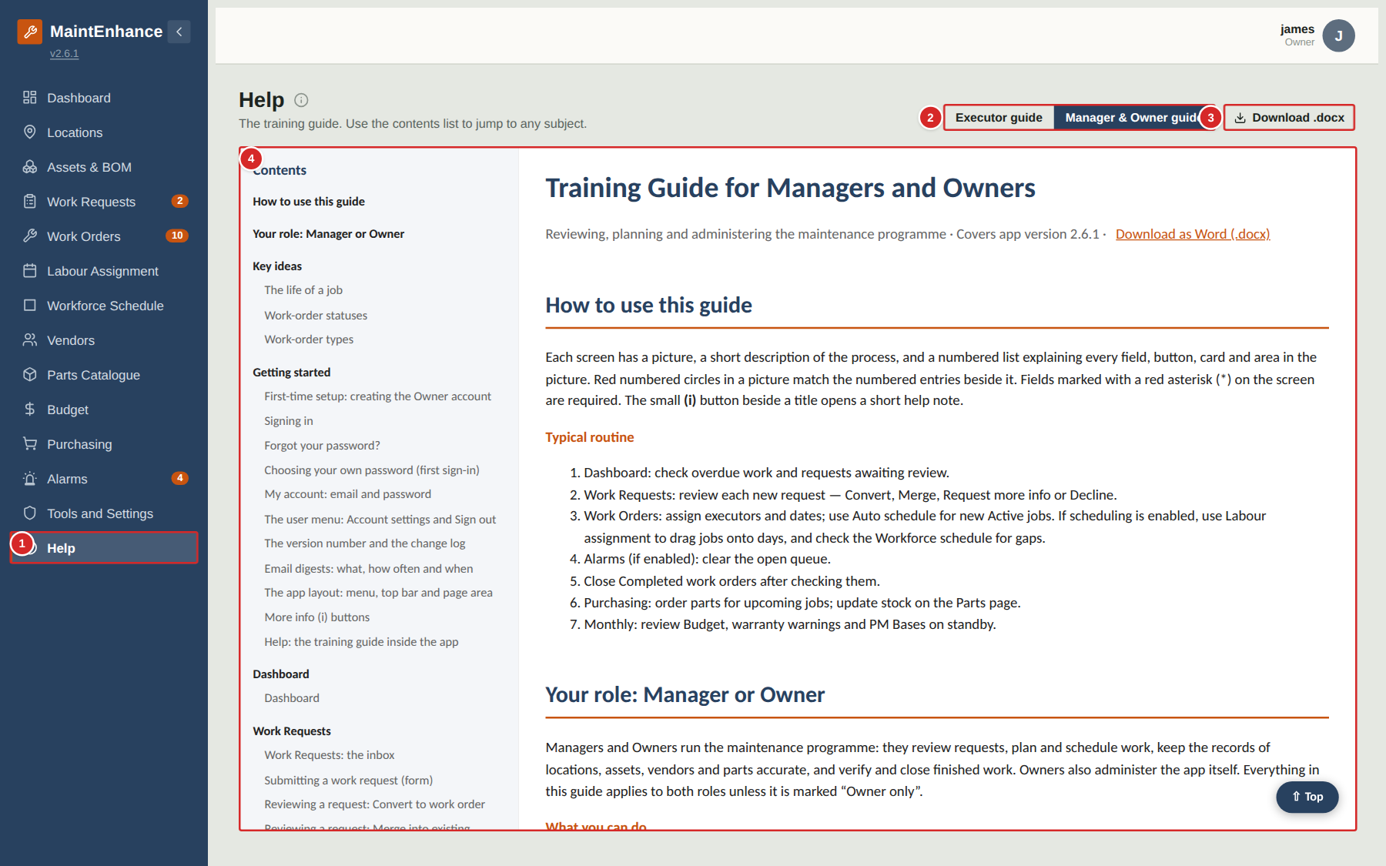
The Help item at the bottom of the menu opens this training guide inside the app. A contents list at the top links to every subject; selecting a title jumps straight to it. Use it when you want to remind yourself how a screen works.
What to do
1. Select Help in the menu.
2. Choose the guide for your role. You can read the other guide too.
3. Select a subject in the Contents list to jump to it, or scroll.
4. Select “Download .docx” to get the Word version to print or share.
Numbered items in the picture
# | Field / area | What it is and how to use it
1 | Help menu item | Opens this page. It is available to everyone.
2 | Guide selector | Switches between the Executor guide and the Manager & Owner guide.
3 | Download .docx | Downloads the Word version of the guide that is showing.
4 | The guide | The training guide itself. Its contents list is at the top and each entry is a link.

Dashboard

Dashboard
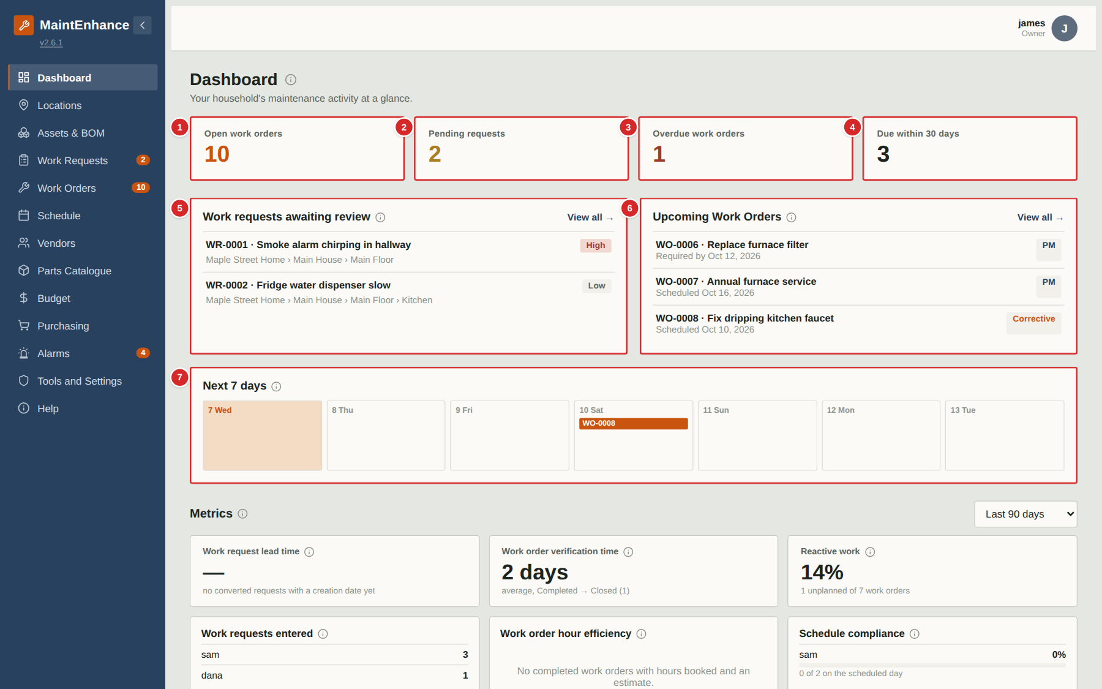
The Dashboard is the first page after you sign in. It answers “what needs attention?” at a glance. Everything on it is a live summary of the other pages — selecting a card or a row takes you to the matching list or record.
What to do
1. Look at the four counters at the top for the overall picture.
2. Review “Work requests awaiting review” first: these are requests from household members that need a decision. Select a row to open it, or “View all” to go to the Work Requests page (managers and owners can Convert, Merge, Request more info or Decline each one there).
3. Check Upcoming Work Orders and the 7-day strip to see what is coming and what is overdue.
4. Check Warranty expiring soon so that claims are made before cover ends.
Numbered items in the picture
# | Field / area | What it is and how to use it
1 | Open work orders | How many work orders are not yet Closed (Active, Scheduled or Completed). Select it to open the Work Orders board.
2 | Pending requests | Work requests that are Submitted or Under Review and still waiting for a decision.
3 | Overdue work orders | Work orders whose required-by date has passed and that are not yet Completed or Closed. Shown in red when above zero.
4 | Due within 30 days | Open work orders due in the next 30 days.
5 | Work requests awaiting review | The latest requests that still need a decision, with number, title, location and priority. “View all” opens the Work Requests page.
6 | Upcoming Work Orders | The next open work orders by date, each with its type tag (PM, Corrective, Unplanned …) and either its scheduled or required-by date.
7 | Next 7 days | One box per day for the coming week. Today is highlighted; scheduled work orders appear as small tags in their day.
8 | Warranty expiring soon | Assets whose warranty ends in the next few months, with the expiry date. Plan repairs or claims before the date.

Work Requests

Work Requests: the inbox
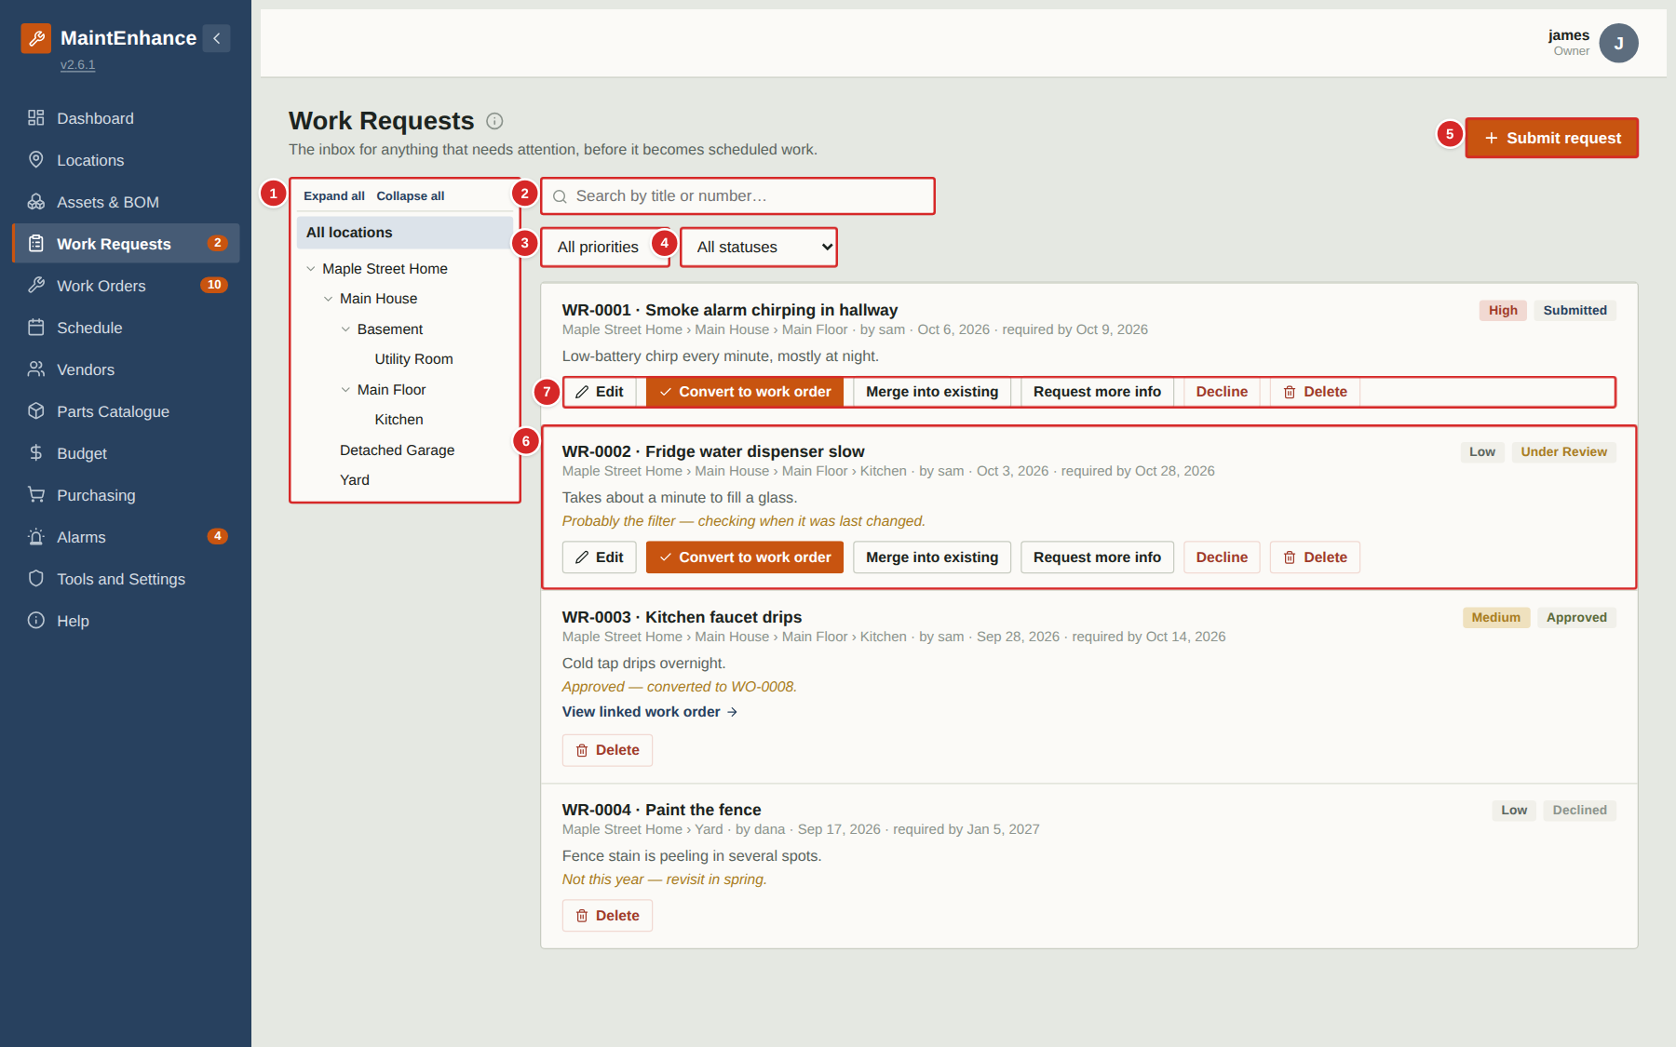
A work request is a note that something needs attention — a leak, a broken light, a strange noise. Anyone can raise one. As a manager or owner you review each request here: convert it into a work order, merge it into an existing work order, ask the submitter for more information, or decline it. Each request card shows its status, and managers see the review buttons directly on the card.
What to do
1. Select “Submit request” to report a new problem (see the next page).
2. Use the location tree, the search box and the two filters to find a request.
3. Read the status tag on the right of each card to see where the request stands: Submitted (not yet looked at), Under Review (a manager has asked a question or is deciding), Approved (converted to a work order), Declined, or Merged.
4. Select Edit on one of your own requests that has not been decided yet to correct it or answer a question from the reviewer.
5. When a request has been approved, select “View linked work order” to follow the work.
Numbered items in the picture
# | Field / area | What it is and how to use it
1 | Location tree | Narrow the list to one place. Selecting a room also shows requests for the things inside it. “Expand all / Collapse all” opens or closes the branches.
2 | Search | Finds requests by words in the title or by number, for example “WR-0002”.
3 | Priority filter | Show only Low, Medium, High or Critical requests.
4 | Status filter | Show only requests with a given status.
5 | Submit request | Opens the form for a new request. Available to every role except Guest.
6 | Request card | One card per request: number and title, location path, who raised it and when, the date it is needed by, the description, and any reply from the reviewer (in italics). The tags at the top right show priority and status.
7 | Review buttons | Managers and owners only. Edit corrects the request; Convert to work order creates the work order; Merge into existing adds it to a work order already open; Request more info sends a question back; Decline closes it with a reason; Delete removes it (managers can delete only requests they created).

Submitting a work request (form)
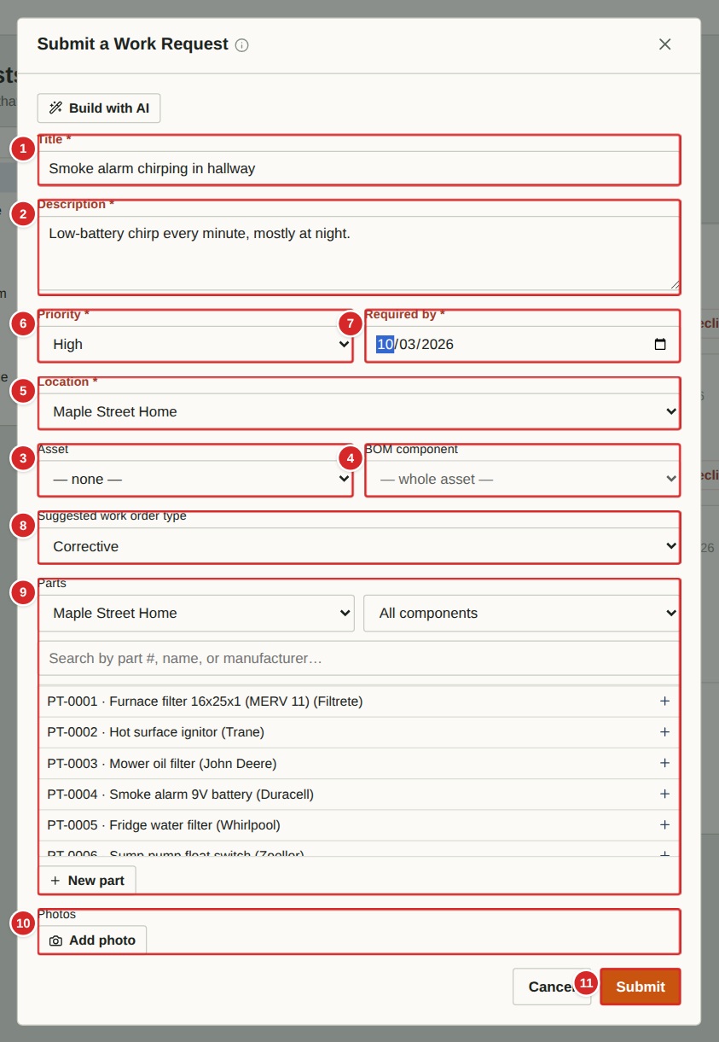 | Use this form whenever something needs attention. Give enough detail that someone who has not seen the problem can understand it. Fields marked with a red asterisk are required. You can edit your own request later, until a manager has decided it.  What to do  1. On the Work Requests page select “Submit request”.  2. Type a short Title that names the problem and where it is (for example “Kitchen tap dripping”).  3. Choose the Location. If the problem is on a specific asset or one of its components, also pick the Asset and the BOM component — this links the request to that item’s history.  4. Set the Priority and the date it is Required by. Pick the date you honestly need it fixed by; managers use it to plan.  5. Optionally suggest a work-order type and any Parts you think will be needed, and attach up to five photos.  6. Select Submit. The request appears in the inbox with the status Submitted. If you are offline the app keeps it on your device and sends it as soon as you are back online.  Numbered items in the picture  1 Title * — A short name for the problem. It becomes the work order title if the request is approved.  2 Description — What you saw, heard or smelled; when it happens; anything you have already tried.  3 Asset — Optional. The equipment concerned (furnace, fridge, mower …). Choosing one links the request to that asset’s history.  4 BOM component — Optional. A part inside the chosen asset (for example the burner of the furnace). Appears once an asset with components is chosen.  5 Location * — Where the problem is. Required. If you chose an asset the location is filled in from it.  6 Priority — Low, Medium, High or Critical. Use High or Critical only for safety issues or loss of an essential service.  7 Required by * — The date by which it needs to be fixed. Required.  8 Suggested work order type — Your suggestion for how the request should be handled: Corrective (fix something broken), PM, PM Base or Benchmark. The reviewer makes the final choice.  9 Parts — Optional. Pick parts from the Parts Catalogue that the job will probably need, with quantities. “New part” adds a catalogue entry on the spot.  10 Photos — Optional. Add up to five photos from the camera or gallery. Photos are shrunk automatically before upload.  11 Submit / Cancel — Submit sends the request. Cancel closes the form; if you typed anything the app asks whether to discard it.

Reviewing a request: Convert to work order
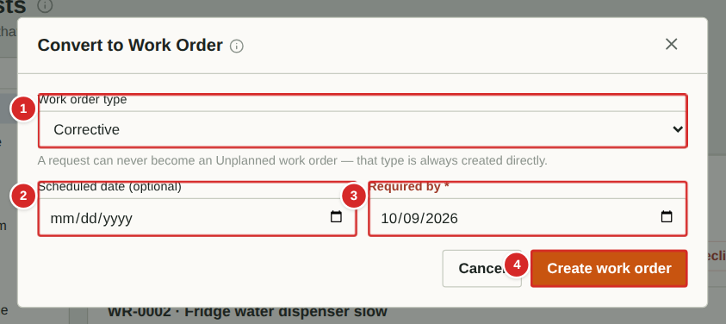
Converting a request creates a work order from it. The request’s title, description, asset, location, priority, parts and photos are copied across, the request’s status becomes Approved, and the submitter can follow the link to the new work order.
What to do
1. On the request card select “Convert to work order”.
2. Choose the Work order type. Corrective creates a one-off repair job. PM creates a single preventive job. PM Base creates a repeating template that generates jobs on a schedule, and Benchmark creates a reusable reference job (see “PM Bases” and “Benchmarks”). Requests can never become an Unplanned work order — that type is only created directly.
3. Optionally set a Scheduled date. Setting one makes the work order Scheduled instead of Active.
4. Check or set the Required by date (required, unless the type is PM Base).
5. Select “Create work order”. The new work order opens on the Work Orders board.
Numbered items in the picture
# | Field / area | What it is and how to use it
1 | Work order type | What kind of work order to create. Choosing PM Base reveals the repeat-schedule fields described under PM Bases.
2 | Scheduled date (optional) | If you enter a date the work order starts in the Scheduled column and appears on the calendar. Leave blank for Active.
3 | Required by * | Deadline for the work. Copied from the request and can be changed here.
4 | Create work order | Creates the work order and marks the request Approved.

Reviewing a request: Merge into existing
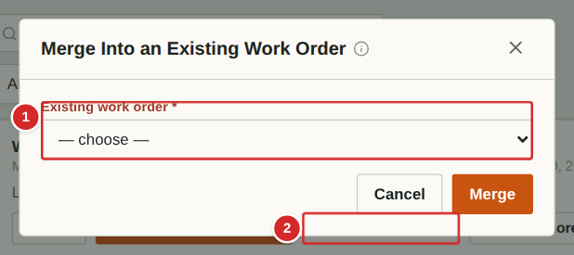
If the problem is already covered by an open work order — for example two people reported the same leak — merge the request into that work order instead of creating a duplicate. The request’s details are added to the work order as a comment and the request is marked Merged.
What to do
1. On the request card select “Merge into existing”.
2. Pick the work order from the Existing work order list.
3. Select Merge. The request becomes Merged and shows a link to the work order.
Numbered items in the picture
# | Field / area | What it is and how to use it
1 | Existing work order * | All work orders that are not yet Closed. Pick the one that already covers this problem.
2 | Merge | Adds the request details to the chosen work order and closes the request as Merged.

Reviewing a request: Request more info
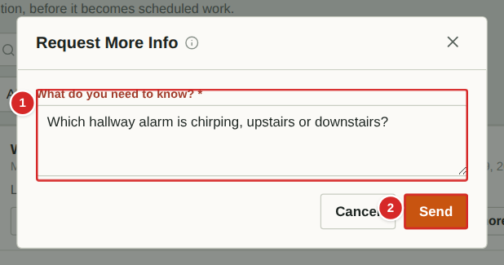
If a request is too vague to act on, ask the submitter a question. The request moves to Under Review and your question appears in italics on the card, where the submitter can read it and edit the request to answer.
What to do
1. On the request card select “Request more info”.
2. Type your question.
3. Select Send. The status changes to Under Review.
4. When the submitter has edited the request, review it again and choose Convert, Merge or Decline.
Numbered items in the picture
# | Field / area | What it is and how to use it
1 | What do you need to know? * | Your question for the submitter. Be specific so one reply is enough.
2 | Send | Saves the question and sets the status to Under Review.

Reviewing a request: Decline
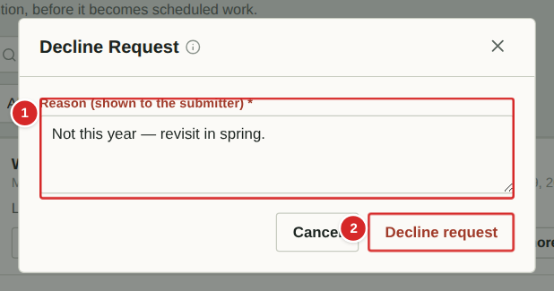
Decline a request when no work will be done — it is a duplicate, out of scope or not worth doing. The reason you give is shown to the submitter on the request card.
What to do
1. On the request card select “Decline”.
2. Type a short reason.
3. Select “Decline request”. The status changes to Declined and the reason appears in italics.
Numbered items in the picture
# | Field / area | What it is and how to use it
1 | Reason * | Why the request is not going ahead. The submitter sees this, so keep it polite and clear.
2 | Decline request | Records the decision. A declined request stays in the list for reference.

Work Orders

Work Orders: the board
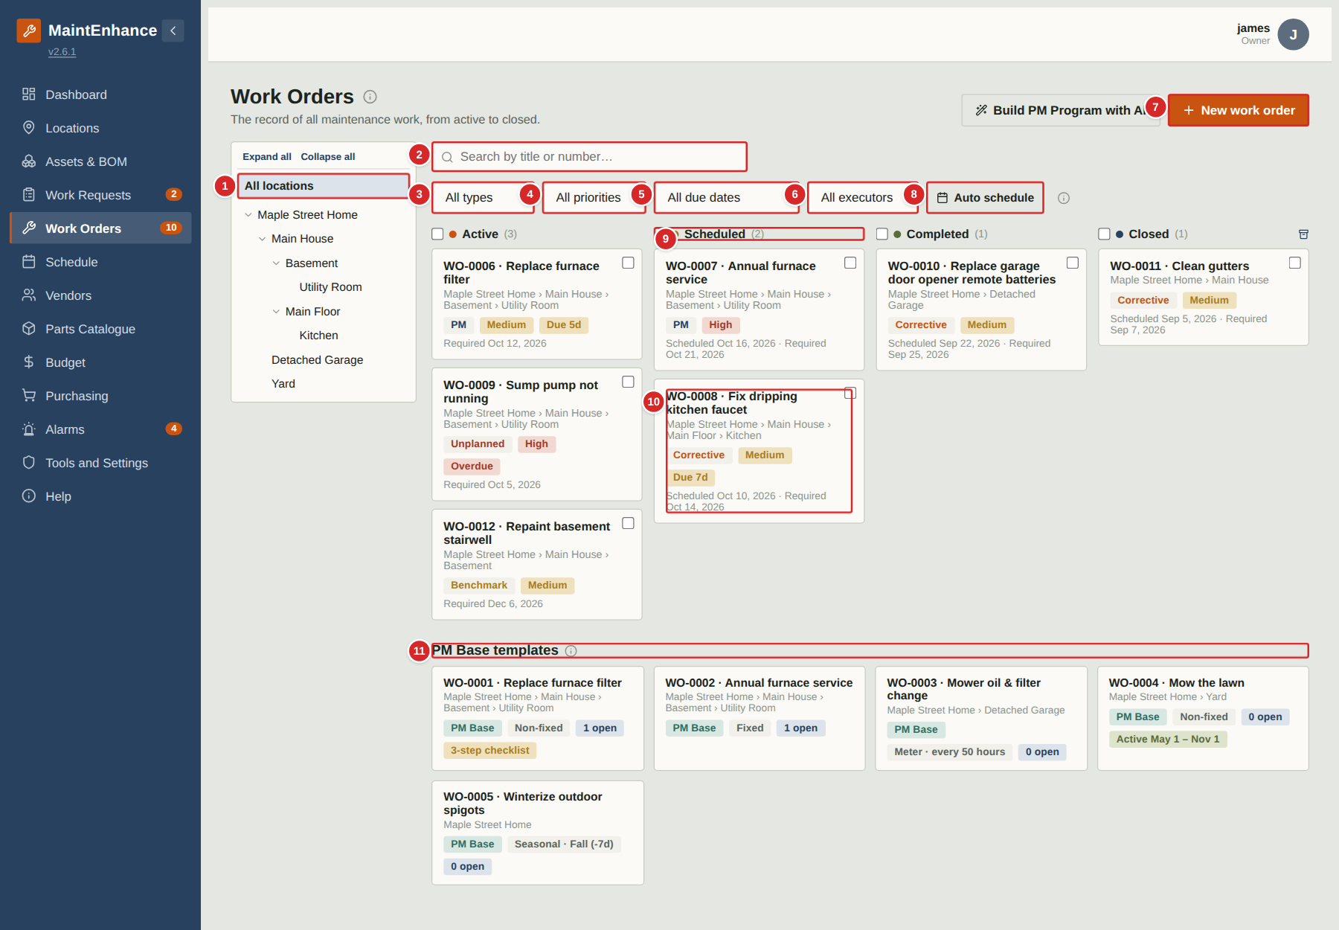
A work order is a job to be done: who, what, where, by when and with which parts. The board shows every work order in four columns that follow its life: Active (open, not yet booked), Scheduled (has a scheduled date), Completed (done, awaiting verification) and Closed (verified by a manager or owner). Cards move between columns when their status changes.
What to do
1. Use the location tree, search and filters to narrow the board. As an Executor the Executor filter starts on your own name so you see the jobs assigned to you; choose “All executors” to see everyone’s.
2. Select a card to open the work order (see “Work order detail”).
3. Select “New work order” to create one (see “Creating a work order”).
4. The archive button at the top of the Closed column lists work orders closed more than 30 days ago.
5. Scroll down (with the Executor filter set to All executors) to see the PM Base templates (see “Viewing a PM Base template”).
Numbered items in the picture
# | Field / area | What it is and how to use it
1 | Location tree | Show only work orders at one place and everything inside it.
2 | Search | Find a work order by words in the title or by number, for example “WO-0008”.
3 | Type filter | PM, PM Base, Benchmark, Corrective or Unplanned.
4 | Priority filter | Low, Medium, High or Critical.
5 | Due-date filter | Overdue, due within 7 days, 30 days and so on.
6 | Executor filter | The person the work is assigned to. Executors start with their own name selected.
7 | New work order | Opens the creation form.
8 | Auto schedule | Managers and owners. Tick cards with the boxes on each card or column header, then select Auto schedule: every selected Active work order is given a scheduled date equal to its required-by date and moves to Scheduled in one step.
9 | Column headers | Active, Scheduled, Completed and Closed, each with the number of cards. Managers and owners also get a tick-box on each header to select every card in the column (used by Auto schedule).
10 | Work order card | Number and title, location, type / priority / “Due 7d” tags, and the scheduled and required-by dates. Select it to open.
11 | PM Base templates | Below the board: the repeating-maintenance templates. Each shows its repeat rule, how many generated jobs are open, and any checklist. See “PM Bases”.

Creating a work order
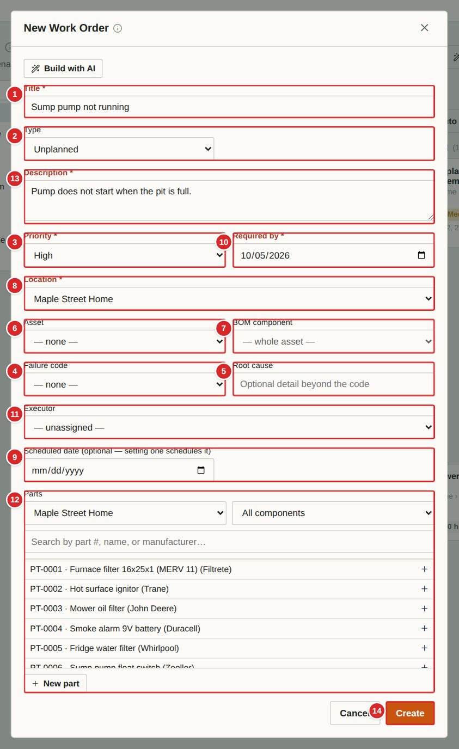 | Create a work order directly when you already know what needs doing — for example an urgent job that cannot wait for a request to be reviewed. (A request, once approved, becomes a work order automatically.) Fields marked with an asterisk are required. The fields shown change a little with the Type you choose.  What to do  1. On the Work Orders page select “New work order”.  2. Type a Title and choose the Type (see “Key ideas”). New work orders default to Unplanned for an unexpected job.  3. Choose the Location, and if relevant the Asset and BOM component. Set Priority and the Required by date.  4. Optionally pick a Vendor and an Executor (the person who will do the work), attach Parts from the catalogue, and add a Description.  5. Select Create. With no scheduled date the work order starts in the Active column; entering a scheduled date makes it Scheduled.  Note: Work order types: PM — a single preventive-maintenance job (usually generated for you by a PM Base). PM Base — a repeating template, not a job itself. Benchmark — a reference job whose procedure you want to reuse. Corrective — a planned repair. Unplanned — an unexpected or emergency job.  Numbered items in the picture  1 Title * — A short name for the job.  2 Type — PM, PM Base, Benchmark, Corrective or Unplanned. Choosing PM Base replaces the date fields with repeat-schedule fields.  3 Priority — Low, Medium, High or Critical.  4 Failure code — Corrective and Unplanned only. A standard category for why it failed (for example Wear), for later analysis.  5 Root cause — Corrective and Unplanned only. Free text for the underlying reason, beyond the code.  6 Asset — The equipment the job is on. Optional but recommended — it feeds the asset’s work-order history.  7 BOM component — A component inside the asset (for example “Burner”).  8 Location * — Where the job is. Filled in from the asset when you choose one.  9 Scheduled date (optional) — Entering a date schedules the work order: it moves to the Scheduled column and appears on the calendar.  10 Required by * — The deadline. Required for every type except PM Base.  11 Executor — The household member responsible. Their Work Orders filter and the Schedule will show the job.  12 Parts — Parts from the catalogue with quantities. They are deducted from stock when the work order is Completed, and shortages show on the Purchasing list.  13 Description — Details, instructions or access notes.  14 Create / Cancel — Create saves the work order. Cancel closes the form (the app asks first if you typed something).

Build with AI: a work order
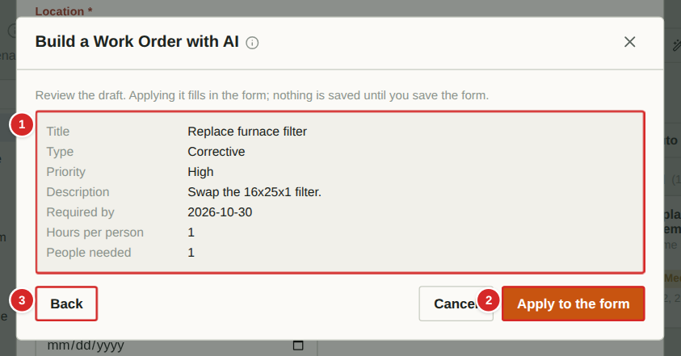
Build with AI sits at the top of the New work order form (and the other entry forms). Describe the job in your own words, add any links, and select Build draft. The AI proposes the details, which you review. Applying them fills in the form; you can still edit anything and nothing is saved until you select Create.
What to do
1. Open New work order and select Build with AI.
2. Type what you want, paste any links, and select Build draft.
3. Read the draft. Select Back to reword your request, or Apply to the form.
4. Edit anything that needs changing and save as usual.
Numbered items in the picture
# | Field / area | What it is and how to use it
1 | The draft | What the AI proposes. Only locations and assets that exist in your app are used.
2 | Apply to the form | Fills in the form with the draft. Nothing is saved yet.
3 | Back | Returns to the text box so you can change your description.

Build with AI: a PM program
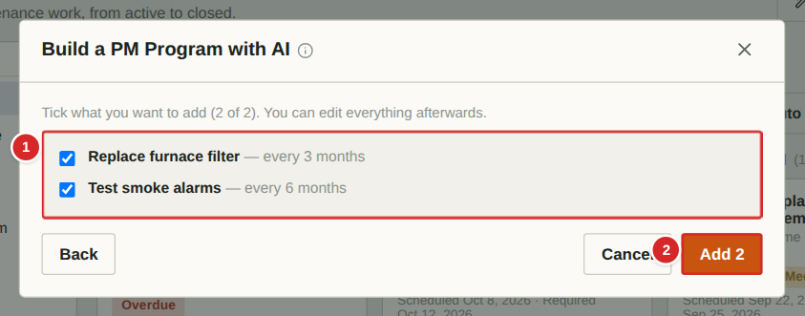
On the Work Orders page, Build PM Program with AI drafts several recurring PM Bases at once. Tick the ones you want and select Add; each becomes a PM Base with its first work order scheduled. The same idea is available as Build Templates with AI on the PM Wizard starter catalogue, Build Locations with AI on Locations and Suggest BOM with AI on an asset.
What to do
1. Select Build PM Program with AI on the Work Orders page.
2. Describe the equipment or property and what you want covered.
3. Untick anything you do not want.
4. Select Add. The PM Bases appear on the board.
Numbered items in the picture
# | Field / area | What it is and how to use it
1 | Suggested PM Bases | Each line shows the job and how often it repeats. Tick the ones to keep.
2 | Add | Creates the ticked PM Bases.

Work order detail (managers and owners)
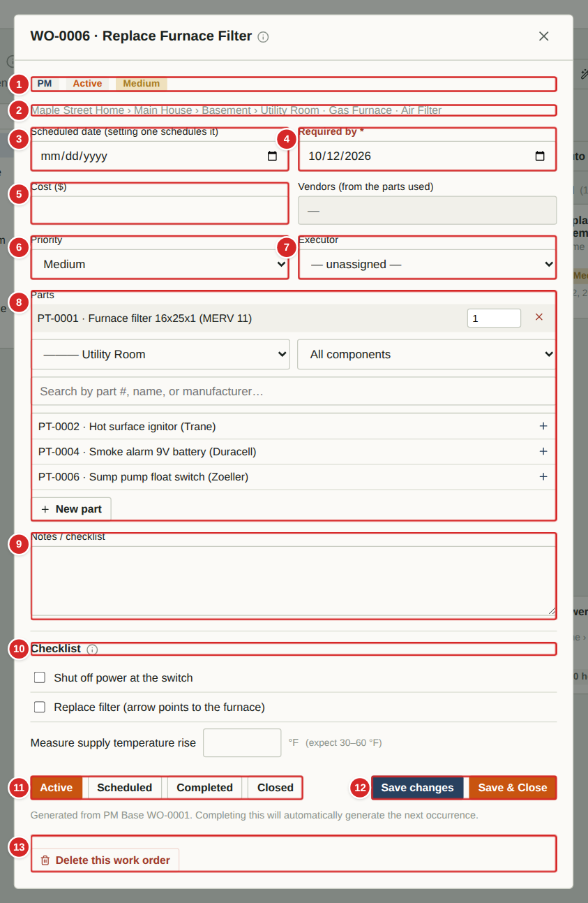 | Selecting a card opens the work order. Managers and owners can edit every field here. Changes are not stored until you select Save changes or Save & Close, although the status buttons act immediately. A preventive (PM) work order that was generated from a PM Base also shows its checklist.  What to do  1. Open a card from the board. The header shows the number and title.  2. Edit the dates, cost, vendor, priority, executor, parts and notes as needed. Setting a Scheduled date and saving moves it to Scheduled; clearing it and choosing Active moves it back.  3. Work through the Checklist if there is one (see “Checklists and readings”).  4. Use the status buttons to move the work order along: Active → Scheduled → Completed → Closed. Moving a work order from Scheduled to Completed asks for a short completion comment. Completing deducts the attached parts from stock. Only managers and owners can Close, which records the verification date.  5. Select Save changes to keep editing, or Save & Close to save and return to the board.  6. Delete this work order removes it permanently. Owners can delete any; managers can delete only work orders they created.  Numbered items in the picture  1 Tags — Type (PM), status (Active) and priority (Medium) at a glance.  2 Location path — Where the work is, down to the asset and component it concerns.  3 Scheduled date — The day the work will be done. Entering a date and saving schedules the work order; it then shows on the Schedule page.  4 Required by * — The deadline. Work past this date is flagged Overdue.  5 Cost ($) — What the job actually cost. It rolls up into the Budget page.  6 Priority — Low, Medium, High or Critical.  7 Executor — The person assigned to do the work.  8 Parts — Parts attached to the job with quantities. Use the location and component filters or the search box to find more, and “New part” to add one to the catalogue.  9 Notes / checklist — Free-text notes and instructions for the work.  10 Checklist — Steps copied from the PM Base. Tick each when done; numeric steps record a reading and flag values outside the expected range.  11 Status buttons — Active, Scheduled, Completed, Closed. The current status is orange.  12 Save changes / Save & Close — Save keeps the window open; Save & Close saves and returns to the board.  13 Delete — Permanently removes the work order after a confirmation.

Completing a work order: the completion comment
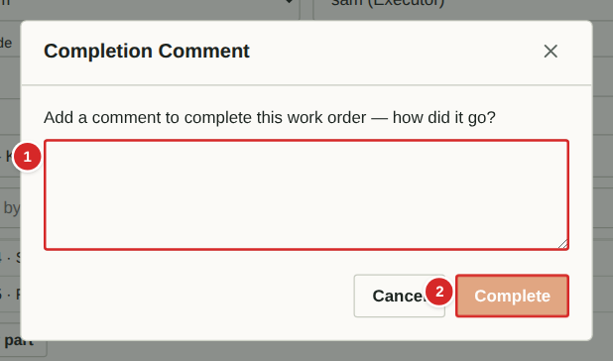
When a Scheduled work order is moved to Completed, the app asks how it went. This comment becomes part of the work order’s permanent history and helps whoever does the job next time. The work order cannot be completed without it.
What to do
1. On the work order select Completed.
2. Describe what was done, anything unexpected, and anything to improve next time (for example “Replaced the cartridge; needed a 3/4 inch wrench”).
3. Select Complete. The work order moves to the Completed column, parts used are deducted from stock, and the date is recorded.
4. A manager or owner reviews the work and then Closes it.
Numbered items in the picture
# | Field / area | What it is and how to use it
1 | Comment | Required. Say how the job went and what to improve.
2 | Complete / Cancel | Complete records the comment and finishes the work order. Cancel leaves it as it was.

Comments on a work order
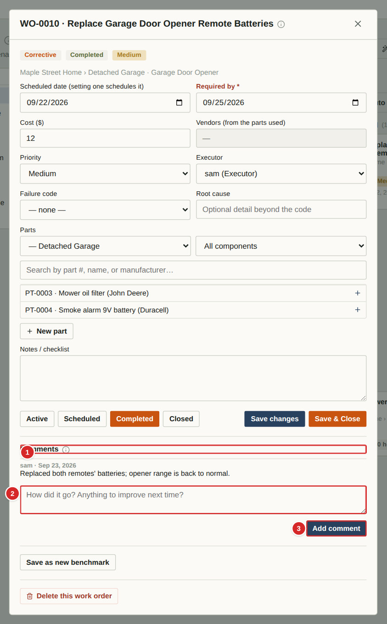 | Once a work order is Completed or Closed — or any time it has comments — a Comments area appears at the bottom. It keeps a dated, signed history of what happened. Executors, managers and owners can add comments; guests can only read them.  What to do  1. Scroll to the Comments area at the bottom of the work order.  2. Read earlier comments (author and date above each).  3. Type your note in the box and select Add comment. Comments cannot be edited or deleted afterwards, so write them carefully.  Numbered items in the picture  1 Comments heading — Everything said about this job, oldest first.  2 New comment box — Type a note about how it went.  3 Add comment — Saves the comment with your name and today’s date.

The closed work-order archive
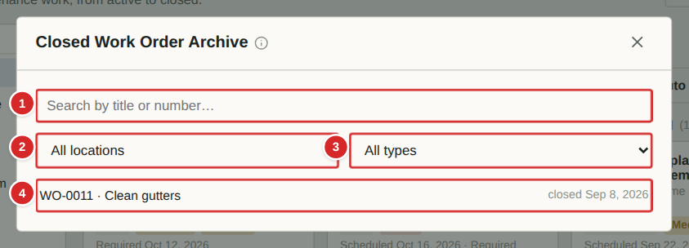
The Closed column of the board only shows recently closed work. The archive lists every closed work order, newest first, so you can look up what was done, when and for how much.
What to do
1. On the board select the archive button at the right end of the Closed column header.
2. Search by title or number and filter by location and type.
3. Select a row to open the work order.
Numbered items in the picture
# | Field / area | What it is and how to use it
1 | Search | Title or number.
2 | Location filter | Only work closed at one place and everything inside it.
3 | Type filter | PM, Benchmark, Corrective or Unplanned.
4 | Closed work order | Number, title and date it was closed. Select it to open.

Auto schedule
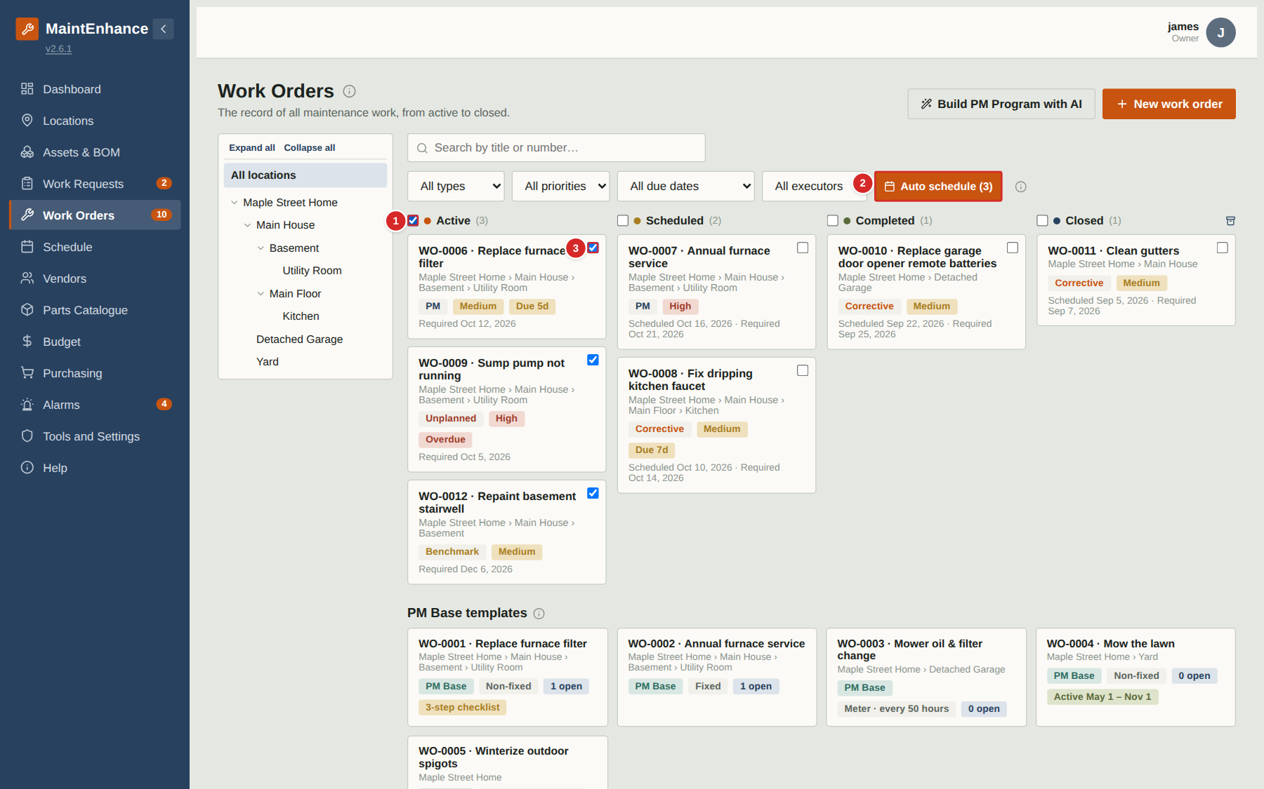
Auto schedule books a batch of Active work orders in one step: each selected work order gets a scheduled date equal to its required-by date and moves to Scheduled. Use it after a request review session or when a PM generates several jobs.
What to do
1. On the Work Orders board tick the box on each Active card, or the box on the Active column header to tick them all.
2. Select “Auto schedule”. The selected work orders move to the Scheduled column on their required-by dates.
3. Adjust any individual date afterwards by opening the work order.
Numbered items in the picture
# | Field / area | What it is and how to use it
1 | Column tick-box | Selects every Active card (and unselects them again).
2 | Auto schedule | Schedules the selected work orders on their required-by dates. It stays disabled until at least one is selected.
3 | Card tick-box | Select a single work order.

PM Bases and Benchmarks

How PM Bases work
What a PM Base is
A PM Base is a template for maintenance that repeats. It is not a job: it is never scheduled or completed. It holds the title, asset and location, priority, vendor, executor, an optional checklist, and a rule for when the next job is due.
How jobs are generated
Creating a PM Base generates the first PM work order from it. When that work order is Completed, the app generates the next one. Only one job from a PM Base can be Active or Scheduled at a time, so work never piles up if a job is late.
Trigger types
Calendar — Non-fixed: due a set interval after the previous job was completed (every 3 months from the last filter change). Calendar — Fixed: due on the same date(s) every year (1 May and 15 October). Meter: due when an asset’s meter reading has advanced by a set amount (every 50 hours of mower use). Seasonal: due once a year around the start of a season, shifted by an offset in days.
Checklists
A checklist template on the PM Base is copied onto every job it generates. Steps may be a tick, a numeric reading with an expected range and unit, a required photo (tracked as an acknowledgement tick for now), or pass/fail. A reading outside its range raises an alarm. Editing the template affects only jobs generated afterwards.
Standby
A PM Base can be put on standby by hand, or limited to a yearly window (for example lawn care between 1 May and 1 November). While on standby no new jobs are generated; jobs already open are left alone. When standby ends generation resumes from the next due date; missed jobs are not back-filled.
Getting started quickly
On a new property, run the PM setup wizard (Locations page) to create a starter set of PM Bases from a catalogue of about 300 common jobs scaled to your climate zone, then edit them to suit.

Creating a PM Base: calendar, repeating on a frequency
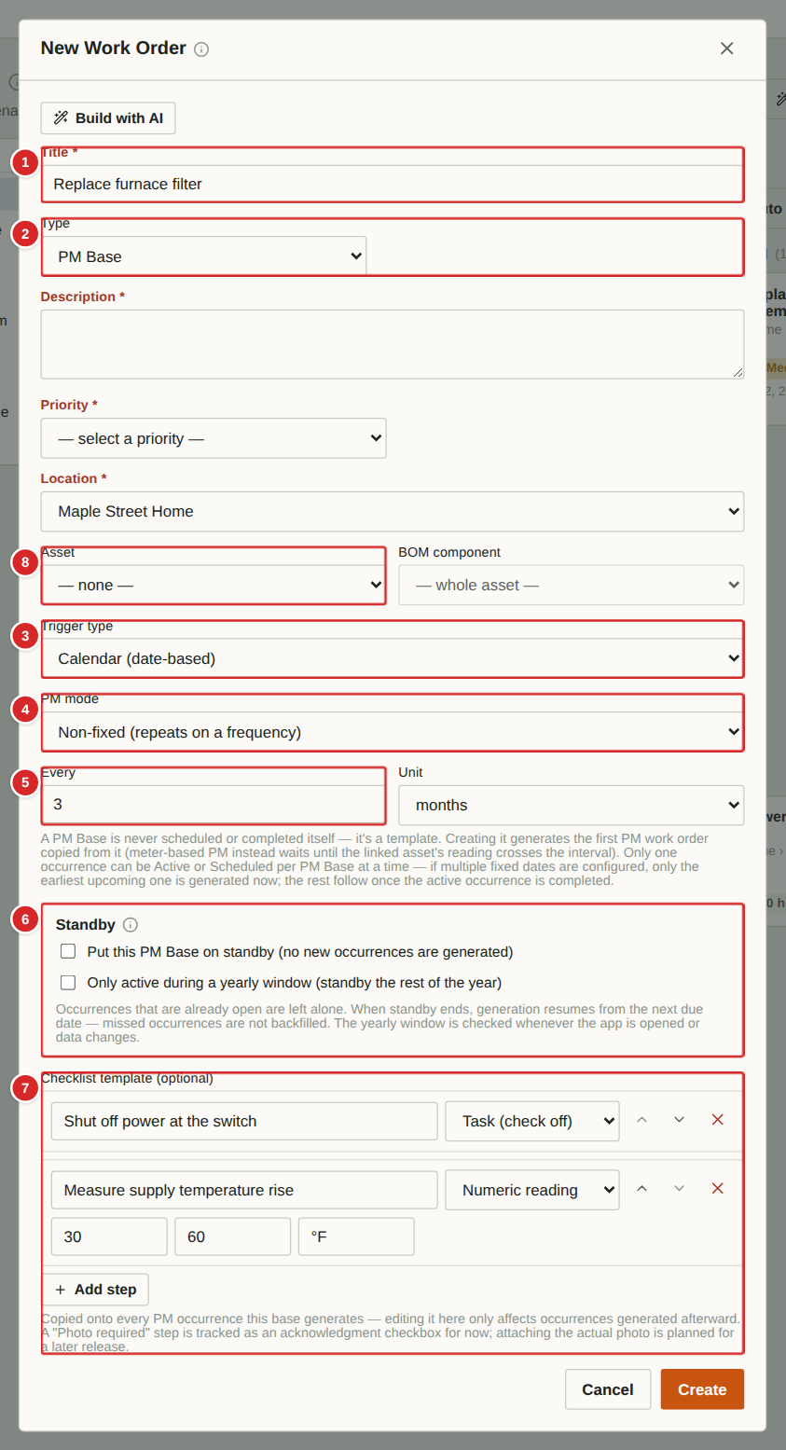 | A PM Base is a template for maintenance that repeats. It is never worked itself. Creating it generates the first real PM work order, copied from it; completing that work order generates the next one. This page shows the default “Calendar, Non-fixed” kind: the next job is due a fixed interval after the previous one was completed (for example three months after the last filter change, whenever that was).  What to do  1. On the Work Orders page select “New work order” and set Type to PM Base.  2. Enter the Title, Priority, and the Asset / Location the job concerns. Vendor, Executor and Description are copied onto every generated job.  3. Leave Trigger type on Calendar and PM mode on Non-fixed, then set the interval with Every and Unit (days, weeks, months or years).  4. Optionally add Checklist steps. Each generated job gets its own fresh copy of them.  5. Select Create. The PM Base appears under “PM Base templates” and its first PM work order appears on the board.  6. From then on, every time a PM work order from this base is completed the next one is created automatically, counted from the completion date.  Numbered items in the picture  1 Title * — The name given to every generated work order.  2 Type = PM Base — Switches the form to repeat-schedule fields. There is no Required by or Scheduled date: those are worked out for each generated job.  3 Trigger type — What starts the next job: Calendar (dates), Meter (hours or miles of use), or Seasonal (a time of year). See the following pages.  4 PM mode — Non-fixed repeats a set time after the last completion. Fixed uses the same date(s) every year.  5 Every / Unit — The interval, for example 3 months.  6 Standby — Pauses generation, or limits it to part of the year. See “Standby and yearly windows”.  7 Checklist template — Steps copied onto every generated job. Each step can be a Task (tick), Numeric reading (with min, max and unit), Photo required, or Pass / fail. Use the arrows to reorder and the red cross to remove a step.  8 Asset / BOM component / Location — Where the maintenance is done. Linking an asset puts the generated jobs in its history. Meter-based PM requires an asset.

PM Base: Fixed dates every year
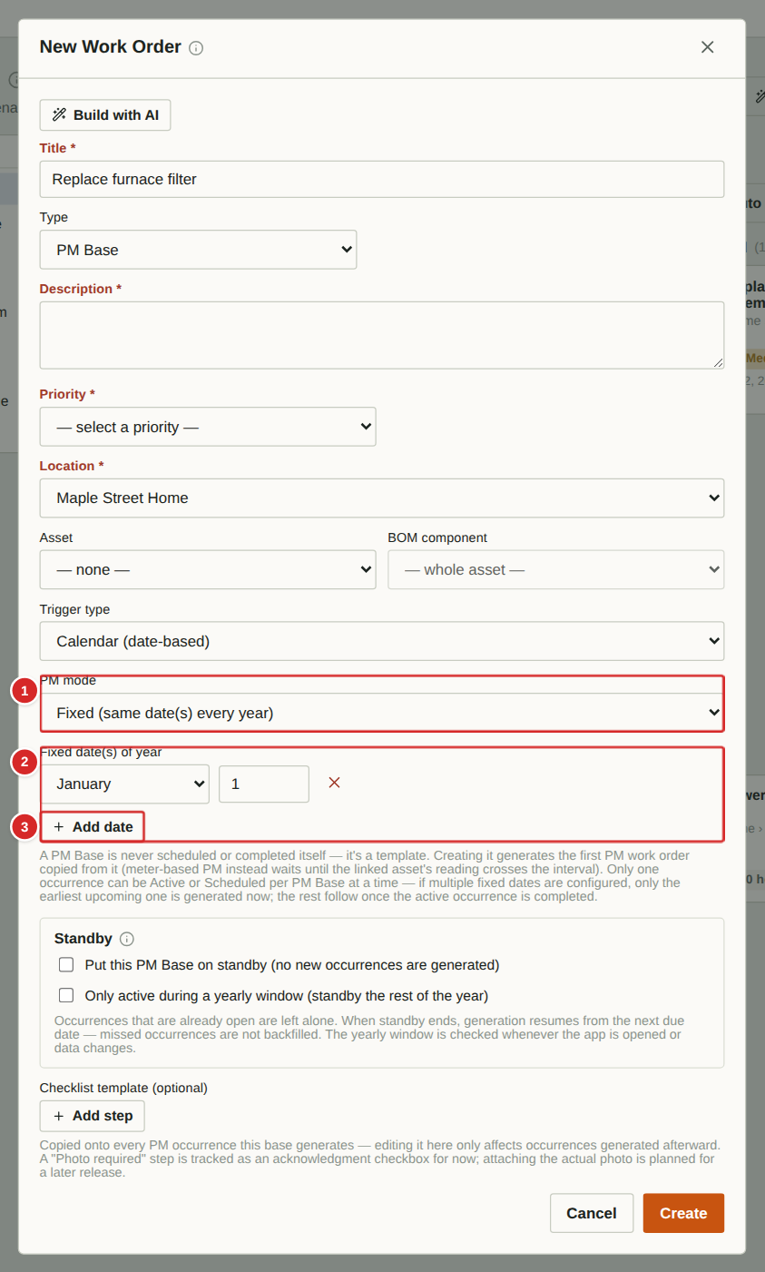 | Use Fixed mode for jobs tied to the calendar rather than to when the last one happened — the smoke-alarm battery change every 1 May and 15 October, say. Each listed date generates one job per year.  What to do  1. Create a PM Base as before and set PM mode to “Fixed (same date(s) every year)”.  2. Select “Add date” for each date, then choose the month and enter the day.  3. Select Create. Only the earliest upcoming date is generated now; the others follow as each job is completed. Only one job from a PM Base is ever open at a time.  Numbered items in the picture  1 PM mode — Set to Fixed.  2 Fixed date(s) of year — One row per date: month, day, and a red cross to remove it.  3 Add date — Adds another row.

PM Base: Meter (usage-based)
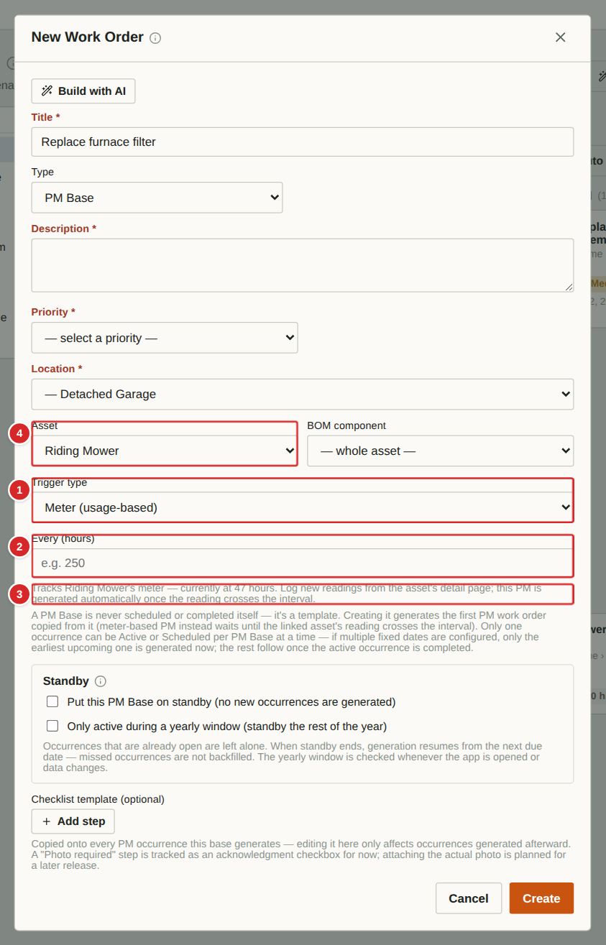 | Some equipment should be serviced by use, not by date — a mower every 50 hours, a generator every 100. A meter PM Base watches the meter reading of an asset. Staff log new readings from the asset’s page (“Log meter reading”); when the reading has advanced by the interval, a PM work order is generated automatically, due that day.  What to do  1. Create a PM Base and set Trigger type to Meter (usage-based).  2. Choose the Asset. It must have a meter unit (hours, km …) set on its record.  3. Enter the interval in the “Every” box, in the asset’s unit (for example 50).  4. Select Create. The reading at that moment becomes the baseline. When someone logs a reading 50 hours above it, the next job is generated.  5. Completing the job moves the baseline forward to the reading at which it was triggered.  Numbered items in the picture  1 Trigger type — Meter (usage-based).  2 Every (unit) — Usage between jobs. The label shows the asset’s meter unit once an asset is chosen.  3 Current reading — Shows the asset’s current meter reading and reminds you where to log new readings.  4 Asset * — Required for a meter PM Base: the equipment whose meter is tracked.

PM Base: Seasonal
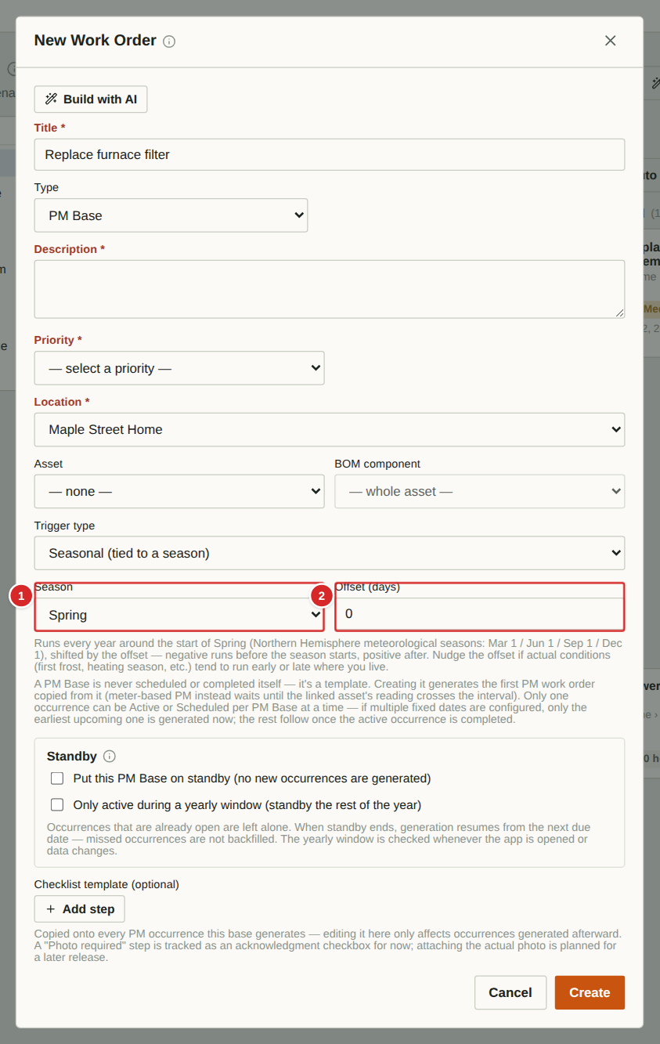 | Seasonal jobs happen once a year around the start of a season — winterising spigots before winter, servicing the A/C in spring. The season starts are the Northern-Hemisphere meteorological dates: Spring 1 March, Summer 1 June, Fall 1 September, Winter 1 December. An offset in days nudges the due date earlier (negative) or later (positive).  What to do  1. Create a PM Base and set Trigger type to Seasonal.  2. Choose the Season and, if wanted, an Offset in days (−7 means one week before the season starts).  3. Select Create. The first job is due on the next such date, and one new job is generated each year after completion.  Numbered items in the picture  1 Season — Spring, Summer, Fall or Winter.  2 Offset (days) — Days before (negative) or after (positive) the season start. Adjust if your local conditions run early or late.

PM Base: Standby and yearly windows
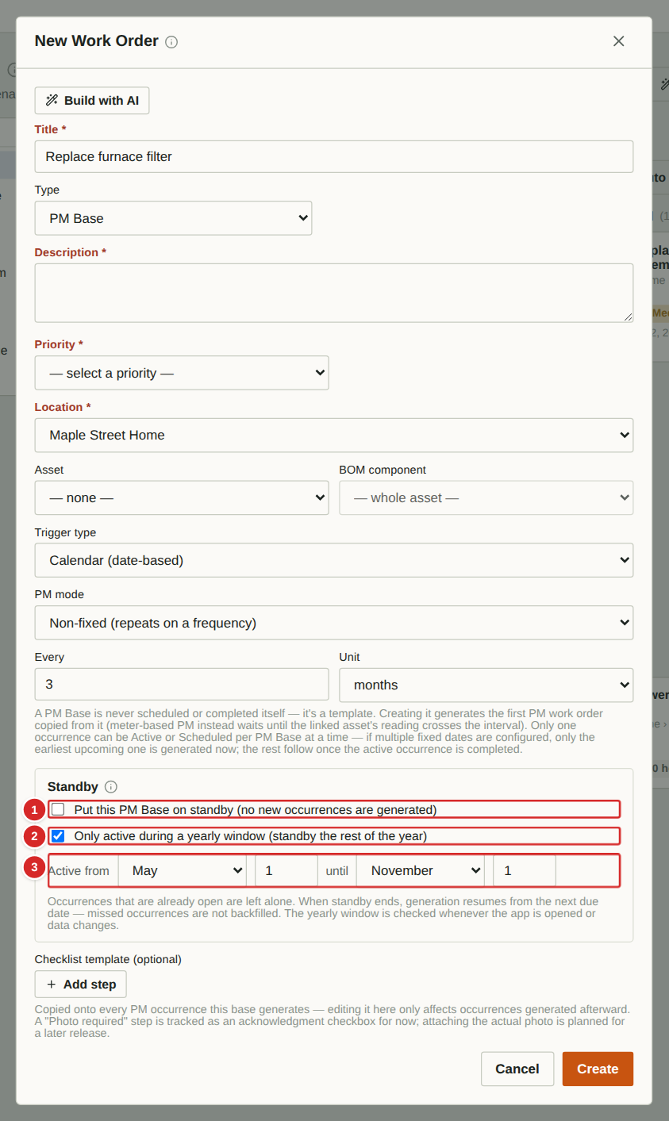 | Standby stops a PM Base from generating new jobs without deleting it. You can switch it on by hand (for example while equipment is out of service) or restrict a base to a yearly window, such as lawn care from 1 May to 1 November. Outside the window the base stands by on its own.  What to do  1. Open the Standby box on the PM Base form (when creating) or on its detail window (when editing).  2. Tick “Put this PM Base on standby” to pause it indefinitely; untick to resume.  3. Or tick “Only active during a yearly window” and choose the start and end month and day.  4. Jobs already open are left alone. When standby ends, generation resumes from the next due date; missed jobs are not backfilled. The window is re-checked whenever the app is opened or data changes.  Numbered items in the picture  1 Manual standby — Pauses generation until you untick it.  2 Yearly window — Active only between the dates below; on standby the rest of the year.  3 Window dates — Start and end month and day of the active window.

Viewing and editing a PM Base
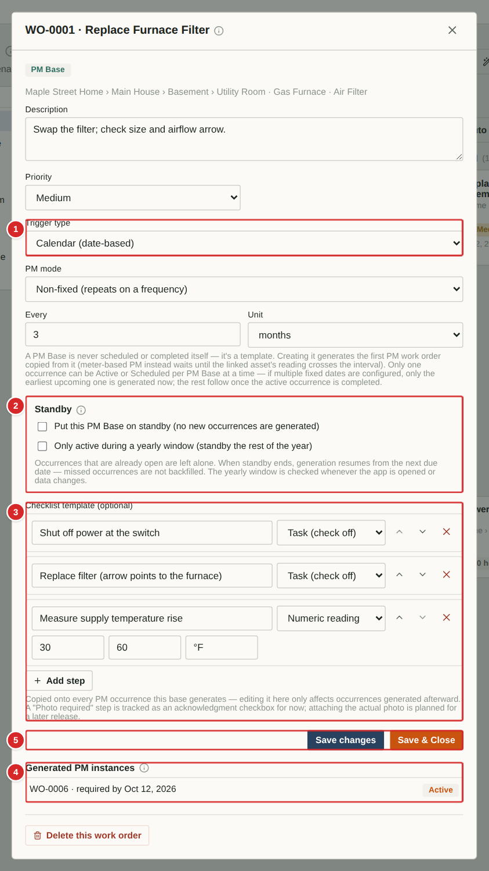 | Select a PM Base template on the Work Orders page to open it. Editing a PM Base changes only jobs generated afterwards; jobs already open keep their old checklist and dates.  What to do  1. Open a template from the “PM Base templates” area.  2. Change the title fields, trigger, interval, standby or checklist and select Save changes.  3. Look at “Generated PM instances” at the bottom: every job created from this base with its status. Select one to open it.  4. Delete this work order removes the template (generated jobs stay, but no more are created).  Numbered items in the picture  1 Trigger / mode / interval — How the next job’s date is worked out.  2 Standby — Pause or limit generation.  3 Checklist template — Steps copied onto future jobs.  4 Generated PM instances — All work orders created from this template, with their status.  5 Save changes / Save & Close — Stores the edits.

How Benchmarks work
What a benchmark is
A benchmark is a saved reference for a kind of job: its checklist or procedure, its estimated cost and its preferred vendor. It captures what “good” looks like once, so the next similar job does not start from a blank page.
Creating one
Do a job as a Benchmark or Corrective work order, recording the steps in Notes / checklist and the cost. Then open it and select “Save as new benchmark”.
Using one
When creating a Corrective work order choose the benchmark under “Copy from benchmark”. Its checklist is copied into the new work order.
Keeping it current
After a later run, open that work order and select “Update benchmark with this run”. The saved procedure and cost are refreshed and the benchmark’s version number increases by one. Benchmarks are different from PM Bases: a benchmark is reference material you copy from, while a PM Base automatically generates jobs on a schedule.

Benchmarks: saving a procedure that worked
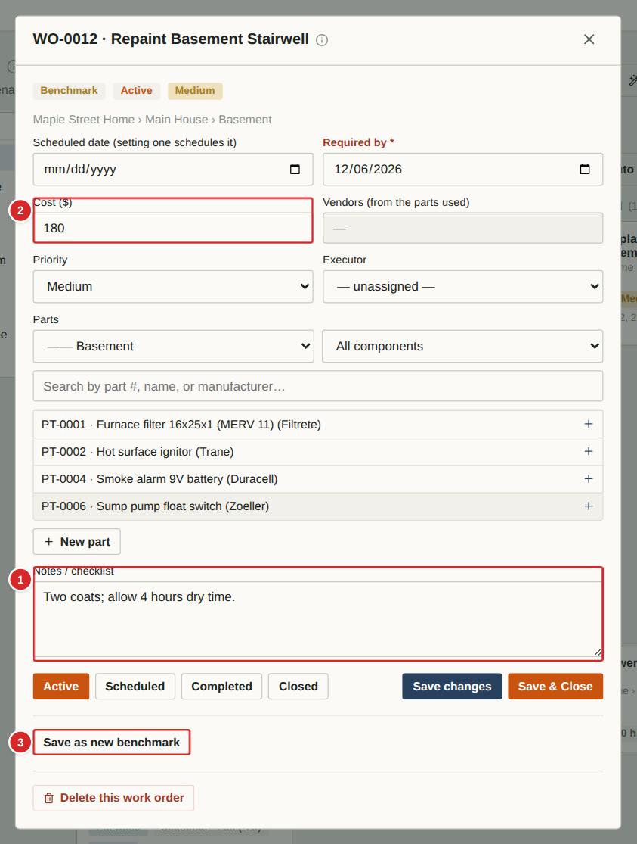 | A benchmark is a saved reference for a kind of job — its checklist or procedure, estimated cost and preferred vendor — kept so the next similar job starts from something proven instead of from a blank page. Benchmarks are created from a finished (or in-progress) Benchmark or Corrective work order.  What to do  1. Create a work order of type Benchmark (or Corrective) and do the job, recording the steps in Notes / checklist and the cost.  2. Open the work order and select “Save as new benchmark”. Give it a name, such as “Repaint stairwell”.  3. Later, create a Corrective work order and choose the benchmark in “Copy from benchmark” (next page): its checklist is copied into the notes.  4. After a later run, open that Corrective work order and select “Update benchmark with this run” to refresh the saved procedure and cost. The benchmark’s version number goes up by one.  Numbered items in the picture  1 Notes / checklist — What you write here becomes the benchmark’s checklist when you save it.  2 Cost ($) — Becomes the benchmark’s estimated cost.  3 Save as new benchmark — Managers and owners only. Asks for a name, then stores the benchmark. If the work order was itself copied from a benchmark, this button reads “Update benchmark with this run” instead.

Benchmarks: starting a job from one
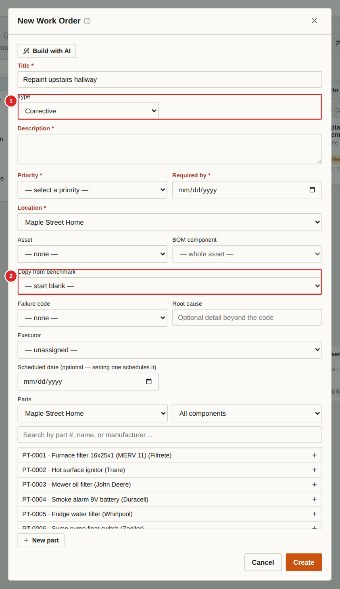 | When you create a Corrective work order, the “Copy from benchmark” list offers every saved benchmark. Choosing one copies its checklist into the new work order’s notes, so the job starts with the proven steps.  What to do  1. Select “New work order” and set Type to Corrective.  2. Pick a benchmark in “Copy from benchmark”.  3. Fill in the rest as usual and select Create. The benchmark’s checklist appears under Notes / checklist, prefixed “Checklist:”.  Numbered items in the picture  1 Type = Corrective — Only Corrective work orders offer the benchmark list.  2 Copy from benchmark — Choose a saved benchmark, or leave “— none —”.

Schedule

Schedule
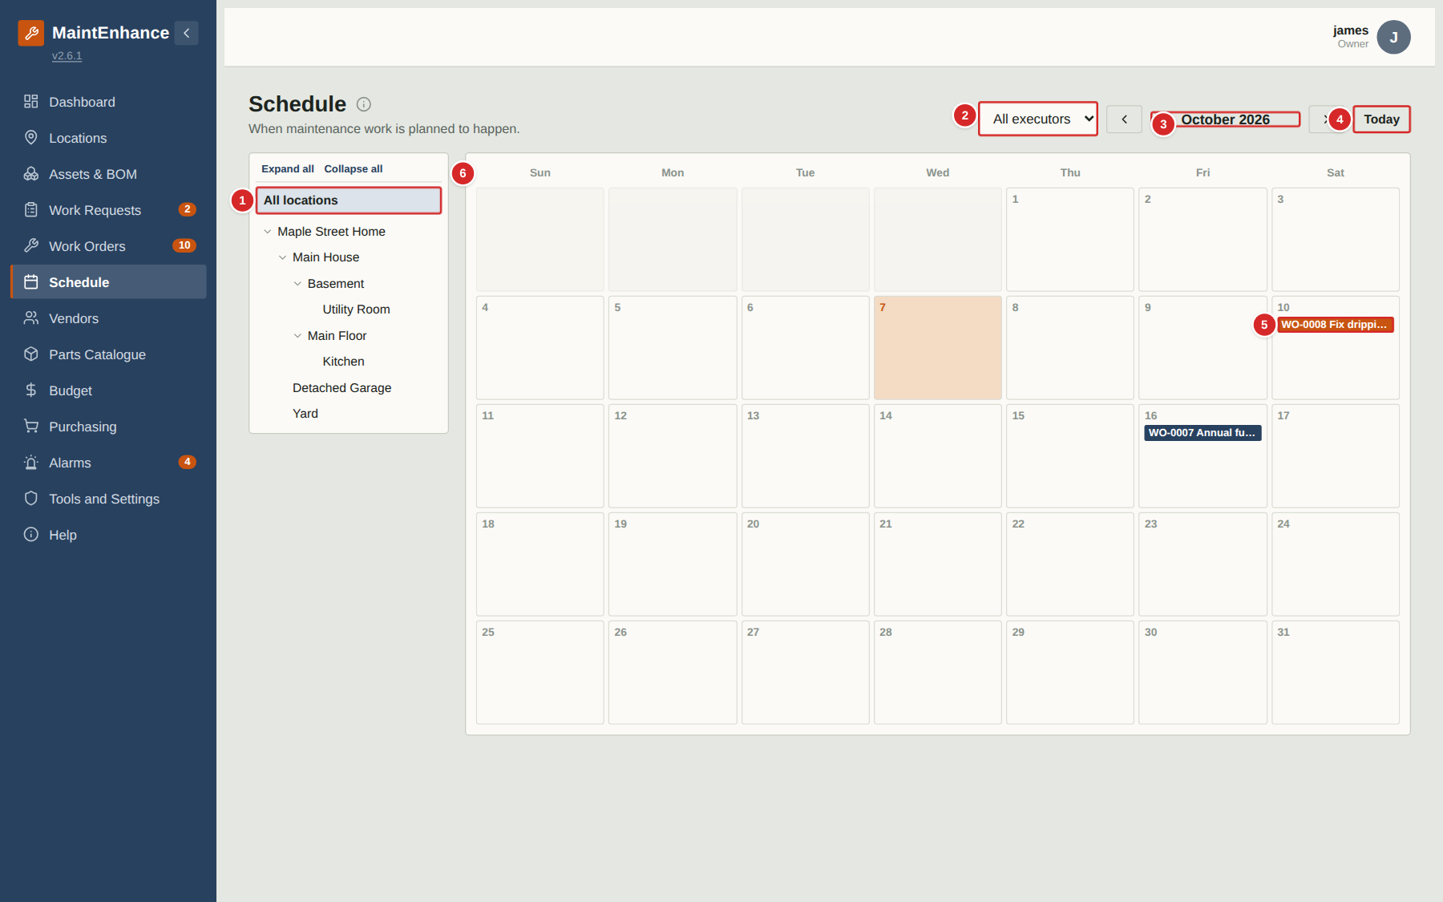
The Schedule is a monthly calendar of every work order that has a scheduled date. Use it to see what is planned for which day and to spot busy weeks.
What to do
1. Use the arrows beside the month name to move between months; “Today” jumps back to the current month.
2. Narrow the calendar with the location tree or the executor filter. Executors start on their own name; choose “All executors” to see everyone’s work.
3. Select a work-order tag in a day to open the work order. Colours follow the work-order type.
4. To change a date, open the work order (managers and owners only).
Numbered items in the picture
# | Field / area | What it is and how to use it
1 | Location tree | Show only work at one place and everything inside it.
2 | Executor filter | Show one person’s work, or everyone’s.
3 | Month and arrows | The month on show; the arrows on either side step back and forward.
4 | Today | Returns to the current month.
5 | Scheduled work order | A tag on the scheduled day. Select it to open the work order.
6 | Calendar header | Days of the week. Today’s box is highlighted.

Locations, Assets and Bill of Materials

Locations: the location hierarchy
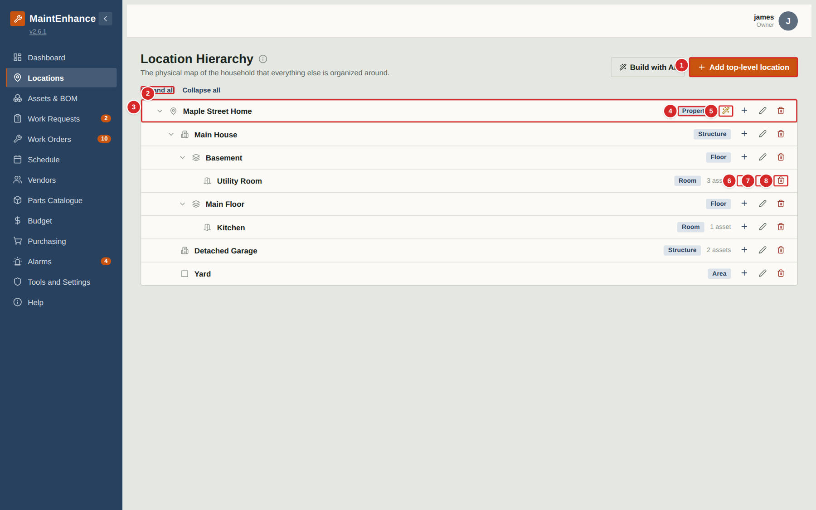
Locations map your home: a property contains buildings, which contain floors, rooms and so on. Everything else in the app — assets, work requests, work orders — is attached to a location. Managers and owners add, rename, move and delete locations here and can run the PM setup wizard on the property.
What to do
1. Select “Add top-level location” to add a new property or area at the top, or the + on a row to add a child inside it.
2. Use the pencil to rename or edit a location and the red bin to delete it (a location with children or assets cannot be deleted).
3. Use the wand on the property row to run the PM setup wizard (next pages).
4. Use Expand all / Collapse all to open or close the tree.
Numbered items in the picture
# | Field / area | What it is and how to use it
1 | Add top-level location | Adds a new location at the top of the tree.
2 | Expand all / Collapse all | Opens or closes every branch of the tree.
3 | Location row | Name, level tag and the count of assets. The arrow opens or closes children.
4 | Level tag | Property, Structure, Floor, Room or Area.
5 | PM setup wizard (wand) | Property rows only. Opens the wizard that creates a starter set of recurring maintenance.
6 | Add child (+) | Adds a location inside this one. The new location’s level defaults to the next level down.
7 | Edit (pencil) | Rename the location or change its level.
8 | Delete (bin) | Removes the location after confirmation. Not allowed while it has children or assets.

Adding or editing a location
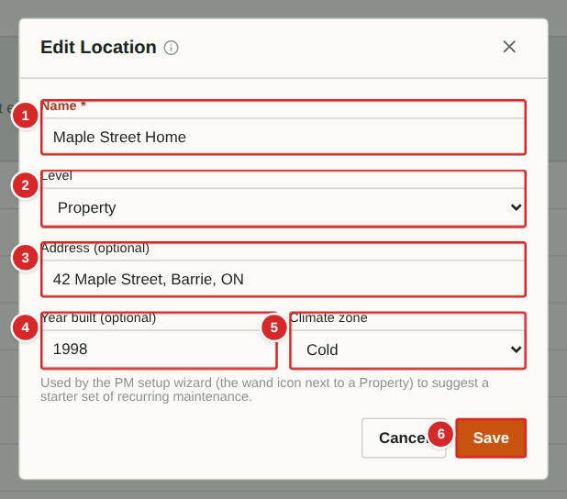
Adding a location is quick: select + (or Add top-level location), type a name straight into the tree and press Enter; the level defaults to the next one down. To change a location’s name, level or property details, select its pencil to open this form.
What to do
1. Type a Name.
2. Choose the Level. It defaults to the next level down from the parent.
3. For a Property, optionally enter the address, year built and climate zone — the PM setup wizard uses them.
4. Select Save.
Numbered items in the picture
# | Field / area | What it is and how to use it
1 | Name * | What the place is called, for example “Kitchen”.
2 | Level | Property, Structure, Floor, Room or Area (the names can be changed in the Tools and settings page).
3 | Address (optional) | Property level only. Used to guess the climate zone.
4 | Year built (optional) | Property level only. Older buildings get extra inspection items in the wizard.
5 | Climate zone | Property level only. Scales the starter maintenance (for example more freeze protection in cold zones).
6 | Save / Cancel | Save stores the location.

PM setup wizard
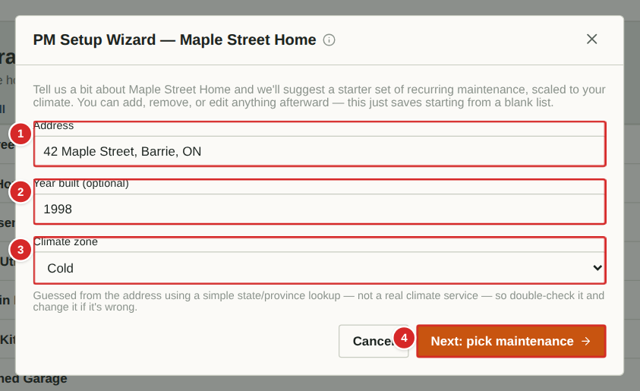
The wizard gets a new household started with preventive maintenance. You describe the property, then choose from a catalogue of common recurring jobs (filters, detectors, gutters, seasonal tasks …); each ticked item becomes a PM Base with a sensible repeat interval for your climate zone.
What to do
1. On the property row select the wand.
2. Check the Address, Year built and Climate zone. The zone is guessed from the address; change it if wrong.
3. Select “Next: pick maintenance”.
4. Tick the items you want. Use the Type and sub-type filters to narrow the catalogue.
5. Create. Each ticked item becomes a PM Base template, and the first job is generated.
Numbered items in the picture
# | Field / area | What it is and how to use it
1 | Address | Used to estimate the climate zone.
2 | Year built (optional) | Older homes get additional checks.
3 | Climate zone | Controls how often seasonal and freeze-related jobs repeat.
4 | Next: pick maintenance | Moves to the catalogue of recommended jobs.

PM setup wizard: choosing the maintenance
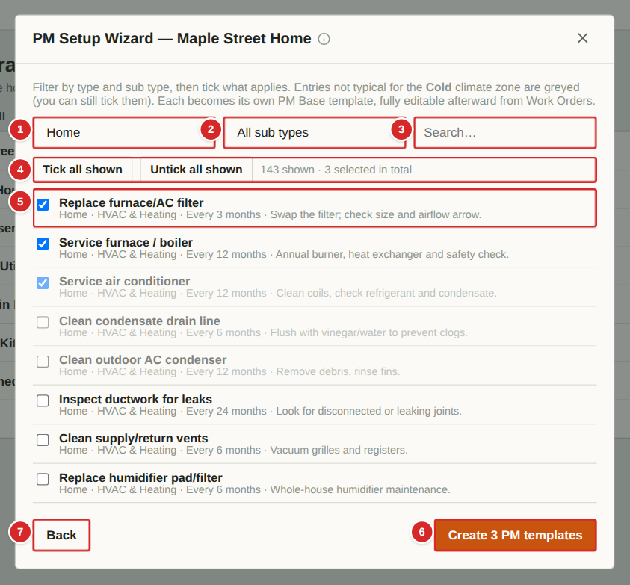
The second step lists the starter catalogue of more than 300 common home-maintenance jobs, each with a type, a sub type and a typical interval. Tick the ones that apply to your home. Entries that do not suit your climate zone are shown greyed out but can still be ticked.
What to do
1. Narrow the list with the Type and Sub type boxes or the search box.
2. Tick items one by one, or use “Tick all shown” for everything currently listed. The counter shows how many are shown and how many are selected in total (selections are kept while you change filters).
3. Select “Create N PM templates”. Each becomes a PM Base (see “PM Bases”) and its first job appears on the Work Orders board.
4. You can edit or delete any of them afterwards.
Numbered items in the picture
# | Field / area | What it is and how to use it
1 | Type filter | Home (houses and household equipment) or Facilities (larger or community buildings).
2 | Sub type filter | A finer category within the chosen type.
3 | Search | Finds catalogue items by name.
4 | Tick / untick all shown | Selects or clears every item currently displayed.
5 | Catalogue item | Tick box, job name, then type · sub type · typical interval and any note.
6 | Create N PM templates | Creates the ticked items as PM Bases.
7 | Back | Returns to the property details.

Assets and Bill of Materials
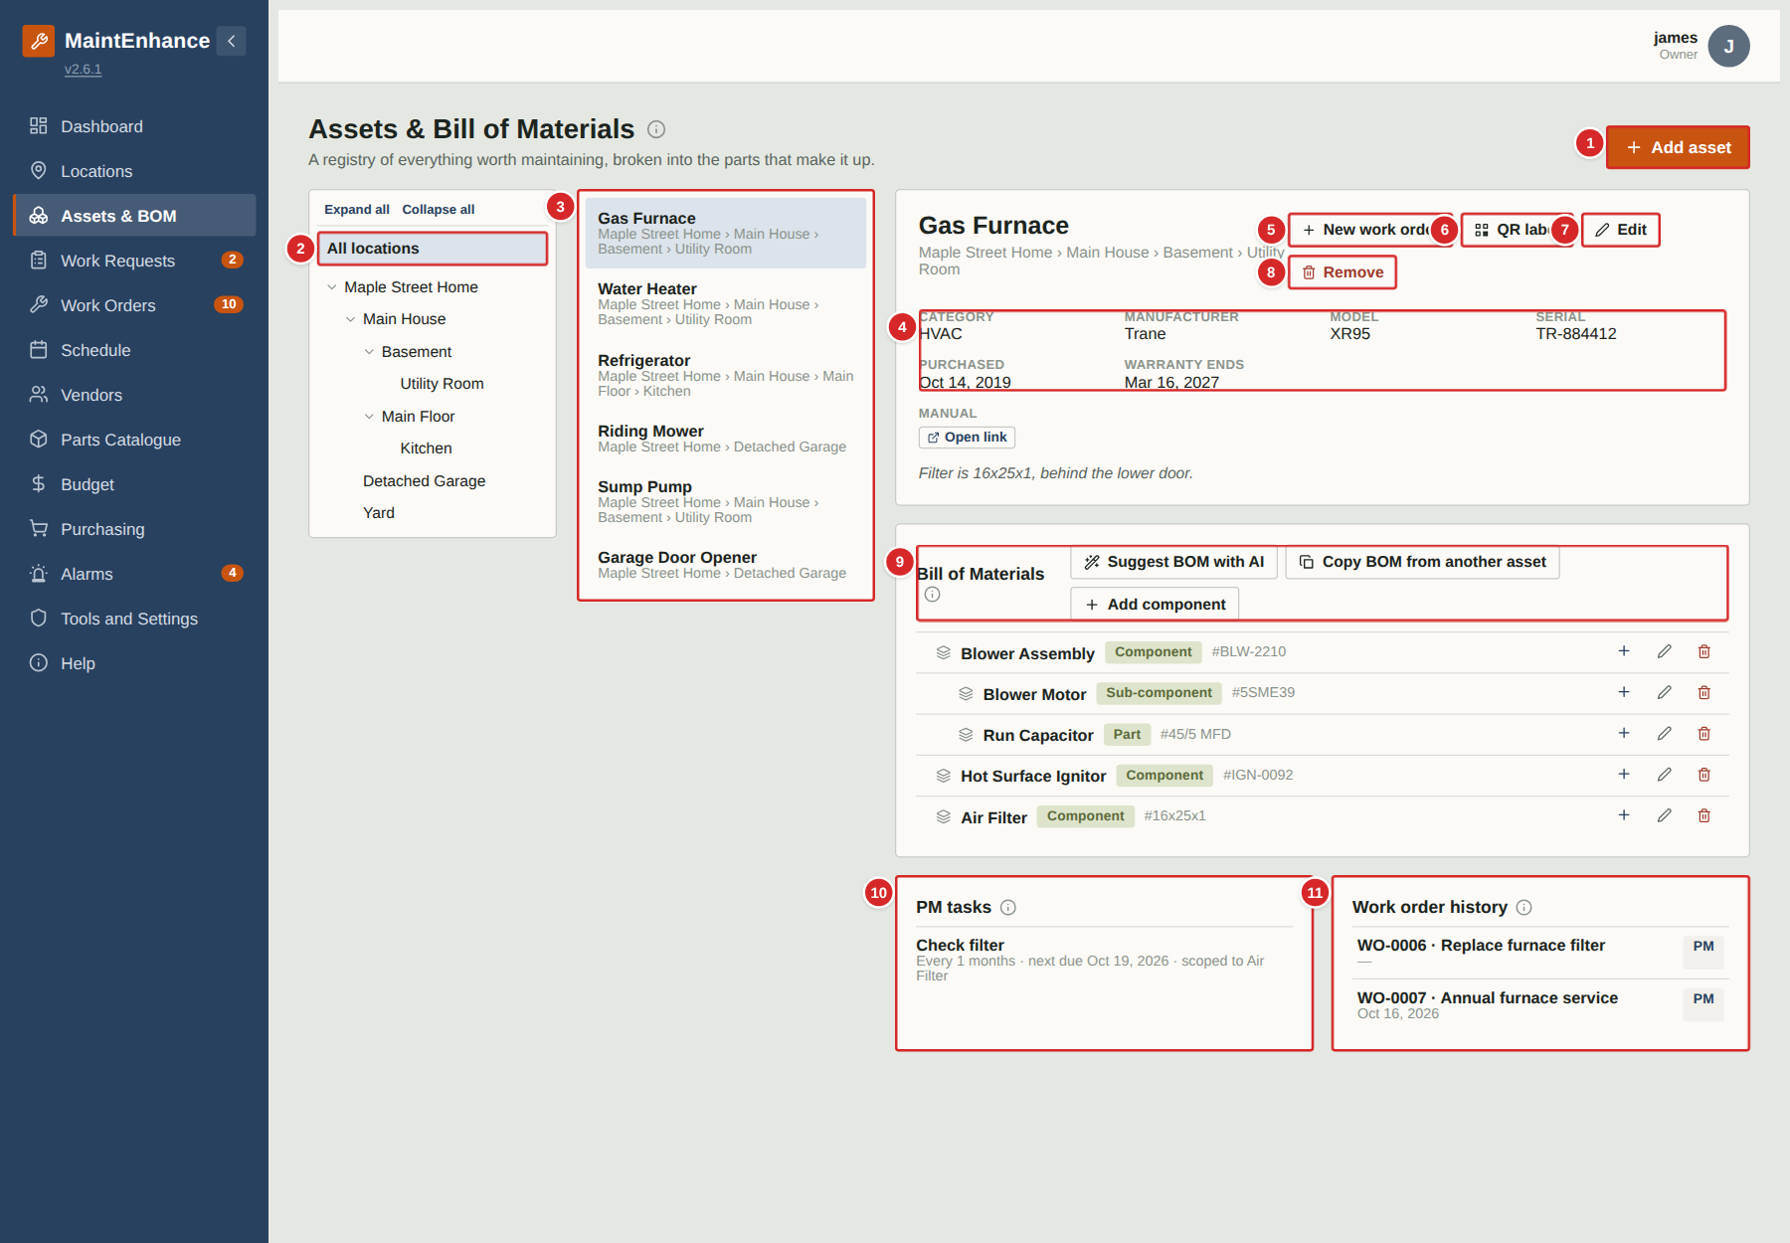
An asset is anything in the home worth maintaining — a furnace, a fridge, a mower. The Bill of Materials (BOM) breaks an asset into the components and parts it is made of, so that work and spare parts can be tied to the exact piece. Managers and owners add, edit and archive assets; owners, managers and executors can edit BOM items.
What to do
1. Select “Add asset” to register a new one (see the next page).
2. Pick a location, then an asset. Use Edit to change its details, QR label to print its label, and Remove to retire it (its history is kept).
3. Build the Bill of Materials with “Add component”, and + on a row to add a child inside it. Use the pencil to edit and the red bin to remove.
4. Use PM tasks and Work order history to review the maintenance record. “New work order” starts a job for this asset.
5. For equipment with a meter (hours, km), use “Log meter reading” (shown on assets with a meter) so that meter-based PM jobs trigger.
Numbered items in the picture
# | Field / area | What it is and how to use it
1 | Add asset | Opens the new-asset form.
2 | Location tree | Filters the asset list to one place and everything inside it.
3 | Asset list | Every asset in the chosen location. Select one to see its details on the right.
4 | Asset details | Category, manufacturer, model, serial number, purchase date, warranty end date, a link to the manual, and notes.
5 | New work order | Creates a work order already linked to this asset.
6 | QR label | Shows a printable label with a QR code. Scanning it with a phone opens this asset directly. Available on assets marked as major.
7 | Edit | Change the asset’s details.
8 | Remove | Retires the asset. Unlinked assets can be deleted; linked ones are archived and keep their history.
9 | Bill of Materials | Tree of components and parts. Add component, + (add child), pencil (edit) and bin (remove).
10 | PM tasks | Recurring maintenance attached to this asset.
11 | Work order history | Every work order for this asset.

Removing an asset
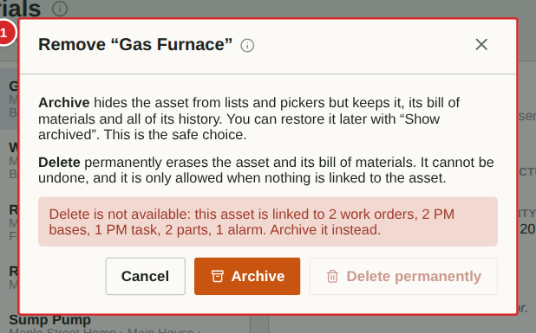
Remove replaces the old Archive button. If nothing links to the asset (no work orders, requests, PMs, parts or alarms) an Owner can delete it permanently; otherwise it can only be archived, which hides it but keeps its history. Managers can delete only assets with no links.
What to do
1. Open the asset and select Remove.
2. Read the explanation in the pop-up.
3. Choose Archive to hide it, or Delete if it is offered.
Numbered items in the picture
# | Field / area | What it is and how to use it
1 | Remove pop-up | Explains what archiving and deleting do and which of them is allowed for this asset.

Adding or editing an asset
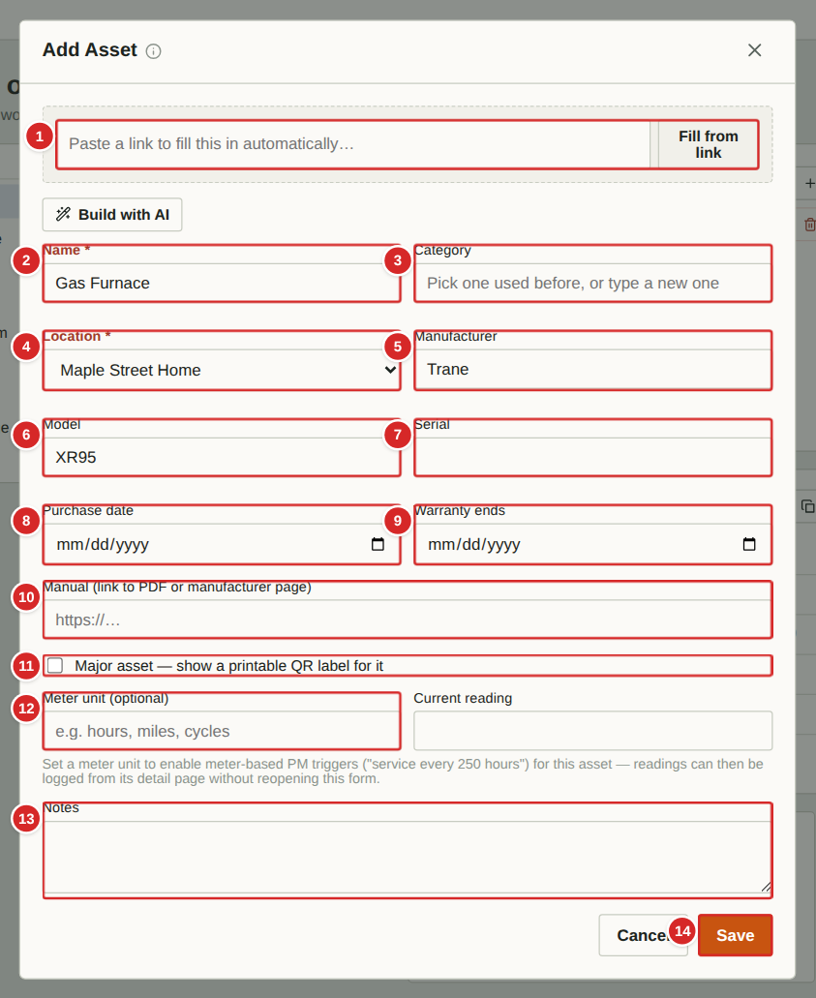 | Register each piece of equipment worth tracking. The more you fill in (model, serial number, warranty date), the more useful the history becomes when you need to order a part or make a warranty claim.  What to do  1. Select “Add asset” (or Edit on an existing asset).  2. Optionally paste a product web link into “Fill from link” and select it: the app reads the page and fills in the name, manufacturer, model and so on for you to check. Each filled field has a small cross to clear it.  3. Enter the Name, Category and Location (required), then the identifying details.  4. Tick “Major asset” to enable a printable QR label. Enter a Meter unit (for example hours) if the asset has a meter, plus the Current reading.  5. Select Save.  Numbered items in the picture  1 Fill from link — Paste a product or manufacturer page; the app tries to fill the form from it. This is a suggestion only — always check the values. (Owners can switch the feature off.)  2 Name * — What you call it.  3 Category — Type of equipment (HVAC, Appliance …). Used by the Budget page.  4 Location * — Where it is installed.  5 Manufacturer — Maker.  6 Model — Model number.  7 Serial — Serial number.  8 Purchase date — When it was bought.  9 Warranty ends — Warranty expiry. The Dashboard warns before it passes.  10 Manual — Link to a PDF or manufacturer page.  11 Major asset — Enables the QR label for this asset.  12 Meter unit / Current reading — For use-based equipment: the unit (hours, km) and the latest reading. Meter-based PM Bases need these.  13 Notes — Anything else worth knowing (for example “Filter is 16x25x1, behind the lower door”).  14 Save / Cancel — Save stores the asset.

Adding or editing a BOM item
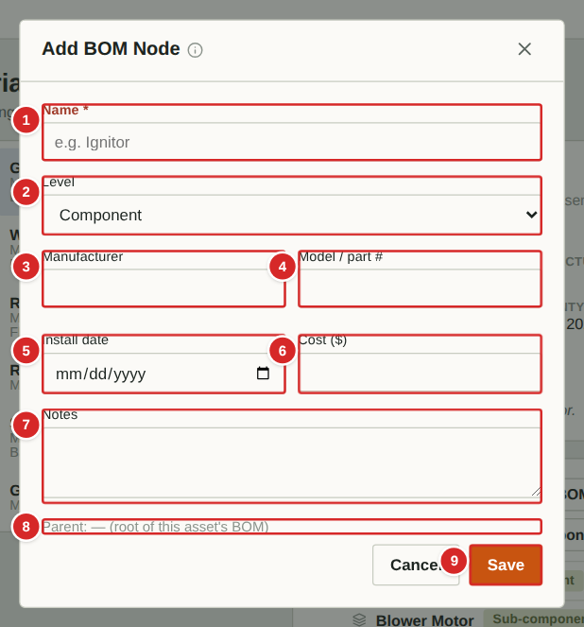 | Each row of the Bill of Materials is a component, sub-component or part of the asset. Keeping it accurate lets work orders and parts point at the exact piece (for example “Blower motor”) rather than just “furnace”. Executors, managers and owners can edit the BOM.  What to do  1. On the asset select “Add component” for a top-level item, or the + on a row to add something inside it. The Parent line shows where it will go.  2. Enter the Name and choose its Level (Component, Sub-component or Part).  3. Add the manufacturer, model / part number and install date so it can be re-ordered later.  4. Select Save. The pencil edits a row; the bin removes it.  Numbered items in the picture  1 Name * — What the component is called (for example “Blower Motor”).  2 Level — Component, Sub-component or Part.  3 Manufacturer — Maker of this item.  4 Model / part # — Model or part number, used when re-ordering.  5 Install date — When this item was fitted or last replaced.  6 Cost ($) — What it cost.  7 Notes — Anything useful, such as size or position.  8 Parent — Where in the tree the new item will sit.  9 Save / Cancel — Save stores the item.

QR label
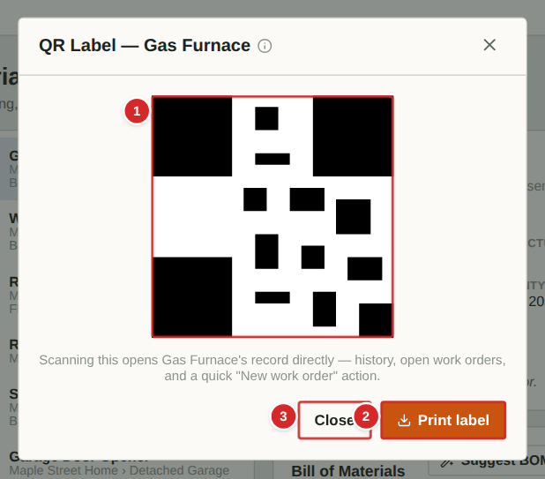
A QR label links a physical item to its record. Stick it on the equipment; anyone who scans it with a phone camera is taken straight to that asset in the app (after signing in), where they can read its details, see its history and start a work order.
What to do
1. Select the asset, then “QR label”.
2. Select “Print label” to print it, then cut out and stick it on the equipment.
3. To use it, scan the code with a phone camera and open the link.
Numbered items in the picture
# | Field / area | What it is and how to use it
1 | QR code | Scan to open this asset. The asset’s name is printed under it.
2 | Print label | Prints the label.
3 | Close | Closes the window.

Logging a meter reading
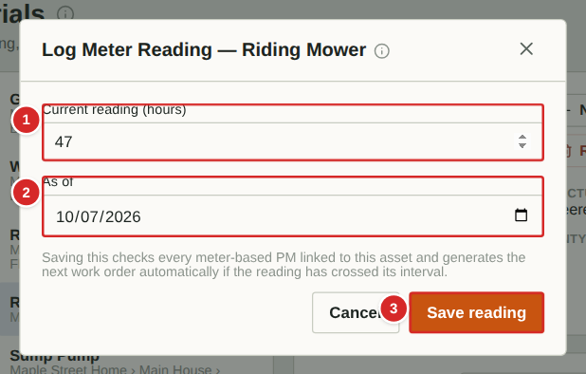
For equipment that wears with use (a mower, a generator), record the meter reading regularly. As soon as a reading takes the asset past the interval of a meter-based PM Base, the next preventive job is generated automatically.
What to do
1. Select the asset, then “Log reading”.
2. Type the number shown on the meter.
3. Select Save reading. Any meter PM that has become due is created at once.
Numbered items in the picture
# | Field / area | What it is and how to use it
1 | Current reading | The meter value, in the asset’s unit (shown in brackets, for example hours).
2 | As of | The date the reading was taken. Defaults to today.
3 | Save reading | Stores the reading and checks the meter-based PM Bases.

Vendors, Parts and Budget

Vendors and service providers
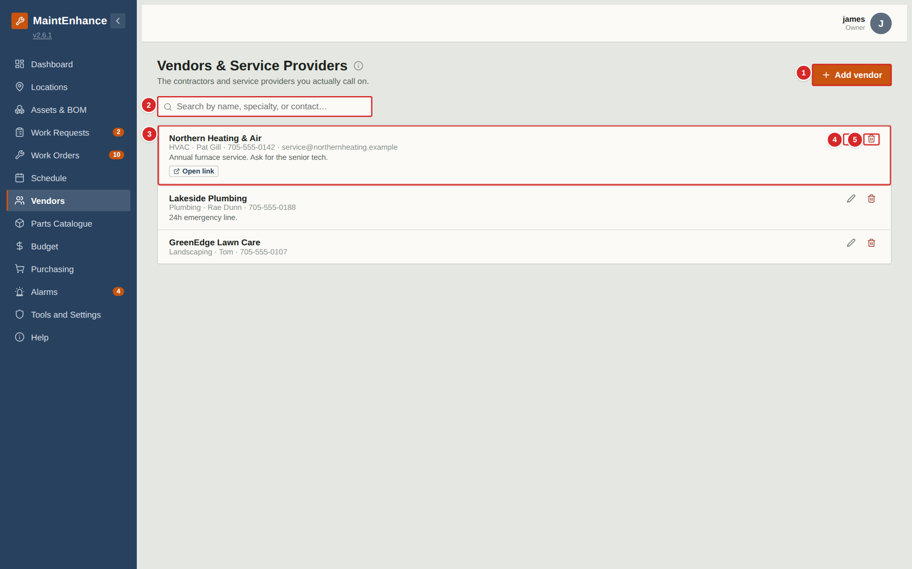
Vendors are the contractors and service providers you call on, kept in one place. Managers and owners add, edit and delete them; everyone can choose a vendor on a work order.
What to do
1. Select “Add vendor” to create one (next page).
2. Search by name, specialty or contact.
3. Use the pencil on a row to edit and the red bin to delete (managers can delete only vendors they created).
4. A vendor chosen on a work order or benchmark is shown there by name.
Numbered items in the picture
# | Field / area | What it is and how to use it
1 | Add vendor | Opens the new-vendor form.
2 | Search | Finds vendors by name, specialty or contact.
3 | Vendor row | Name, specialty, contact and notes, plus “Open link” if a website is saved.
4 | Edit (pencil) | Change the vendor’s details.
5 | Delete (bin) | Remove the vendor after confirmation.

Adding or editing a vendor
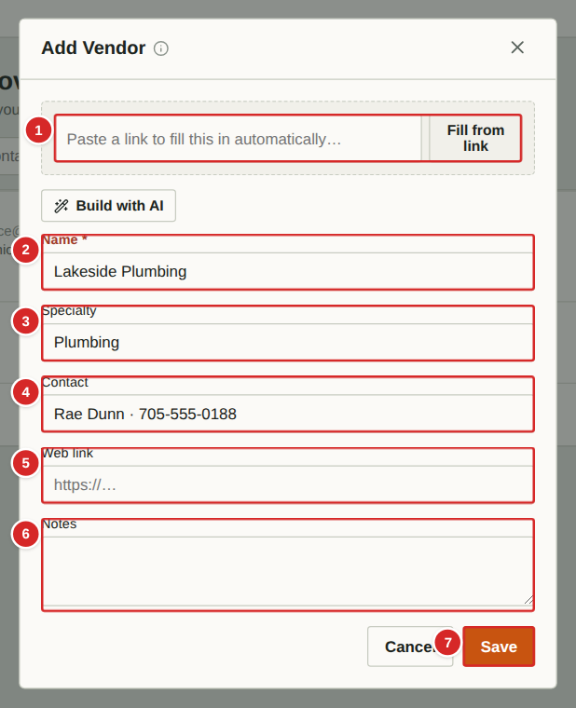 | Record who a contractor is and how to reach them. You can pre-fill the form from the vendor’s website.  What to do  1. Optionally paste the vendor’s website into the “Fill from link” bar and select the button: the app reads the page and suggests a name, specialty and contact details. Check them; the small cross clears a suggestion.  2. Type or correct the Name (required), Specialty, Contact, Web link and Notes.  3. Select Save.  Numbered items in the picture  1 Fill from link — Paste the vendor’s web address to prefill the form.  2 Name * — The business name.  3 Specialty — What they do (HVAC, plumbing, landscaping …).  4 Contact — Person, phone and email.  5 Web link — Website; shown as “Open link” on the vendor row.  6 Notes — For example “24h emergency line”.  7 Save / Cancel — Save stores the vendor.

Parts Catalogue
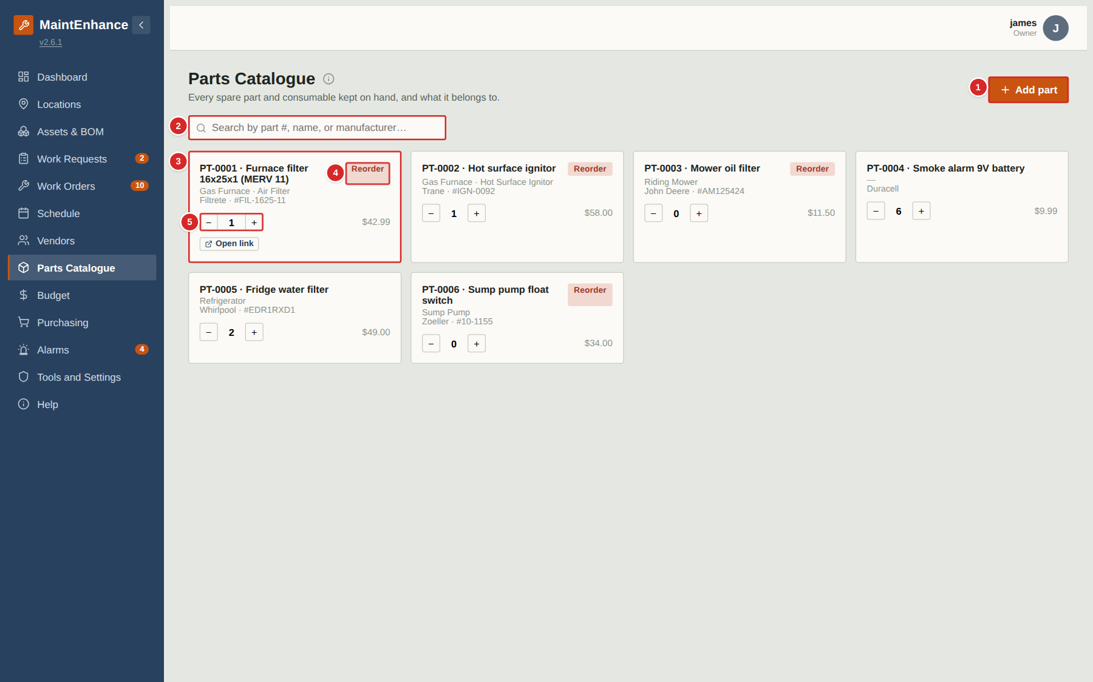
The Parts Catalogue is the master list of spare parts and consumables the household keeps. Managers and owners add, edit and delete parts; everyone can adjust the quantity on hand.
What to do
1. Select “Add part” to add a catalogue entry (next page).
2. Search by part number, name or manufacturer.
3. Select a part’s name to edit it, including the quantity on hand and reorder level.
4. Use − and + to adjust stock quickly. A part at or below its reorder level is tagged “Reorder”.
Numbered items in the picture
# | Field / area | What it is and how to use it
1 | Add part | Opens the new-part form.
2 | Search | Finds parts by number, name or manufacturer.
3 | Part card | Number, name, asset/component, manufacturer, part number, price. Select the name to edit.
4 | Reorder tag | Stock is at or below the reorder level.
5 | Quantity − / + | Adjust stock on hand by one.

Adding or editing a part
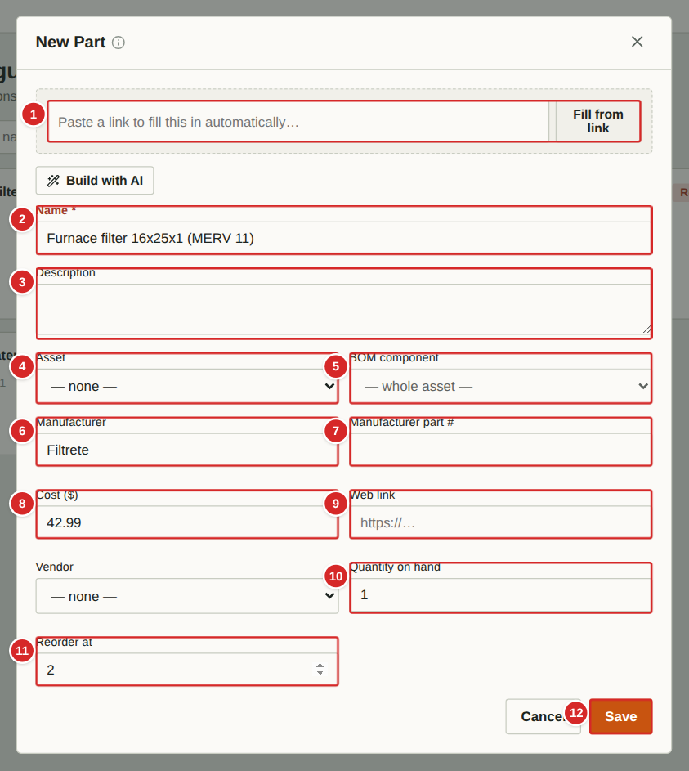 | Each part gets its own number (PT-0001, PT-0002 …) automatically. Link it to the asset or component it fits so it is easy to find when you attach it to a work order from that asset.  What to do  1. Optionally paste a supplier page into “Fill from link” to prefill the name, manufacturer, part number and cost.  2. Enter the Name (required) and, if known, the Asset and BOM component it fits.  3. Enter the manufacturer details, cost and web link.  4. Set the Quantity on hand and the Reorder at level: when stock falls to that number the part is flagged Reorder.  5. Select Save.  Numbered items in the picture  1 Fill from link — Paste a supplier’s product page to prefill the form.  2 Name * — What the part is.  3 Description — Size, type or other detail.  4 Asset — The equipment it fits.  5 BOM component — The component inside that asset.  6 Manufacturer — Maker.  7 Manufacturer part # — The maker’s own number, for ordering.  8 Cost ($) — Unit price.  9 Web link — Supplier page; shown as “Open link”.  10 Quantity on hand — How many are in stock now.  11 Reorder at — Stock level at or below which the part is flagged Reorder.  12 Save / Cancel — Saves the part.

Budget and cost tracking
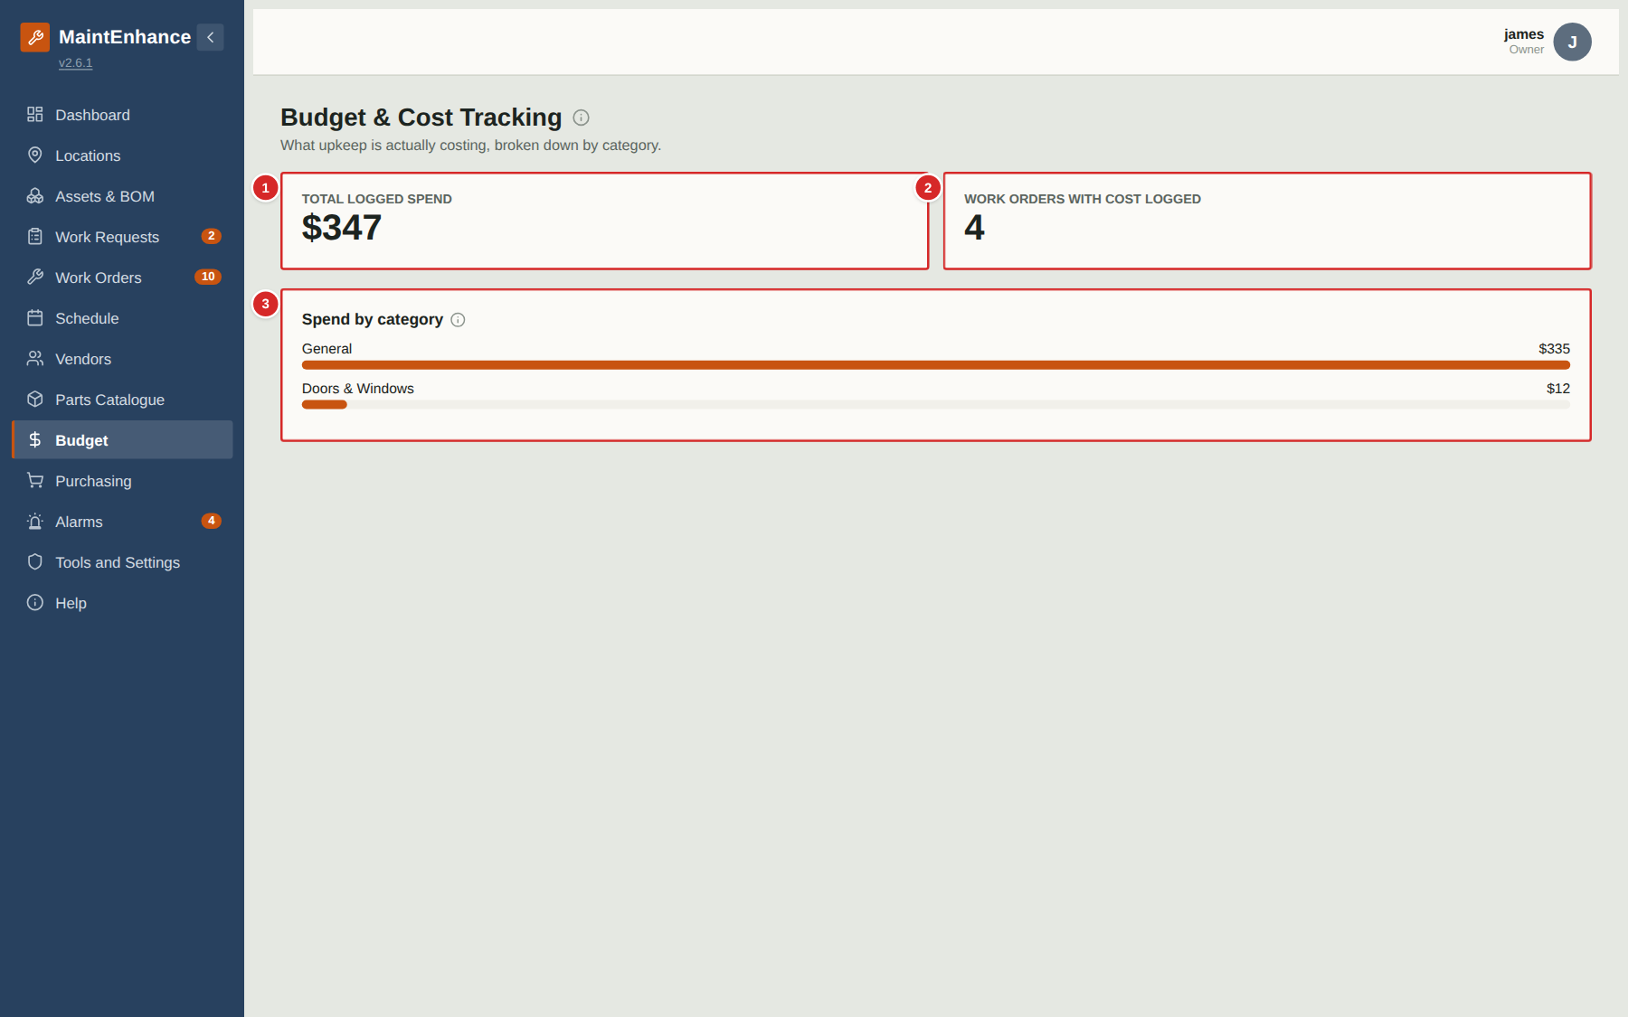
The Budget page shows what upkeep is actually costing, calculated from the costs recorded on work orders. There is nothing to type here — enter a cost on a work order and this page updates by itself.
What to do
1. Read “Total logged spend” for the overall figure and “Work orders with cost logged” for how many jobs it covers.
2. Look at “Spend by category” to see which kinds of asset cost the most: each bar is a category, longer meaning more spend.
3. To change a figure, correct the cost on the work order (managers and owners).
Numbered items in the picture
# | Field / area | What it is and how to use it
1 | Total logged spend | Sum of all costs entered on work orders.
2 | Work orders with cost logged | How many work orders have a cost entered.
3 | Spend by category | One bar per asset category with its total. Work orders without an asset are grouped as “General”.

Purchasing

Purchasing list
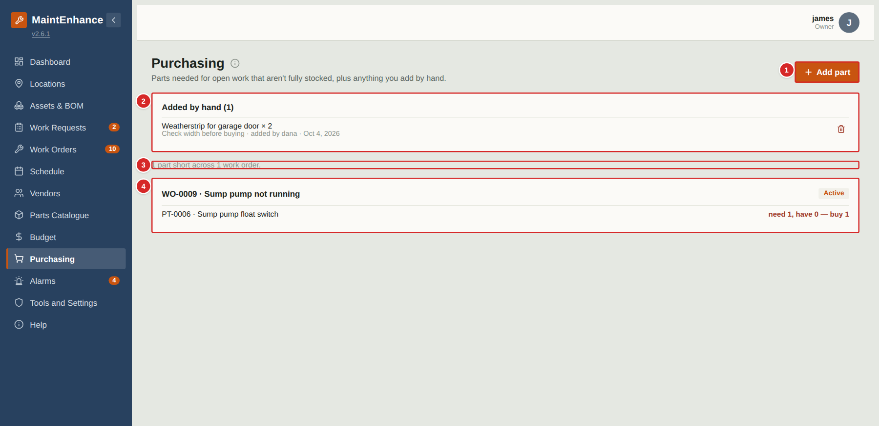
Purchasing is a shopping list the app builds for you. Any part attached to an Active or Scheduled work order in a quantity larger than what is in stock appears here, grouped by the work order that needs it. You can also add things by hand. The page is for managers and owners.
What to do
1. Review the groups: each work order lists the parts it is short of and “need 2, have 0 — buy 2”.
2. Select a work order’s heading to open it.
3. Use “Add part” to put anything else on the list — a catalogue part, or free text such as “Weatherstrip for garage door × 2”.
4. After buying, restock the part on the Parts Catalogue page (+ button) — the shortage disappears — and delete hand-added items with the bin.
Numbered items in the picture
# | Field / area | What it is and how to use it
1 | Add part | Adds a hand-entered item to the list.
2 | Added by hand | Items you or another manager added manually, with a note and who added them. The bin removes one.
3 | Summary line | How many parts are short across how many work orders.
4 | Shortage group | A work order and the parts it is short of. Red text shows the quantity needed, in stock and to buy.

Adding a part to buy
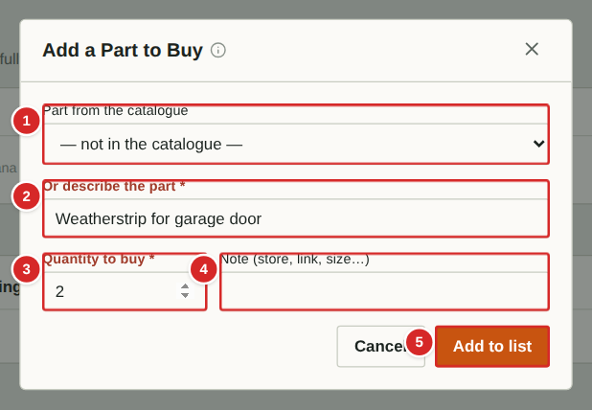
Use this form to put an item on the shopping list that is not tied to a work order — or that is not in the catalogue at all.
What to do
1. Either choose a part from the catalogue, or describe the part in your own words.
2. Enter the quantity to buy.
3. Optionally add a note (store, link, size).
4. Select “Add to list”.
Numbered items in the picture
# | Field / area | What it is and how to use it
1 | Part from the catalogue | Pick an existing part; its name is used.
2 | Or describe the part * | Free text, used when the part is not in the catalogue. One of the two is required.
3 | Quantity to buy * | How many.
4 | Note | Store, link, size or anything else useful.
5 | Add to list | Adds the item.

Alarms

Alarms
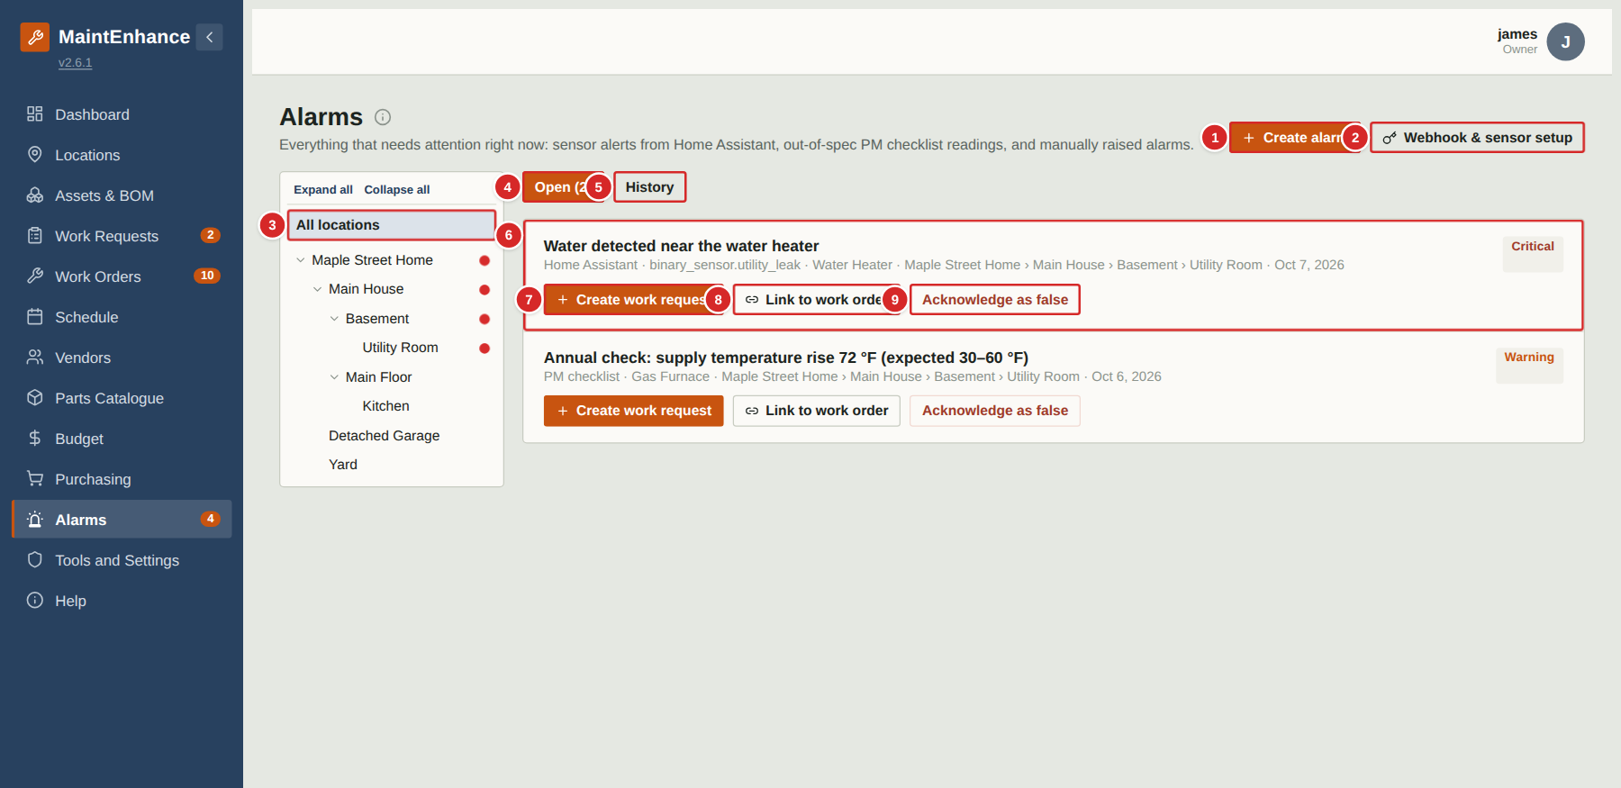
Alarms is one place for everything that needs attention right now and might not yet deserve a work order: sensor alerts sent by Home Assistant (a leak, a freezer running warm), a checklist reading that came back outside its expected range, or an alarm someone raised by hand. It sits upstream of Work Requests, because not every alert should become work. The page is for managers and owners; the Alarms entry in the menu carries a count of open alarms.
What to do
1. Open Alarms to see the open queue, sorted by severity and age. A red flashing beacon beside a location in the tree shows where open alarms are; it also appears on every parent location above it, so an alarm in the Utility Room lights up Basement, Main House and the property.
2. Select a location to see only alarms there.
3. Decide what each alarm needs: “Create work request” if it needs a fix, “Link to work order” if a job already exists (the alarm becomes evidence on it), or “Acknowledge as false” if the sensor was wrong.
4. Use the History tab to review resolved and false alarms, and to tune noisy sensors.
5. Use “Create alarm” to record something by hand.
Numbered items in the picture
# | Field / area | What it is and how to use it
1 | Create alarm | Raises an alarm manually.
2 | Webhook & sensor setup | Opens the panel that connects Home Assistant (shown only when your Owner has enabled that feature).
3 | Location tree with beacons | Red dots mark locations with open alarms, cascading up to the parents. Select a location to filter the list.
4 | Open tab | Alarms still waiting for action, with their number.
5 | History tab | Alarms already acknowledged, linked or converted.
6 | Alarm card | Title, source (Home Assistant, PM checklist or manual), asset, location and date, and a severity tag (Info, Warning, Critical) at the right.
7 | Create work request | Turns the alarm into a work request for review (next pages).
8 | Link to work order | Attaches the alarm to a work order that already exists.
9 | Acknowledge as false | Closes the alarm as a false positive, recording why.

Alarms: webhook and sensor setup
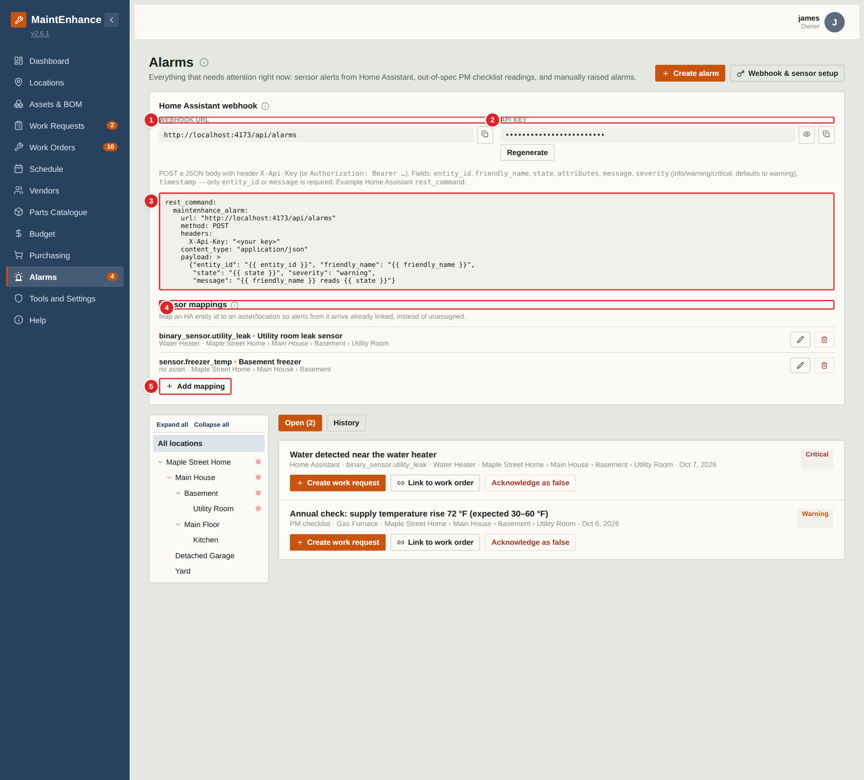
If your Owner has enabled the Home Assistant feature, this panel connects your smart-home system to the app. Home Assistant decides when something is really wrong (threshold, debounce, duration) and sends a message to the webhook URL; the app turns it into an alarm. The panel gives you the address, the secret key, a ready-to-paste example, and the mapping of sensors to assets and locations.
What to do
1. Select “Webhook & sensor setup”.
2. Copy the Webhook URL and the API key (Owners can reveal and regenerate the key) into Home Assistant, using the example rest_command shown.
3. Under Sensor mappings select “Add mapping” and enter the Home Assistant entity id, a friendly name, and the asset and location it belongs to, so alerts arrive already linked.
4. Use the pencil to edit a mapping and the bin to delete it.
Numbered items in the picture
# | Field / area | What it is and how to use it
1 | Webhook URL | The address Home Assistant posts alerts to. The button beside it copies it.
2 | API key | The shared secret. Reveal shows it, Copy copies it, and Regenerate creates a new one (the old one stops working). Regenerate is Owner-only.
3 | Example | A ready-to-paste Home Assistant rest_command that posts to the webhook.
4 | Sensor mappings | Each row links a Home Assistant entity to an asset and location, so alarms from it are pre-linked. Pencil edits; bin removes.
5 | Add mapping | Adds a new entity-to-asset mapping.

Creating an alarm by hand
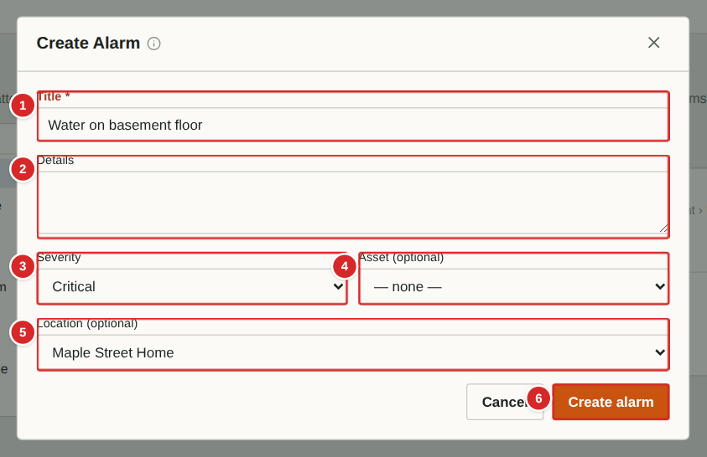
Anyone with access to this page can raise an alarm directly — for example when you notice something that is urgent but not yet a job.
What to do
1. Select “Create alarm”.
2. Enter a Title and optional Details.
3. Choose the Severity and, if known, the Asset and Location (so the beacon shows in the right place).
4. Select “Create alarm”.
Numbered items in the picture
# | Field / area | What it is and how to use it
1 | Title * | What is wrong.
2 | Details | More information.
3 | Severity | Info, Warning or Critical. Critical alarms sort to the top.
4 | Asset (optional) | The equipment concerned.
5 | Location (optional) | Where it is. The location’s beacon will flash.
6 | Create alarm | Records the alarm.

Alarm actions: create a work request
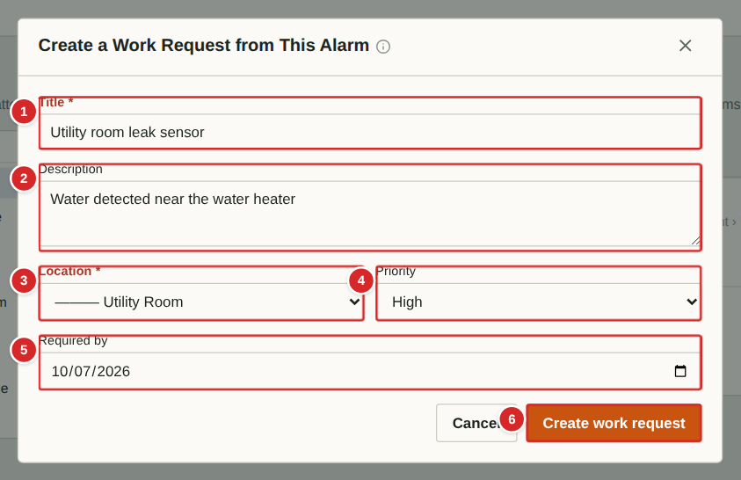
Converting an alarm creates an ordinary work request, pre-filled from the alarm, which then goes through the normal review. The alarm is marked as converted.
What to do
1. On the alarm select “Create work request”.
2. Check or edit the Title, Description, Location, Priority and Required by date.
3. Select “Create work request”. It appears in the Work Requests inbox.
Numbered items in the picture
# | Field / area | What it is and how to use it
1 | Title * | Pre-filled from the alarm.
2 | Description | Pre-filled with the alarm message.
3 | Location * | Pre-filled from the alarm.
4 | Priority | Defaults from the alarm’s severity.
5 | Required by | Deadline for the request.
6 | Create work request | Creates the request.

Alarm actions: link to a work order
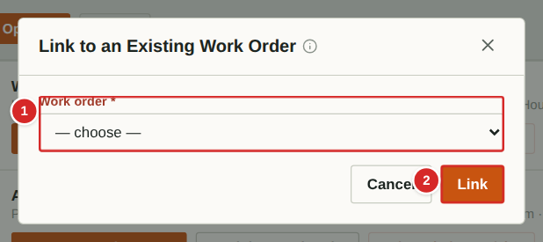
If a work order already covers the problem, link the alarm to it instead of creating something new. The alarm is recorded on that work order as evidence.
What to do
1. On the alarm select “Link to work order”.
2. Pick the work order.
3. Select Link.
Numbered items in the picture
# | Field / area | What it is and how to use it
1 | Work order * | Open work orders to choose from.
2 | Link | Attaches the alarm to the chosen work order.

Alarm actions: acknowledge as false
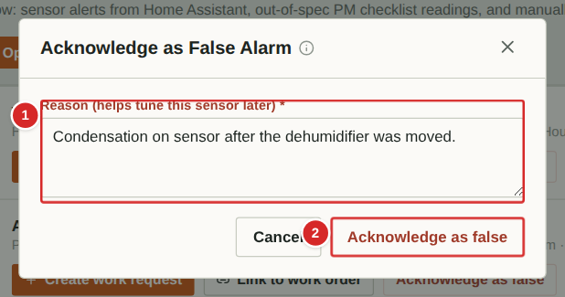
If the alarm was a false positive, acknowledge it as such. The reason is kept in History so that a noisy sensor can be adjusted later.
What to do
1. On the alarm select “Acknowledge as false”.
2. Type why it was false.
3. Select “Acknowledge as false”. The alarm moves to History.
Numbered items in the picture
# | Field / area | What it is and how to use it
1 | Reason * | Why you believe it was false — used to tune the sensor.
2 | Acknowledge as false | Closes the alarm.

Tools and settings

Tools and settings: what you see by role
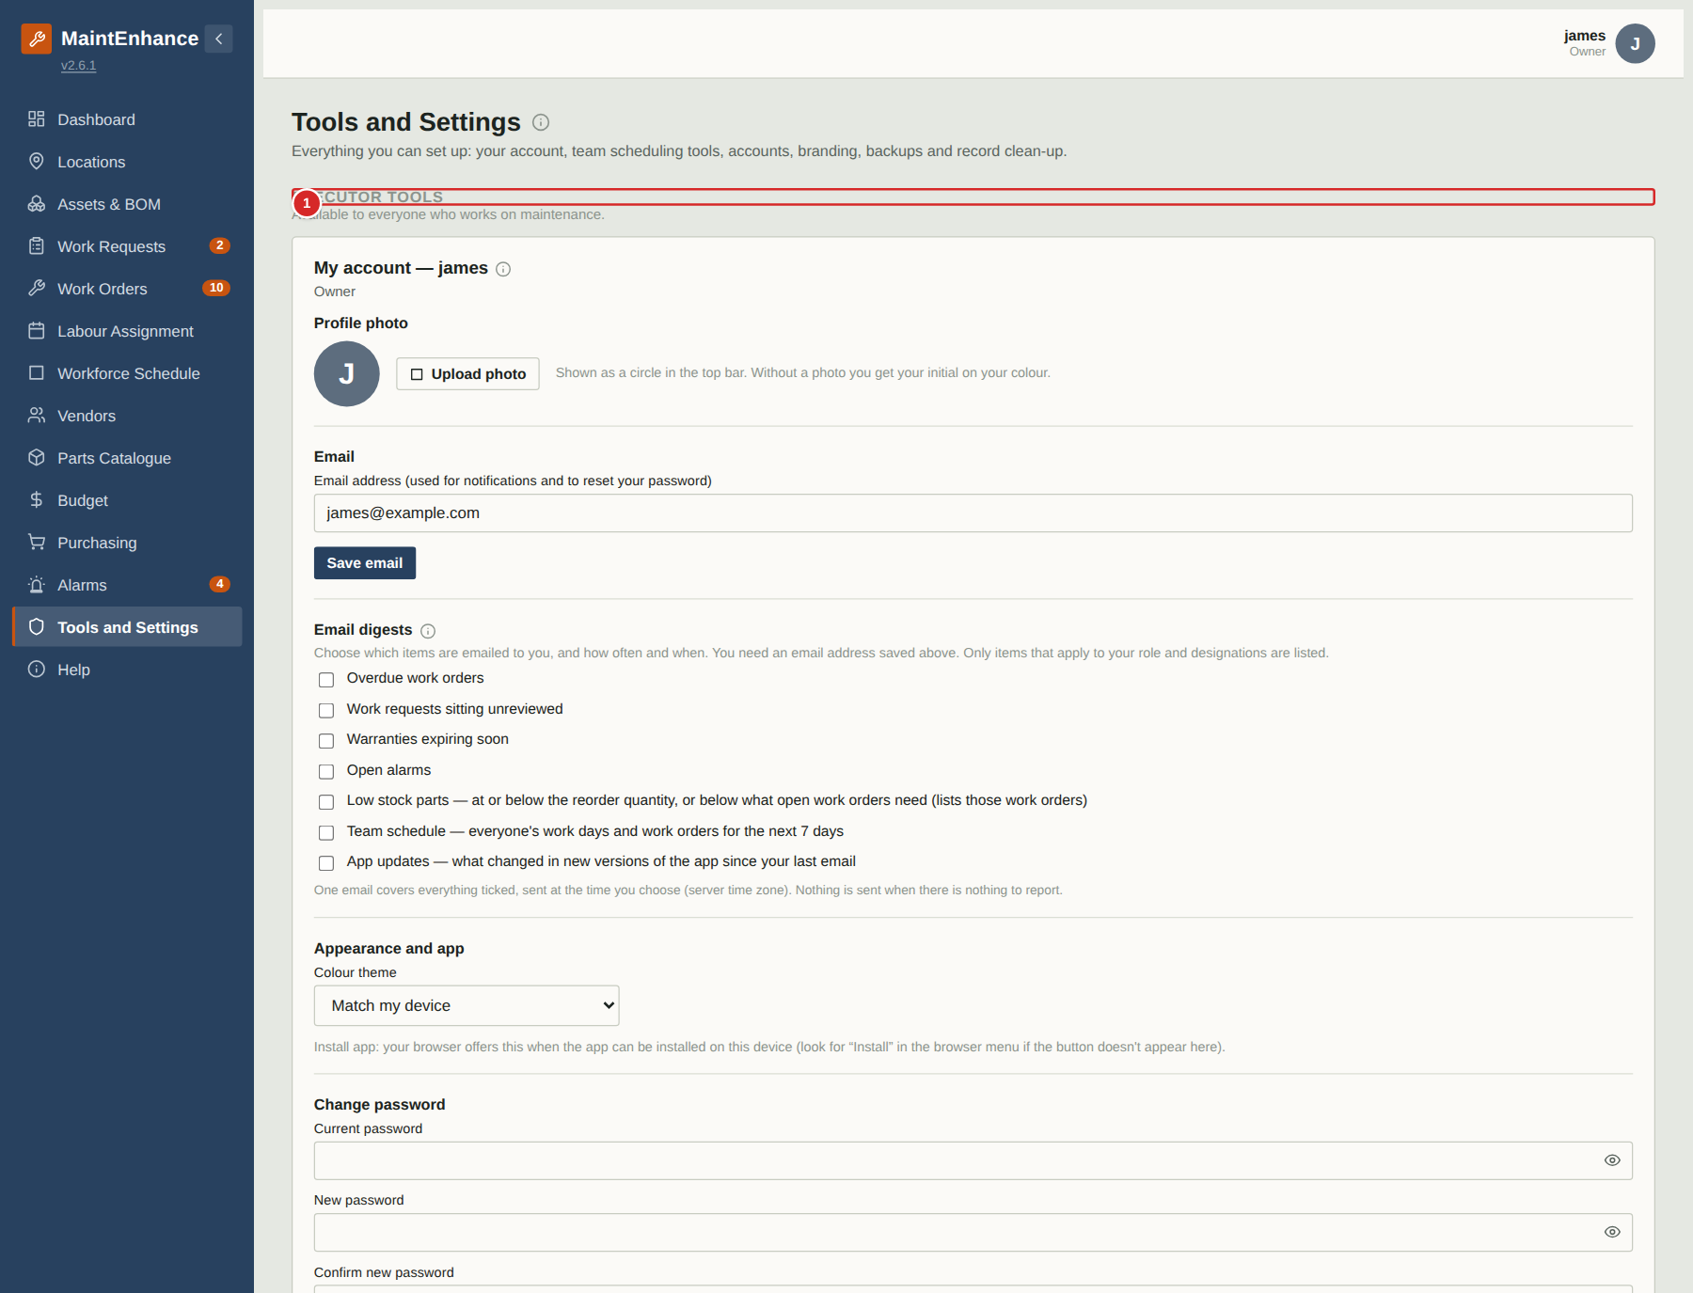
The Tools and settings tab replaced “Tools and settings”. Its cards depend on your role: Executors see their own tools, Managers also see the manager tools, and Owners see everything, including the administration cards described on the following pages. Cards are grouped under headings so it is clear which level they belong to.
What to do
1. Open Tools and settings from the menu.
2. Work down the page: Executor tools, then Manager tools, then (Owners only) Owner tools.
3. Select the small “i” beside any card title for a short explanation.
Numbered items in the picture
# | Field / area | What it is and how to use it
1 | Executor tools | My account and My hours. Everyone except guests.
2 | Manager tools | Executor colours, Shift templates and the all-executor hours report. Managers and Owners.
3 | Owner tools | Members, Branding & terminology, Features, Backup, the PM Wizard catalogue and the delete tools. Owners only.

Tools and settings: Executor colours
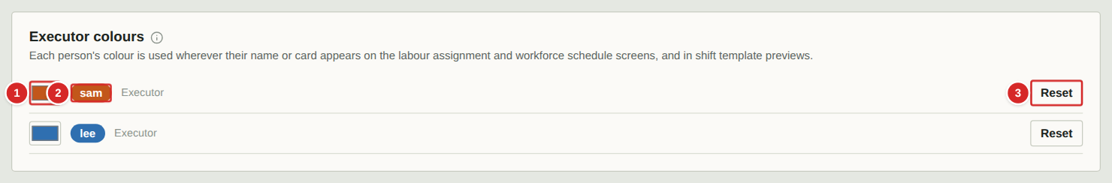
Give each person a colour. It is used wherever their name or card appears on Labour assignment, Workforce schedule and the shift pop-ups, so you can recognise people at a glance.
What to do
1. Select a colour swatch and pick a colour.
2. To go back to the automatic colour select Reset beside the person.
Numbered items in the picture
# | Field / area | What it is and how to use it
1 | Colour swatch | Opens the colour picker for this person.
2 | Name chip | How the person's name appears on the schedule screens, in their colour.
3 | Reset | Appears once a colour has been chosen; returns the person to their automatic colour.

Tools and settings: Shift templates
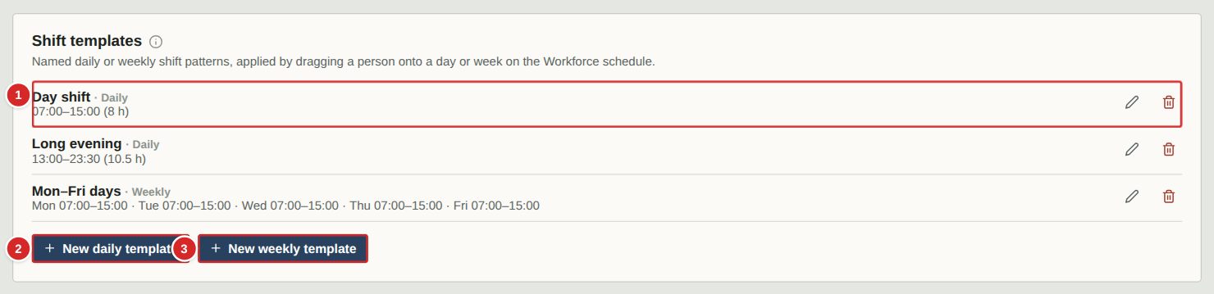
Shift templates are saved shift patterns. They make scheduling people on the Workforce schedule a single drop. A daily template is one shift; a weekly template has a shift (or a day off) for each of the seven days.
What to do
1. Select “New daily template” or “New weekly template”.
2. Name it and fill in the shift (next pages).
3. Use the pencil to edit a template and the bin to delete one. Deleting a template does not change shifts already scheduled.
Numbered items in the picture
# | Field / area | What it is and how to use it
1 | A template | Name, whether it is Daily or Weekly, and a summary of its times. Pencil edits, bin deletes.
2 | New daily template | Creates a one-shift pattern.
3 | New weekly template | Creates a seven-day pattern.

Shift templates: a daily template
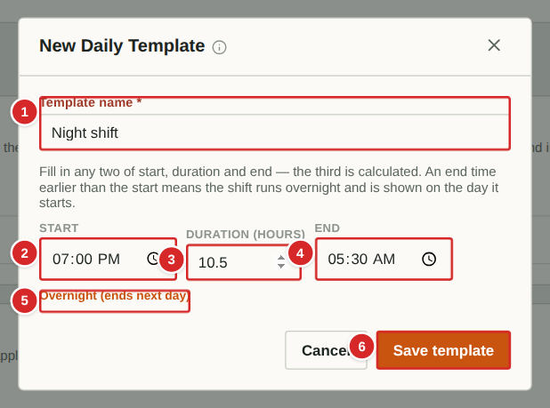
A daily template is a start time, a duration and an end time. Fill in any two and the app works out the third. If the end is earlier than the start the shift runs overnight and is always shown on the day it starts.
What to do
1. Type a name.
2. Enter two of: start, duration, end. The third is filled in for you.
3. Change any field later and the oldest of the other two is recalculated.
4. Select Save template.
Numbered items in the picture
# | Field / area | What it is and how to use it
1 | Template name * | The name shown when you drop a person on the schedule.
2 | Start | When the shift starts.
3 | Duration | Any number of hours, for example 7.5.
4 | End | When the shift ends. Calculated here from start and duration.
5 | Overnight | Shown when the end is earlier than the start.
6 | Save template | Stores the template.

Shift templates: a weekly template
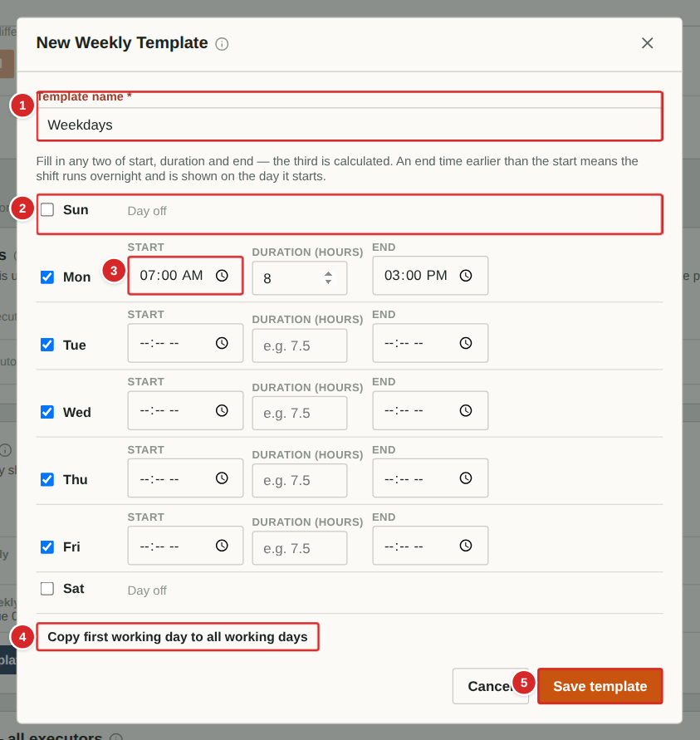 | A weekly template has the same start, duration and end options for each day of the week. Untick a day to make it a day off.  What to do  1. Name the template.  2. Tick the days that are worked and fill in each day's shift.  3. Use “Copy first working day to all working days” to repeat one day's shift.  4. Select Save template.  Numbered items in the picture  1 Template name * — Name shown when you drop a person on a week.  2 A day row — Tick the box to work that day. Unticked days show “Day off”.  3 Shift fields — Start, duration and end for that day (any two).  4 Copy first working day… — Copies the first working day's shift onto every working day.  5 Save template — Stores the template.

Tools and settings: Hours worked (all executors)
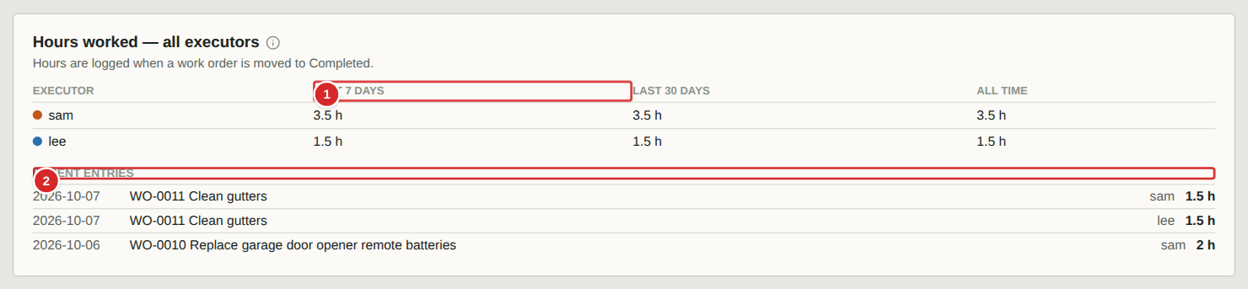
When an executor completes a work order they enter the hours they worked. This card adds those entries up for each person and lists the most recent ones, which helps with timesheets and with checking estimates against reality.
What to do
1. Open Tools and scroll to this card.
2. Read the totals per person for the last 7 days, last 30 days and all time.
3. Scan Recent entries for the work order, date, person and hours.
Numbered items in the picture
# | Field / area | What it is and how to use it
1 | Totals | Hours per executor over three periods.
2 | Recent entries | The latest hours logged: date, work order, person and hours.

Tools and settings: owner administration
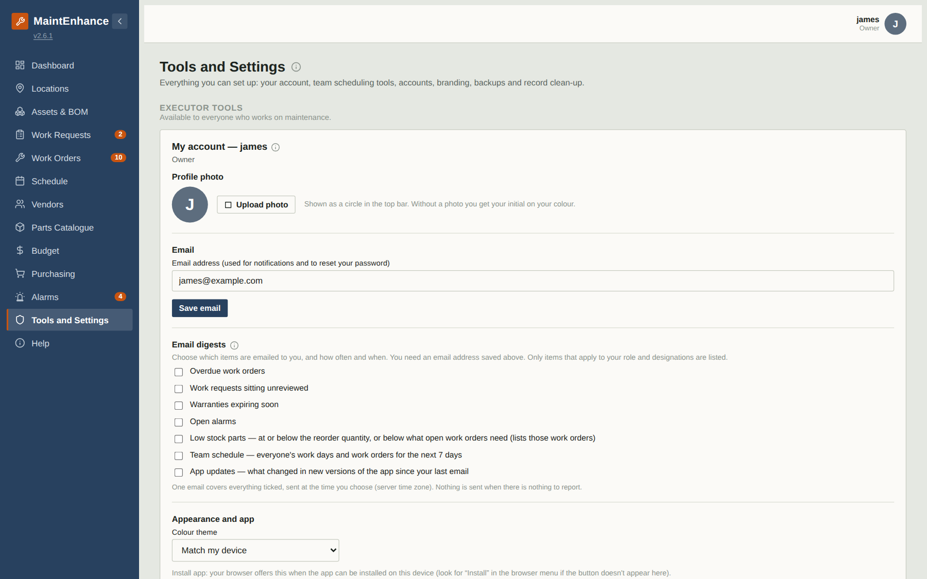
The Owner tools section of the Tools and settings page holds the administration that should not be scattered through the rest of the app: who has an account, how the app looks and what it calls things, optional features, backups and data clean-up. It is available to Owners only — Managers have wide rights elsewhere in the app but do not see this page. The page is long; the following pages describe each card in turn.
What to do
1. Open Tools and settings from the bottom of the menu and scroll to the Owner tools heading.
2. Work down the page through the cards: Members, Branding & terminology, Features, Backup & bulk edit, PM Wizard starter catalogue, Delete a work order, Delete a work request.
3. Changes to Branding, Features and Members take effect immediately for everyone.
Numbered items in the picture
# | Field / area | What it is and how to use it
1 | Members | Accounts: who can sign in and their role.
2 | Branding & terminology | Name, logo, colours and the words the app uses (shown in part).

Tools and settings: Members
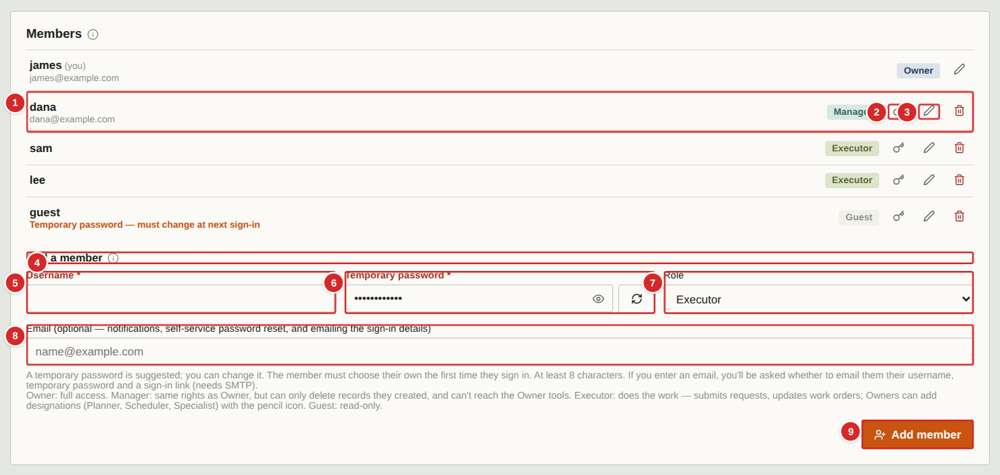
Members lists everyone with an account, with their role. Use it to add people, set temporary passwords, set an email address and notification preferences for each person, and remove accounts.
What to do
1. To add someone, fill in the Add a member form and select “Add member”. Give them the username and the temporary password; they must choose their own at first sign-in (see “Choosing your own password”).
2. Roles: Owner has full access including the Tools and settings page. Manager has the same rights except the Tools and settings page, deletes only records they created and cannot reveal the alarm webhook key. Executor submits requests, creates and works work orders, and views everything else. Guest can only read.
3. Use the pencil on a row to set the person’s email address and notification preferences (daily digest).
4. Use the key on a row to reset a password. Leave the box blank to have the app generate a temporary password and show it to you once.
5. Use the red bin to remove an account. You cannot remove your own.
Numbered items in the picture
# | Field / area | What it is and how to use it
1 | Member row | Username, email (if set), a role tag, and three buttons. A line “Temporary password — must change at next sign-in” shows for people who have not yet chosen their own.
2 | Reset password (key) | Sets a new temporary password for that person.
3 | Member settings (pencil) | Email address and notification preferences for that person.
4 | Add a member | Form to create an account.
5 | Username * | The name they sign in with.
6 | Temporary password * | At least 8 characters. Temporary: they must change it at first sign-in.
7 | Role | Owner, Manager, Executor or Guest.
8 | Email (optional) | Used for notifications and self-service password reset.
9 | Add member | Creates the account.

Tools and settings: a member’s email and notification settings
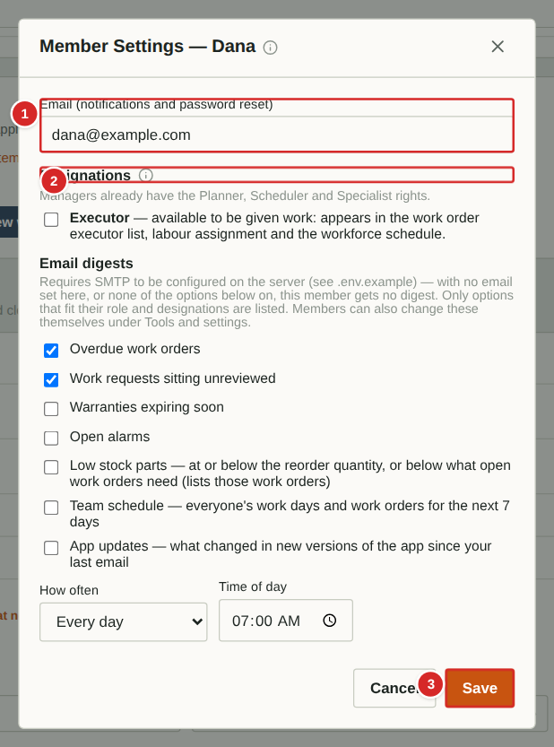 | Set where a person’s emails go and what they receive. Notification emails need your Owner to have configured a mail server for the app.  What to do  1. On the member’s row select the pencil.  2. Enter or change the email address.  3. Tick the items to include in the person’s daily digest email: overdue work orders, warranties expiring soon, and work requests sitting unreviewed.  4. Save.  Numbered items in the picture  1 Email — Where this person’s notification emails and reset links are sent.  2 Designations — Planner, Scheduler and Specialist for executors; an Executor flag for Owners and Managers (off by default). They decide who can plan, schedule and be assigned work.  3 Save — Stores the settings.

Tools and settings: resetting a password
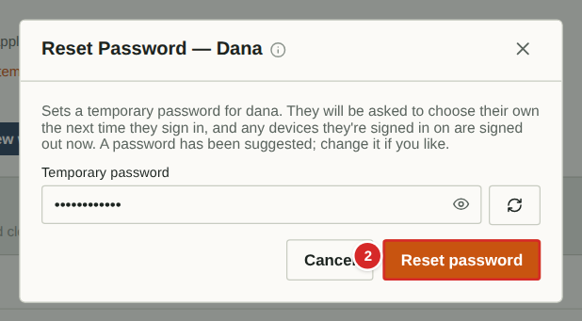
If someone forgets their password and cannot use the email reset, set a new temporary one. They must change it at their next sign-in, and any devices where they were signed in are signed out.
What to do
1. Select the key on their row.
2. Type a temporary password, or leave the box empty to have one generated.
3. Select “Reset password” and give the person the temporary password (a generated one is shown once).
Numbered items in the picture
# | Field / area | What it is and how to use it
1 | Temporary password | At least 8 characters; blank means generate one.
2 | Reset password | Applies the change and signs the person out everywhere.

Tools and settings: Branding and terminology
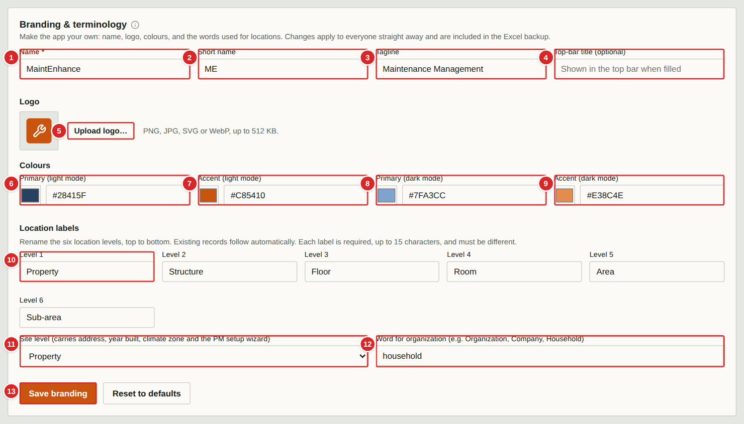
Make the app your own: its name, logo and colours, and the words used for locations. Changes apply to everyone straight away and are included in the Excel backup.
What to do
1. Fill in the names: Name (required), Short name (used where space is tight), Tagline (below the logo) and an optional Top-bar title.
2. Upload a logo (PNG, JPG, SVG or WebP, up to 512 KB).
3. Choose the four colours: primary and accent for light mode and for dark mode. Enter a hex code such as #28415F or use the colour square. The app warns if the text contrast would be hard to read.
4. Rename the six location levels, from largest to smallest, and choose which level is the “site” level (it carries the address, year built, climate zone and the PM wizard).
5. Optionally change the word “household” (to organization, say).
6. Select “Save branding”, or “Reset to defaults” to undo your changes.
Numbered items in the picture
# | Field / area | What it is and how to use it
1 | Name * | The app’s name, shown at the top of the menu and on the sign-in screen.
2 | Short name | A short form used in small spaces.
3 | Tagline | Line shown under the name.
4 | Top-bar title (optional) | If filled, shown in the top bar.
5 | Logo | The image beside the name. The square to the left previews the current one.
6 | Primary (light mode) | Main colour (menu background, headings) when the app is in light mode.
7 | Accent (light mode) | Highlight colour (buttons, badges) in light mode.
8 | Primary (dark mode) | Main colour in dark mode.
9 | Accent (dark mode) | Highlight colour in dark mode.
10 | Location levels 1–6 | The names of the six location levels, largest first. Each is required, up to 15 characters, and all must differ.
11 | Site level | Which level is the property that carries address, year built, climate zone and the PM wizard.
12 | Word for “household” | Replaces the word wherever the app says household.
13 | Save branding / Reset to defaults | Save applies the changes; Reset restores the original look.

Tools and settings: Features
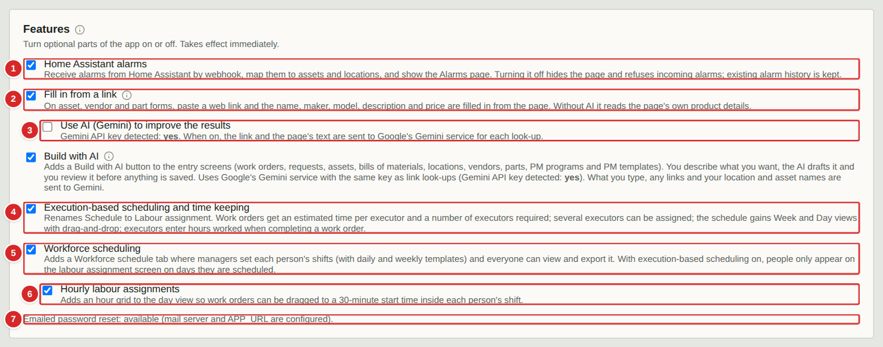
Features switches optional parts of the app on or off. Changes take effect immediately. Nothing is deleted when something is switched off; it is simply hidden.
What to do
1. Tick “Home Assistant alarms” to enable the webhook, sensor mappings and the Alarms page.
2. Tick “Fill in from a link” to show the paste-a-link helper on asset, vendor and part forms; tick “Use AI (Gemini)” beneath it to improve results (needs a key set on the server).
3. Tick “Execution-based scheduling and time keeping” to rename Schedule to Labour assignment and add estimates, crews, multiple executors, week and day views and hours worked.
4. Tick “Workforce scheduling” to add the Workforce schedule tab.
5. Tick “Hourly labour assignments” to add the 30-minute grid to the day view. It is available only when the two scheduling features above are both on.
Numbered items in the picture
# | Field / area | What it is and how to use it
1 | Home Assistant alarms | Turns the sensor webhook and Alarms page on or off.
2 | Fill in from a link | Turns the paste-a-link helper on or off.
3 | Use AI (Gemini) | Optional AI refinement of filled-in values.
4 | Execution-based scheduling and time keeping | Labour assignment, estimates, crews, hours worked.
5 | Workforce scheduling | Adds the Workforce schedule tab, shift templates and PDF export.
6 | Hourly labour assignments | 30-minute grid in the day view; needs both of the above.
7 | Emailed password reset status | Shows whether people can reset their own password by email.

Tools and settings: Backup and bulk edit
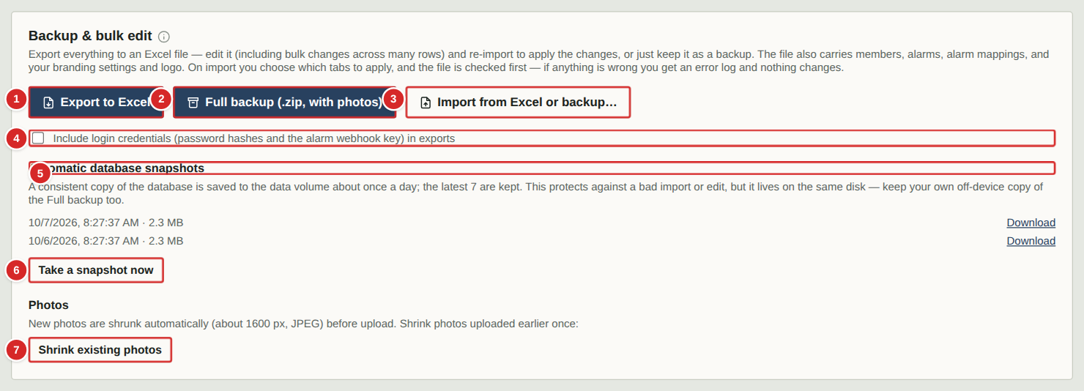
Everything in the app can be exported to an Excel workbook or a full backup file, edited in bulk, and imported again. The app also keeps its own automatic nightly snapshots.
What to do
1. “Export to Excel” downloads a workbook with one sheet per kind of record. Edit rows (including bulk changes) and re-import it, or keep it as a backup.
2. “Full backup” downloads a .zip with the workbook and all photos.
3. “Import from Excel or backup…” asks for a file, checks it, and lets you choose which tabs to apply. If anything is wrong you get an error log and nothing changes.
4. Tick “Include login credentials” only if you want password hashes and the webhook key in the export; leave it off for files you will share.
5. Automatic snapshots are taken about once a day and the latest seven are kept. Download one, or select “Take a snapshot now”. They live on the same disk as the app, so also keep your own Full backup elsewhere.
6. “Shrink existing photos” reduces the size of photos uploaded before automatic shrinking was added.
Numbered items in the picture
# | Field / area | What it is and how to use it
1 | Export to Excel | Downloads all records as a workbook.
2 | Full backup (.zip, with photos) | Downloads everything including photos.
3 | Import from Excel or backup… | Pre-checks a file and applies the tabs you choose.
4 | Include login credentials | Adds password hashes and the alarm webhook key to exports. Leave off unless you need a complete restore.
5 | Automatic database snapshots | The seven most recent nightly copies, each with date, time and size and a Download link.
6 | Take a snapshot now | Makes a snapshot immediately, for example before a big edit.
7 | Shrink existing photos | One-off clean-up that reduces older photos to the standard size.

Tools and settings: PM Wizard starter catalogue
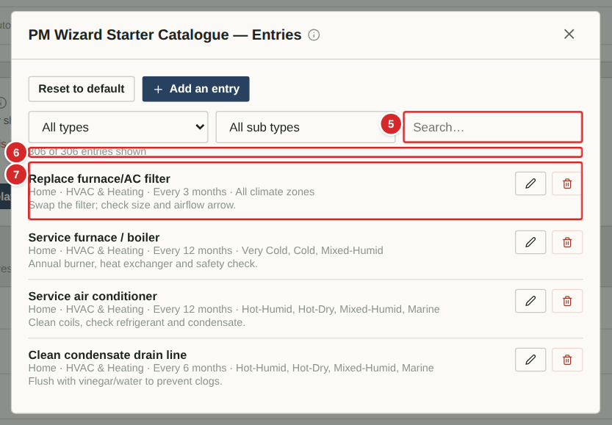
The starter catalogue is the list of about 300 suggested maintenance jobs offered by the PM setup wizard. Edit it to match your household — remove what never applies, change intervals, add your own. Editing the catalogue never changes PM Bases that were already created. (Only the first few entries are shown here; the real list is long.)
What to do
1. Narrow the list with the Type and Sub type boxes or the search box.
2. Use the pencil on a row to edit it and the red bin to remove it.
3. Select “View entries” to open the list, then “Add an entry” to add your own (next page).
4. “Reset to default” restores the original catalogue (your edits are lost).
Numbered items in the picture
# | Field / area | What it is and how to use it
1 | Reset to default | Restores the built-in catalogue.
2 | Add entry | Adds a new suggested job.
3 | Type filter | Home or Facilities (and any types you add).
4 | Sub type filter | Category within the type (HVAC & Heating, Plumbing & Water …).
5 | Search | Find an entry by name.
6 | Count | How many entries match the filters.
7 | Catalogue entry | Title, then type · sub type · repeat interval · climate zones, then a note. Pencil edits; bin removes.

Tools and settings: adding or editing a catalogue entry
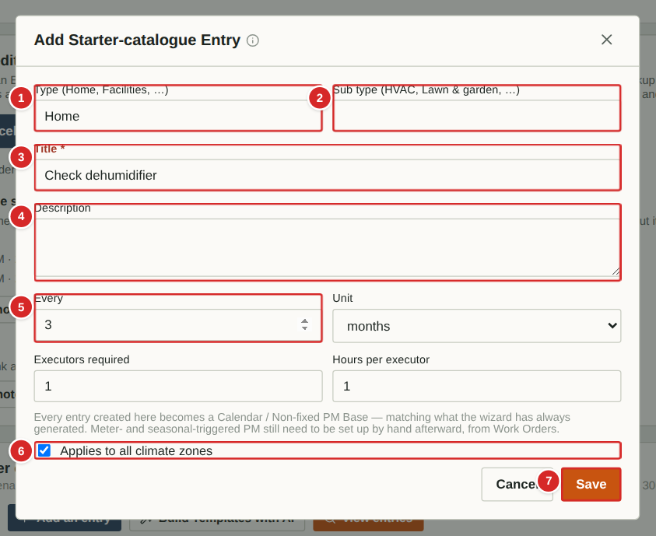
Each catalogue entry becomes a PM Base when someone ticks it in the wizard.
What to do
1. Enter or choose the Type and Sub type (a new name creates a new group).
2. Type the Title and an optional Description.
3. Set how often it repeats with Every and Unit.
4. Leave “Applies to all climate zones” ticked, or untick it and choose the zones where it makes sense.
5. Select Save.
Numbered items in the picture
# | Field / area | What it is and how to use it
1 | Type | Home, Facilities or your own type.
2 | Sub type | Category within the type.
3 | Title * | Becomes the PM Base title.
4 | Description | Note shown in the wizard and copied to the PM Base.
5 | Every / Unit | Repeat interval.
6 | Applies to all climate zones | Untick to limit the entry to chosen climate zones; others are greyed out in the wizard.
7 | Save / Cancel | Save stores the entry.

Tools and settings: Delete a work order or request
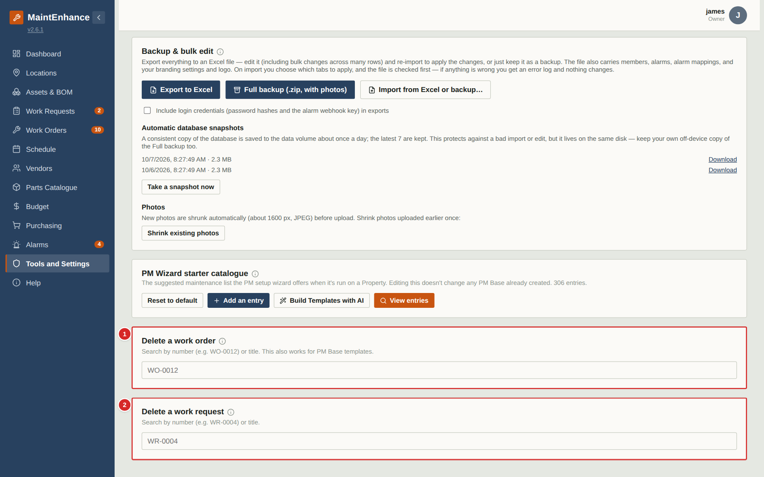
Normally a mistaken work order or request is declined or closed so the record is kept. If one was created in error and must disappear completely, an Owner can delete it here by number or title. This is permanent.
What to do
1. Type the number (WO-0012, WR-0004) or part of the title in the box.
2. Select the matching result and confirm.
3. Deleting a PM Base removes the template; jobs generated from it stay but no more are created. A request linked to a deleted work order simply loses the link.
Numbered items in the picture
# | Field / area | What it is and how to use it
1 | Delete a work order | Search by number or title (also works for PM Base templates).
2 | Delete a work request | Search by number or title.

Scheduling and time keeping (optional)

How scheduling and time keeping work
Three optional switches
Your Owner can switch on three optional features in Tools > Features: Execution-based scheduling (labour assignment and hours worked), Workforce scheduling (who works when) and Hourly assignment (a 30-minute grid inside each day). Hourly needs the other two. With all three off the app looks and behaves as in earlier versions.
Estimate, crew and executors
On a work order enter Estimated hours (per person), Crew required (how many people at once) and one or more executors. The first executor listed remains the primary executor for filters and reports.
Labour assignment
The Schedule page becomes Labour assignment. Drag a work order onto a day (or an hour) to schedule it, and drag a person’s name onto a work order to assign them. A day that is short of people for the crew required is flagged as under-staffed.
Workforce schedule
A calendar of who is working when. Drag a person onto a week or a day, then choose a shift template or enter a one-time shift. When you edit a shift enter any two of start, duration and end and the third is calculated. An end time earlier than the start means an overnight shift, shown on the day it starts. Each day header shows first start, last end and any gap in coverage (in red).
Hours worked
When an executor completes a work order they are asked how many hours they worked. Hours appear on the work order, in Tools > My hours and, for managers, in Tools > Hours worked.
Touch screens
On a tablet or phone, tap a work order card or a person’s name to pick it up (it is highlighted and a banner shows what you are holding), then tap the day, person’s day, week box or hour slot where it should go. Tap Cancel or the held card again to put it down, or Open to see the work order.
PDF
Both planning calendars have a Print / PDF button that exports the visible month, week or day.

Labour assignment: month view
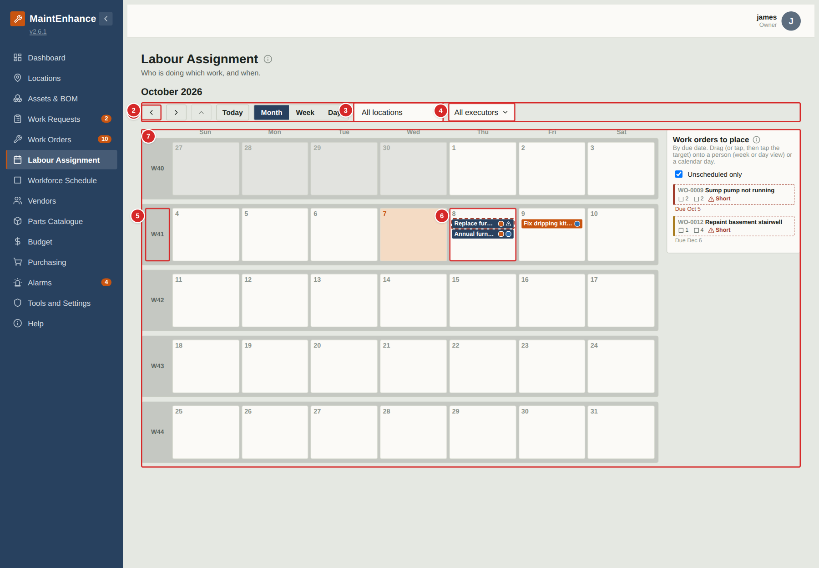
Labour assignment is the Schedule renamed when execution-based scheduling is on. Use it to decide who does which work and when. The month view shows each week in its own box, with the ISO week number on the left.
What to do
1. Use the arrows to change month; the up arrow is disabled here because this is the top level.
2. Select a day number to open that day, or the week number to open that week.
3. Drag a work order from the side list onto a day to schedule it for that day. Then open the week or day view to give it people.
4. Use the executor and location filters to focus on part of the work.
Numbered items in the picture
# | Field / area | What it is and how to use it
1 | Back and forward | Previous and next month.
2 | Month / Week / Day | Jumps directly to a view.
3 | Location filter | Show only work at one place and everything inside it.
4 | Executor filter | Tick one or more people; blank shows everyone.
5 | Week header | ISO week number. Select it to open the week view.
6 | Day box | Work scheduled that day. Select the number to open the day. Coloured dots show who is assigned; a dashed red outline means not enough people.
7 | Work orders to place | Open work orders by due date. Drag one onto a day.

Editing or deleting a shift
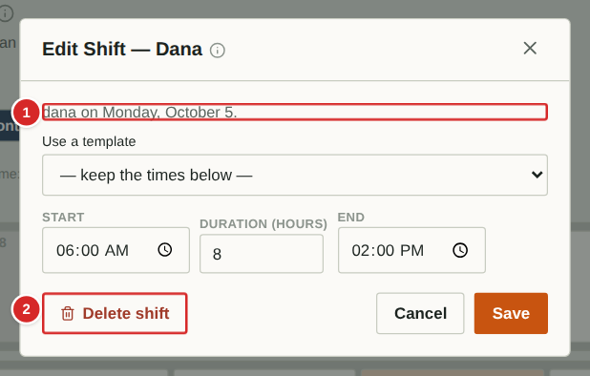
On the Workforce schedule, tap any shift chip to edit it. The pop-up lets you change the start, duration and end (fill any two) or pick a daily template, and has a Delete shift button. There is no small x on the chips any more.
What to do
1. Tap a shift on the Workforce schedule.
2. Change the times, or choose a template.
3. Select Save, or Delete shift to remove it.
Numbered items in the picture
# | Field / area | What it is and how to use it
1 | Who and when | The person and the day of the shift.
2 | Delete | Removes this shift from the schedule.

Labour assignment: week view
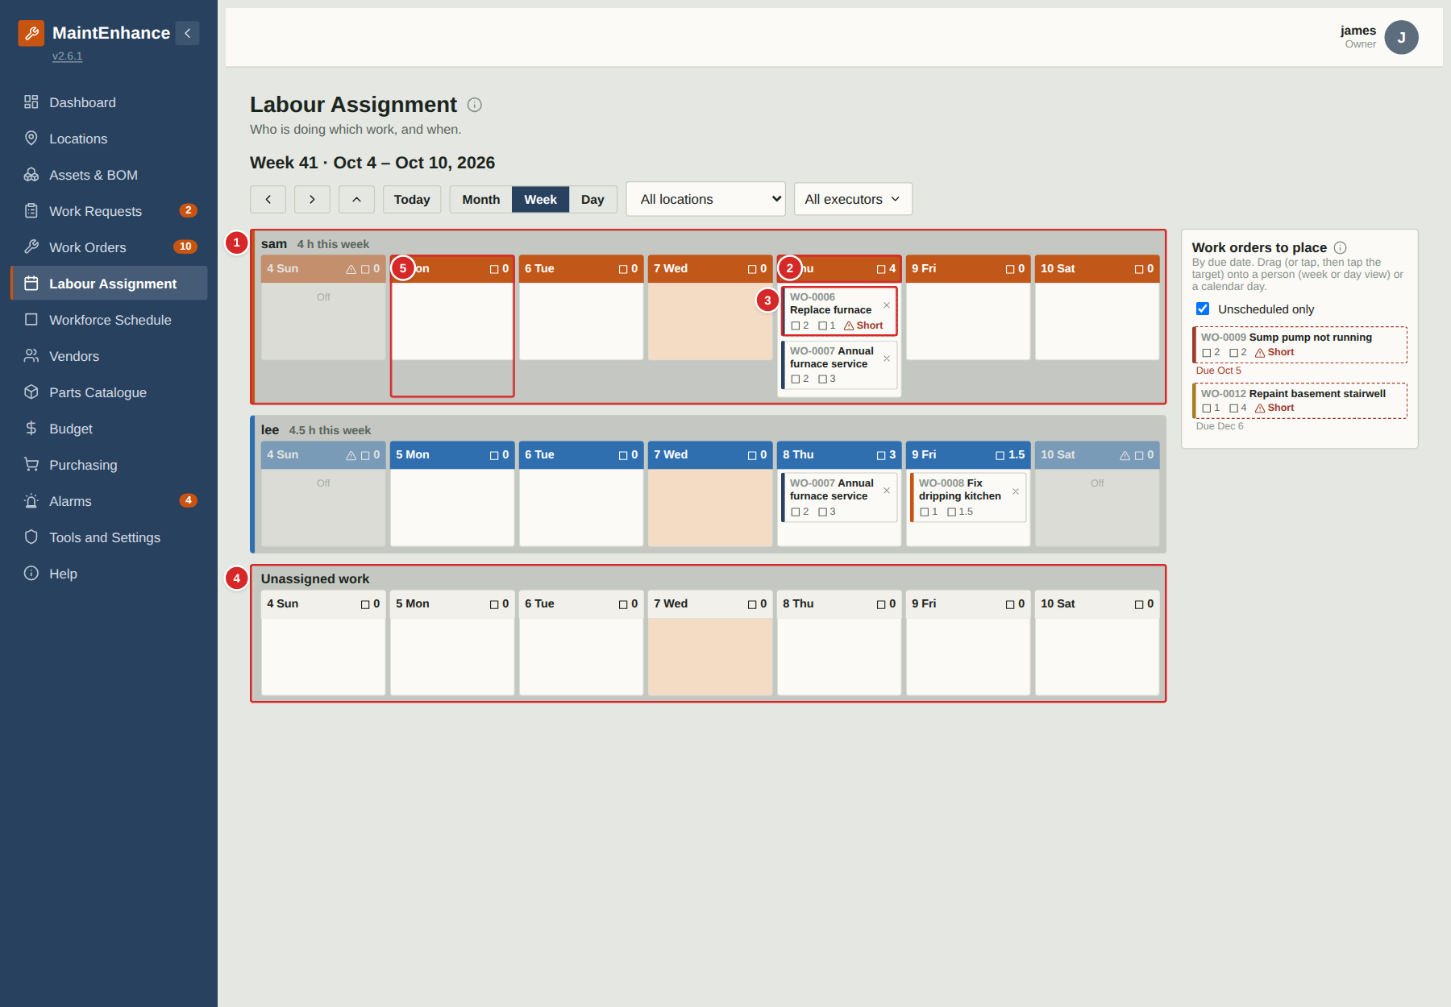
The week view has one board per person with a column for each day, and an Unassigned board for work with nobody on it yet. Each column header shows that person's total scheduled hours for the day.
What to do
1. Drag a work order from the side list onto a person's day to add that person to it and schedule it for that day.
2. Drag a card from one person to another to move it. Use the small x on a card to take it off that person.
3. Select a day header to open the day view.
4. A person only has a column for days they are on shift when Workforce scheduling is on; days off are greyed.
Numbered items in the picture
# | Field / area | What it is and how to use it
1 | A person's board | Their name, their hours for the week and a column for each day.
2 | Day header | Day and total estimated hours for this person that day. Select it to open the day.
3 | Work order card | Title, people needed (person icon), hours each (clock icon). “Short” with a dashed red outline means more people are needed.
4 | Unassigned work | Scheduled work that has no person yet. Drag its card to a person.
5 | Off day | Greyed: not on shift that day (Workforce scheduling on).

Labour assignment: day view
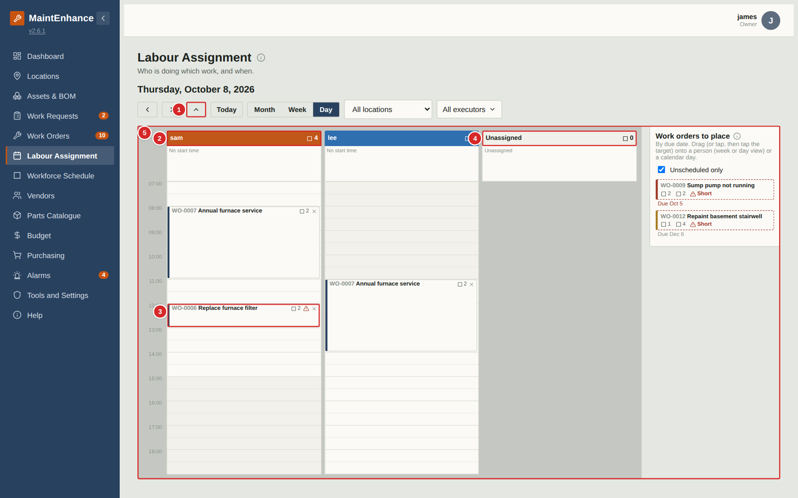
The day view has one column for each person working that day, plus Unassigned. All columns fit on one screen. It is the place to balance a day's workload.
What to do
1. Drag work orders from the side list onto a person's column.
2. Check each header's hours against the length of the shift.
3. A work order that needs several people appears in several columns; add a person by dragging it onto another column.
4. Use the up arrow to go back to the week.
Numbered items in the picture
# | Field / area | What it is and how to use it
1 | Up arrow | Day to Week.
2 | Person header | Name in their colour and total estimated hours that day.
3 | Card with crew and hours | Person icon: people needed. Clock icon: hours each.
4 | Unassigned column | Work on this day with nobody assigned yet.
5 | Work orders to place | Drag from here onto a column.

Labour assignment: hourly day view
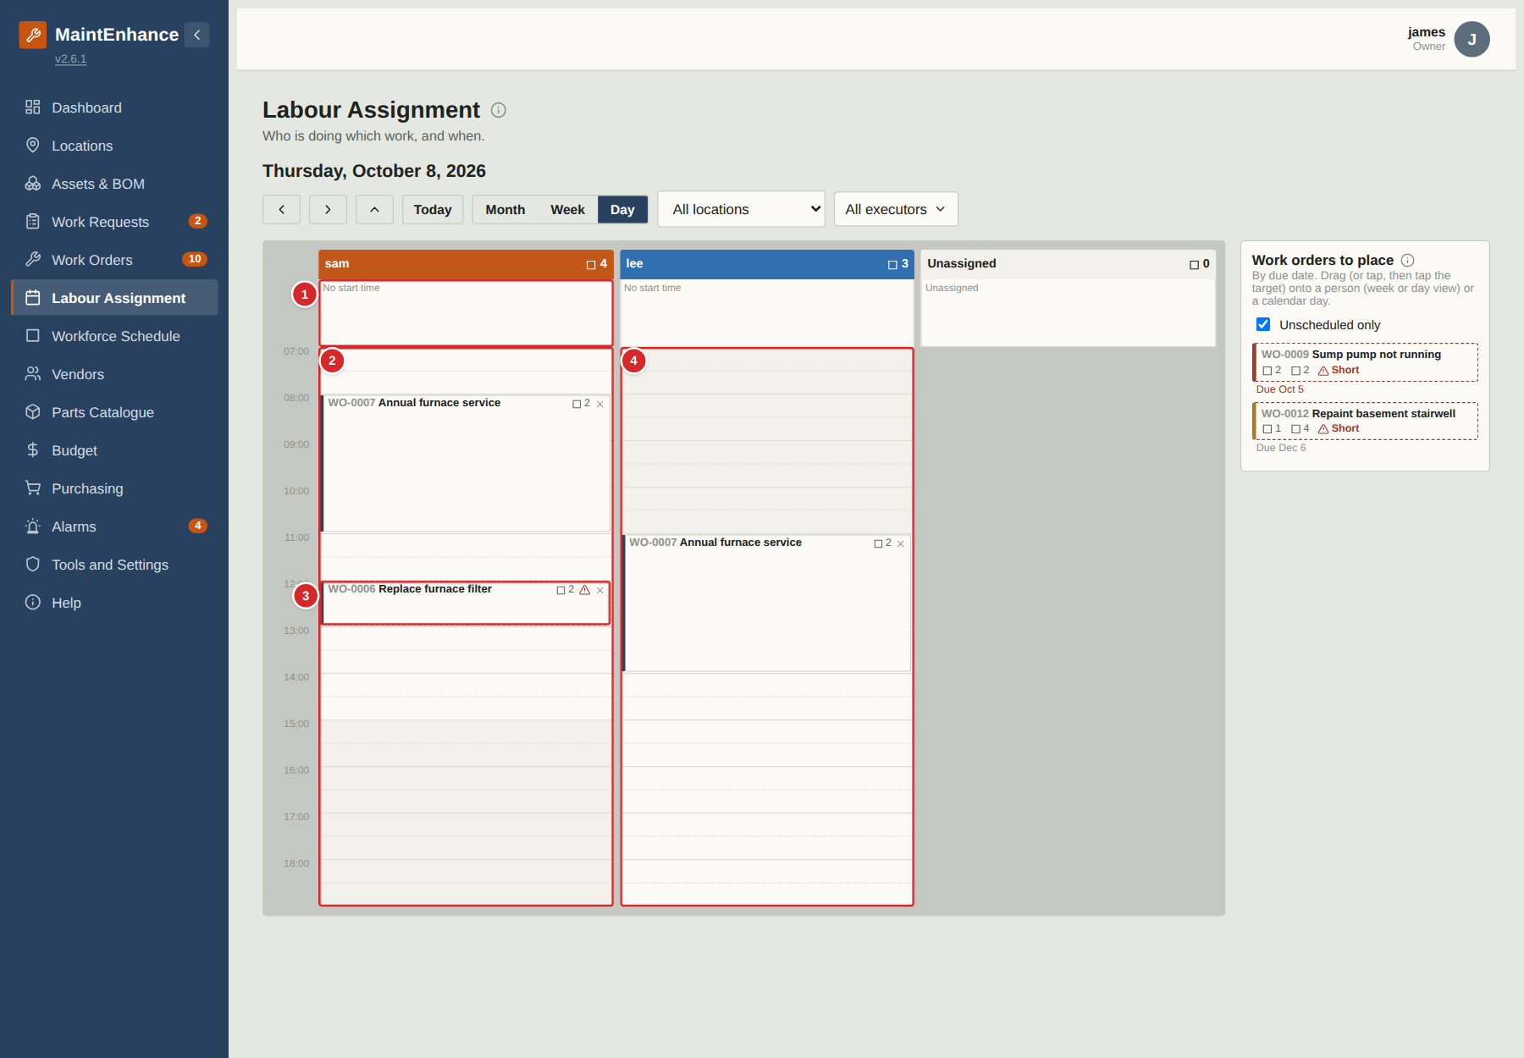
When Hourly labour assignments is on (it needs both scheduling features), each person's column becomes a grid of 30-minute slots that follows their shift. Drag a card to the slot where the work should start and it stretches to the length of the task.
What to do
1. Drag a card from the side list, or from the “No start time” strip, onto a slot inside the person's shift.
2. Slots outside the shift are shaded and cannot be used.
3. Drag a card to a new slot to change its start time; drop it on the “No start time” strip to clear the time.
4. Overlapping cards sit side by side.
Numbered items in the picture
# | Field / area | What it is and how to use it
1 | No start time strip | Cards for the day that have no time yet.
2 | Hour grid | 30-minute slots from the earliest shift start to the latest end. Shaded slots are outside this person's shift.
3 | Placed card | Starts in its slot and is as tall as its estimated hours.
4 | Another person's grid | Each person's shaded and unshaded slots follow their own shift.

Work orders: executors, estimate and crew
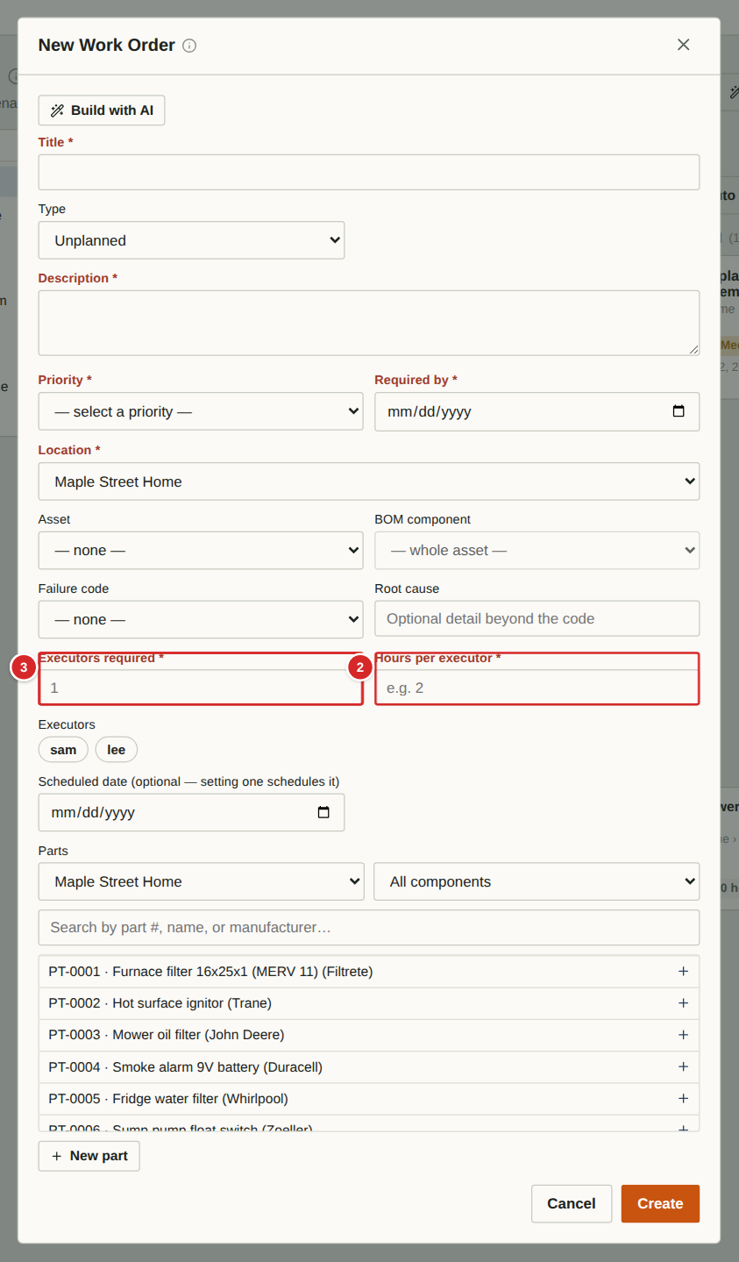 | With execution-based scheduling on, the work order form lets you assign several executors, estimate the time and say how many people are needed. The same fields appear when you edit a work order.  What to do  1. Tap the names to choose one or more executors; a tick shows who is chosen.  2. Enter the estimated hours per executor.  3. Enter how many executors are required. If fewer are assigned than required, the work order is flagged on Labour assignment.  Numbered items in the picture  1 Executors — Tap a name to add or remove that person.  2 Hours per executor — How long one person needs. A two-person job of 3 hours each is 6 hours of labour.  3 Executors required — How many people the job needs (default 1).

Hours worked prompt
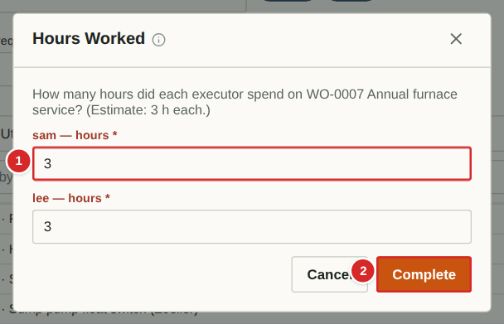
When any work order is completed with execution-based scheduling on, the person completing it enters hours for each assigned executor (or for themselves if nobody is assigned). Totals appear on Tools under “Hours worked — all executors”.
What to do
1. Open the work order and choose Completed.
2. Enter hours for each executor.
3. Select Complete.
Numbered items in the picture
# | Field / area | What it is and how to use it
1 | Hours per executor | Required and greater than 0.
2 | Complete | Saves the hours as time entries and completes the work order.

Workforce schedule: month view
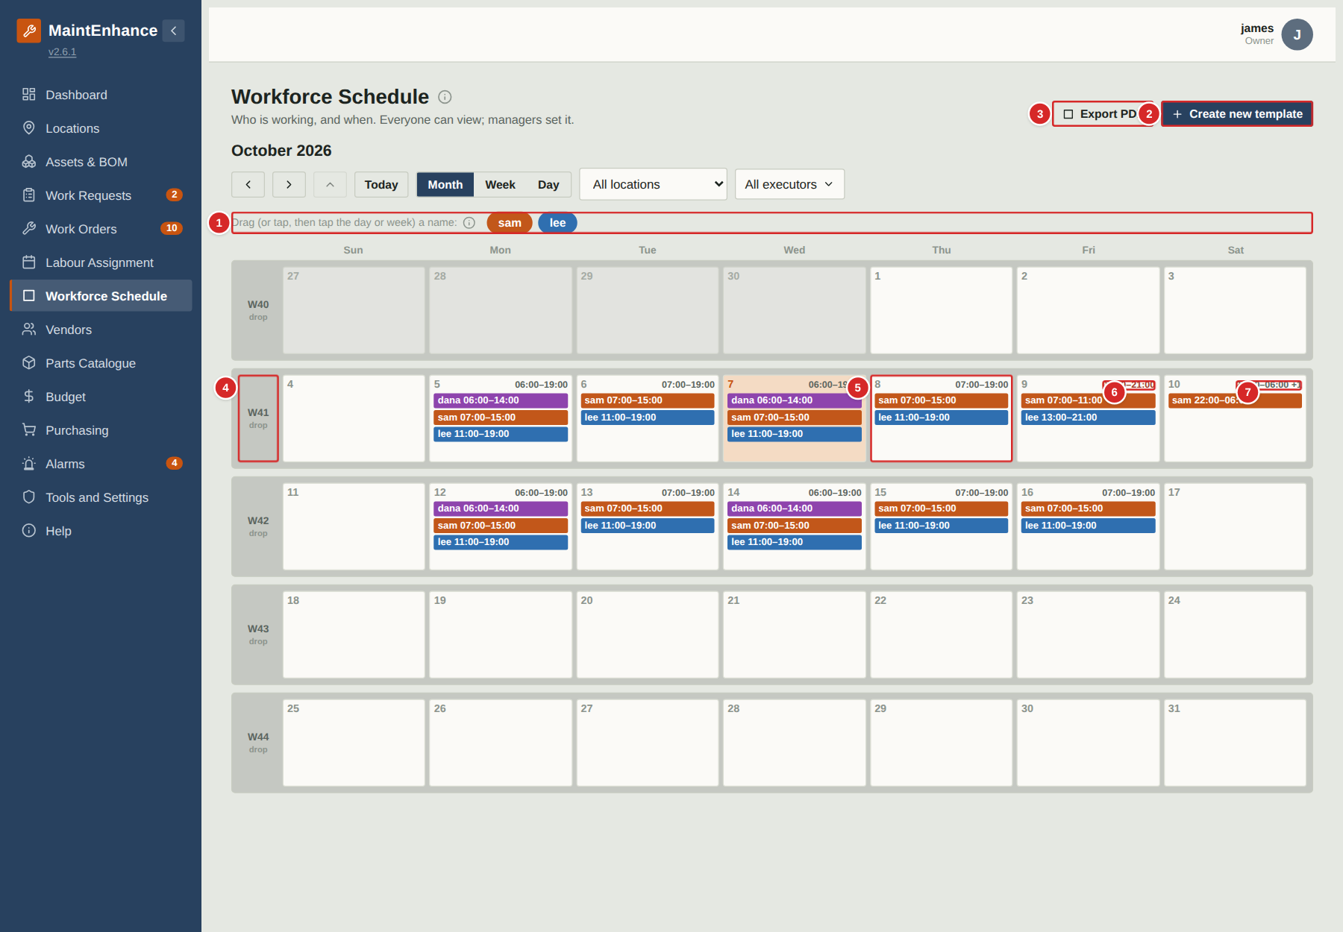
The Workforce schedule is where managers set who is working when. Everyone can view it. Name cards for the team sit across the top; drag one onto a day or onto a week number to schedule that person.
What to do
1. Drag a name card onto a day to schedule one day, or onto the week number box to schedule a whole week.
2. Choose a template in the window that appears, or set a one-time schedule (next pages).
3. Remove a shift with the small x on it.
4. Select Export PDF to print the schedule, or Create new template to go to Tools.
Numbered items in the picture
# | Field / area | What it is and how to use it
1 | Name cards | One per person, in their colour. They stay where they are so you can use them again.
2 | Create new template | Opens Tools at the Shift templates card.
3 | Export PDF | Printable page of the month, week or day on screen.
4 | Week header (drop zone) | Drop a name card here to schedule a whole week. Select it to open the week.
5 | Day box | Shifts that day. Select the number to open the day.
6 | Day hours | First start and last end of the day. Red means a gap in coverage; hover to see when.
7 | Overnight shift | A shift that ends before it starts runs overnight and is shown on the day it starts (the +1 means it ends the next day).

Workforce schedule: week view
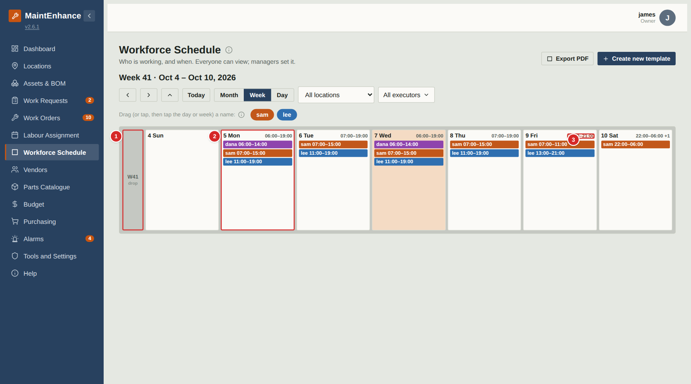
The week view lists the shifts for each day of one week. The left-hand box carries the week number and is where a name card is dropped to schedule the whole week.
What to do
1. Drop a name card on a day column for one day, or on the week box for the week.
2. Check each day's times in red or grey at the top.
3. Use the arrows to move week by week.
Numbered items in the picture
# | Field / area | What it is and how to use it
1 | Week box | Drop a name card here for the whole week.
2 | Day column | That day's shifts, earliest first.
3 | Gap warning | Red times: nobody works between 11:00 and 13:00 on this day. Hover to read the explanation.

Workforce schedule: day view
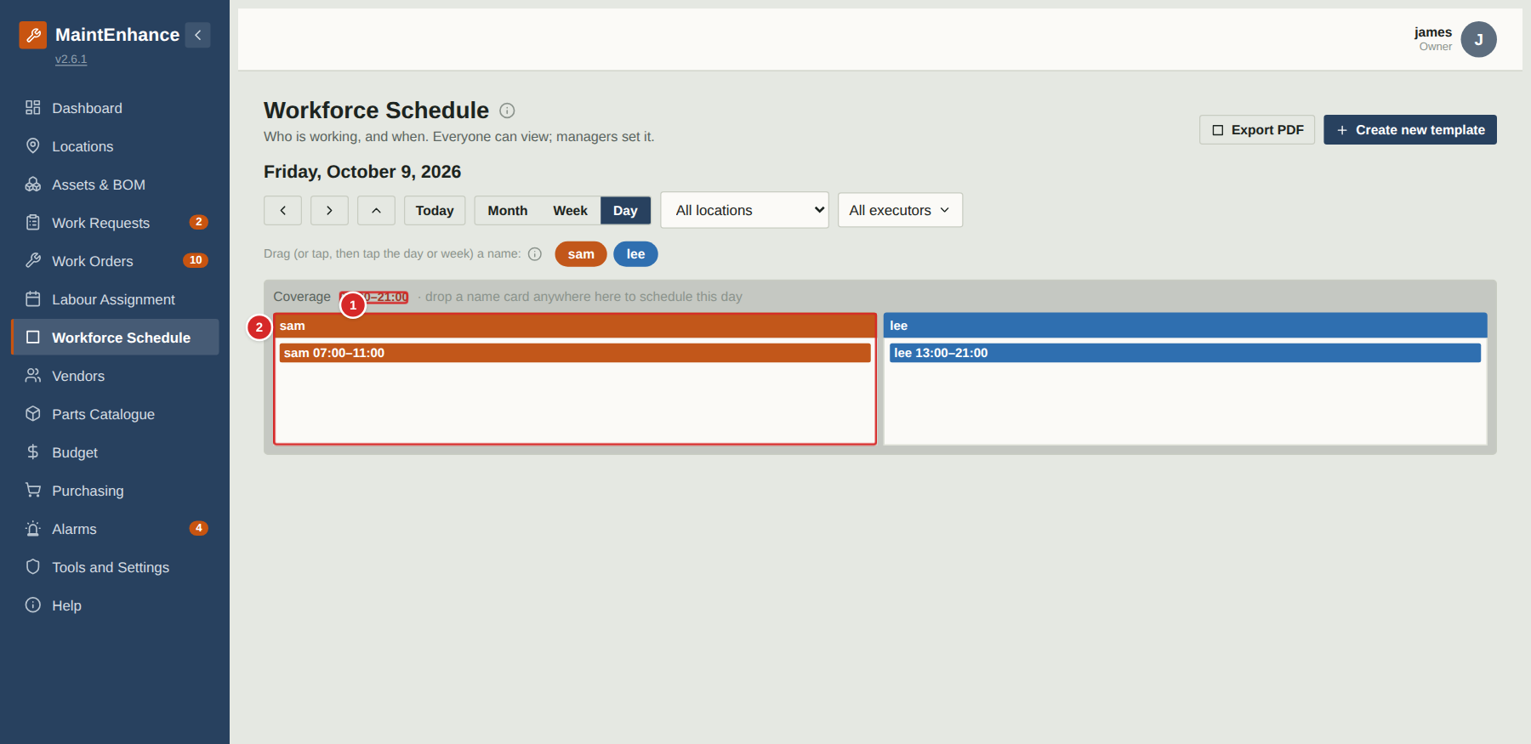
The day view shows each person's shift for the day in their column, with the day's coverage at the top.
What to do
1. Drop a name card anywhere on the day to schedule that person for the day.
2. Use the arrows to go to the next or previous day.
Numbered items in the picture
# | Field / area | What it is and how to use it
1 | Coverage | First start to last end. Red when part of that time has nobody working.
2 | A person's column | Their shift for the day, or “Not scheduled”.

Scheduling a person: choosing a template
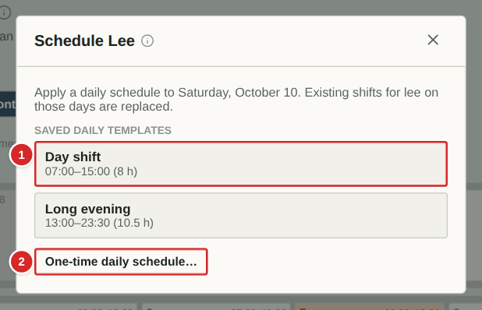
After you drop a name card on a day, this window asks which shift to apply. Dropping on a week box offers weekly templates instead. The person's existing shifts on those days are replaced.
What to do
1. Select a saved template to apply it straight away.
2. Or select “One-time daily schedule…” (or weekly) for a schedule you will not reuse.
3. Check the schedule and change it if needed.
Numbered items in the picture
# | Field / area | What it is and how to use it
1 | Saved template | Name and times. Selecting it applies it at once.
2 | One-time schedule | Opens a form to set the shift just for this drop.

Scheduling a person: a one-time schedule
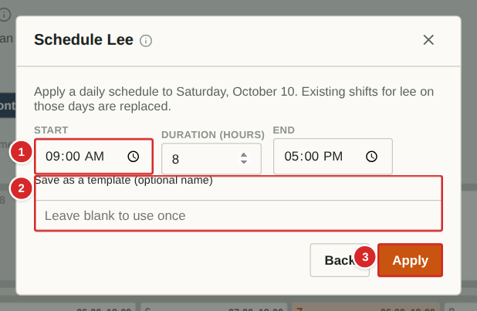
A one-time schedule lets you set an unusual shift without making a template. You can still save it as a template for next time.
What to do
1. Fill in any two of start, duration and end.
2. Optionally type a name to save it as a template.
3. Select Apply.
Numbered items in the picture
# | Field / area | What it is and how to use it
1 | Start / duration / end | Fill in any two; the third is calculated.
2 | Save as a template | Optional name. Leave blank to use the schedule only once.
3 | Apply | Schedules the person on the chosen day(s).

Quick reference: permissions by role
Capability | Guest | Executor | Manager | Owner
View all pages (except admin pages) | Yes | Yes | Yes | Yes
Submit work requests; edit your own while pending | No | Yes | Yes | Yes
Review requests (convert, merge, ask, decline) | No | No | Yes | Yes
Create work orders | No | Yes | Yes | Yes
Change work-order status (not Closed); add comments; checklists | No | Yes | Yes | Yes
Edit work-order fields (dates, cost, vendor, executor, parts) | No | No | Yes | Yes
Close work orders | No | No | Yes | Yes
Create PM Bases and Benchmarks; Auto schedule | No | No | Yes | Yes
Edit locations and assets; run PM wizard | No | No | Yes | Yes
Edit Bill of Materials | No | Yes | Yes | Yes
Edit vendors and catalogue parts | No | No | Yes | Yes
Adjust part quantity on hand | No | Yes | Yes | Yes
Purchasing list and Alarms | No | No | Yes | Yes
Delete records | No | No | Own only | Any
Tools: executor tools (colour, my hours) | No | Yes | Yes | Yes
Tools: manager tools (shift templates, hours worked, executor colours) | No | No | Yes | Yes
Tools: owner tools (members, branding, features, backup …) | No | No | No | Yes
Labour assignment and Workforce schedule (when enabled) | View | View; record own hours | Edit | Edit
Help tab and (i) info buttons | Yes | Yes | Yes | Yes

Glossary
Term | Meaning
Active / Scheduled / Completed / Closed | The four stages of a work order. See Key ideas.
Alarm | An alert that needs attention: from a sensor (Home Assistant), an out-of-range checklist reading, or entered by hand. Managers and owners handle alarms.
Archive | The list of all Closed work orders, reached from the Closed column.
Asset | A piece of equipment or an item worth maintaining (furnace, fridge, mower).
Benchmark | A saved reference procedure and cost for a kind of job, copied onto new Corrective work orders.
BOM (Bill of Materials) | The tree of components, sub-components and parts that make up an asset.
Checklist | The steps on a PM work order; steps may be ticks, readings, photos or pass/fail.
Climate zone | A setting on the property (Very Cold … Marine) that scales the starter PM catalogue.
Corrective | A work order type: a planned repair.
Executor | Role (and a field on a work order): the person who does the work.
Fixed / Non-fixed | PM modes. Fixed repeats on the same calendar date(s) each year; Non-fixed repeats a set interval after the last completion.
Location | A place in the household tree: property, structure, floor, room, area. The words are configurable.
Meter | A usage counter on an asset (hours, kilometres) used by meter-based PM.
PM / PM Base | Preventive maintenance: a PM is one job; a PM Base is the repeating template that generates them.
Priority | Low, Medium, High or Critical.
QR label | A printable label whose QR code opens the asset’s record.
Required by | The deadline for a request or work order. Work past it is flagged Overdue.
Reorder level | The stock level at or below which a part is flagged Reorder.
Crew required | How many people a work order needs at the same time. Used by the planning calendars to flag an under-staffed day.
Estimated hours | How long a work order is expected to take per person. Used for hourly scheduling and to compare with hours worked.
Executor colour | The colour each executor is shown in on the planning calendars.
Hours worked | Time recorded against a work order by an executor when it is completed; totals appear in Tools.
Info button (i) | A small round button beside a title that opens a short explanation: what the area is for, how to use it and who can.
Overnight shift | A shift whose end time is earlier than its start time. It ends the next day but is always shown on the day it starts.
Shift template | A saved daily or weekly shift pattern that can be dropped onto a person and a day or week on the Workforce schedule.
Standby | A pause on a PM Base, by hand or outside a yearly window.
Work request | A report that something needs attention, awaiting review by a manager or owner.
Work order | A job to be done, with who, what, where, when, parts and cost.

