**­**

**FAQ of E-Commerce Revenue Management:**

**1. How can we modify the size of the plots?**

By using figsize() one can modify/autoscale the plots

**2. What is markdown feature in python?**

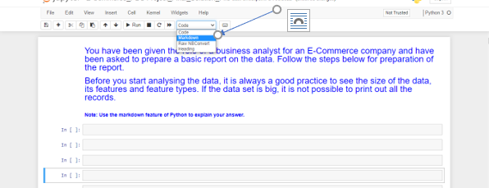

We can change the cell type to markdown from code. Using a markdown cell, we can write text and it will not be executed as a python code.

**3. How total Revenue is calculated for E-Commerce Company?**

Total Revenue = total Commission charged by the ecommerce company basis the conditions given in the problem statement.

Calculate revenue of E-commerce company using the conditions mentioned above Question 5 and then do the total (sum) of all.

**4. How total Brand Revenue is calculated?**

Brand Revenue is the discounted price minus the Revenue (generated using the conditions given above Q5)

Brand Revenue is discounted_price – revenue calculated from the conditions mentioned above Q5.

**5. What do you mean by deductions in Q6?**

Deduction means there might be other charges based on certain conditions that also needs to be adjusted, if any. (There is no column as deductions in the dataset.)

**6. What do mean by average product_rating within each brand?**

Basically, we need to calculate the average rating for each brand and not the product within it.

**7. What exactly is expected from Q8?**

Here as per the question, create the columns using groupby to identify the aggregates and finally show all the results into one dataframe and show pairplot.

**8. In Q9, how to get monthly data? For the monthly net revenue of the company what should be considered?**

Convert the order_date into a datetime format and then get the month information from it.

Ideally, it's asking for seasonal sales. So, it should be 12 months only on the line.

**9. How can we identify best & worst performing months for each region?**

Based upon the lineplot generated for the monthly net Revenue of E-Commerce Company for each region separately, we can easily identify.