Power Platform Security Architecture
Data Segregation and Access Control Decision Framework
Army National Guard — FORECAST / Guardian Nexus
Multi-State Hub-and-Spoke Deployment

Architecture Reference Document
Prepared for the ARNG Power Platform Delivery Team
Solution Architect: James
Version 1.0

Executive summary
This document establishes the security architecture framework for Power Platform and Dataverse solutions delivered by the ARNG Power Platform team. It defines how to identify data segregation boundaries, select between the available security constructs (business units, teams, security roles, hierarchy security, and row-level sharing), and layer them into a coherent model that scales from small pilot apps to the multi-state FORECAST and Guardian Nexus deployments.
The framework is opinionated. It reflects the delivery patterns established under the REDM methodology and the hub-and-spoke ALM model in which ARNG HQ owns the managed core solution and states consume and extend it within their own business units. Security decisions made during architecture are costly to reverse once states are onboarded, so the framework front-loads the identification exercise and provides decision criteria at each branch.
Three principles guide every decision in this document. First, the source system's native access boundary is the first signal for the Dataverse boundary. Second, hard boundaries (enforced by Dataverse) are distinct from soft boundaries (enforced by the app layer), and the choice of which to use must follow the data sensitivity, not the convenience of the developer. Third, the security model should reflect doctrinal and legal boundaries, not organizational convenience; finer granularity belongs in teams, not in the BU hierarchy.

How to use this document
- Architects run the identification exercise in Section 3 at the start of every new solution or state onboarding.
- Pod leads reference Section 5 (the decision tree) when sizing a security model for a new app.
- State delivery teams reference Section 7 (the hub-and-spoke model) to understand how their extensions integrate with the ARNG core.
- Section 9 (anti-patterns) is required reading before publishing any new managed solution.

The four-layer boundary model
Every Power Platform security decision resolves to one of four concentric layers. Naming them explicitly prevents the most common architectural failure: conflating layers and using the wrong construct for the enforcement you need.

Layer 1: Tenant and environment
The absolute boundary. Enforced by Azure Active Directory and the Power Platform Admin Center. Users in one tenant cannot access resources in another without a guest invitation and explicit licensing. Environments within a tenant are hard boundaries for data but soft boundaries for identity — the same AAD user can exist in multiple environments with different access in each.
For ARNG, the relevant environments are FORECAST-DEV (per-state dev environments), FORECAST-PROD (single production environment partitioned by BU), and Guardian-PROD (downstream force visibility). Environment selection is the coarsest security decision and is governed by the ALM strategy, not the feature-level security model.

Layer 2: Business unit
The hard data boundary within an environment. Every Dataverse record is owned by a user or team, and every user and team belongs to exactly one business unit. The root business unit is created with the environment and cannot be deleted. Child business units form a hierarchy.
A security role scoped at BU level allows a user to see records owned within their BU. A role scoped at parent-child level allows visibility into the user's BU and all descendants. This is the mechanism that lets ARNG HQ see across states without letting states see across one another.
- Use BUs when the boundary is legal, doctrinal, or represents a distinct accountability chain.
- Avoid BUs when the boundary is merely organizational convenience. Teams are cheaper.
- Avoid deep BU hierarchies. Beyond three levels, the security role permutations become unmanageable.

Layer 3: Teams (owner and access)
Soft groupings within a business unit. Two distinct mechanisms with very different semantics.
Owner teams own records directly. They are created manually or by Azure AD group sync, hold security roles, and appear as an owner option alongside individual users. Use owner teams when a group of users shares responsibility for a set of records and the membership is stable.
Access teams do not own records. They are auto-created per record from a team template and grant specific permissions (read, write, share, etc.) only on that record. Use access teams when access is dynamic, per-record, and cross-functional — exactly the pattern for a DOMOPS mission that spans multiple states.

Layer 4: Row and column
Fine-grained controls that sit inside a BU and team structure. Four mechanisms.
- Field security profiles — restrict specific columns (SSN, DOB, medical codes) to named users or teams, regardless of their table-level permissions.
- Hierarchy security — grants managers read or read/write access to records owned by direct or indirect reports. Configured on the user or position hierarchy.
- Row-level sharing (POA table) — explicit grants per record per user or team. Powerful, but the Principal Object Access table bloats quickly and becomes a performance tax if used at scale.
- App-layer filters (Canvas, model-driven views, Power BI RLS) — soft boundaries. The user could still reach the data via the API or a different app. Appropriate for rollup and reporting, inappropriate for PII protection.

The identification exercise
Before drawing a single business unit, work through this four-step exercise with the delivery team. It typically takes a half day and produces the inputs that drive every downstream security decision. Run it at the start of a new solution and again at the start of each state onboarding.

Step 1: Inventory source systems and their native boundaries
List every system feeding data into the solution. For each, document the native access boundary — the way the source system already segregates its own data. That boundary is the first signal for how Dataverse should be structured.
For FORECAST, the inventory is:
- IPPS-A — organized by state and UIC. Person-centric model; position succession is not native.
- MilConnect — DoD-wide, segregated by personnel eligibility attributes.
- MedChart — state-bounded for Guard, with medical PHI protections that exceed standard PII.
- ATTRS — training records, typically state or unit-scoped.
- DAMPS — aviation maintenance, unit-scoped.
- DFAS pay tables — keyed to SMU and fund cite.
- GSA per diem rates — public reference data; no segregation required.
The rule that emerges: if a source system segregates data by state, your Dataverse must segregate by state, or you become the enforcement point for data that upstream owners assumed was already partitioned. That is an accreditation burden you do not want.

Step 2: Map the user populations
Do not think in roles yet. Think in populations. For each group, document the expected user count, their organizational home, and the scope of data they need to see.
Population | Typical size | Organizational home | Scope of data needed
ARNG HQ staff | 50 to 200 | Root BU | Read across all states; write limited to HQ-owned reference data
State J-staff | 20 to 80 per state | State BU | Read and write within state; read HQ reference
Unit-level planners | 5 to 20 per unit | State BU (not sub-BU) | Read and write for their unit's missions; managed via owner team within state BU
AGR personnel managers | 2 to 10 per state | State BU | Read and write AGR-specific tables; Title 10 vs Title 32 scoping may require different roles
Solution architects and developers | under 20 | Root BU or dedicated Build BU | System admin in dev; read-only or break-glass in prod

The sizing signal: if a population is under ten people and does not appear on an organizational chart in its own right, it is almost certainly a team, not a business unit.

Step 3: For each table, answer three questions
For every table you are ingesting, creating, or extending, answer: who owns a row, who needs to read it, and who needs to write it.
If the read population equals the write population equals the owner population, security roles alone are sufficient. If read extends beyond ownership — which is almost always true for HQ rollup reporting — you need either a BU hierarchy with parent-child scope or a sharing mechanism.
Example for FORECAST projected cost records:
- Owner: state that created the cost projection
- Read: owning state (full detail); ARNG HQ (aggregate and detail); other states (no access)
- Write: owning state only; HQ read-only
That maps cleanly to a BU hierarchy with HQ holding parent-child read on cost tables and state-scoped write roles. No sharing required.

Step 4: Identify the exceptions
Every organization has them. Cross-state DOMOPS missions. Multi-state AT rotations. A soldier on temporary assignment to another state. A joint planning cell for a named exercise.
Do not try to model these exceptions as additional BUs. The result is a combinatorial explosion and an unmaintainable role matrix. These are the access team scenarios. Handle them with team templates on the affected tables, granting just the permissions needed, scoped to just the affected records.

Worksheet outputs
By the end of the exercise you should have:
- A source system inventory with native boundary documented for each.
- A population table sized and scoped.
- A per-table matrix of owner, read, and write populations.
- A list of exception patterns with proposed access team templates.
These artifacts drive the decisions in Sections 4 through 7 directly. Archive them in the solution's design folder alongside the ALM and environment strategy documents.

Hard boundaries and soft boundaries
The single most consequential distinction in Power Platform security design. Confusing the two is how PII ends up accessible to populations that were supposed to be excluded. The test is simple: if a user bypasses the app and hits the Dataverse Web API directly with their own credentials, what do they see?
Mechanism | Hard boundary | Soft boundary
Business unit scope on role | Yes — record ownership is enforced by Dataverse.
Column security profile | Yes — enforced at the column read level.
Hierarchy security | Yes — enforced by Dataverse based on manager or position.
Row-level sharing (POA) | Yes — explicit grants checked on every access.
Canvas app filter expression |  | Soft — the filter lives in the app, the API sees all rows the role allows.
Model-driven view filter |  | Soft — advanced find will return anything the role allows.
Power BI RLS over Dataverse |  | Soft if the underlying Dataverse role is org-wide; the Web API still exposes everything.

The rule for FORECAST and Guardian Nexus: anything containing PII, medical data, or individual pay detail gets a hard boundary. Anything that is aggregate, projected, or reference data can live behind soft boundaries. This maps directly to the FedRAMP and DoD IL controls inherited from the platform authorization — Power Platform provides the enforcement; app-layer filters are convenience, not security.

The security model decision tree
A structured walk from the problem to the security mechanism. Apply in order. Stop at the first level that resolves the requirement. The visual below summarizes the full framework — the branches, the scale tiers, the common combinations, and the anti-patterns to avoid — on a single page for quick reference during design reviews.
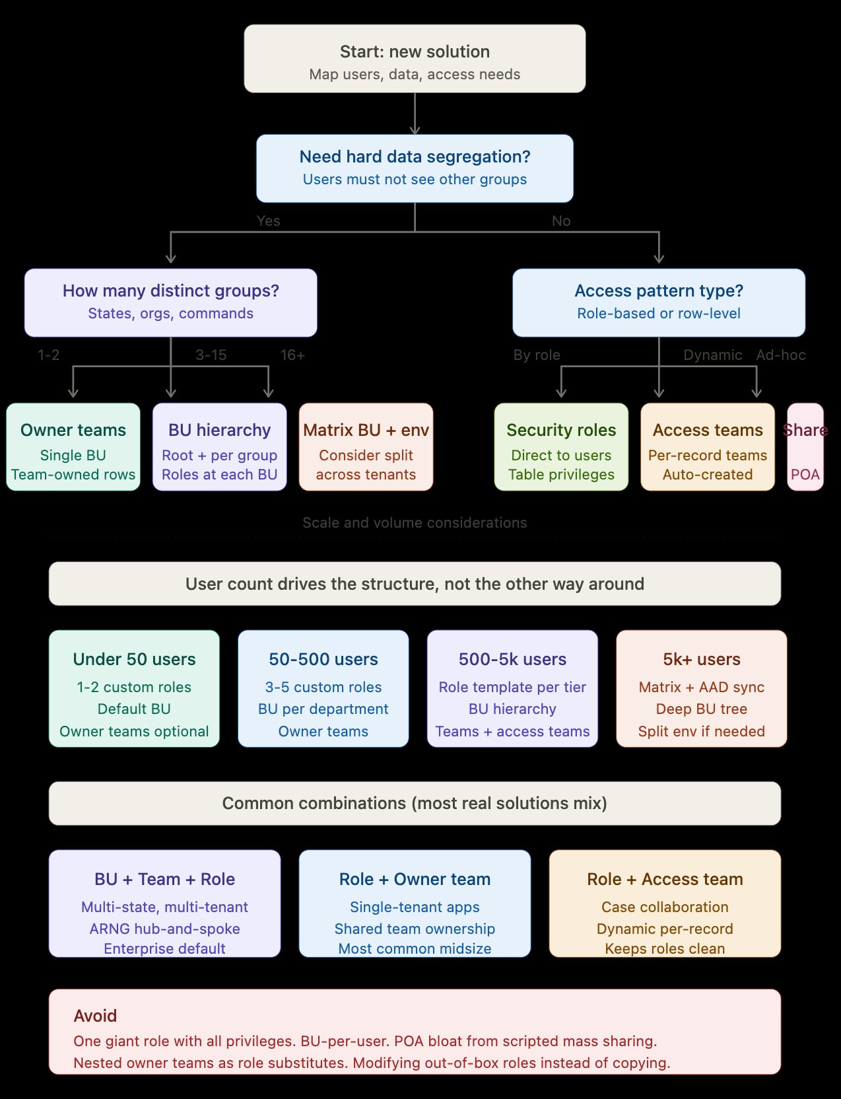
Figure 1. Power Platform security decision tree — boundary selection, sizing by user count, combination patterns, and anti-patterns.

The sections that follow elaborate each branch in the tree with the reasoning behind the recommendation.

Q1: Is hard data segregation required?
Determined by the outputs of the identification exercise. If any table contains PII, PHI, individual pay, or operational data that state A must not see from state B, the answer is yes.
- Yes, hard segregation required → proceed to Q2.
- No, all populations can technically see all data but UX should show only relevant slices → skip to Q4.

Q2: How many distinct groups need segregation?
Count the populations from Step 2 of the identification exercise that require hard segregation from one another.
Count | Recommended structure
1 to 2 | Single business unit. Use owner teams or direct user ownership to segregate.  Do not create additional BUs at this scale — they add operational overhead without security value.
3 to 15 | Business unit hierarchy. Root BU plus one child BU per group. Security roles scoped at BU level for state users and parent-child for HQ.  This is the FORECAST / Guardian Nexus scenario. Most ARNG solutions land here.
16+ | Matrix approach. Consider splitting into multiple Dataverse environments with a shared reference environment, or compress the hierarchy by grouping states into regions.  At this scale, role and team permutations become unmanageable within a single environment. Environment split simplifies operations.

Q3: Within each group, do users need to share record ownership?
Inside a business unit, users can own records individually or through owner teams. The question is whether a group of users within the BU should collectively own a set of records such that any member can work them.
- Yes, stable groups share ownership → owner teams inside the BU, populated by AAD group sync where possible.
- No, individual ownership is sufficient → direct user ownership; security roles handle the rest.

Q4: Do you need dynamic per-record access that crosses roles or BUs?
This is the cross-state DOMOPS mission scenario, the joint exercise scenario, and the temporary assignment scenario. Access requirements are specific to one record and change over its lifetime.
- Yes → access teams with team templates on the affected tables. Grant only the permissions needed on the specific record.
- No, all record access is predictable from the user's role and BU → stop here; security roles and owner teams are sufficient.

Q5: Are there columns with sensitivity beyond the table level?
SSNs, medical codes, specific pay details, protected veteran status. Users need to work with the table but should not see specific columns.
- Yes → field security profile per sensitive column, granting read only to the populations with a need to know.
- No, table-level permissions are sufficient.

Sizing guidance by user count
The user count at launch does not always predict the count at steady state, especially for state-onboarded solutions where the first state may have a hundred users and the fifteenth state adds five hundred. Design for the two-year projection, not today's count.
User count | Role structure | BU structure | Team usage
Under 50 | - 1 to 2 custom roles  - Copy from out-of-box; never modify originals | - Default BU only  - No hierarchy | - Owner teams optional  - Access teams rarely needed
50 to 500 | - 3 to 5 custom roles  - Read, write, admin tiers | - BU per department if segregation needed  - Flat hierarchy, one level below root | - Owner teams per functional group  - Access teams for collaboration-heavy tables
500 to 5,000 | - Role template per tier  - Parent-child scope for rollup | - Two-level BU hierarchy  - Root + groups (e.g., states) | - Owner teams + access teams layered  - AAD group-synced teams
5,000+ | - Matrix of role templates  - AAD group sync for role assignment | - Consider environment split  - Deep BU tree with regional groupings | - Heavy team usage to reduce role permutations  - Team templates in managed solution

The 5,000+ row is where FORECAST and Guardian Nexus land at full deployment. A single production environment remains viable at this scale because the write-mediation pattern (custom APIs and cloud flows) keeps the POA table off the critical path. Environment split becomes necessary only when states require independent delivery cadences that the shared managed solution cannot accommodate.

The hub-and-spoke security model
The reference architecture for multi-state ARNG Power Platform deployments. ARNG HQ is the hub; states are spokes building in the same tenant. This section documents the security decisions specific to that model.

Business unit hierarchy
Two-level hierarchy in the production environment. Root BU represents ARNG HQ. One child BU per participating state (Colorado, Maryland, North Dakota, Puerto Rico, Illinois, and onboarding states).
Do not create sub-state BUs for units, armories, or commands. State users own their unit's records individually or via owner teams within the state BU. Finer granularity in the BU tree creates role explosion with no security benefit.

Publisher and solution layering
Publisher prefix strategy mirrors the ownership of the extension. ARNG core solution uses the arng_ prefix. Each state uses its own prefix (co_, md_, il_, nd_, pr_). State solutions are layered on top of the ARNG managed core, never modifying core tables directly.

Security role model
Four role templates, defined in the managed core solution and deployed to every state BU:
Role | Scope | Permissions summary
State Builder | State BU | Create, read, write, delete on state-prefix tables. Read on ARNG core tables. No write on ARNG core tables; write mediated through custom APIs.
State Admin | State BU | Manage users, teams, and security role assignments within the state BU. Cannot escalate privileges; cannot assign roles above State Admin.
State User | State BU | Read and write on state and ARNG data within BU scope. Typical end-user role.
State Reader | State BU | Read-only on all state-accessible tables. Appropriate for auditors, observers, and cross-training personnel.

HQ roles are separate and use parent-child scope on cost, mission, and rollup tables. HQ roles do not grant access to PII tables at parent-child scope; individual soldier PII is never readable from HQ without an explicit access team grant or a redacted view backed by a security-trimmed API.

Write mediation
States are never granted direct write access to ARNG core tables. All writes flow through one of two mechanisms:
- Custom API on the ARNG core solution. States invoke the API with their State Builder or State User role. The API enforces business rules, audit logging, and cross-state consistency.
- Cloud flow triggered on state-owned table. The flow runs under a service principal with elevated rights and performs the write to the ARNG core table after validation.
This pattern is the core of the hub-and-spoke. It lets states move fast on their own extensions while guaranteeing that the shared data model stays consistent. It also keeps the POA table off the critical path for cross-BU data sharing — states do not share records to HQ; the mediated writes create records that HQ owns natively.

Cross-state collaboration: access team templates
Access teams with team templates handle the exception cases that the BU hierarchy cannot. The canonical example is a DOMOPS mission that spans Colorado and Wyoming. The mission record is owned by Colorado (the lead state). A team template named Mission_CrossState_Collaboration grants read and append access to the mission record and creates an access team per mission. Wyoming planners are added to the access team for the specific mission, gaining visibility without having any broader access to Colorado records.
Team templates are defined in the ARNG managed core solution and deployed uniformly to every state. This keeps the cross-state collaboration pattern consistent and auditable.

Field security on PII
Field security profiles restrict columns containing SSN, DOB, home address, and medical codes to named users or teams. State User and State Reader roles do not include the field security profile by default; access is granted individually or via a PII-cleared team.

Common combinations
Most real Power Platform solutions combine multiple security constructs. Three combinations cover the majority of ARNG scenarios.

BU + Team + Role (enterprise default)
The FORECAST / Guardian Nexus pattern. BUs enforce hard segregation between states. Owner teams inside each state BU group users by function (DOMOPS planners, IDT schedulers, orders clerks). Security roles define table-level permissions and are assigned to teams, not individuals, wherever possible.
Access teams layer on top for cross-BU collaboration. Field security profiles handle PII column restrictions. This is the most complex combination and also the most scalable.

Role + Owner team (single-tenant midsize)
Appropriate for solutions without cross-boundary requirements. A departmental app serving a single command or a single state. No BU hierarchy. Owner teams group users by function; roles assigned to teams.
Most standalone Power Platform apps built for a specific customer fall into this pattern. It is the right default when the identification exercise returns only one hard segregation group.

Role + Access team (collaboration-heavy)
Appropriate for solutions built around case management, mission tracking, or any workflow where the relevant collaborators for a record are known only after the record is created. Security roles establish baseline permissions; access teams grant per-record collaboration rights.
This keeps the role matrix simple. Rather than creating a role per collaboration pattern, the roles define default permissions and access teams fill in the exceptions.

Anti-patterns
Required reading. Each of these is a pattern that looks reasonable at small scale and fails at production scale. Avoid all of them.

One giant role with all privileges
Symptom. A single custom role with organization-wide permissions on every table. Developers assign it to end users because it was convenient during build.
Failure mode. Violates least privilege, defeats BU segregation, creates an audit finding on first DoD review, and is extremely difficult to unwind once users depend on it.
Correct approach. Define the role templates during design. Start with Reader and Writer; add Admin and Builder only when the identification exercise justifies them. Never grant org-wide scope except to actual system admins.

Business unit per user
Symptom. A BU created for every team, command, or sub-organization. The hierarchy has four or more levels.
Failure mode. Role permutations multiply. Each role-scope combination must be reasoned about separately. Users moving between units requires BU changes, which means record ownership transfers and cached view invalidation.
Correct approach. BUs represent legal or doctrinal boundaries. Everything finer is a team. Most ARNG solutions need no more than two BU levels.

POA bloat from scripted mass sharing
Symptom. A cloud flow or plugin that iterates over users and calls GrantAccess on records to "fix" visibility. The Principal Object Access table grows to millions of rows.
Failure mode. POA checks run on every query. Performance degrades proportionally to POA size. Eventually, model-driven forms time out.
Correct approach. If many users need access to many records, the access pattern belongs in the role or BU structure, not in sharing. Sharing is for exceptions. Access teams are a better fit for dynamic per-record access.

Nested owner teams as role substitutes
Symptom. Owner teams created and nested to mimic an organizational hierarchy, with roles assigned to the teams based on position.
Failure mode. Owner teams do not inherit permissions from parent teams. The nesting is cosmetic; every team must be assigned its roles directly. Membership management becomes a maintenance burden.
Correct approach. Use AAD group-synced teams. AAD handles the hierarchy and membership. Roles assigned to the team flow through automatically. For actual hierarchical permissions, use hierarchy security on the manager or position hierarchy.

Modifying out-of-box roles
Symptom. Customizing the Salesperson, System Customizer, or other default roles to fit the specific solution's needs.
Failure mode. Out-of-box role modifications survive some solution imports and break on others. Platform updates may reset them. New Dataverse features assume the default roles are in their default state.
Correct approach. Copy the role first, rename it with the arng_ prefix, and modify the copy. Ship the copy in the managed solution.

Security designed after the app is built
Symptom. The app is functionally complete, users are clamoring for access, and security is added in a rush before go-live.
Failure mode. The security model is shaped by the app's existing data relationships rather than by the requirements. PII ends up in tables that mix sensitivity levels. Retrofitting column security on populated tables requires data migration.
Correct approach. Run the identification exercise in Section 3 before the first table is designed. Security requirements drive the data model; the data model does not drive security.

Governance and review
Security architecture is not done at go-live. Three review cadences keep the model aligned with the organization.

Per-state onboarding review
Before a new state is added to FORECAST or Guardian Nexus, the state's solution architect and the ARNG architect run the identification exercise together. Outputs include the state-specific role assignments, any required access team templates, and a list of field security profile exceptions. The review is captured in the onboarding packet.

Quarterly role audit
Each quarter, generate a report of role assignments by user and team. Flag users with more than one role, users with roles above their functional tier, and any role-BU combinations that were not in the design. Remediate before the next cycle.

Annual architecture review
Once a year, revisit this document. Evaluate whether the hub-and-spoke model remains appropriate, whether any anti-patterns have crept in, and whether new platform capabilities (virtual tables, elastic tables, plugin changes) warrant updates. Publish the updated version and communicate changes to all pod leads.

Points of contact
- Solution Architect: James
- Power Platform Team Lead: Eric
- Data Lead: Raj
- BA and PM Lead: Aly

