MS. BALUARTE FOR MODIFICATIONS:
USERNAME AND PASSWORD FOR ALL USERS:
WHEN UPPERCASE …maconvert into lowercase
ADMIN FUNCTION
- Remove Radio Button VATABLE and NONVAT in product entry
Transfer to stock out (transaction)
- If VATABLE- displays the VAT
- If NONVAT- vat is 0.00

- If muhatag discount- VAT Total should also be reflected
- In clients profile- fax number should only accept numbers
SPECIALIST FUNCTION
- Number 1 in Admin should apply
- Should have returned items ( transaction)
- Should have clients profile ( note fax nos. should only accept number)
ASSISTANT FUCNTION
- Number 1 in Admin should apply
- Should have returned items (transaction)

Suggestions:
- Title in Login Page (top): Credit Sales Monitoring with Stockpile Itemization System
- Home Page for Admin, Specialist and Assistant should contain images of Elixir products.
- Radio Button : Order and Warranty be placed in Stock Out ( Transaction)
Purpose of radio button… parts that will be replaced for the machine during warranty period will be taken from remaining stocks (stock out)
Type
Order or Warranty
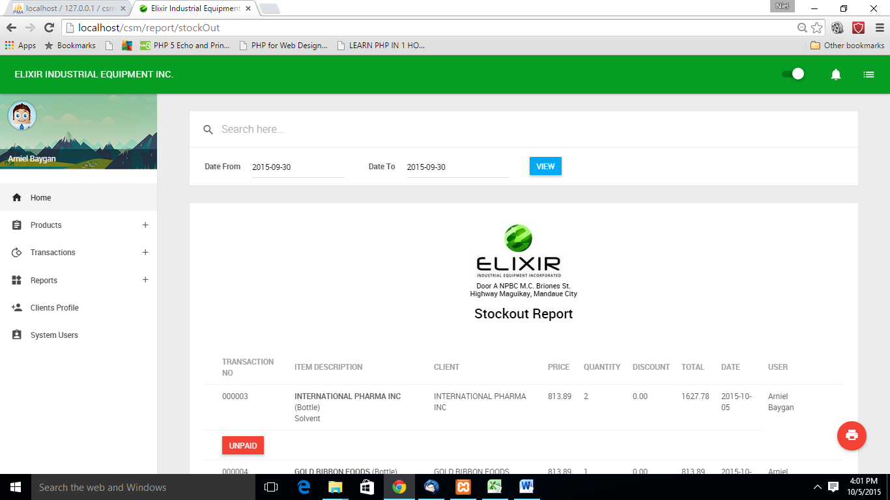
REPORTS:

Product Entry
- Client is allowed to do 3 unpaid transactions before their order will be placed on hold.
- The minimum entry of selling price and unit price should be 6 digits. Any numbers lower than that should not be accepted.(dili mo accept ug 1,000)

