**MSH2**

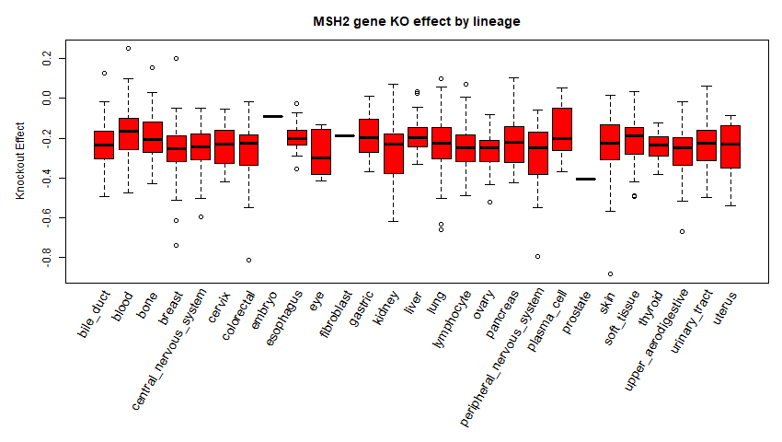

**Colorectal Cancer**

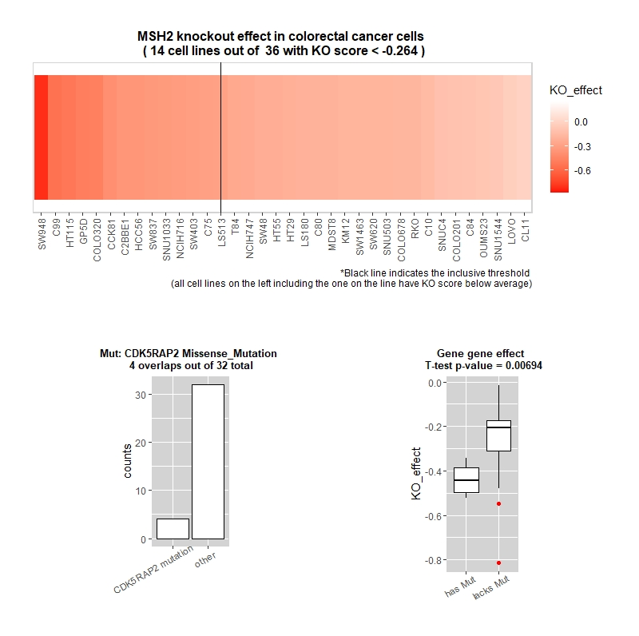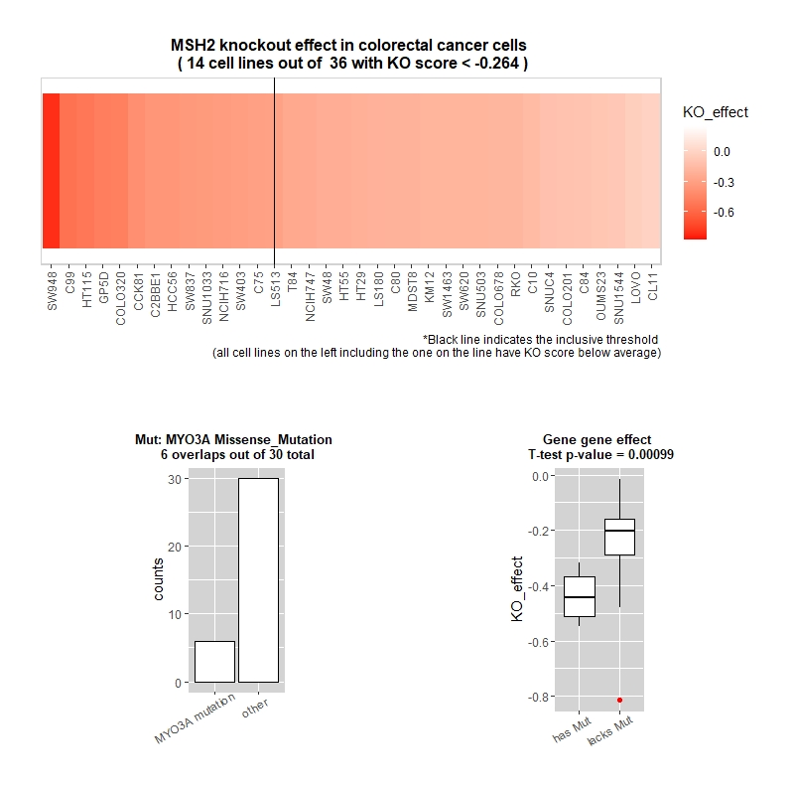

**Other common mutations**: NOX5, PKD2L1, PRL, RALGAPA1, SCAF4, SI, ZNF91, ABCA9

**Pancreatic cancer**

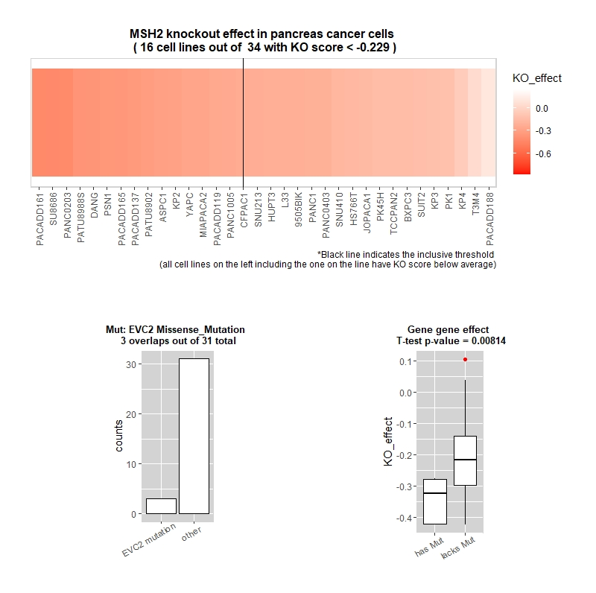

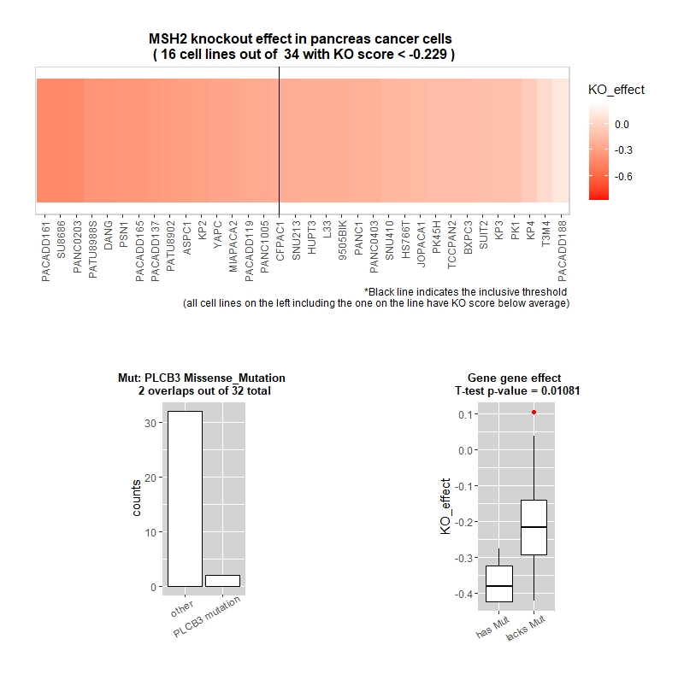

**Other common mutations:** ARID1A, RREB1, ZNF141, ADCY6, ALDH4A1, AMPH, APOB, ARHGEF40