**UBR1**

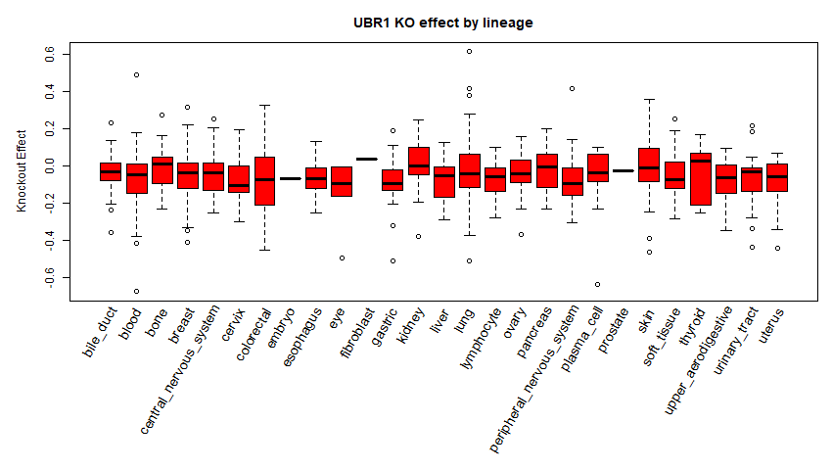

**Colorectal Cancer**

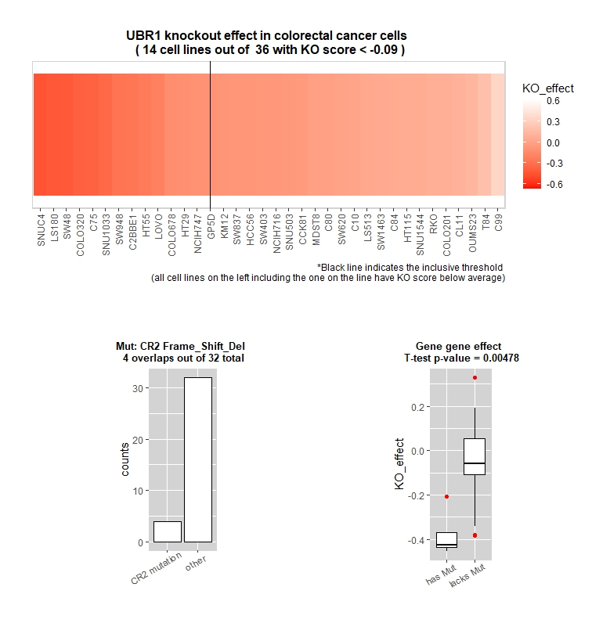

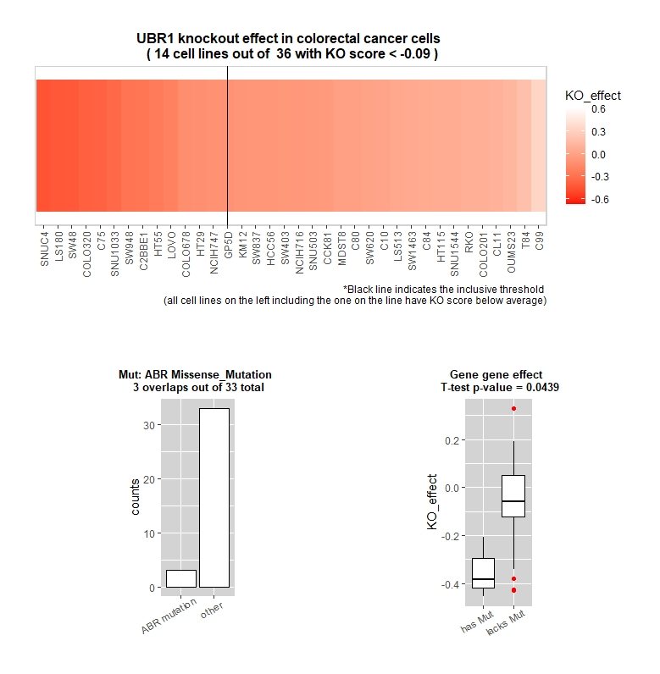

**Other common mutations**: KCTD3, ADCY5, ARNT, ASIC1, ATP8B1, CDH24, CELSR1, CLASP2

**Pancreatic cancer**

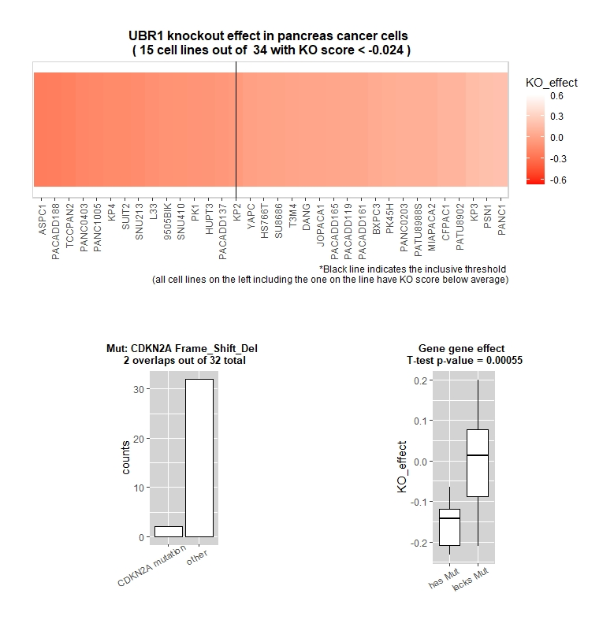

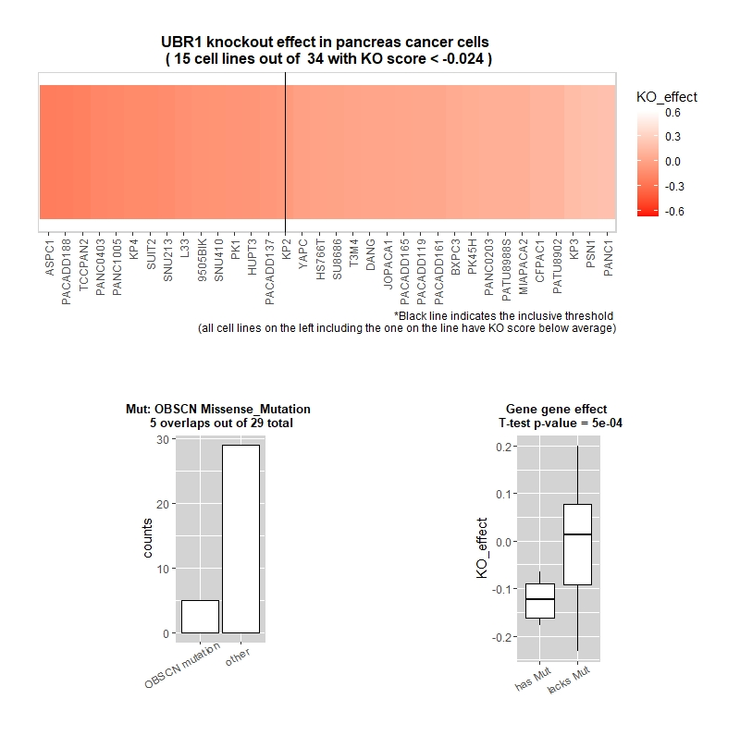

**Other common mutations:** ATP10A, CHUK, EPHA10, OR4C15, TTN, ACTL7B, ANKRD30A, ARHGAP29