# Comparison between scGEAToolbox PCNet function and dna/R PCNet function

Matlab code

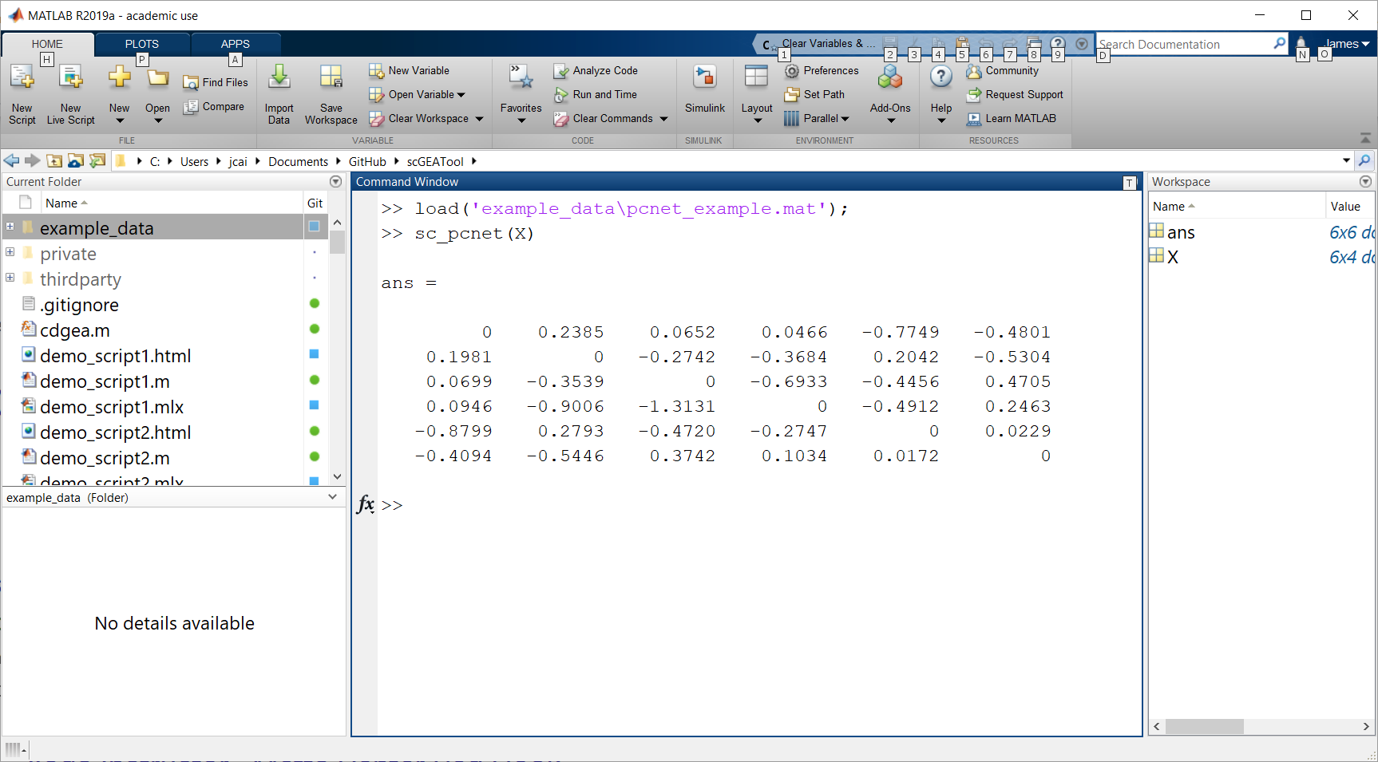

R code

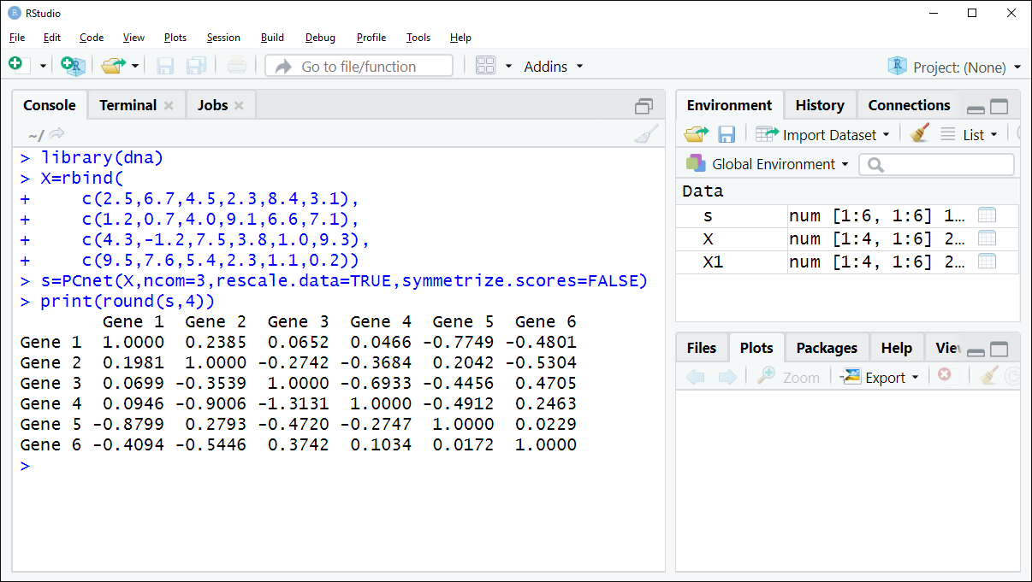

# Comparison between scGEAToolbox PCNet algorithm and R/GENIE3

# **Comparison between scGEAToolbox SC_SC3 function and R/Bioconductor SC3**

R code



Matlab code



# **Comparison between scGEAToolbox SC_TSCAN function and R/Bioconductor TSCAN**

Matlab code





R code



