Supplementary data

Application Notes

scGEAToolbox: a Matlab toolbox for single-cell RNA sequencing data analysis

James J. Cai1,2

1Department of Veterinary Integrative Biosciences, 2Department of Electrical & Computer Engineering, Texas A&M University, College Station, TX 77843-4458, USA.

*I. Numerical comparisons between selected scGEAToolbox Matlab functions and R functions*

# Comparison between scGEAToolbox PCNet function and dna/R PCNet function

Matlab code

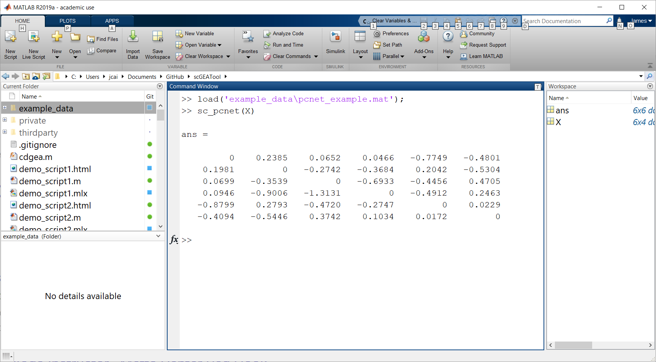

R code

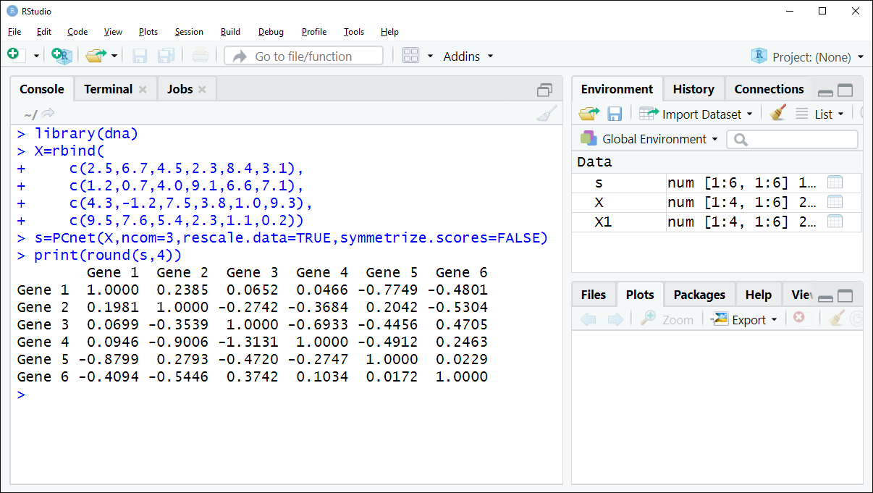

# **Comparison between scGEAToolbox function SC_SC3 and R/Bioconductor SC3**

R code



Matlab code



Compare clustering results using NMI



# **Comparison between scGEAToolbox SC_TSCAN function and R/Bioconductor TSCAN**

Matlab code





R code



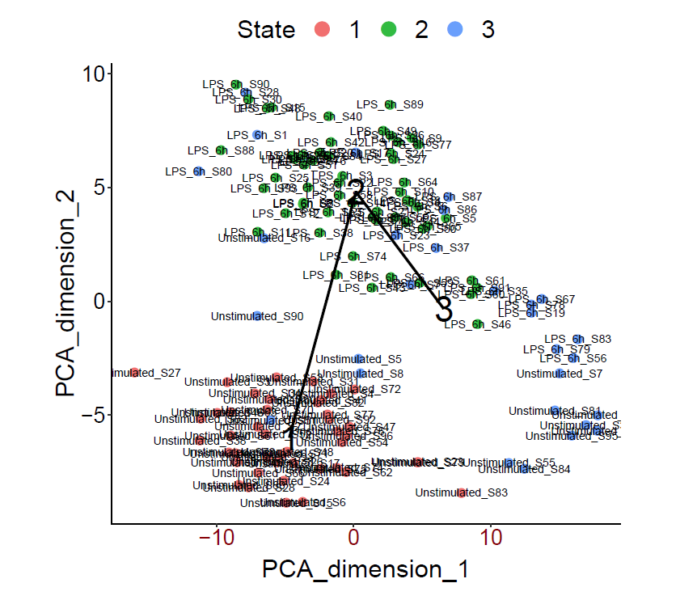

*II. scGEAToolbox Demonstration Scripts*