TEAM Quick Run Guide

This quick run guide has been written to assist new users of the Transport Energy Air pollution Model (TEAM), including TEAM-Kenya, TEAM-UK, etc., in running through the model for the first time. It is designed to complement the comprehensive [reference guide (2019)](https://d2e1qxpsswcpgz.cloudfront.net/uploads/2020/03/ukerc_wp_team_guide.pdf) and the UK Transport Carbon Model (TCM) [user guide (2010)](https://www.researchgate.net/publication/257427154_UK_Transport_Carbon_Model_User_Guide_v10).

By following this guide, you will be able to run the main modules of TEAM in the correct sequence and extract data from the model for subsequent analysis in MS Excel, Python, etc. This quick run guide does **not** cover how to edit input data in TEAM (for constructing scenarios). For that, see the TEAM Quick Data Guide.

**You will need to follow the TEAM Quick Setup Guide before following this guide.**

If you have any questions outstanding, please contact James Dixon ([james.dixon@strath.ac.uk](mailto:james.dixon@strath.ac.uk)) in the first instance.

TEAM was originally developed by Christian Brand at the University of Oxford. For more details, see [here](https://ukerc.ac.uk/project/team-model/).

# Introduction to the Graphical User Interface (GUI)

Open TEAM by opening MS Access, selecting open, navigating to the folder where the model is located and opening the EXP_TEAM-KEN_v1 file.

If you have followed the TEAM Quick Setup Guide and the *stars have aligned*, opening TEAM should appear as the below. For the first time, you may need to click through some error messages at first. These may relate to databases not being linked up. We will address this in section 2!

There are three separate sections to the GUI: Demand and Supply, Direct Energy and Emissions, and Lifecycle Emissions and Impacts. For information on what these do, the reader is **strongly** urged to go through chapter 2 (at a minimum) of the TEAM [reference guide (2019)](https://d2e1qxpsswcpgz.cloudfront.net/uploads/2020/03/ukerc_wp_team_guide.pdf).

If this interface is closed, you can re-open it by hitting F11, going to Forms > Interface_Main.

# Connect Databases and Set Up VSM Data Tables

TEAM is based on calculations between a linked set of databases. When opening for the first time, or if you move TEAM to a different location on your PC, you will need to link these databases. Do this by selecting Transport Demand and Vehicle Stock (TDVS) **TDVS admin** from the main interface, and then **Connect Databases**.

The screenshot above represents what the dialog box should look like when it has been set up correctly. You will have to link up each database in turn. Use the below table to match your selections (all entries for File are in the model folder).

|  |  |
| --- | --- |
| **Database** | **File** |
| Demand and Vehicle Stock Data Database | …_TDVS_D_v1 |
| Interface to Models Down the Chain (VEEM, LCM/EIM) and the DSS | …_VSM_ALL_v1 |
| Interface to Scenario Database (Scenario) | sScenario_v1 |
| Common Database Tables | sC_Tables_v1 |
| UK tcm direct energy and emissions data database (DEEM_D) | …_DEEM_v1 |
| Interface to LCEIM | …_DEEM_EIM_v1 |
| Transport Noise Model | …_TNM_v1 |
| Interface to the Export database | …_EIM_v1 |
| Life cycle and environmental impacts model data database | …_LCMEIM_D_v1 |

Then, click on Set Up VSM Data Tables. This will run some queries and let you know when finished.

# Policy Modelling and Update TDVS Costs

For simulating policy scenarios, we do this outside of the TEAM user interface. However, to run TEAM, you still need to click through the following sections. First, click TDVS policy modelling from the main interface.

Then click TDVS policy modelling, and the following box will open. Since we will define policy data elsewhere, just click ‘Save and go back’ (and ‘Yes’ when prompted). Some queries will then run, as TEAM applies the input policies to the model. This will take 1-2 minutes.

Then click **Update TDVS costs**. This will copy the policy data through to the costs of each technology in TEAM. This should take 1-2 minutes.

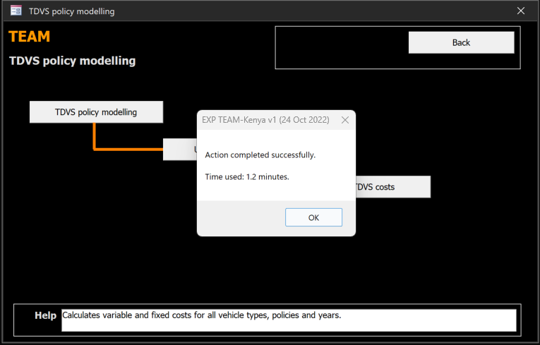

# Run the TDVS model

Navigate to **Run the TDVS model**. Delete the results of the previous model run before running it.

Then set the number of years according to the year of simulation desired. Setting it to **39** years will result in an end year of 2050.

Click the spiky hole icon to run. This will take **10-15 minutes**. Go and have a **cup of tea**.

# Import TDVS data to DEEM, run DEEM and export data

Once the TDVS model has completed, navigate back to the main interface. To import the TDVS output data into the Direct Energy and Emissions Model (DEEM), navigate to **DEEM data imports**.

Click **Import Data** to load the following dialog box. Click Import > OK.

Some queries will run. This should take around 20 seconds.

To run the DEEM, navigate back to the main interface. Navigate to **DEEM policies and runs**, and then **Perform calculation**.

Select Alternative VEEM #7, **calib – TEAM-Kenya calibration to 20xx**. Then click Run.

This should take around 1-2 minutes.

To export the data from the DEEM, navigate back to the main interface. Go to **DEEM data export**. Click Export, and then Export again (from the following dialog box).

This should take around 3-4 minutes.

# Define LCEIM Data and run LCEIM

To enter data for the life cycle emissions and impacts model (LCEIM), navigate back to the main interface, and then navigate to **LCEIM policy modelling**. Change the Alternative name (top left) to REF_2020. Ensure that the Electricity Generation Mix dropdown is set to KEN_REF. This ensures that Kenyan electricity mix (current and projection) are used to calculate lifecycle emissions).

Then you can run the LCEIM. Navigate back to the main interface, click **LCEIM runs and results** then **Execute**. The following dialog box will appear. Move the parameter selections according to the below. The easiest way to do this is to:

1. Click ‘Select All’
2. Click the double back arrow (<<) on LCM/EIM Alternatives
3. Click REF_2020 from LCM/EIM Alternatives and click the single forward arrow (>)

This should take around 5-6 minutes.

# Export Data Tables and loading into TEAM-Kenya dashboard

Congratulations, you’ve now run TEAM! There are several built-in methods to view results in TEAM, which you can explore.

It can be easier, however, to export the raw data in the form of MS Excel worksheets (.xlsx) for further manipulation in Excel or another means of data analysis.

There are five tables of interest from TEAM. These can be found by hitting F11, selecting Tables and using the search box.

The five tables are as follows.

|  |  |
| --- | --- |
| **Table** | **Description** |
| Interface_VSM_NumVeh | Vehicle stock by technology and year (including scrapped, total, new vehicles) |
| Interface_VSM_VehKM | Vehicle-kilometres by technology and year |
| ED | Direct emissions by technology and year |
| ET | Total emissions by technology and year |
| Mode_Shares_TripLength | Mode shares by trip length by year |

Click Export > Excel, and follow the instructions in the dialog box. Do **not** change the names of the saved files (although do feel free to change the folder you are saving into).

To upload the data onto the TEAM-Kenya dashboard, you need to upload the five Excel files corresponding to the five tables above onto the TEAM-Kenya github page. There are various ways of doing this, but the reader is advised to follow the instructions available on the [Readme](https://github.com/ClimateCompatibleGrowth/team-kenya).