
Flokefama Website
How the site works and its integrations
Prepared for Flokefama Company Limited
Preview build · 1 October 2026
Repository: github.com/jamesjnr1/Floke-Fama
Status in one line
The new site runs as a preview on its own address and is hidden from search engines. The current WordPress site at flokefama.com is unchanged and stays live until Flokefama approves a launch in writing.

Contents
- Summary
- The website for visitors
- The portals: sign-in, client portal and engineer portal
- Integrations
- Managing content
- Security, privacy and launch protection
- Performance, reliability and accessibility
- Design system
- Quality checks
- Configuration reference
- Launch checklist and what is needed from Flokefama
- Appendix: commands and repository layout

1. Summary
The new Flokefama website is a modern rebuild of flokefama.com. It presents the company and its services, lets hospitals and laboratories find equipment and ask for quotes, and adds two portals: one for client facilities and one for Flokefama’s biomedical engineers.
It is built so that it works on day one with no accounts set up. Every outside service (content management, search, CRM) is optional: when one is not connected, the site falls back to a built-in alternative, so nothing breaks and no enquiry is lost.

Key points
- No lost enquiries. Quote requests, contact messages and portal registrations go to the CRM (HubSpot) once it is connected. Until then the visitor gets a ready-to-send email or WhatsApp message with everything filled in.
- Two portals with sign-in. Hospitals see their service requests, equipment and certificates; engineers manage tickets, calibrations and documentation. Each account can only open its own portal.
- Built for real conditions. Fast pages on mid-range phones, an offline page with emergency contacts, and accessibility options (larger text, high contrast, reduced motion and more).
- Safe preview. Hidden from Google, never linked to the live site, and the live WordPress site is not touched.

At a glance
Area | What it includes
Public pages | Home, About Us, Awards, Products & Services, Events & Activities, Shop (catalogue and product pages), ESG, Contact, Request a quote, Offline page
Portals | Portal access (/login, Sign in and Register), Client portal (/portal), Engineer portal (/engineer)
Integrations | Sanity (content), Algolia (search), HubSpot (CRM), Google Maps, email and WhatsApp hand-off, Vercel (hosting) and GitHub (code and checks)
Content today | 18 products in 5 categories, company content, events and news taken from the current site (bundled with the code until Sanity is connected)
Portal data today | Clearly labelled demo data (a fictional hospital and engineers) until a real service backend is connected
Technology | Next.js 15 (React 19, TypeScript), Tailwind CSS v4, Radix UI, Motion, Three.js

2. The website for visitors

2.1 Navigation
The menu mirrors flokefama.com: Home · Company (About Us, Awards) · Products & Services · Events & Activities · Shop · ESG · Contact, plus two buttons: Get a Quote and Client Portal Access (in place of the old “My Account”). Below 1280 px wide the menu folds into a menu button. Old WordPress addresses (for example /index.php/shop or /index.php/about-us) are permanently redirected to the new pages, so existing links and search results keep working after launch.
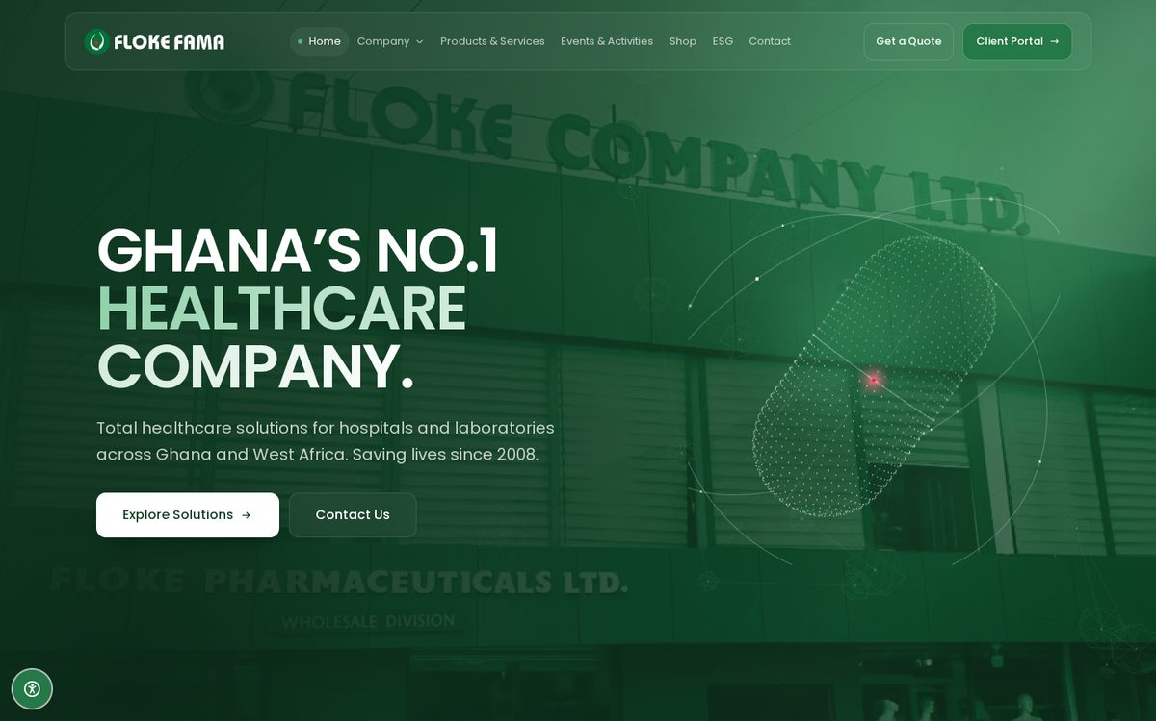
Figure 1. Home page: “Ghana’s No.1 Healthcare Company.” with the 3D capsule on brand green over the head office photo

2.2 Pages
Page | Address | What it shows
Home | / | Hero with the 3D dotted capsule over a faint head office photo; partners and clientele; the in-vitro diagnostics story; the product universe; testimonials
About Us | /about | Who Flokefama is, impact figures and stories, mission, vision and aim, core values
Awards | /awards | Photographs of the actual awards and recognition
Products & Services | /services | The six-stage service lifecycle: equipment sales; installation and commissioning; technical support and maintenance; calibration; repairs and spare parts; training. Why choose Flokefama
Events & Activities | /events | Upcoming and past events (for example Floke Praise 2025 with its flyer) and Media Centre news. Events move from Upcoming to Past automatically
Shop | /products | New arrivals, category tabs and instant search over the catalogue
Product page | /products/<name> | Full specification sheet, highlights and a quote button. Opens as an overlay from the Shop; a full page when linked directly
ESG | /esg | Patient safety, community, education, governance and local industry
Contact | /contact | Phone, emails, message form, head office photo, Google map with directions, the six branches
Request a quote | /quote | Five-step procurement form for a quote or a demo
Offline | /offline | Shown when there is no connection; lists emergency support contacts

2.3 Finding equipment (Shop)
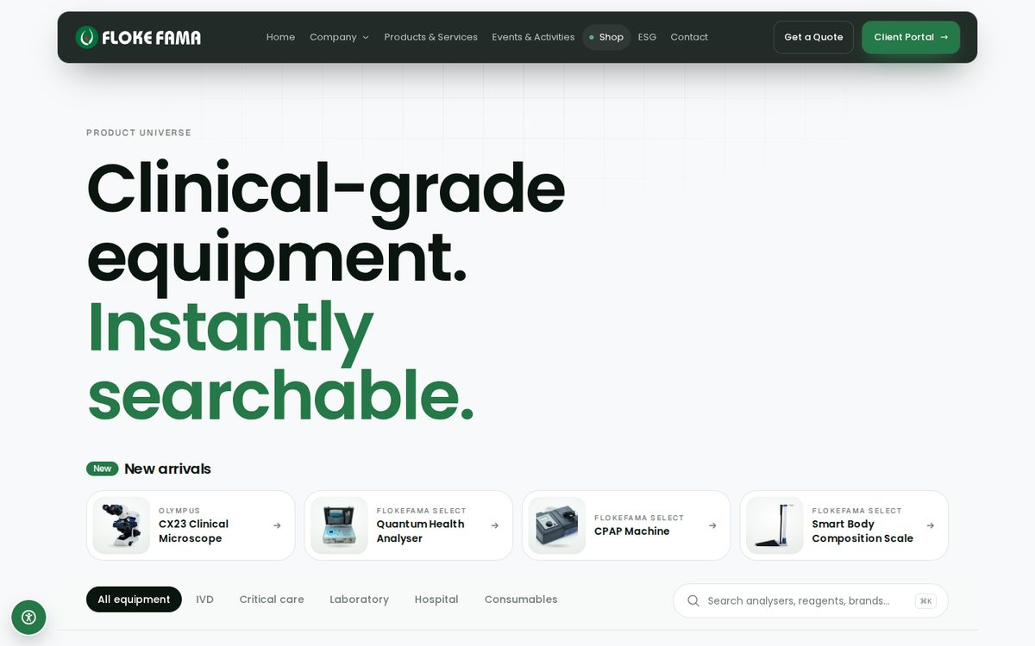
Figure 2. The Shop: new arrivals, categories and instant search
- Categories switch instantly without reloading the page; search filters as you type (press / or Ctrl/⌘ K to jump to the search box).
- The address bar updates with the chosen category and search, so a view can be shared as a link.
- Products flagged as New arrival appear in a strip at the top and carry a “New” badge.
- The site is quote-led: there are no prices or cart. Each product leads to a quote request. If nothing matches a search, “Ask us to source it” opens the quote form with the search filled in.
- Specifications are marked as indicative until they have been checked against the manufacturer’s datasheet.

2.4 Requesting a quote
The quote form at /quote takes the visitor through five short steps, checking each step before moving on:
- Your department: quote or demo, and which department the equipment is for.
- Equipment: choose items from the catalogue or add anything missing.
- Timeline: when it needs to be installed.
- Your details: name, facility, phone and email (role and notes optional).
- Review: check everything, then send. The visitor gets a reference number such as FF-K3ZQ1A.
Where the request goes is explained in section 4 (HubSpot, or the email and WhatsApp hand-off).

2.5 Contact
- Message form with three topics, each routed to the right inbox: Sales & quotes → sales@flokefama.com; Service & support → support@flokefama.com; General enquiry → info@flokefama.com.
- Phone and WhatsApp: +233 53 339 2863.
- Map and directions: the Google map of the head office, a Directions button, and links to the six branches: Santa Maria (head office), Korle-Bu, Okaishie, Kumasi, Aflao and Techiman.

2.6 Accessibility options
A round button at the bottom left of every public page opens the accessibility panel. Visitors can choose larger text (two steps), high contrast, reduce motion, underline links and a more readable font. Choices are remembered on that device and applied before the page appears, so there is no flicker. The site also follows the device’s own “reduce motion” setting.

3. The portals

3.1 Portal access: Sign in and Register
Client Portal Access in the menu leads to the portal access page (/login): a photo of the head office on the left and a light panel on the right with two tabs, as on the original site’s account page.
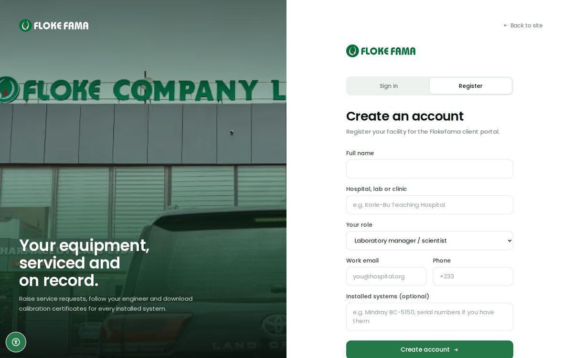
Figure 3. Portal access with the Register tab open
- Sign in: email and password. Each account is sent to its own portal. A Forgot password? link opens a pre-filled email to support.
- Register: full name; hospital, lab or clinic; role; work email; phone; installed systems (optional). Flokefama verifies every facility before an account goes live, so registration sends an access request (to HubSpot when connected, otherwise as a pre-filled email or WhatsApp to support@flokefama.com).
- The link /login?mode=register opens the Register tab directly.
- The engineer sign-in (/login?next=/engineer) has no Register tab: engineer accounts are created internally.

3.2 Client portal (Flokefama Care)
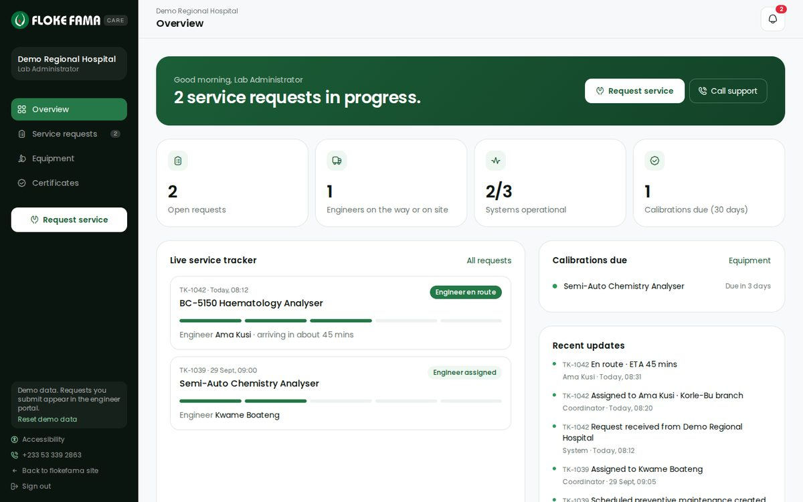
Figure 4. Client portal overview (demo data)
Section | What a hospital can do
Overview | Live figures, the service tracker for open requests (engineer and arrival time), calibrations coming due, latest updates and quick actions
Service requests | Submit a request (equipment, problem, urgency, contact, preferred visit time); follow its progress step by step; message the engineer; rate the visit when it is resolved
Equipment | Every installed system with health, warranty, calibration status and service history; report a fault; order consumables
Certificates | Download calibration certificates

3.3 Engineer portal
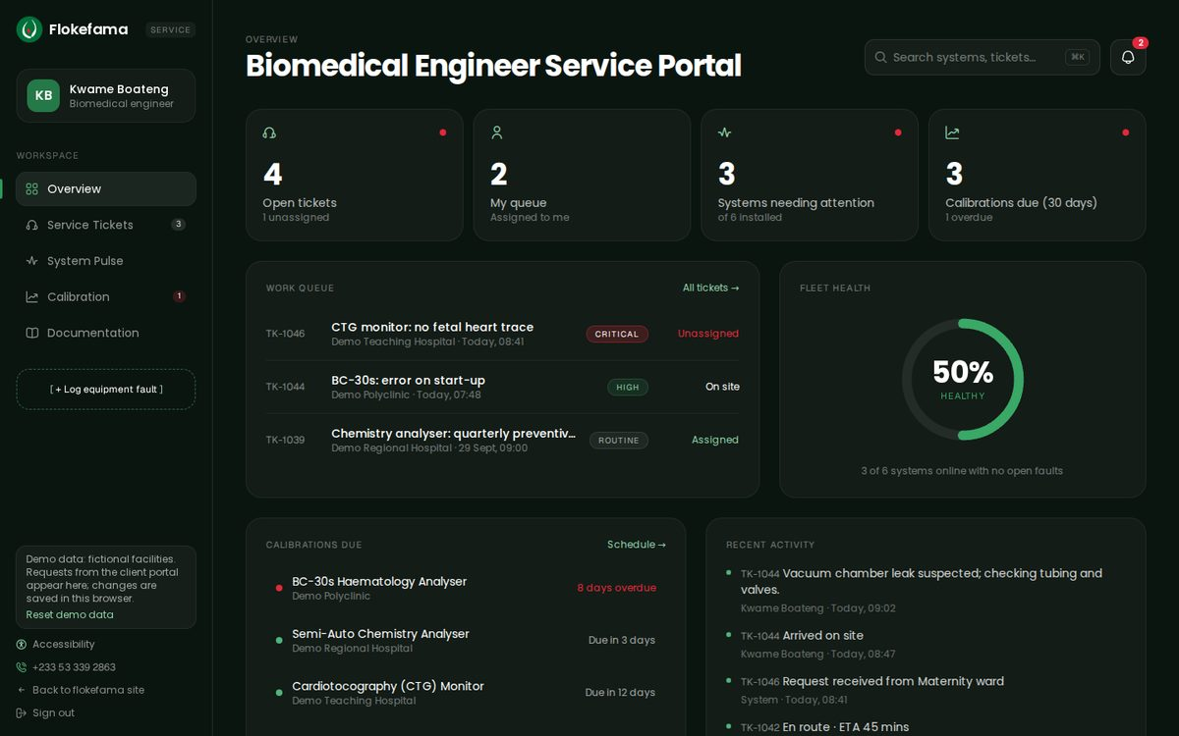
Figure 5. Engineer portal overview (demo data)
Section | What an engineer can do
Overview | Live figures, work queue, fleet health, calibrations due, recent activity
Service Tickets | Filter tickets; assign → en route (with arrival time) → on site → resolve with a report; add work-log notes and parts
System Pulse | Status of every installed system, worked out from open tickets, with a facility filter
Calibration | Overdue and due-soon calibrations; record a result, which issues a certificate and sets the next due date
Documentation | System sheets, service history, downloadable certificates, manual requests
Everywhere | Command palette (Ctrl/⌘ K) to jump to any ticket or system; notifications

3.4 How the two portals work together
Both portals share one service desk. A request a hospital submits in the client portal lands in the engineers’ queue; each step an engineer takes (assign, en route, on site, resolved with a report, calibration certificate) appears for the hospital straight away, with a notification for the other side.
Today vs. production
Today (preview): the service desk lives in the browser so the full round trip can be demonstrated with the two demo accounts (it even syncs between two open tabs). Data stays on that device.
Production: the same actions call a real service-management backend, so every hospital and engineer sees shared, permanent records. This is phase 2 (see section 11).

3.5 How sign-in is protected
- Every request to /portal, /engineer and /login is checked before the page loads. Without a valid session the visitor is sent to sign in; a client who tries the engineer portal (or the other way round) is sent to their own portal. Each page checks the session again before showing anything.
- A session is a signed cookie (ff_session, HMAC-SHA-256, 8-hour expiry). It cannot be read by page scripts, is only sent over HTTPS in production, and any tampered or expired cookie is rejected.
- Wrong details give one general message that never says whether the email or the password was wrong. The return address after sign-in is only honoured inside the account’s own area, so the page cannot be used to redirect people elsewhere.
- Passwords are stored as hashes and compared in constant time. Portal pages are never cached by the browser or the offline cache, which matters on shared hospital computers.
Preview demo accounts (fictional data; the sign-in page shows one-click buttons for them):
Portal | Email | Password
Client | client@demo.flokefama.com | FlokeCare-2026
Engineer | engineer@demo.flokefama.com | FlokeEng-2026

4. Integrations
Each integration is switched on by adding its settings (environment variables) in the hosting dashboard. None is required for the site to run; section 10 lists every setting.
Integration | What it does | Status today | Without it
Sanity (CMS) | Staff edit products, categories, figures and milestones | Ready, not connected | Content bundled with the code
Algolia | Instant, typo-tolerant product search | Ready, not connected | Built-in search (fine for today’s catalogue)
HubSpot (CRM) | Receives quote requests, contact messages and portal registrations | Ready, not connected | Pre-filled email or WhatsApp to the right inbox
Email & WhatsApp | Hand-off for forms; contact links | Active | n/a
Google Maps | Head office map, directions, branch links | Active (no key needed) | n/a
Vercel | Hosting, preview link for every change | Ready to import | n/a
GitHub Actions | Checks every change before it is merged | Active | n/a
Identity provider | Real per-facility accounts, password reset, two-factor for engineers | Planned (phase 2) | Demo accounts
Service backend | Shared, permanent tickets, equipment and certificates | Planned (phase 2) | Demo service desk in the browser
Analytics | Visitor statistics and conversions | Not installed | No statistics

4.1 Sanity: content management
Sanity is a hosted content system. Once connected, Flokefama staff edit content in Sanity Studio (included in the repository under studio/) instead of asking a developer.
- Content types: Category; Product (name, brand, category, summary, image, featured, new arrival, highlights, search keywords, specifications, “specs verified” tick box, compatibility, datasheet/brochure/manual PDFs); Metric (headline figures); Milestone.
- How it updates: pages are pre-built for speed and refreshed every 10 minutes, so edits go live within 10 minutes without a redeploy.
- If Sanity is unreachable, the site quietly falls back to the bundled content and stays up.
- Setup: create a project at sanity.io; set NEXT_PUBLIC_SANITY_PROJECT_ID, NEXT_PUBLIC_SANITY_DATASET (usually production) and SANITY_API_READ_TOKEN; deploy the Studio and run its importer (studio/import-seed.ts) to load today’s content.
- Events, testimonials and branch details are currently edited in src/data/seed.ts; they can be moved into Sanity later.

4.2 Algolia: product search
- When connected, search on the Shop is answered by Algolia: instant and tolerant of typos, across names, brands, keywords, summaries and specification values, with featured products first and the category filter applied.
- Only a search-only key is used in the browser; the admin key stays on the server.
- Keeping it in sync: run npm run algolia:sync after catalogue changes (it reads Sanity when connected, otherwise the bundled catalogue). It can be automated with a Sanity webhook.
- Setup: set NEXT_PUBLIC_ALGOLIA_APP_ID, NEXT_PUBLIC_ALGOLIA_SEARCH_KEY, NEXT_PUBLIC_ALGOLIA_INDEX (default products) and, for syncing, ALGOLIA_ADMIN_KEY.

4.3 HubSpot: enquiries into the CRM
Three forms send to HubSpot through its Forms API. Each is checked on the server first (required fields, valid email and phone), and a hidden “honeypot” field quietly discards spam bots.
Form | Page | What HubSpot receives
Quote or demo request | /quote | Name, email, phone, facility, role, and a message with the reference number, intent, department, equipment, timeline and notes
Contact message | /contact | Name, email, phone, and the message prefixed with its topic
Portal registration | /login?mode=register | Name, email, phone, facility, role, and “[Client portal access request]” with the installed systems
- HubSpot form fields used: firstname, lastname, email, phone, company, jobtitle, message. The HubSpot form must contain these fields.
- If HubSpot rejects a submission, the visitor sees a short error with the phone number to call.
- Setup: create one HubSpot form with the fields above; set HUBSPOT_PORTAL_ID and HUBSPOT_FORM_GUID. Visitors then see “Request received” instead of the hand-off step.

4.4 Email and WhatsApp hand-off
Until HubSpot is connected, the form endpoints answer “not delivered” and the page shows Send by email and Send on WhatsApp buttons with the whole request already written, so the visitor only presses send. Quotes go to sales@; contact messages go to sales@, support@ or info@ by topic; registrations go to support@. WhatsApp messages go to +233 53 339 2863.

4.5 Google Maps
The Contact page embeds the Google Maps listing for Flokefama Company Limited, with a Directions button and a search link for each branch. It uses Google’s standard embed and links, so no API key or billing is needed.

4.6 Hosting (Vercel) and code (GitHub)
- The code lives on GitHub (jamesjnr1/Floke-Fama). Work happens on branches and is merged by pull request.
- On every push and pull request, GitHub Actions runs the linter, the strict type-check and a full production build.
- Once the repository is imported into Vercel, every pull request gets its own preview link and the main branch deploys to the project’s own *.vercel.app address.
- Never without Flokefama’s written approval: add the flokefama.com domain in Vercel, change DNS, or change the live WordPress site.

4.7 Planned integrations
- Identity provider (for example Auth.js or Clerk): real accounts per facility, self-service password reset and two-factor sign-in for engineers. Registration requests would then create accounts after Flokefama approves them.
- Service-management backend: a database behind the shared service desk, so tickets, equipment and certificates are permanent and shared across devices.
- Analytics: recommended before launch, using a privacy-friendly tool (for example Vercel Web Analytics or Plausible). Track quote submissions, WhatsApp and phone clicks as conversions.

5. Managing content
Content | Where it is edited today | After Sanity is connected
Products and categories | src/data/seed.ts | Sanity Studio
Headline figures and milestones | src/data/seed.ts | Sanity Studio
Events (with optional image), news, testimonials, awards | src/data/seed.ts | Seed file (can move to Sanity later)
Contact details and branches | src/data/seed.ts | Seed file
Images | public/images/ (WebP) | Product images in Sanity

Content rules
- No invented facts. Figures, events, services and testimonials come from Flokefama’s own published material.
- Product specifications show an “indicative” note until they are verified against the manufacturer’s datasheet (the “specs verified” tick box).
- Only products in Flokefama’s actual catalogue are named.
- Photos should be real Flokefama photos. New photos can be converted to optimised WebP with npm run images -- photo.jpg 1600.

6. Security, privacy and launch protection

6.1 Security headers
Every response carries: Strict-Transport-Security (HTTPS only, two years), X-Content-Type-Options nosniff, X-Frame-Options SAMEORIGIN, Referrer-Policy strict-origin-when-cross-origin, and a Permissions-Policy that blocks camera, microphone and location.

6.2 Pre-launch protection
Until NEXT_PUBLIC_ALLOW_INDEXING is set to exactly true, the preview is hidden from search engines in four ways, so it can never compete with the live site in Google:
- robots.txt disallows all crawlers.
- Every page carries a noindex, nofollow meta tag.
- Every response, including images and PDFs, carries an X-Robots-Tag: noindex, nofollow header.
- Canonical links, the sitemap and structured data use the preview’s own address, never flokefama.com.

6.3 Forms and data
- All form input is validated twice: in the browser for quick feedback and again on the server.
- A hidden honeypot field filters spam bots without bothering real visitors.
- Secret keys (Sanity read token, Algolia admin key, HubSpot settings, session secret) stay on the server and are never sent to the browser.
- Portal pages are never stored by the offline cache, so private data does not survive sign-out on shared machines.

7. Performance, reliability and accessibility
- Fast pages: most pages are pre-built and served from a global CDN, refreshed every 10 minutes (events daily).
- Images: served in modern formats (AVIF/WebP) at the right size for each screen.
- 3D hero: loads separately after the page, pauses when scrolled out of view and shows a still frame when “reduce motion” is on. It uses only points and lines, which keeps it light on mid-range phones.
- Fonts: self-hosted (Poppins and Geist Sans), so no third-party font requests.
- Offline: a service worker keeps recently visited pages and images. Pages are fetched fresh when online and fall back to the saved copy, then to the offline page with emergency support contacts.
- Accessibility: keyboard and screen-reader support through Radix components, a skip link, visible focus rings, alt text on images, and the accessibility panel described in section 2.6. A full WCAG 2.1 AA audit is still recommended before launch.

8. Design system
Element | Specification
Logo | The official Flokefama logo as vector artwork, taken from the company brochure: logo green #00703A, red #ED1C24 and white. The “FLOKE FAMA” lettering is white on dark backgrounds and logo green on light ones. No font is needed
Brand green | #257847 with a scale from #EEF7F1 (tint) to #134228 (deep). Deep green gradients for the home hero and the service panel
Signal red | #E4283C, used sparingly (alerts, the logo dot)
Neutrals | Ink #0B1510, near-white canvas #F8F9FA, white paper, soft greys for lines and muted text. No blue or purple anywhere
Typefaces | Poppins for headings and text; Geist Sans for labels, numbers and small accents
Layout | 12-column grid up to 1280 px wide (the menu bar widens to 1400 px on very large screens); phone layouts turn card stacks into swipeable rows

9. Quality checks
Check | What it covers | How to run
Lint, type-check, build | Code style, strict TypeScript, a full production build. Runs in GitHub Actions on every change | npm run check
Page QA | 14 pages (including both portals, signed in) at 390, 1440 and 1600 px: no sideways scrolling, menu bar contents fit inside the bar, no console errors, no broken images. 42 checks; screenshots saved to qa/ | npm run build && npm start, then npm run qa
During development, further end-to-end scripts were also run on each change: sign-in and role separation (16 checks), the client portal round trip (21), the engineer portal (18), accessibility settings (10), the brand colour audit (13) and portal registration (15). These live outside the repository today; adding them to it is recommended so they run in CI.

10. Configuration reference
Settings are added as environment variables in Vercel (or in .env.local for local development; .env.example lists them all).
Variable | Used for | Notes
NEXT_PUBLIC_SANITY_PROJECT_ID | Sanity | Turns on the CMS
NEXT_PUBLIC_SANITY_DATASET | Sanity | Usually production
SANITY_API_READ_TOKEN | Sanity | Server only
NEXT_PUBLIC_ALGOLIA_APP_ID | Algolia | Turns on Algolia search
NEXT_PUBLIC_ALGOLIA_SEARCH_KEY | Algolia | Search-only key (safe in the browser)
NEXT_PUBLIC_ALGOLIA_INDEX | Algolia | Default products
ALGOLIA_ADMIN_KEY | Algolia sync | Server only; used by npm run algolia:sync
HUBSPOT_PORTAL_ID | HubSpot | With the form GUID, turns on CRM delivery
HUBSPOT_FORM_GUID | HubSpot | The form with the fields listed in 4.3
SESSION_SECRET | Portal sign-in | Required before real users: a long random value (e.g. openssl rand -base64 48)
ENABLE_DEMO_ACCOUNTS | Portal sign-in | Demo accounts are on unless this is exactly false
NEXT_PUBLIC_SITE_URL | Site address | Leave unset on Vercel. Do not set to flokefama.com before an approved launch
NEXT_PUBLIC_ALLOW_INDEXING | Launch switch | Search engines are blocked unless this is exactly true. Set only at launch

11. Launch checklist and what is needed from Flokefama

11.1 Accounts and settings
- Vercel project (import the GitHub repository).
- HubSpot portal and a form with the fields in section 4.3, so enquiries reach the CRM directly.
- Sanity project, if staff will edit content themselves.
- Algolia application, if the catalogue grows large (optional today).
- A long random SESSION_SECRET, and ENABLE_DEMO_ACCOUNTS=false once real accounts exist.

11.2 Phase 2 (portals with real data)
- An identity provider with per-facility accounts, password reset and two-factor sign-in for engineers.
- A service-management backend for tickets, equipment, calibrations and certificates.

11.3 Content to confirm or supply
- Verified product specifications and datasheets; real product photography.
- Confirmation of headline figures, testimonials and the “Ghana’s No.1” claim (the site audit flagged these as needing proof).
- A privacy policy and terms of use.
- Usage rights for the head office photo on the portal access page (it comes from a public Google Maps upload), or a replacement photo.
- A web-sized copy of the company brochure, if it should be offered for download.

11.4 Launch day (only with written approval)
- Back up the live WordPress site.
- Set NEXT_PUBLIC_SITE_URL to https://flokefama.com and NEXT_PUBLIC_ALLOW_INDEXING to true.
- Add the flokefama.com domain in Vercel.
- Switch DNS to Vercel and check the redirects from the old /index.php/ addresses.
- Submit the new sitemap in Google Search Console.

12. Appendix: commands and repository layout

Commands
Command | What it does
npm install | Install dependencies (Node 20.9 or newer)
npm run dev | Development server at http://localhost:3000 (runs on bundled content, no keys needed)
npm run check | Lint, type-check and production build (what CI runs)
npm run build && npm start | Production build and server
npm run qa | Page QA (with the server running); screenshots in qa/
npm run algolia:sync | Push the catalogue to Algolia
npm run images -- photo.jpg 1600 | Convert a photo to optimised WebP
npm run icons | Rebuild the icon subset after adding or removing icons
npm run flyers | Render social media flyer templates

Repository layout
Folder | Contents
src/app/(site)/ | Public pages with the menu and footer
src/app/login/ | Portal access (Sign in and Register)
src/app/portal/, src/app/engineer/ | The two portals, each with its own layout
src/app/api/ | Form endpoints: quote, contact, register
src/middleware.ts | Protects the portals (sign-in and role check)
src/components/ | Page sections and shared components (including the official logo in layout/logo.tsx)
src/data/seed.ts | Bundled content taken from the current site
src/lib/ | Sign-in, CMS access, search, CRM delivery, form rules, the 3D scene, the service desk
studio/ | Sanity Studio: content types and importer
public/ | Images and the service worker
docs/ | Site audit, strategy, design system, social media playbook, architecture, and this guide

