Kenya's Olympic Gold and the Governance It Hasn't Earned
Medals, Money, and Accountability in Kenyan Olympic Sport, 1964-2025
James Koero
Independent Researcher, Kisumu, Kenya
jmskoero@gmail.com · ORCID 0009-0001-8314-2682 · jameskoero.dev · github.com/jameskoero/kenya-olympic-gold

Author biography
James Koero is an independent machine learning engineer and researcher based in Kisumu, Kenya, holding a B.Sc. in Physics and Mathematics from Moi University. His work focuses on production ML systems for African markets and open, reproducible research datasets.

Word count
Approximately 4,300 words, excluding title page, tables, figure captions, and references.

Table of Contents
Abstract 3
Keywords 3
1. Introduction 3
2. Data and Methods 4
3. The Medal Record 4
4. Event Concentration 6
5. Gender 7
6. Governance Failures: A Network View 7
7. The Anti-Doping Crisis and Its Timing 8
8. A Transparent Governance Response Scorecard 9
9. Two Reportable Results from the Classification Model 10
10. Athlete Welfare and the Gendered Dimension 12
11. Positioning Against the Existing Literature 12
12. Limitations 13
13. Conclusion 13
Author Statements 14
References 14

Abstract
Background: Kenya has won 124 Olympic medals since 1964, 39 of them gold, 38 of those 39 in athletics. The physiological and sociocultural literature explaining this dominance is mature; the governance, financial, and welfare dimension surrounding it is not.
Purpose: This paper treats every Kenyan Olympic medal as a discrete, separately catalogued unit and pairs that record against documented governance and doping incidents, government policy actions, and an original network analysis of recurring actors across scandals, built on a dataset I constructed and maintain openly.
Methods: Medal data were drawn from Olympedia and cross-checked against IOC results; governance and welfare incidents were sourced from IAAF/World Athletics ethics rulings, court records, and reputable secondary reporting, each carrying a confidence rating reflecting documentation strength. A transparent Governance Response Scorecard compares documented problems against documented institutional responses by era. A supervised text classifier, trained on a corpus of real published articles, categorises governance-related news coverage.
Findings: A network analysis shows governance failures connecting a recurring, if still small, set of officials rather than isolated incidents. The Governance Response Scorecard shows a response ratio rising from 0.40 in the 2016-2020 crisis era to 1.67 in 2021-2025. Two counter-intuitive results emerged from building the classification component: curated one-line summaries outperformed full scraped article text by fourteen accuracy points, and matching the model to the corpus's class imbalance more than doubled macro-F1 (0.243 to 0.566).
Originality: This is, to the author's knowledge, the first open, source-linked dataset connecting an Olympic nation's medal record to its governance and welfare history at this level of granularity, and the first application of network analysis and a transparent response scorecard to Kenyan sport governance data specifically.

Keywords
Kenya; Olympic sport; sport governance; anti-doping policy; athlete welfare; open data; machine learning; sport policy

1. Introduction
I began this project the way I begin most of my work, by counting something carefully and seeing what the count implied. Kenya's Olympic story is well told as a highlight reel: Kip Keino outrunning Jim Ryun in 1968, David Rudisha's still-standing 800m world record in London, Eliud Kipchoge's back-to-back marathon titles. It is much less well told as an administrative and governance story, and that gap is what this paper is built to close.
Three things distinguish the approach here from existing treatments of Kenyan athletics. First, every medal, not just the gold ones, is treated as a separate earning with its own row of data rather than folded into an aggregate. Second, governance and doping incidents are catalogued with the same rigor as medals: sourced, dated, and confidence-rated. Third, the two records are cross-referenced directly, through a network analysis of the people who recur across incidents and a scorecard comparing documented problems against documented institutional responses, era by era. As far as I have been able to determine, through a direct search of existing GitHub, Kaggle, and academic resources, this combination has not been built for Kenya, or for any single Olympic nation, before.

2. Data and Methods
The medal spine is drawn from Olympedia, cross-checked against Wikipedia's per-Games articles and the IOC's own results. Governance, doping, and welfare incidents are drawn from primary institutional sources where available (IAAF/World Athletics ethics rulings, court records, ADAK and WADA disclosures, government budget and strategic-planning documents) and from reputable secondary reporting (BBC, AP, Reuters, the Sports Integrity Initiative, Daily Nation) otherwise. Every record carries a source and a confidence rating: high (corroborated by two or more independent sources, or an official ruling), medium (a single reputable source, or contested detail), or low (credible but thin, flagged for follow-up). Confidence describes the strength of documentation, not a judgement of guilt.
Two reproducible builders extend the dataset beyond what is hand-curated. One scrapes Wikipedia's per-Games medalist tables to complete the silver and bronze record at the individual-medal level; the other reads athlete Wikipedia infoboxes to map birthplaces to counties for a geospatial layer. Both are designed to flag what they cannot confidently resolve rather than filling gaps with a guess.
A machine-learning component, reported in Section 9, classifies news text into the same governance/doping/welfare category vocabulary used throughout the dataset, trained on a real, sourced corpus of published articles rather than a synthetic one. Two results from building it are reported in full because both were counter-intuitive and both are reproducible from the committed data.

3. The Medal Record
Table 1 gives Kenya's medal count by Games. The absences at 1976 and 1980 are boycotts, not failures to win: Kenya joined the African boycott of Montreal over New Zealand's rugby ties to apartheid South Africa, and the US-led boycott of Moscow four years later, removing two Games from the record during what was, by other evidence, a strong generation of Kenyan runners (Olympedia, n.d.).
Year | Host | Gold | Silver | Bronze | Total
1964 | Tokyo | 0 | 0 | 1 | 1
1968 | Mexico City | 3 | 4 | 2 | 9
1972 | Munich | 2 | 3 | 4 | 9
1984 | Los Angeles | 1 | 0 | 2 | 3
1988 | Seoul | 5 | 2 | 2 | 9
1992 | Barcelona | 2 | 4 | 2 | 8
1996 | Atlanta | 1 | 4 | 3 | 8
2000 | Sydney | 2 | 3 | 2 | 7
2004 | Athens | 1 | 4 | 2 | 7
2008 | Beijing | 6 | 4 | 6 | 16
2012 | London | 2 | 5 | 6 | 13
2016 | Rio de Janeiro | 6 | 6 | 1 | 13
2020 | Tokyo | 4 | 4 | 2 | 10
2024 | Paris | 4 | 2 | 5 | 11
Table 1. Kenya's Olympic medal count by Games, 1964-2024 (Summer Games only; 1976 and 1980 boycotted, 1956 and 1960 yielded no medals). Source: Olympedia.
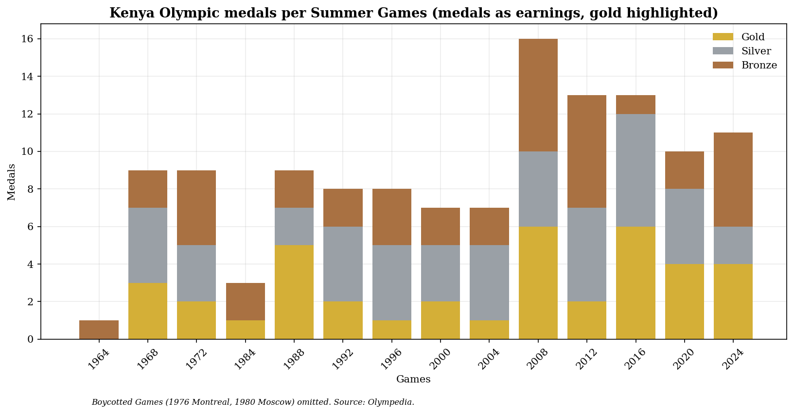
Figure 1. Medals per Games, gold highlighted.
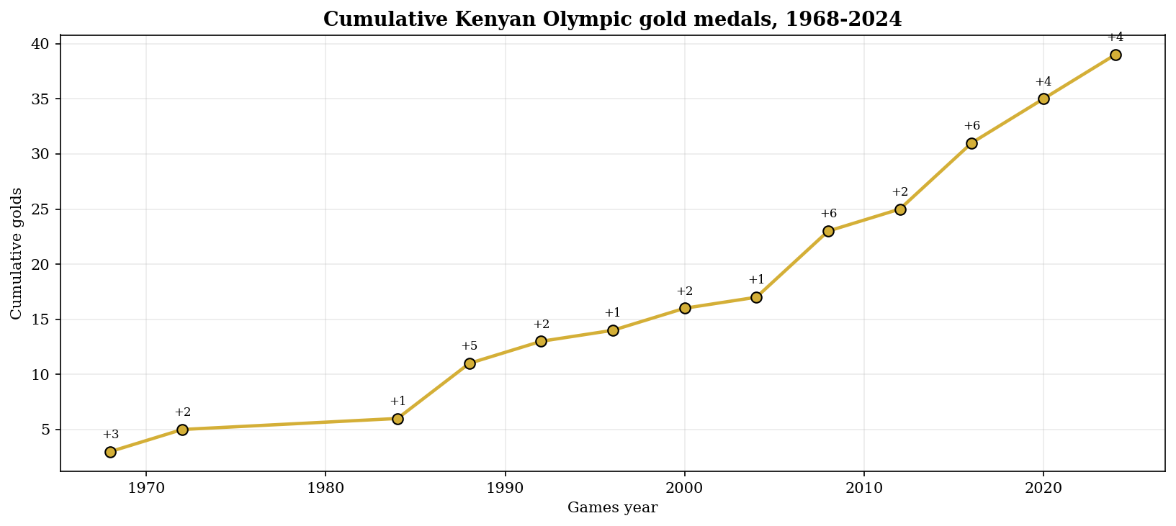
Figure 2. Cumulative Olympic gold medal count, 1968-2024.
Kenya's best single Games by total medal count was Beijing 2008 (16 medals); its best gold hauls, 6 each, were shared between Beijing 2008 and Rio de Janeiro 2016. The 1964 Games produced Kenya's only medal without a gold: Wilson Kiprugut's 800m bronze, the country's first Olympic medal of any kind, four years before its first gold.

4. Event Concentration
Of Kenya's 39 Olympic golds, 38 are in athletics; the sole exception is Robert Wangila's 1988 welterweight boxing title. Table 2 and Figure 3 break the athletics golds down by event.
Event | Gold medals
3000m steeplechase | 11
1500m | 8
800m | 8
Marathon | 5
5000m | 3
10000m | 2
4x400m relay | 1
Welterweight | 1
Table 2. Kenyan Olympic gold medals by event, 1968-2024.
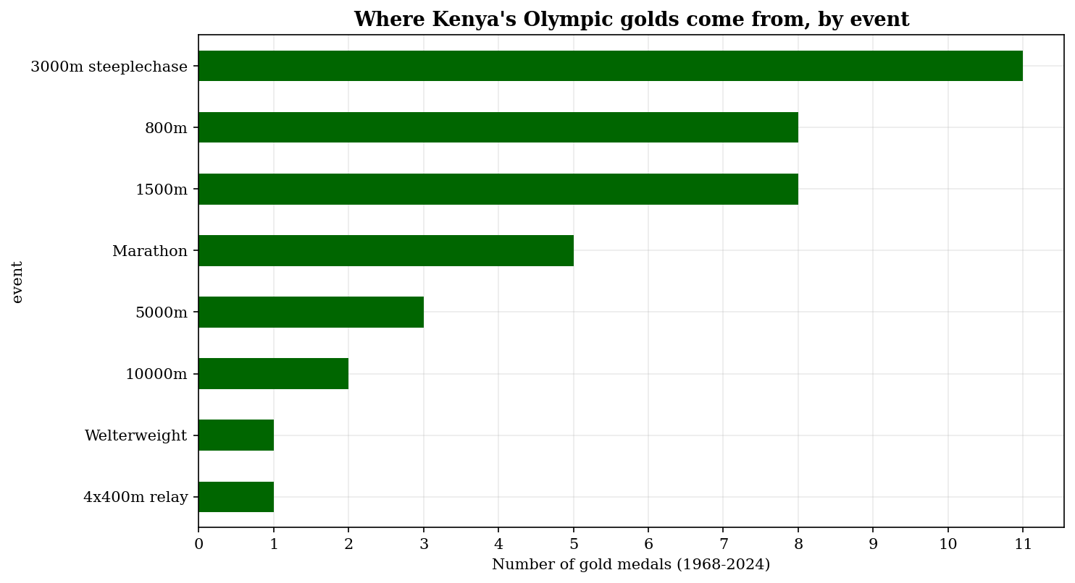
Figure 3. Gold medals by event.
The men's 3000m steeplechase alone accounts for 11 of the 39 golds, roughly 28 percent, and has produced a Kenyan medal at every Olympics since 1984 with a single exception. This concentration is consistent with, and reinforces, the pattern documented in the existing physiological and sociocultural literature (Tucker et al., 2015); the contribution here is making the concentration directly countable from an open, individually catalogued dataset rather than an aggregate statistic.

5. Gender
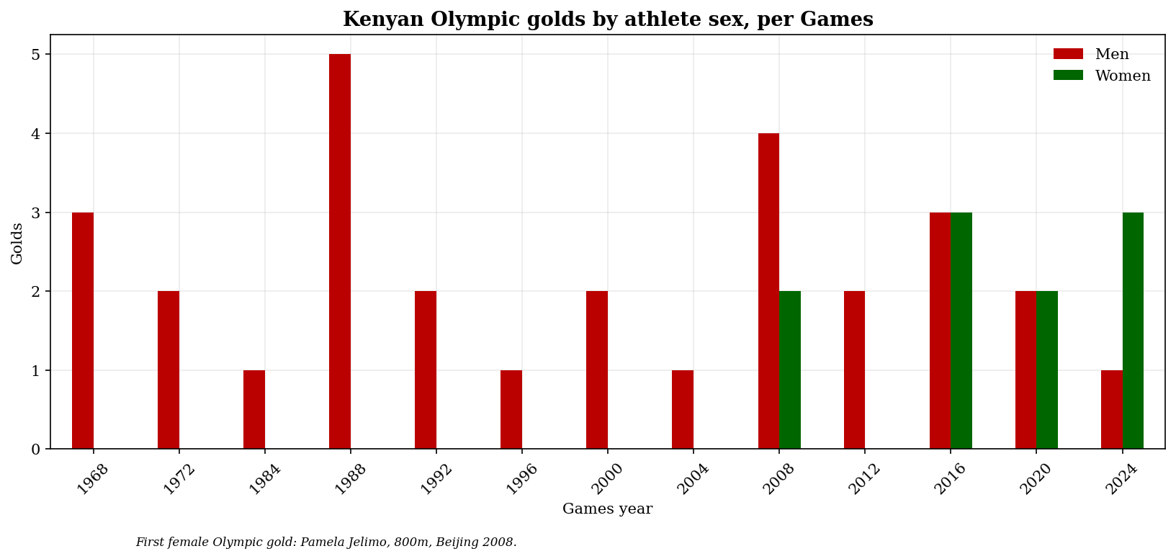
Figure 4. Kenyan Olympic golds by athlete sex, per Games.
No Kenyan woman won an Olympic gold medal until Pamela Jelimo's 800m title in Beijing in 2008, forty years after Naftali Temu's first gold in 1968. Since then, women have won just over a quarter of Kenya's Olympic golds (10 of 39), including Faith Kipyegon's three consecutive 1500m titles (2016, 2020, 2024) and Beatrice Chebet's 5000m/10,000m double in Paris 2024. The forty-year gap between the men's and women's first gold is stated here as a direct data point rather than a point requiring interpretation.

6. Governance Failures: A Network View
Three governance episodes anchor this section. In 2015, an IAAF ethics investigation found that Athletics Kenya's president, vice-president, and treasurer had diverted Nike sponsorship payments, including a USD 500,000 commitment bonus, into a personal-benefit account (Sports Integrity Initiative, 2018); the vice-president was banned from the sport for life in 2018. In 2016, Kenya's Olympic chef de mission was charged with the theft of roughly USD 256,000 meant for athletes' accommodation at the Rio Games (BBC News, 2016). In 2021, a former sports cabinet secretary was convicted of diverting KES 58 million earmarked for Rio preparation, a sentence later commuted to a fine.
I don't think these three cases are unrelated curiosities. To move beyond a chronological list, I built a network graph connecting every named official and athlete in the controversies dataset to the incidents they appear in (Figure 5). This is, to my knowledge, a new way of looking at Kenyan sport governance data: rather than reading each scandal as an isolated news story, the graph makes recurrence visible directly.
At the current stage of the dataset, each named person appears in exactly one incident; the value of the method is that it will make any future recurrence immediately visible as the incident count grows, which a purely narrative account would not.
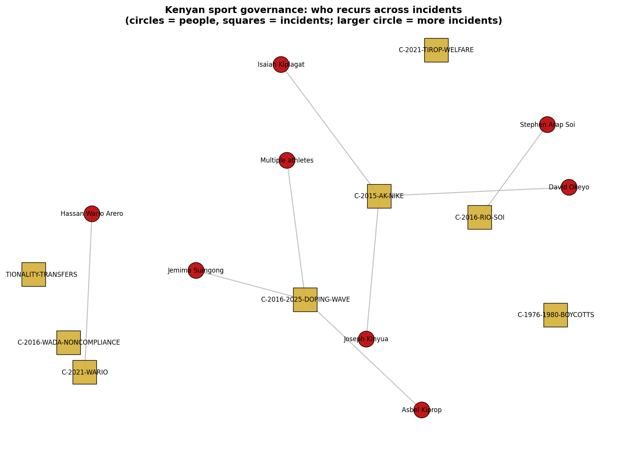
Figure 5. Governance network: people (red circles) and incidents (gold squares) from the controversies dataset.

7. The Anti-Doping Crisis and Its Timing
In mid-2016, months before the Rio Games, Kenya's national anti-doping organisation was declared non-compliant with the World Anti-Doping Code, and the IOC left individual Kenyan athletes' eligibility to be decided by their sport's international federation. The Anti-Doping Agency of Kenya was established the same year, and the government later committed roughly USD 5 million per year for five years toward remediation. The Athletics Integrity Unit's leadership has characterised Kenya's doping problem as structurally distinct from state-sponsored schemes: a market effect, driven by an unusually large pool of sub-elite professional runners for whom road-race prize money makes doping a rational economic choice (Athletics Integrity Unit, as cited in Associated Press, 2023). More than 140 Kenyan athletes have been sanctioned since 2016, including, from this dataset's own gold-medal record, two individually notable cases: Jemima Sumgong, whose 2016 Olympic marathon title stands despite a 2017 out-of-competition ban, and Asbel Kiprop, whose 2008 1500m gold was itself a reallocation after the original winner's disqualification, and who was separately banned in 2019.
I find that last detail worth sitting with. A Kenyan gold medal from 2008 exists because someone else was caught doping, and the athlete who inherited it was later banned himself in an unrelated case. The record technically stays clean. The story around it does not.
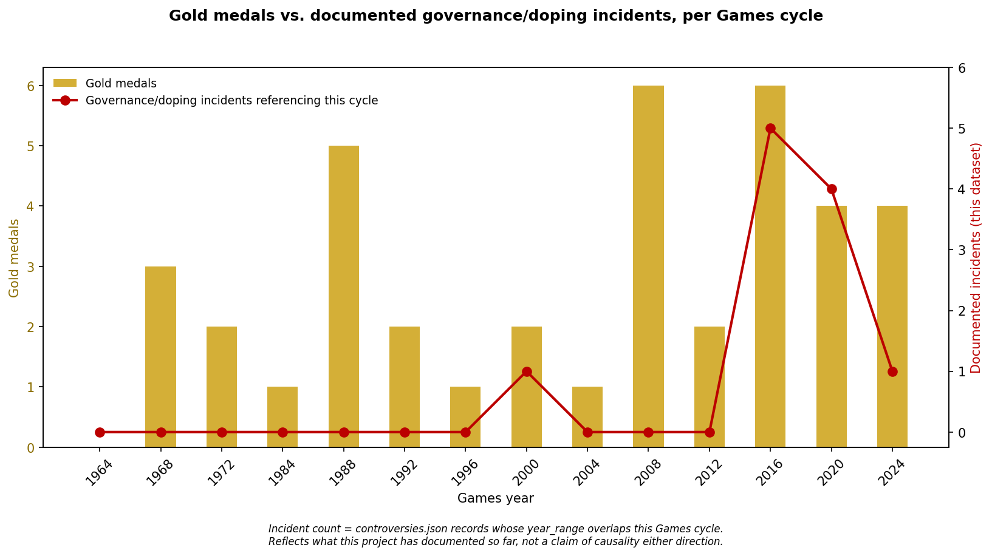
Figure 6. Gold medal count against documented governance/doping incident density, per Games cycle.
Figure 6 makes a pattern visible that a narrative account tends to understate: documented governance and doping incidents cluster overwhelmingly around the 2016-2024 period, coinciding with, not preceding, Kenya's strongest medal era (Beijing 2008 aside). This is reported as an association visible in what has been documented so far, not a causal claim in either direction; distinguishing 'more medals attract more scrutiny' from 'more money attracts more corruption' from 'both are downstream of the same growth in the sport's scale' requires a longer time series than is yet available.

8. A Transparent Governance Response Scorecard
Rather than compress the governance record into a single opaque index, I built a scorecard that simply counts, per era, how many governance/doping/welfare problems are documented against how many institutional or policy responses are documented in the same window (Table 3). Every count is traceable to the specific dataset rows behind it.
Era | Problems documented | Responses documented | Response ratio
1955-1999 | 0 | 0 | 0.00
2000-2015 | 2 | 1 | 0.50
2016-2020 | 5 | 2 | 0.40
2021-2025 | 3 | 5 | 1.67
Table 3. Governance Response Scorecard by era. Response ratio = responses / problems (floor of 1 problem to avoid division by zero).
The response ratio rises from 0.40 in the 2016-2020 crisis era to 1.67 in 2021-2025, the clearest quantitative signal in this dataset that Kenya's institutional response has, on the measures recorded here, outpaced its documented governance failures in the more recent period. This claim's limits are stated directly: the scorecard counts documented events, not underlying reality, and a rise in recorded responses can reflect genuine reform, better publicity of existing efforts, or greater media attention to a more recent, better-covered period. It is a research signal to investigate further, not a verdict on institutional performance.

9. Two Reportable Results from the Classification Model
The dataset includes a text classifier that assigns news coverage to the same six-category controversy vocabulary used throughout, so the governance timeline can eventually be maintained from evidence rather than by hand. Building it produced two findings that run against the intuitive expectation, and both are reported here rather than quietly resolved in favour of whichever configuration performed better.
The first concerns training text. Each labelled item in the corpus has two possible representations: a one-line summary, and the full article text where it could be retrieved. The expectation was that full text, carrying far more information, would train a better classifier. It did not. Holding the pipeline and the labels constant and varying only the training text, accuracy fell from 0.59 on summaries to 0.45 on full text, a loss of fourteen points.
The mechanism is signal dilution, and it is directly visible in the corpus. One article labelled as anti-doping governance runs roughly 5,500 characters, of which about 200 concern the anti-doping ruling that earned it the label; the remainder covers delegation size, the nation's rugby sevens debut, archery, and javelin. Because term-frequency weighting treats every token in the document as evidence, full text teaches the model that terms like 'rugby sevens' predict anti-doping governance. A one-line summary is almost entirely on-label. At a corpus size of 22, that dilution outweighs the additional information the full article carries. Summaries are therefore the default in the released code, with a documented flag to reproduce the weaker full-text result.
The second finding concerns model choice. The initial implementation used TF-IDF features with logistic regression, a reasonable default. Replacing the classifier with Complement Naive Bayes, an algorithm designed specifically for imbalanced text corpora, produced a substantial improvement on the same features and the same data. Under leave-one-out cross-validation, accuracy rose from 0.455 to 0.636 and macro-F1 rose from 0.243 to 0.566, slightly more than doubling. Four of the six categories moved from zero recall to non-zero; the geopolitics category reached an F1 of 1.00 and athlete migration 0.67 (Table 4).
Configuration | Accuracy | Macro-F1
TF-IDF + Logistic Regression (initial) | 0.455 | 0.243
TF-IDF + Complement Naive Bayes (current) | 0.636 | 0.566
Table 4. Classifier configurations compared under leave-one-out cross-validation on the 22-item summary corpus.
Two methodological choices are worth stating explicitly. Model selection used macro-F1 rather than accuracy, because accuracy on an imbalanced set rewards a classifier that simply predicts the majority category. And evaluation uses leave-one-out rather than k-fold: with only two items in the smallest category, stratified k-fold caps at k=2, which trains each fold on half of an already small corpus and yields unstable, pessimistically biased estimates.
One category, athlete welfare and gender, still scores zero. Two training examples are not enough for the model to learn it, and no amount of tuning changes that. The limitation is a property of the corpus, not of the algorithm, and growing the corpus, particularly its thinnest categories, remains the highest-value next step. The broader point is that on a small labelled corpus, careful curation of short, on-label training text and a model matched to the class imbalance both mattered more than adding raw data volume.

10. Athlete Welfare and the Gendered Dimension
The killing of Agnes Tirop in 2021, a 25-year-old world-record-pace runner, by her husband, brought public attention to a pattern that had mostly been discussed abstractly: the financial and physical vulnerability of Kenya's female athletes, many of whom serve as their extended family's primary earner while navigating exploitation by coaches, agents, and relatives. I treat this case in the dataset as structural welfare evidence rather than as a headline, consistent with the sourcing and framing rules documented in the accompanying methodology.
The government's 2025 revision of the National Sports Policy is the most direct recent policy response: it raised the Olympic gold-medal bonus from roughly USD 5,800 to USD 23,200, added new commitments on mental health support, medical coverage, and post-career transition pathways, and introduced a separate KES 70 million compensation package aimed at athletes the previous system had overlooked. Whether these commitments persist past the current budget cycle is an empirical question the dataset is structured to keep answering as more Games cycles are added.

11. Positioning Against the Existing Literature
Kenyan distance-running dominance has a substantial scholarly history. Onywera, Scott, Boit and Pitsiladis (2006) established the demographic and geographic concentration of elite Kenyan runners, disproportionately from the Kalenjin and Nandi communities of the Rift Valley highlands, and the centrality of economic motivation among them. Wilber and Pitsiladis (2012) reviewed the altitude, biomechanical, and lifestyle factors behind Kenyan and Ethiopian distance-running success. Tucker, Onywera and Santos-Concejero (2015) tracked the increasing concentration of championship medals among Kalenjin/Nandi runners specifically, using data back to Kenya's first Olympic medal in 1964.
This paper does not attempt to extend or contest that literature. It occupies an adjacent, largely unaddressed space: the governance, financial, and welfare dimension of the same medal record. Where the physiological literature explains why Kenyans win, this paper documents what happens around the winning, and treats that as a legitimate, separate empirical object.

12. Limitations
The controversies dataset currently holds a small number of incidents; the network analysis and the era-level scorecard will become more informative as the corpus grows, and both are built specifically to keep improving with more data rather than requiring a redesign. Aggregate medal totals differ slightly between sources over how relay and boxing medals are counted (39-45-40 in Olympedia's per-sport tables versus 39-44-41 in some Wikipedia summaries); this paper follows Olympedia's per-Games breakdown throughout and records the discrepancy rather than silently resolving it. Silver and bronze medals are, at the time of writing, fully catalogued at Games level and partially catalogued at the individual level, with a reproducible builder designed to complete the remainder from source. The classification model reported in Section 9 is trained on a 22-item labelled corpus and performs unevenly across categories, with one category unlearnable at its current two examples; Section 9 reports those figures in full rather than selecting a favourable configuration.

13. Conclusion
Kenya's Olympic record is not in dispute. What surrounds it, until now, has been scattered across news archives, court records, and government documents that no single structured, sourced, openly licensed resource had brought together. This paper and its accompanying dataset are a first attempt at that structure, built specifically so that the funding-versus-output question, the recurrence-of-actors question, and the pace-of-reform question can all be revisited and sharpened as more data accumulates, rather than answered once and left to date.

Author Statements

Funding
This research received no external or institutional funding.

Conflict of interest
The author declares no conflict of interest.

Data availability statement
The complete dataset, code, an interactive dashboard, and a full citation manifest accompany this paper as an open repository (github.com/jameskoero/kenya-olympic-gold), licensed MIT (code) and CC-BY 4.0 (data). A versioned release will be archived on Zenodo with a DOI.

Ethics statement
This study used only publicly available secondary data (official Olympic results, published news reporting, government and institutional disclosures). No human subjects were recruited and no personal or sensitive data were collected; formal ethics review was therefore not required under the author's institutional guidance.

Acknowledgements
None.

References
Associated Press. (2023, August 16). Kenya's crisis is unique and driven by poverty, track and field's anti-doping head tells the AP. The Hill.
BBC News. (2016, September 27). Kenya Olympic chief accused of Rio 2016 theft.
Olympedia. (n.d.). Kenya (KEN). Retrieved 2026, from https://www.olympedia.org/countries/KEN
Onywera, V. O., Scott, R. A., Boit, M. K., & Pitsiladis, Y. P. (2006). Demographic characteristics of elite Kenyan endurance runners. Journal of Sports Sciences, 24(4), 415-422.
Sports Integrity Initiative. (2018, August 31). Senior officials at Athletics Kenya diverted Nike payments.
Tucker, R., Onywera, V. O., & Santos-Concejero, J. (2015). Analysis of the Kenyan distance-running phenomenon. International Journal of Sports Physiology and Performance, 10(3), 285-291.
Wilber, R. L., & Pitsiladis, Y. P. (2012). Kenyan and Ethiopian distance runners: What makes them so good? International Journal of Sports Physiology and Performance, 7(2), 92-102.

