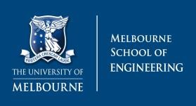Engineering Examination Coversheet

Student Number

1079860

Please note that you:

# Must keep a full copy of your submission for this examination

|  |  |
| --- | --- |
| **Examination Title:** | ISYS10001 Final Exam Semester 2 |
| **Subject Number:** | ISYS10001 |
| **Subject Name:** | Foundations of Information Systems |
| **Student Name:** | James La Fontaine |
| **Airline name** | Virgin Australia |
| **Lecturer/Tutor:** | Dr Charlynn Miller & Dr Libo Liu |
| **Due Date:** | 13/11/2020 |

## For Late Examinations Only

Has an extension been granted? Yes / No (circle)

A per-day late penalty may apply if you submit this exam after the due date/extension. Please check with your Department/coordinator for further information.

## Plagiarism

Plagiarism is the act of representing as one's own original work the creative works of another, without appropriate acknowledgment of the author or source.

## Collusion

Collusion is the presentation by a student of an examination as his or her own which is in fact the result in whole or in part of unauthorised collaboration with another person or persons. Collusion involves the cooperation of two or more students in plagiarism or other forms of academic misconduct.

Both collusion and plagiarism can occur in group work. For examples of plagiarism, collusion and academic misconduct in group work please see the University’s policy on Academic Honesty and Plagiarism: <http://academichonesty.unimelb.edu.au/>

Plagiarism and collusion constitute cheating. Disciplinary action will be taken against students who engage in plagiarism and collusion as outlined in University policy. Proven involvement in plagiarism or collusion may be recorded on my academic file in accordance with Statute 13.1.18.

**STUDENT DECLARATION**

Please sign below to indicate that you understand the following statements: I declare that:

* This examination is my own original work, except where I have appropriately cited the original source.
* This examination has not previously been submitted for assessment in this or any other subject.

For the purposes of assessment, I give the assessor of this examination the permission to:

* Reproduce this examination and provide a copy to another member of staff; and
* Take steps to authenticate the examination, including communicating a copy of this examination to a checking service (which may retain a copy of the examination on its database for future plagiarism checking).

Student signature JAMES LA FONTAINE Date 13/11/2020

File: network\engineering student centre\Forms\eng_exam_coversheet.pdf Updated: 12/11/20

Author: cmiller

*Word count (answers only): 1153 words*

1. **Discuss Porter’s five forces in the context of your specific airline.**

**[8 marks]**

**BARGAINING POWER OF BUYERS:**

The bargaining power of buyers in the airline industry is a moderately strong force as they have a plethora of other airlines to choose from such as Qantas, Singapore, Etihad, or Emirates in Australia alone. Additionally, the switching costs for customers are low and customers can find similar products (flights) across these many options with relative ease. Virgin Australia do provide an award-winning loyalty program though, which likely does persuade some buyers to stick with Virgin Australia.

**BARGAINING POWER OF SUPPLIERS:**

The bargaining power of suppliers is a strong force. There are essentially only two dominant airplane manufacturers, Airbus and Boeing. It is also quite difficult for airline companies to switch suppliers as they tend to be locked into long term contracts.

**THREAT OF SUBSTITUTE PRODUCTS OR SERVICES:**

The threat of substitute products or services is a fairly weak force. There are multiple alternative forms of transportation available to consumers such as car, bus, train, or boat transportation. However, planes provide the most cost efficient, time efficient, and convenient method of transportation by a significant amount, making them the transportation method of choice for any longer distance travel. Airlines also tend to be able to provide the best customer service during transportation as well.

**THREAT OF NEW ENTRANTS:**

The threat of new entrants in the airline industry is a definite weak force. The barriers for entry into the airline industry are extremely high. The capital required to enter the industry is large and customers tend to trust established airlines more than new entrants. On top of this, dominant airlines can take advantage of their high capital to drive new entrants out of the industry through means such as lowering costs and taking a temporary loss. COVID-19 has also made running an airline business more difficult than ever with all the flight restrictions.

**RIVALRY AMONG EXISTING COMPETITORS:**

The rivalry among existing competitors in the airline industry is a strong force. There are multiple competitors in the market, many of whom have a large amount of capital to work with, and which allows them to all offer low prices and create intense competition between each other. The fixed costs are also immensely high, and the products involved (the planes) are quite complex.

1. **What is the Competitive Advantage of this airline?**
2. **Discuss the specific advantages this airline has over the others above**

**[4 marks]**

Before COVID-19 had such an adverse effect on the airline company,

Virgin Australia created competitive advantage through combined cost leadership and product differentiation in the Australian airline industry.

Virgin Australia had low operating costs and is a member of the large Virgin Group, which consequently gave them the ability to offer low-cost airfares. Virgin Australia also created competitive advantage through product differentiation with their widely respected and award-winning customer service and customer experience. More specifically, Virgin Australia have won multiple awards for the World’s Best Cabin Crew, and several awards relating to their passenger experience and have even received multiple Five Star Major Regional Official Airline Ratings at the APEX (Airline Passenger Experience Association) Awards. Virgin also boasts high level sustainability through their many initiatives such as the preservation of Tasmanian forests, reduction of food waste, and push for recycling. Virgin Australia has historically been one of the most respected airlines in Australia.

The combination of excellent customer experience and service combined with low costs (product differentiation and cost leadership) worked together in harmony to provide a competitive advantage to Virgin Australia over the other airlines listed above.

1. **Compare your airline to at least two other airlines listed above**

**[4 marks]**

Qantas is the leader in the Australian airline industry and thus is also able to match Virgin Australia’s low-cost pricing strategies. Qantas also have more frequent services into the mainland Australia capital cities than Virgin Australia do, but lacks behind Virgin in Tasmania and Gold Coast services. In terms of customer service, Virgin is said to provide a better experience in business class flights than Qantas and also provides cheaper economy service than Qantas.

Emirates are renowned for their international airline service and are one of the leaders in this area even by Australian opinion. However, Virgin Australia will tend to be the better option for consumers looking for a more cost-friendly option. Emirates are therefore more product differentiation focused than Virgin Australia are and so Virgin Australia are more cost leadership focused than Emirates.

1. **Business Process Modelling [8 marks]**

**INSURANCE CLAIM HANDLING PROCESS**

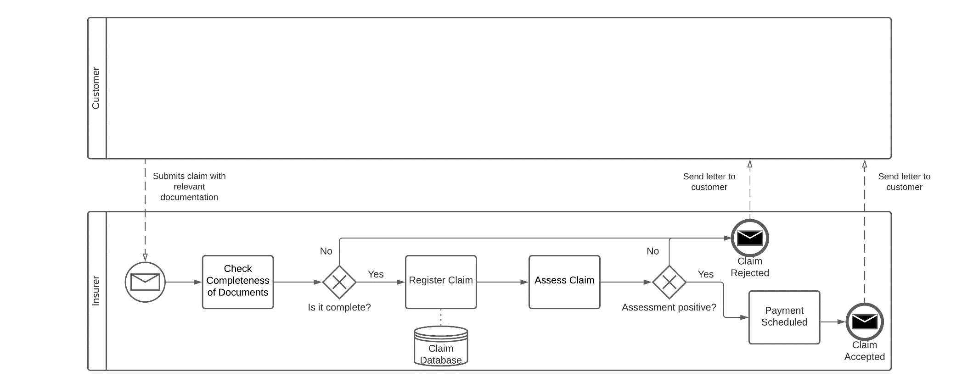 <https://lucid.app/invitations/accept/c1071bbc-953f-4f03-a894-fe20b45ccd2e>

1. **What types of Organisational Change occurred within the airline as result of COVID19? [8 marks]**

Virgin Australia has been one of the most severely impacted airlines as a result of COVID-19. The company entered voluntary administration in April 2020 to try to recapitalize the business after their biggest shareholders, including Richard Branson’s Virgin Group, and the federal government were unable to provide financial aid. 3000 Virgin Australia employees have also lost their jobs as a result of the whole situation. With the acquisition of Virgin Australia by Bain Capital, the CEO Paul Scurrah announced his resignation and is set to be replaced sometime in November 2020 by Jayne Hrdlicka, a former senior partner with Bain and the CEO of Jetstar from July 2012 to October 2017. Virgin announced they are planning to “create a stronger airline business” to survive the rest of COVID-19 and whatever the future may hold under their new owners Bain Capital. Virgin will no longer operate as a full-service carrier and will become a more cost leadership focused company. Virgin have also said that they will be operating a smaller fleet of Boeing 737s once flights resume after COVID.

Overall a significant level of organizational change has occurred within Virgin Australia and they have even been pushed to give ownership of the company to new owners Bain Capital. Virgin will focus more on cost leadership in the future as opposed to exemplary service which companies like Qantas and Emirates will likely continue to strive in.

1. **Customer Relationship Management (CRM)**

**• Explain how the airline would benefit from the implementation of a CRM system [4 marks].**

Virgin Australia would benefit from the implementation of a CRM system in multiple ways. A CRM system would give Virgin Australia a great source of information pertaining to their customers. They could then utilize this information to identify their most valuable customers and target market, therefore allowing them to create more flight sale opportunities and more successful promotions. CRM would also allow Virgin Australia to more easily maintain high-level customer service and allows them to personalize customer interactions which would make customers feel more appreciated by the company and therefore make them more likely to continue flying with Virgin Australia.

**• Propose a plan for how the airline would use CRM to increase customer satisfaction [4 marks].**

Virgin Australia could use CRM to increase customer satisfaction by directly implementing customer’s requests and informing their customer base when they do make these implementations. This could be further expanded upon by directly marketing and advertising to customers that new features are specifically tailored around them. Through collection of information regarding their customers, Virgin Australia could also create more personalized interactions through their customer service and marketing. Customers would feel like they are more affiliated and involved with the Virgin Australia brand, thereby increasing customer satisfaction with Virgin Australia and increasing customer retention.

Another way Virgin Australia could increase customer satisfaction is to encourage already satisfied customers to share their positive experiences to other customers through reviews and customer testimonials which could then be used in their advertising and on their website to affirm potential customers of the company’s reliability and quality of service.

Sources

* <https://www.investopedia.com/ask/answers/050415/what-companies-are-major-players-airline-supply-business.asp#:~:text=Airbus%20and%20Boeing%2C%20the%20world's,Airbus's%20A%2Dseries%20of%20jets>.
* <https://www.virginaustralia.com/au/en/about-us/company-overview/our-awards/>
* <https://www.virginaustralia.com/au/en/about-us/company-overview/the-virgin-family/>
* <https://www.virginaustralia.com/au/en/about-us/company-overview/virgin-australia-history/>
* <https://www.virginaustralia.com/au/en/about-us/sustainability/>
* <https://simpleflying.com/qantas-vs-virgin-australia/>
* <http://www.roymorgan.com/findings/8153-csa-results-august-2019-international-airline-satisfaction-201909300211>
* <https://travel.virginaustralia.com/au/coronavirus-update>
* <https://www.moodysanalytics.com/articles/2020/covid-19-disruption-pushes-virgin-australia-into-administration#:~:text=In%20February%202020%2C%20travel%20restrictions,next%20two%20to%20three%20months>.
* <https://australianaviation.com.au/2020/08/no-international-virgin-flights-for-two-years-says-scurrah-85308/>
* <https://www.abc.net.au/news/2020-09-04/bain-capital-new-owner-of-virgin-australia-creditors-vote-yes/12629528>
* <https://aviationstrategy.aero/newsletter/Feb-2001/7/CRM%3A_the_search_for_airline_customer_retention#:~:text=Customer%20Relationship%20Management%20(CRM)%20is,databases%20as%20a%20data%20sources>.