Novel Rectenna Design for RF Harvesting

Vrian Jay V. Ylaya¹, Robert R. Bacarro²

¹PhEdD-Technology Management, Graduate School, Surigao State College of Technology, Surigao City, Philippines 8400

²BS Electronics Engineering, CEIT, Surigao State College of Technology, Surigao City, Philippines 8400

Email Address: ¹vrianjayylaya@ssct.edu.ph, ²rbuba@ssct.edu.ph

Abstract—This paper presents a rectenna system that can harvest RF energy. The system features a differential microstrip antenna. The rectenna is integrated with an Adaptive Neuro-fuzzy inference system or an Adaptive Network-Based Fuzzy System. The implementation of an improved impedance matching circuit has shown great potential and can achieve a gain of 30dBi and a power output of 100uW. The design and implementation of the circuit are performed through simulation. The paper also describes a dual bandpass matching circuit that can improve the rectenna's working efficiency.

Keywords— Rectenna, Wireless sensor networks (WSN), Adaptive Neuro-Fuzzy Inference System, Differential Microstrip Antenna

Introduction
Conservation of energy can be initiated by taking advantage of the energy that's already been used [1]. This resource can be found in various forms, such as radio waves and wireless devices [2]. The key to harvesting this energy is finding a receiver that can receive and convert the signals [3].
One promising technology for energy harvesting is the use of radiofrequency (RF) energy [4]. This process was first introduced in the 1990s [5], and it can be utilized for supplying continuous power to standalone devices [6].
A rectenna is a type of antenna that's used to convert electromagnetic energy into DC power [7]. It's commonly used in wireless transmission systems to transmit signals [8]. The efficiency of this type of antenna is the most important factor to evaluate its performance [9].
This paper aims to provide a comprehensive design for the rectenna system, which will allow for improved efficiency and wideband frequencies.

Conceptual Framework of The Study
This section explains the conceptual framework of the study to develop a novel rectenna which consists of a block diagram of the study, receiving signal, radio link & Friis equation and free space path loss [10].
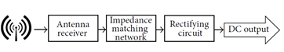
Fig. 1. Block Diagram
- Receiving Antenna and the Free Space Transmission
Any devices that cater information signal such as distribution of internet in the Wi-Fi modem and hibernation of mobile phones emits signals from time to time. Transmitting aperture area At, receiving aperture area Ar, transmitted signal wavelength λ, and the separation of distance between the aperture is D [11].
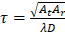 (1)
The size and expense of these components are related to the used wavelength and the desired transmission efficiency [12]. The relationship between these two factors is given in Equation 1 where power density at the receiving location Pr, total radiated power from the transmitter is Pt, total area of the transmitting antenna, and the distance between apertures D [13].
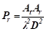 (2)
At the receiver side, to achieve a desired value of Pr while being constrained by a fixed transmitter power Pt, the transmitting aperture area varies as the inverse square of the wavelength of the radiation [14].
- Radio Link and Friis Equation
The gain and power of a general radio link are indicated in the figure shown. The distance R is the distance between the transmit and receiver antenna [15]:
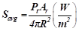 (3)
This concept is deduced from the fact that the power radiated by the antenna is distributed isotopically and has an area of 4R2 [16]. If the antenna has a positive, then the radiated power density can be calculated by multiplying it [17].
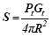 (4)
Also, we can include the radiation efficiency factor if the transmitter antenna has losses. Thus, the general expression for the power density radiated by an arbitrary transmit antenna is [18]:
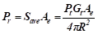 (5)
In this example, the power density formula is used to obtain the received power.
- Free Space Path Loss
This loss occurs when a radio transmission's signal strength is lost through free space. It is usually caused by the absence of nearby obstructers. The first effect is electromagnetic energy spreading out in free space, while the second one is loss of signal strength where power unit area S and the total power transmitted Pt [19].
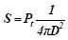 (6)
The second effect is that of the receiving antenna's aperture, which describes the antenna's power receiving capacity from an incoming electromagnetic wave [13]. For an isotropic antenna, this is derived by [20]:
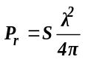 (6)
The total free-space loss path can be derived by combining the following effects. It becomes proportional to the distance between the receiver and transmitter where the signal wavelength λ, signal frequency f, distance from the transmitter d, and the speed of light c [21].
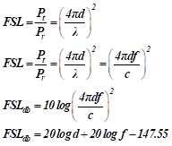 (7)
- Antenna Design
A dual-layered, electromagnetically coupled, rectangular, and inverted suspended microstrip antenna is commonly referred to as a differential microstrip antenna [7]. The top patch is made up of a suspended microstrip and a dielectric cover.
The top patch is coupled with a bottom patch to increase its bandwidth. The dielectric constant of the top patch is very low, which leads to a higher gain [17]. The bottom patch can also be shorted to the ground to provide a center grounded antenna. The air gap between the top and bottom patches is also considered to design the appropriate size [21].
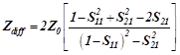 (8)
The Zdiff and Zo impedance of the bottom patch are the properties of the microstrip patch antenna that are required to match the DUT's input impedance [6].
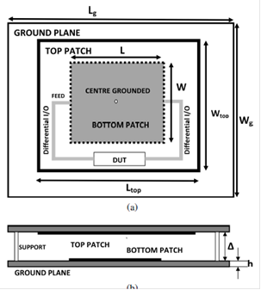
Fig. 2. EM Simulation using WIPL-D
The idea in specifications are done using variations of differential impedances. The Zdiff and Zo impedance of the bottom patch are the properties of the microstrip patch antenna that are required to match the DUT's input impedance [10].
An Adaptive Neuro-fuzzy inference system will allow the antenna to turn on and off according to the frequency of the available signal [19].
- Improved Impedance Matching Technique
The goal of impedance matching is to match the frequencies of two different terminations, such as the Resource and RLoad, without having to control the stop-band frequencies.
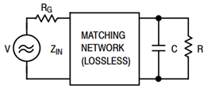
Fig. 3. General Matching Conditions

The reflection coefficient between transformed load and generator is equal to Γ where this is zero when perfectly match, and one in total reflection [1].
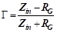 (9)
The ratio of the reflected incident power is:
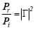 (10)
The fundamental limitation on the matching takes the form:
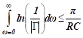 (11)
Inductors and capacitors are commonly used in bandpass filters, which are used in radiofrequency applications. These components enable the transmission of a wide range of frequencies [11].
One of the main drawbacks of energy harvesting is the issue of mismatched components. This can affect the system's performance. This research aims to introduce a new dual bandpass matching circuit [8].
To avoid this issue, the researcher focused on establishing input power levels that are low enough to allow the system to perform well. An additional section was then added to the circuit to increase its efficiency as shown if Figure 4.
- Rectifier Design and Performance
The tunnel field-effect transistor, also known as TFET, is a type of transistor that exhibits a different fundamental switching mechanism than a metal-oxide-semiconducting field-effect transistor [13].

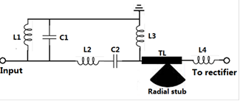
Fig.4. Bandpass Filters Design

The performance metrics of an RF rectifier are mainly concerned with the output power, voltage, and PCE. To achieve a high PCE, minimizing power losses is very important. The use of high on-state current and steep slope characteristics can help minimize these losses [7].
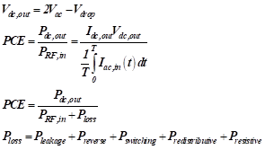
The average power loss in a rectifier is indicated by the PLOSS, which includes the leakage loss, the PSWITCHING, the reverse conduction loss, and the PREDISTRIBUTIVE [9].
The power loss from the lumped voltage across a rectifier circuit is referred to as the PDROP. This component is typically reduced using various device characteristics such as high on-state current, steep slope, and uni-directional conduction [3].
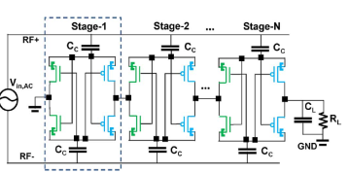
Fig. 5. Multiple Stage Rectifier using H4T

The input impedance of a circuit is affected by the load level, frequency, and power level. This design feature of multiple-stage rectifiers is commonly used to reduce PCE degradation.

Results and Discussion
The conversion efficiency of a given power band is calculated by considering the fraction of output power and the average total power that the band receives:
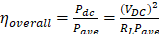 (12)
where PDC is the output power, Pave is the average total received power in the band, VDC is the output voltage, and RL is the load.

TABLE I. Comparison of the proposed rectenna and related designs
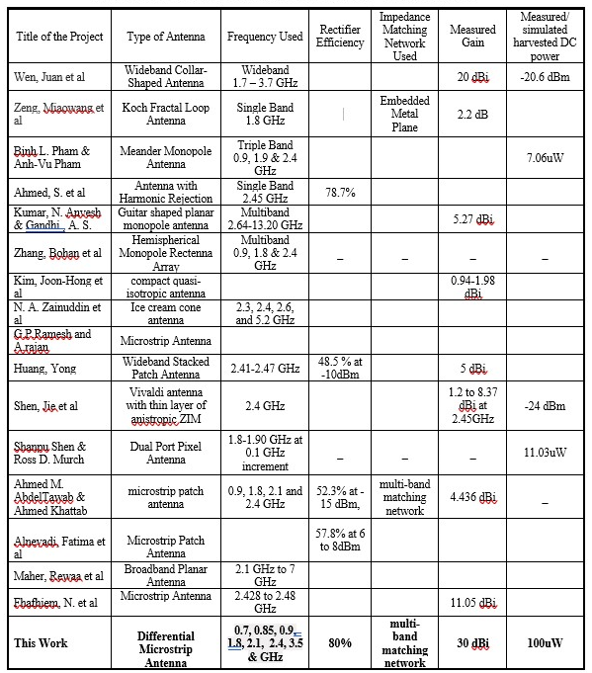

In comparing our rectenna design to some of the other designs, we found that their outputs are significantly smaller than our proposed output power. Aside from being able to receive random polarization, our design also has a stable performance for wide range of load conditions. Most of the designs are optimized for a fixed load, and the conversion efficiency is dependent on the load. The proposed rectenna design is a very good candidate for energy harvesting in real-world applications.

Conclusion
A novel rectenna design for RF energy harvesting is presented. The implementation of an improved impedance matching circuit has shown great potential and can achieve a gain of 30dBi and a power output of 100uW. The design and implementation of the circuit are performed through simulation. The proposed design can be widely used in low-power wireless applications. It achieves its outstanding performance despite the varying conditions.
References
[1] D. Ma, G. Lan, M. Hassan, W. Hu, and S. K. Das, “Sensing, Computing, and Communications for Energy Harvesting IoTs: A Survey,” IEEE Commun. Surv. Tutorials, vol. 22, no. 2, pp. 1222–1250, Apr. 2020, doi: 10.1109/COMST.2019.2962526.
[2] W. C. Brown, “The History of Power Transmission by Radio Waves,” IEEE Trans. Microw. Theory Tech., vol. 32, no. 9, pp. 1230–1242, 1984, doi: 10.1109/TMTT.1984.1132833.
[3] J. Bito, J. G. Hester, and M. M. Tentzeris, “Ambient RF Energy Harvesting from a Two-Way Talk Radio for Flexible Wearable Wireless Sensor Devices Utilizing Inkjet Printing Technologies,” IEEE Trans. Microw. Theory Tech., vol. 63, no. 12, pp. 4533–4543, Dec. 2015, doi: 10.1109/TMTT.2015.2495289.
[4] L. G. Tran, H. K. Cha, and W. T. Park, “RF power harvesting: a review on designing methodologies and applications,” Micro Nano Syst. Lett., vol. 5, no. 1, pp. 1–16, Dec. 2017, doi: 10.1186/S40486-017-0051-0/TABLES/5.
[5] C. A. Reynaud et al., “Rectifying antennas for energy harvesting from the microwaves to visible light: A review,” Prog. Quantum Electron., vol. 72, p. 100265, Aug. 2020, doi: 10.1016/J.PQUANTELEC.2020.100265.
[6] K. Afridi, “Wireless charging of electric vehicles,” Bridge, vol. 47, no. 4, pp. 17–22, Dec. 2017, doi: 10.1016/B978-0-12-811407-0.00038-6.
[7] M. Aboualalaa and H. Elsadek, “Rectenna Systems for RF Energy Harvesting and Wireless Power Transfer,” Recent Wirel. Power Transf. Technol., Oct. 2019, doi: 10.5772/INTECHOPEN.89674.
[8] S. Agrawal, M. S. Parihar, and P. N. Kondekar, “Broadband Rectenna for Radio Frequency Energy Harvesting Application,” https://doi.org/10.1080/03772063.2017.1356755, vol. 64, no. 3, pp. 347–353, May 2017, doi: 10.1080/03772063.2017.1356755.
[9] A. Boivin and R. Tremblay, “Concepts and Techniques of Microwave Optics,” Appl. Opt. Vol. 5, Issue 2, pp. 249-278, vol. 5, no. 2, pp. 249–278, Feb. 1966, doi: 10.1364/AO.5.000249.
[10] by Dr-Ing Marwan Younis Sevda Abadpour, “Lecture notes for Advanced Radio Communication I,” Accessed: Mar. 17, 2022. [Online]. Available: www.ihe.kit.edu.
[11] T. Norman, “Radio Frequency Systems,” Integr. Secur. Syst. Des., pp. 251–266, 2014, doi: 10.1016/B978-0-12-800022-9.00012-7.
[12] “Free Space Path Loss: Details & Calculator » Electronics Notes.” https://www.electronics-notes.com/articles/antennas-propagation/propagation-overview/free-space-path-loss.php (accessed Mar. 17, 2022).
[13] S. Farahani, “RF Propagation, Antennas, and Regulatory Requirements,” ZigBee Wirel. Networks Transceivers, pp. 171–206, 2008, doi: 10.1016/B978-0-7506-8393-7.00005-4.
[14] M. Arrawatia, M. S. Baghini, and G. Kumar, “Differential microstrip antenna for RF energy harvesting,” IEEE Trans. Antennas Propag., vol. 63, no. 4, pp. 1581–1588, Apr. 2015, doi: 10.1109/TAP.2015.2399939.
[15] “A Fully Differential Electromagnetically Coupled Microstrip Antenna | Industrial Research and Consultancy Centre.” https://rnd.iitb.ac.in/technology/fully-differential-electromagnetically-coupled-microstrip-antenna (accessed Mar. 17, 2022).
[16] W. R. Deal, V. Radisic, Y. Qian, and T. Itoh, “Microwave Active Circuits and Integrated Antennas,” Electr. Eng. Handb., pp. 691–706, 2005, doi: 10.1016/B978-012170960-0/50048-7.
[17] N. K. Das, “Antennas and Radiation: II Antenna Elements and Arrays,” Electr. Eng. Handb., pp. 569–583, 2005, doi: 10.1016/B978-012170960-0/50043-8.
[18] “important Impedance_Matching.pdf - Impedance Matching Iulian Rosu, YO3DAC / VA3IUL, http:/www.qsl.net/va3iul/ The term Impedance is a general term which | Course Hero.” https://www.coursehero.com/file/59008676/important-Impedance-Matchingpdf/ (accessed Mar. 17, 2022).
[19] A. Bakkali, J. Pelegri-Sebastia, T. Sogorb, V. Llario, and A. Bou-Escriva, “A Dual-Band Antenna for RF Energy Harvesting Systems in Wireless Sensor Networks,” J. Sensors, vol. 2016, 2016, doi: 10.1155/2016/5725836.
[20] N. D. Chien and C. H. Shih, “Oxide thickness-dependent effects of source doping profile on the performance of single- and double-gate tunnel field-effect transistors,” Superlattices Microstruct., vol. 102, pp. 284–299, Feb. 2017, doi: 10.1016/J.SPMI.2016.12.048.
[21] A. Godinho et al., “A Dynamic Threshold Cancellation Technique for a High-Power Conversion Efficiency CMOS Rectifier,” Sensors (Basel)., vol. 21, no. 20, Oct. 2021, doi: 10.3390/S21206883.

