Request For Proposal for
Waste Development Study

[LOGO]

[SPV NAME]

23rd November 2022

Rev. | Purpose of Issue | Date | Originator | Approved
5.00 | First version | 23rd Nov 2022 | Mr. Rijswijk

Table of Contents

1 Definitions 3
2 Project Background 4
3 RFP Outline 5
3.1 Objective 5
3.2 Award criteria 6
4 Data sheet 7
5 Terms of Reference (TOR) 8
5.1 Scope of Work 8
5.2 Deliverables & Milestones 9
5.3 Project Management 10
6 Proposal requirements 11
6.1 Minimum Administrative Requirements 11
6.2 Technical Proposal 11
6.3 Financial Proposal 12
Annexure I – Data sheet 13
Annexure II – Minimum Administrative Requirements 14
Annexure III – Terms and Conditions 15
Annexure IV – Project reporting template 16

Definitions

Abbreviation or Term | Definition
Bidder | A business entity or consortium that submits its Proposal according and in response to this RFP
Consultant | The selected Bidder selected, bound by a signed contract
FIDIC | International Federation of Consulting Engineers
IFC | International Finance Corporation
Price | Total cost of the Proposal, containing all related costs for all the work required
Proposal | The offer made by the Bidder according to this RFP, for consideration or acceptance
RFP | Request for Proposal
SPV | Special Purpose Vehicle “[SPV NAME]”
WtE | Waste-to-Energy

Project Background

The company [SPV NAME] consisting of strong and knowledgeable partners in the field of Waste-to-Energy (WtE) plants, has the ambition to develop and construct a world-class “beyond Best Available Technology” facility in [PROJECT], with a capacity of processing around [TPD] tons of waste per day (the Project). The proposed plant will produce around net [MW] MW of electricity to be sold to the grid, depending on the caloric value of the waste.

[BRIEF PROJECT HISTORY + STATUS].

[SPV NAME] is specifically set up to pursue opportunities in [COUNTRY] to develop WtE plants with Harvest Waste’s High Efficiency WtE technology based on and similar to the AEB WtE plant in Amsterdam, The Netherlands. This reference plant uses the world’s most efficient technology for generating electricity from waste and it will treat the current and future municipal solid waste of [PROJECT]. WtE technology minimizes land requirements and produces baseload clean energy. In addition to that, the remaining slag from the incineration process can be recycled to further reduce landfills and provide valuable inert materials and metals for the construction industry.

The waste development study, together with the results of the waste characterization study, must lead to a tenable determination of the future waste composition and its calorific value. It shall be executed according to the standards as prescribed in this RFP.

For any further information please contact

Name: Mr. Lars Rijswijk
Email: l.rijswijk@harvestwaste.com
Tel: +31650224330

RFP Outline

Objective

The SPV concludes contracts for a 25-year period. For this, it is necessary to make the best possible prediction about the future development of the waste composition as well. That is why, parallel to the waste characterization study, this waste development study is requested. The results will allow the SPV obtain an accurate picture of the current and future waste composition and accurately validate assumptions in line with the project business case.

- The waste development study, together with the results of the waste characterization study, must lead to a tenable determination of the future waste composition and its calorific value.

This can be achieved by obtaining an understanding of the current and future waste composition, the waste management chain, waste policies, the waste origin, and to gain insights into the potential recycling potential and identify potential interventions which can be taken jointly with the local government to improve the waste management system in the [PROJECT] Governorate.

The study shall be executed in close cooperation with and under supervision of technology provider of [SPV NAME] (Harvest Waste).

Award criteria

Section | Criterium | Max. points
1 – Minimum administrative requirements | Pass – Fail  All requirements must be met by the Bidder. If one item will not be met, the Proposal will not be evaluated. | N/A
2 – Technical Proposal | Project Approach  Bidder to provide a description of its company and project approach, including a project schedule with a visible critical path. Milestones, stipulated in the previous paragraph, must be included in the schedule. If the Bidder decides to participate as a consortium, the split of scope must be made known. The project approach will be assessed in conjunction with the planning. | 25
 | Project references  Bidder to provide references. The better these references match with the TOR of this RFP, the higher this item will be valued. | 25
 | Project team  Bidders’ proposed project team and CV’s will be evaluated on applicable references | 25
3 – Financial Proposal | Price level  The lump sum price in USD. The award of points is made relative to the lowest price. Best bidder gets 25 points. The % deviation from the lowest price is also the % that is deducted from 25 points. Calculation example below | 25

Calculation example award of points for financial proposal

Bidder 1 – USD 100,000 – lowest bidder = reference for calculation - 25 points
Bidder 2 – USD 120,000 – 20% higher than lowest bid - 20 points
Bidder 3 – USD 150,000 – 50% higher than lowest bid - 12,5 points

Data sheet

[SPV NAME] will provide the following project information upfront, as input for the Bidders’ Proposal

- SPV’s bid proposal for [PROJECT], including (amongst others)
- Preliminary Waste Acceptance criteria

All information provided will be verified and validated during feasibility phase. The assumptions, assessments, statements, and information contained in this Data sheet, may not be complete. This information may only be used to develop a Proposal.

For study results and reporting, each Bidder should, therefore, conduct its own investigations and analysis and should check the accuracy, adequacy, correctness, reliability and completeness of the assumptions, assessments, statements, and information contained in this Data Sheet and obtain independent advice from appropriate sources.

This Data Sheet information is provided in Annexure I

Terms of Reference (TOR)

This TOR is the basis for the request for proposal, consultancy agreement and the final study results. The TOR consists of two elements:

- Scope of Work provides a non-exhaustive list of activities to be performed by the Consultant and criteria, standards, and guidelines against which the Consultant must assess the project.
- Deliverables & Milestones specifies the minimum requirements that reports and results must comply with.
- Project Management prescribes what SPV expects from Consultant with regard to basic project management areas like progress reporting, planning, variations management, etc.

Scope of Work

The scope of the study must entail the following activities/items:

- Map the current waste management situation; strategy, logistics, collection schemes, waste sources etc.
- Assess the recycle potential for current and future MSW and compliance with the waste acceptance criteria (in close cooperation with the WCS)
- Provide the impact of population and economic factor in the region (current, expected, economic, wealth, etc.). Map the development of the waste production (amount, quality) on the population and economic growth.
- Policies, regulations, and waste management strategies (in development). Existing available policies, legal and regulatory documents (current & planned) relevant to SWM, must be assessed and gaps must be identified that need to be addressed. Current regulation must be compared with good international practice.
- Financial structure for waste management.
  - Define how current waste management systems are financed, including tariff system, billing system, fee collection and, if any, full cost recovery.
  - Mapping all stakeholders for governmental, private, and other organizations directly and indirectly involved in the management of solid waste in the project area.
  - Mapping of the existing organizational setup and current staffing
  - Assess the institutional capacity of the relevant authorities
- Reporting

Deliverables & Milestones

The assessment must end up in a report with summary and conclusions, using the results of the SOW as an index.

Activity | Deliverable / result | Minimum Requirement | Milestone
Kick off meeting | Workshop & minutes | Introduce key personnel from [SPV NAME] and Bidder  Introduce Consultants’ the project approach:  - organisation, roles & responsibilities  - project schedule & milestones  - communication  - involved stakeholders  - proposed deliverables  - indicate required initial data | M1  t = 0
SoW item 1-5 | Draft report | - Reporting structure according to the objective of this study (3.1) and the items, described in paragraph 5.1.  - Additionally, include conclusions, summary and recommendations | M2  t + 12 weeks
Review by SPV | Review results | Review of draft report by [SPV NAME] | t + 14 weeks
SoW item 6 | Final report | - Reporting structure according to the objective of this study (3.1) and the items, described in paragraph 5.1.  - Additionally, include conclusions, summary and recommendations | M3  t + 16 weeks

Final time frame may be negotiated with Bidder prior to contract signing.

Project Management

Project reporting
In general, project baselines define starting points for
- project scope (according to this RFP)
- project schedule (based on the RFP milestones)
- project cost (financial proposal)

These baselines are fixed reference points to measure and compare the project’s progress against. This allows SPV to assess the performance of the project over time. Any proposed changes to a baseline document, will be subject to variations management.

As a minimum, a formal monthly progress report is requested for:
- Project progress, Summary of last developments and next steps, in brief wording
- Project schedule: schedule baseline vs actual and a forecast
- Project risks Log: top 3-5 risks, including suggested mitigations and impact value
- Project variations Log: variations requests status impacting budget & schedule

The SPV will hold weekly update meetings with the Consultant. This will be done online or live, subject to availability.

The reporting template is provided in Annexure IV.

Project Scheduling
The project schedule must serve to:
- represent how and when the project will deliver the project scope
- serve as a tool for communication and managing stakeholders’ expectations
- serve as a basis for performance reporting

The Consultants’ project schedule must be made available in editable format, preferably in Microsoft Projects, Excel or comparable

Variations management
The Consultant may request a change. Issues, found while the project work is performed, could lead to a ‘variation’, and may modify any deliverable of project baseline and requires a variations request, to be made by the initiator.

Only approved variations may be executed and, after approval, will be incorporated into a revised baseline. Inspections can be used to verify whether a variation request has been followed up according to the approval.

Proposal requirements

The language of the Proposal must be in English. The Bidders’ Proposal must consist of the following three sections.

Minimum Administrative Requirements

Proposals which comply with minimum requirements and criteria will be the subject to evaluation. Minimum administrative requirements will be evaluated using ‘pass or fail’ criteria. If one of these requirements is not met, [SPV NAME] holds the right to not evaluate the Proposal. The list of administrative requirements is provided in Annexure II. Bidder will have to provide a signed version of Annexure II.

Technical Proposal

Type | Requirement | Proof (free format)
Project Approach | - A description of the methods applied, applicable standards, the proposed management structure, how it plans to ensure the quality of its performance; and its capability to quickly mobilize required experts.  - A project schedule, specified in weeks, including visible critical path and milestones  - If the Bidder decides to participate as a consortium, the consortium members and split of scope must be made known. | Description  Gantt chart  Consortium companies, split of scope
Project References | - Demonstration of experience in similar projects for (international) financial Institutions like IFC, the World Bank or Asian Development Bank | Reference list, for each project, include:  - Project description  - Client name  - Start date & completion date
Project team | - Project team lead  - Suitably qualified personnel required to perform the contract. Indication of specialists. Combined roles may be performed by one person | - Organogram of the project organisation  - CV of Project Manager and project team members

Financial Proposal

Financial proposal outline

Bidder must include a Financial Proposal, with the following content:
- The Price, based on lump sum
- A breakdown of the Price in separate cost items according to the items in the Statement of Work, with specification of hourly effort of each project member.
- Its liability cap to the SPV, expressed in USD amount and as percentage (%) of its lump sum proposal.
- Standard hourly rate tables for consideration due to variations

Payment milestones

# | Description | Deliverable | Payment
M1 | Kick off meeting | Minutes of the workshop | 30%
M2 | Draft report | Draft report | 30%
M3 | Final report | Final report | 40%

The final payment term is set on 40%. This expresses the importance for the SPV to obtain the final report, according to schedule.

Annexure I – Data sheet

Annexure II – Minimum Administrative Requirements

Regarding this RFP, I the undersigned with authority on behalf of [name of Bidder Company]

Name: [……………………………………………………………………]
Position: [……………………………………………………………………]
Company: [……………………………………………………………………]

declare that the Proposal complies with the requirements, provided in the table below:

No | Requirement | Initials
1 | Bidder is not in a state of bankruptcy, insolvency, or receivership
2 | Bidder is not subject to the suspension of its business activities
3 | Bidder is not subject to any pending criminal lawsuits
4 | Bidder is not listed on any debarment list published by multilateral financial institutions
5 | Bidder has no conflicts of interest in undertaking this assignment
6 | Bidder agrees to sign a Non-Disclosure Agreement with the SPV

Although the requirements will apply to all subcontractors as well, the Consultant will be liable for its application.

This Statement has been made truthfully.

[signature]

[date]

Annexure III – Terms and Conditions

In general, Consultant must cooperate with information requests from the SPV’s lenders (i.e. access to the Consultant’s books, accounts and records, access to the Consultant’s premises).

FIDIC Client / Consultant Model Services Agreement, Fifth edition 2017 will be applicable.

Some clauses will be subject to negotiation with the selected Bidder.
- The SPV proposes to include additions and amendments to ‘Part A Particular Conditions’
- The SPV proposes to include additions and amendments to ‘Part B Additional or Amended Clauses’ of the FIDIC Client / Consultant Model Services Agreement’

Part A and Part B are provided on the next pages.

Annexure IV – Project reporting template

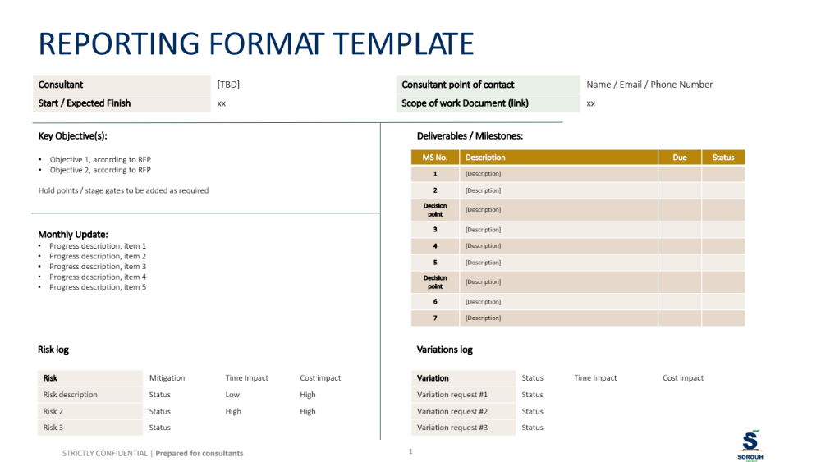

www.harvestwaste.com
Power Purchase Agreement (PPA) and Waste Concession (WC)
Bidder is allowed to participate as a Consortium. In that case, the minimum administrative requirements must also be met by the subcontractors
Bidder to include company quality standards like ISO9001/14001/45001, if applicable
Where appropriate, quantitative metrics are to be used to clarify forecast information
According to reference framework
As specified in FIDIC White (5th Edition)

