**Final Group Project – DBAS 3017**

**Project Data AND overview.**

Select a dataset for your project that you and your group find interesting.

The dataset should be large enough in scope to ensure that you will be able to create several charts. It is suggested to have some geospatial component to your data so that you can include a map in your final presentation/report. Including a temporal element will allow you to show changes over time, which would also be a good idea. Prior approval of your selected dataset is required. Emphasis should be paced on “good” data visualization and you should allow the data to tell the Story. Your Story should make use of the Pre-attentive Visual Properties including: Colour, Form, Motion and Spatial Positioning

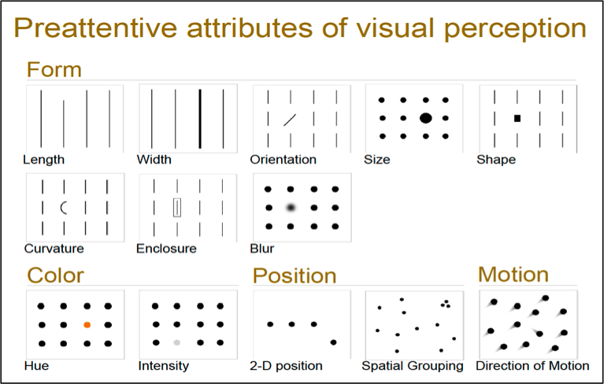

**Project Deliverables.**

Project Documentation

Your Final Project should include the following:

1. *A link to the raw data*
2. *Your Final PowerPoint presentation*

Depending on what two data Visualization Tools you select you will need to submit the following:

1. *A link to your Flourish Project (*[https](https://nscc-my.sharepoint.com/personal/w0038182_campus_nscc_ca/Documents/Classes/Fall2020/OSYS%203017%20-%20DataMangementinLinux/GroupFinalProject/https)[://app.flourish.studio/projects](https://app.flourish.studio/projects)*)*
2. *A copy of your SSRS Report in pdf*
3. *Your MS Power BI file (pbix)*
4. *MS Excel Spreadsheet*
5. *R script/s*

You will be Graded based on the following

1. Use of Preattentive Attributes
2. Your Storytelling/Journalism – Engagement of Peers
3. Clarity of message conveyed
4. Ability to present temporal data in a cohesive and understandable manner
5. Ability to present spatial data using a clear and legible map
6. Presentation of relevant Descriptive Statistics
7. References to all sources in APA style
8. Marks will be lost based on:
   1. Aesthetic Issues
   2. Perceptual Issues
   3. Substantive Issues

Final Presentation [Week 14 – Start Friday 8th December]

The Final Group Presentation should be a live demo, and include the use of at least two of the following data Visualization Tools:

1. MS Excel – pivot table, descriptive statistics, histogram
2. MS PowerBI – map, tables, graphs
3. R – descriptive statistics, kernel density plot, histogram, scatter plot, or bar chart
4. SSRS Report – graphs, tablix
5. Flourish – live graph/s

Your Group’s Grade will be based on:

1. Presentation 20 mins (20pts)
2. Use of Visualization Tools (10pts)

The Project Documentation will be due by start of class on 8th December. All submissions are to be made via an Email. The subject line of the email should include the following: **DBAS 3017 Group <A,B,C,D,E> - Final Project Documentation**

NOTE: Late submissions will not be accepted. No exceptions will be made.