**C.R.U. (Conflagration Response Unit)** Game Design Document (GDD)



***‘Hell fire looms on the horizon. Get everyone out!’*** – Full House Studios

This page: Table of Contents and Team Member Listing

|  |  |  |
| --- | --- | --- |
| Table of Contents  [1 Game Overview](https://n-xovwktmtjsnaxyc2mwes2xu7pohqedmdm6zjw5q-2lu-script.googleusercontent.com/userCodeAppPanel)  [2 High Concept](https://n-xovwktmtjsnaxyc2mwes2xu7pohqedmdm6zjw5q-2lu-script.googleusercontent.com/userCodeAppPanel)  [3 Unique Selling Points](https://n-xovwktmtjsnaxyc2mwes2xu7pohqedmdm6zjw5q-2lu-script.googleusercontent.com/userCodeAppPanel)  [4 Platform Minimum Requirements](https://n-xovwktmtjsnaxyc2mwes2xu7pohqedmdm6zjw5q-2lu-script.googleusercontent.com/userCodeAppPanel)  [5 Competitors / Similar Titles](https://n-xovwktmtjsnaxyc2mwes2xu7pohqedmdm6zjw5q-2lu-script.googleusercontent.com/userCodeAppPanel)  [6 Synopsis](https://n-xovwktmtjsnaxyc2mwes2xu7pohqedmdm6zjw5q-2lu-script.googleusercontent.com/userCodeAppPanel)  [7 Game Objectives](https://n-xovwktmtjsnaxyc2mwes2xu7pohqedmdm6zjw5q-2lu-script.googleusercontent.com/userCodeAppPanel)  [8 Game Rules](https://n-xovwktmtjsnaxyc2mwes2xu7pohqedmdm6zjw5q-2lu-script.googleusercontent.com/userCodeAppPanel)  [9 Game Structure](https://n-xovwktmtjsnaxyc2mwes2xu7pohqedmdm6zjw5q-2lu-script.googleusercontent.com/userCodeAppPanel)  [10 Game Play](https://n-xovwktmtjsnaxyc2mwes2xu7pohqedmdm6zjw5q-2lu-script.googleusercontent.com/userCodeAppPanel)  [10.1 Game Controls](https://n-xovwktmtjsnaxyc2mwes2xu7pohqedmdm6zjw5q-2lu-script.googleusercontent.com/userCodeAppPanel)  [10.2 Game Camera](https://n-xovwktmtjsnaxyc2mwes2xu7pohqedmdm6zjw5q-2lu-script.googleusercontent.com/userCodeAppPanel)  [10.2.1 HUD](https://n-xovwktmtjsnaxyc2mwes2xu7pohqedmdm6zjw5q-2lu-script.googleusercontent.com/userCodeAppPanel)  [10.2.2 Maps](https://n-xovwktmtjsnaxyc2mwes2xu7pohqedmdm6zjw5q-2lu-script.googleusercontent.com/userCodeAppPanel)  [11 Players](https://n-xovwktmtjsnaxyc2mwes2xu7pohqedmdm6zjw5q-2lu-script.googleusercontent.com/userCodeAppPanel)  [11.1 Characters](https://n-xovwktmtjsnaxyc2mwes2xu7pohqedmdm6zjw5q-2lu-script.googleusercontent.com/userCodeAppPanel)  [11.2 Metrics](https://n-xovwktmtjsnaxyc2mwes2xu7pohqedmdm6zjw5q-2lu-script.googleusercontent.com/userCodeAppPanel)  [11.3 States](https://n-xovwktmtjsnaxyc2mwes2xu7pohqedmdm6zjw5q-2lu-script.googleusercontent.com/userCodeAppPanel)  [11.4 Weapons](https://n-xovwktmtjsnaxyc2mwes2xu7pohqedmdm6zjw5q-2lu-script.googleusercontent.com/userCodeAppPanel)  [12 Player Line-up](https://n-xovwktmtjsnaxyc2mwes2xu7pohqedmdm6zjw5q-2lu-script.googleusercontent.com/userCodeAppPanel)  [13 NPC](https://n-xovwktmtjsnaxyc2mwes2xu7pohqedmdm6zjw5q-2lu-script.googleusercontent.com/userCodeAppPanel)  [13.1 Enemies](https://n-xovwktmtjsnaxyc2mwes2xu7pohqedmdm6zjw5q-2lu-script.googleusercontent.com/userCodeAppPanel)  [13.1.1 Enemy States](https://n-xovwktmtjsnaxyc2mwes2xu7pohqedmdm6zjw5q-2lu-script.googleusercontent.com/userCodeAppPanel)  [13.1.2 Enemy Spawn Points](https://n-xovwktmtjsnaxyc2mwes2xu7pohqedmdm6zjw5q-2lu-script.googleusercontent.com/userCodeAppPanel)  [13.2 Allies / Companions](https://n-xovwktmtjsnaxyc2mwes2xu7pohqedmdm6zjw5q-2lu-script.googleusercontent.com/userCodeAppPanel)  [13.2.1 Ally States](https://n-xovwktmtjsnaxyc2mwes2xu7pohqedmdm6zjw5q-2lu-script.googleusercontent.com/userCodeAppPanel)  [13.2.2 Ally Spawn Points](https://n-xovwktmtjsnaxyc2mwes2xu7pohqedmdm6zjw5q-2lu-script.googleusercontent.com/userCodeAppPanel)  [14 Art](https://n-xovwktmtjsnaxyc2mwes2xu7pohqedmdm6zjw5q-2lu-script.googleusercontent.com/userCodeAppPanel)  [14.1 Setting](https://n-xovwktmtjsnaxyc2mwes2xu7pohqedmdm6zjw5q-2lu-script.googleusercontent.com/userCodeAppPanel)  [14.2 Level Design](https://n-xovwktmtjsnaxyc2mwes2xu7pohqedmdm6zjw5q-2lu-script.googleusercontent.com/userCodeAppPanel)  [14.3 Audio](https://n-xovwktmtjsnaxyc2mwes2xu7pohqedmdm6zjw5q-2lu-script.googleusercontent.com/userCodeAppPanel)  [15 Procedurally Generated Content](https://n-xovwktmtjsnaxyc2mwes2xu7pohqedmdm6zjw5q-2lu-script.googleusercontent.com/userCodeAppPanel)  [15.1 Environment](https://n-xovwktmtjsnaxyc2mwes2xu7pohqedmdm6zjw5q-2lu-script.googleusercontent.com/userCodeAppPanel)  [15.2 Levels](https://n-xovwktmtjsnaxyc2mwes2xu7pohqedmdm6zjw5q-2lu-script.googleusercontent.com/userCodeAppPanel)  [15.3 Artificial Intelligence NPC](https://n-xovwktmtjsnaxyc2mwes2xu7pohqedmdm6zjw5q-2lu-script.googleusercontent.com/userCodeAppPanel)  [15.4 Visual Arts](https://n-xovwktmtjsnaxyc2mwes2xu7pohqedmdm6zjw5q-2lu-script.googleusercontent.com/userCodeAppPanel)  [15.5 Audio](https://n-xovwktmtjsnaxyc2mwes2xu7pohqedmdm6zjw5q-2lu-script.googleusercontent.com/userCodeAppPanel)  [15.6 Minimum Viable Product (MPV)](https://n-xovwktmtjsnaxyc2mwes2xu7pohqedmdm6zjw5q-2lu-script.googleusercontent.com/userCodeAppPanel)  [16 Wish List](https://n-xovwktmtjsnaxyc2mwes2xu7pohqedmdm6zjw5q-2lu-script.googleusercontent.com/userCodeAppPanel)   |  | | --- | |  | | Game Development Team Members    PRODUCER  Samer Madieh  James Lee  James Chi Lee  Jonathan D’Anneo    PRODUCTION MANAGER  Samer Madieh  James Lee  James Chi Lee  Jonathan D’Anneo    PRODUCTION COORDINATOR  Samer Madieh  James Lee  James Chi Lee  Jonathan D’Anneo  GAME DESIGNERS  Samer Madieh  PROGRAMMERS  Samer Madieh  James Lee  James Chi Lee  Jonathan D’Anneo  TECHNICAL ARTISTS  James Chi Lee  AUDIO ENGINEERS  James Lee  UX TESTERS  Samer Madieh  James Lee  James Chi Lee  Jonathan D’Anneo |

|  |
| --- |
|  |

# 1. GAME OVERVIEW

**Title:** C.R.U. (Conflagration Response Unit)

**Platform:** PC/Mac

**Genre:** Simulation

**Rating:** (10+) ESRB

**Target:** Casual gamer (aging from 12 - 30)

**Release date:** December 2020

**Publisher:** Full House Studios

C.R.U. is a third-person simulation game where the Player is a rescue worker who is tasked with rescuing citizens before a wildfire engulfs the whole town. The more citizens the Player rescues, the more points they will accrue. In addition, they must avoid obstacles littered throughout the town as, if the rescue vehicle takes too much damage, it will break down and they will lose the game. Twice per game, an optional quest will spawn that will allow the Player to rescue an animal, thereby increasing their score.

2. HIGH CONCEPT

C.R.U. places the Player, a rescue worker, in a safe zone in a town that is being threatened by a wildfire. The player must drive around town and rescue the victims of the wildfire, returning them to the safe zone. While navigating the town, the Player will have to avoid obstacles and vehicle damage that may put the rescue mission in jeopardy.

3. UNIQUE SELLING POINTS

* Natural disaster
* Engaging gameplay
* Addictive
* Easy to learn

4. PLATFORM MINIMUM REQUIREMENTS

**OS:** Windows XP or newer

**Graphics Card:** Anything after 2010 should work. Works perfectly on an old Intel HD Graphics 4000. (Likely older graphics cards will also work.

**RAM:** 2GB

5. COMPETITORS / SIMILAR TITLES

* Need for Speed – EA
* GTA V – Rock* Games
* Crazy Taxi – Hitmaker
* Simpsons: Hit & Run – Vivendi Universal Games

6. SYNOPSIS

A wildfire has engulfed your town and as a rescue worker, it is your job to stay behind and rescue the citizens before it is too late.

7. GAME OBJECTIVES

The objective of the game is to rescue as many people as you can, as quickly as you can, to maximize your score. To maximize your score, partake in the optional quests to rescue an animal to earn bonus points.

8. GAME RULES

* 3-minute time limit before the whole city burns
* Only one citizen can be rescued at a time
  + A citizen is picked up by driving through the citizen-designated rings (red/orange)
  + The Player receives points for picking up a citizen and additional points for taking them to the drop zone.
* The rescue vehicle has 100 hit points (HP) and crashing into obstacles decreases the HP
  + If the HP reaches zero, the Player loses
* Every minute, a quest will spawn an animal. The animals are harder to find, but reward more points.
  + An animal is picked up by driving through the animal-designated rings (yellow/green)
  + The Player receives points for picking up an animal and additional points for taking them to the drop zone.
  + An animal can be picked up, even if there is already a citizen in the rescue vehicle.

9. GAME STRUCTURE

Title Screen

Gameplay (time limit)

Ending Screen

10. GAME PLAY

10.1. GAME CONTROLS

**Movement:** WASD keys controls the vehicle.

**Brake:** Spacebar

10.2. GAME CAMERA

The camera is a third-person perspective that follows the rescue vehicle. The camera will always stay behind the vehicle.

10.2.1. HUD

**Vehicle Health:** Indicates the vehicle’s remaining HP

**Time Remaining:** Indicates the amount of time before the town is burned down

**Citizens Remaining:** Indicates the number of citizens remaining before the entire town is rescued

**Occupancy:** Indicates “Full” if there is a citizen in the rescue vehicle and “Open” if the rescue vehicle has space to make a rescue

**Badge:** Goes from bronze 🡪 gold as more citizens are rescued.

10.2.2. MAPS

There is one map representing the town the Player must rescue. The map contains residential areas, a gas station, and more rural areas. Additionally, there is a hospital, which acts as the safe zone/drop-off location for the Player and citizens.

11. PLAYERS

11.1. CHARACTERS

**Rescue Worker:** Has a Firefighting bloodline and is a street racer for fun

**Citizens:** Helpless people scattered throughout the town

**Animals:** Helpless animals scattered throughout the town

11.2. METRICS

**Max Health:** 100

**Mass:** 1500

**Motor Force:** 1200

**Break Force:** 3000

**Max Steer Angle:** 30o

11.3. STATES

**Idle:**

**Moving:**

11.4. WEAPONS

There are no weapons in the game.

12. PLAYER LINE-UP

**Rescue Worker/Rescue Vehicle:**

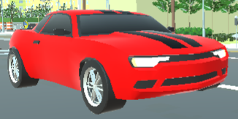

13. NPC

13.1. ENEMIES

Burning objects throughout the town – does 10 damage when hit by the Player.

(NEED TO INCLUDE THESE IMAGES HERE – D’ANNEO, JON)

13.2. ALLIES / COMPANIONS

**Citizens:**



**Animals:**

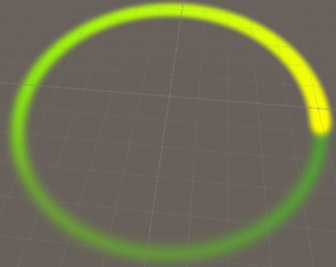

14. Art

14.1. SETTING

The game takes place in a town that is being overrun by a wildfire.

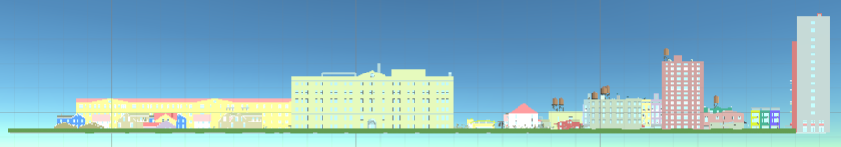

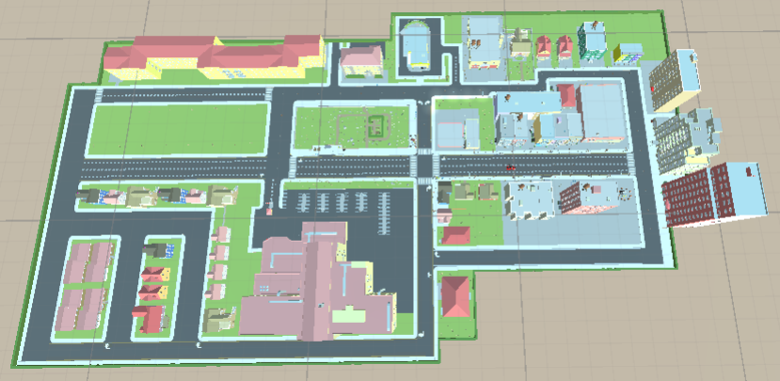

14.2. LEVEL DESIGN

The level consists of a town containing buildings, trees, burning objects, and typical features found in a town. There are 11 spawn locations for citizens (indicated by red circles) and four spawn locations for animal quests (indicated by green circles). The drop-off locations is denoted by the blue circle and, in-game, appears as the graphic below.

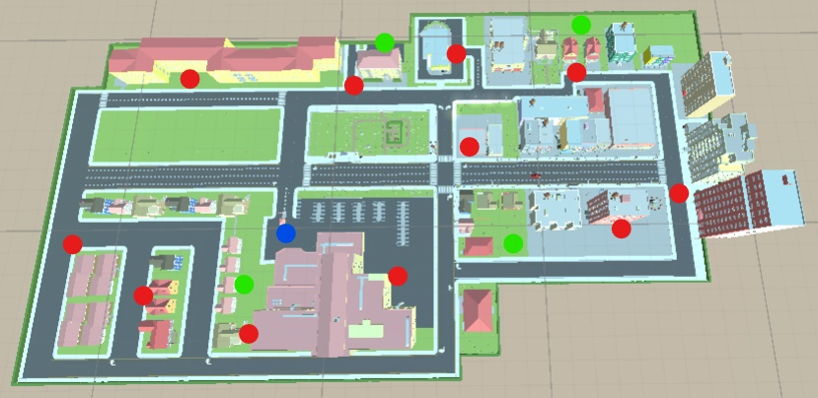

**Drop-off Location:**

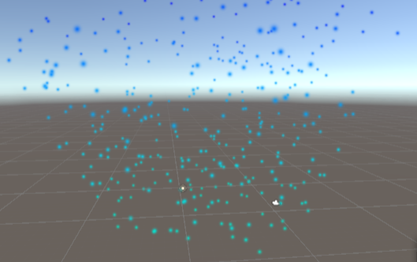

14.3. AUDIO

(NEED TO LIST AUDIO WHEN WE GET IT – LEE, JAMES)

15. PROCEDURALLY GENERATED CONTENT

There is no procedurally-generated content in this game. All levels, characters, assets, and sounds are static.

16. WISH LIST

* Different rescue vehicle
* Models for citizens and animals
* Multiple maps
* Gadgets to car (e.g. fire extinguisher).
* More detailed sky to reflect a fire is nearby
* Mini-map that would ping the spawned-in citizens

17. BIBLIOGRAPHY

17.1. LOGO

* Lee, J. Chi. (2020, November 12). *CRU Logo.png*. Krita.

17.2. ART

17.2.1. BORROWED ART

17.2.2. ORIGINAL ARTWORK

* Lee, J. Chi. (2020, December 8). *AboutControl.png*. Krita.
* Lee, J. Chi. (2020, December 8). *Blaze.png*. Krita.
* Lee, J. Chi. (2020, December 8). *CapAnimation.png*. Krita.
* Lee, J. Chi. (2020, December 8). *Heartbeat.png*. Krita.
* Lee, J. Chi. (2020, December 8). *HUD back.png*. Krita.
* Lee, J. Chi. (2020, December 8). *Logo Animation 1.png*. Krita.
* Lee, J. Chi. (2020, December 9). *Medals GSB.png*. Krita
* Lee, J. Chi. (2020, December 8). *MenuBackGround.png*. Krita.

17.2.3. PREFABS

* D’Anneo, Jonathan. (2020, December 8). Citizen.prefab. Unity.
* D’Anneo, Jonathan. (2020, December 8). Dropoff.prefab. Unity.
* D’Anneo, Jonathan. (2020, December 8). QuestSpawn.prefab. Unity.

17.3. SOUNDS

* *catMeow.mp3*. (Copyright 2019). *ZapSplat.*

<https://www.zapslat.com/?s=meow&post>_type=music&sound-effect-category-id. Public Domain.

* *Yell4.mp3*. (Copyright 2020). *Free Sound Effects.com.*

https://www.freesoundeffects.com/free-sounds/crowd-sounds-10029/0/tot_sold/20/1/. Public Domain.

17.5. VIDEOS

* Madieh, S. (2020, December 8). *Intro.mp4*. Panzoid.

17.5. CODE

* Lee, J. (2020, December 9). *AudioController.cs*. Visual Studio.
* Madieh, S. (2020, December 8). *CameraFollow.cs*. Visual Studio.
* Madieh, S. (2020, December 8). *CarController.cs*. Visual Studio.
* Lee, J. Chi. (2020, December 8). *Crash.cs*. Visual Studio.
* D’Anneo, J. (2020, December 8). *MainMenu.cs*. Visual Studio.
* D’Anneo, J. (2020, December 9). *PickUpCitizens.cs*. Visual Studio.
* Lee, J. (2020, December 9). *Sound.cs*. Visual Studio.
* D’Anneo, J. (2020, December 9). *SpawnSystem.cs*. Visual Studio.
* Lee, J. Chi. (2020, December 8). *Timer.cs*. Visual Studio.
* Lee, J. Chi. (2020, December 8). *VehicleData.cs*. Visual Studio.

17.6. SCENES

* D’Anneo, J. (2020, December 8). *Credits.unity*. Unity.
* Madieh, S., Lee, J., Chi, Lee, J., and D’Anneo, J. (2020, December 9). *Game.unity*. Unity.
* Lee, J. Chi and D’Anneo, J. (2020, December 9). *MainMenu.unity*. Unity.
* Madieh, S. and D’Anneo, J. (2020, December 8). *TeamSplashScreen.unity*. Unity.

17.7. ANIMATIONS/CONTROLLERS

* D’Anneo, J. (2020, December 8). *CreditsAnimation.anim/Credits.controller*. Unity.
* Lee, J. Chi. (2020, December 8). *FireAnim.anim*. Unity.
* Lee, J. Chi. (2020, December 8). *Full.anim*. Unity.
* Lee, J. Chi. (2020, December 8). *Health.controller*. Unity.
* Lee, J. Chi. (2020, December 8). *LogoAnimation.anim/LogoAnimationController.controller*. Unity.
* Lee, J. Chi. (2020, December 8). *OpenAnim.anim*. Unity.
* Lee, J. Chi. (2020, December 8). *PulseAnim.anim/PulseAnim2.anim*. Unity.
* Lee, J. Chi and D’Anneo, J. (2020, December 8). *VacantAnimationController.controller*. Unity.