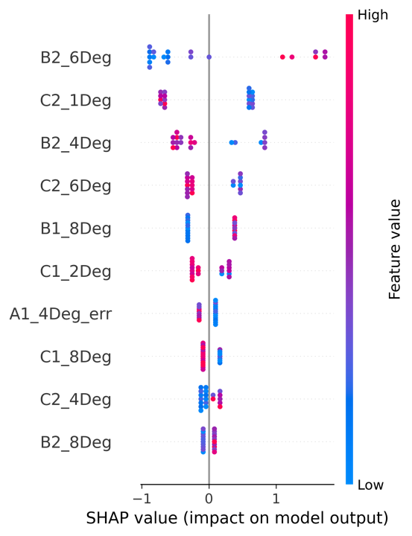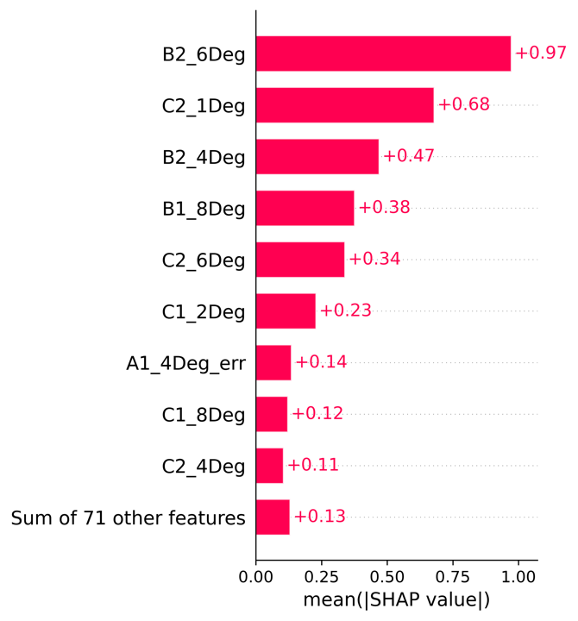

**Fig. 1.** The summarized SHAP values for the top 10 most important features of both first and second trails presented with global feature importance (**A)** and local explanation summary(B)

***Model interpretation with SHAP***

It is crucial to analyze the model to measure the importance of the input features which assists us to reveal relationships between the input features and prediction results. Although our XGBC model can achieve high accuracy in prediction, it is poor in the interpretability of results. Thus, we adopted the SHAP value to elaborate the XGBC model for PD and healthy control classification. The first and second trials of summarized SHAP values for the top 10 most important features at the y-axis and the SHAP mean value at the x-axis were shown in Fig 1.

The global features importance of the top 10 features is shown in Fig 1(a) which indicates that only 9 features have absolute feature importance values larger than 0. It is worth noting that the frequency(B) and phase shift(C) contribute most to the XGBC model as shown in Fig 1(a). This led to the fact that the PD subject was trying to catch up with the stimulus on the screen. This agrees with the visual analysis of the waveform from eye movement data. We explored on these two parameters to get further insights.

The phase shift of the peak of the fitted trigonometric function is how far the function shifted horizontally from the stimulus wave position. Routinely, the well-known parameter to evaluate the smooth pursuit of eye movement (SPEM) is the gain (the ratio of eye velocity to stimulus velocity). Generally, the SPEM gain values in healthy controls are close to 1 and the phase shift (i.e. phase lag) is small for stimulus reaching the peak velocity of 30 deg/s(C Shupert *et al* , 1988).

The phase shift is one of the most distributive features in differentiating between PD and healthy control from the result of our algorithm. The phase shift values in PD subjects are higher than in the healthy control. This will lead to the fact that the gain in PD subjects is lower than the healthy control. It is worth noting that the phase shift and gain are negatively correlated in our findings.

The oculomotor abnormalities can be seen in many neurodegenerative disorders. Corin *et al*(1972)reported that some kind of oculomotor abnormalities can be found in PD patients. They described SPEM have abnormalities with reduced gain or speed of eye movement. This is in good agreement with our findings. Our findings indicate that the increased phase shift in PD patients causes the gain to reduce.

The local explanation summary from Fig 1(b) shows the direction of the relationship between a variable and the result of the XGBC. Positive values are indications of PD, while negative values are indications of normal. According to the color bar, the higher values are in red color, while the lower values are in blue color.

In order to confirm the most contributed features from subjects, we run our XGBC model with a second trial only. As demonstrated in Fig 2(a) and (b), the frequency and phase shift variables are the most important feature in the second trial, which is in good agreement with the previous first trial + second trial XGBC model.

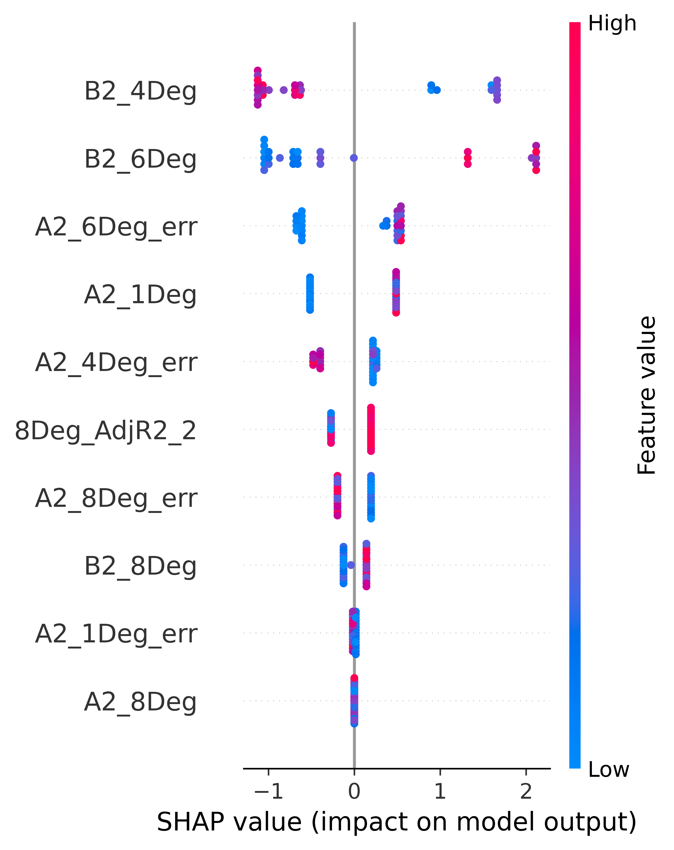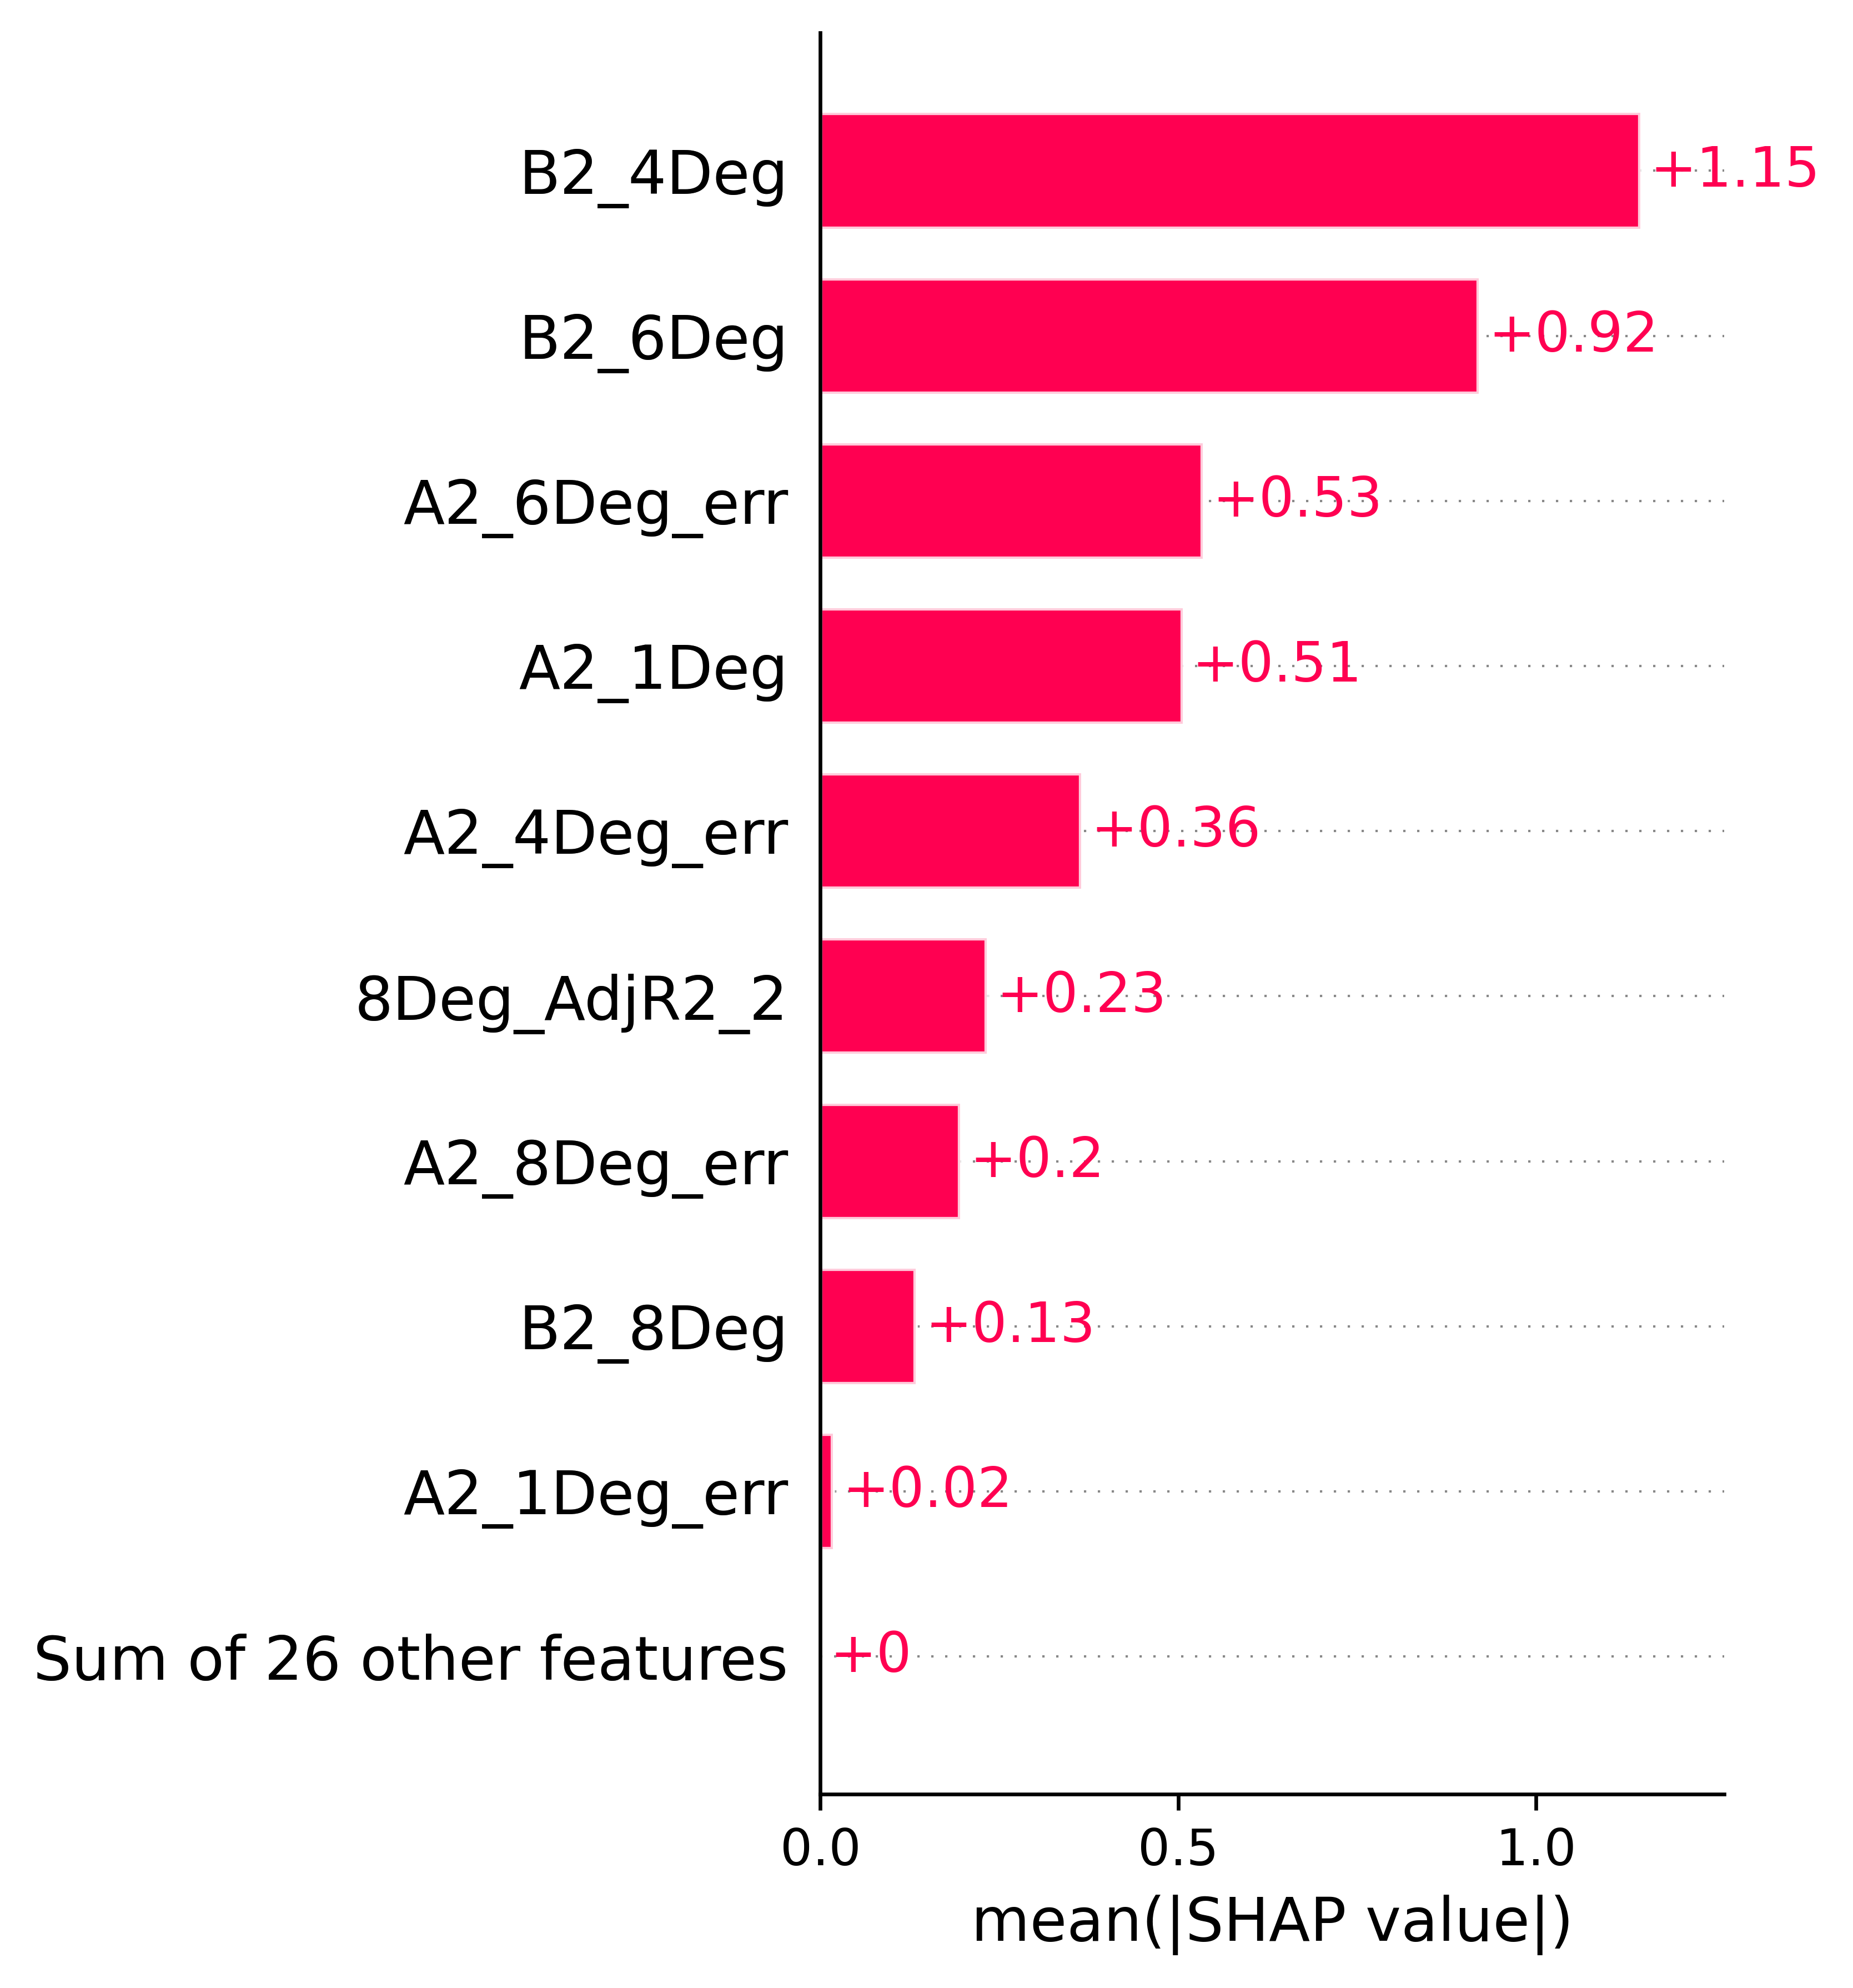

**Fig. 2.** The summarized SHAP values for the top 10 most important features presented with global feature importance (**A)** and local explanation summary(B)

**Fig. 3.** The local bar plot of SHAP value for the first instance

We can see from Fig 3 that for this instance of data features ( C2_1Deg, B2_4Deg, and A1_4Deg_err) contribute negatively and features(B2_6Deg,C2_6Deg,B1_8Deg, C1_2Deg,C1_8Deg and B2_8Deg) contribute positively for the final prediction. Again, it is obvious to find out that the frequency(B) and phase shift(C) have a larger value than the rest of the other features.

**Fig. 4.** The force plot SHAP for the first instance

The final step with SHAP values analysis is to check the features with a force plot. Each SHAP value can be seen as a force that either increases or decreases values. The SHAP value is an arrow that pushes to increase( positive values as shown in red) or decrease (negative value shown in blue). It can be summarized that the bigger impact comes from frequency(B) and phase shift(C) since they have a bigger area in the force plot.

We concluded that the most important features of our XGBC model are the frequency and the phase shift variables. This means that the PD subject’s eye is having a hard time catching up with the stimulus on the screen. This effect is more prominent and stable after one trial which indicated that the features from the second trial contribute larger than the first trial. Thus, our SHAP analysis suggests that the data analysis should be carried out starting from the second trials.