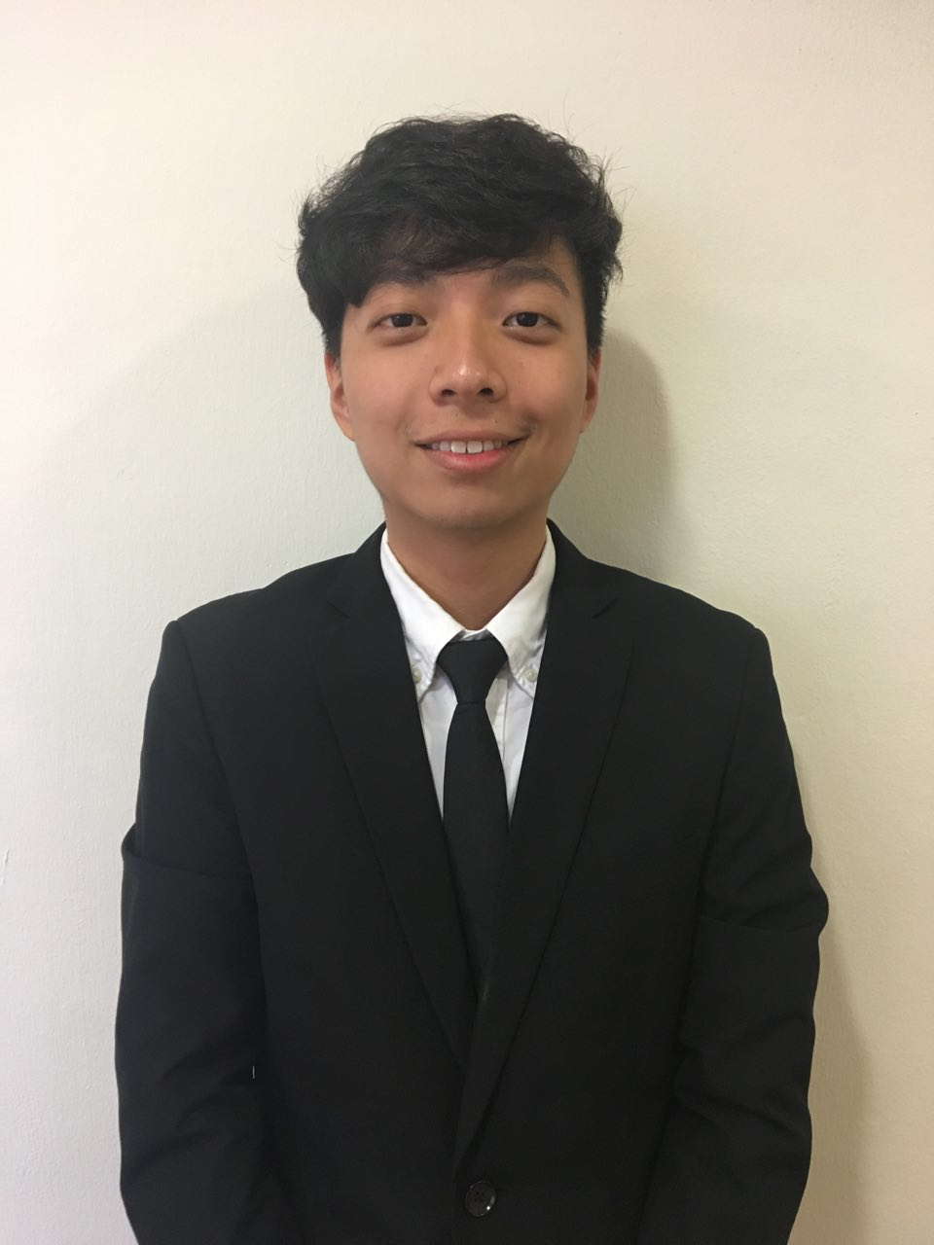

**James Liu Song Yu**

Mobile: +65 9189 6934

US Mobile: +1 415 606 6349

Email: songyu.liu@u.nus.edu

Skype: james.liu26

Website: www.jamesliusongyu.com

# 

**Personal Statement**

Introduction

Growing up in Singapore, a South-East Asian country with one of the heaviest emphasis on grades and work performance, I have grown up to believe in the power of knowledge and how it can transform a small fishing village to the regional economic success the world knows today. In this increasingly connected world we live in today, knowledge is passed around quickly and with the advent of open-source technology trends, one can easily learn information beyond textbooks and classrooms that will change their life.

About me

My life changed completely after I picked up coding and analytics at the start of my university education. I fell in love with debugging, visualizations and machine learning. Soon, I began watching courses on Coursera, going on GitHub and using different API packages on my own. I loved it and I wished sometimes I could have more time on my own to learn about extra content- image recognition, neural networks, artificial intelligence (the list is endless). This brings me to my first point:

Passionate about data and machine learning

I consider myself to be extremely passionate when it comes to data and machine learning. I enjoy breaking data down into understandable content for front-end users and doing analytics for them. For example, my previous internship at RadioActive Singapore required me to prototype visualization metrics for the front-end users and perform simple machine learning algorithms on them such as clustering. I have also recently participated in the Data Science Competition 2018 organized by the National University of Singapore with over 50 teams. We emerged top 10, performing back propagation and gradient descent with a machine learning model in order to predict the amount of rainfall.

Motivation to self-learn makes me a capable worker

I believe I am motivated to self-learn and grow. I think most of my motivation comes from passion and excitement around the task at hand. This determination results in me picking up new skills fast on the job and definitely plays a part in allowing me to solve problems assigned to me. For example, at RadioActive Singapore, there were times I stayed back after working hours with my supervisor just to learn more about the company and the tech stack they mainly used which was ElasticSearch and Jupyter. This helped me better understand the way the company worked, allowing me to create more value for the company.

Communication skills in a team

Lastly, I have strong communication skills and am comfortable with speaking to an audience. I understand that in a start-up, information is ever-changing and is also passed around quickly. Hence, it is essential for employees to be constantly contactable and communicate responsibly. An example would be me leading the organization and planning of a 4 Day 3 Night university camp for over 200 freshmen. I worked with university administration staff, professors and student leaders and developed ways of responsible and effective communication through systems where they had to report to their team leaders. In this way, I ensured that information was passed up and down swiftly which resulted in a successful camp.

Conclusion

I have a unique skillset of hard and soft skills such as analytics and communication. Definitely willing to learn and give my best in any endeavor, I believe I am a good candidate for any company.

**Education**

|  |  |  |
| --- | --- | --- |
| Aug 2016 - Present | **National University of Singapore**  Bachelor of Science (Honors) in Business Analytics  *(Relevant courses in Appendix A)* | Singapore |
| Aug 2017 – Dec 2017 | **Undergraduate Research Assistant**   * Built a predictive time series model in R to predict comfort levels of rooms in the National University of Singapore * Used SQL queries to retrieve data from MySQL WorkBench * Used ShinyR framework to build and deploy the interactive web application | Singapore |
| Jan 2012 - Dec 2013 | **Hwa Chong Junior College**  Singapore-Cambridge General Certificate of Education Advanced Level  Subjects: Math (A), History (A), Economics (B), English Literature (B) | Singapore |

**Work Experience**

|  |  |  |  |
| --- | --- | --- | --- |
| Aug 2018 – July 2019 | | **Smule, San Fransisco**  *Data Scientist and Engineer*   * Using Vertica, VSQL and Python, worked on a Beta Geometric Model to predict MAP (Monthly Active Participation) to better help UA Team to decide amount of spend. * Also worked on productionizing a Kmeans Clustering Model to group active users in the app into 4 main groups. | Singapore |
| May 2018 – July 2018 | | **Shopee , Singapore**  *Operations Finance Data Intern*   * Used Spark and SQL to productionize and automate financial reconciliation Python code * Generated a list of matching and non-matching Philippines payments | Singapore |
| Jan 2018 – April 2018 | **Code Gakko, Singapore**  *Python Instructor*   * Taking on the role of an instructor teaching Nanyang Technological University Year 4 PBL Finance Undergraduates Python and Data Analysis (BF3209 Portfolio Management and Analysis) * Also part of the CTO team that is in charge of designing course curriculum | Singapore |
| Dec 2017 - Jan 2018 | **Technical Internship @ RadioActive Singapore**  *Junior Data Scientist*   * Used Python to clean, process and visualize online radio streams that were stored in ElasticSearch * Used Python to discover patterns amongst intersections (listening similarities) between unique listeners * Demonstrated ability to use different Python visualization libraries such as UpSet and Chord Diagrams * Used Python to create interactive grouped bar visualizations in Bokeh that takes in user input and outputs specific results based on the user query | Singapore |

**Scholastic Achievements/Extracurricular Activities**

|  |  |  |
| --- | --- | --- |
| Mar 2018 – Mar 2018 | **National University of Singapore Data Science Competition 2018 With TerraData & Shopee**  *Python Machine Learning and Data Analysis Coder*   * Emerged top 10 out of 50 teams * Calibrated weather station sensors using gradient descent and back-propagation in Python by building a machine learning model that seeks to minimize errors | Singapore |
| Nov 2017 – Feb 2018 | **Hong Kong KPMG Start-Up Business Administration Paper**  *Technical Entrepreneur*   * Qualified for the Hong Kong Grand Finals out of 300 teams that participated and emerged the top foreign team * Crafted a detailed start-up business proposal in the area of image recognition in the E-Commerce industry | Hong Kong |
| 21 Oct 2017 - 22 Oct 2017 | **#startathon @ideasinc, NTC (Nanyang Technological Centre)**  *Technical Entrepreneur & Coder*   * Won 2nd place and a $2000 cash prize out of 25 teams that participated * Did mobile game application prototyping and tackled the problem of high diabetes rate in Singapore under 30 hours * Presented and pitched to a panel of judges from Singapore Health Promotion Board | Singapore |
| Aug 2016 - Aug 2017 | **Project Director for Residential College Four Freshmen Orientation Camp 2017**   * Organized and led over 300 university students through a 4 Day 3 Night Camp * Demonstrated proficient communication and organizational skills | Singapore |
| Jan 2017 - Present | **President of the Music Performing Club**   * Planned and organized music performances for over 150 university students throughout the year | Singapore |

**Skill Sets & Proficiency**

|  |  |  |
| --- | --- | --- |
| **Programming** | Java  Python  R | Intermediate  Intermediate  Intermediate |
| **Knowledge Domain** | Data Visualisation with Bokeh  Data Processing with Pandas, NumPy  Machine Learning with Scikit-Learn  Web application development with ShinyR | Proficient  Intermediate  Basic  Intermediate |
| **Database** | MySQL DBMS  SQL  ElasticSearch  FireBase  Vertica | Intermediate  Intermediate  Intermediate  Intermediate  Intermediate |
| **Multimedia** | Microsoft Excel  Adobe Photoshop | Basic  Basic |

**Language Proficiency**

|  |  |
| --- | --- |
| **Spoken**  **Written** | English – fluent; Mandarin – fluent  English – competent; Chinese –competent |

**Additional Information**

|  |
| --- |
| Enjoys a good cup of coffee, song writing, playing the piano and soccer. |

**APPENDIX A**

**Degree:** Bachelor of Science (Honours) in Business Analytics

**Cumulative Average Point: 4.15 / 5.00**

|  |  |
| --- | --- |
| **Knowledge Domain** | **Course Description** |
| Programming | Programming Methodology |
|  | Data Structures and Algorithms I |
|  | Data Structures and Algorithms II |
| Machine Learning | Introduction to Business Analytics |
|  | Decision Making Methods and Tools |
| Web Application Development and Databases | Data Management and Visualization |
|  | Application Systems Development for Business Analytics |
| Mathematics | Quantitative Reasoning |
|  | Calculus for Computing |
|  | Linear Algebra I |
|  | Probability and Statistics |
| Business | Business and Technical Communication |
|  | Introduction To Optimization |
|  | Principles of Marketing |