# Customer Brief

HTML 5 Banner

Name: Bookatable

Business: Restaurant booking

Targeted Customers: Adults

Logo: (get from website)

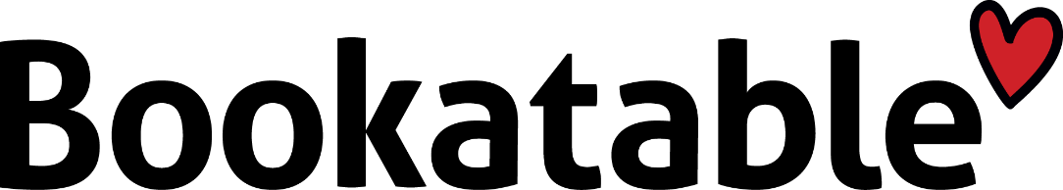

Website: https://www.bookatable.se

Design&color scheme: Black and blue

##### Job Description

The client wants an animated html5 banner to promote their restaurant booking service. Create a banner that first shows an empty table, which then in a creative way is being set for a romantic dinner. Charis being pulled up, and a wine bottle and glasses making their way to the table. You’ll find all the images you’ll need in the folder **Q_H5B_11_Restaurant**. Underneath the table there should be a clickable button saying; “Make a reservation”.