MIDTERM PROJECT PROPOSAL
BarangayKo: A Mobile-Based Barangay Management and Resident Services System
A Mobile-Based Barangay Digital Services Application

Submitted by:
James Lylle A. Duller
Submitted to:
MR. ARMAN DOYOGAN

PROE 4 — IS Project Management 2 (LAB)
Jose Rizal Memorial State University
March 19, 2026

Introduction
In today's digital age, local government units such as barangays are increasingly expected to deliver fast, transparent, and accessible public services to their constituents. However, most barangays in the Philippines still rely on manual, paper-based processes for handling resident requests, issuing certificates, recording incidents, and disseminating announcements. This outdated approach creates significant delays, long queues, and inefficiencies that frustrate residents and overwhelm barangay officials.
BarangayKo is a mobile-based barangay management and resident services system designed to modernize and digitize the core services of a barangay. By providing residents with a convenient mobile platform to request documents, view announcements, report concerns, and access barangay services anytime and anywhere, BarangayKo eliminates the need for residents to physically visit the barangay hall for routine transactions.
This proposal outlines the complete system design, objectives, scope, development methodology, and expected outcomes of BarangayKo, providing a comprehensive blueprint for its successful development and deployment in support of digital governance at the barangay level.

Problem Statement
Barangay offices across the Philippines continue to operate using manual, paper-based workflows that are inefficient, prone to human error, and inaccessible to residents outside office hours. Residents are required to physically visit the barangay hall to request documents, report incidents, or receive official information — a process that is time-consuming and impractical, particularly for working residents and those with mobility limitations.
The absence of a centralized digital platform results in the following core problems:
- No mobile platform for residents to request barangay documents such as Barangay Clearance, Certificates of Indigency, and Residency.
- Residents must physically visit the barangay hall during office hours to access services, causing long queues and delays.
- Barangay announcements, advisories, and emergency alerts are disseminated inconsistently through informal channels such as social media and verbal notices.
- Blotter reports and incident records are maintained in physical logbooks, making them difficult to retrieve, track, and analyze.
- No mechanism for residents to submit concerns or feedback to barangay officials digitally.
- Barangay officials lack real-time data and analytics to support evidence-based decision-making and resource allocation.

Project Objectives

General Objective
To develop a fully functional mobile-based barangay management system that enables residents to access barangay services digitally, and provides barangay officials with a centralized platform to manage requests, announcements, blotter records, and resident data efficiently.

Specific Objectives
- Cross-Platform Mobile Application: Develop a responsive mobile application using Flutter for cross-platform (iOS and Android) compatibility, enabling intuitive access to all barangay services and resident features.
- Robust Backend Infrastructure: Implement a scalable backend using Node.js and PostgreSQL to support secure user authentication, real-time data management, document request processing, and notification delivery.
- Core Barangay Service Features: Provide key digital services including online document requests, digital certificate generation, incident/blotter reporting, announcement broadcasting, and a resident concern submission portal.
- Accessibility and Performance: Ensure high accessibility, ease of use, and performance optimization to serve all residents including elderly users and those in areas with limited connectivity.
- Measurable Governance Impact: Achieve a 60% reduction in average document processing time, improved resident satisfaction, and a significant decrease in in-person barangay hall visits within the first six months of deployment.

Project Scope

In-Scope
The following components and functionalities are included within the boundaries of this system:
- Full-stack mobile application using Flutter (frontend), Node.js (backend APIs), and PostgreSQL (database).
- Core features: resident registration and login, online document request and tracking, digital certificate generation (Barangay Clearance, Certificate of Indigency, Certificate of Residency), blotter and incident reporting, barangay announcement broadcasting, resident concern submission, and admin dashboard for officials.
- Real-time push notifications for request status updates, announcements, and emergency alerts.
- Security measures including JWT-based authentication, data encryption, and role-based access control for barangay officials and residents.
- Comprehensive testing covering functionality, performance, usability, and cross-device compatibility.

Out-of-Scope
The following are beyond the boundaries of the current system development phase:
- Physical document printing, delivery, or courier services (the system handles digital issuance and status tracking only).
- Integration with national government databases such as PhilSys, COMELEC voter records, or PSA civil registry systems.
- Web-based or desktop versions, and integration with other LGU-level systems.
- Advanced AI/ML capabilities such as predictive crime analytics or automated legal document drafting.
- Post-launch maintenance, cloud hosting infrastructure beyond the development setup, or advanced GIS mapping features.

Development Methodology
BarangayKo will be developed using the Agile Software Development Methodology, specifically following the Scrum framework. This iterative and incremental approach allows the development team to deliver functional software in short, manageable cycles called sprints, typically lasting two to three weeks each.
Agile was selected for this project due to its flexibility in accommodating evolving barangay service requirements, continuous delivery of working software, and emphasis on collaboration between the developer and barangay stakeholders. Each sprint will focus on building, testing, and refining a specific set of features, ensuring the final product aligns closely with both technical requirements and the actual workflows of the barangay.

Development Phases
- Phase 1 — Requirements Gathering: Identify and document all functional and non-functional requirements through interviews with barangay officials, resident surveys, and analysis of existing manual workflows.
- Phase 2 — System Design: Design the system architecture, database schema, UI/UX wireframes, use case diagrams, and data flow diagrams.
- Phase 3 — Iterative Development (Sprints): Implement core features in successive sprints including user authentication, document request module, blotter system, announcements, and admin dashboard.
- Phase 4 — Testing and Quality Assurance: Conduct unit testing, integration testing, user acceptance testing (UAT) with actual barangay officials and residents, and performance testing.
- Phase 5 — Deployment and Evaluation: Deploy the application, gather feedback from initial users, and measure system performance against defined governance objectives.

System Architecture
BarangayKo follows a three-tier client-server architecture composed of the following interconnected layers:

Layer | Technology | Responsibilities
Presentation Layer (Frontend) | Flutter | Cross-platform mobile UI for Android and iOS. Handles resident registration, document requests, blotter reporting, announcements, concern submission, and certificate viewing.
Application Layer (Backend) | Node.js | Business logic processing, REST API management, JWT authentication, role-based access control, document request processing, push notification delivery, and frontend-database communication.
Data Layer (Database) | PostgreSQL | Persistent storage of resident profiles, document requests, certificates, blotter records, announcements, concerns, and transaction logs in a structured relational database.

Key Features
The following table summarizes the primary features included in BarangayKo:

Feature | Description
Resident Registration and Login | Secure account creation and login using JWT-based authentication with role-based access for residents and barangay officials.
Online Document Request | Residents can request Barangay Clearance, Certificate of Indigency, Certificate of Residency, and other documents directly from the app.
Digital Certificate Generation | Approved requests automatically generate official-looking digital certificates that residents can download or present.
Blotter and Incident Reporting | Residents can submit incident reports digitally; officials can manage, track, and update blotter records within the app.
Announcement Broadcasting | Barangay officials can publish official announcements, advisories, and emergency alerts that are instantly pushed to all residents.
Resident Concern Submission | Residents can submit concerns, complaints, or requests for assistance to barangay officials through a structured digital form.
Push Notifications | Automated alerts for document request status updates, new announcements, emergency advisories, and concern responses.
Admin Dashboard | Centralized management panel for barangay officials to manage requests, blotter records, resident profiles, announcements, and view analytics.
Request Status Tracking | Residents can monitor the real-time status of their submitted document requests from pending, processing, to approved or released.
Resident Directory | Officials can search and manage registered resident profiles with contact information and household details.

Database Design
The system's relational database is built on PostgreSQL. The following tables form the core of the data schema:

Table | Description
Residents | Stores resident account information including personal details, contact number, home address, household ID, and account credentials.
Officials | Stores barangay official accounts including name, position, assigned role, and authentication credentials.
Document Requests | Records all document requests submitted by residents including document type, purpose, status, timestamps, and processing history.
Certificates | Stores generated digital certificates linked to approved document requests including certificate number and issued date.
Blotter Records | Records all incident and blotter reports including complainant, respondent, incident description, date, and resolution status.
Announcements | Stores all official barangay announcements including title, content, category, publish date, and expiry date.
Concerns | Stores resident-submitted concerns and complaints including description, category, status, and official response.
Notifications | Tracks all push notification records, delivery status, and resident read/unread states.
Households | Stores household records linking multiple resident members to a single household address and barangay zone.

System Diagrams

Use Case Diagram
The Use Case Diagram below illustrates the interactions between system actors (Resident and Barangay Official/Admin) and the core functionalities of BarangayKo.
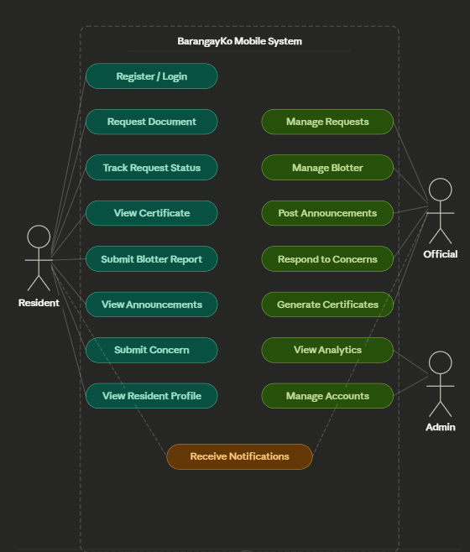
Figure. Use Case Diagram — BarangayKo

Entity Relationship Diagram (ERD)
The ERD below depicts the relational structure of the database, showing the entities, their attributes, and the relationships between them.
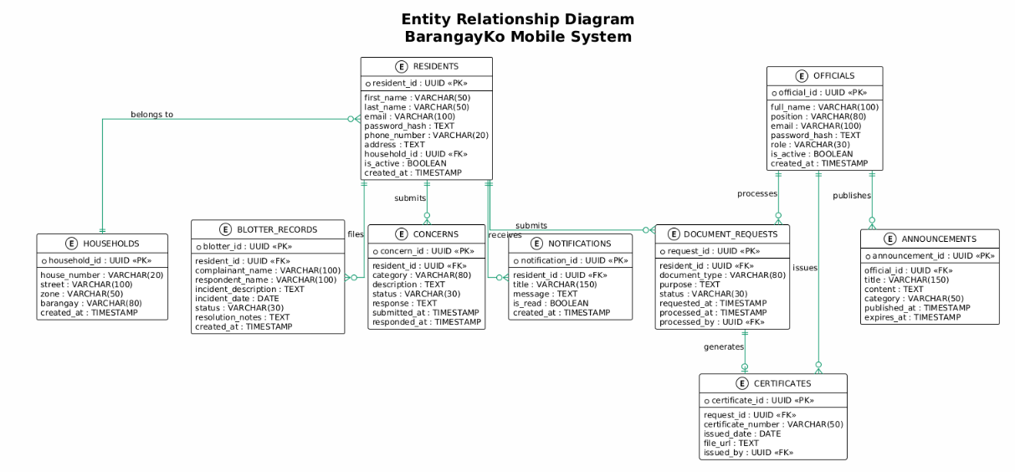
Figure. Entity Relationship Diagram (ERD)

Data Flow Diagram (DFD)
The Data Flow Diagram illustrates how data moves between residents, processes, and the database within the system.
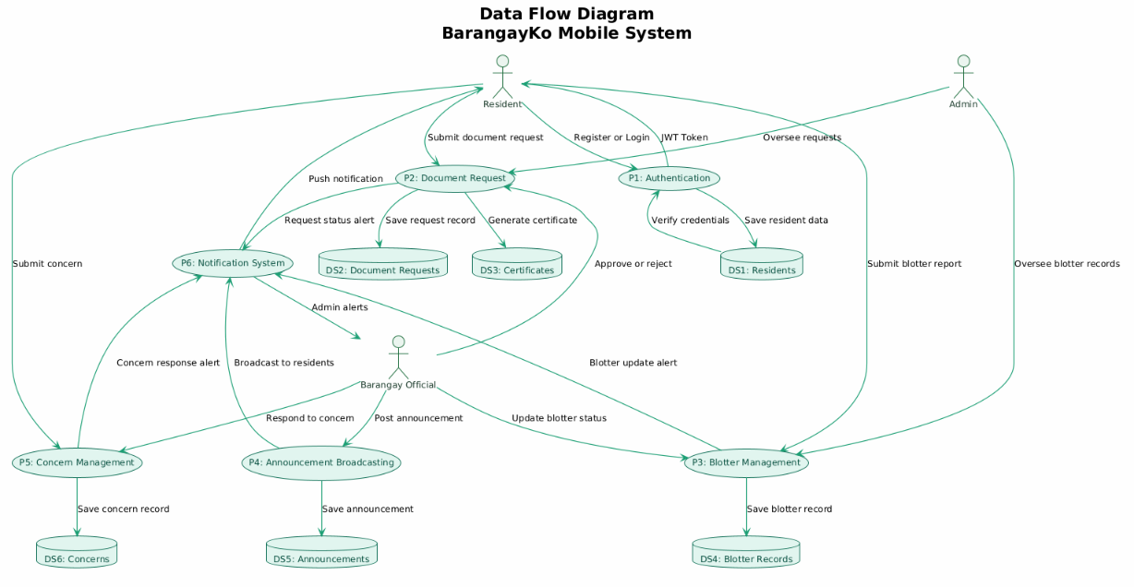
Figure. Data Flow Diagram (DFD)

Activity Diagram (Swimlane)
The Activity Diagram Swimlane below details the complete workflow for the document request and approval process across all system actors.

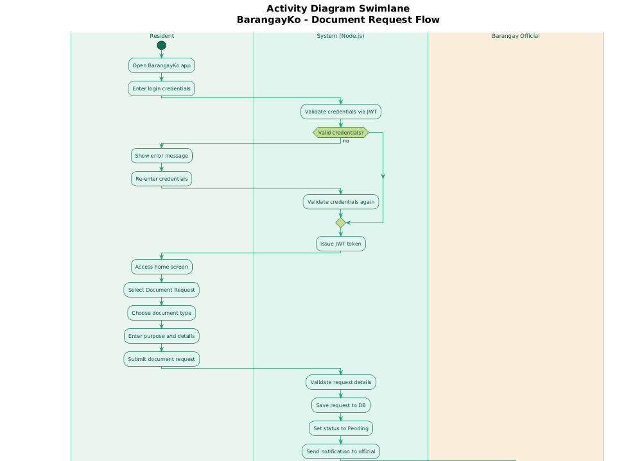
Figure a. Activity Diagram Swimlane — Document Request Flow

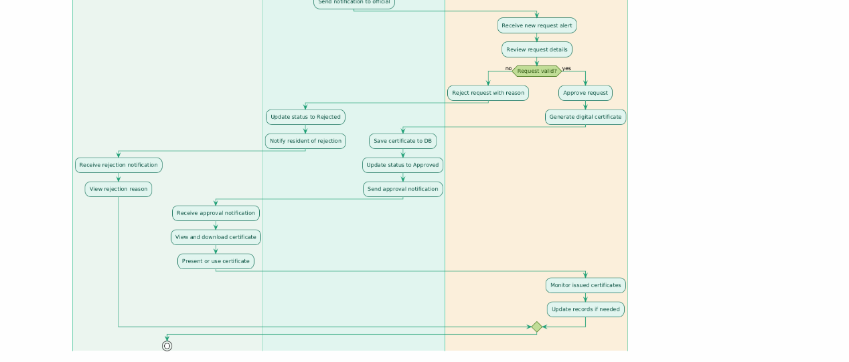
Figure b. Activity Diagram Swimlane — Document Request Flow

Conceptual Framework
The conceptual framework of BarangayKo is structured around the Input-Process-Output (IPO) model, which illustrates how resident data and official interactions are transformed into meaningful barangay service outcomes.

INPUT | PROCESS | OUTPUT
- Resident personal information  - Barangay official credentials  - Document request details  - Incident/blotter report data  - Admin updates and announcements  - Resident feedback and concerns | - User Authentication (JWT)  - Document Request Processing  - Blotter and Incident Management  - Announcement Broadcasting  - Certificate Generation  - Push Notification System  - Data Storage (PostgreSQL) | - Functional mobile app (Android & iOS)  - Issued barangay documents and certificates  - Real-time announcements to residents  - Admin dashboard with analytics  - Digital blotter records  - Centralized barangay digital hub
Figure. Input-Process-Output (IPO) Conceptual Framework

Expected Outcomes
Upon successful development and deployment, BarangayKo is expected to deliver the following measurable results:
- 60% Reduction in Document Processing Time: Achieved through automated digital request routing, eliminating manual paper-based processing queues.
- Improved Resident Satisfaction: A convenient, always-accessible mobile platform that allows residents to access barangay services without visiting the hall.
- Reduced Barangay Hall Congestion: Fewer in-person visits for routine document requests frees up barangay staff to handle more complex governance tasks.
- Faster Emergency Communication: Real-time push notifications enable the barangay to broadcast emergency alerts and advisories to all residents instantly.
- Accurate and Accessible Blotter Records: Digitized incident records improve the accuracy, retrieval speed, and security of blotter documentation.
- Data-Driven Governance: Admin analytics provide officials with actionable insights on resident demographics, common concerns, and service utilization trends.

Project Timeline
The following table presents the estimated project schedule for BarangayKo, organized by development phase:

Phase / Activity | Duration | Target Timeline
Phase 1: Requirements Gathering and Analysis | 1 week | Week 1
Phase 2: System Design (Architecture, UI/UX, ERD) | 1 week | Week 2
Phase 3: Sprint 1 — Auth, Resident Registration, Document Request | 2 weeks | Weeks 3–4
Phase 3: Sprint 2 — Blotter System, Announcements, Notifications | 2 weeks | Weeks 5–6
Phase 3: Sprint 3 — Concerns Module, Certificate Generation, Admin Dashboard | 2 weeks | Weeks 7–8
Phase 4: Testing and Quality Assurance | 2 weeks | Weeks 9–10
Phase 5: Deployment, UAT with Barangay Officials, and Evaluation | 2 weeks | Weeks 11–12

Significance of the Study
The development of BarangayKo holds significant value for multiple stakeholders at the community and academic levels:

For Residents
BarangayKo directly benefits barangay residents by eliminating the need to take time off work or travel to the barangay hall for routine transactions. Residents can request documents, report incidents, receive official announcements, and submit concerns anytime from their smartphones, resulting in a faster, more convenient, and more dignified public service experience.

For Barangay Officials
The system presents a significant opportunity for barangay officials to professionalize their operations, reduce paperwork, and serve constituents more efficiently. The centralized admin dashboard provides real-time visibility into pending requests, blotter cases, and resident concerns, allowing officials to prioritize and respond more effectively. Analytics also support evidence-based governance decisions.

For the Local Community
BarangayKo promotes digital inclusion at the grassroots level by bringing modern e-government services to the smallest administrative unit in the Philippines. It fosters greater civic engagement, transparency, and accountability between residents and their local government, strengthening community trust and participation.

For Future Researchers and Developers
This study serves as a valuable reference for future researchers and developers who aim to build similar mobile-based local government management systems. The documentation, system architecture, and development approach using Flutter, Node.js, and PostgreSQL can serve as a practical guide for future academic and industry projects in e-governance and public sector digital transformation.

For the Academic Community
The system demonstrates the practical application of modern mobile technologies in addressing real-world governance challenges at the local level. It contributes to the body of knowledge in mobile application development, e-government systems, and software engineering, particularly in the context of Philippine barangay-level public service delivery.

Definition of Terms
The following terms are defined as used within the context of BarangayKo:

Term | Definition
Barangay | The smallest administrative division in the Philippines, functioning as a local government unit responsible for delivering basic public services to residents within its jurisdiction.
BarangayKo | The proposed mobile-based barangay management system developed in this study, designed to digitize resident services and barangay administration.
Flutter | An open-source UI software development kit created by Google for building natively compiled cross-platform mobile applications for Android and iOS from a single codebase.
Node.js | A JavaScript runtime environment used to build the backend API handling business logic, document request processing, and user authentication.
PostgreSQL | An open-source relational database management system used to store and manage all system data including residents, document requests, and blotter records.
JWT (JSON Web Token) | A compact and secure method for transmitting authentication information between parties, used here for resident and official login and session management.
Barangay Clearance | An official document issued by the barangay certifying that the holder is a resident of good standing with no pending cases within the barangay.
Blotter Record | An official log of incidents, complaints, and disputes recorded by the barangay. In this system, it refers to the digitized record of resident-reported incidents.
Push Notification | An automated message delivered to a resident's mobile device to provide updates on document requests, announcements, and emergency alerts.
Role-Based Access Control | A security mechanism that restricts system access based on a user's assigned role — either resident or barangay official — ensuring appropriate data visibility and feature access.
REST API | Representational State Transfer Application Programming Interface — the standard communication protocol between the Flutter frontend and the Node.js backend.
Agile Methodology | An iterative software development approach emphasizing flexibility, collaboration, and incremental delivery of working software through short development cycles called sprints.

