Because of the way that SQL has been setup in lab 2A314, you will need to do a number of things to the SOA-Registry files when you place them on the lab computers to work on. If you install them on your own machine (at home or laptop) you may need to complete some (or all of these steps) as well …
- Unzipping the Assign1-SOA file
  - You must unzip the files to the C: drive (not your network share (G: drive))
  - And because the files are contained in a ZIP – you need to set permissions on the SOA folder
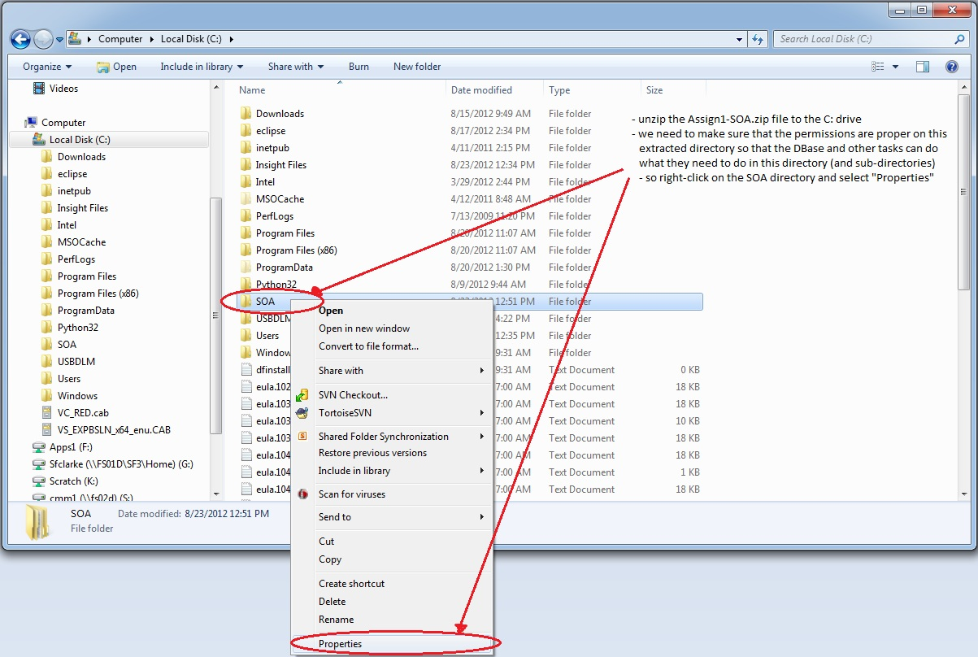
- Ensure that the SOA folder (all subfolders and files) are not read-only
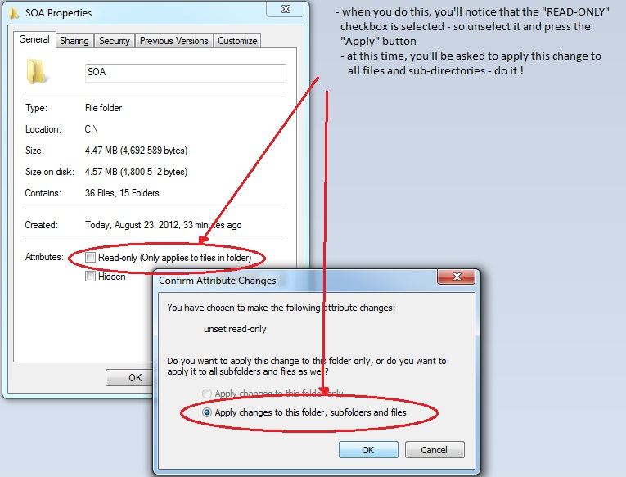
- When you run the sample client application, the SOA-Registry server and you own applications – you will be running them as a “user” on the lab computer. Files are modified (database and log files) – so it is important that the lab computer’s “User” group be given full-control of the SOA folder.
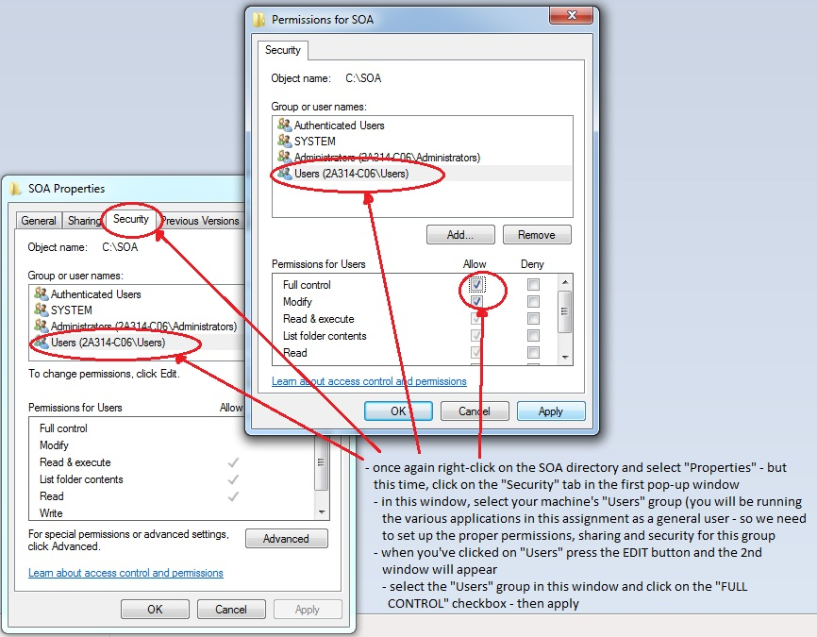
- Now let’s modify the SQLEXPRESS2008 settings – first in the SQL Configuration Manager …
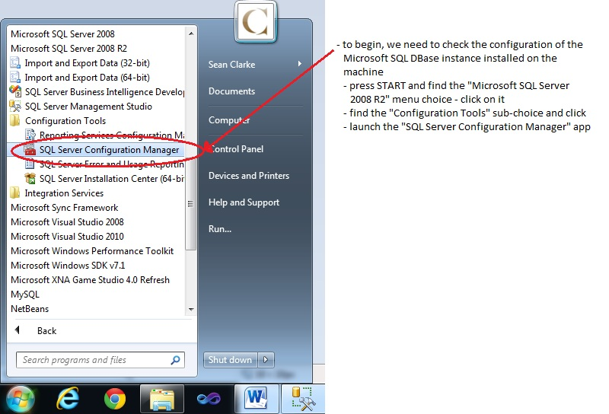
- The SOA-Registry server application “talks” to its backend database over TCP/IP – you need to enable this protocol on the 64-bit SQLEXPRESS2008 instance. A number of setting changes like this, require the SQLEXPRESS2008 service to be restarted …
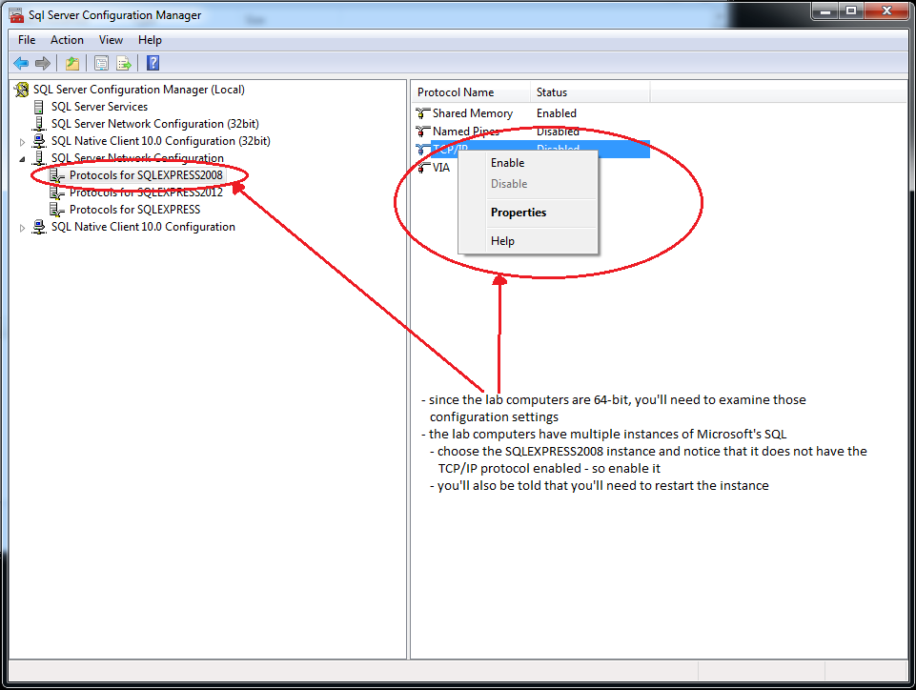
This is how to restart the SQLEXPRESS2008 Dbase service … Ideally we should be able to do this within the Configuration Manager as follows. In the 2A314 lab however, this doesn’t work …
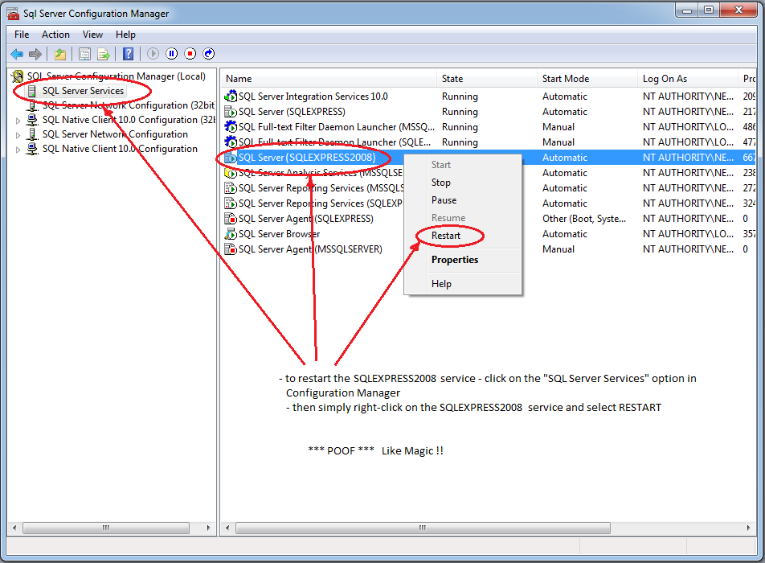

So instead we need to access the Services through the Administrative Tools of the Control panel as follows. This is another way to restart the service.
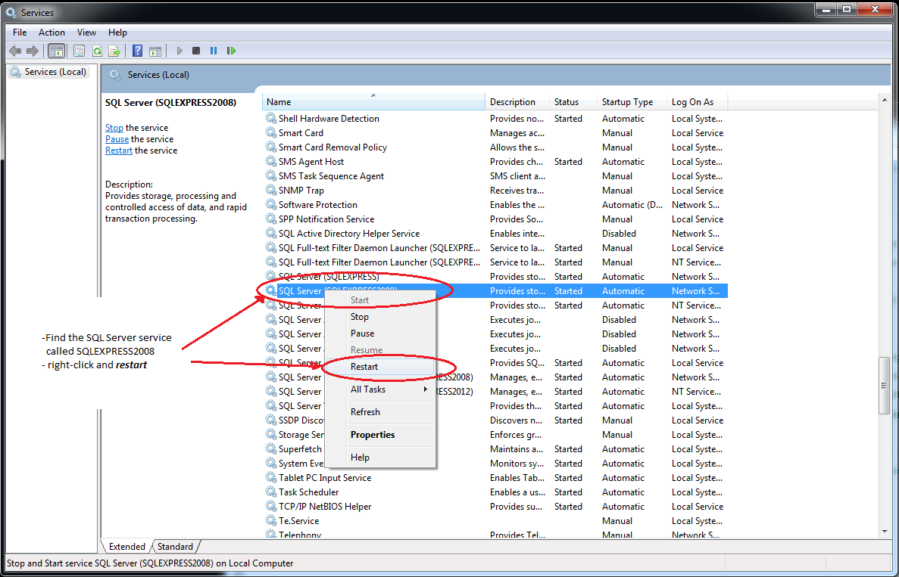
Now we need to make sure that SQLEXPRESS2008 instance is listening for TCP communications on port 1433
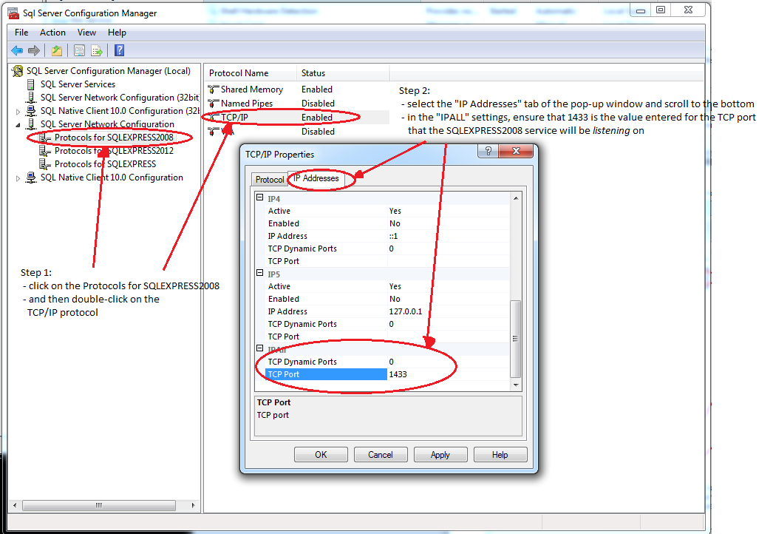
- Finally, you’ll need to ensure that SQLEXPRESS2008 instance has TCP/IP enabled for any client applications – for any C# applications you may want to write that need to talk to the DBase
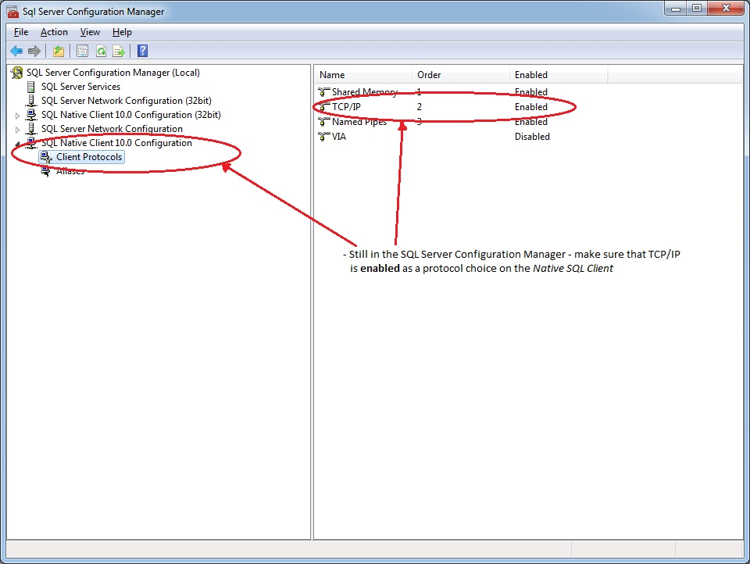
- Now you are ready to attach the provided SOA-Registry database and begin developing and playing in Thorton’s SOA.
  - Launch the SQL Management Studio to do this
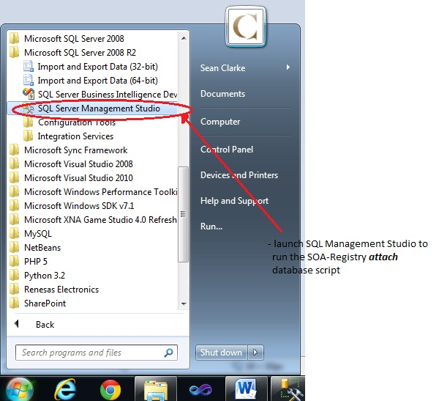
  - Log into the SQLEXPRESS2008 instance
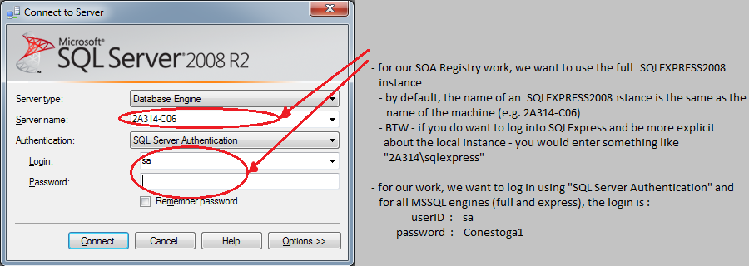
  - open and run the C:\SOA\Runtime\SOA-Registry\database\scripts\attachSOARegister.sql script

- Prepare the rest of the SOA-Register and Sample-Client command scripts and configuration files as indicated in C:\SOA\Runtime\README.txt

