**Aims**

Quantify the fitness cost of pyrethroid resistance conferred by the *kdr* mutation in RLEM using field trials

**Data analysis methods**

Two models were fit the data to quantify fitness costs. The first was a statistical model controlling for repeated plot measurements through time determine the rate of declines. The second was a mechanistic model using quantitative genetics principles to estimate relative fitness.

*Statistical model*

The measured resistance allele frequency through time was modelled using logistic regression with random effects for repeated measured on plot weighted by the number of alleles screened (i.e. twice the number of individual mites).

$$Y \sim Bernoulli(θ)$$

$$logit\left(θ_{i,t}\right)=α+βx_{1}+γx_{2}+ϵ$$

where $α$ and $β$ are parameters, $x_{1}$ denotes the trial location $($ WA = 1, SA = 0), $x_{2}$ denotes the normalise time since trial commencement with random effects for each plot $ϵ$.

Model comparison was conducted for simpler models omitting covariates and more complex models including interactions but did not yield lower AIC scores.

*Population genetics model*

Assuming Hardy-Weinberg ratios, the mean fitness of a population can be calculated from the proportion of resistance alleles in a population, $p$ (and susceptible alleles, $q = 1 - p$), as well as the relative fitness for each genotype $w_{RR}$, $w_{RS}$, and $w_{SS}$:

$$\overline{w}= p^{2}w_{RR} + 2pqw_{RS} + q^{2}w_{SS}$$

Assuming the relative fitness of the homozygous susceptible genotype to be $w_{SS}= 1$, the resistant allele frequency in the next generation $\hat{p}$ can thus be calculated as:

$$\hat{p} = p^{2}\frac{w_{RR}}{\overline{w}} + pq\frac{w_{RS}}{\overline{w}}$$

The dominance of fitness costs to be $h,$ can be utilised solve for the relative fitness of heterozygotes as:

$$w_{RS} =h w_{RR} + \left(1 - h\right) w_{SS}$$

The free parameters are, thus, $w_{RR}$, $h$, and the starting allele frequency of resistance at each field site $p_{0}$, which can be estimated from data using non-linear least squares regression. Dates are converted to generation by assuming three generations per year with no development during diapause from Nov-April.

**Results**

**Table.** Model comparison

|  |  |  |  |  |  |  |
| --- | --- | --- | --- | --- | --- | --- |
| Model | K | AIC | $Δ$ AIC | Model Likelihood | AIC  Weight | Log-likelihood |
| Loc + Time | 4 | 1951.0 | 0.0 | 1.00 | 0.7 | -971.4 |
| Loc + Time + Loc*Time | 5 | 1952.7 | 1.7 | 0.42 | 0.3 | -971.2 |
| Time | 3 | 2014.5 | 63.5 | 0.00 | 0.0 | -1004.2 |
| Loc | 3 | 2109.2 | 158.2 | 0.00 | 0.0 | -1051.6 |
| Null model | 2 | 2172.8 | 221.8 | 0.00 | 0.0 | -1084.4 |

**Table.** Coefficients and 95% confidence interval

|  |  |  |
| --- | --- | --- |
| Model term | Description | Coefficient estimate  [95 % CI] |
| Intercept | Mean allele frequency at Arthur River | 1.60 [1.44. 1.77] |
| Loc | Mean allele frequency at Tintinara | -2.15 [-2.38. -1.92] |
| Time | Normalised time since first measurement | -0.23 [-0.27. -0.19] |

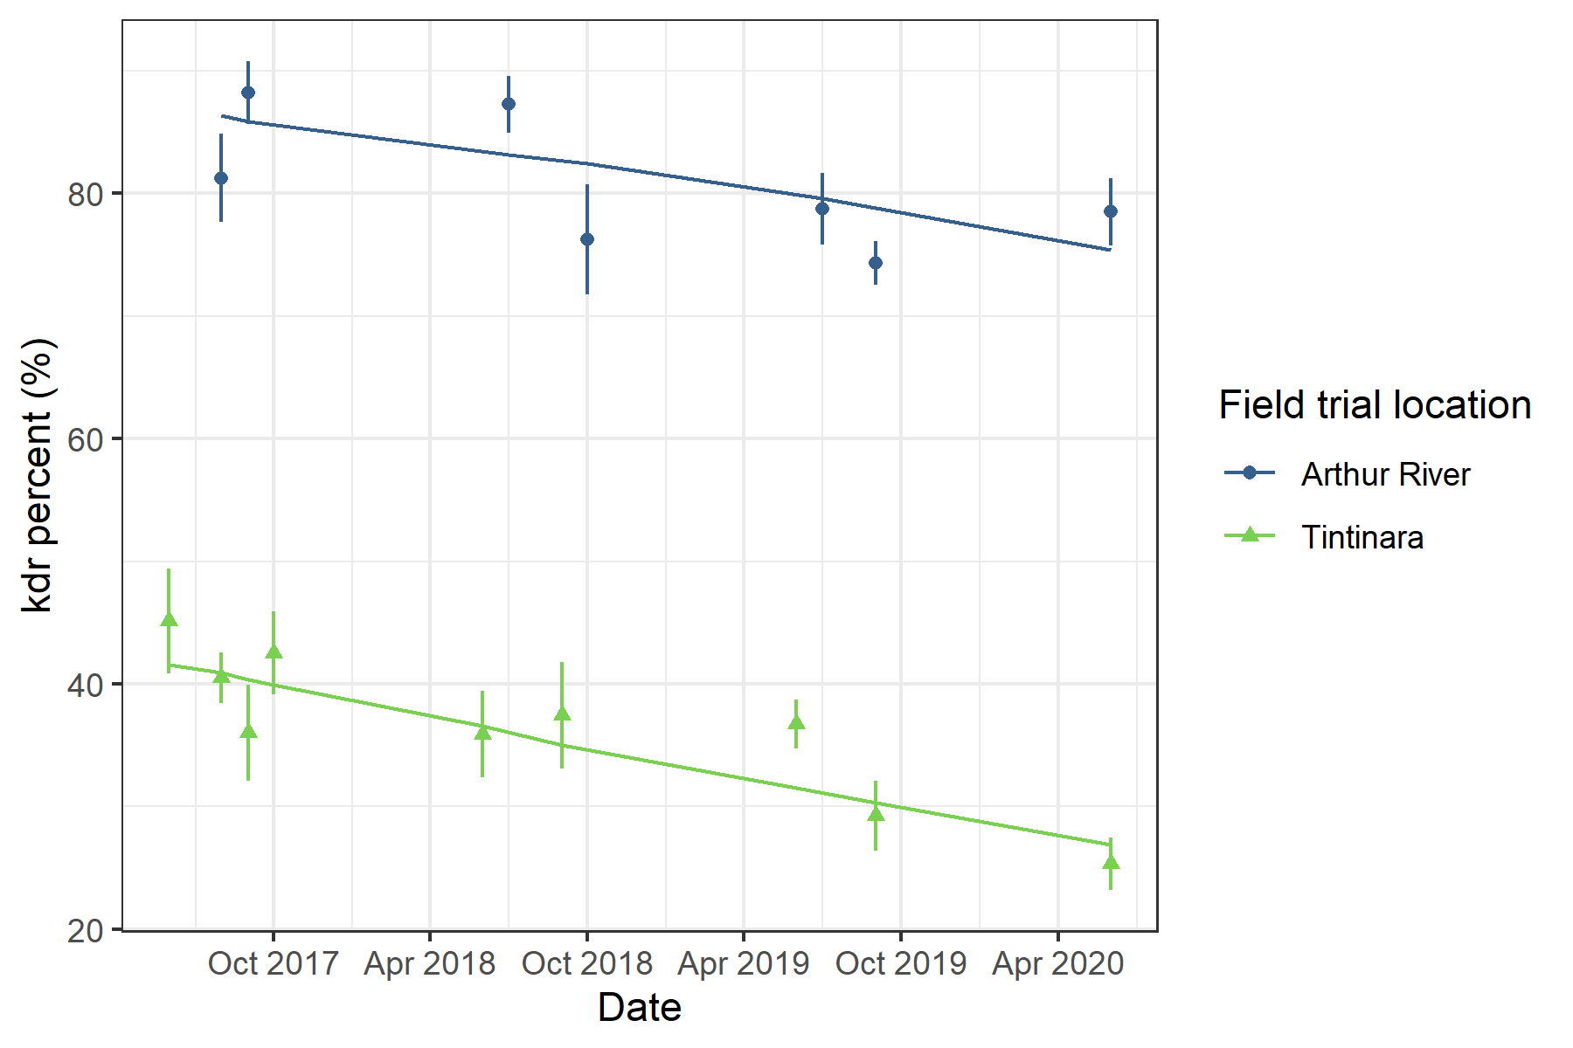

**Figure.** Allele frequencies through time. Mixed-effect logistic regression model prediction shown by lines. Points represent means for each sample date with standard errors shown by vertical bars.

**Table.** Parameter estimates using population genetic model and non-linear least squares regression

|  |  |  |
| --- | --- | --- |
| Parameter | Description | Coefficient estimate  [95 % CI] |
| $$w_{RR}$$ | Relative fitness costs of homozygous resistance alleles. | 0.87  [0.81. 0.93] |
| $$h$$ | Dominance of fitness costs | 0.70  [0.06. 1.32] |
| $$p_{0}^{A}$$ | Starting resistance allele frequency at Arthur River | 0.84  [0.80. 0.87] |
| $$p_{0}^{T}$$ | Starting resistance allele frequency at Tintinara | 0.43  [0.39. 0.48] |

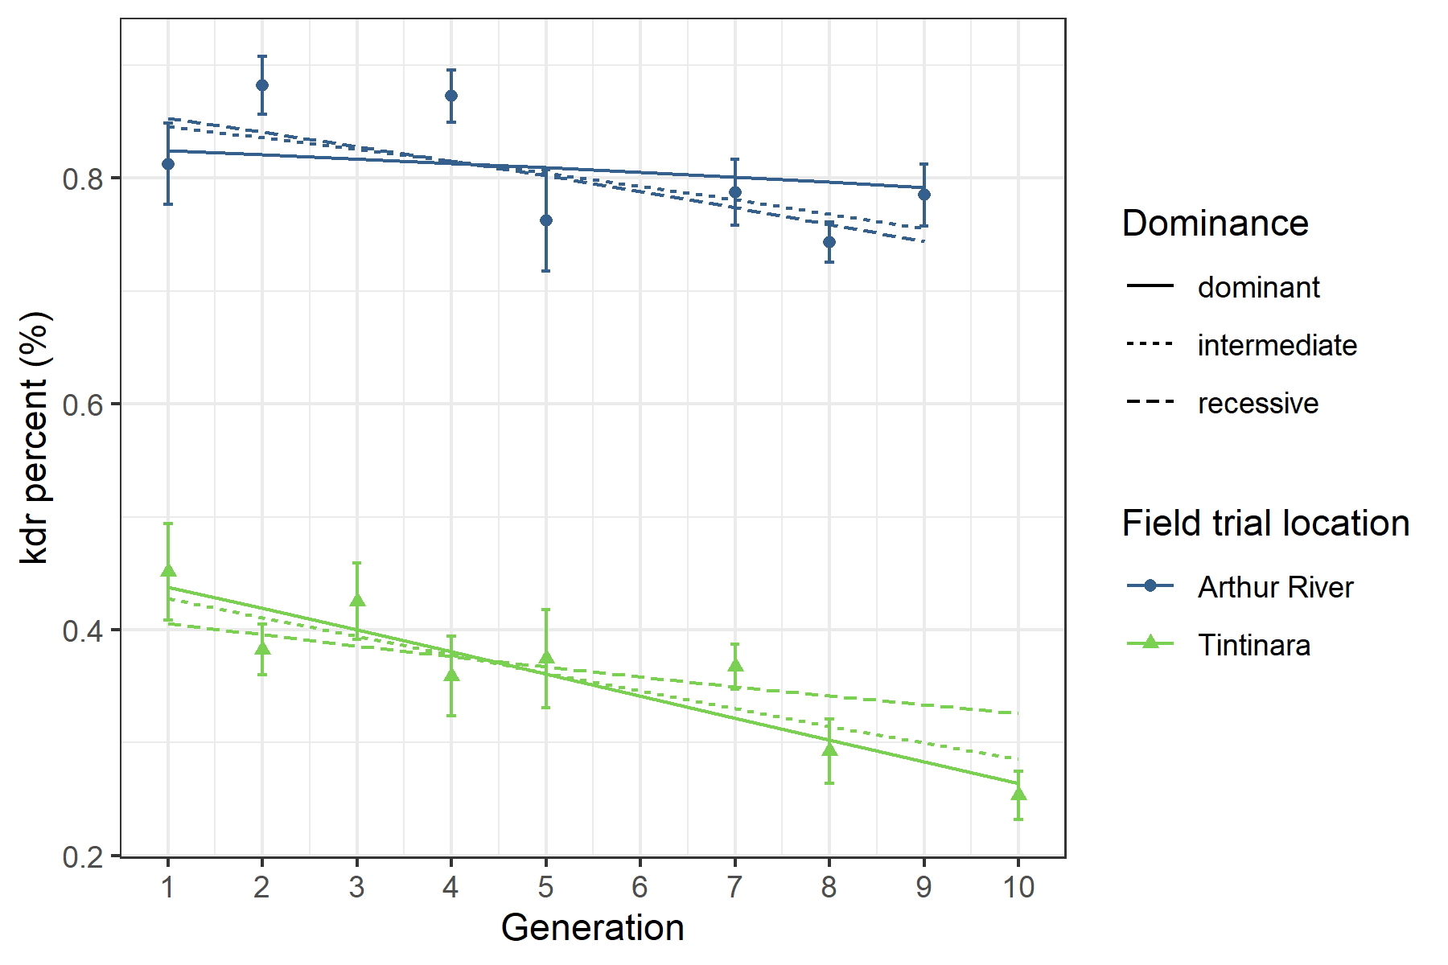

**Figure.** Allele frequencies across generation. Fitted population genetics model prediction estimated with non-linear least squares shown by lines for dominant (h=1), intermediate (h=0.5), and recessive (h = 0) fitness costs. Points represent means for each sample date with standard errors shown by vertical bars.