**Aims**

Quantify the fitness cost of pyrethroid resistance conferred by the *kdr* mutation in RLEM using field trials

**Data analysis methods**

Two models were fit the data to quantify fitness costs of the resistant allele. The first was a statistical model controlling for repeated plot measurements through time to estimate the rates of decline in allele frequency. The second was a population genetics model with different levels of dominance of the resistant allele to estimate relative fitness.

*Statistical model*

The measured resistance allele frequency through time *t* was modelled using logistic regression with random effects for repeated measures on plots weighted by the number of alleles screened (i.e. twice the number of individual mites).

$$Y \sim Bernoulli(θ)$$

$$logit\left(θ_{t}\right)=α+βx+γt+ϵ$$

where $α$, $β$ and $γ$ are parameters, $x$ denotes the trial location $($ Arthur River = 1, Tintinara = 0), $t$ denotes the normalised time since trial commencement with random effects for each plot $ϵ$.

Simpler models omitting covariates and more complex models that included interactions did not yield lower AIC scores.

*Population genetics model*

We assume Hardy-Weinberg ratios after random mating following selection in the previous generation. In the new round of selection in the current generation, the mean fitness of a population $\overline{w}$ can then be calculated from the proportion of resistance alleles in a population, $p$ (and susceptible alleles, $q = 1 - p$), as well as the relative fitness for each genotype $w_{RR}$, $w_{RS}$, and $w_{SS}$:

$$\overline{w}= p^{2}w_{RR} + 2pqw_{RS} + q^{2}w_{SS}$$

Assuming the relative fitness of the homozygous susceptible genotype to be $w_{SS}= 1$, the resistant allele frequency in the next generation $\hat{p}$ can thus be calculated as:

$$\hat{p} = p^{2}\frac{w_{RR}}{\overline{w}} + pq\frac{w_{RS}}{\overline{w}}$$

The dominance of fitness costs $h$ can be set to determine the relative fitness of heterozygotes as:

$w_{RS} =h w_{RR} + \left(1 - h\right) w_{SS}$,

with $h$ = 1 indicating dominance for the resistant allele and $h$ = 0 indicating dominance for the recessive allele.

The parameters to vary are therefore $w_{RR}$, $h$, and the starting allele frequency of resistance at each field site, $p_{0}$, which can be estimated from data using non-linear least squares regression. Dates are converted to generation by assuming three evenly spaced generations per year with no development during diapause from Nov-April.

**Results**

* Trial location and time significantly improved the model compared with simpler models that omitted these variables (Table X)
* The estimated coefficient for the Tintinara location was significantly negative confirming the lower rates of resistance at this site (Table Y, Figure X)
* The estimated coefficient for time was significantly negative indicating a decreasing proportion of *kdr* alleles in the populations through time (Table Y, Figure X)
* The relative fitness costs of resistance of homozygous resistant individuals was able to be estimated with high degree of confidence with a mean and 95% confidence interval of $w_{RR}$ = 0.87 [0.81. 0.93]
* In contrast, while the best fit value for dominance was intermediate *h* = 0.7 [0.06. 1.00], excluding zero at the 95% confidence level, the relationship was relatively insensitive to other levels of dominance (Table Z, Figure Y)

**Table X.** Logistic mixed-effect model comparison

|  |  |  |  |  |  |  |
| --- | --- | --- | --- | --- | --- | --- |
| Model | K | AIC | $Δ$ AIC | Model Likelihood | AIC  Weight | Log-likelihood |
| Loc + Time | 4 | 1951.0 | 0.0 | 1.0 | 0.7 | -971.4 |
| Loc + Time + Loc*Time | 5 | 1952.7 | 1.7 | 0.4 | 0.3 | -971.2 |
| Time | 3 | 2014.5 | 63.5 | 0.0 | 0.0 | -1004.2 |
| Loc | 3 | 2109.2 | 158.2 | 0.0 | 0.0 | -1051.6 |
| Null model | 2 | 2172.8 | 221.8 | 0.0 | 0.0 | -1084.4 |

**Table Y.** Logistic mixed-effect model coefficients and 95% confidence intervals

|  |  |  |
| --- | --- | --- |
| Model term | Description | Logit-scale  coefficient estimate  [95 % CI] |
| Intercept | Mean allele frequency at Arthur River | 1.60 [1.44. 1.77] |
| Loc | Mean allele frequency at Tintinara | -2.15 [-2.38. -1.92] |
| Time | Normalised time since first measurement | -0.23 [-0.27. -0.19] |

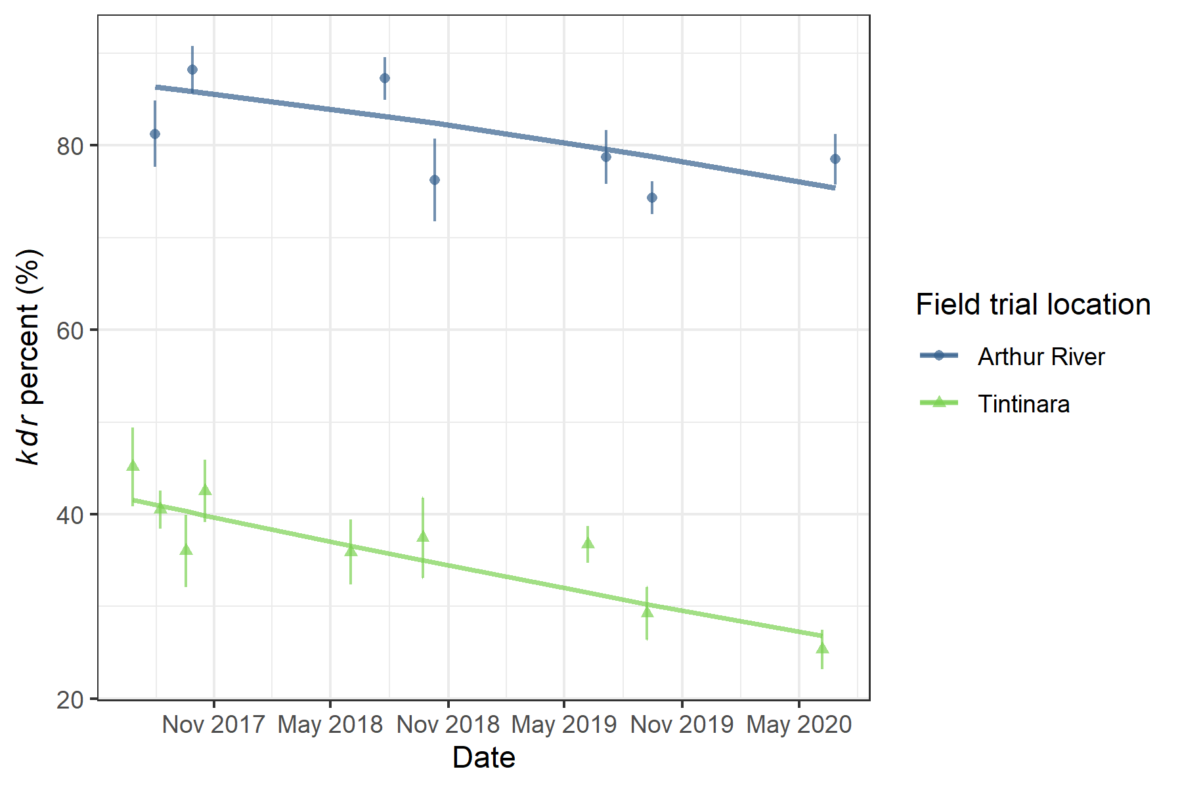

**Figure X.** Frequency of the *kdr* allele through time, with mixed-effect logistic regression model prediction shown by lines (holding random effects at zero). Points represent means for each sample date with standard errors shown by vertical bars based on plot values.

**Table Z.** Parameter estimates using the population genetics model and non-linear least squares regression

|  |  |  |
| --- | --- | --- |
| Parameter | Description | Coefficient estimate  [95 % CI] |
| $$w_{RR}$$ | Relative fitness costs of homozygous resistance alleles. | 0.87  [0.81. 0.93] |
| $$h$$ | Dominance of fitness costs | 0.70  [0.06. 1.00] |
| $$p_{0}^{A}$$ | Starting resistance allele frequency at Arthur River | 0.84  [0.80. 0.87] |
| $$p_{0}^{T}$$ | Starting resistance allele frequency at Tintinara | 0.43  [0.39. 0.48] |

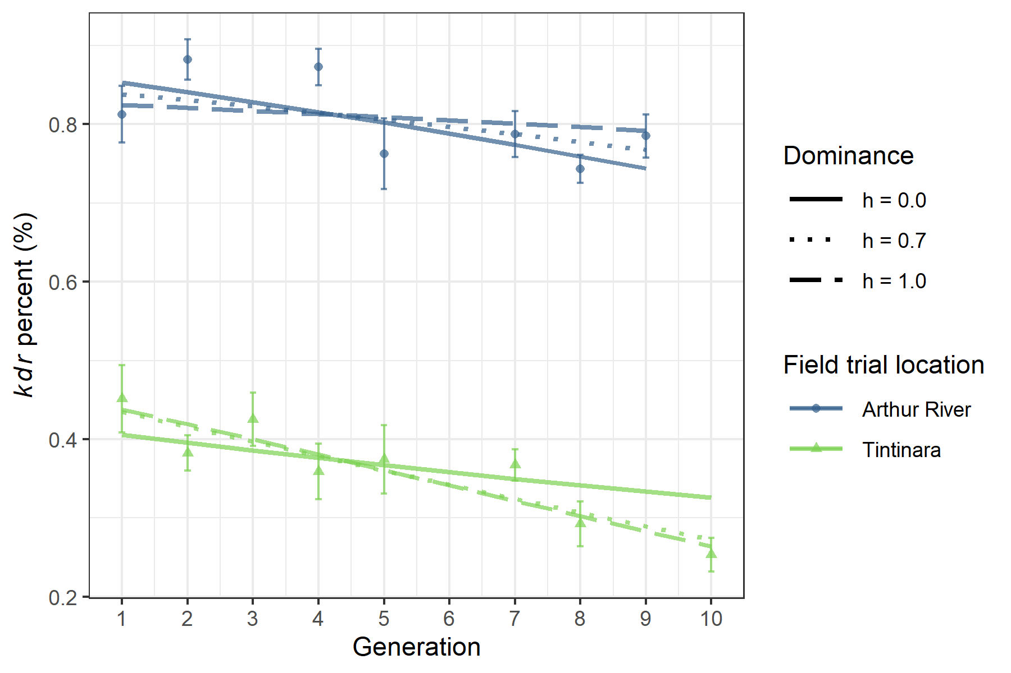

**Figure Y.** Frequency of the *kdr* allele across estimated generations, with fitted population genetics model prediction estimated with non-linear least squares shown by lines for dominant (h = 1), best-fit intermediate (h = 0.7), and recessive (h = 0) fitness costs for the resistant allele. Points represent means for each sample date with standard errors shown by vertical bars.