Adamson University  
College of Engineering  
Computer Engineering Department

Data Structures & Algorithm Analysis Lab  
MW/7am-10am/CL3

Laboratory Exercise #4  
ARRAY

Submitted by:  
Luyon, James Matthew P.

Submitted to:  
Engr. Maria Concepcion A. Mirabueno

March 20, 2019  
Date

II. The Output







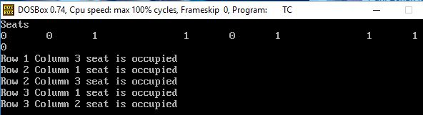

III. Analysis/Conclusion

The first array exercise is simply getting the average quiz score of John Eric with the average of 31.4, the second array exercise is similar to first array exercise but for this, is just simply displaying all the constant values in the array. The third array exercise is just simply show how to sort the values. And lastly the fourth array exercise shows how the multi-dimensional array works in simply counting the seats if it’s occupied.

Therefore all the array exercise have been debugged and executed well, the use of array is to stores a fixed-size sequential collection of elements of the same type. An array is used to store a collection of data, but it is often more useful to think of an array as a collection of variables of the same type, a specific element in an array is accessed by an index.