Adamson University  
College of Engineering  
Computer Engineering Department

Data Structures & Algorithm Analysis Lab  
MW/7am-10am/CL3

Supplementary Exercise #3  
ARRAY

Submitted by:  
Luyon, James Matthew P.

Submitted to:  
Engr. Maria Concepcion A. Mirabueno

March 20, 2019  
Date

Screen Shots:

“SUPP3A”

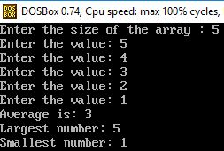

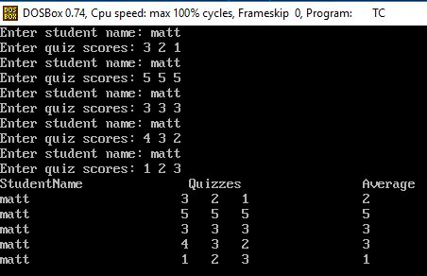“SUPP3B”

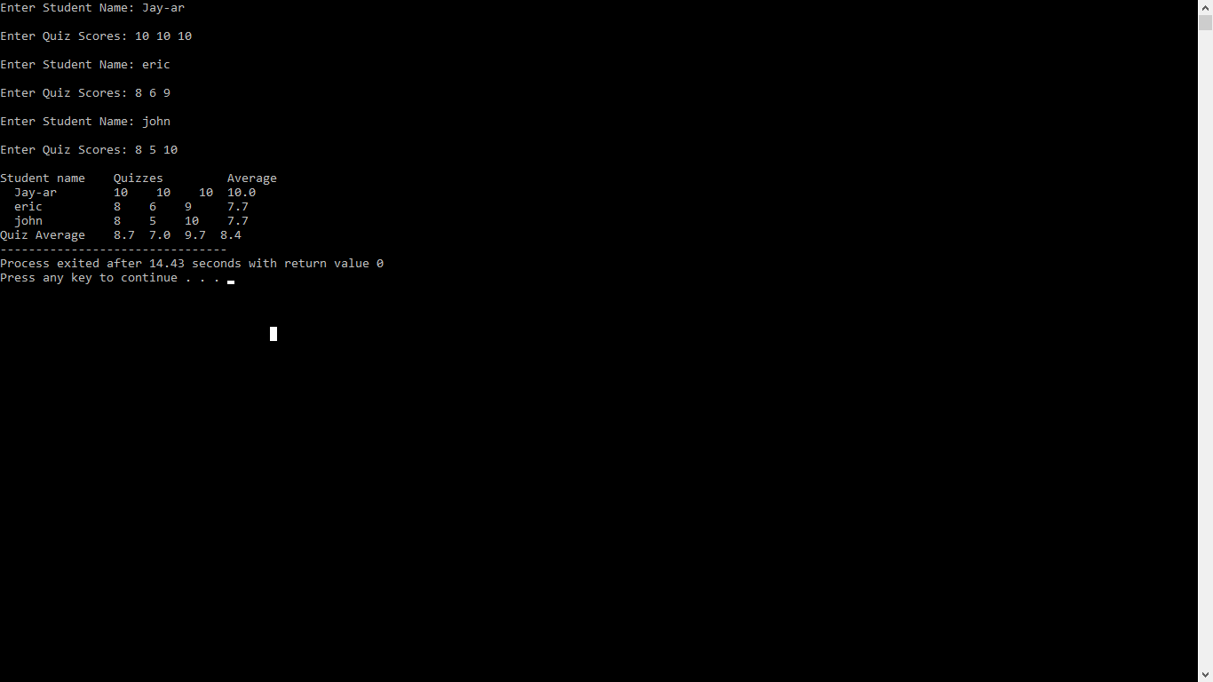

II. The Source Code

(SUPP3A)

#include<iostream.h>  
#include<conio.h>  
void main ()  
{  
clrscr();  
int array[100], n, i, max, min;  
float average,sum;  
cout<< "Enter the size of the array : ";  
cin>>n;  
for (i = 0; i < n ; i++)  
{  
 cout<<"Enter the value: ";  
 cin>>array[i];  
 sum = sum + array[i];  
 max = array[0];  
 min = array[0];  
 if(max < array[i])  
 {  
 max = array[i];  
 }  
 if(min > array[i])  
 {  
 min = array[i];  
 }  
 }  
 average = sum/n;  
 cout<<"Average is: "<< average << endl;  
 cout<<"Largest number: " << max <<endl;  
 cout<<"Smallest number: " << min;  
 getch();  
}

(SUPP3B)

#include <iostream.h>  
#include <stdio.h>  
#include <conio.h>  
#include <string.h>  
#include <iomanip.h>

string StudentName[3];  
double Sum=0.0;  
int main()  
{

int Scores[3][3];  
double StudentAve[3], QuizAve[3], TotalQuizAve3;  
cout<<setprecision(1)<<fixed;  
for(int i=0; i<3; i++)  
 {  
 cout<<"Enter Student Name: ";cin>>StudentName[i];  
 cout<<"\nEnter Quiz Scores: ";  
 for(int j=0; j<3; j++)  
 {cin>>Scores[i][j];}  
 cout<<endl;}  
for(int i=0; i<3; i++){ for(int j=0; j<3; j++){ Sum = Sum + Scores[i][j];}  
StudentAve[i]=Sum/3;  
Sum=0;}  
for(int i=0; i<1; i++){ for(int j=0; j<3; j++){Sum= Sum + StudentAve[j];}  
TotalQuizAve3= Sum/3;  
Sum=0;  
}   
for(int j=0; j<3; j++){ for(int i=0; i<3; i++){Sum = Sum + Scores[i][j];}  
QuizAve[j]=Sum/3;  
Sum=0;  
}  
cout<<"Student name"<<"\tQuizzes"<<"\t\tAverage"<<endl;  
for(int i=0; i<3; i++){ cout<<" "<<StudentName[i];  
if(i>=1){cout<<" ";}cout<<"\t";  
for(int j=0; j<3; j++){  
if(j>=1){cout<<" ";}cout<<Scores[i][j]<<" ";}  
if(i<=0){cout<<StudentAve[i];}   
else{cout<<"\t"<<StudentAve[i];}cout<<endl;}  
cout<<"Quiz Average\t";  
for(int i=0; i<4; i++){cout<<QuizAve[i]<<" ";QuizAve[3]=TotalQuizAve3;   
}  
getch();  
return 0;  
}