Analysis of the included studies

Table of Contents

# Human vaccine-preventable diseases

## Collaboration types (aggregated)

## Locations studied

### Real versus hypothetical

### Larger than one country

### Countries studied

### Continents studied

## Geographic connection of authors to the studied locations

### Author affiliation in the studied location (overall)

## Interventions

### Types of interventions

### Impact of vaccination

## Modelling objectives

## Outbreak types

## Individual heterogeneity: agent-based versus compartmental models

## Spatial heterogeneity

## Model dynamics: deterministic vs stochastic

## Outcomes measured

## Sensitivity analysis

## Data use and data availability

## Code availability

# Foot and mouth disease (FMD)

## Unique combinations of author affiliation types

## Collaboration types (aggregated)

### Proportions of the total publications per year by collaboration type

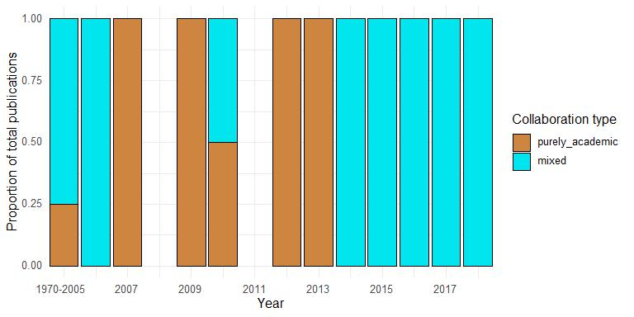

### Absolute number of publications per year by collaboration type

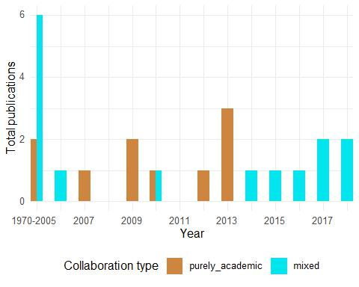

## Geographic connection of authors to the studied locations

### Aggregated

## Interventions

### Types of interventions

### Impact of vaccination

## Modelling objectives

## Outbreak types

## Individual heterogeneity: agent-based versus compartmental models

## Spatial heterogeneity

## Model dynamics: deterministic vs stochastic

## Outcomes measured

## Parametrization methods

## Validation methods

## Sensitivity analysis

## Data use and data availability

## Code availability