**How Git works**

Here is a basic overview of how Git works:

1. Create a "repository" (project) with a git hosting tool (like Bitbucket)
2. Copy (or clone) the repository to your local machine
3. Add a file to your local repo and "commit" (save) the changes
4. "Push" your changes to your master branch
5. Make a change to your file with a git hosting tool and commit
6. "Pull" the changes to your local machine
7. Create a "branch" (version), make a change, commit the change
8. Open a "pull request" (propose changes to the master branch)
9. 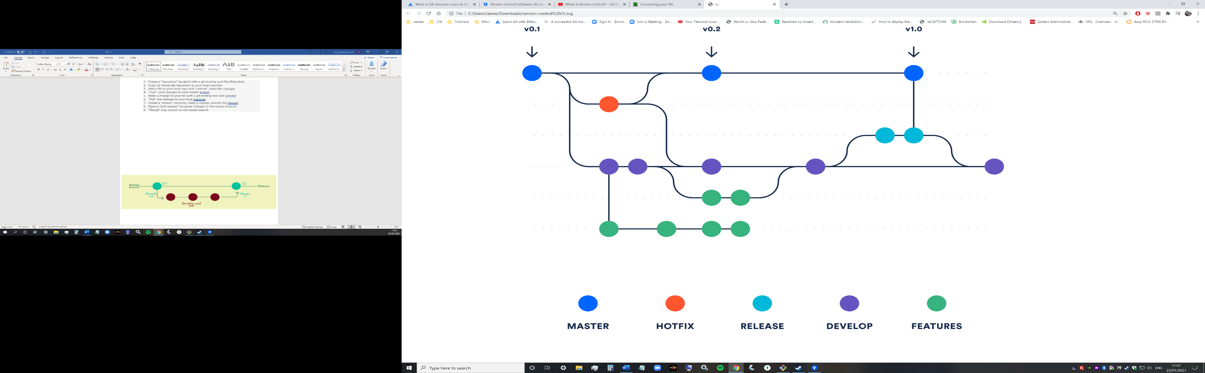"Merge" your branch to the master branch

