INTERNSHIP COMPLETION REPORT

Submitted By

XXXXXX Y (Reg. No: 952520501001)

Internship offered by

Company name
City

Mentored by
Dr.X.YYYYY
ASSOCIATE PROFESSOR
DEPARTMENT OF ARTIFICIAL INTELLIGENCE AND DATA SCIENCE
RENGANAYAGI VARATHARAJ COLLEGE OF ENGINEERING, SIVAKASI


RENGANAYAGI VARATHARAJ COLLEGE OF ENGINEERING
Approved by AICTE, New Delhi | Affiliated to Anna University, Chennai | Recognised under UGC section 2F
An ISO 21001:2018 Certified Institution
Sivakasi, Virudhunagar District - 626 128

JUNE - 2026

BONIFIDE CERTIFICATE AND VERIFICATION

This is to certify that the report is the bonafide work of "S RAJA (Reg. No: 953720501001)” who completed the internship report during the academic year 2023-2024.

Submitted on ___________________

SIGNATURE SIGNATURE
Mrs.S.XXXXXX Dr.X.YYYYYY
Placement Coordinator Prof. & Head
Dept. of CSE, RVCE Dept. of CSE, RVCE

TPO PRINCIPAL
Dr.V.VIVEK Dr.R.SELVABHARATHI
Training & Placement officer (i/c) Principal
Placement Cell, RVCE RVCE

Bonofide Certificate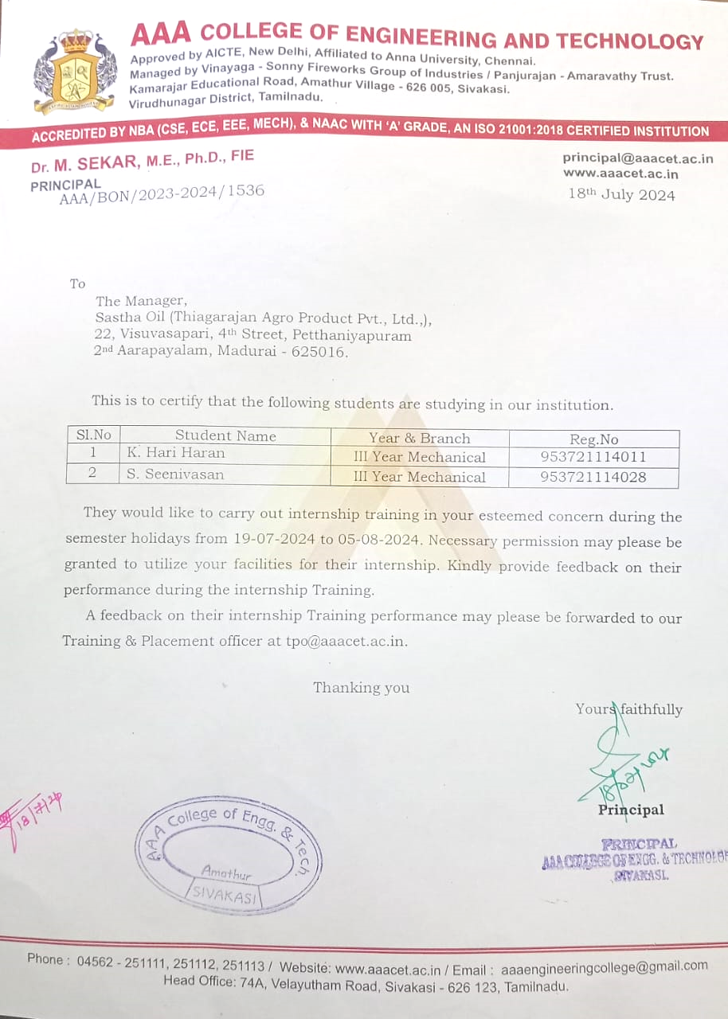Internship Completion Certificate
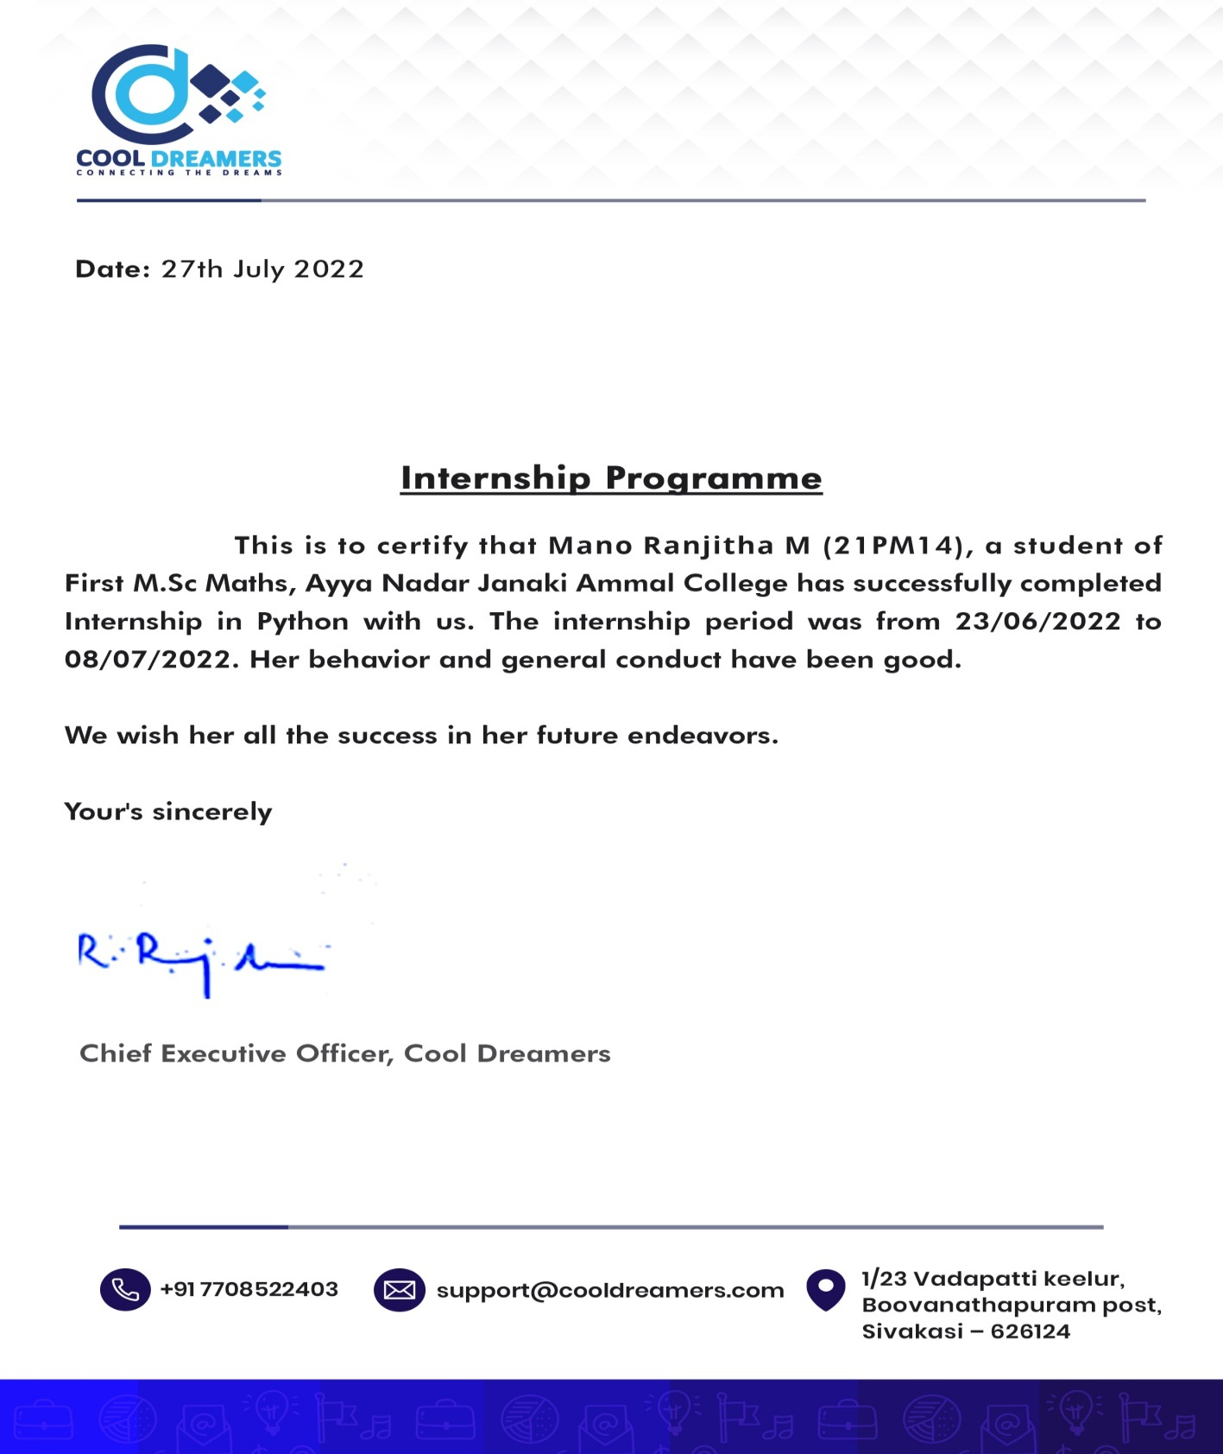

- Overview of the Organization (word limit: min. 500 words)
- Brief history
- Introduction of the organization
- Policy of the organization
- Competitors
- Organizational Structure (word limit: min. 500 words)
- Organizational Hierarchy chart
- Number of employees
- Main offices
- Introduction of all the departments
- Comments on the organizational structure
Note: In section #8-9, students are expected to collect information from various sources such as interaction with the organization’s personnel (managers, internship supervisor, colleagues etc.) and company website, documents, brochures etc. but it is necessary to mention the sources of information in report.
- Plan of your internship program (word limit: min. 300 words)
  - A brief introduction of the branch/ area office of the organization where you did your internship
  - Starting and ending dates of your internship
  - Names of the departments in which you got training and the duration of your training
- Training Program (word limit: min. 2000 words)
- Detailed description of the operations/activities performed by the department(s) you worked in.
- Detailed description of the task(s) assigned to you OR detailed description of the project assigned.
5. Reflective Journal Entries (word limit: min. 2550 words)
- In reflective journal writing, student will reflect on all activities during each day of internship in that organization and then will enter in reflective journal on daily basis.
- Entry for a single day should be very comprehensive and should include all important happenings of that particular day. A comprehensive journal not only includes information on assignments and tasks you are given, but also your impression of the organization and the staff at your internship.
- In case of any leave or holiday students will also mention it in reflective journal along with reason for observing that leave.

6. Work Samples (word limit for this section is not specified as it depends on the nature of work sample)
Compile at least 2 samples of your work during your internship. Some examples of work samples include: news stories, articles, interviews, spreadsheets, log sheets, correspondence, videos, CDs with audio or visual clips, photos, layouts, press releases, media lists, speeches etc. Each work sample should have a short description of your role in that work sample or how you used the sample.

7. Critical Analysis (word limit: min. 1500 words)
Relate the theoretical concepts with your practical experience during your internship in the organization. Execute an overall analysis of the organization.

8. SWOT Analysis (word limit: min. 1000 words)
Clearly describe all the strengths, weaknesses, opportunities and threats of the organization where you have done internship. Remember that strengths and weaknesses are internal to the organization and represent its culture while opportunities and threats correspond to the environment outside the organization.
Strengths are those qualities which distinguish or give an edge to the organization over other organizations.
Weaknesses are the attributes of an organization that are harmful in achieving the objectives of an organization.
Opportunities are the external factors that are helpful in achieving the objectives of the organization.
Threats are the external factors which could damage the business performance of the organization.

9. Conclusion (word limit: min. 350 words)
In this section you are required to describe the organization according to your evaluation/assessment in the light of critical and SWOT analyses.

