CprE 381: Computer Organization and Assembly-Level Programming

Project Part 1 Report

Team Members: _Ella Knott
_James Minardi

Project Teams Group #:___03-06_______________

Refer to the highlighted language in the project 1 instruction for the context of the following questions.

[Part 1 (d)] Include your final MIPS processor schematic in your lab report.
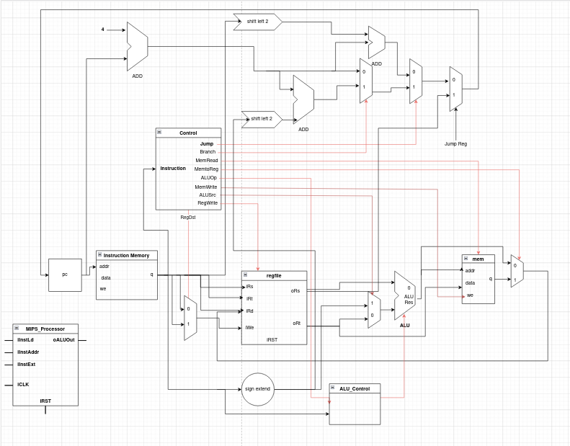
[Part 2 (a.i)] Create a spreadsheet detailing the list of M instructions to be supported in your project alongside their binary opcodes and funct fields, if applicable. Create a separate column for each binary bit. Inside this spreadsheet, create a new column for the N control signals needed by your datapath implementation. The end result should be an N*M table where each row corresponds to the output of the control logic module for a given instruction.
See control_logic.ods

[Part 2 (a.ii)] Implement the control logic module using whatever method and coding style you prefer. Create a testbench to test this module individually and show that your output matches the expected control signals from problem 1(a).

[Part 2 (b.i)] What are the control flow possibilities that your instruction fetch logic must support? Describe these possibilities as a function of the different control flow-related instructions you are required to implement.
Fetch logic must support branch and jump instructions with the flow control, as they do not follow the consistent PC+4 that most other instructions do. These funtions include: BNE, BEQ, Jal, J, JR

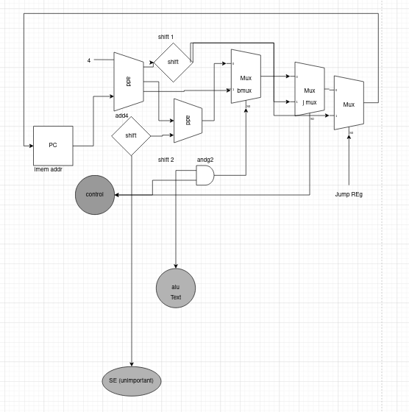
[Part 2 (b.ii)] Draw a schematic for the instruction fetch logic and any other datapath modifications needed for control flow instructions. What additional control signals are needed?

[Part 2 (b.iii)] Implement your new instruction fetch logic using VHDL. Use QuestaSim to test your design thoroughly to make sure it is working as expected. Describe how the execution of the control flow possibilities corresponds to the QuestaSim waveforms in your writeup.

[Part 2 (c.i.1)] Describe the difference between logical (srl) and arithmetic (sra) shifts. Why does MIPS not have a sla instruction?
SRL fills in zeros in the shift, and arithmetic SRA fills in the sign bits. MIPS doesn’t have an SLA functions because the way MIPS functions would end up filling the sign bits with a least significant bit instead of the most significant bit, which would cause problems.

[Part 2 (c.i.2)] In your writeup, briefly describe how your VHDL code implements both the arithmetic and logical shifting operations.
Our shifter implements arithmetic options by including a control input for the arithmetic value (1 for arithmetic 0 for logic) and selects for left shift operations.

[Part 2 (c.i.3)] In your writeup, explain how the right barrel shifter above can be enhanced to also support left shifting operations.
To support left shift you would just need to reverse the bit order, perform the shift, and then reverse it agian

[Part 2 (c.i.4)] Describe how the execution of the different shifting operations corresponds to the QuestaSim waveforms in your writeup.
(we did all the tests in one so the screenshots are cropped a little weird)
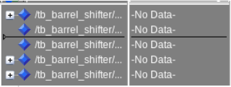
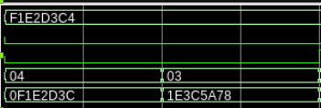
SRL
SRL2

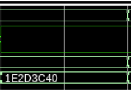
SRA

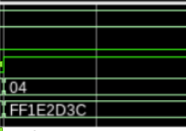
SLL (0bit)
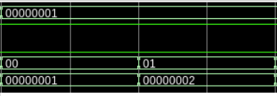
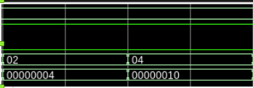
SLL(1bit)
SLL(2bit)
SLL(4bit)
SLL(8bit)
SLL(16bit)
[Part 2 (c.ii.1)] In your writeup, briefly describe your design approach, including any resources you used to choose or implement the design. Include at least one design decision you had to make.
Our ALU control determined the action that was being performed from the ALUOpcode input

[Part 2 (c.ii.2)] Describe how the execution of the different operations corresponds to the QuestaSim waveforms in your writeup.

[Part 2 (c.iii)] Draw a simplified, high-level schematic for the 32-bit ALU. Consider the following questions: how is Overflow calculated? How is Zero calculated? How is slt implemented?
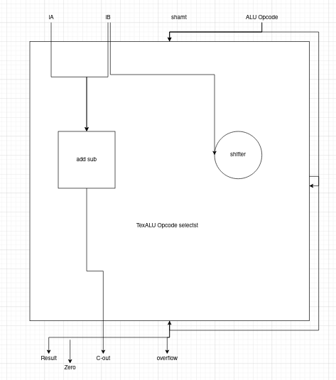
[Part 2 (c.v)] Describe how the execution of the different operations corresponds to the QuestaSim waveforms in your writeup.

[Part 2 (c.viii)] justify why your test plan is comprehensive. Include waveforms that demonstrate your test programs functioning.

[Part 3] In your writeup, show the QuestaSim output for each of the following tests, and provide a discussion of result correctness. It may be helpful to also annotate the waveforms directly.

[Part 3 (a)] Create a test application that makes use of every required arithmetic/logical instruction at least once. The application need not perform any particularly useful task, but it should demonstrate the full functionality of the processor (e.g., sequences of many instructions executed sequentially, 1 per cycle while data written into registers can be effectively retrieved and used by later instructions). Name this file Proj1_base_test.s.

[Part 3 (b)] Create and test an application which uses each of the required control-flow instructions and has a call depth of at least 5 (i.e., the number of activation records on the stack is at least 4). Name this file Proj1_cf_test.s.

[Part 3 (c)] Create and test an application that sorts an array with N elements using the BubbleSort algorithm (link). Name this file Proj1_bubblesort.s.
see Proj1_bubblesort.s

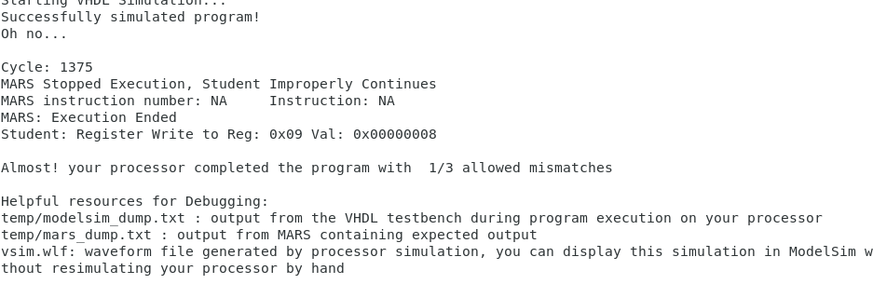
When running the bubble sort we only received one mismatch due to the process continuing more than necessary

[Part 4] Report the maximum frequency your processor can run at and determine what your critical path is. Draw this critical path on top of your top-level schematic from part 1. What components would you focus on to improve the frequency?
Unable to run synthesis

