**Question 1**

import datetime

import logging

import random

class Customer:

    def __init__(self, name: str, phone: str, email: str):

        self.name: str = name

        self.phone: str = phone

        self.email: str = email

    @property

    def name(self):

        return self._name

    @property

    def phone(self):

        return self._phone

    @property

    def email(self):

        return self._email

    @name.setter

    def name(self, new_name):

        self._name = new_name

    @phone.setter

    def phone(self, new_phone):

        self._phone = new_phone

    @email.setter

    def email(self, new_email):

        self._email = new_email

class Stock:

    def __init__(self, book_name: str, author: str, price: float):

        self.book_name: str = book_name

        self.author: str = author

        self.price: float = price

    @property

    def book_name(self):

        return self._book_name

    @property

    def author(self):

        return self._author

    @property

    def price(self):

        return self._price

    @book_name.setter

    def book_name(self, new_book_name):

        self._book_name = new_book_name

    @author.setter

    def author(self, new_author):

        self._author = new_author

    @price.setter

    def price(self, new_price):

        self._price = new_price

class Order:

    def __init__(self, customer: Customer, stock: Stock):

        self.customer: Customer = customer

        self.stock: Stock = stock

    @property

    def customer(self):

        return self._customer

    @property

    def stock(self):

        return self._stock

    @customer.setter

    def customer(self, new_customer):

        self._customer = new_customer

    @stock.setter

    def stock(self, new_stock):

        self._stock = new_stock

class Shipping:

    urgent_cost: float = 5.45

    basic_cost: float  = 3.95

    def __init__(self, order: Order, ship_date: datetime):

        self.order: Order = order

        self.ship_date: datetime = ship_date

        self.ship_cost: int = 0

        self.count_urgent: int = 0

    def set_ship_cost(self, ship_cost: float):

        self.ship_cost = ship_cost

    # calculating the shipping cost. 3.95 if not urgent, 5.45 if it is urgent

    def calc_ship_cost(self, is_urgent: bool):

        if is_urgent:

            self.ship_cost = self.urgent_cost

            self.add_urgent_shipment()

        else:

            self.ship_cost = self.basic_cost

        return self.ship_cost

    # helper function to increment the count urgent for a given shipment. could allow us to extend our functionality in case we need have many levels of urgency

    def add_urgent_shipment(self):

        self.count_urgent += 1

    @property

    def ship_date(self):

        return self._ship_date

    @property

    def ship_cost(self):

        return self._ship_cost

    @ship_date.setter

    def ship_date(self, new_ship_date):

        self._ship_date = new_ship_date

    @ship_cost.setter

    def ship_cost(self, new_ship_cost):

        self._ship_cost = new_ship_cost

class Invoice:

    def __init__(self, invoice_nbr: str, stock: Stock, ship_order: Shipping):

        self.invoice_nbr: str = invoice_nbr

        self.stock: Stock = stock

        self.ship_order: Shipping = ship_order

        self.total_cost: int = 0

    # The invoice value is the price of the book + the price of the shipping

    def invoice(self):

        self.total_cost = self.stock.price + self.ship_order.ship_cost

        return self.total_cost

    @property

    def invoice_nbr(self):

        return self._invoice_nbr

    @invoice_nbr.setter

    def invoice_nbr(self, new_invoice_nbr):

        self._invoice_nbr = new_invoice_nbr

class BookStore:

    def __init__(self):

        self.invoices: list[Invoice] = []

    # function to search through all the invoices in the bookstore looking for invoices matching the nbr number

    def search_invoice(self, nbr: str):

        for invoice in self.invoices:

            if invoice.invoice_nbr == nbr:

                return invoice

        else:

            print("Invoice not found")

    # helper function to return all invoices from the bookstore

    def get_all_invoices(self):

        return self.invoices

    @property

    def invoices(self):

        return self._invoices

    @invoices.setter

    def invoices(self, new_invoices):

        self._invoices = new_invoices

class Test:

    def main():

        logging.info("Creating 3 Test Customer Objects")

        customer1 = Customer("Mike", "".join([str(random.randint(0, 9)) for _ in range(0, 11)]), "mike@gmail.com")

        customer2 = Customer("Alice", "".join([str(random.randint(0, 9)) for _ in range(0, 11)]), "alice@hotmail.co.uk")

        customer3 = Customer("Bob", "".join([str(random.randint(0, 9)) for _ in range(0, 11)]), "bob@btinternet.com")

        logging.info("Creating 3 Test Stock Objects")

        stock1 = Stock("A Christmas Carol", "Charles Dickens", 2.73)

        stock2 = Stock("To Kill a Mockingbird", "Harper Lee", 8.16)

        stock3 = Stock("The Great Gatsby", "F. Scott Fitzgerald", 57.17)

        logging.info("Creating 3 Test Order Objects")

        order1 = Order(customer1, stock1)

        order2 = Order(customer2, stock2)

        order3 = Order(customer3, stock3)

        logging.info("Creating 3 Test Shipping Objects")

        shipping1 = Shipping(order1, datetime.date.today())

        shipping2 = Shipping(order2, datetime.date.today())

        shipping3 = Shipping(order3, datetime.date.today())

        logging.info("Setting Shipping Costs")

        shipping1.set_ship_cost(shipping1.calc_ship_cost(True))

        shipping2.set_ship_cost(shipping2.calc_ship_cost(False))

        shipping3.set_ship_cost(shipping3.calc_ship_cost(True))

        logging.info("Creating 3 Invoices")

        invoice1 = Invoice("INV0001", stock1, shipping1)

        invoice2 = Invoice("INV0002", stock2, shipping2)

        invoice3 = Invoice("INV0003", stock3, shipping3)

        logging.info("Creating a Bookstore")

        bookstore = BookStore()

        logging.info("Adding the invoices to our bookstore")

        bookstore.invoices.append(invoice1)

        bookstore.invoices.append(invoice2)

        bookstore.invoices.append(invoice3)

        print(f"Number of urgent shipments: {shipping1.count_urgent}")

        print(f"Invoice 1 total cost: {invoice1.invoice():.2f}")

        print(f"Invoice 2 total cost: {invoice2.invoice():.2f}")

        print(f"Invoice 3 total cost: {invoice3.invoice():.2f}")

        print(f"Number of Invoices in BookStore: {bookstore.get_all_invoices()}")

        assert bookstore.search_invoice("INV0004") is None

        assert shipping1.count_urgent == 1

        assert len(bookstore.get_all_invoices()) == 3

if __name__ == "__main__":

    Test.main()

**Test Cases:**

* Scenario 1 (Running as seen in the code above):

Output:

* Scenario 2 (Changing the assertions):

assert bookstore.search_invoice("INV0004") is not None

        assert shipping1.count_urgent == 1

        assert len(bookstore.get_all_invoices()) == 4

Output:

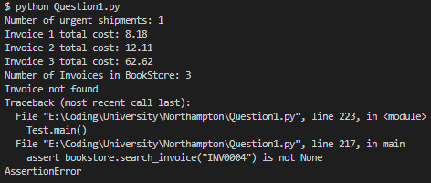

**Question 2**

# Importing Regex to use later to strip out punctuation

import re

import os

import sys

class SentimentLexicon:

    def __init__(self):

        # Initialising the Dictionary that will store all the words from the input values with their respective positive/negative values

        self.dictionary = {}

    def create_lexicon(self, positive_words_file, negative_words_file):

# os.path.join(sys.path[0]) takes the path of the directory the python file is running in and joins it with the file name.

      # This means the input needs to be in the same folder as the code.

        with open((os.path.join(sys.path[0], positive_words_file)), 'r') as positive_words:

            for line in positive_words: # looping through each line in the input file

                if ";" not in line: # the first lines of the input file are commented and contain semi colons. These need to be omitted.

                    word = line.strip() # stripping away /n characters

                    self.dictionary[word] = 1 # adding positive words to the dictionary with the value of positive 1

        with open((os.path.join(sys.path[0], negative_words_file)), 'r') as negative_words:

            for line in negative_words: # looping through each line in the input file

                if ";" not in line:  # the first lines of the input file are commented and contain semi colons. These need to be omitted.

                    word = line.strip() # stripping away /n characters

                    self.dictionary[word] = -1 # adding positive words to the dictionary with the value of negative 1

class Classifier:

    def __init__(self, sentiment_lexicon):

        self.sentiment_lexicon: SentimentLexicon = sentiment_lexicon # giving the classifier access to the already instantiated SentimentLexicon - This could be done via inheritence

        self.classified_sentences: list[dict] = [] # will store the results of all the processed texts

# a short list of negation words which will allow us to invert the score of positive of negative words

        self.negation_words = ["not", "never", "nothing", "nowhere", "noone", "none",

                               "havent", "hasnt", "hadnt", "cant", "couldnt", "shouldnt",

                               "wont", "wouldnt", "dont", "doesnt", "didnt", "isnt", "arent", "aint"]

    def classify(self, text: str):

        score = 0

        negation = False # the word "bad" would be scored as -1 but if it is "not bad" it should be scored a 1 since it is inverted with the use of not

        for word in text.split():

            word = re.sub(r'[^\w\s]','', word) # stripping punctuation from the word using regex

            if word in self.negation_words:

                negation = True if not negation else False # if negation is False make it True. If it is True make it False. This accounts for double negatives like "not not bad"

            if word in self.sentiment_lexicon.dictionary:

                if negation: # if negation is true the next adjective in the list of dictionary words from the lexicon class will have its score inverted. 1 => -1 or -1 => 1

                    score -= self.sentiment_lexicon.dictionary[word]

                    negation = False # after the negative has been used negation is then reset to False

                else:

                    score += self.sentiment_lexicon.dictionary[word]

        if score > 0: # if the sentence score > 0 sentiment is 1

            sentiment = 1

        elif score < 0: # if the sentence score < 0 sentiment is 0

            sentiment = -1

        else: # if the sentence score is not greater than or less than 0 it must be 0 - the sentiment is nothing then.

            sentiment = 0

        result = {"text": text, "sentiment": sentiment}

        self.classified_sentences.append(result) # appending the current result to the history of classified_sentences

    def classify_multiple_words(self, list_of_text): # helper function to loop through and classify multiple words/sentences.

        for text in list_of_text:

            self.classify(text)

    def show_classified_sentences(self): # helper function to display all previously classified sentences.

        for sentence in self.classified_sentences:

            print(sentence)

lexicon = SentimentLexicon() # instantiating the lexicon

lexicon.create_lexicon("positive-words.txt", "negative-words.txt") # calling the function that will populate the lexicon dictionary

classifier = Classifier(lexicon) # instatiating the classifier and passing in the lexicon

example_text = [ # example sentences

    "I love Python",

    "Python is the language I love!",

    "The iPhone is clearly not the most terrible and worst phone ever. It is the best."

]

classifier.classify_multiple_words(example_text) # calling the helper function that loops through the sentences above and classifies them

classifier.show_classified_sentences() # calling the helper function that loops through the stored sentence,sentiment pairs and prints them

**Test Cases:**

* Scenario 1**:**

example_text = [ # example sentences

    "I love Python",

    "Python is the language I love!",

    "The iPhone is clearly not the most terrible and worst phone ever. It is the best."

]

Output:

* Scenario 2:

example_text = [ # example sentences

    "I hate every programming language including Python!",

    "I really don't hate this but it's not good...",

    "Anyone who likes coding is good but not great because it's difficult."

]

Output:

**Question 3**

Output:

**Question 4**

Data Exploration:

We can see from a simple describe function of the dataset that the minimum price of a single item in the dataset has stayed almost the same (only increasing by £4) whereas the maximum price of a single item in the dataset has increased by £33. We can also see that there is a smaller jump with the median price April 2022 => September 2022 (only increasing by £3) compared to the previous jump (£9) however the increased by £10. This means that generally items under the median price of £88 where the items that increased the most in value.

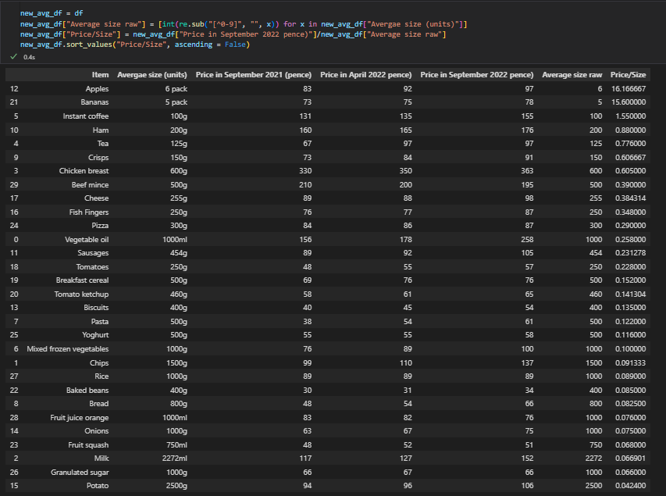

We’re able to created an extra column which have the average size with the units stripped away. We can use this to work out the price/unit (milliliter or gram). I did this for the September 2022 prices but this can be done over all three time periods or over any of the individual ones. We can see that the most expensive item via this metric are fruits. This makes sense as 97p for only 6 apples is quite a lot. This is only because the unit used for the fruit is “pack” instead of “grams”. We can discount these as anomolies as we know that 6 apples or 5 bananas would be quite heavy. If we used grams instead the values would be more logical. We can then see that the most expensive item is instant coffee. This makes a lot of sense as coffee is generally quite expensive and you don’t get a lot. The inverse is that potatos are the cheapest per gram. This is also expected as potatos are incredibly cheap and you get lots of them. Through this analysis you will notice the bottom 10 items (the 10 cheapest per size) as often staple items in all cookery (Potatos => Chips). This is the reason why these items are such staples of cookery as everyone can afford them.

Comparing these values over the years would not be useful currently as the quauntity value is the same and would just give the same values as the next graph with just a factor of the quantity taken out.

Through plotting the data on a bar chart with price on the y axis and item on the x axis with 3 split bars for each time of data we can see that all the food items have increased in price from September 2021 => September 2022 with the exception of Fruit Orange Juice and Granulated Sugar and Beef Mince.

The summed prices of all the items has obviously also increased over time. Here we can see the difference in price between all the summed items. We can then actually work out price increase. Since the gradient of the line between April 2022 => September 2022 is steeper than the Increase from September 2021 => April 2022 we know that the prices have increased more. The exact values of the increase are

|  |  |  |  |
| --- | --- | --- | --- |
| Dates | Price Points | Raw Diff | % Change |
| September 2021 => April 2022 | 2742 => 2929 | +187 | +6.8% |
| April 2022 => September 2022 | 2929 => 3210 | +281 | +9.6% |

By performing a groupby on the Average size and then grouping by the average size we can see how many items fall into each band of size. This would be equal to a SQL query: SELECT average_raw_size, COUNT(*) FROM dataframe GROUP BY average_raw_size. This is done to see the distribution of weights. From this we can see that the most popular weight is 1000g (1Kg) but as expected there is a long tail. We could equally try to fit the raw_size into bands of 200. We could use an analysis like that to work out how much you could fit in a shopping bag for example. Given that you can only carry so much.

By comparing the means and maxes of items between September 2021 => September 2022 I was able to assert that the average increase per item was 17.07% but one item had a single increase of 65% in just one year!

Tkinter Code:

from matplotlib.backends.backend_tkagg import FigureCanvasTkAgg

import tkinter as tk

import pandas as pd

import os

import sys

import matplotlib.pyplot as plt

from pandas import DataFrame

def graph_data(dataframe: DataFrame):

    fig1 = plt.figure()

    fig2 = plt.figure()

    ax1 = fig1.add_subplot(111)

    ax2 = fig2.add_subplot(111)

    summed = dataframe.sum(numeric_only=True)

    summed.plot(figsize=(15,10), kind='bar', ax=ax2)

    summed.plot(figsize=(15,10), kind='line', color='red', linewidth='5', ax=ax2)

    dataframe.plot(x="Item", kind='bar', figsize=(10,5), ax=ax1)

    #Add x and y axis labels and a title

    plt.xlabel('Item')

    plt.ylabel('Price')

    plt.title('Price of Each Item in given times')

    plt.text(0,1.2,'This text will be on top of the graph', transform=ax1.transAxes)

    fig1.set_tight_layout(True)

    fig2.set_tight_layout(True)

    ax1.legend(loc='upper left', bbox_to_anchor=(1,1), fontsize=6)

    canvas1 = FigureCanvasTkAgg(fig1, master=root)

    canvas1.get_tk_widget().pack()

    canvas1.draw()

    canvas2 = FigureCanvasTkAgg(fig2, master=root)

    canvas2.get_tk_widget().pack()

    canvas2.draw()

def on_closing():

    root.destroy()

def main():

    dataframe: DataFrame = pd.read_excel((os.path.join(sys.path[0],'food-data.xlsx')))

    button = tk.Button(root, text="Show Graph", bg="green", fg="white", font=("Helvetica", 16), command=lambda: graph_data(dataframe))

    button.pack()

    root.protocol("WM_DELETE_WINDOW", on_closing)

    root.mainloop()

if __name__ == "__main__":

    root = tk.Tk()

    main()

Screenshots:

