Football Craze Sweepstakes Workflow

This document describes the steps taken for enabling online purchasing through GEMS, distributing electronic sweepstake tickets (E-Tickets) and posting weekly winners.

Prequisites
The person designated for distributing the e-tickets will need the FootballCrazeSweepstakes desktop application. Additionally, it’s recommended to have an application/utility for viewing the purchase information that gets stored in a sql lite database.

FootballCrazeSweepstakes Application
The app handles uploading the e-tickets and emailing e-tickets to people who have purchased e-tickets through Gems. It’s a desktop application. The database is stored locally so you want to run the application only on one computer to keep the database in sync:
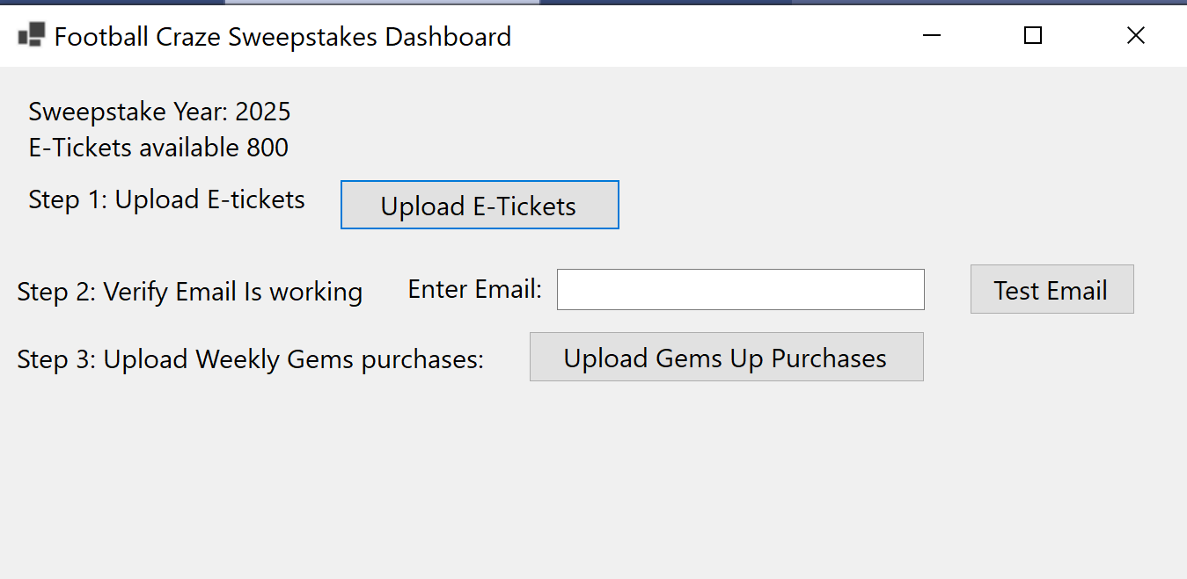
The app works only for sales for the current year by design so sales must end before January first of the upcoming year. Sales generally end around week 8 so this should never be an issue. SMTP along with some other settings can be updated in the appsetting.json file. There are two directories the application uses for uploading e-tickets and uploading the purchases Excel file that gets downloaded from Gems:

Free Application for Viewing Purchase Information

Setting Up Online Purchasing for the Current Year

