

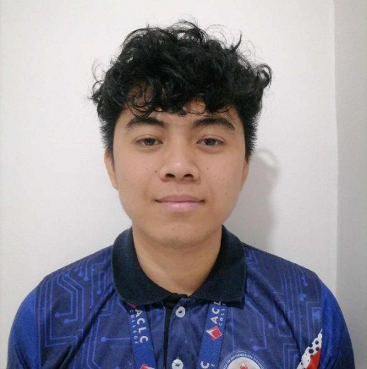

**FAMINIANO, ERMAN LOUIE A.**

INTERN

February 20, 2002

P13 POBLACION VALENCIA CITY, BUKIDNON

Contact Person:

EMMALOU F. DAYTIC

09777783428

**LACUESTA, ALJOHN T.**

INTERN

July 31, 2001

P3 TONGANTONGAN VAL. C. Buk

Contact Person:

ORENCIO LACUESTA SR.

09750374282

**ALFARERO, ALREY D.**

INTERN

MAY 4, 2002

P3 NORTH POBLACION MARAMAG BUKIDNON

Contact Person:

JENNY D. ALFARERO

09355390590

**PABIONA, TED RAPHAEL A.**

INTERN

FEBRUARY 19, 2003

P5 SINAYAWAN VALENCIA CITY BUKIDNON

Contact Person:

NINIAN PABIONA

09351967981



**ADOBAS, ARC ANGELO C.**

INTERN

FEBRUARY 19, 2003

P5 SINAYAWAN VALENCIA CITY BUKIDNON

Contact Person:

NINIAN PABIONA

09351967981