**Get started with LinkedIn**

**Signing up**

Signing up with LinkedIn is simple. Just follow these simple steps:

1. Browse to [linkedin.com](https://www.linkedin.com/)
2. Click **Join now** or **Join with resume**.

If you clicked **Join now**:

1. Enter your email address and a password and click **Agree & Join** (or click **Join with Google** to link to a Google account).
2. Enter your first and last name and click **Continue**.
3. Enter your country/region, your postal code, and location with the area (this helps LinkedIn find job opportunities near you).
4. Enter your most recent job title, or select **I’m a student**.
5. If you entered your most recent job title, select your employment type and enter the name of your most recent company.
6. If you selected self-employed or freelance, LinkedIn will ask for your industry.
7. Click confirm your email address. You will receive an email from LinkedIn.
8. To confirm your email address, click **Agree & Confirm** in your email.
9. LinkedIn will then ask if you are looking for a job. Click the answer that applies. If you select Yes, LinkedIn will help you start looking for job opportunities.

If you clicked **Join with resume**:

1. Click **Upload your resume** and select the file to upload.
2. Follow any of the steps under **Join Now** that are relevant.

The Join with resume option saves you some time because it auto-fills most of the information from your resume. And just like that, your initial profile is now ready!

**Including basic information in your profile**

It is a good idea to take your time filling out every section of your profile. This helps recruiters find your profile and helps people you connect with get to know you better. Start with your photo. Here are some tips to help you choose a great picture for your new profile:

* Choose an image that looks like you: You want to make sure that your profile is the best representation of you and that includes your photo. You want a potential connection or potential employer to be able to recognize you from your profile picture if you were to meet.
* Use your industry as an example: If you are having trouble deciding what is appropriate for your profile image, look at other profiles in the same industry or from companies you are interested in to get a better sense of what you should be doing.
* Choose a high-resolution image: The better the resolution, the better impression it makes, so make sure the image you choose isn’t blurry. The ideal image size for a LinkedIn profile picture is 400 x 400 pixels. Use a photo where your face takes up at least 60% of the space in the frame.
* Remember to smile: Your profile picture is a snapshot of who you are as a person so it is okay to be serious in your photo. But smiling helps put potential connections and potential employers at ease.



**Adding connections**

Connections are a great way to keep up to date with your previous coworkers, colleagues, classmates, or even companies you want to work with. The world is a big place with a lot of people. So here are some tips to help get you started.

1. Connect to people you know personally.
2. Add a personal touch to your invitation message. Instead of just letting them know you would like to connect, let them know why.
3. Make sure your profile picture is current so people can recognize you.
4. Add value. Provide them with a resource, a website link, or even some content they might find interesting in your invitation to connect.

**Finding leaders and influencers**

LinkedIn is a great place to find great people and great ideas. From technology to marketing, and everything in between, there are all kinds of influencers and thought leaders active on LinkedIn. If you have ever wanted to know the thoughts of some of the most influential and respected minds in a certain field, LinkedIn is a great place to start. Following your favorite people takes only a few minutes. You can search for people or companies individually, or you can use these lists as starting points.

[Top influencers on LinkedIn](https://lists.linkedin.com/2015/top-voices/influencers) [LinkedIn Top Voices 2020: Data Science & AI](https://www.linkedin.com/pulse/linkedin-top-voices-2020-data-science-ai-jessi-hempel/)

**Looking for a new position**

On LinkedIn, letting recruiters and potential employers know that you are in the market for a new job is simple. Just follow these steps:

1. Click the **Me** icon at the top of your LinkedIn homepage.
2. Click **View profile**.
3. Click the blue **Open to** button prompting a drop-down menu and under Intro, select **Finding a new job**.
4. Provide the requested job title and location requests within the pop-up window.
5. When you are done updating, click on the **Save** button which will add the tags to your public profile.

Make sure to select the appropriate filters for the new positions you might be looking for and update your profile to better fit the role that you are applying for.

**Keeping your profile up to date**

Add to your profile to keep it complete, current, and interesting. For example, remember to add the Google Data Analytics Certificate to your profile after you complete the program!

**Build connections on LinkedIn**

**Using LinkedIn to connect**

A **connection** is someone you know and trust on a personal or professional basis. Your connections are who make up your network. And when it comes to your network, it is important to remember quality over quantity. So don’t focus on how many connections you have. Instead, make sure that everyone you connect with adds value to your network, and vice versa.

**Inviting those you know versus making cold requests**

Adding connections on LinkedIn is easy. You invite people to join your network, and they accept your invitation. When you send an invitation, you can attach a personal note. Personal notes are highly recommended.

A great way to increase the number of your connections is to invite classmates, friends, teachers, or even members of a club or organization you are in. LinkedIn also gives suggestions for connections based on your profile information. Here's an example (template) that you can use to connect with a former co-worker:

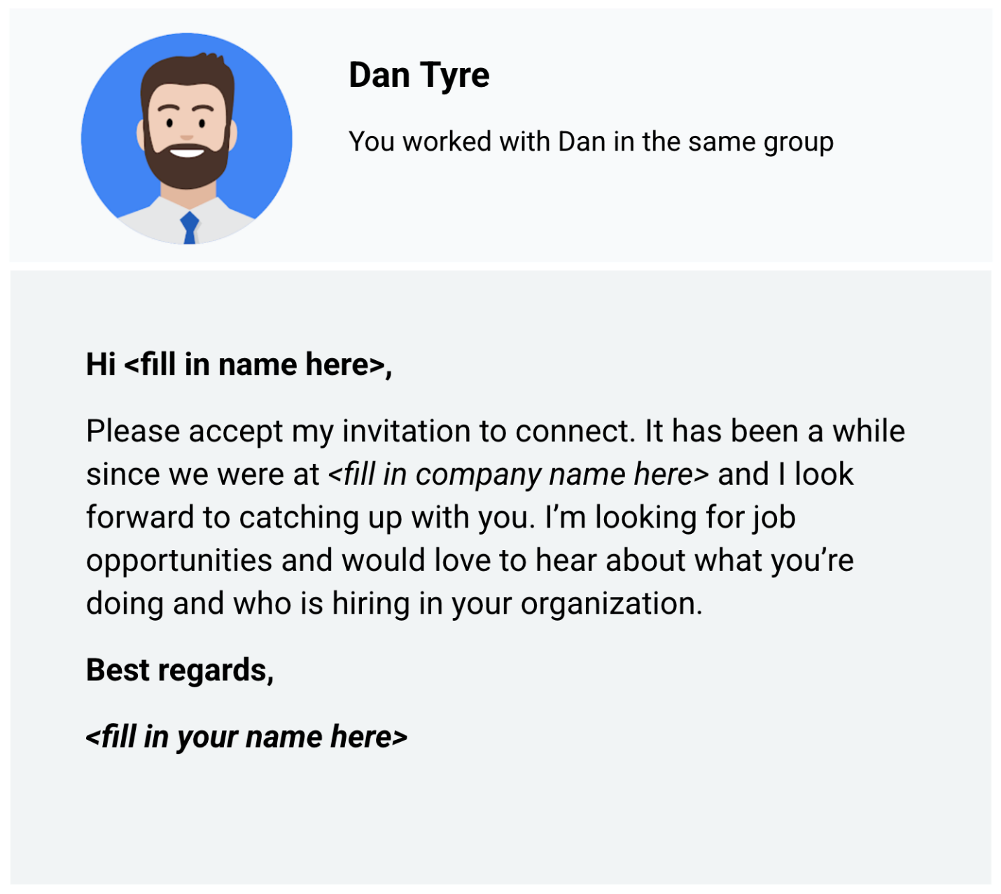The message: Hi <fill in name here>, Please accept my invitation to connect. It has been a while since we were at <fill in company name here> and I look forward to catching up with you. I’m looking for job opportunities and would love to hear about what you’re doing and who is hiring in your organization. Best regards, <fill in your name here>

Cold requests on LinkedIn are invitations to connect with people you don’t know personally or professionally. When you start to build your network, it is best to connect with people you already know. But cold requests might be the only way to connect with people who work at companies you are interested in. You can learn a lot about a company’s culture and job openings from current employees. As a best practice, send cold requests rarely and only when there is no other way to connect.

**Asking for recommendations (references)**

Recommendations on LinkedIn are a great way to have others vouch for you. Ask people to comment on your past performance, how you handled a challenging project, or your strengths as a data analyst. You can choose to accept, reject, show, or hide recommendations in your profile.

Here are some tips for asking for a recommendation:

* Reach out to a variety of people for a 360-degree view: supervisors, co-workers, direct reports, partners, and clients
* Personalize the recommendation request with a custom message
* Suggest strengths and capabilities they can highlight as part of your request
* Be willing to write a recommendation in return
* Read the recommendation carefully before you accept it into your profile

Sometimes the hardest part of getting a recommendation is creating the right request message. Here's an example (template) that you can use to ask for a recommendation:

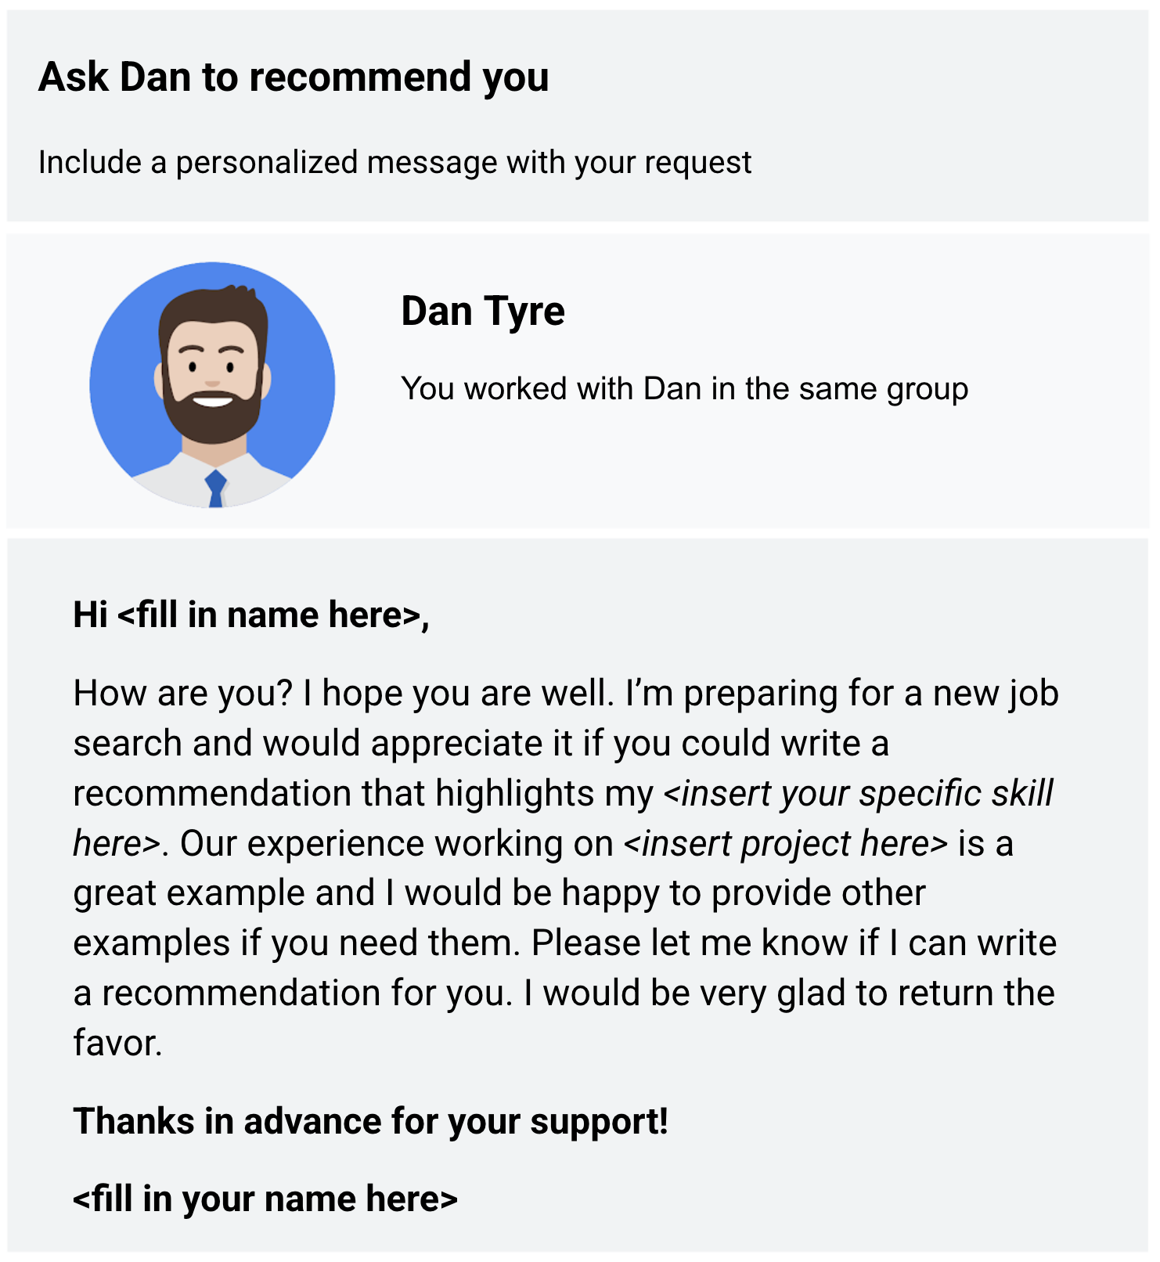Hi <fill in name here>, How are you? I hope you are well. I’m preparing for a new job search and would appreciate it if you could write a recommendation that highlights my <insert your specific skill here>. Our experience working on <insert project here> is a great example and I would be happy to provide other examples if you need them. Please let me know if I can write a recommendation for you. I would be very glad to return the favor. Thanks in advance for your support! <fill in your name here>

Ask a few connections to recommend you and highlight why you should be hired. Recommendations help prospective employers get a better idea of who you are and the quality of your work.

**Summing it up**

When you write thoughtful posts and respond to others genuinely, people in and even outside your network will be open and ready to help you during your job search.

Hello. Let's talk about social media.

Today, there's 3.8 billion

people using social media around the world.

There's a good chance you probably already

have an online presence. That's great.

It means you're already connecting with people online,

maybe even professionally on websites like LinkedIn.

If you aren't, getting started

is as easy as signing up today.

But there's some really easy ways you

can enhance your online presence even

more and use your existing profiles

to build your professional identity.

One of the first things you

should ask yourself when looking at

your new or existing online presence is this:

would you be okay with potential employers and

colleagues seeing your social media profiles?

Try putting yourself in their shoes.

When a potential employer is

looking at your public profiles,

they're asking themselves if you're the right person

to represent their company and values.

Is there anything on your current accounts

that could make them think otherwise?

If you want to limit what you share,

be sure to check the privacy settings on your accounts.

If they're set to public,

anyone can see everything you post.

You can also make specific photos or albums private,

but remember this doesn't erase them from the internet.

Keep in mind, changing your privacy settings

doesn't necessarily keep all of your posts secure,

so you should always think carefully before you post.

Now the best way to make sure that your posts

and photos are appropriate and professional

is to delete any that you wouldn't

want your future boss to see.

If you're getting ready to upload

photos for the first time,

think about how those pictures

represent you before posting them.

Feel free to back up these photos

for your personal files,

but maybe don't put them on Facebook or Instagram.

Speaking of Facebook and Instagram,

there are some easy options for deleting

posts on these platforms.

Both Facebook and Instagram have

an archive function that allows

you to remove posts from your profile.

You can even mass delete posts on Facebook.

While you're at it, check your Twitter.

Your social media profiles are probably connected,

so it's important to make sure that they're all

representing you the way

you want to be seen professionally.

A good rule of thumb:

your posts should be family-friendly.

This goes for photos and text posts.

Check to make sure your content and

language is appropriate for the whole family.

While you're working on enhancing your online persona,

a professional profile picture is a great touch.

Even if your account is set to private,

recruiters will likely still

be able to see your profile picture.

Having a photo for your LinkedIn profile

is important because

it significantly

increases your chances of being contacted.

Make your profile picture one that represents

your professional side in the best way possible.

Once you've gotten your profiles up and running,

post mindfully. Think about

the professional image you are

trying to create and stick to it.

This means curating posts for different platforms.

Decide which platform you

want to use for family and friends,

like Facebook and Instagram, and keep

updates about your personal life on those platforms.

Use professional platforms, like LinkedIn, for posts

related to your work life

and building professional relationships.

A huge number of companies and hiring managers

use online sources to identify and pick candidates.

So it's important to make sure that

your online presence has

a positive impact on your real life.

Make sure your online presence is job

appropriate by making your accounts private,

deleting posts you wouldn't want your boss or

colleagues to see, and posting mindfully.

Don't be afraid to ask someone you respect

professionally to take a look and give you some feedback.

That can be a big help in building that online presence

and using it to make connections

within your professional community.

Now that we've built and enhanced our online presence,

let's learn more about building networks and reaching

out to other professionals. See you soon.

Which profession does the best networking?

The fishing industry.

But in all seriousness,

the work we do has everything to do with people.

Once you've learned the skills and

developed a strong portfolio,

the next step is to connect with

people in your profession or

industry who can help you

use those strengths to build a career.

In this video, we're going to talk about networking.

Networking can be called

professional relationship building.

It's all about meeting people both on and

offline and building relationships with them.

Networking will help you meet people

who are similar and different from

you and also stay current with

what's going on in your fields.

Even within the organization you're in,

you want to network with other teams to

better understand the projects you're working on.

Here's the truth, lots of

the best opportunities aren't posted on job boards.

They're out there in the real world.

Problems waiting to be solved,

innovations just waiting for inspiration.

Building your network with other data analysts

could really increase your odds

of breaking into the field.

Actually, networking with

any industry professionals can help you do that.

Here's a few things you can start with,

search for public meetups in your area.

There's usually at least one in every major city.

Just google data analytics meetups

near you or search on meetup.com.

Then you can learn more about different types of

data analytics or share

your interest with other people in the field.

It's also good to remember

that we live in a digital world,

so don't feel confined to in-person networking.

Some of the best data analysis influencers

are on social media.

Follow interesting companies or

thought leaders on LinkedIn, Twitter,

Facebook, and Instagram, interact with them,

and share their content.

If there's a post you like,

maybe leave a comment explaining why.

Digital networking can take you anywhere these days.

On top of that, there's also plenty of

great data podcasts to follow,

Not only can they help you stay up to

date with how the industry is evolving,

but hearing the concepts repeated over time,

can help build your confidence in your own knowledge.

There's also a ton of blogs and

online communities like O'Reilly, Kaggle,

KDnuggets, GitHub and Medium,

that can help you connect with peers and experts.

The possibilities are virtually

limitless when it comes to building your network.

In our next video,

we'll talk about one of the most

effective methods, finding a mentor.

Trust me, you don't want to miss this.

**Develop a network**

In this reading, you will be introduced to online and in-person opportunities to connect with other data analysts. This is part of how you develop professional relationships, which is very important when you are just starting out in your career



**Online connections**

If you spend a few hours on social media every day you might be totally comfortable connecting with other data analysts online. But, where should you look if you don’t know any data analysts?

Even if you aren’t on social media and just created your LinkedIn profile yesterday, you can still use your online presence to find and network with other data analysts.

Knowing where to look is key. Here are some suggestions on where to start online:

* **Subscriptions** to newsletters like [Data Elixir](https://dataelixir.com/). Not only will this give you a treasure trove of useful information on a regular basis, but you will also learn the names of data science experts who you can follow, or possibly even connect with if you have good reason to.
* **Hackathons** (competitions) like those sponsored by [Kaggle](https://www.kaggle.com/), one of the largest data science and machine learning communities in the world. Participating in a hackathon might not be for everyone. But after joining a community, you typically have access to forums where you can chat and connect with other data analysts.
* **Meetups**, or online meetings that are usually local to your geography. Enter a search for ‘data science meetups near me’ to see what results you get. There is usually a posted schedule for upcoming meetings so you can attend virtually to meet other data analysts. Find out more information about [meetups happening around the world](https://www.meetup.com/topics/data-analytics/).
* **Platforms** like LinkedIn and Twitter. Use a search on either platform to find data science or data analysis hashtags to follow. You can also post your own questions or articles to generate responses and build connections that way. At the time of this writing, the LinkedIn #dataanalyst hashtag had 11,842 followers, the #dataanalytics hashtag had 98,412 followers, and the #datascience hashtag had 746,945 followers. Many of the same hashtags work on Twitter and even on Instagram.
* Webinars may showcase a panel of speakers and are usually recorded for convenient access and playback. You can see who is on a webinar panel and follow them too. Plus, a lot of webinars are free. One interesting pick is the [Tableau on Tableau webinar series](https://www.tableau.com/learn/series/how-we-do-data). Find out how Tableau has used Tableau in its internal departments.

**In-person (offline) gatherings**



In-person gatherings are super valuable in a digitized world. They are a great way to meet people. A lot of online relationships start from in-person gatherings and are carried on after people return home. Many organizations that sponsor annual gatherings also offer virtual meetings and resources during the rest of the year.

Here are a few suggestions to find in-person gatherings in your area:

* **Conferences** usually present innovative ideas and topics. The cost of conferences vary, and some are pricey. But lots of conferences offer discounts to students and some conferences like [Women in Analytics](https://womeninanalytics.com/about/) aim to increase the number of under-represented groups in the field. Leading research and advisory companies such as [Gartner](https://emtemp.gcom.cloud/ngw/eventassets/common/conference-calendar/gartner-conference-calendar.pdf) also sponsor conferences for data and analytics. The [KDNuggets list of meetings and online events](https://www.kdnuggets.com/meetings/index.html) for AI, analytics, big data, data science, and machine learning is useful.
* **Associations** or **societies** gather members to promote a field like data science. Many memberships are free. The [Digital Analytics Association](https://www.digitalanalyticsassociation.org/) is one example. The [KDNuggets list of societies and group](https://www.kdnuggets.com/websites/societies.html)s for analytics, data mining, data science, and knowledge discovery is useful.
* **User communities** and **summits** offer events for users of data analysis tools; this is a chance to learn from the best. Have you seen the [Tableau community](https://community.tableau.com/s/)?
* **Non-profit organizations** that promote the ethical use of data science and might offer events for the professional advancement of their members. The [Data Science Association](https://www.datascienceassn.org/) is one example.

**Key takeaways**

Your connections will help you increase your knowledge and skills. Making and keeping connections is also important to those already working in the field of data analytics. So look for online communities that promote data analysis tools or advance data science. And if available where you live, look for meetups to connect with more people face-to-face. Take advantage of both routes for the best of both worlds! It is easier to have a conversation and exchange information in-person, but the key advantage of online connections is that they aren’t limited to where you live. Online communities might even connect you to an international crowd.

It was Maya Angelou for Oprah Winfrey.

Steven Spielberg for JJ Abrams.

And Warren Buffett for Bill Gates.

It's a mentor, and having one can have

a huge impact on your career and your life in general.

Basically, a mentor is a

professional who shares their knowledge,

skills, and experience to help you develop and grow.

About 3 out of 4 people think that having

a mentor is an important part

of professional development.

But studies found only 37 percent actually have a mentor.

As a data analyst,

you're not required to have a mentor,

but those who find a good one never forget them.

Mentors come in many forms.

They can be trusted advisors, sounding boards,

critics, resources or all of the above.

Sometimes the relationship happens naturally,

but usually you need to formally ask them to mentor you

because they might not know

you're interested in their mentorship.

I've tried to seek out mentors

at every stage of my career,

from school to my current role at Google.

It's always good to make sure

your mentors have the time to support your growth

and it's just as important for you to

keep up a professional relationship with them.

On top of a mentor,

a sponsor can also help you in your career development.

But we'll talk more about that a bit later.

It's very important to figure out

what you're looking for in a mentor.

This will help narrow down

your list of potential professionals.

Try thinking about your strengths and

challenges at work and how you'd like to

grow as a data analyst. And share

that openly with potential mentors!

It's also great to think about

shared experiences or common ground.

Maybe you're a veteran who would benefit from

the guidance of a data analyst for the military.

Or maybe you just think you could really benefit

from talking with someone from your hometown.

There's no one right way to find the perfect mentor.

Your mentor doesn't even have to work with you.

If there's no one you can connect

with in your current work environment,

you can find mentors

anywhere from a social media platform,

networking event or mentor matching program.

For instance, websites like Score.org and

MicroMentor.org and an app called Mentorship

allow you to look for

specific credentials that match your needs.

You can then arrange dedicated times,

maybe on the platform, to meet up or talk on the phone.

Personally, I like reaching out with

a friendly email or message

on a professional networking site.

If you go this route,

take some time to describe your career goals

and how they might align with their own experiences.

Try mentioning some things you

particularly like about their work or published content.

From there you can easily suggest a coffee chat,

virtual meetup, or email exchange to get things going.

Once you've had a few exchanges,

be sure to check in with yourself.

Make sure it's a natural fit

and you're getting everything you need.

It's also a good idea to check in with

your mentor to make sure it's working well for them too.

Remember, this is a partnership.

You and your mentor are equal participants.

The more authentic and honest you

are about it, the better it will go.

For example, it's always a good idea to

share your gratitude for their time and effort.

Now, while a mentor will help you gain

critical skills and navigate challenges at work,

a lot of people find that having

a sponsor can take their career even further.

A sponsor is a professional advocate who's committed to

moving a sponsee's career forward with an organization.

To understand the difference between these two roles,

think of it like this.

A mentor helps you skill up,

a sponsor helps you move up.

Having the support of a sponsor

is like having a safety net.

They can give you the confidence to take risks at work,

like asking for a new assignment or promotion.

Let's talk about how you get a sponsor.

Well, unlike mentors, you

don't get to choose the sponsor.

The sponsor almost always chooses you.

The best course of action is to commit

yourself to doing your best work at all times.

There's a good chance someone with

influence will take notice.

Now that we've seen the importance

of networking in relationships,

it's a good idea to take some proactive steps.

First, build and nurture your LinkedIn presence.

Next, look at your current social media presence

and make sure it's helping you put

your best foot forward.

Finally, always be open to

connecting with peers and colleagues.

You never know what great

things a conversation will bring.

Hi. My name is Rachel, and I'm

the business systems and analytics lead at Verily.

I've been lucky enough to have

some really great mentors over

the course of my career, and I cannot

emphasize enough how important it is to have someone in

your corner as you're navigating all

of the different ins and outs of your career.

For me, I have had some wonderful mentors who

have guided me through

some really tough career decisions,

starting way back at the very beginning.

My first mentor was a professor at school,

and this professor gave me wonderful advice

of how to follow my dreams

and how to lean into what I was interested in.

I think it's very important to

also have great mentors at work.

My mentor helps me navigate

all the ins and outs of my organization,

all the ins and outs of the politics sometimes,

and also helps me make decisions on what to do next.

It's nice to have a mentor

who's outside of what's going on,

but it's also really nice to sometimes have

a mentor who understands the environment.

I catch up with my mentor regularly

just to touch base,

just to see how we're doing, to

maintain a relationship,

but I specifically will schedule time

with my mentor when I'm wrestling with

some sort of tough question or when

I have a pivotal moment coming up.

For example, I've had some great conversations with

my mentor about whether I really

lean in on the finance side of my career or

whether I want to lean in on

the IT side and the system side,

and helping make some of those decisions about where to

focus and what to take some classes in,

what to continue education on,

and where to lean in with upcoming projects.

Talking that through with somebody

has really helped me make

sense of some jumbled thoughts

and figure out where to go next.

I think the most important thing

to look for in a mentor is

somebody who you will get

along with and somebody that you trust.

This is a person that you are going to go to with

some of potentially the toughest choices of your career,

looking to them for

guidance and for help and for support.

My most successful mentors,

the most successful mentoring relationships that I've

had, have been with people who

I'm close to personally or

professionally and who I trust and who

I feel comfortable sharing

potentially deep thoughts with,

and a lot of

potentially sensitive details about what I'm thinking,

what I'm going through, and what I want

so that they can help me make sense

of that and figure out what to do.

I love now that I can pay

that forward and share some of the wisdom

that I've learned from my mentors and

from some of the experiences that I've had in

my career and help share

that with someone else so that they can

navigate some of their same decisions

and some of those same situations,

and hopefully learn from some of

my experiences and some of my mistakes,

and helping pay that forward is what's

really exciting about being a mentor.

Glossary

Data Analytics

Terms and definitions from Course 3

A

Access control: Features such as password protection, user permissions, and encryption that

are used to protect a spreadsheet

Administrative metadata: Metadata that indicates the technical source of a digital asset

Agenda: A list of scheduled appointments

Analytical thinking: The process of identifying and defining a problem, then solving it by using

data in an organized, step-by-step manner

Audio file: Digitized audio storage usually in an MP3, AAC, or other compressed format

B

Bad data source: A data source that is not reliable, original, comprehensive, current, and cited

(ROCCC)

Bias: A conscious or subconscious preference in favor of or against a person, group of people,

or thing

Boolean data: A data type with only two possible values, usually true or false

C

Confirmation bias: The tendency to search for or interpret information in a way that confirms

pre-existing beliefs

Consent: The aspect of data ethics that presumes an individual’s right to know how and why

their personal data will be used before agreeing to provide it

Continuous data: Data that is measured and can have almost any numeric value

Cookie: A small file stored on a computer that contains information about its users

CSV (comma-separated values) file: A delimited text file that uses a comma to separate

values

Currency: The aspect of data ethics that presumes individuals should be aware of financial

transactions resulting from the use of their personal data and the scale of those transactions

D

Data anonymization: The process of protecting people's private or sensitive data by eliminating

identifying information

Data bias: When a preference in favor of or against a person, group of people, or thing

systematically skews data analysis results in a certain direction

Data element: A piece of information in a dataset

Data ethics: Well-founded standards of right and wrong that dictate how data is collected,

shared, and used

Data governance: A process for ensuring the formal management of a company’s data assets

Data interoperability: The ability to integrate data from multiple sources and a key factor

leading to the successful use of open data among companies and governments

Data model: A tool for organizing data elements and how they relate to one another

Data privacy: Preserving a data subject’s information any time a data transaction occurs

Data security: Protecting data from unauthorized access or corruption by adopting safety

measures

Data type: An attribute that describes a piece of data based on its values, its programming

language, or the operations it can perform

Data visualization: The graphical representation of data

Descriptive metadata: Metadata that describes a piece of data and can be used to identify it at

a later point in time

Digital photo: An electronic or computer-based image usually in BMP or JPG format

Discrete data: Data that is counted and has a limited number of values

E

Ethics: Well-founded standards of right and wrong that prescribe what humans ought to do,

usually in terms of rights, obligations, benefits to society, fairness, or specific virtues

Experimenter bias: The tendency for different people to observe things differently (also called

observer bias)

External data: Data that lives, and is generated, outside of an organization

F

Fairness: A quality of data analysis that does not create or reinforce bias

Field: A single piece of information from a row or column of a spreadsheet; in a data table,

typically a column in the table

First-party data: Data collected by an individual or group using their own resources

Foreign key: A field within a database table that is a primary key in another table (Refer to

primary key)

FROM: The section of a query that indicates where the selected data comes from

G

General Data Protection Regulation of the European Union (GDPR): Policy-making body in

the European Union created to help protect people and their data

Geolocation: The geographical location of a person or device by means of digital information

Good data source: A data source that is reliable, original, comprehensive, current, and cited

(ROCCC)

H

I

Internal data: Data that lives within a company’s own systems

Interpretation bias: The tendency to interpret ambiguous situations in a positive or negative

way

J

K

L

Long data: A dataset in which each row is one time point per subject, so each subject has data

in multiple rows

M

Mentor: Someone who shares knowledge, skills, and experience to help another grow both

professionally and personally

Metadata: Data about data

Metadata repository: A database created to store metadata

N

Naming conventions: Consistent guidelines that describe the content, creation date, and

version of a file in its name

Networking: Building relationships by meeting people both in person and online

Nominal data: A type of qualitative data that is categorized without a set order

Normalized database: A database in which only related data is stored in each table

Notebook: An interactive, editable programming environment for creating data reports and

showcasing data skills

O

Observer bias: The tendency for different people to observe things differently (also called

experimenter bias)

Open data: Data that is available to the public

Openness: The aspect of data ethics that promotes the free access, usage, and sharing of data

Ordinal data: Qualitative data with a set order or scale

Ownership: The aspect of data ethics that presumes individuals own the raw data they provide

and have primary control over its usage, processing, and sharing

P

Pixel: In digital imaging, a small area of illumination on a display screen that, when combined

with other adjacent areas, forms a digital image

Population: In data analytics, all possible data values in a dataset

Primary key: An identifier in a database that references a column in which each value is unique

(Refer to foreign key)

Q

R

Record: A collection of related data in a data table, usually synonymous with row

Redundancy: When the same piece of data is stored in two or more places

Relational database: A database that contains a series of tables that can be connected to form

relationships

S

Sample: In data analytics, a segment of a population that is representative of the entire

population

Sampling bias: Overrepresenting or underrepresenting certain members of a population as a

result of working with a sample that is not representative of the population as a whole

Schema: A way of describing how something, such as data, is organized

Second-party data: Data collected by a group directly from its audience and then sold

SELECT: The section of a query that indicates the subset of a dataset

Social media: Websites and applications through which users create and share content or

participate in social networking

String data type: A sequence of characters and punctuation that contains textual information

(Refer to Text data type)

Structural metadata: Metadata that indicates how a piece of data is organized and whether it is

part of one or more than one data collection

Structured data: Data organized in a certain format such as rows and columns

T

Text data type: A sequence of characters and punctuation that contains textual information

(also called string data type)

Third-party data: Data provided from outside sources who didn’t collect it directly

Transaction transparency: The aspect of data ethics that presumes all data-processing

activities and algorithms should be explainable and understood by the individual who provides

the data

U

Unbiased sampling: When the sample of the population being measured is representative of

the population as a whole

United States Census Bureau: An agency in the U.S. Department of Commerce that serves as

the nation’s leading provider of quality data about its people and economy

Unstructured data: Data that is not organized in any easily identifiable manner

V

Video file: A collection of images, audio files, and other data usually encoded in a compressed

format such as MP4, MV4, MOV, AVI, or FLV

W

WHERE: The section of a query that specifies criteria that the requested data must meet

Wide data: A dataset in which every data subject has a single row with multiple columns to hold

the values of various attributes of the subject

World Health Organization: An organization whose primary role is to direct and coordinate

international health within the United Nations system

X

Y

Z

Welcome back.

Before we get started, let's take a moment to celebrate how far you've come and

everything you've learned in this course.

You're almost halfway through this program.

Thanks for sticking with it.

So far you've learned about data types and data structures and discovered

the importance of bias and credibility in data preparation and analysis.

We also explored databases, different ways to organize and protect your data and

even how to join the data analytics community.

All of this will help you prepare your data for

the next step in the data analysis life cycle: processing.

Processing your data to make sure that it's clean and

complete is the last step you take before you start analyzing it.

And that's exactly what the next course is all about.

I'm excited to reintroduce fellow Googler, Sally, Performance Measurement and

Analytical Lead.

She's going to be your guide throughout this next course,

which is all about cleaning and processing your data for analysis.

Coming up, you're going to learn about integrity and data analytics,

basic data cleaning skills and data cleaning in SQL.

We'll also learn how to verify and report your data cleaning results and,

if you're up for it, adding data to your resume.

Before you go, let me just say one more time: fantastic job! When you're ready,

you can go ahead and start the next course.

Sally will be there to guide you through it.