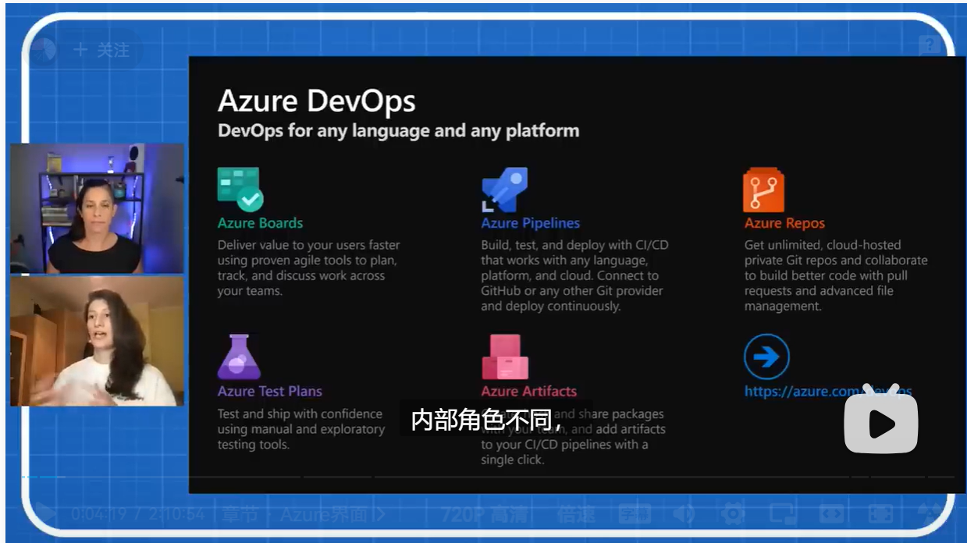

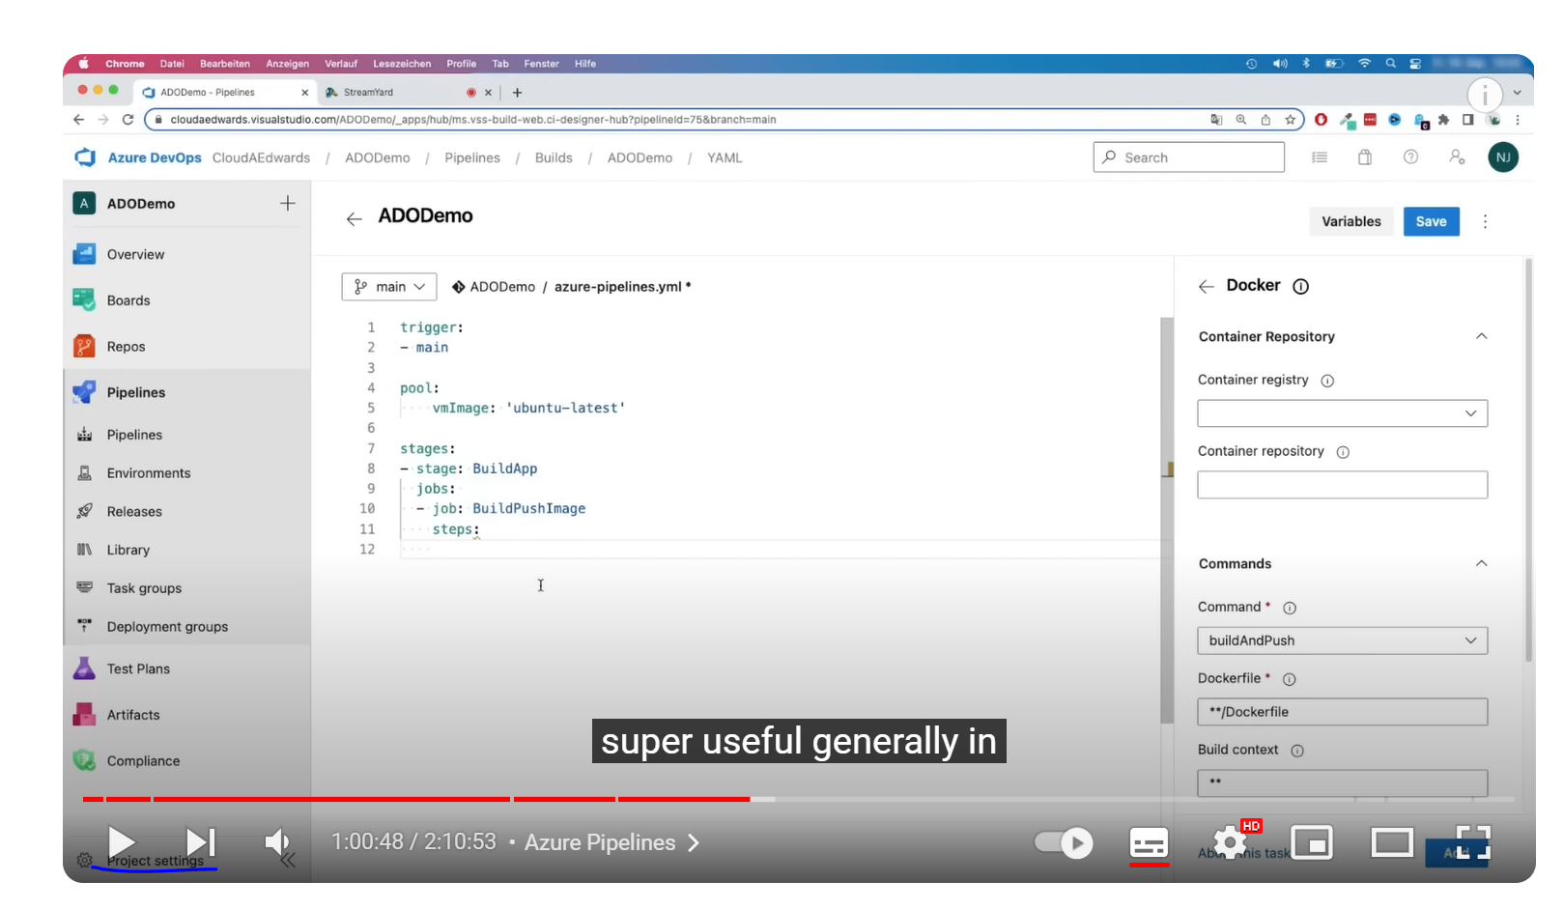

配置service connection

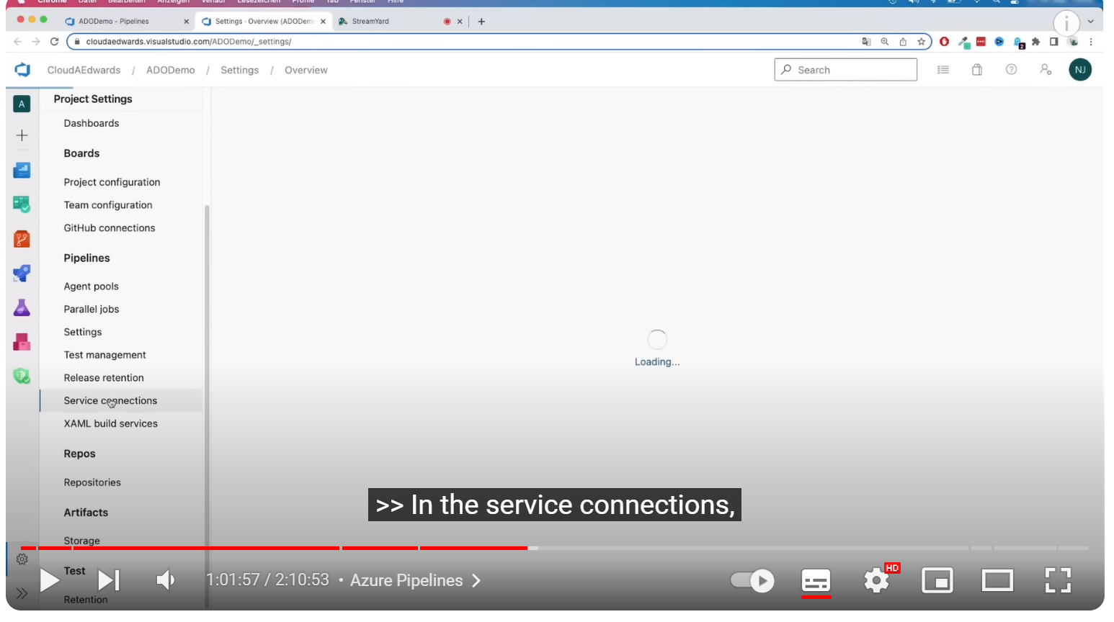

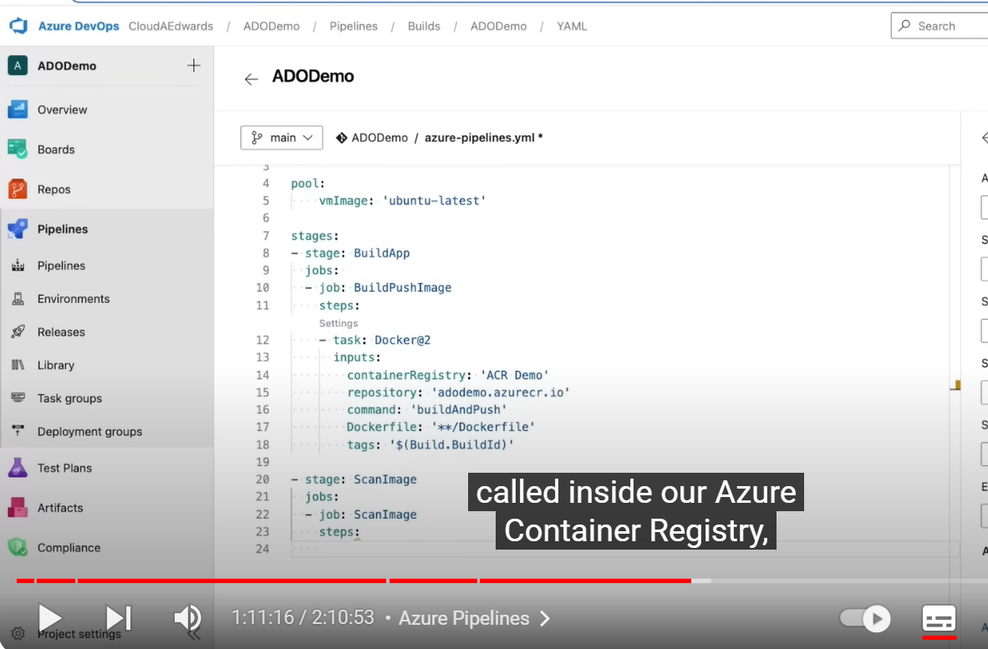

mkdir azagent;cd azagent;curl -fkSL -o vstsagent.tar.gz https://vstsagentpackage.azureedge.net/agent/3.227.2/vsts-agent-linux-x64-3.227.2.tar.gz;tar -zxvf vstsagent.tar.gz; if [ -x "$(command -v systemctl)" ]; then ./config.sh --environment --environmentname "dev" --acceptteeeula --agent $HOSTNAME --url https://dev.azure.com/jampei/ --work _work --projectname 'pipeline-java' --auth PAT --token slaajm2iyxkep4cme7oo2ibo2syzhj427pq7nrxcxkdmtjkjehjq --runasservice; sudo ./svc.sh install; sudo ./svc.sh start; else ./config.sh --environment --environmentname "dev" --acceptteeeula --agent $HOSTNAME --url https://dev.azure.com/jampei/ --work _work --projectname 'pipeline-java' --auth PAT --token slaajm2iyxkep4cme7oo2ibo2syzhj427pq7nrxcxkdmtjkjehjq; ./run.sh; fi

