# Grazioso Salvare Dashboard

## About the Project

This project is a user-friendly dashboard created for Grazioso Salvare to find animal candidates for search-and-rescue training. It uses Dash, Plotly, and Leaflet for the UI layer, Python middleware for CRUD functionality, and a MongoDB layer to store the data.

## Getting Started

The following sections explain how to get set up, and provide examples of code usage.

## Installation

Install the following tools:

* Python 3.6
* Pymongo 4.2
* MongoDB 4.2
* Dash
* Plotly
* Numpy
* Pandas

Also requires:

* AnimalShelter (Python module)
* AAC Dataset

## Usage

AnimalShelter includes the following methods:

1. __init__(username, password) – Constructor. Accepts username and password strings as arguments. Handles authorization and connection to the AAC database.
2. create(data) – Accepts a dictionary of data as an argument. If the data is empty, an exception is raised. Otherwise, it inserts the data into the database and returns the status of the insert.
3. read(data) – Accepts a dictionary of data as an argument. If the dictionary’s key and value pair exist as a record, it returns that record. Otherwise, it returns all records.
4. update(query, data) – Accepts two dictionaries as arguments, one for the query, and the other for the new data. If the query matches existing records, it updates them and prints “Updated” to the console. Otherwise, an exception is raised.
5. delete(data) – Accepts a dictionary of data as an argument. If the data is empty, an exception is raised. Otherwise, it deletes all matches of the data and “Deleted” is printed to the console.

### Screenshots – MongoDB

* Upload the Austin Animal Center Outcomes dataset into MongoDB

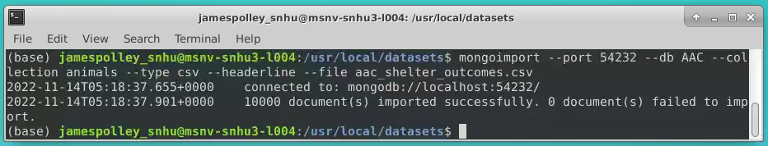

* Create an admin account

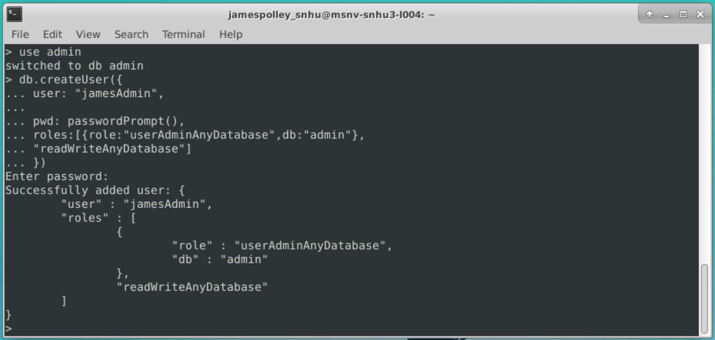

* Create a user account

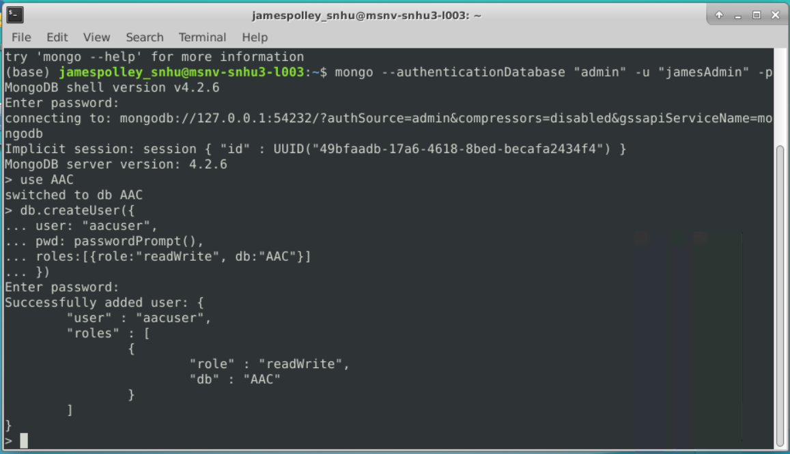

### Screenshots – AnimalShelter

* Import module and create an instance of AnimalShelter

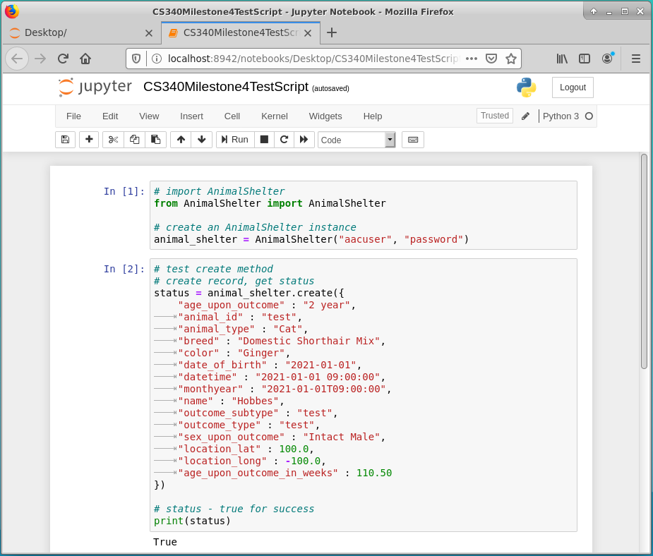

* Create method



* Read method

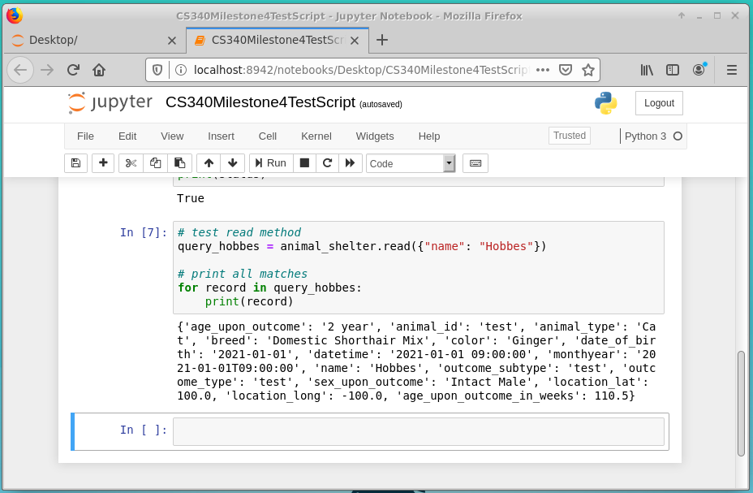

* Update method

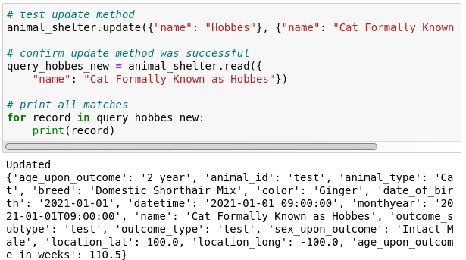

* Delete method

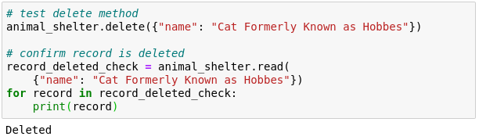

**Screenshots – Dashboard**

* Starting State – All (Unfiltered)

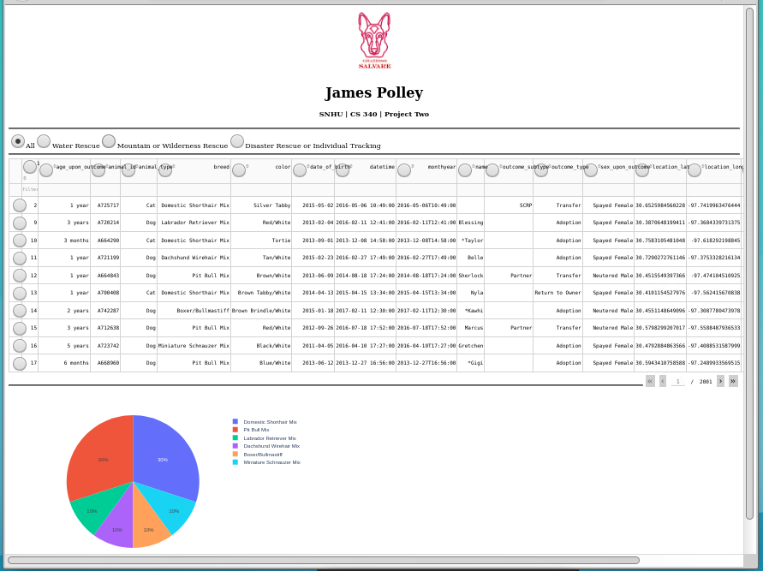

* Filter: Water Rescue

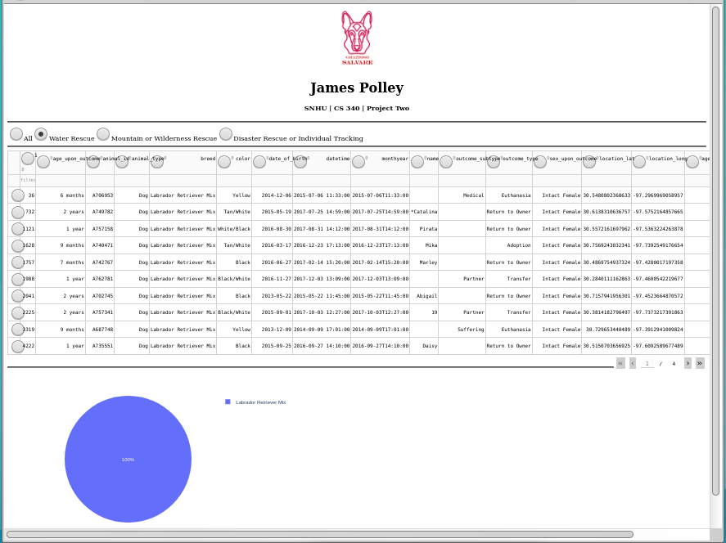

* Filter: Mountain or Wilderness Rescue

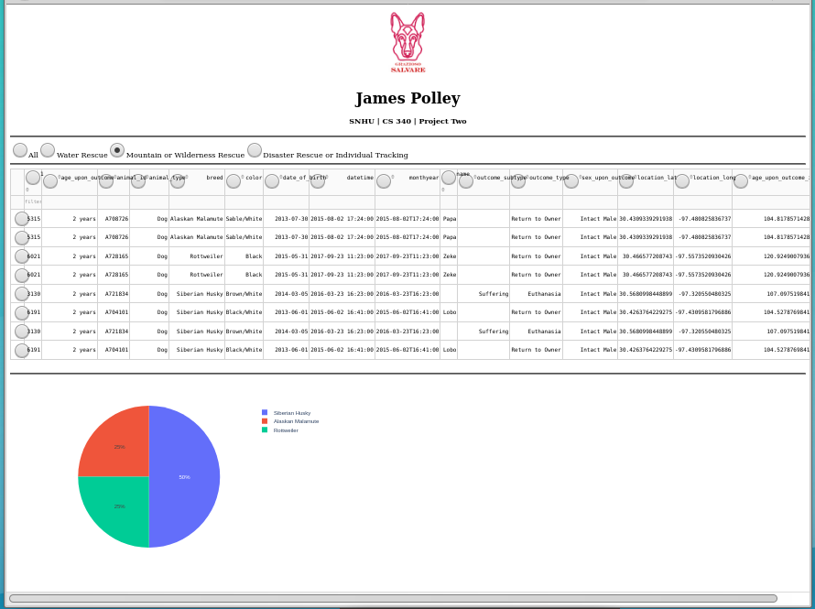

* Filter: Disaster or Individual Tracking

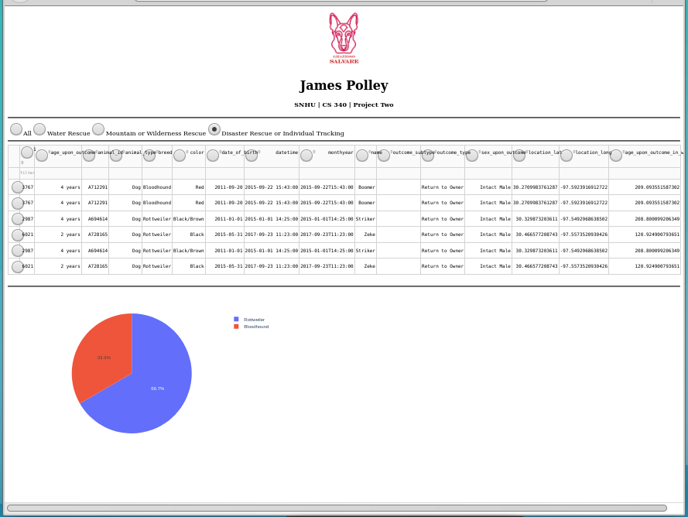

## Contact

James Polley

james.polley@snhu.edu