To select the k_{th} smallest number of the given array, one direct solution is to sort the array from the smallest number to the largest number first, and then just select array’s k_{th} number. It seems that there are no significant advantages in this solution, which would be discussed later
The other solutions apply divide and conquer algorithm. Without sorting all the array, the algorithm can get the kth smallest number. Possible sorting methods includes merge sort, heap sort and quick sort. The sorting algorithms used here is quick sort, In this report we try to optimize it with different ways.
Quicksort is an efficient sorting algorithm in practice, serving as a systematic method for placing the elements of an array in order. The average time complexity of the quicksort is O(nlogn) while the worst case is O(n²), which is relatively not stable compared with mergesort and Heapsort. Its worst case occurs only when the whole array is reverse order. Moreover, quicksort is nearly the fastest sorting method because of its unique operation. Swapping data by the pivot will cause less movements. The solution in this report are all based on quicksort.
Consider the first case that sort all the arrays and select the kth smallest number. Though we can do some optimization like applying insertion sort in small section, or choose the appropriate pivot, it’s still too slow when dealing with the large-size array. Actually, it’s unnecessary to sort the whole array. Using the swapping operation in the quicksort, what we need to do is just moving the pivot to k step by step, denote the kth integer is D, D=arr[k]. In this case, all the integers smaller than D would be moved to the left, and all the intergers larger than D would be moved to right. This operation would promote the time complexity from O(nlogn) to O(n). All the swapping and sorting are in linear time and we do divide, without conquering every subarray. To tell it more clearly, here we can take an example. We create a random array with 27 integers.

6,3,66,423,45,69,4,5,34,79,89,46,46,7,8,3,5,4,-7,897,-3,54,548,587,77,6,7

The testing result is for the tradition quicksort (first solution) is shown as followed. From the figure we can see that ,the whole array has been sorted ,and we just pick the kth smallest one.
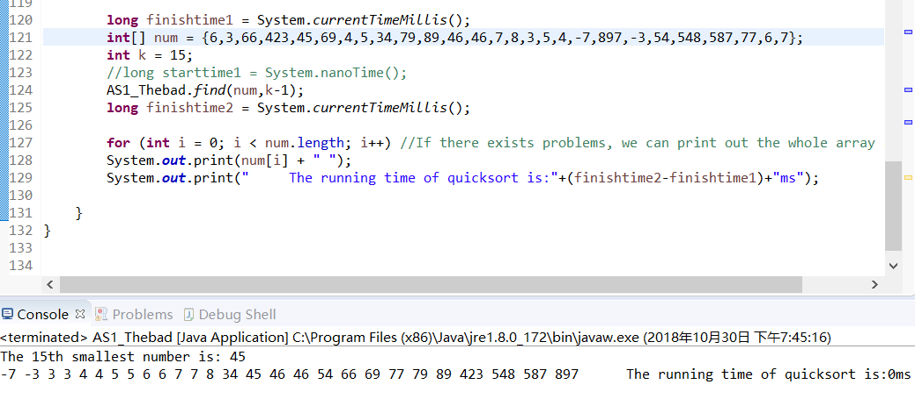
The testing result is for the optimized quicksort (first solution) is shown as followed. From the figure we can see that ,the whole array has not been sorted. we swapping all the larger number after the kth smallest one. All the integers smaller than 45 are on the left, that is, 45 is the 15th smallest number.
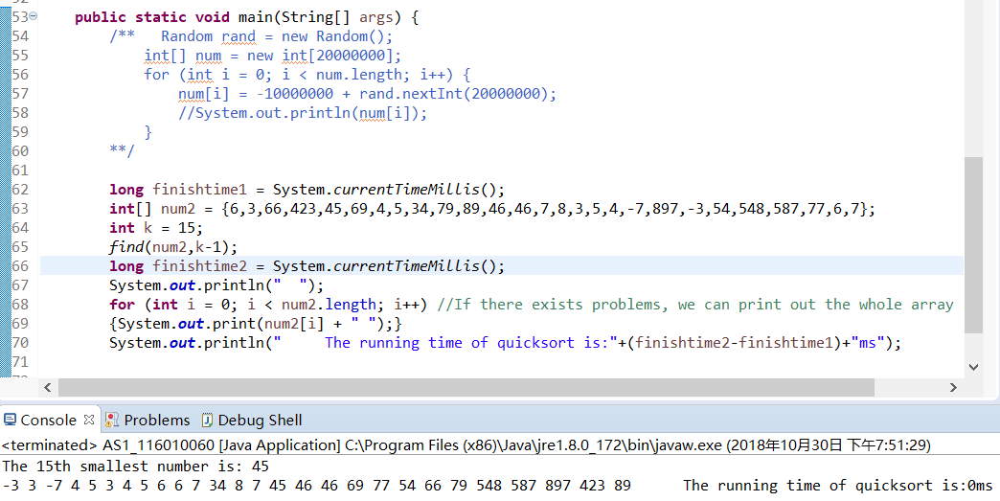
Conduct another test, Compare two quicksort methods when sorting 100000 random number, the difference is significance. The optimization works.
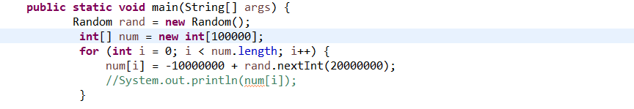
Finally, we can calculate that for some highly reverse order array, the swapping operation would take most of the time in this optimized quicksort method. To solve the problem, we can use the median-of-median-of-five partition method, the main thought is that divide that first divide the n element of the input array into [n/5] groups of 5 elements each, find their median (can using simple algorithm like insertion sort) and then pick the median. Use quicksort recursively to find the median x, partition the input array around the median-of medians x. And the following steps are just my solution in the report.

