EIE3810 Microprocessor System Design Laboratory

**Laboratory Report #3**

Name: 关嘉俊

Student ID: 116010060

Date: March 23rd

The Chinese University of Hong Kong, Shenzhen

● Experiment A: e.g. learn to use the drawdot function to draw the expected line.

● Experiment B: e.g. understand how to write a subroutine to fill a rectangle with one color.

● Experiment C: e.g. Draw the digit number by drawing rectangle of the seven segment, and conduct the countdown function.

● Experiment D: e.g. Design the subroutine to show the character. Learn to use the program to show the expected ID in the screen.

**I. Experiment A**

1. Basic procedure: 1.Download the EIE3810_TFTLCD.c 2. Try to achieve that make the whole screen into white. 3.Draw five different lines.
2. Raw material:

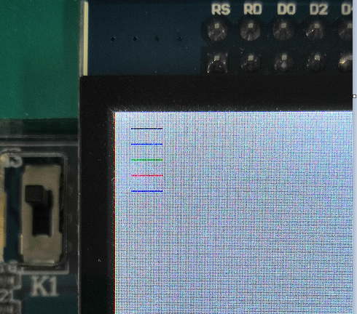

Since the blue line can’t be seen in the white background, here I change the color from white to blue. The result meet the requirement.

Figure 1 Draw 5 lines with different colors

1. Experiment Code:

int main(void)

{

EIE3810_TFTLCD_Init();

Delay(1000000);

EIE3810_TFTLCD_WrCmd(0x3600);

EIE3810_TFTLCD_WrData(0x00);

EIE3810_TFTLCD_DrawAll(0, 0, WHITE);

EIE3810_exp1();

EIE3810_exp2();

EIE3810_exp4();

EIE3810_exp3();}

void EIE3810_exp1()

{ int i;

for(i=0;i<20;i++)

{

EIE3810_TFTLCD_DrawDot(10+i,10,BLACK);

EIE3810_TFTLCD_DrawDot(10+i,20,WHITE);

EIE3810_TFTLCD_DrawDot(10+i,30,GREEN);

EIE3810_TFTLCD_DrawDot(10+i,40,RED);

EIE3810_TFTLCD_DrawDot(10+i,50,BLUE); }}

void EIE3810_TFTLCD_DrawAll(u16 x, u16 y, u16 color)

{

int i;

EIE3810_TFTLCD_WrCmd(0x2A00);

EIE3810_TFTLCD_WrData(x>>8);

EIE3810_TFTLCD_WrCmd(0x2A01);

EIE3810_TFTLCD_WrData(x & 0xFF);

EIE3810_TFTLCD_WrCmd(0x2B00);

EIE3810_TFTLCD_WrData(y>>8);

EIE3810_TFTLCD_WrCmd(0x2B01);

EIE3810_TFTLCD_WrData(y & 0xFF);

EIE3810_TFTLCD_WrCmd(0x2C00);

for (i=0;i<384000;i++)

{

EIE3810_TFTLCD_WrData(color);

} }

**II. Experiment B**

1. Procedure (1)Type the function supplied in the example (2)Change the Parameter and draw a rectangle with yellow color.
2. Raw material

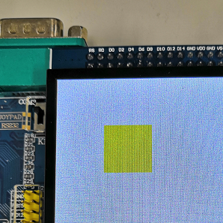

Figure 2 Yellow rectangle figure

1. Code:

void EIE3810_exp2()

{

EIE3810_TFTLCD_FillRectangle(100,100,100,100,YELLOW);

}

**III. Experiment C**

1. Procedure

1) Create a subroutine “EIE3810_TFTLCD_SevenSegment(u16 start_x, u16 start_y, u8 digit, u16 color)”.

2) Use the rectangle subroutine to draw digit “8” (Seven-segment format) at the center of the screen with your favorite color.

3) Write a program to display count-down digit from 9 to 0, periodically. After it comes to 0, go back to 9. The period of each count is around 1 second, which can be implemented with Delay().

1. Raw Material:

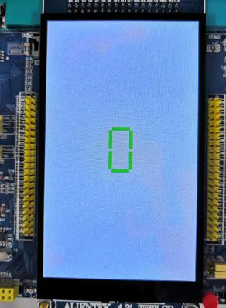 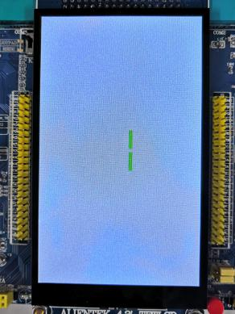 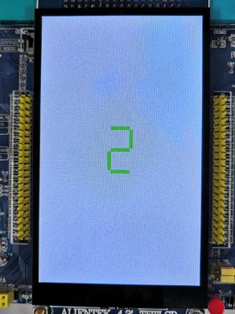 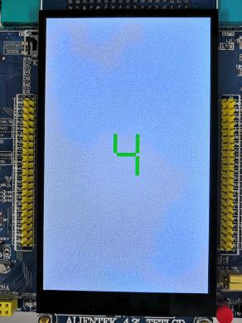

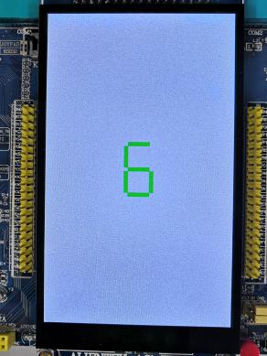 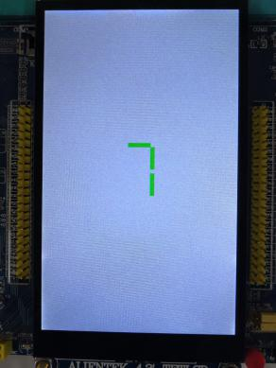 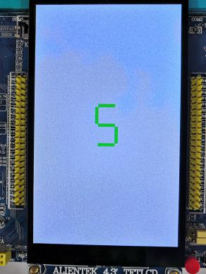

The experiment result meet the expectation well.

1. Source Code

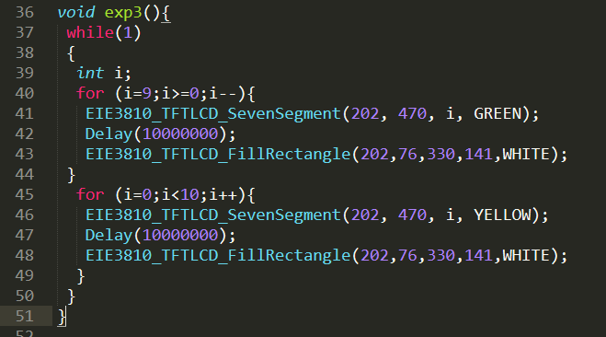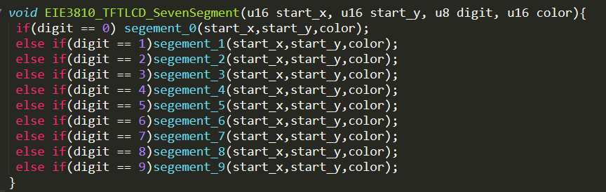

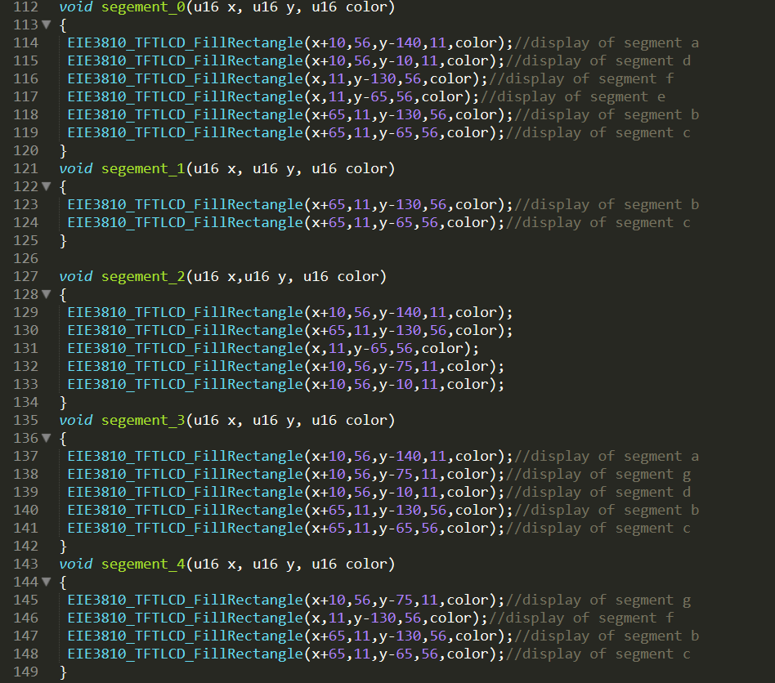

**IV. Experiment D**

1. **Procedure**

1) Download Font.H and add it into “board” folder. Include it in the EIE3810_TFTLCD.c as below and design the subroutine to show the character.

2) Write the program that uses the subroutine in to show my CUHKSZ ID on the screen. The background color should be any color other than white.

3) Include experiments 3.1-3.4 into the one main().

**(b) Raw material**

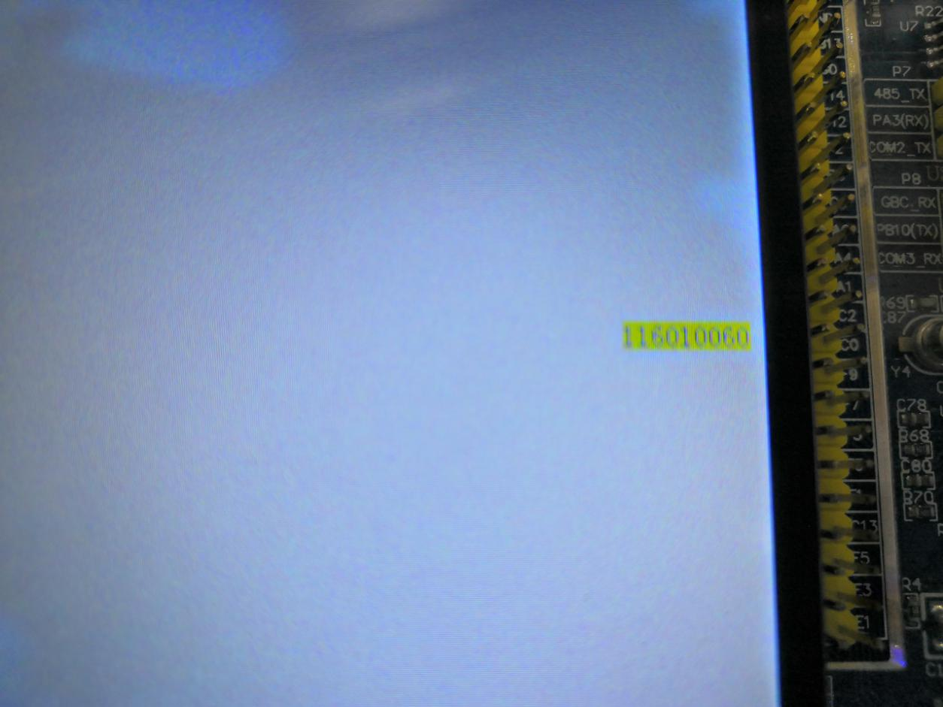 

**(c)Source code:**

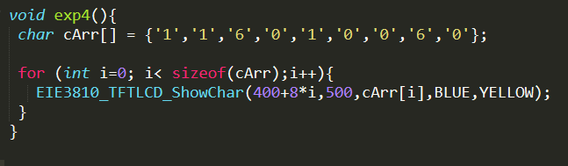

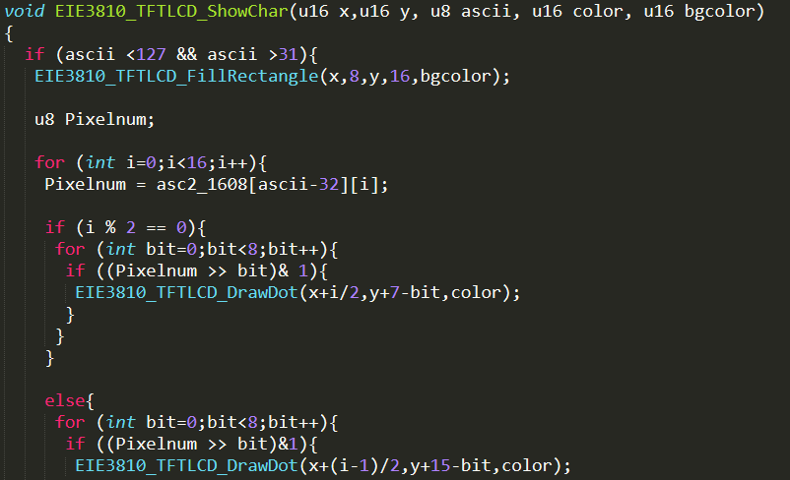

1. **Question solution:**

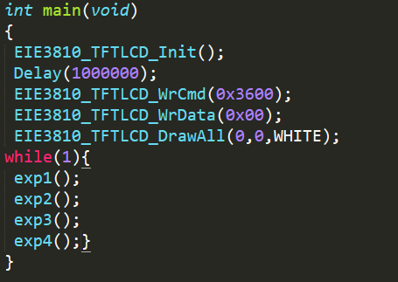

Figure 3 The combination of th

1. The place of the pixel should not be overlapped, the x and y should be in the proper position.
2. For the digit count down, it is a infinite while loop. We should bring forward the while loop in the experiment 3.