-Setting up a Transparent Proxy with Squid3 on Debian Squeeze-

I recommend reading this tutorial all the way through first. I assume you'll use nano for editing files.

Wiring:
Physical wiring of the proxy is the first step: the proxy must have two ethernet cards and be physically between the clients (users) to be proxied, and the internet, such that network traffic cannot reach the Internet without going through it. This tutorial assumes you have wired it so:
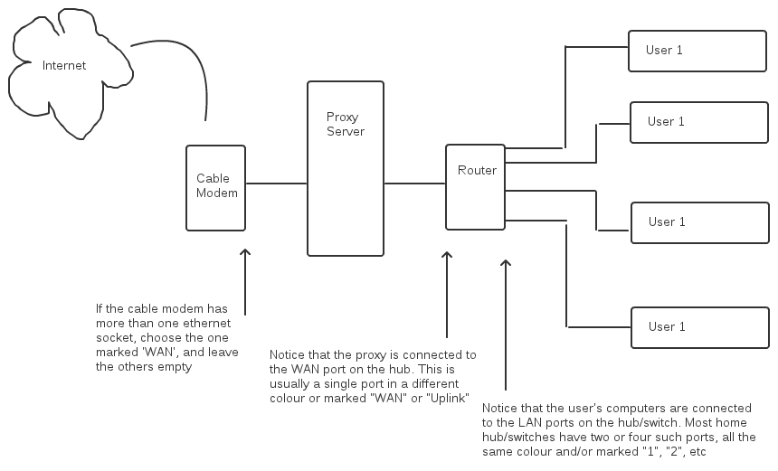

I assume your configuration looks like this to begin with:
Cable modem -> [ (wan use DHCP) Router (lan uses 192.168.1.1)] -> Clients 192.168.1.x

In the end we will have this:
Cable modem -> [ (eth0 uses DHCP) Squid StuffProxy (eth1 uses 192.168.2.2)] -> [(wan uses 192.168.2.1) Router (lan uses 192.168.21.1) -> Clients 192.168.21.x

I also assume you know your way around GNU\Linux a bit. I don't think you may can get by without knowing how to use Linux or if just starting out.

Note: This configuration has been tested on a Debian 6 clean install
Also, CTRL+X will exit nano and CTRL+c will end commands such as ping and tail -f
I recommend backing configuration files up first by opening the file with nano and pressing CTRL+o and typing in a different file name, I also recommend typing the file name then adding .backup to it so you know what it is. Like 'interfaces' would now be 'interfaces.backup'

You need two ethernet cards, eth0 will be connected to the cable modem, eth1 will be connected to the router.
Now you need to configure the ethernet cards, eth0 will beuse DHCP and eth1 will be static.
Lets edit the interfaces file:

sudo nano /etc/network/interfaces

copy this exactly:

# The loopback network interface
auto lo
iface lo inet loopback

# External Network
allow-hotplug eth0
iface eth0 inet dhcp
auto eth0

# Internal Network
allow-hotplug eth1
iface eth1 inet static
address 192.168.2.2
netmask 255.255.255.0
network 192.168.2.0
broadcast 192.168.2.255
auto eth1

Press CTRL+X to eExit nano and press Y to override the old file.
Now perform the following command to use the new configuration:
sudo /etc/init.d/networking restart

To double check your hardware configuration is working try pinging out from the proxy(to stop pinging press CTRL+c)

ping google.com

If you can get out to the internet, you are on track.
Now lets install Squid3

sudo apt-get install squid3

After the installation, edit the configuration file. (It also wouldn't be a bad ideal to backup the default squid.conf file)

sudo nano /etc/squid3/squid.conf

Copy this exactly:

http_port 3128 transparent
hierarchy_stoplist cgi-bin ?
acl QUERY urlpath_regex cgi-bin \?
cache deny QUERY
acl apache rep_header Server ^Apache
access_log /var/log/squid3/access.log squid
hosts_file /etc/hosts
refresh_pattern ^ftp: 1440 20% 10080
refresh_pattern ^gopher: 1440 0% 1440
refresh_pattern . 0 20% 4320

acl manager proto cache_object
acl localhost src 127.0.0.1/32
acl to_localhost dst 127.0.0.0/8
acl SSL_ports port 443 563 # https, snews
acl SSL_ports port 873 # rsync
acl Safe_ports port 80 # http
acl Safe_ports port 21 # ftp
acl Safe_ports port 443 563 # https, snews
acl Safe_ports port 70 # gopher
acl Safe_ports port 210 # wais
acl Safe_ports port 1025-65535 # unregistered ports
acl Safe_ports port 280 # http-mgmt
acl Safe_ports port 488 # gss-http
acl Safe_ports port 591 # filemaker
acl Safe_ports port 777 # multiling http
acl Safe_ports port 631 # cups
acl Safe_ports port 873 # rsync
acl Safe_ports port 901 # SWAT
acl purge method PURGE
acl CONNECT method CONNECT
http_access allow manager localhost
http_access deny manager
http_access allow purge localhost
http_access deny purge
http_access deny !Safe_ports
http_access deny CONNECT !SSL_ports
http_access allow localhost
acl lan src 192.168.2.0/24
http_access allow localhost
http_access allow lan
http_access deny all
http_reply_access allow all
icp_access allow all
visible_hostname Gateway
always_direct allow all
coredump_dir /var/spool/squid3
always_direct allow all

After you edit the file you need to restart squid,

sudo /etc/init.d/squid3 restart

Now we need to setup iptables. Create a new file, lets call it iptables_setup

cd /etc/init.d
sudo nano iptables_setup

now copy and paste this exactly into the new file:

#!/bin/sh
# squid server IP
SQUID_SERVER="192.168.1.1"
# Interface connected to Internet
INTERNET="eth0"
# Interface connected to LAN
LAN_IN="eth1"
# Squid port
SQUID_PORT="3128"
# DO NOT MODIFY BELOW
# Clean old firewall
iptables -F
iptables -X
iptables -t nat -F
iptables -t nat -X
iptables -t mangle -F
iptables -t mangle -X
# Load IPTABLES modules for NAT and IP conntrack support
modprobe ip_conntrack
modprobe ip_conntrack_ftp
# For win xp ftp client
#modprobe ip_nat_ftp
echo 1 > /proc/sys/net/ipv4/ip_forward
# Setting default filter policy
iptables -P INPUT DROP
iptables -P OUTPUT ACCEPT
# Unlimited access to loop back
iptables -A INPUT -i lo -j ACCEPT
iptables -A OUTPUT -o lo -j ACCEPT
# Allow UDP, DNS and Passive FTP
iptables -A INPUT -i $INTERNET -m state --state ESTABLISHED,RELATED -j ACCEPT
# set this system as a router for Rest of LAN
iptables --table nat --append POSTROUTING --out-interface $INTERNET -j MASQUERADE
iptables --append FORWARD --in-interface $LAN_IN -j ACCEPT
# unlimited access to LAN
iptables -A INPUT -i $LAN_IN -j ACCEPT
iptables -A OUTPUT -o $LAN_IN -j ACCEPT
# DNAT port 80 request comming from LAN systems to squid 3128 ($SQUID_PORT) aka transparent proxy
iptables -t nat -A PREROUTING -i $LAN_IN -p tcp --dport 80 -j DNAT --to $SQUID_SERVER:$SQUID_PORT
# if it is same system
iptables -t nat -A PREROUTING -i $INTERNET -p tcp --dport 80 -j REDIRECT --to-port $SQUID_PORT
# DROP everything and Log it
iptables -A INPUT -j LOG
iptables -A INPUT -j DROP

now, lets give it permissions

sudo chmod +x iptables_setup

Lets add this script to the start

sudo update-rc.d iptables_setup defaults

Go ahead and the run the script now
sudo ./iptables_setup

Double check you can still access the internet by pinging google or something similar
If you want to be safe you can reboot the server (sudo reboot)

Now we have to configure the router. Due to the amountwide variety of different routers I cannot write a tutorial for all of them. so I will be using a Linksys based router. I recommend plugging a computer directly into the router for configuration and unplugging it from the server. Since mMy Linksys router has the address 192.168.1.1 that is how I will access it and I'll access it's configuration pages there from a user's computer, not the proxy.

I do so by opening my browser and typinging http://192.168.1.1 and typing in the username and password.
On the very first page (Setup, then Basic Setup is how to get to the page)

Click on the very first drop down box that says "Automatic Configuration - DHCP" and change it to "Static IP"
Now type this in:
Internet IP Address (aka WAN Address): 192.168.2.1
Subnet Mask: 255.255.255.0
Gateway: 192.168.2.2
Static DNS 1 (You should put your DNS provided by your ISP or you can use Google's Public DNS): 8.8.8.8
Static DNS 2 (Same situation as above or use Google's): 8.8.4.4

For more information about Google's DNS see here: http://code.google.com/speed/public-dns/

Now still on the router page, scroll down a bit and change the Local IP Address from 192.168.1.1 to 192.168.2.1

That should do it, now save the settings. Plug the Server back into the router (Note: the server should be plugged into the WAN port or the Internet port)
Also, tTo access the router again you type 192.168.1.1 to get back to the configuration page., since that is its new IP Address

You should now be able to access Now try accessing the internet from a user's computer. that is connected to the router either by wireless or wired, it does not matter.

Also to watch traffic, go back to the server and type:

sudo tail -f /var/log/squid3/access.log

to stop, press CTRL+c

Sources:
http://www.cyberciti.biz/tips/linux-setup-transparent-proxy-squid-howto.html
http://code.google.com/speed/public-dns/
http://www.debian-administration.org/articles/28
And Alistair_Mann from Reddit.com

Written by James Little (Lamez)

