AldatesX User Guide
v0.3
Table of Contents
Introduction 2
The Main Screen 2
Camera Control 3
Advanced Camera Controls 3
Extras 3
System Power 5
System Log 5

Introduction
AldatesX is a control system for audio/visual equipment such as video switchers and mixers. It's designed around a touchscreen interface to send commands via a controller machine to various pieces of equipment.

The Main Screen
The main interface screen for AldatesX consists of a row of input-selection buttons along the top, a grid of output-selection buttons on the right, a toolbar along the bottom and a central area which shows device-specific controls (for example, if a camera is selected, it will show camera controls).
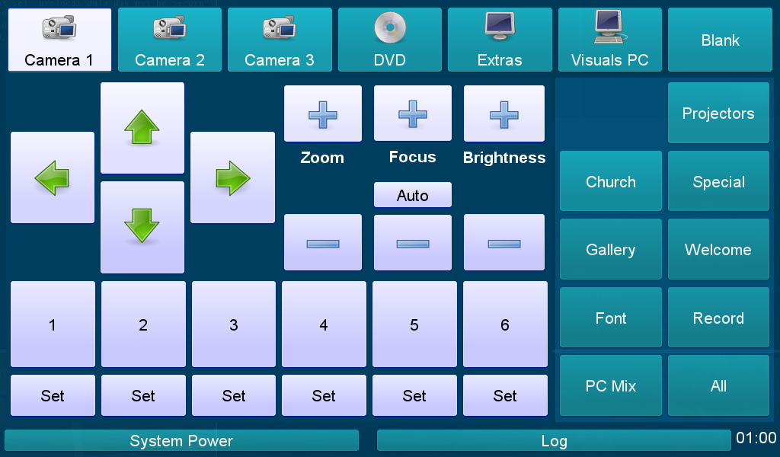Image 1: Main screen, showing camera controls
Pressing an input button will display that input on the preview monitor, and will display the relevant controls in the central area of the main screen. (If there are no relevant controls for a given input, the text “No controllable device” will be displayed.) It is also possible to select inputs using the number keys 0-6 on a keyboard, if one is connected. (0 is the selection for 'Blank'.)
With an input selected, pressing one of the output buttons on the right will display that input on the chosen output. Selecting “PC Mix” will display the input behind the main visuals PC output (e.g. behind song words). This can be previewed by pressing the “PC Mix” input. Selecting “All”, or pressing the spacebar, will display the input on all outputs except PC Mix.
Note that it does not make sense to send Visuals PC to PC Mix, and nothing will happen should you attempt to do so!

Camera Control
There are three cameras in the system: two located on pillars in church, and one in the welcome area by the font. Selecting a camera input will display the camera controls, as shown in Image 1.
You can move the camera up, down, left and right by pressing the arrow buttons. It is also possible to move the cameras with the cursor keys if a keyboard is connected. You may also zoom and focus the cameras with the labelled controls. Pressing “Auto” will tell the camera to automatically focus, and it will remain in auto-focus mode until the focus+ or focus- buttons are pressed.
Backlight compensation can be toggled on or off with the Brightness+/- buttons. This is useful when the subject is against a bright background; other areas of the image might become overexposed.
Each camera has six presets available. You can store the current position, zoom and focus of a camera by pressing one of the six “Set” buttons. You can then later move the camera back to those settings by pressing the relevant number button. Presets are lost when the system is turned off. When a preset is recalled, the button is highlighted until the camera is moved.

Advanced Camera Controls
Advanced camera controls are available by long-pressing the camera input selection buttons. The advanced controls allow you to read the exact pan, tilt and zoom values from the camera. Further controls will be added in future releases.
Press Back to exit the advanced controls screen.

Extras
It is possible to connect extra inputs to the system. These can be accessed via the “Extras” screen, shown in Image 2 on page 4.
The inputs “Extras 1” through “4” are on the front of the video patch bay. The second graphics output from the visuals PC is also available on this screen.
To preview an extra input, select it and press the “Preview / PC Mix” button. Note that it is not possible to preview an extra input without also sending it to PC Mix, and vice versa.
To display an extra input on an output, select it and press the desired output, as with the usual inputs. This includes PC Mix (selecting this will also change the preview screen if a different input is currently being previewed).
You can also control some functions of the “Extras” scan converter: pressing “Overscan” will toggle the overscan mode on and off, expanding the picture to fill the screen. Pressing “Freeze” will freeze the video until it is pressed a second time. (This applies only to the “Visuals PC video” input, not Extras 1-4.)
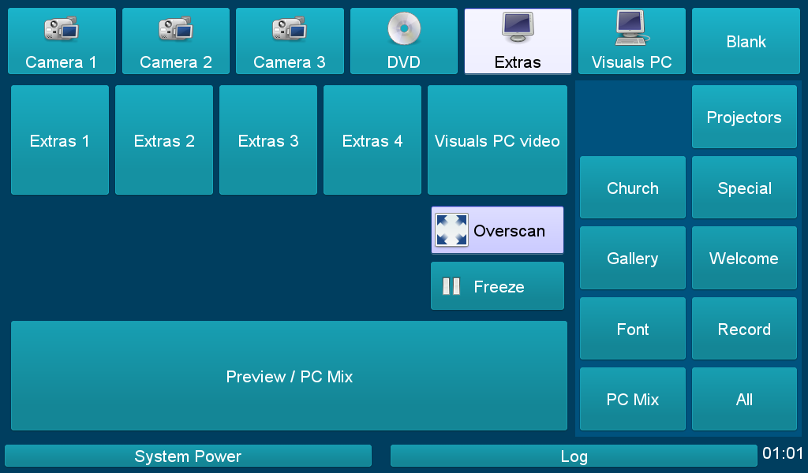Image 2: Extras screen
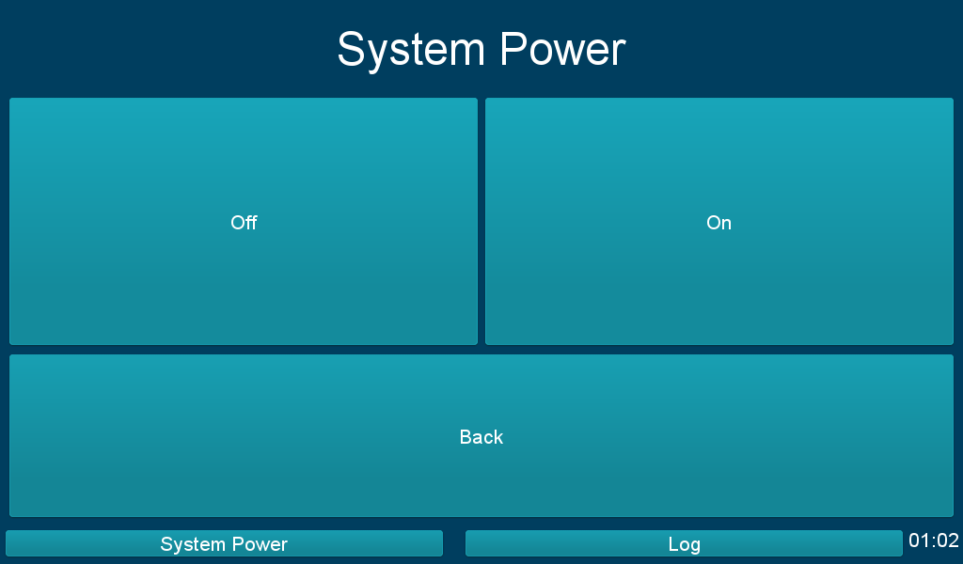Image 3: System Power screen

System Power
The main system power can be turned on and off through the System Power screen (Image 3 on page 4), which is displayed by pressing “System Power” in the bottom toolbar.
Pressing “On” will begin a timed sequence to switch the system on. There will not currently be any feedback that this process has started, but after 20-30 seconds the system should be powered up fully.
Likewise, pressing “Off” will begin a timed sequence to turn the system off. Again, there is no feedback that this process is underway, but after 20-30 seconds the system will be powered off.
The sound desk and CD/DVD player racks are not currently controlled by the system, and are powered on and off using the power switch on top of the DVD player.
You can return to the main screen at any time by pressing Back. This will not interrupt a power-up or power-down.

System Log
The system log of the controller is viewable by pressing the Log button in the bottom toolbar. This gives technical details from the controller computer. Only the last 100 log entries are kept. This feature is intended for troubleshooting purposes.
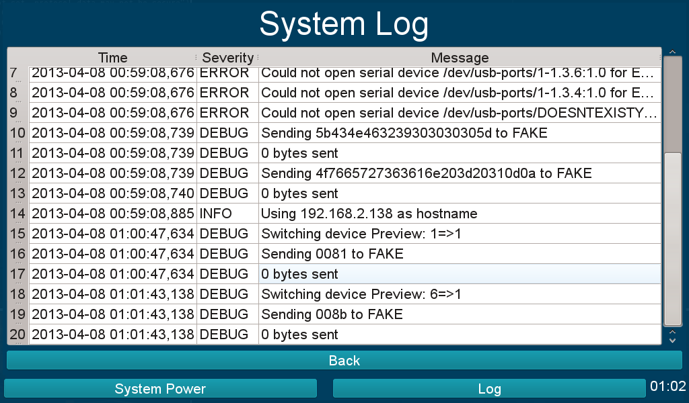Image 4: System log screen

