RESULTS

Here we describe the patterns of variation in species richness, exotic abundance, functional richness and functional dispersion of riparian plant communities, as they relate to metrics describing river hydrology, flow modification, land use, climate and soil properties.

Due to considerable collinearity in the environmental dataset, description of univariate relationships is mostly limited to variables selected by variance partitioning for inclusion in the final multiple regression models. Statistics for the all statistically significant univariate regression models can be found in the Supporting Information S2. The adj. R2 value shown in variance partitioning Venn diagrams (Figs 1-4b) may not correspond directly to the sum of its fractions as represented in Figs 1-4a., as negative R2 values (not shown in Figs 1-4a) can result from the adjustment algorithm. All R2 values given in the text are adjusted R2.

*Environmental drivers of variation in species richness*

A substantial portion of variation in species richness across the study area (0.787) could be explained by a combination of models describing hydrology, flow modification, climate and soil conditions (Fig Xa,b). Hydrology and flow modification were co-dominant, while climate and soil variables contributed a minor component of variation; variation explained by the climate model was almost completely subsumed by the hydrology model. Land use and climate were also associated with species richness but independently explained no variation (not shown in Fig Xx, but see Data S1 for regression statistics). Increased SR in response to these conditions could not be explained by an increased number of exotic species present, and although species richness did decrease with exotic proportional abundance (R2 = 0.115) (see Supporting Information S1), exotic abundance did not independently explain variation in SR.

Species richness was highest when minimum flow conditions were unevenly distributed throughout the year (C_MinM, R2 = 0.237, Fig Xc), and where these seasonal patterns of minimum flows were consistent between years (M_MinM, R2 = 0.129, Fig Xd). Richness declined with increasing duration of high flow periods (HSMeanDur, R2 = .290, Fig Xe), but increased somewhat as these high flow periods became more frequent (MDFAnnHSNum, R2 = 0.106, Fig Xf). Increased dry season flows due to flow modification were weakly associated reduced species richness (MDFMDFDry.mod, R2 = 0.117, Fig Xg). Alterations to seasonal consistency of minimum flow patterns had a strong effect (M_MinM.mod, R2 = 0.412,Fig Xh), and corroborated the trend observed in Fig Xd: species richness increased as patterns of monthly minimum flows became more consistent throughout the hydrological record. With respect to climate, SR was greater at sites which experienced higher rainfall (clim_pwet, R2 = 0.390, Fig Xi) and less seasonal temperature regimes (clim_tsea, R2 = 0.349, Fig Xj). Soils which contained more organic carbon (soil_soc, R2 = 0.202, Fig Xj) and higher silt content (soil_slt, R2 = 0.239, Fig Xk), lower total phosphorus (soil_pto, R2 = 0.110, Fig Xl) and lower available water capacity (soil_awc, R2 = 0.203, Fig Xm) supported richer communities.

The data do not support hypothesis 1a, that rivers with more heterogeneous flow regimes host communities with higher species richness, or hypothesis 1b, that there is a unimodal relationship between species richness and flow heterogeneity. Further, these results oppose hypothesis 2 (that species richness and functional diversity decrease and abundance of exotic species increases along gradients of increasing flow modification and catchment land-use intensity), given that rivers which experienced more consistent patterns of minimum flows and flood durations hosted richer plant communities.

*Environmental drivers of functional richness (FRic.SES)*

Variation in FRic.SES was best explained by a combination of hydrological and soil models (variation explained by the combined model = 0.405) (Fig Xa,b), of which the hydrological model gave the most explanatory power. Soil variables independently explained a small fraction of variation, and while flow modification and climatic variables were also associated with FRic.SES, neither model explained any variation independently.

FRic.SES was distributed unimodally across gradients of interannual variability in baseflow index (CVAnnBFI, R2 = 0.170, Fig Xc); values at the upper end of the gradient were somewhat reduced from the central peak. Greater frequency of high flow periods was associated with lower functional richness (MDFAnnHSNum, R2 = 0.142, Fig Xd) FRic.SES also declined as precipitation in the wettest quarter (clim_pwet, R2 = 0.246, Fig Xe), soil total nitrogen (soil_nto, R2 = 0.144, Fig Xf) and soil organic carbon (soil_soc, R2 = 0.257, Fig Xg) increased.

Hypothesis 1a was not supported, given that reduced functional richness was associated with increasing frequency of high flows. Hypothesis 1b was supported by a significant unimodal relationship interannual variability in baseflow (Fig Xc) and functional richness (delta AICc between linear and quadratic models = 3.70). Although not selected for the final hydrological model, mean and interannual variability in duration of high flow periods (Data S1) also showed significant unimodal relationships with FRic.SES (R2 = 0.213, 0.182, respectively). Hypothesis 2 was not supported; we found no effect of either land use or flow modification on functional richness, except a weak relationship with modification of dry season mean daily flow (Data S1).

*Environmental drivers of functional divergence (FDis.SES)*

FDis.SES varied substantially across the study area (3.96 standard deviations of the null distribution), and was associated with gradients of hydrology, flow modification, climatic and soil conditions. The soil model explained 0.483 of the of variation in FDis.SES; hydrology, flow modification and climatic models did not independently explain further variation (Fig Xa,b).

Rivers with moderate seasonality of maximum flows tended to support communities with high functional divergence (C_MaxM, R2 = 0.321, Fig Xc). The entire range of FDis.SES was represented by rivers associated with highly seasonal patterns of maximum flows (C_MaxM), however. As with functional richness, FDis.SES declined with increasing frequency of high flows (MDFAnnHSNum, R2 = 0.112, Fig Xd). Functional divergence also varied with flow modification affecting high flow frequency (MDFAnnHSNum.mod, R2 = 0.144, Fig Xe): lower flooding frequency tended to be associated with higher functional divergence. Also tracking trends observed for FRic.SES, FDis.SES declined with increasing rainfall (clim_pwet, R2 = 0.141, Fig Xf), soil total nitrogen (soil_nto, R2 = 0.111, Fig Xg) and soil organic carbon (soil_soc, R2 = 0.344, Fig Xh).

Environmental heterogeneity, as indicated by high flow frequency, was associated with lower functional divergence (Fig Xd,e), opposing the prediction made in hypothesis 1a, while the unimodal relationship with constancy of maximum flows (Fig Xc) provided some support for hypothesis 1b (delta AICc between linear and quadratic models = 10.0751). Scant evidence to support hypothesis 2 was found; as with FRic.SES, a weak but significant relationship was present between FDis.SES and dry season mean daily flow (Data S1).

*Environmental drivers of variation in proportional abundance of exotic species*

Variation in exotic species abundance was jointly explained by hydrology, land use, soil and climatic models (0.665 of variation explained by the combined model) (Fig Xa,b). Hydrological models (0.581 of variation explained) and land use (0.515 of variation explained) models were dominant. Two individual metrics of flow modification had significant relationships with exotic abundance (C_MinM.mod, R2 = 0.124; LSPeak.mod, quadratic R2 = 0.105), but these effects were strongly influenced by outlying values; the flow modification model combining these metrics explained no variation independently

Exotic abundance strongly tracked interannual variability in baseflow index (CVAnnBFI, R2 =0.412, Fig Xc), and also increased as maximum flows became more uniformly distributed across seasons (i.e. a lack of flow seasonality) (C_MaxM, R2 = 0.157, Fig Xd). We found a trough-shaped relationship between interannual variability in dry season flows and exotic abundance (CVMDFDry, R2 = 0.412, Fig Xe), although the lower end of the distribution was data-poor and may have been unduly influenced by values for a single pair of sites. Throughout the centre and upper ranges of the distribution, however, exotic abundance increased strongly with interannual variability in dry season flow. Exotic abundance also increased with interannual variability in high spell duration (CVAnnHSMeanDur, R2 = 0.129, Fig Xf). The proportion of the upstream catchment used for irrigated agricultural production was a strong positive predictor of exotic abundance (production_irrigated, R2 = 0.37, Fig Xg), as was production from relatively natural environments, although somewhat less so (production_natural, R2 = 0.232, Fig. Xh). Exotic abundance declined as dry season precipitation increased (clim_pdry, R2 = 0.207, Fig Xi), increased with soil pH (soil_phc, R2 = 0.242, Fig Xj), and decreased with soil depth to hard rock (soil_der, R2 = 0.140, Fig Xk).

With respect to hypothesis 1a, we found the opposite of expected: hydrological heterogeneity (as measured by CVAnnBFI, CVMDFDry and CVAnnHSMeanDur) appears to be associated with higher exotic abundance. These relationships did not exhibit unimodality. Production land uses were associated with higher exotic abundance, supporting hypothesis 2.

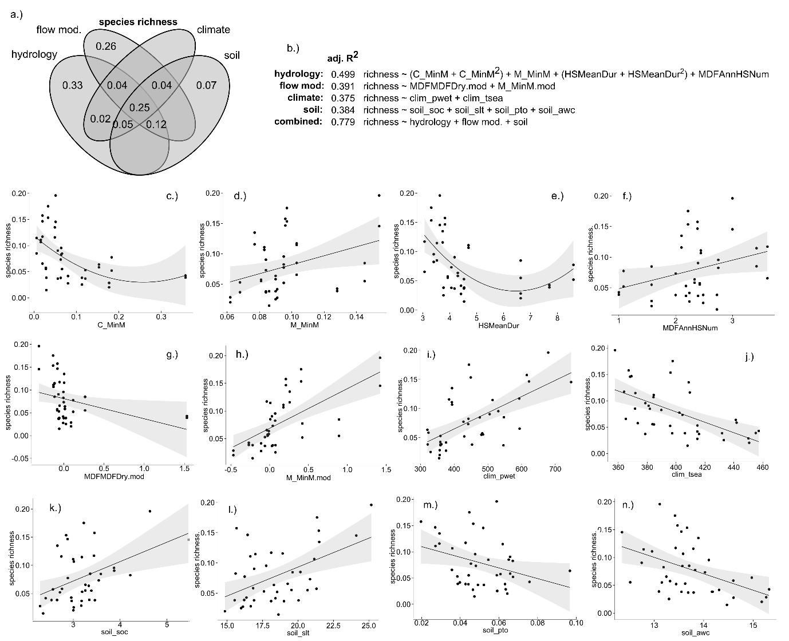

Figure 1. Environmental drivers of area-standardised species richness (units = species per m2) in riparian plant communities. a.) variance partitioning Venn diagram. Numbers within the diagram represent adjusted R2 (adj. R2) values associated with each fraction of variation; b.) multiple regression models representing each set of environmental conditions, and their optimal combination. Quadratic terms are enclosed in parentheses; selected univariate relationships between species richness and environmental variables describing c.) constancy of monthly minimum daily flow (C_MinM); d.) contingency of monthly minimum daily flows (M_MinM); e.) mean duration of high flow periods (HSMeanDur, days); f.) mean annual frequency of high flow periods (MDFAnnHSNum, upper 5th percentile of flows); g.) modification of dry season mean daily flow (MDFMDFDry.mod, % change); h.) modification of contingency of monthly minimum daily flows (M_MinM.mod, % change); i.) precipitation in the wettest quarter of the year (clim_pwet, mm); j.) temperature seasonality (clim_tsea, standard deviation * 100); k.) soil organic carbon (soil_soc, %); l.) soil silt content (soil_slt, %); m.) soil total phosphorus (soil_pto, %); n.) soil available water capacity (soil_awc, %). Species richness is presented as standardised by plot area. Fitted lines depict ordinary least-squares regression models. Shaded areas depict the smoothed 95% confidence interval around the regression model.

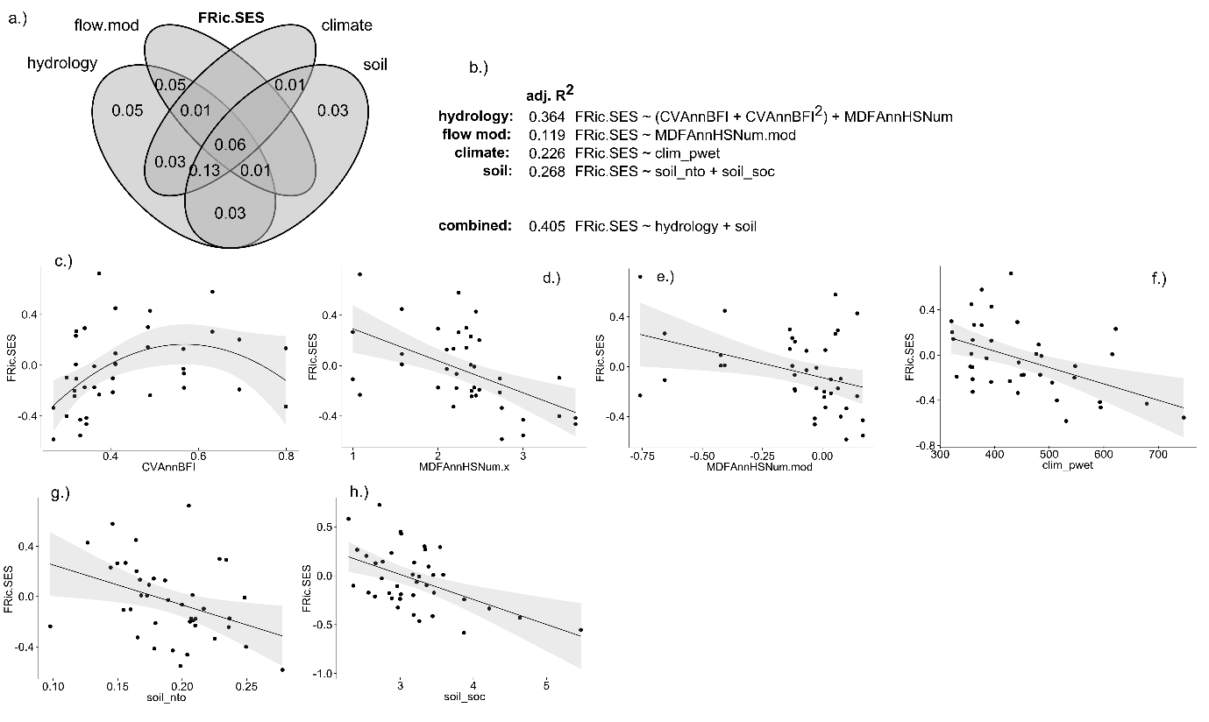

Figure 3. Environmental drivers of standardised effect size functional richness (FRic.SES) in riparian plant communities. a.) variance partitioning Venn diagram. Numbers within the diagram represent adjusted R2 (adj. R2) values associated with each fraction of variation; b.) multiple regression models representing each set of environmental conditions, and their optimal combination. Quadratic terms are enclosed in parentheses; selected relationships between FRic.SES and environmental variables describing c.) interannual variability in baseflow (CVAnnBFI); d.) mean annual frequency of high flow periods (MDFAnnHSNum, upper 5th percentile of flows); e.) modification of mean annual frequency of high flow periods (MDFAnnHSNum, % change); f.) precipitation in the wettest quarter (clim_pwet, mm); g.) soil total nitrogen (soil_nto, %); h.) soil organic carbon (soil_soc, %). Fitted lines depict ordinary least-squares regression models. Shaded areas depict the smoothed 95% confidence interval around the regression model.

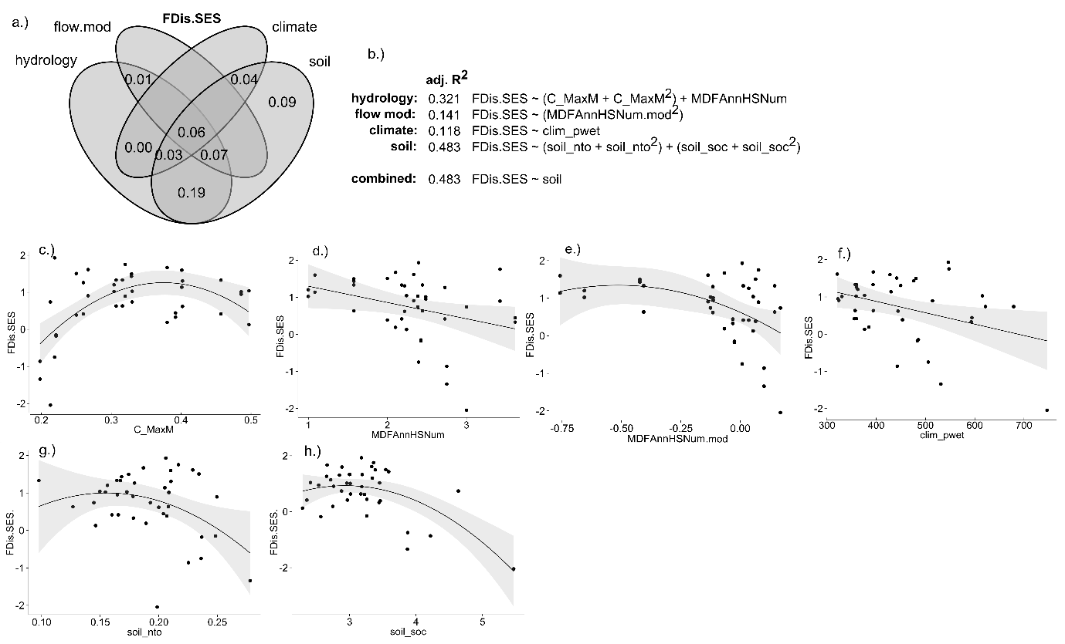

Figure 4. Environmental drivers of standardised effect size functional dispersion (FDis.SES) in riparian plant communities. a.) variance partitioning Venn diagram. Numbers within the diagram represent adjusted R2 (adj. R2) values associated with each fraction of variation; b.) multiple regression models representing each set of environmental conditions, and their optimal combination. Quadratic terms are enclosed in parentheses; selected relationships between FDis.SES and environmental variables describing c.) constancy of monthly maximum daily flows (C_MaxM); d.) mean annual frequency of high flow periods (MDFAnnHSNum, upper 5th percentile of flows); e.) modification of mean annual frequency of high flow periods (MDFAnnHSNum, % change); f.) precipitation in wettest quarter (clim_pwet, mm); g.) soil total nitrogen (soil_nto, %); h.) soil organic carbon (soil_soc, %). Fitted lines depict ordinary least-squares regression models. Shaded areas depict the smoothed 95% confidence interval around the regression model.

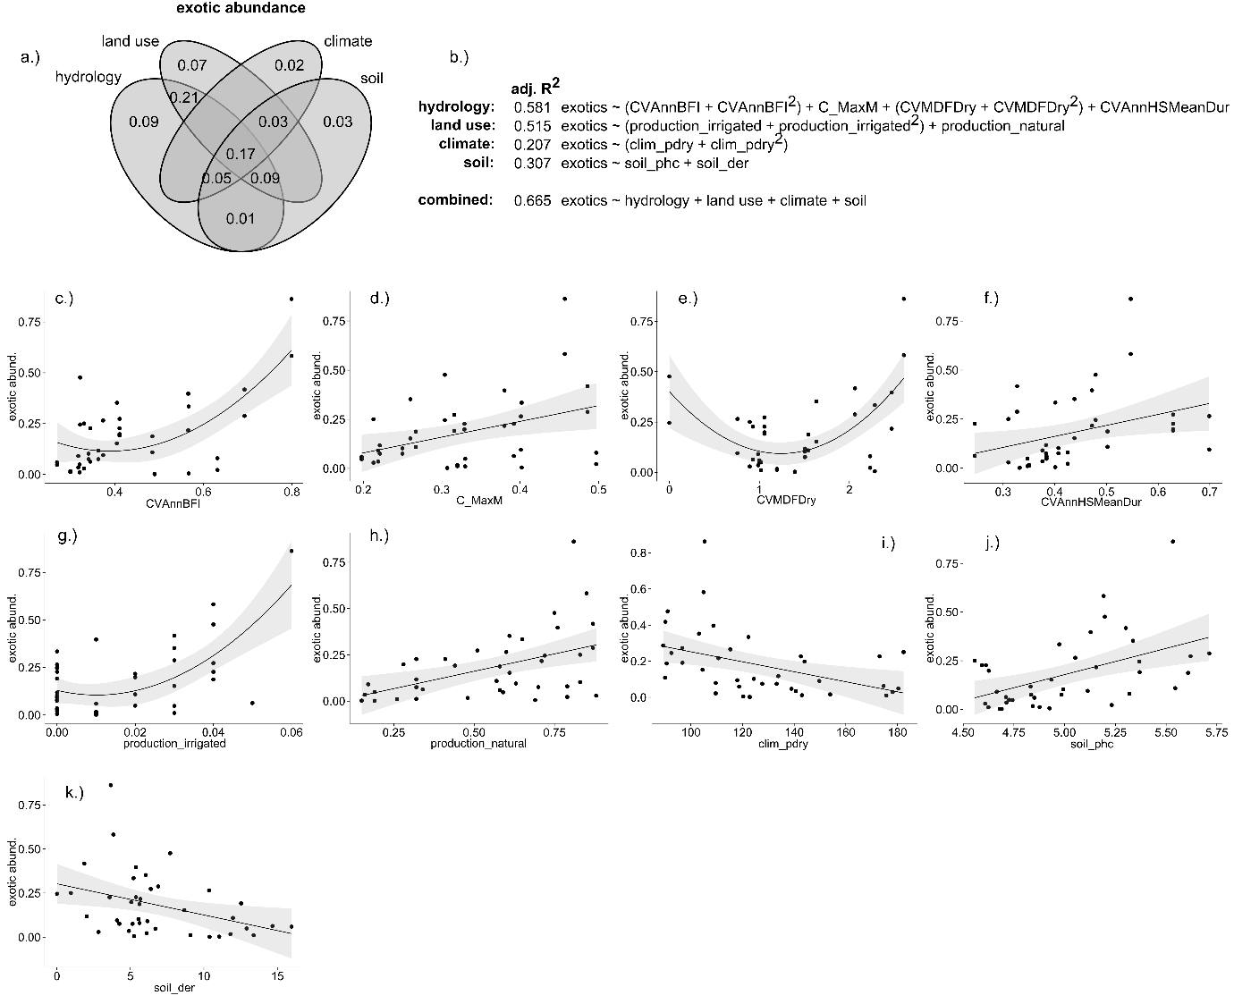

Figure 2. Environmental drivers of the proportional abundance of exotic species in riparian plant communities. a.) variance partitioning Venn diagram. Numbers within the diagram represent adjusted R2 (adj. R2) values associated with each fraction of variation; b.) multiple regression models representing each set of environmental conditions, and their optimal combination. Quadratic terms are enclosed in parentheses; selected relationships between exotic abundance and environmental variables describing c.) interannual variability in baseflow index (CVAnnBFI); d.) constancy of monthly maximum daily flows (C_MaxM); e.) interannual variability in dry season mean daily flow (CVMDFDry); f.) interannual variability in mean duration of high flow periods; g.) proportion of catchment used for irrigated agricultural production (production_irrigated, geographically weighted %); h.) proportion of catchment used for production from relatively natural environments (production_natural, geographically weighted %); i.) precipitation in the driest quarter (clim_pdry, mm); j.) soil pH (soil_phc, %); k.) depth of regolith (soil_der, m to hard rock). Fitted lines depict ordinary least-squares regression models. Shaded areas depict the smoothed 95% confidence interval around the regression model.