**Manual for DP14 Leaf Proteomics Project data processing pipeline**

04/011/2016

Overview:

This document describes the pipeline for processing proteomics data for the *Eucalyptus* (inc. *Angophora* and *Corymbia*) species of the Leaf Proteomics Project. The pipeline involves the following sequential steps:

1. Calculate protein areas
   1. Load and stitch together SWATH data
   2. Filter SWATH data by false discovery rate (FDR): for a given peptide, there must be minimum of 3 samples with FDR < 0.01
   3. Calculate protein areas using top2top3 method
      1. For a given peptide, peptide area = the sum of the top two most intense ions
      2. Then, for a given protein, protein area = the average of the three peptides with the greatest area
2. Calculate protein amounts using the ovalbumin peptide ‘GGLEP’ as a standard
   1. Find GGLEP top2 areas for each sample
   2. Find protein areas relative to GGLEP area
   3. Multiply by 5.64x10^-11 to get moles per cm2
   4. Multiply by protein molecular weight to get g/cm2
      1. Molecular weight is calculated using amino acid sequences using the R package *peptides*
   5. multiply by 10^07 to get mg/m2
   6. check MS derived values against protein assay values

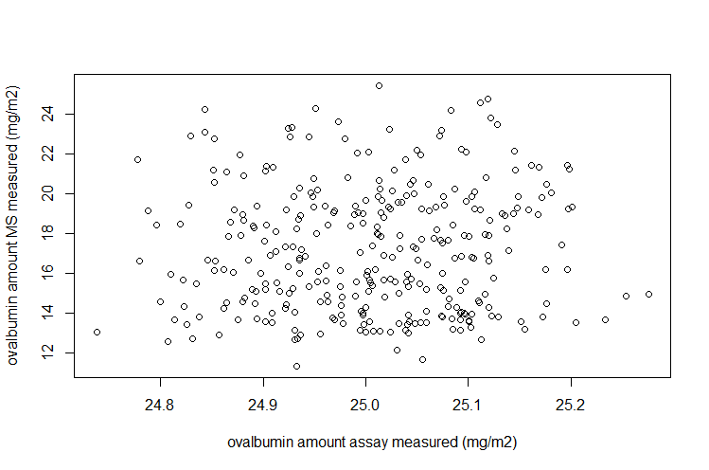

1. Generate MAPMAN/Mercator functional annotations
   1. Constrain Egrandis_Eglobulus_chloroplast_Myrtales_At_mt_cRAP_160405 protein sequence data to only include proteins reliably identified by MS.
   2. Convert to fastA format and upload to *http://www.plabipd.de/portal/mercator-sequence-annotation?p_p_id=Mercator_WAR_Mercatorportlet&p_p_lifecycle=0&p_p_state=maximized&p_p_mode=view*

Structure:

The data processing code is split into a number of files, some of which source / depend on each other, and which must be run in the correct order to produce the desired output.

|  |  |  |
| --- | --- | --- |
| *Script file* | *Dependencies* | *Description* |
|  |  |  |
|  |  |  |
|  |  |  |
|  |  |  |
|  |  |  |