Results:

*Confirmation of hydrological classes*

The three classes of river in this study were significantly different across the chosen hydrological metrics (at P < 0.05). Stable baseflow rivers (hydrological class 1) were most different from unpredictable intermittent rivers (category 3), R2 = 0.644, and slightly less so from unpredictable baseflow rivers (hydrological class 2), R2 = 0.617. Unpredictable intermittent and unpredictable baseflow rivers exhibited greater similarity, R2 = 0.379.

*Differences in wood density between hydrological classes*

Using abundance weighted site mean values, wood density was found to be significantly different between unpredictable baseflow rivers and stable baseflow rivers. The difference btween unpredictable intermittent rivers and stable baseflow rivers approached significance (P = 0.052), indicating that differences wood density between classes of river tracks differences in hydrology. No significant difference in raw wood density values was found between hydrological classes at P < 0.05.

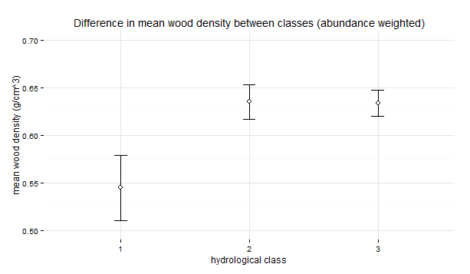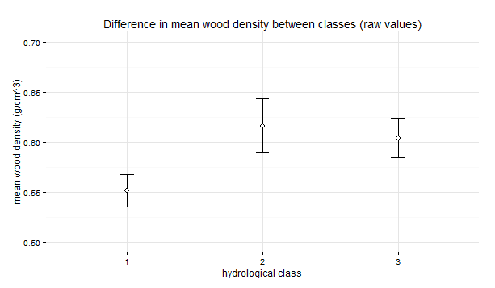

Figure . Comparison of mean wood density between hydrological classes using a.) abundance weighted means, b.) means of raw wood density values. Error bars represent standard error of the mean.

*How does wood density change over hydrological gradients?*

Significant positive relationships were apparent between metrics of flooding magnitude and abundance weighted site mean wood density, but not flooding frequency. Interannual variability in flood magnitude did not show a significant relationship with wood density after Benjamini-Hochberg adjustment, although a trend is apparent. Removing the Snowy Creek site as an outlier, due to its high mean wood density (0.66 g/cm3) relative to other stable winter baseflow sites, produces a tight relationship (R2 = 75.4, p > 0.001). Variability in flood rise and fall rates were also significant positive predictors of wood density, while mean flood rise and fall rates showed no significant relationship. This indicates that outlier flow events may be driving the observed patterns of wood density.

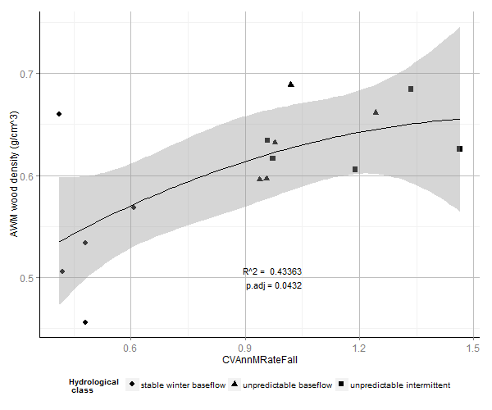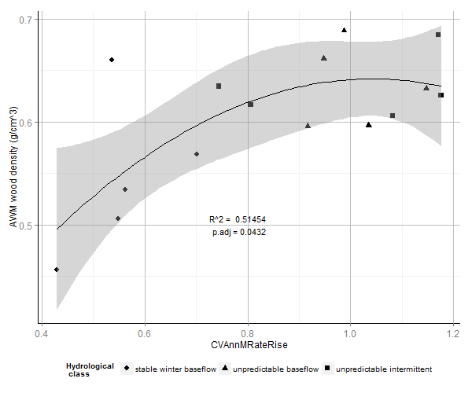

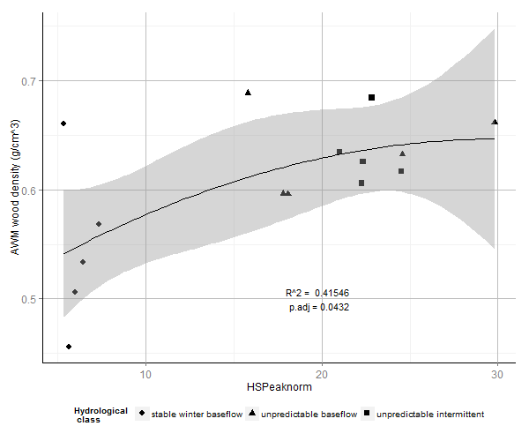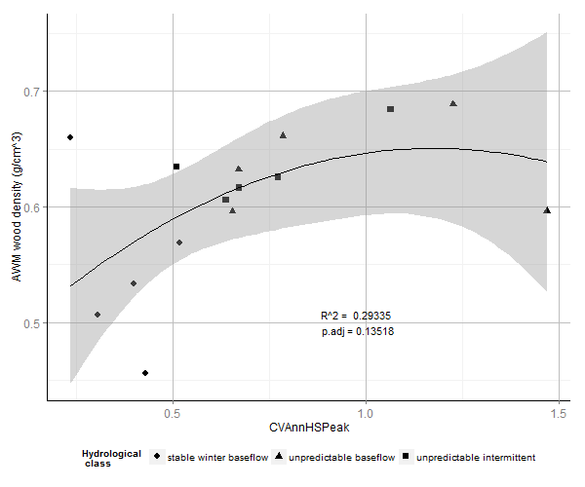

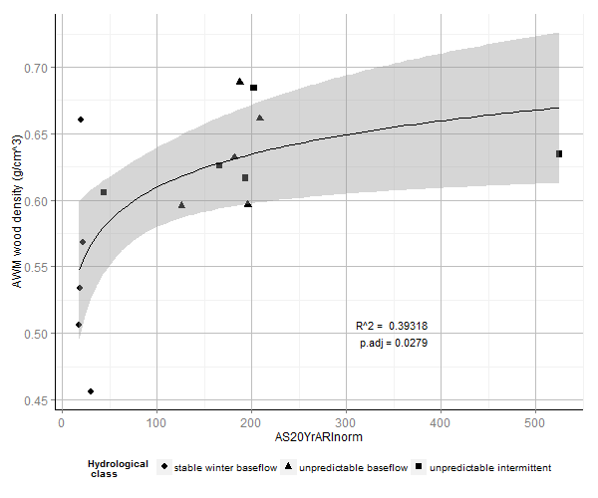

Figure . Relationships between abundance weighted mean wood density and hydrological metrics describing a.) variability in flood fall rates, b.) variability in flood rise rates, c.) mean high flow magnitude, d.) variability in high flow magnitude, e.) magnitude of the 20 year average return interval flood. Fit lines depict ordinary least squares regression models. a. – d. are quadratic fits, e. is an exponential fit. Shaded areas depict the 95% confidence interval around the regression model.

We found denser woody tissues were increasingly favoured as water availability became less consistent over daily (as measured by decreasing baseflow index), as well as over seasonal and annual timescales. Wood density increased as patterns of average flow conditions became a.) less uniformly distributed across seasons – (interseasonal uniformity - constancy, C), and b.) less uniformly distributed year to year (inter-annual uniformity, contingency, M). Thus plot mean wood density is maximised when average flows patterns are highly seasonal, but the season with which they are associated is not consistent throughout the record. Wood density was negatively predicted by interannual uniformity (contingency), but not constancy of minimum flows. That is to say, it was not important how strongly minimum flows were associated with particular seasons, but whether the seasonal pattern of flows was the same across years of the record.

A similar relationship was observed for inter-annual but not inter-seasonal uniformity of minimum flows. Mean wood density also increased with increasing interannual variability in baseflow index, pointing to a strong effect from years in which baseflow deviated from the mean.

Wood density also decreased with mean low spell flow, and with removal of Snowy Creek as an outlier, the mean 7 day minimum flow (for both of which a higher values indicate wetter minimum flow conditions). Metrics of low flow duration did not significantly predict wood density.

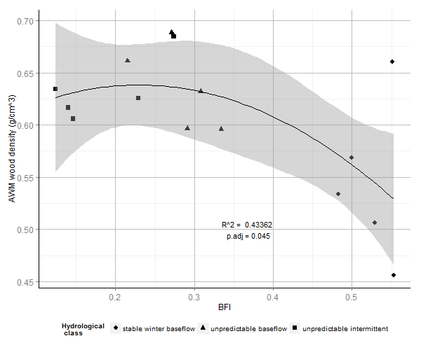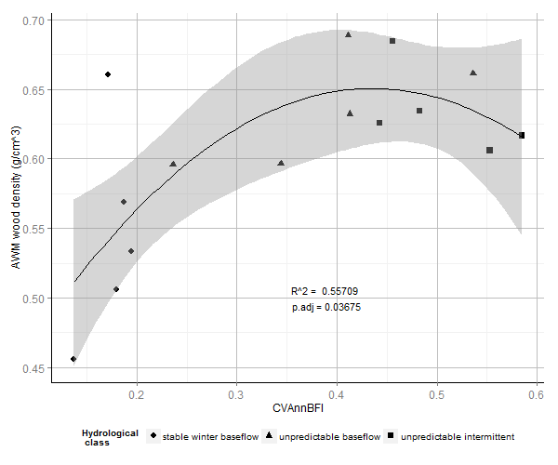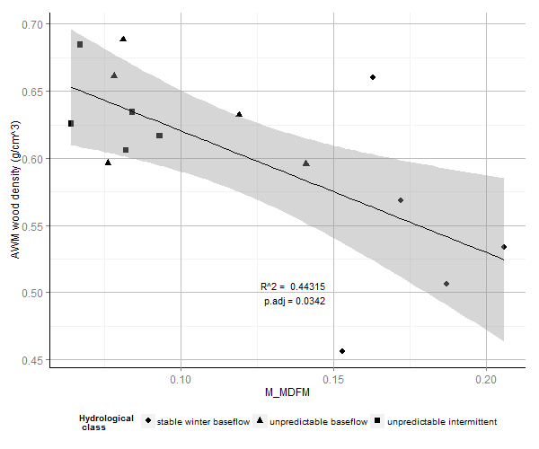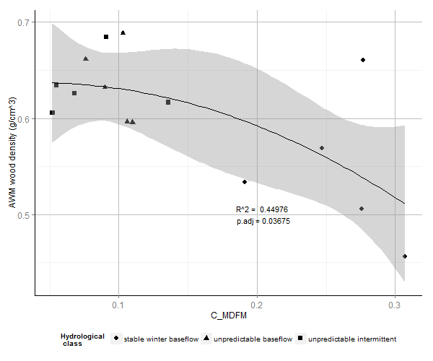

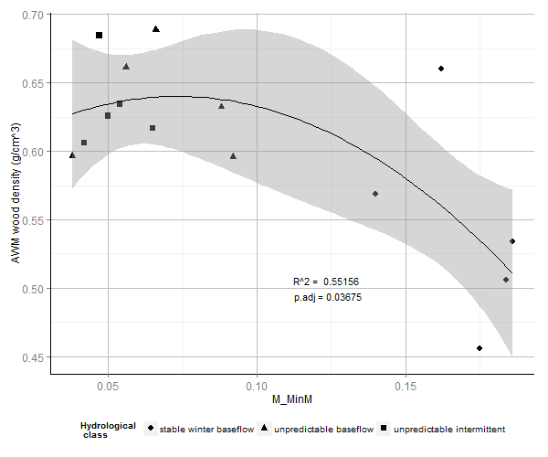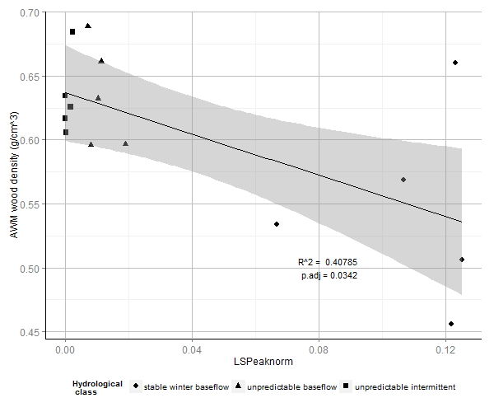

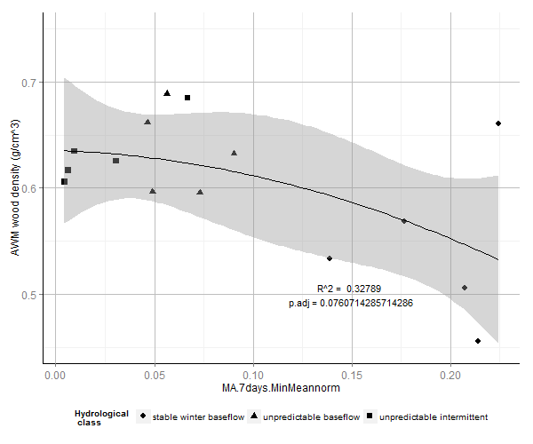

In summary, we found evidence that mean riparian wood density is positively related to flood magnitude and extremes in flow rise and fall rates, as well as to inconsistency in flow conditions over daily, seasonal and annual timescales. Patterns of class-wise clustering were generally maintained across continua of specific hydrological gradients. Relationships were typically described best by quadratic or exponential models, indicating a saturation point above which variation in hydrology ceases to be associated with changes in mean wood density. Removing Snowy Creek as an outlier value substantially tightens up relationships between wood density and hydrological metrics. This site was located within Victoria State Forestry and appeared to have been disturbed significantly. Compared with upstream reaches within National Parks land, seral scrubs of dense stemmed *Leptospermum spp.* were considerably more abundant, which may account for this discrepancy.

*What are the principal components of variation in hydrology that predict wood density?*

Hydrological metrics that significantly explaining site mean wood density were highly autocorrelated in our dataset. Principal Components Analysis (PCA) identified one dominant axis within these metrics, representing 83.78% of variation. The remaining variation was split between several minor axes.

Importance of components:

PC1 PC2 PC3 PC4 PC5 PC6 PC7 PC8 PC9

Standard deviation 2.8961 0.85829 0.55727 0.52554 0.3549 0.25338 0.21775 0.16830 0.1342

Proportion of Variance 0.8387 0.07367 0.03106 0.02762 0.0126 0.00642 0.00474 0.00283 0.0018

Cumulative Proportion 0.8387 0.91240 0.94346 0.97108 0.9837 0.99009 0.99483 0.99767 0.9995

PC10

Standard deviation 0.07295

Proportion of Variance 0.00053

Cumulative Proportion 1.00000

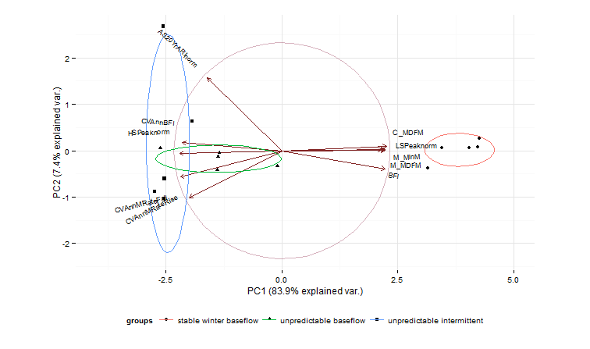

Figure . Biplot of sites ordinated across the first two principal components (PC) of the PCA. Points represent positions of individual sites. Ellipses indicate clustering of sites according to hydrological class. Arrows represent loadings of hydrological metrics across each PC.

Metrics that are maximised under conditions of weak seasonality and low variability in water availability sit at the positive end of the PC1 axis, while metrics that are maximised under conditions of high baseflow variability and high intensity flooding sit at the negative end. PC1 therefore represents a gradient of environmental harshness that integrates baseflow characteristics, seasonality and flooding intensity. Stable baseflow rivers exhibit lower site mean wood density, and are clustered at the ‘mild’ positive end of the PC1 gradient. Unpredictable baseflow and unpredictable intermittent rivers overlap across PC1 and are located distally towards the ‘harsh’ negative end, and are associated with higher site mean wood density. Here we see the pattern of differentiation in wood density between hydrological classes reiterated, and largely reduced to a single axis of variation.