**Hydrological conditions predict wood density in Australian riparian plants**

**Introduction**

Functional trait oriented approaches to understanding community assembly (McGill, Enquist, Weiher, & Westoby, 2006) have been *de mode* over the last decade, especially in plant ecology (Kattge et al., 2011). These approaches attempt to understand community assembly processes by linking morphological or physiological attributes of species to organismal success under given environmental conditions. Suites of traits can be conceptualized as axes of variation in terms of ‘ecological strategy’, and distribution of this variation across environmental gradients can provide insight into where these strategies are successful (Westoby, Falster, Moles, Vesk, & Wright, 2002).

Hydrology is widely considered to be the dominant abiotic force structuring riparian ecosystems. Hydrological variability in turn drives variation in moisture and substrate availability and flood disturbance, with cyclical resets to early successional conditions being characteristic of the riparian environment (Merritt, Scott, Poff, Auble, & Lytle, 2010). These are the conditions which are likely to dictate success of a particular ecological strategy. Several authors have recently suggested functional trait biology as a means of understanding the response of riparian plant communities to hydrological gradients (Catford et al., 2012; Merritt et al., 2010). While a number of studies have investigated ecohydrological classification as a tool to explain community attributes such as species richness, stand structure and composition (following ELOHA), functional approaches in ecohydrology are still novel.

Woody plants determine the coarse physical structure of many riparian plant communities and are integral to the interplay of biological and physical elements that drive fluvial biogeomorphic processes (Corenblit, Steiger, Gurnell, Tabacchi, & Roques, 2009). Consequently, an understanding of the mechanisms of riparian woody plant community assembly will provide important insights into fluvial landscapes. Wood density (the ratio of kiln-dried mass to green volume of a wood sample (Cornelissen et al., 2003) is widely recognised as an important functional trait in plant ecology (Westoby & Wright, 2006), and has been proposed as one of just several key axes of variation within which all major plant ecological strategies can be described (Westoby et al., 2002). Wood density is in fact an emergent property of a combination of woody tissue traits, including vessel geometry and arrangement, and the density and proportion of surrounding lignified tissue (Chave et al., 2009). Combined variation in these traits corresponds to the wide range of ecological strategies among woody plants.

How might variation in wood density confer advantages to woody plant species in riparian environments? There is little direct evidence from riparian species, however general relationships between wood density and other ecological traits have been recognised from a variety of previous studies that can provide some insight into the importance of variation in wood density in riparian communities. Dense wood confers mechanical stiffness (D. S. Falster, 2006; Niklas & Spatz, 2010), as well as resistance to pathogens (Augspurger & Kelly, 1984) and herbivory (Coley, 1983), but requires more investment of biomass and is therefore more costly to construct per unit of stem height. According to this trade-off, it follows that several relationships between wood density and life-history strategy are apparent: studies of tropical rainforest species have shown an inverse relationship between growth rate and wood density (King, Davies, Tan, & Noor, 2006; Kraft, Metz, Condit, & Chave, 2010; L Poorter et al., 2008; Lourens Poorter et al., 2010; Wright et al., 2010), however no such relationship was found in a study of New Zealand tree species (Russo et al., 2010)Cohort survival was positively correlated with wood density in the same tropical rainforest studies (King et al., 2006; Kraft et al., 2010; L Poorter et al., 2008; Lourens Poorter et al., 2010; Wright et al., 2010). Following disturbance caused by a large cyclone in northern Queensland, Australia, wood density of rainforest trees was indicative of both damage sustained and subsequent recovery of biomass. Trees with dense wood were more likely to have experienced only minor damage, while of those trees that experienced major stem and branch damage, lower wood density trees were more likely to resprout and recover biomass faster post-disturbance (Curran, Gersbach, Edwards, & Krockenberger, 2008). In a study of 45 rainforest species in tropical Queensland, Falster and Westoby (2005) found that wood density increased with plant height along a successional gradient. Thus it seems likely that these observed relationships between wood density and recovery from disturbance at the individual level, as well as post-disturbance succession at the community level, may be true also for riparian systems.

In step with growing understanding of the role of woody plant tissue density in the biotic and physical structure of landscapes, the recent decade has seen an increase in understanding of the phylogenetic and environmental patterning of wood density variation. Phylogenetic analyses across two large wood density datasets (Swenson & Enquist, 2007; Zanne et al., 2010) have shown wood density to be highly conserved, with a large proportion of variation explained at the genus level. Strong phylogenetic signals in wood density variation have also been found in studies of coastal Californian angiosperms (Preston, Cornwell, & Denoyer, 2006) and Florida oaks (Cavender-Bares, Kitajima, & Bazzaz, 2004).

Some studies (Weimann & Williamson, 2002; Swenson & Enquist, 2007), found little relationship between wood density and rainfall while others (Martínez-Cabrera, Jones, Espino, & Schenk, 2009; Preston et al., 2006), found that wood density was correlated with mean annual precipitation across a transcontinental gradient, and with soil moisture, respectively. High wood density, along with low SLA and low maximum height, has been associated with environmental stress tolerance and conservative use of resources **(Reich et al 2003, Westoby LHS 1998, Swenson & Enquist 2007).** For riparian plants, fluctuations in soil moisture driven primarily by hydrological patterns may therefore be an important driver of variation in wood density. More basic investigations of the functional ecology of wood density are needed, particularly outside of the tropical rainforest systems that dominate the current literature.

In the sense that woody tissue determines plant responses to these to flooding disturbance and fluctuations in water availability, wood density is likely to be the primary indicator of riparian woody plant ecological strategy. Here we consider variation in wood density of dominant woody riparian plant species over a range of hydrological conditions, across 15 riparian sites within south-eastern Australia. We sought to address the following questions: (1) do riparian vegetation communities along hydrologically distinct classes of river exhibit differences in wood density? (2) is wood density related to the frequency and magnitude of flood disturbance? (3) is wood density related to predictability of water availability in the riparian zone? Further, we develop method based on Trait Gradient Analysis to ask: (4) do strong hydrological conditions induce specialisation in ecological strategy, as indicated by wood density?

**Methods**

**Study site selection**

Fifteen riparian sites were selected along gauged rivers within the South-East Coast and south-eastern Murray Darling drainage basins of Australia (see *Figure 1*). To differentiate rivers according to ecologically relevant components of hydrology, Olden and Poff (2003) described a statistical methodology for determining a minimally redundant set of hydrological descriptors. Kennard et al. (2010) followed this methodology to define a set of 120 hydrological metrics relevant to Australian rivers, which included metrics of central tendency and dispersion in all five dimensions of hydrological variation (magnitude, frequency, duration, timing, and rate of change). They then used these metrics to classify Australian river systems into twelve distinct flow regime classes, providing a foundation for analysing the properties of ecosystems across hydrological gradients. Sites in this study were drawn from rivers corresponding to ‘stable winter baseflow’, ‘unpredictable baseflow’ and ‘unpredictable intermittent’ hydrological classes, as described by Kennard et al. (2010). These are the best represented hydrological classes in eastern NSW and VIC, and represent a clear gradient over ecologically relevant hydrological parameters. Five sites per hydrological class were selected based on the criteria outlined below.

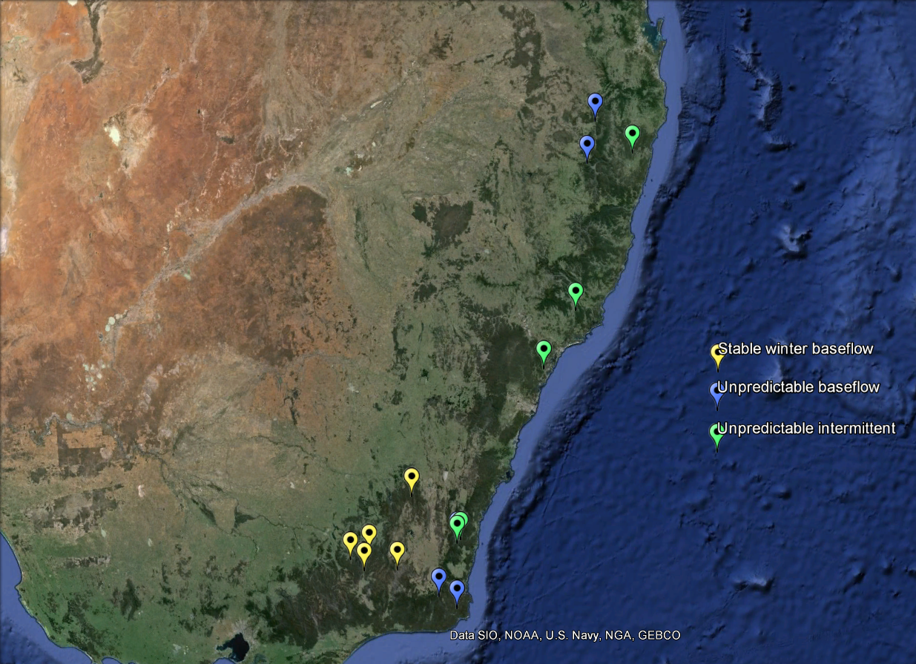

Figure 1. Map of south-eastern Australia showing location of field sites.

Gauged locations were selected that had >15 years of associated continuous hydrological data, and an absence of flow regulation, significant water extraction or catchment urbanisation (following Kennard et al., 2010). Of these, locations from the hydrological classes of interest were located within the study area. To minimise signals associated with human land-use, the following further criteria were used to shortlist possible study sites: intact native riparian vegetation cover (a band of native riparian vegetation extending >15 m from the channel edge), natural geomorphic condition (lack of significant human-induced erosional or depositional landforms), and minimal catchment clearing (catchment predominantly covered by native vegetation). These criteria were assessed using a combination of visual inspection of satellite photography (Google Earth, Microsoft Bing), information from the NSW Riparian Vegetation Extent dataset and the NSW Office of Water River Styles® geospatial dataset (NSW Office of Water, Department of Primary Industries). Large rivers with catchment area >1000 km2 were then removed. To select the 15 study sites from this shortlist, accessibility by road, permission from state or private landholders, and proximity of accessible areas to continuous hydrological monitoring stations were considered.

**Species abundance and trait data collection**

Data collection was undertaken between December 2012 and May 2013. At each site, a 10 m by 50 m plot was marked out, with the longest side abutting the channel edge. Criteria for selection of plot locations were: geomorphic homogeneity (the plot comprising only sloping bank where possible) and lack of anthropogenic disturbance such as built structures, roads or tracks, recent logging or clearing (in the last 20-30 years), herbicide spraying or animal grazing.

Proportional cover of woody vegetation was assessed at three strata levels: shrub (1-4 m), subcanopy (4-8 m) and canopy (>8 m). Species were identified using appropriate field guides, and were verified against herbarium specimens at the Macquarie University Herbarium. Hard to identify specimens were identified by staff at the Royal Botanic Gardens, Sydney.

# Wood samples were collected from dominant woody species present within the plot at >5% cover in shrub, sub canopy or canopy strata, and which had trunks robust enough to core. A 5.15 mm diameter, triple threaded increment borer (Haglöf Sweden) was used to extract a 100 mm wood sample from each of two individuals per species. Samples were extracted from the base of the main trunk, 10 cm above the leaf litter level, and air-dried at 20-45°C. On return to the laboratory, samples were rehydrated in deionised water and dissected into cylindrical sections of bark, sapwood and heartwood, using visual inspection of vessel occlusion as an indicator of tissue type. Sections were measured (x, y and z dimensions) with calipers (Mitzuni) to calculate wet volume, were then oven-dried at 80°C for 48 hours and weighed using a microbalance (Mettler Toledo). Wood density was then calculated as the ratio of oven dry mass to wet volume (g/cm3).

**Hydrological data analysis**

Hydrological data pertaining to each field site were collated from the PINNNENA CW 10.1 database (NSW Office of Water, Department of Primary Industries) and the NSW Office of Water Continuous Water Monitoring network website (<http://realtimedata.water.nsw.gov.au/water.stm>) (for NSW sites), and the Victoria State Government’s Water Measurement Information System website (<http://data.water.vic.gov.au/monitoring.htm>). Daily discharge rate data is recorded as timestamped average daily flow datapoints in units of megalitres per day. Where possible 30 year time series were obtained, spanning years 1983 – 2012. Records were truncated for three sites, spanning 15, 19 and 28 years. Missing data were approximated using the Time Series Manager module in River Analysis Package (REF). Consistency of the resulting outputs were checked by visual inspection of hydrographs. For Mammy Johnson’s River, Mann River, Sportsman’s Creek and Wallagaraugh River, multiple linear regression was chosen as the most appropriate method. Linear interpolation was used for Jilliby Creek data.

A minimal set of hydrological metrics was pared from the full set described by Kennard et al. (2010). These metrics were chosen to be representative of variability in high flow magnitude and frequency as well as predictability and consistency of water availability in the riparian environment (see Table 1 for a description). We used the Time Series Analysis module in River Analysis Package to generate these metrics. Means and coefficients of variation were calculated for most metrics to indicate central tendency as well as spread within the data. Low and high spell metrics were thresholded at the 5th and 95th percentiles, respectively, with a flood independence criterion of 7 days between peaks events 20 year average return interval (ARI) flood magnitude was also calculated with a flood independence value of 7 days between peaks. Colwell’s Indices were calculated using mean values over monthly time periods and a class distribution of 11 flow classes. Metrics of flow magnitude were normalised by mean daily flow to allow for comparison between different sizes of river.

|  |  |  |  |  |
| --- | --- | --- | --- | --- |
| **Parameter** | **Abbreviation** | | **Units** | **Description** |
| *Flood frequency and magnitude* | | | | |
| Mean magnitude of high spells* | HSPeaknorm | dimensionless | | High spells are periods of flow above the 95th percentile on the flow duration curve. We were interested in how frequently these conditions occurred over the time series as well as the mean magnitude of peak flows during these periods. 20 year average return interval (ARI) floods are extreme flow events that have the potential to resculpt the fluvial landscape. Together, these metrics indicate the intensity and frequency with which mechanical stress is applied to plants in the riparian zone. |
| CV of all years’ mean high spell magnitude | CVAnnHSPeak | dimensionless | |
| 20 year ARI flood magnitude* | AS20YrARInorm | dimensionless | |
| Mean of all years’ number of high spells | MDFAnnHSNum | year-1 | |
| CV of all years’ number of high spells | CVAnnHSNum | dimensionless | |
| *Rise and fall rates* | | | | |
| Mean rate of rise * | MRateRisenorm | dimensionless | | Rise and fall rates represent flow flashiness. Fast rise rates are associated with flood waves and intense mechanical stress to plant stems. Slow fall rates keep exposed substrate moist for longer periods, which may produce favourable conditions for germination. Historical discharge records are unfortunately limited to daily resolution, so are unable to fully capture flood discharge shapes. High variability between years indicates the occurrence of extreme events which may not have been captured by the mean value. |
| Mean rate of fall * | MRateFallnorm | dimensionless | |
| CV of all years mean rate of rise | CVAnnMRateRise | dimensionless | |
| CV of all years mean rate of rise | CVAnnMRateFall | dimensionless | |
| *Baseflow index* | | | | |
| Baseflow index | BFI | dimensionless | | Baseflow index is calculated using the ratio of flow during average conditions to total flow. It is a useful metric of consistency of water availability, in that it is maximised when average flow conditions dominate, and minimised when total flow is dominated by above average flow events. Intra-annual variability in baseflow index measures how predictable baseflow index is between years. |
| CV of all years Baseflow Index | CVAnnBFI | dimensionless | |
| *Low flow magnitude, frequency and duration* | | | | |
| CV of all years’ mean low spell magnitude | LSPeaknorm | dimensionless | | Low spells are periods of flow below the 5th percentile on the flow duration curve. We were interested in how frequently these conditions occurred over the time series as well as the mean and interannual variability in magnitude and duration of low flows. |
| CV of all years mean of low spell magnitude | CVAnnLSPeak | dimensionless | |
| Mean of all years number of low spells | MDFAnnLSNum | year-1 | |
| CV of all years’ number of low spells | CVAnnLSNum | dimensionless | |
| Mean duration of low spells | LSMeanDur | days | |
| CV of all years’ low spell mean duration | CVAnnLSMeanDur | dimensionless | |
| Mean flow during driest week* | MA.7daysMinMeannorm | dimensionless | |
| Mean days per year under 0.1ML/day flow | MDFAnnUnder0.1 | days/year | |
| CV of all year’s days per year under 0.1ML/day flow | CVAnnMDFAnnUnder0.1 | dimensionless | |
| *Colwell’s indices* | | | | |
| Constancy based on monthly mean daily flow | C_MDFM | dimensionless | | Colwell’s indices provide a measure of the seasonal predictability of flow events and therefore water availability within the riparian zone. Constancy (M) measures uniformity of flow across seasons, and is maximised when flow conditions do not differ between seasons. Contingency (M) is a measure of interannual uniformity in seasonal flow patterns, and is maximized when seasonal patterns of flow are consistent between years.  We generated Colwells indices for both average flow conditions and minimum flows conditions. |
| Contingency based on monthly mean daily flow | M_MDFM | dimensionless | |
| Constancy based on monthly minimum daily flow | C_MinM | dimensionless | |
| Contingency based on monthly minimum daily flow | M_MinM | dimensionless | |

Table 2. Hydrological parameters used as metrics of variability in high flow magnitude and frequency and predictability and consistency of water availability in the riparian environment. * - normalised by mean daily flow (ML/day)

Finally, we performed permutational multivariate analysis of variance using distance matrices (using the vegan package in R) across these chosen metrics to confirm that our field sites did indeed comprise three significantly different hydrological categories.

**Abundance weighted site means of wood density**

To investigate variation in wood density across hydrological gradients at the community level, abundance weighted means of wood density were generated for each site. Species relative abundance was compiled from records of % cover at the shrub (1-4m), subcanopy (4-8m) and canopy (8+) strata. Wood density values were then weighted according to species relative abundance and then summed to produce the abundance weighted site mean. This method integrates particular trait values with their real world abundance as a measure of ‘performance’, while providing a useful reduction in data dimensionality. Wood density varies only over one order of magnitude, while exhibiting relatively high intra-species plasticity. As such, abundance weighted site means work well for environmental gradient studies because the focus is maintained on the functional characteristics of the community, rather than on species *per se*.

**Comparing wood density between hydrological classes**

Raw species trait values were lumped according to the hydrological class membership and differences between classes tested for using a post-hoc Tukey’s HSD test. This test was repeated using class-lumped abundance weighted site means.

**Testing relationships between mean wood density and hydrological conditions**

Ordinary least-squares regression models were generated for selected metrics to determine relationships between hydrological gradients and abundance weighted site mean values. Wood density data was normally distributed and did not require transformation. To reduce the occurrence of Type 1 statistical error, we adjusted the resulting p values using the Benjamini and Hochberg (BH) procedure for controlling family-wise error rate (stats package in R). Although sound ecological rationale underlay inclusion of each subgroup of hydrological metrics, these metrics were highly autocorrelated. The BH procedure has been shown to control the false discovery rate for positively dependent test statistics (Benjamini and Yekutieli, 2001). We then identified the most ecologically relevant axes of variation in hydrological conditions by running a principal components analysis over hydrological metrics showing significant relationships with site mean wood density values.

**Results:**

*Confirmation of hydrological classes*

The three classes of river in this study were significantly different across the chosen hydrological metrics (at P < 0.05). Stable baseflow rivers (hydrological class 1) were most different from unpredictable intermittent rivers (category 3), R2 = 0.644, and slightly less so from unpredictable baseflow rivers (hydrological class 2), R2 = 0.617. Unpredictable intermittent and unpredictable baseflow rivers exhibited greater similarity, R2 = 0.379.

*Differences in wood density between hydrological classes*

Using abundance weighted site mean values, wood density was found to be significantly different between unpredictable baseflow rivers and stable baseflow rivers. The difference btween unpredictable intermittent rivers and stable baseflow rivers approached significance (P = 0.052), indicating that differences wood density between classes of river tracks differences in hydrology. No significant difference in raw wood density values was found between hydrological classes at P < 0.05.

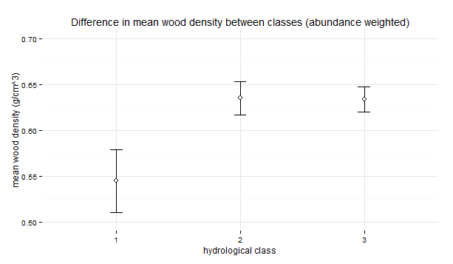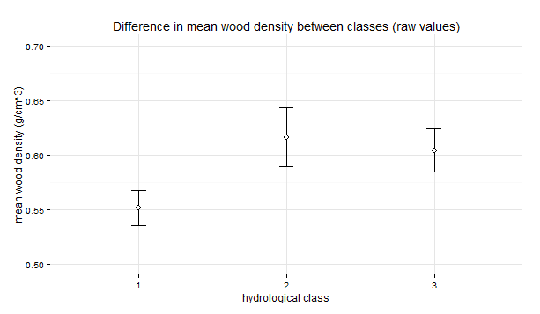

Figure 3. Comparison of mean wood density between hydrological classes using a.) abundance weighted means, b.) means of raw wood density values. Error bars represent standard error of the mean.

*How does wood density change over hydrological gradients?*

Significant positive relationships were apparent between metrics of flooding magnitude and abundance weighted site mean wood density, but not flooding frequency. Interannual variability in flood magnitude did not show a significant relationship with wood density after Benjamini-Hochberg adjustment, although a trend is apparent. Removing the Snowy Creek site as an outlier, due to its high mean wood density (0.66 g/cm3) relative to other stable winter baseflow sites, produces a tight relationship (R2 = 75.4, p > 0.001). Variability in flood rise and fall rates were also significant positive predictors of wood density, while mean flood rise and fall rates showed no significant relationship. This indicates that outlier flow events may be driving the observed patterns of wood density.

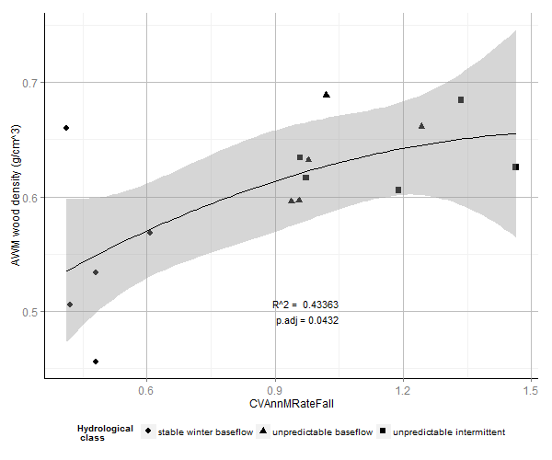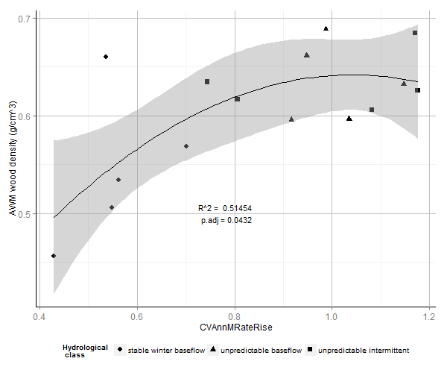

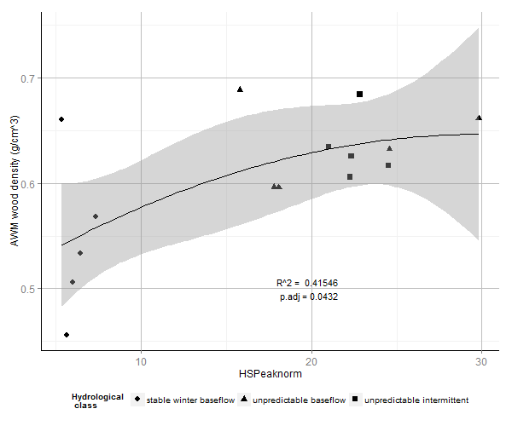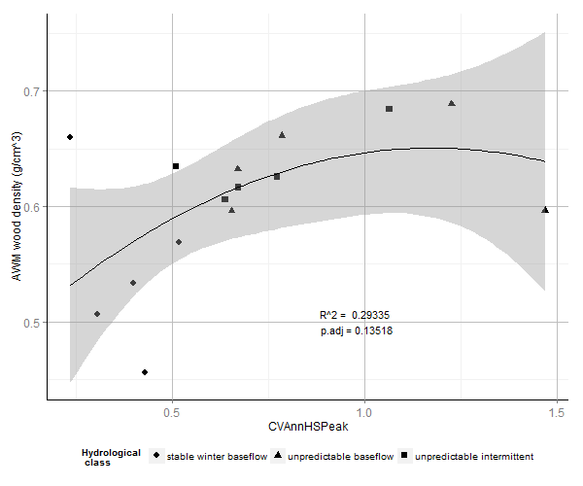

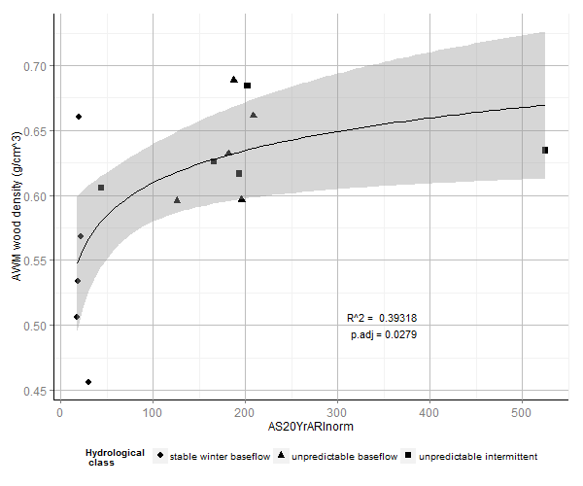

Figure 4. Relationships between abundance weighted mean wood density and hydrological metrics describing a.) variability in flood fall rates, b.) variability in flood rise rates, c.) mean high flow magnitude, d.) variability in high flow magnitude, e.) magnitude of the 20 year average return interval flood. Fit lines depict ordinary least squares regression models. a. – d. are quadratic fits, e. is an exponential fit. Shaded areas depict the 95% confidence interval around the regression model.

We found denser woody tissues were increasingly favoured as water availability became less consistent over daily (as measured by decreasing baseflow index), as well as over seasonal and annual timescales. Wood density increased as patterns of average flow conditions became a.) less uniformly distributed across seasons – (interseasonal uniformity - constancy, C), and b.) less uniformly distributed year to year (inter-annual uniformity, contingency, M). Thus plot mean wood density is maximised when average flows patterns are highly seasonal, but the season with which they are associated is not consistent throughout the record. Wood density was negatively predicted by interannual uniformity (contingency), but not constancy of minimum flows. That is to say, it was not important how strongly minimum flows were associated with particular seasons, but whether the seasonal pattern of flows was the same across years of the record.

A similar relationship was observed for inter-annual but not inter-seasonal uniformity of minimum flows. Mean wood density also increased with increasing interannual variability in baseflow index, pointing to a strong effect from years in which baseflow deviated from the mean.

Wood density also decreased with mean low spell flow, and with removal of Snowy Creek as an outlier, the mean 7 day minimum flow (for both of which a higher values indicate wetter minimum flow conditions). Metrics of low flow duration did not significantly predict wood density.

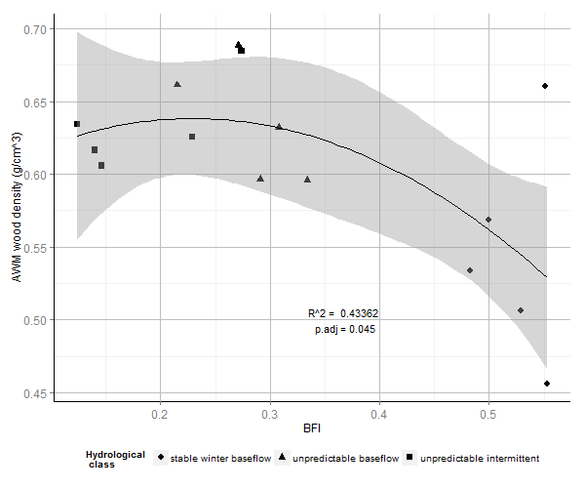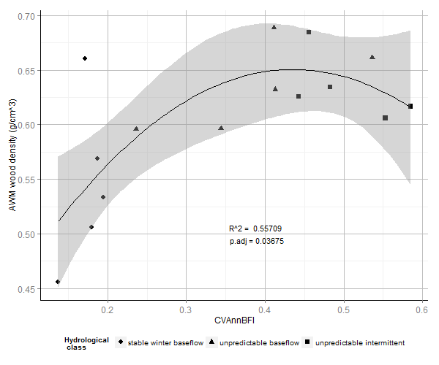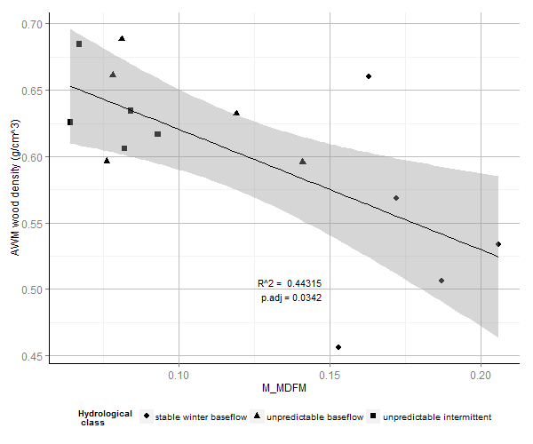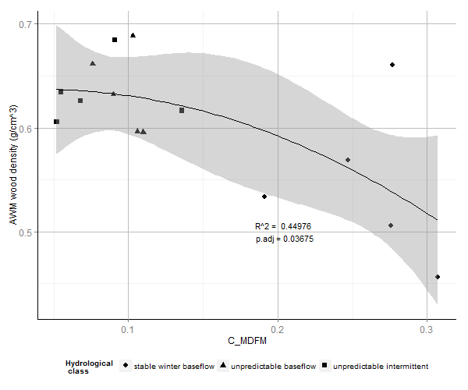

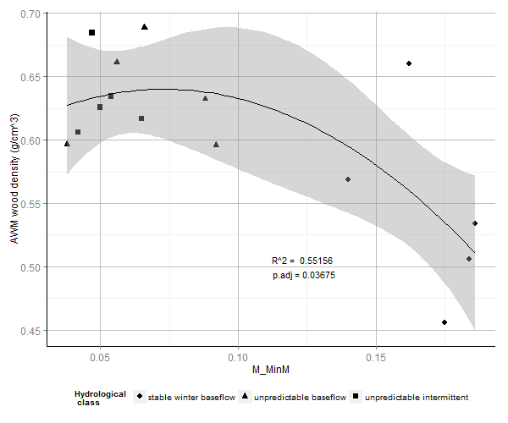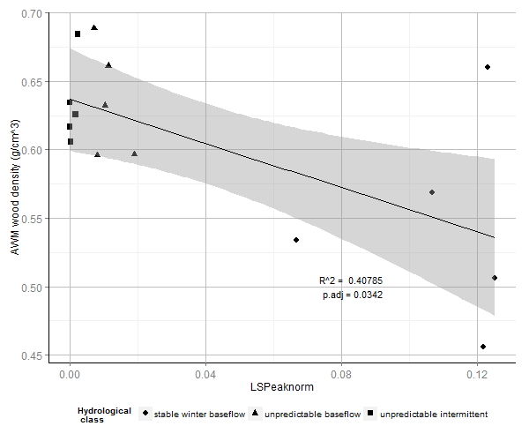

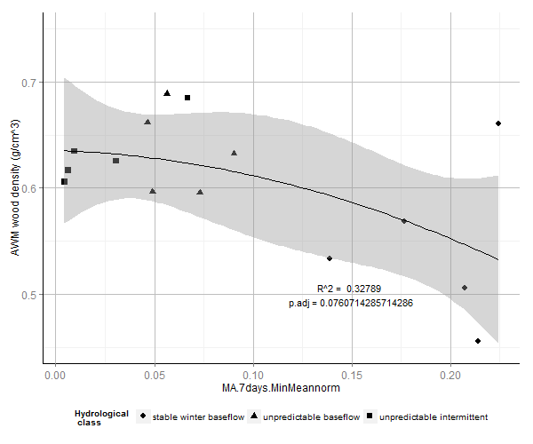

|  |  |  |  |  |  |  |
| --- | --- | --- | --- | --- | --- | --- |
|  | All values included | |  | Snowy Creek value removed | | |
| *Metric* | *p* | *p.adj* | *R2* | *p* | *p.adj* | *R2* |
| M_MinM | 0.0038 | 0.0432 | 0.552 | 0.0002 | 0.0008 | 0.740 |
| CVAnnBFI | 0.0064 | 0.0432 | 0.557 | 0.0001 | 0.0007 | 0.838 |
| CVAnnMRateRise | 0.0068 | 0.0432 | 0.515 | 0.0001 | 0.0007 | 0.787 |
| M_MDFM | 0.0094 | 0.0432 | 0.443 | 0.0018 | 0.0039 | 0.606 |
| C_MDFM | 0.0098 | 0.0432 | 0.450 | 0.0001 | 0.0007 | 0.758 |
| CVAnnMRateFall | 0.0117 | 0.0432 | 0.434 | 0.0001 | 0.0007 | 0.783 |
| AS20YrARInorm | 0.0124 | 0.0279 | 0.393 | 0.0057 | 0.0114 | 0.668 |
| LSPeaknorm | 0.0128 | 0.0432 | 0.427 | 0.0002 | 0.0008 | 0.724 |
| HSPeaknorm | 0.0144 | 0.0432 | 0.415 | 0.0005 | 0.0013 | 0.708 |
| BFI | 0.0180 | 0.0480 | 0.434 | 0.0001 | 0.0007 | 0.816 |
| MA.7daysMinMeannorm | 0.0355 | 0.0852 | 0.328 | 0.0003 | 0.0009 | 0.755 |
| CVAnnHSPeak | 0.0751 | 0.1502 | 0.293 | 0.0017 | 0.0039 | 0.754 |
| MRateRisenorm | 0.1631 | 0.2899 | 0.348 | 0.0730 | 0.1348 | 0.528 |
| CVAnnHSNum | 0.1691 | 0.2899 | 0.164 | 0.2300 | 0.3450 | 0.135 |
| MDFAnnLSNum | 0.1908 | 0.3053 | 0.208 | 0.2600 | 0.3671 | 0.183 |
| MRateFallnorm | 0.2098 | 0.3061 | 0.283 | 0.1100 | 0.1886 | 0.443 |
| CVAnnLSPeak | 0.2168 | 0.3061 | 0.245 | 0.1500 | 0.2400 | 0.339 |
| LSMeanDur | 0.4115 | 0.5487 | 0.180 | 0.4300 | 0.5280 | 0.159 |
| CVAnnLSNum | 0.4417 | 0.5579 | 0.052 | 0.4400 | 0.5280 | 0.054 |
| C_MinM | 0.4919 | 0.5903 | 0.259 | 0.3700 | 0.4933 | 0.427 |
| MDFAnnUnder0.1 | 0.5904 | 0.6747 | 0.071 | 0.5100 | 0.5829 | 0.105 |
| MDFAnnZer | 0.6360 | 0.6938 | 0.092 | 0.5600 | 0.6109 | 0.130 |
| MDFAnnHSNum | 0.6885 | 0.7184 | 0.262 | 0.8100 | 0.8100 | 0.254 |
| CVAnnLSMeanDur | 0.8483 | 0.8483 | 0.029 | 0.6700 | 0.6991 | 0.028 |

Table 1. Statistics for regression models comparing hydrological metrics with site mean wood density. Statistics for models where Snowy Creek was removed as an outlier are also given. The initial best fit for AS20YrARInorm was an exponential model, but after removal of Snowy Creek, values are given for a quadratic model which gave a better fit. The model for MA.7daysMinMeannorm was made non-significant after p-value adjustment, but returned to significance following outlier removal. CVAnnHSPeak was non-significant initially but a significant relationship became apparent following outlier removal.

In summary, we found evidence that mean riparian wood density is positively related to flood magnitude and extremes in flow rise and fall rates, as well as to inconsistency in flow conditions over daily, seasonal and annual timescales. Patterns of class-wise clustering were generally maintained across continua of specific hydrological gradients. Relationships were typically described best by quadratic or exponential models, indicating a saturation point above which variation in hydrology ceases to be associated with changes in mean wood density. Removing Snowy Creek as an outlier value substantially tightens up relationships between wood density and hydrological metrics (see Table 2.). This site was located within Victoria State Forestry and appeared to have been disturbed significantly. Compared with upstream reaches within National Parks land, seral scrubs of dense stemmed *Leptospermum spp.* were considerably more abundant, which may account for this discrepancy.

*What are the principal components of variation in hydrology that predict wood density?*

Hydrological metrics that significantly explaining site mean wood density were highly autocorrelated in our dataset. Principal Components Analysis (PCA) identified one dominant axis within these metrics, representing 83.78% of variation. The remaining variation was split between several minor axes.

Importance of components:

PC1 PC2 PC3 PC4 PC5 PC6 PC7 PC8 PC9

Standard deviation 2.8961 0.85829 0.55727 0.52554 0.3549 0.25338 0.21775 0.16830 0.1342

Proportion of Variance 0.8387 0.07367 0.03106 0.02762 0.0126 0.00642 0.00474 0.00283 0.0018

Cumulative Proportion 0.8387 0.91240 0.94346 0.97108 0.9837 0.99009 0.99483 0.99767 0.9995

PC10

Standard deviation 0.07295

Proportion of Variance 0.00053

Cumulative Proportion 1.00000

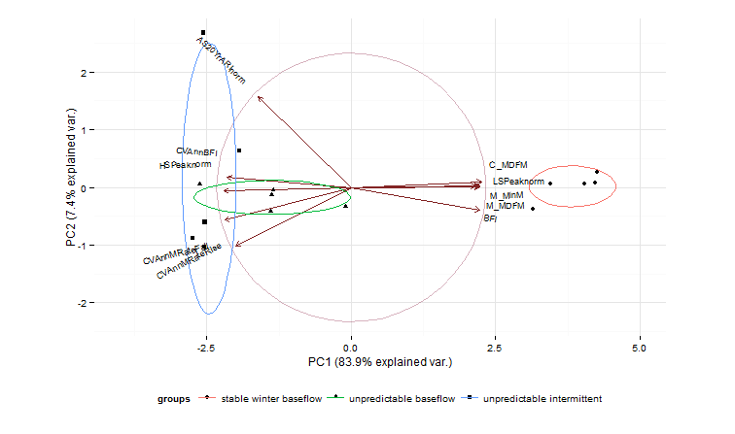

Figure 5. Biplot of sites ordinated across the first two principal components (PC) of the PCA. Points represent positions of individual sites. Ellipses indicate clustering of sites according to hydrological class. Arrows represent loadings of hydrological metrics across each PC.

Metrics that are maximised under conditions of weak seasonality and low variability in water availability sit at the positive end of the PC1 axis, while metrics that are maximised under conditions of high baseflow variability and high intensity flooding sit at the negative end. PC1 therefore represents a gradient of environmental harshness that integrates baseflow characteristics, seasonality and flooding intensity. Stable baseflow rivers exhibit lower site mean wood density, and are clustered at the ‘mild’ positive end of the PC1 gradient. Unpredictable baseflow and unpredictable intermittent rivers overlap across PC1 and are located distally towards the ‘harsh’ negative end, and are associated with higher site mean wood density. Here we see the pattern of differentiation in wood density between hydrological classes reiterated, and largely reduced to a single axis of variation.

Discussion:

While resolution between hydrologically similar classes of river was weak, these results lend credibility to broad-scale ecohydrological classification as a coarse but useful tool in riparian functional ecology. Where river systems belong to different hydrological classes but are spatially or climatically close, it makes sense to dig deeper than lumped categorical comparisons and compare continuous hydrological parameters.

We found that wood density increased with intensity of flooding disturbance. Wood density was not correlated with the frequency of high flow periods, which individually may not correspond to significant disturbance events, depending on the hydrological characteristics of the given river. Rather, it was the actual magnitude of flow during high flow periods that was important. The observation that variability but not average values of flood rise and fall rates predicted wood density, indicates the influence of low frequency, intensely flashy outlier flow events not captured by the mean. A pattern is apparent then, in which wood density in riparian communities is driven by powerful but relatively rare flow events. The abundance of high wood density strategies in these environments indicates that infrequent but high-stakes events are a greater force of selection in riparian plant communities than average conditions. We therefore suggest that a ‘brick house’ ecological strategy is selected for in riparian environments that experience intense flooding. This suggestion concurs with findings that trees tend to overcompensate for mechanical stress, with investment in defences increasing cumulatively in response to rare, extreme events (Cohen & Mangel 1999, Telewski 1995).

Predictability of water availability in the riparian zone was also strongly predictive of mean wood density. We can extend the observation about the influence of intense ‘pulse’ flow events on wood density: plants living in environments where flow occurs unpredictably and largely within specific events, rather than being evenly distributed throughout time, will experience more intense pulses of water stress.

High wood density may be symptomatic of wood anatomy strategies that allow plants to tolerate water stress (Hacke et al 2001, Jacobsen 2005, 2007a). Numerous studies have discussed the role of various anatomical components of woody tissue in stabilising xylem against cavitation when plants are under severe water stress, but the exact role that woody fibres play in stabilising xylem vessels appears to be inconsistent (Martinez-Cabrera 2009). Overall, resistance against cavitation appears to result from complex interactions between wood anatomical traits Lens 2010, Zieminska 2013) and/or aboveground biomass production traits (Cochard et al. 2007), both of which are tangentially related to wood density.

A more compelling rationale for our findings is that riparian woody plants are again overcompensating for the possibility of rare life-or-death stress events. In the absence of predictable cues about timing of watering flows, broad phenotypic plasticity in resource use traits may in fact be maladaptive in highly unpredictable environments (Valladares 2002, Valladares 2005), and conservative resource-use phenotypes such as high wood density would be favoured (Valladares et al. 2007). Traits associated with conservative resource use and better recovery following periods of extreme stress actually confer as much or greater fitness than traits associated with tolerating the event itself, such as thermotolerance (Gutschick & BassiriRad 2003).

Strategies in which species avoid harsh hydrological conditions by completing their lifecycles in between extreme events may also be successful. Pioneer species employing a fast relative growth rate, low wood density ecological strategy are benefitted by repeated setbacks to early successional conditions. Abundance weighted means may obfuscate the true pattern where differentiation in ecological strategy is strong, due to their inability to capture multimodality in trait distributions. In this case, higher abundance of these species would drive down mean wood density values through the upper ranges of disturbance intensity. This observation offers a potential explanation for the goodness of fit of quadratic models which begin to dip after reaching an apex at three quarters of their maximum value, rather than simply approaching an asymptote (e.g. Figs XYZ).

Another further for coping with harsh conditions is possible. Some species also have the ability to radically change their wood density throughout their life history. *Casuarina cunnhinghamiana*, for instance, is an obligate riparian species whose entire life history revolves around response to flooding disturbance. After seeding *en masse* onto fresh substrate, dense stands of flexible-stemmed saplings emerge, protecting each other from flood flows. Self-thinning subsequently occurs, and stem wood density increases in the maturing plant to help it withstand its environment. This strategy is likewise difficult to capture using abundance weighted means.

The gradient we identified by Principal Components Analysis integrates predictability of water availability, seasonality and flood intensity into a single axis of hydrological variation. It is not possible to tease out individual drivers of variation in wood density, however as they become more harsh, the sets of hydrological conditions associated with both environmental unpredictability and mechanical disturbance act in unison to constrain community wood density to higher mean values. Based on our findings, hydrological regionalisation frameworks that distinguish between rivers according to predictability and perenniality of flow provide a basis for predicting wood density.

Hydrological classification therefore becomes useful in projecting changes to the functional attributes of riparian plant communities under changing flow conditions.

In the south-eastern Australian context, changing flow conditions are caused by damming and water extraction, and the changing climate (Australian State of the Environment Committee 2011). Artificial flow modification by damming and water extraction reduces overall flow volume and the magnitude and frequency of high flow events, while increasing flow predictability and altering seasonality. The converse of this situation is presented by predictions of future climatic conditions: in Australia, warming of 0.4 – 0.7oC has occurred since 1950, attended by a reduction in rainfall across southern and eastern regions of the continent, and an increase in intensity of droughts. Increases in flooding and drought are predicted with high confidence over the next century (Hennessy *et al.* 2007). Overall, climate change projections highlight increasing climatic variability and unpredictability, and intensification of the ENSO phenomenon that is an integral driver of eastern Australia’s climate patterns (Hennessy 2008). If changes in spatial extent of climate zones can be related to changes in runoff - a complicated, but progressing area of research in hydroclimatology (Peel et al. 2011) – functional approaches to ecohydrology can give insight into the changing ecology of riparian plant communities.

Our study emphasises the importance of hydrological conditions – particularly disturbance and environmental unpredictability, as determinants of ecological strategy in riparian plants. This is likely to hold important ecological consequences for riparian plant communities in south-eastern Australia, where increasing climatic variability and frequency of extreme events are hallmarks of climate change predictions.