“Community assembly of riparian plants along hydrological gradients is mediated by wood density strategy”

“Wood density strategies of riparian plants are determined by hydrological gradients”

“Hydrological gradients determine community assembly of riparian plants by wood density”

Paper is ultimately a community assembly paper. It’s about functional traits, environmental gradients, community assembly, and drivers of habitat specialisation. The riparian system is chosen for its strong gradients of disturbance and resource (water) availability.

Wood density results outline

Are hydrological categories really different?

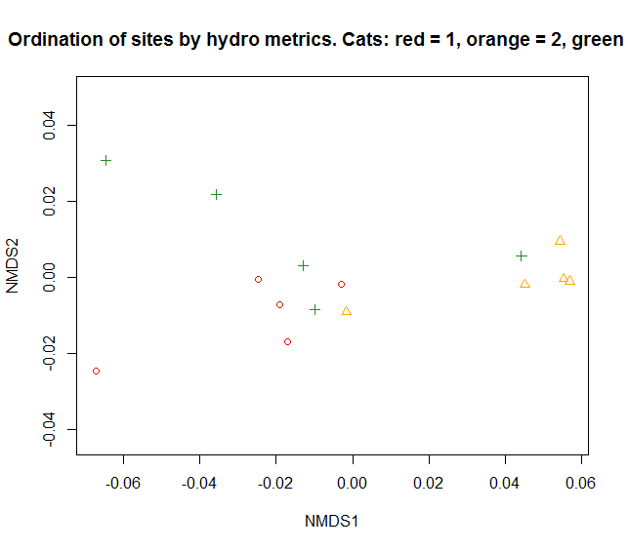  
Hmm things don’t look all that different…

Lets ask adonis() – permutational multivariate analysis of variance using distance matrices (vegan)

Call:

adonis(formula = hydro_cat12.bc.dist ~ cat12, data = cats)

Terms added sequentially (first to last)

Df SumsOfSqs MeanSqs F.Model R2 Pr(>F)

cat12 1 0.17563 0.175625 12.903 0.61728 0.005 **

Residuals 8 0.10889 0.013611 0.38272

Total 9 0.28451 1.00000

---

Signif. codes: 0 ‘***’ 0.001 ‘**’ 0.01 ‘*’ 0.05 ‘.’ 0.1 ‘ ’ 1

adonis(formula = hydro_cat13.bc.dist ~ cat13, data = cats)

Terms added sequentially (first to last)

Df SumsOfSqs MeanSqs F.Model R2 Pr(>F)

cat13 1 0.54436 0.54436 14.494 0.64435 0.011 *

Residuals 8 0.30046 0.03756 0.35565

Total 9 0.84481 1.00000

---

Signif. codes: 0 ‘***’ 0.001 ‘**’ 0.01 ‘*’ 0.05 ‘.’ 0.1 ‘ ’ 1

adonis(formula = hydro_cat23.bc.dist ~ cat23, data = cats)

Terms added sequentially (first to last)

Df SumsOfSqs MeanSqs F.Model R2 Pr(>F)

cat23 1 0.20088 0.200883 4.8864 0.37919 0.012 *

Residuals 8 0.32888 0.041111 0.62081

Total 9 0.52977 1.00000

---

Signif. codes: 0 ‘***’ 0.001 ‘**’ 0.01 ‘*’ 0.05 ‘.’ 0.1 ‘ ’ 1

Is wood density different across different hydrological classes of river?

* Raw vs. abundance weighted
* > TukeyHSD(aov(heart.avg ~ category, data = WD_hydronorm))
* Tukey multiple comparisons of means
* 95% family-wise confidence level
* Fit: aov(formula = heart.avg ~ category, data = WD_hydronorm)
* $category
* diff lwr upr p adj
* 2-1 0.068336018 -0.008966076 0.14563811 0.0935143
* 3-1 0.065316261 -0.003081666 0.13371419 0.0642400
* 3-2 -0.003019757 -0.075870896 0.06983138 0.9945576
* >
* > TukeyHSD(aov(CWM ~ Category, data = CWM_cats))
* Tukey multiple comparisons of means
* 95% family-wise confidence level
* Fit: aov(formula = CWM ~ Category, data = CWM_cats)
* $Category
* diff lwr upr p adj
* 2-1 0.090049480 0.0006167801 0.17948218 0.0484075
* 3-1 0.088549896 -0.0008828039 0.17798260 0.0523667
* 3-2 -0.001499584 -0.0909322839 0.08793312 0.9988974

YES, when abundance weighted plot mean are used.

Is wood density related to the frequency and magnitude of flood disturbance?

Reminding ourselves which hydro metrics we’re using to represent frequency and magnitude of flood disturbance…

|  |  |  |  |
| --- | --- | --- | --- |
|  | pval | adj.BH | R2 |
| CVAnnMRateRise.value | 0.00799 | 0.0279 | 0.430 |
| CVAnnMRateFall.value | 0.00941 | 0.0279 | 0.416 |
| HSPeaknorm.value | 0.0117 | 0.0279 | 0.398 |
| log10AS20YrARInorm.value | 0.0124 | 0.0279 | 0.393 |
| CVAnnHSPeak.value | 0.0751 | 0.13518 |  |
| CVAnnHSNum.value | 0.155 | 0.2325 |  |
| MRateRisenorm.value | 0.206 | 0.264857 |  |
| MRateFallnorm.value | 0.239 | 0.268875 |  |
| MDFAnnHSNum.value | 0.718 | 0.718 |  |

YES – related to flood intensity but not frequency (at least at 95pcile). Also related to variability in rise and fall rates.

What’s the best flood model for predicting WD?

> summary(CWM_flood.step)

Call:

lm(formula = CWM ~ CVAnnMRateRise, data = CWM_cats_hydronorm)

Residuals:

Min 1Q Median 3Q Max

-0.07682 -0.03547 -0.01949 0.03357 0.10931

Coefficients:

Estimate Std. Error t value Pr(>|t|)

(Intercept) 0.45980 0.04809 9.561 3.02e-07 ***

CVAnnMRateRise 0.16958 0.05420 3.129 0.00799 **

---

Signif. codes: 0 ‘***’ 0.001 ‘**’ 0.01 ‘*’ 0.05 ‘.’ 0.1 ‘ ’ 1

Residual standard error: 0.05144 on 13 degrees of freedom

Multiple R-squared: 0.4296, Adjusted R-squared: 0.3857

F-statistic: 9.79 on 1 and 13 DF, p-value: 0.007991

Is wood density related to riparian water availability?

|  |  |  |  |
| --- | --- | --- | --- |
|  | pval | adj.BH | R2 |
| CVAnnBFI.value | 0.0114 | 0.0323 | 0.400 |
| P_MDFM.value | 0.00447 | 0.0323 | 0.475 |
| C_MDFM.value | 0.00783 | 0.0323 | 0.431 |
| M_MDFM.value | 0.00675 | 0.0323 | 0.443 |
| M_MinM.value | 0.0043 | 0.0323 | 0.478 |
| LSPeaknorm.value | 0.0104 | 0.0323 | 0.408 |
| BFI.value | 0.0193 | 0.046871 | 0.354 |
| MA.7daysMinMeannorm.value | 0.0297 | 0.063113 |  |
| P_MinM.value | 0.0518 | 0.097844 |  |
| MDFAnnLSNum.value | 0.192 | 0.3264 |  |
| CVAnnLSPeak.value | 0.225 | 0.347727 |  |
| LSMeanDur.value | 0.426 | 0.557077 |  |
| CVAnnLSNum.value | 0.423 | 0.557077 |  |
| C_MinM.value | 0.53 | 0.643571 |  |
| MDFAnnUnder0.1.value | 0.584 | 0.661867 |  |
| MDFAnnZer.value | 0.635 | 0.674688 |  |
| CVAnnLSMeanDur.value | 0.844 | 0.844 |  |

YES – primarily to metrics of flow constancy and seasonality. LSPeaknorm is a mean magnitude metric. Frequency of low spells or duration don’t seem to be important whereas magnitude does.

What’s the best water stress model for predicting WD?

Call:

lm(formula = CWM ~ M_MinM, data = CWM_cats_hydronorm)

Residuals:

Min 1Q Median 3Q Max

-0.085182 -0.021897 -0.004024 0.022827 0.108628

Coefficients:

Estimate Std. Error t value Pr(>|t|)

(Intercept) 0.68198 0.02582 26.417 1.11e-12 ***

M_MinM -0.80511 0.23329 -3.451 0.0043 **

---

Signif. codes: 0 ‘***’ 0.001 ‘**’ 0.01 ‘*’ 0.05 ‘.’ 0.1 ‘ ’ 1

Residual standard error: 0.0492 on 13 degrees of freedom

Multiple R-squared: 0.4781, Adjusted R-squared: 0.438

F-statistic: 11.91 on 1 and 13 DF, p-value: 0.004299

Is it reasonable to assume that low betaT.range translates to species specialisation?

> cor.test(fieldnull_cv_hydro$betaT.range, fieldnull_cv_hydro$Rs.mean)

Pearson's product-moment correlation

data: fieldnull_cv_hydro$betaT.range and fieldnull_cv_hydro$Rs.mean

t = 3.6718, df = 13, p-value = 0.002818

alternative hypothesis: true correlation is not equal to 0

95 percent confidence interval:

0.3171793 0.8976708

sample estimates:

cor

0.7135114

YES – pretty reasonable at least, especially given the size of the dataset.

Is flooding disturbance associated with specialisation in wood density strategy?

|  |  |  |  |
| --- | --- | --- | --- |
|  | pval | pval.adj.BH | R2 |
| CVAnnMRateFall.value | 0.000552 | 0.002484 | 0.614 |
| HSPeaknorm.value | 0.000281 | 0.002484 | 0.650 |
| log10AS20YrARInorm.value | 0.00111 | 0.00333 | 0.572 |
| CVAnnMRateRise.value | 0.0276 | 0.0621 | 0.321 |
| CVAnnHSPeak.value | 0.0559 | 0.10062 |  |
| MRateRisenorm.value | 0.08 | 0.102857 |  |
| MRateFallnorm.value | 0.0795 | 0.102857 |  |
| MDFAnnHSNum.value | 0.51 | 0.57375 |  |
| CVAnnHSNum.value | 0.885 | 0.885 |  |

Using BH p-value adjustment, YES... – flood intensity and variability in fall rate. CVAnnMRateFall is pretty strongly correlated (0.9) to CVAnnMRateRise as well. Probably in a larger hydro dataset we’d see even higher correlation.

What about if we resample sites to generate null model and use that to check for significance (betaT.range has a highly non-normal distribution)?

|  |  |  |
| --- | --- | --- |
| floods | pval | Pval.adj.BH |
| HSPeaknorm | 0.000281 | 0.0024840 |
| CVAnnMRateFall | 0.000552 | 0.0024840 |
| log10AS20YrARInorm | 0.001106 | 0.0033180 |
| CVAnnMRateRise | 0.02759 | 0.0620775 |
| CVAnnHSPeak | 0.05588 | 0.1005840 |
| MRateFallnorm | 0.079542 | 0.1028250 |
| MRateRisenorm | 0.079975 | 0.1028250 |
| MDFAnnHSNum | 0.50969 | 0.5734012 |
| CVAnnHSNum | 0.884526 | 0.8845260 |

YES – so we also add CVAnnMRateRise, which makes sense.

What’s the best predictor model?

> summary(betaTrange_flood.step)

Call:

lm(formula = betaT.range ~ CVAnnMRateFall + log10AS20YrARInorm,

data = fieldnull_cv_hydro)

Residuals:

Min 1Q Median 3Q Max

-0.041926 -0.012809 -0.005166 0.012322 0.038486

Coefficients:

Estimate Std. Error t value Pr(>|t|)

(Intercept) 0.16045 0.02522 6.363 3.6e-05 ***

CVAnnMRateFall -0.05402 0.02781 -1.942 0.0759 .

log10AS20YrARInorm -0.02884 0.01930 -1.495 0.1608

---

Signif. codes: 0 ‘***’ 0.001 ‘**’ 0.01 ‘*’ 0.05 ‘.’ 0.1 ‘ ’ 1

Residual standard error: 0.02312 on 12 degrees of freedom

Multiple R-squared: 0.6742, Adjusted R-squared: 0.6199

F-statistic: 12.42 on 2 and 12 DF, p-value: 0.001195

Is unpredictability of water availability associated with specialisation in wood density strategy?

|  |  |  |  |
| --- | --- | --- | --- |
|  | pval | pval.adj.BH | R2 |
| MA.7daysMinMeannorm.value | 0.000104 | 0.001768 | 0.700 |
| BFI.value | 0.000273 | 0.002321 | 0.652 |
| M_MinM.value | 0.00058 | 0.002465 | 0.611 |
| LSPeaknorm.value | 0.000492 | 0.002465 | 0.620 |
| P_MDFM.value | 0.000788 | 0.002679 | 0.593 |
| CVAnnBFI.value | 0.00136 | 0.003303 | 0.559 |
| M_MDFM.value | 0.00122 | 0.003303 | 0.565 |
| C_MDFM.value | 0.00219 | 0.004654 | 0.527 |
| MDFAnnZer.value | 0.0693 | 0.1071 |  |
| MDFAnnUnder0.1.value | 0.0588 | 0.1071 |  |
| LSMeanDur.value | 0.0632 | 0.1071 |  |
| CVAnnLSMeanDur.value | 0.122 | 0.172833 |  |
| CVAnnLSPeak.value | 0.145 | 0.176071 |  |
| P_MinM.value | 0.142 | 0.176071 |  |
| MDFAnnLSNum.value | 0.429 | 0.4862 |  |
| CVAnnLSNum.value | 0.629 | 0.668313 |  |
| C_MinM.value | 0.948 | 0.948 |  |

YES – it’s all about variability in availability of water, as well as total magnitude of low spells

Checking with null model comparison…

|  |  |  |
| --- | --- | --- |
| waterstress | pval | pval.adj.BH |
| MA.7daysMinMeannorm | 0.000104 | 0.001768000 |
| BFI | 0.000273 | 0.002320500 |
| LSPeaknorm | 0.000492 | 0.002465000 |
| M_MinM | 0.00058 | 0.002465000 |
| P_MDFM | 0.000788 | 0.002679200 |
| M_MDFM | 0.001223 | 0.003300429 |
| CVAnnBFI | 0.001359 | 0.003300429 |
| C_MDFM | 0.002192 | 0.004658000 |
| MDFAnnUnder0.1 | 0.058777 | 0.107172636 |
| LSMeanDur | 0.063158 | 0.107172636 |
| MDFAnnZer | 0.069347 | 0.107172636 |
| CVAnnLSMeanDur | 0.122419 | 0.173426917 |
| P_MinM | 0.142304 | 0.176008286 |
| CVAnnLSPeak | 0.144948 | 0.176008286 |
| MDFAnnLSNum | 0.429459 | 0.486720200 |
| CVAnnLSNum | 0.628683 | 0.667975688 |
| C_MinM | 0.948256 | 0.948256000 |

Same vars. – even very similar p values!

What is the best predictor model?

Call:

lm(formula = betaT.range ~ MA.7daysMinMeannorm + P_MDFM + M_MDFM +

C_MDFM, data = fieldnull_cv_hydro)

Residuals:

Min 1Q Median 3Q Max

-0.024672 -0.011314 0.000197 0.010327 0.032982

Coefficients:

Estimate Std. Error t value Pr(>|t|)

(Intercept) 0.01188 0.01705 0.697 0.5016

MA.7daysMinMeannorm 0.49663 0.21214 2.341 0.0413 *

P_MDFM 18.97420 10.72143 1.770 0.1072

M_MDFM -18.76018 10.71115 -1.751 0.1104

C_MDFM -19.14341 10.67206 -1.794 0.1031

---

Signif. codes: 0 ‘***’ 0.001 ‘**’ 0.01 ‘*’ 0.05 ‘.’ 0.1 ‘ ’ 1

Residual standard error: 0.01932 on 10 degrees of freedom

Multiple R-squared: 0.8104, Adjusted R-squared: 0.7346

F-statistic: 10.69 on 4 and 10 DF, p-value: 0.001237

How correlated are the winning hydro parameters?

* Very fucking correlated. PCA gives essentially one axis.

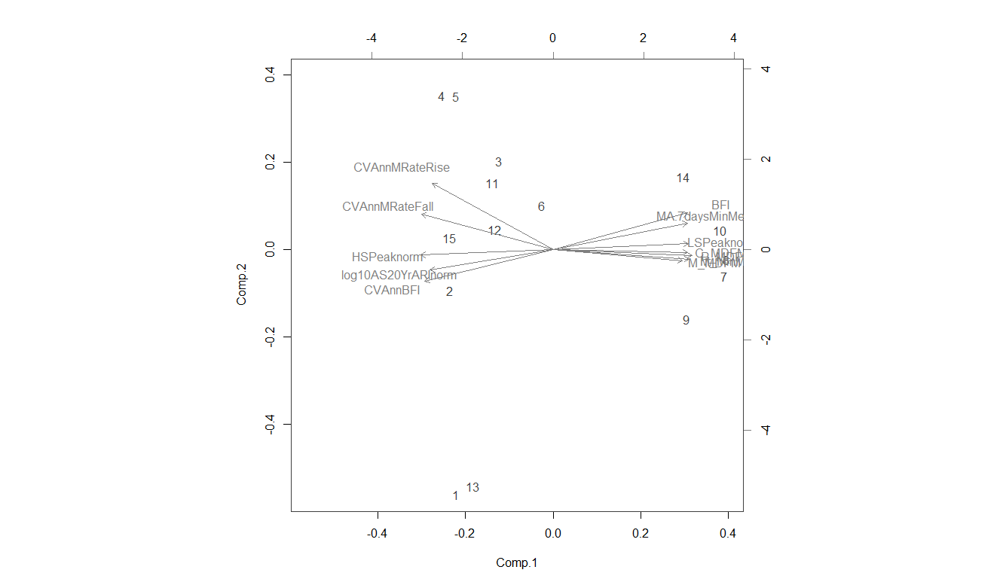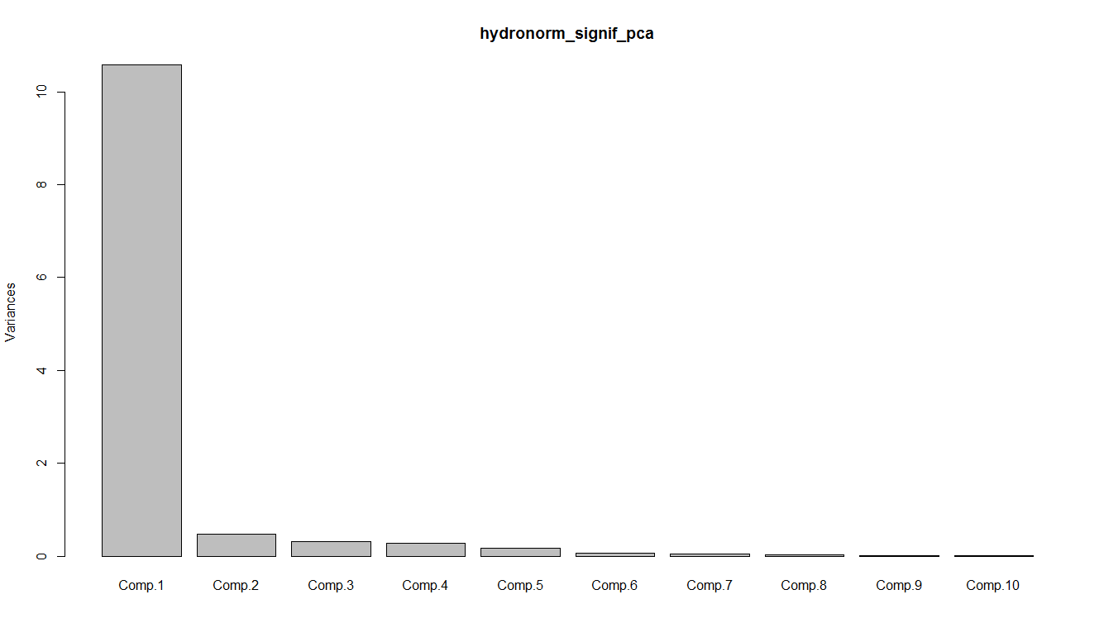

What to do about patchy sampling?

If you look at BFI, for example, species at low BFI sites are most commonly found at only one site. Sportsman’s Creek is a bummer example where all species are found only at that site. If we look, we find that Nplots is actually significantly correlated with BFI. The R2 is pretty low, however – 0.082. So the effect of sampling patchiness is real, but the signal is strong enough to get through it. Because this effect mainly matters when looking at betaT.disp, we can ask how the null model might help as well. Species trait values and their corresponding abundances are randomly resampled by plot. So in a given iteration, a plot may be assigned species from any other plot. “This approach maintains the distribution of plot diversity, *the number of occurrences per species*, and the intraspecific distribution of both abundance and trait values within species” – ergo, the null model can’t help us.

*N.B.* these correlations are only significant for some parameters.

A final issue exists with this approach in that if sampling is patchy, species with the same real niche ranges may be assigned different betaT values. As the ratio of Rs to the number of sites used to calculate betaT increases, so too does the potential error associated with betaT. Therefore for species found at more than one site, this ratio Rs/Nplots can be used as a99 metric of error. We can plot site mean Rs/Nplots ratios against an environmental variable for kicks. The model shouldn’t be significant. Sites such as Sportsmans Creek which have a completely unique assemblage with in the datasets, giving both Rs and Nplots of zero for all species, are essentially a statistical bummer. The fact that this site sits neatly within observed trends gives the value some credence at least.

Not all field data comes from big budget programmes with saturating sampling intensity, and we shouldn’t let patchiness in ecological sampling deter us too much. We simply need to be clear on what our tests are able to say about the data we have available.

What were the species?