RESULTS

Summary statistics for all combinations of treatments are shown for all measurements in Table 1.

Table 1.



*Gas exchange and water use efficiency*

Effects of CO2 level and waterlogging on gas exchange were species specific, and some interaction effects were significant, but we found no evidence that interactive effects were maintained following recovery from waterlogging.

Elevated CO2 significantly increased leaf-level photosynthesis for all three species (*A. floribunda*, p = 0.074, Fig. 1a; *C cunninghamiana*, p = 0.002, Fig. 1b). Photosynthetic rate in *E. camaldulensis* was significantly greater in recovery treatment plants than control plants (p = 0.008, Fig. 1c). No significant interactions were found between CO2 level and waterlogging status for photosynthetic rate, although waterlogged *A. floribunda* exhibit a only small difference in mean photosynthetic rate between CO2 treatments (20.9 and 22.6 umol blah, respectively, Fig. 1a).

Neither CO2 level nor waterlogging status significantly influenced stomatal conductance of A. floribunda or C. cunninghamiana, alone or interactively. Recovering E. camaldulensis plants had higher rates of stomatal conductance than waterlogged plants (p = 0.059) and control plants (0.0002); waterlogged plants higher stomatal conductance than control plants (0.042); no CO2 effect was found for E. camaldulensis.

A significant interaction effect was identified for transpiration rate of A. floribunda (p = 0.075, Fig. 1d); no differences were significant upon post-hoc analysis, however. Elevated CO2 significantly increased transpiration rate in C. cunninghamiana (p = 0.009, Fig. 1e), but not E. camaldulensis (Fig. 1f). eCO2 stimulation of transpiration in waterlogged C. cunninghamiana also appears diminished, despite non-significance of the interaction term (Fig. 1e). Control E. camaldulensis plants transpired less than waterlogged plants (p = 0.019) and recovery plants (p = 0.0005).

Water use efficiency in A. floribunda was higher in control than waterlogged (p = 0.002), and higher in control than recovery (p = 0.04), but not waterlogged and recovery plants (Fig. 1g). WUE increased under elevated CO2 as a main effect for E. camaldulensis (p = 0.002, Fig. 1h), and interactively with CO2 level for C. cunninghamiana (p = 0.063); WUE was higher under eCO2 for waterlogged plants (p = 0.022, Fig. 1i) but not control or recovery plants.

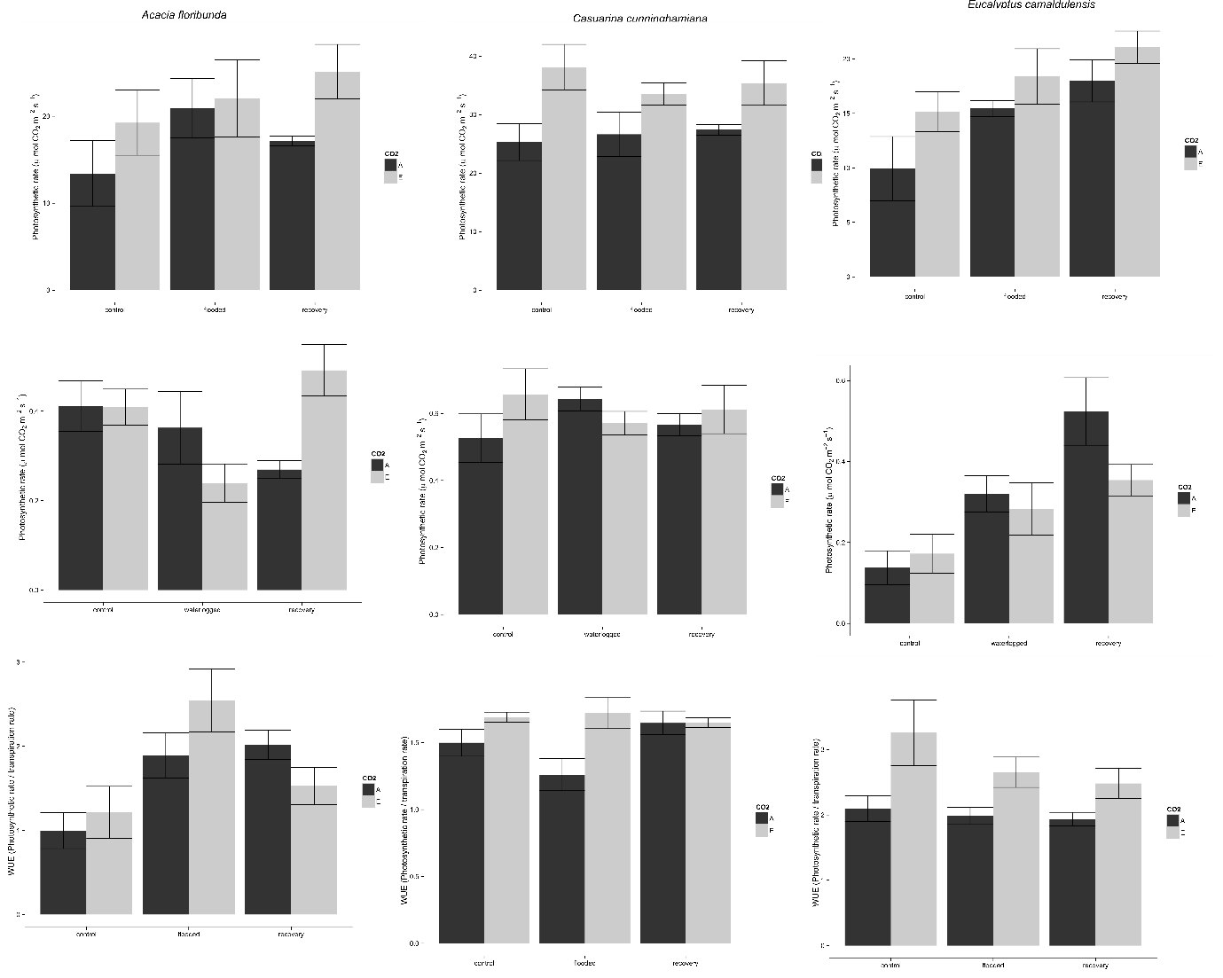

Figure 1

*Biomass production*

Waterlogging status and CO2 level interacted strongly for one species: eCO2 stimulation of biomass production in C. cunninghamiana was diminished following recovery from waterlogging.

Total root biomass of plants recovering from waterlogging was lower than control plants for A. floribunda (p = 0.028, Fig. 2a). A significant interaction effect was identified for C. cunninghamiana (p = 0.049): total root biomass was substantially increased under eCO2 for control (p = 0.011) but not recovery plants (Fig. 2b). Neither CO2 level nor waterlogging had an effect on E. camaldulensis total root biomass (Fig. 2c).

Fine root biomass was lower in recovery plants than control plants (p = 0.005), with no CO2 effect (Fig. 2d). A marginally significant interaction effect was also present for C. cunninghamiana fine root biomass (p = 0.076); post-hoc analysis confirmed that control but not recovery plants had significantly higher fine root biomass under eCO2 (p = 0.008) (Fig. 2e). Waterlogging stimulated fine root growth in E. camaldulensis (p = 0.046), but CO2 level had no effect (Fig. 2f).

Neither CO2 level nor waterlogging had any effect on shoot biomass for A. floribunda (Fig. 2g) or E. camaldulensis (Fig. 2i). As with total root biomass and fine root biomass, CO2 level and waterlogging influenced C. cunninghamiana biomass interactively (p = 0.009): shoot biomass was higher under eCO2 for control (p = 0.015) but not recovery plants (Fig. 2h).

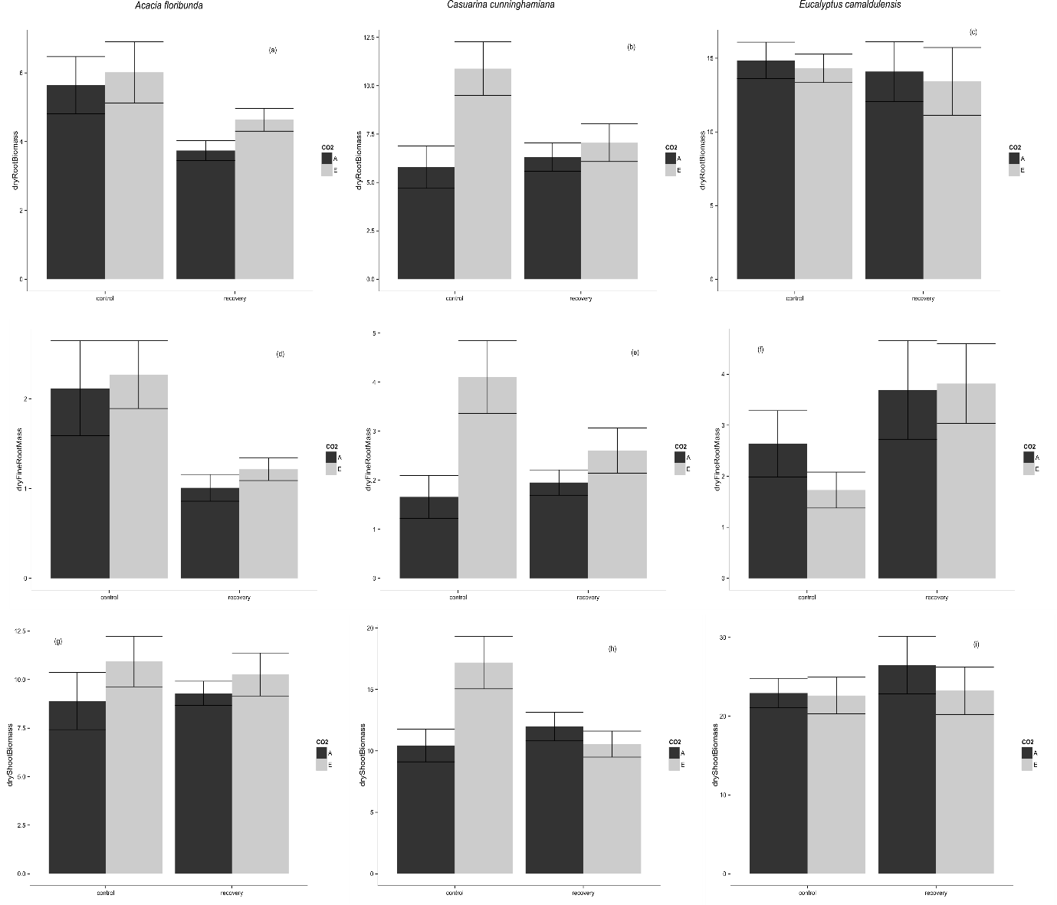

Figure 2

*Functional traits & biomass allocation*

We found no evidence to suggest that CO2 mediates biomass allocation or functional traits in response to waterlogging status.

Fine root DMC was higher in waterlogged A. floribunda than recovery plants (p = 0.027), but not different between control and recovery or control and waterlogged plants. A marginally significant interaction effect was also present for A. floribunda (p = 0.067), but no differences were significant upon post-hoc analysis. Waterlogging status also affected E. camaldulensis fine root DMC (Fig. 3b): control plants had higher fine root DMC than waterlogged plants (p = 0.018), and recovery plants (p = 0.053) (marginally significant). eCO2 was associated with significantly increased fine root DMC in C. cunninghamiana (p = 0.013, Fig. 3c), but waterlogging status had no effect.

Waterlogged A. floribunda had lower SLA than control (p = 0.001), and recovery plants (p = 0.00008) (Fig. 3 d). Waterlogged E. camaldulensis had higher SLA than control (p = 0.0013) and recovery plants (p = 0.0006) (Fig. 3f). Waterlogging status had no effect on C. cunninghamiana SLA (Fig. 3e). CO2 level had no effect on the SLA of any species.

Stem density in C. cunninghamiana was increased under elevated CO2 (p = 0.0177) (Fig. 3h). Stem density was lower in waterlogged C. cunninghamiana than control (p = 0.0167) or recovery plants (0.050) Neither CO2 nor waterlogging status had any effect on stem density of A. floribunda (Fig. 3g) or E. camaldulensis (3i).

Root mass fraction was decreased by waterlogging for all species, but no significant CO2 or interaction effects were found. RMF of A. floribunda was lower in waterlogged than control plants (0.00000), and lower in waterlogged than recovery plants (0.00003). RMF of A. floribunda recovery plants was also lower than control plants (0.016). RMF of C. cunninghamiana was lower in waterlogged than control plants (0.00003), and lower in waterlogged than recovery plants (0.00004), but there was no difference between recovery and control plants. RMF of E. camaldulensis was lower in waterlogged than control plants (0.0000002), and lower in waterlogged than recovery plants (0.0000374), but there was no difference between recovery and control plants.

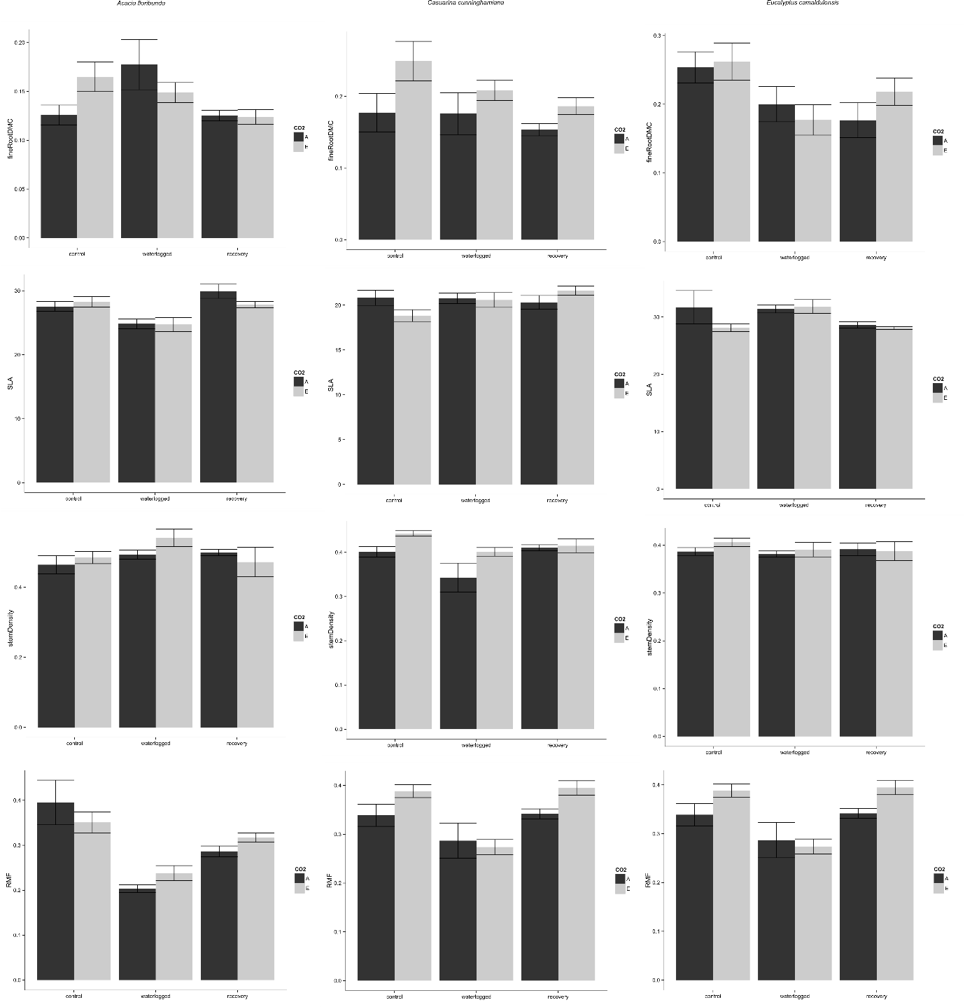

Figure 3