

**Dissertation**

Multi-User Interactive Delay-Tolerant Network

*Rekop Poker*

**I hereby declare that this dissertation is all my own work, except as indicated in the text**

**Signature:** J. W. Scully

**Date:** 21/4/20

James Scully (14304469)

[psyjs20@nottingham.ac.uk](mailto:psyjs20@nottingham.ac.uk)

G400 Computer Science

Contents

Introduction 3

Motivation 3

Methodology 4

Test-Driven Development (TDD) 4

Agile 4

Design 5

Overview 5

Backend 5

Networking 6

Introduction 6

Server 6

Client 7

Communication / Diagram 7

User Interface 8

Algorithms 9

Implementation 10

Project Requirements 10

Backend 10

Server 10

Application 10

Client 10

Server 11

Overview 11

Development 12

Data Classes 13

Overview 13

Face / Suit 13

Build System 14

Evaluation 16

Unit Testing 16

Testing Over a Network 17

Summary and Reflections 17

Management 17

Contributions and Reflections 18

Build System 18

Data Classes 18

Conclusion 18

References 19

# Introduction

Poker is a type of card game that is played and watched in tournaments by many around the world. Because of its wide popularity, it has spawned multiple types, the most popular one being Texas Hold'em, which is the main type used in both research (Gilpin & Sandholm, 2006) and is the main variant used in the World Series of Poker (World Series of Poker, 2019). Other types include the similar yet lesser-known Omaha Hold’em and Five-card draw; a simpler type of poker, which does not utilize the typical table seen in both hold'ems.

*Dumb down the the web-brwoser etc, so users can understand*

A common problem encountered with most networks is that the client or user of a service can have a weak or 'spotty' internet connection, whereby they may lose connectivity occasionally or in certain bursts. This is especially prevalent with mobile connections, where rural or otherwise distanced areas can have trouble holding a steady connection. In these cases, it is vital that both the client is able to use the network or join as normal and that the server does not grind to a halt waiting on this person or break due to it, known as a delay-tolerant network (DTN) **(refs)**.

Delay-tolerant networks **refs** have been especially important in the modern world since the advent of mobile devices and their surge in popularity. This is since they do not have a regular stable internet connection like most desktop computers do and have the problem of losing signal due to physical movement or placement of the device. If a network cannot handle delay or dropouts from a mobile client gracefully this can have devastating impacts on data integrity or the overall function of the service.

**Diagram showing users playing poker over intermittent networks ?**

Though the term mobile devices can insinuate **??** the idea of mobile phones, mobile devices can range from not only a handheld device but to vehicles, robotics, aeroplanes, and satellites (Goth, 2006). Whilst data integrity to a mobile phone may not be incredibly important, data integrity is certainly important to an aeroplane or satellite, where a small error or wrong instruction can result in major failure.

The service must be able to realise that a device is either experiencing delay/dropouts and must respond accordingly, either **by aiming to keep future data consistent with the previously sent data, or by accounting for the delay – explain more and give diagrams**.

# Motivation

Rekop poker aims to provide an open-sourced framework for the popular variant of poker, Texas Hold'em. Many existing games of poker often include microtransactions **?? explain/give example** and no ability to customize the game mode, host their own servers or modify the source code to implement other game modes or wanted features. Moreover, the game of poker can be used as a great vessel - especially considering mobile networks - to learn more about delay-tolerant networks, as this is becoming the most important feature of any given service on the internet as mobile devices rise in popularity **ref**.

# Methodology

## Test-Driven Development (TDD)

Test-Driven Development (TDD) drove the development of the poker evaluation algorithm because we can easily check what the highest suit of a hand is manually, such as if it is a straight or a flush. When developing these small functions, we could easily write test cases ahead of actual programming and then run them with each change. This had the added benefit of being able to easily write edge cases for each function to make sure that it was rigorous, and we were not experiencing "bias" or writing tests to fit the current code when testing.

For example, the isStraight function at one point had a small case where a straight only needed 4 cards to be ascending/descending.

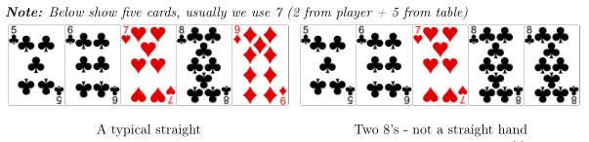

Had we not taken a test-heavy approach, given that a straight itself is quite uncommon (Ramsey & Hawaii, 2005), at around 0.392465% this could have been undetected for quite some time.

However, a benefit of this that was only realised afterwards was that writing unit-testable code made the actual codebase much more modular. This has led to the actual evaluator in turn becoming much higher quality code, as there is much less overlap between each function when determining the outcome of a hand. Appendix 8.8 shows this, as we can see that we only have functions to call rather than intertwining them.

## Agile

Agile is a relatively new methodology that can be described as very iterative, with a low design overhead. Its principles hold a focus on the self-sustenance of developers, rapid and continuous delivery of working software and continuous communication between each team member, as declared by its manifesto (Beck, et al., 2001).It has been reported that the more the methodology is applied to a project, the more likely a project is to be considered successful. (Serrador & Pinto, 2015)

Whilst this was a one-man project, the principles and ideas behind the Agile methodology have not been forgotten. This is primarily because of how well the rapid development cycle coincides with TDD; we were able to get instantaneous feedback and improve upon it. This especially occurred in the backend of the project, whereby we could push better quality code and constantly improve with a concrete set of tests.

We were accepting to new requirements as it was realised that the initial idea of a grandiose mobile application may be a bit too much to handle within the given timeframe; we instead decided to move towards developing the core idea of the project: exploring creating a delay tolerant network.

When it came to developing the server and client connection, we realised that making an incredibly detailed design on a concept that was not particularly familiar with the author would more than likely end up in time wasted. Therefore, we decided to iteratively work on getting certain milestones completed: basic connection, starting with small ping messages. Next, we would work on implementing sending a single card between the client/server, then we would work on getting a hand of cards over.

# Design

## Overview

The project itself is broken down into two components, the back-end, which is the processing of poker hands and the representation of poker data classes, and the other component being the server, which is responsible for handling incoming connections and disconnections gracefully.

*We designed the server to handle it this way*

In order to handle re-connections and disconnections gracefully, **it was decided to make the server handle most of the work, only sending small chunks to the clients.** Appendix 8.6 shows this, with the client only receiving prompts to give their actions to the server and receiving data on what is currently on the table / the outcome of the match.

The previously mentioned chunks are easily sent over the network as they are enumerated, meaning that they can easily be recreated on the client side with less code needed, and in the case of a delay, there is only one 'packet' to receive or send back. This was inspired by similar approaches to synchronizing clients in video games such as the original DOOM (id Software, 1997), albeit not continuous incremental changes; this means anyone joining back would be able to see all updates, not just new ones.

## Backend

The backend - that is, the Texas Hold'em evaluator and other objects - is written solely in Java as the language itself is platform agnostic, which allows for the server to run on Linux, Windows and Mac, as per the requirements defined in the initial vision and scope document. This makes the client and server portable as the running platform needs only a Java 8 compatible virtual machine**. (was anything else other than java considered** )

*Why did we choose Java?*

It has been broken down in such a way that it is modular, by having the basics common to all other types of poker involved, such as cards, ranks, values and suits, as well as a 52-card deck with the ability to pull a guaranteed random, unique card regardless of where the code is executed (via a singleton pattern). **Explain more**

***Show in more detail – show file structure to highlight***

The backend was the most tedious to design, as it was very difficult to use traditional methods such as pseudocode for evaluation algorithms. However, as we will discuss later on, unit testing drove the development through trial and error via set tests.

## Networking

### Introduction

The networking is based upon client-server architecture using a Thread-pool written in Java. Initially, we wished to use a Peer-to-Peer / UPnP approach, however delay/disconnection-tolerance, whilst possible, can become difficult to implement; given that all clients would have to be constantly synchronized on the state of the host, then delegate a host if the original was to disconnect. %(?)

In this case, delay tolerance means that a player who disconnects from the poker match will be able to reconnect at the end of the game. A new, unique player will not take their slot however, and we decided to allow the game to continue as normal, because otherwise the match could be on hold indefinitely waiting for the player to reconnect.

*The server async -*

### Server

For the server, we needed a way for each connection to exist independent of each other, meaning that if one were to disconnect, the others would not experience issues because of it **(asynchronous)**. There were multiple options that we could have taken to design the server, including a single-threaded approach, a thread pool, and a multi-process approach. **(diagram)**

To clarify, a thread is a single line of execution - that is, a sequence of instructions separate to others - that is processed on a CPU at one time. As noted by Kleiman, the rise of client-server programming and multiple processors on a CPU drove the use of threads (Kleiman, Shah, & Smaalders, 1996). A process is essentially a separate program entity, meaning that instead of the program creating a separate line of execution for a client, it would ask the operating system to create and run a new process to handle the client. This also means that it would need to create new memory for this new client, thus a new addressing space and the inability to use variables seamlessly between processes.

With networking, it is typical that each connection is given its own thread. This is because networking code involves the retrieving and sending of data, the former blocks execution of code because generally instructions ahead rely on the said data. This means that a single-threaded approach, while would work, would not adequately show delay tolerance as we would only have one client; the purpose is to show that this network can cope with dropouts.

In regard to the multi-process approach, it would become cumbersome to create a new process for each connection that comes in. This is because synchronizing processes is a much more difficult task than synchronizing between threads - a process contains threads rather than vice versa. This would mean that we would need some external file or 'management' system that each process can read from.

% show process -> thread

This is how we arrived at a thread-pool approach, where we had a process containing a main thread, which accepts connections and pushes them into a worker pool. In initial tests, we found it very difficult to not implement a thread pool, as it was realised without it there would be difficulty in achieving delay-tolerance; single threaded approaches or ones which executed each thread were prone to breaking if connection was lost. **diagram**

### Client

The client is written in Java for compatibility with the server counterpart, as they will transfer Java objects. However, it was designed such that it is not a mobile application itself but rather an interface for the application to use. This was because during development, it made unit testing the client much easier as it was running locally on the machine. Beyond this, the author's home network was restricted, meaning that running the client and server on the same machine meant they could connect, and multiple instances of the client could be run.

The clients on their first launch create an identity file that is unique to them, through the generation of a random number **ref**. This identity file is used when connecting to the server as a way of determining if the player has joined before and gives the opportunity to block or prevent certain players from joining. However, it primarily is used to allow players who have had a dropout and may have disconnected from the game to join back. In any case, certain identification of a connecting client can be used in many ways, verification, management of users, etc.

### Communication / Diagram

In order to achieve a delay-tolerant network, the architecture of communication is a major factor in it being successful. For example, when a player is to disconnect there is a mechanism of “caching” or storing updates to send when a player reconnects. In our case, the data between initial disconnection and reconnection is not of importance**, so we are able to send the current state of the game. Whilst some DTNs such as satellite communication do not work well with it (Durst, Feighery, & Scott, 1999), Transmission Control Protocol (TCP) should be used as this guarantees that the recipient will receive the data –not clear?.**

**Phys layer – to TCP -**

In order to communicate with each client effectively, we needed to abstract the way that we handle connections. As previously mentioned, the architecture is important as an unexpected disconnection can cause a wide range of errors depending on the state of the current program. %(?)

This became evident during development when we kept object I/O streams within the TPokerThread class. Accessing these streams generated undefined behaviour when the player had lost connection. Whilst we have a thread pool to keep connections alive, we needed a method of flagging that a user has folded but not disconnected or vice versa, and a way to communicate certain procedures to them. In this case, an aptly named class *Player* was created.

The Player class is handled and only used by the server, as it is the counterpart to the TPokerClient, which runs on a separate computer or device. It provides the server with necessary information such as where to write objects to or read them from, the ID of the player in order of creation and the players identity file, which acts as an authorization key, and the TPokerThread that it represents in the thread-pool.

**Show diagram and layers to improve clarity**

## 

## User Interface

The most critical part and the binding element of this project is the actual mobile application itself. The user interface is to be kept simple, with the main menu being a simple strip of buttons that can be added to for extra game modes or features. There is a navigation bar that will allow the user to switch between playing, statistics, profile and to exit.

The interface is required to be simple, as this allows for intuitive and good user experience with the application **refs or user trials?**.

*Talk about console – user trials*

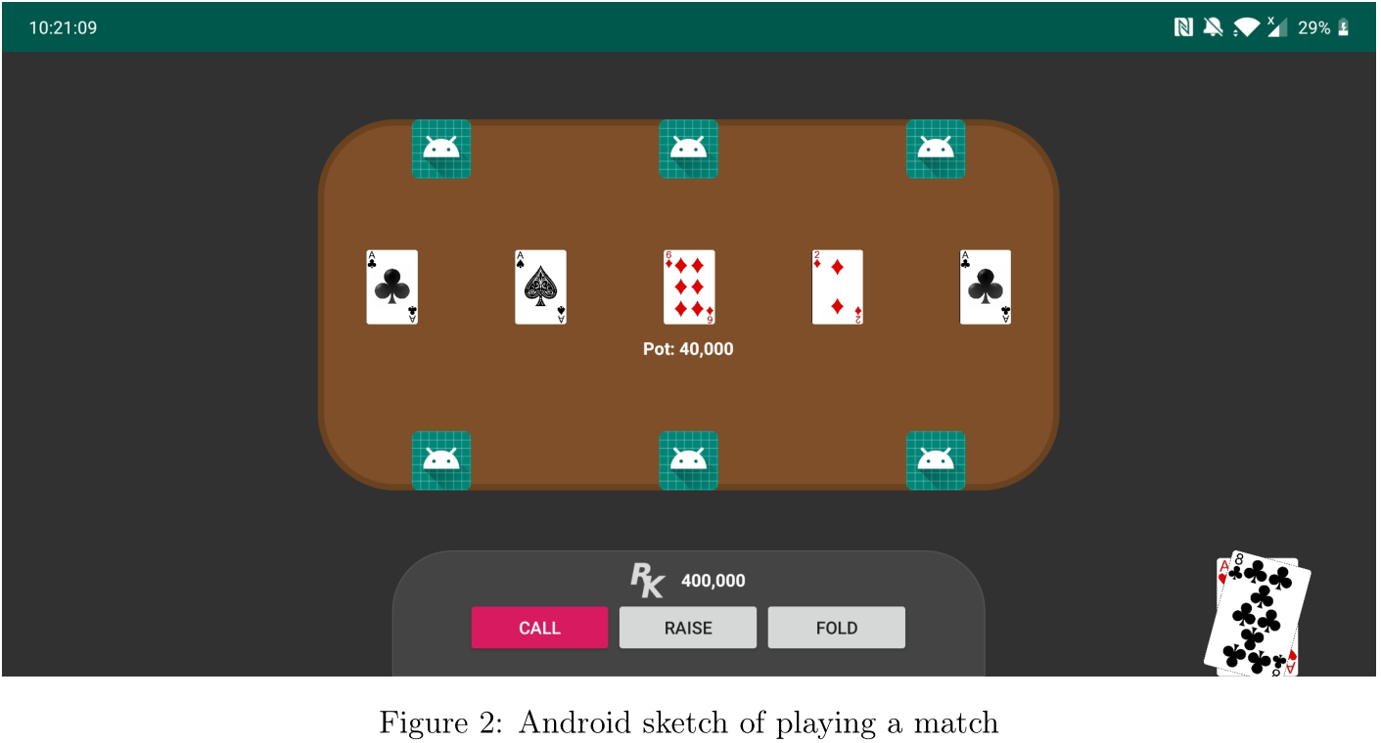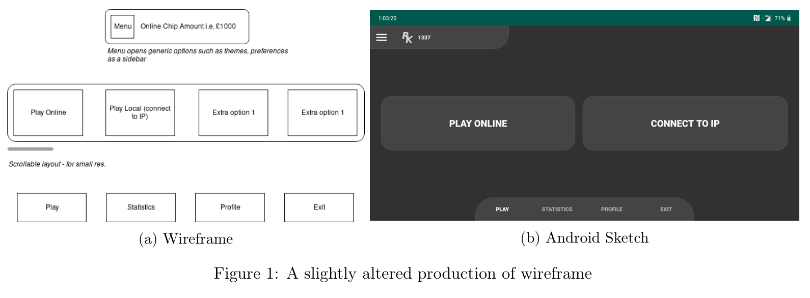The following figure shows how we have changed our initial wireframe slightly. As we have implemented it into Android, we have attempted to make it appeal to certain conventions, such as using the Hamburger icon for the menu and moving it to the side of the screen.

## Algorithms

Evaluating a hand's strength is rather difficult and can be approached many ways. In our case, we opted to use a more human readable format by writing many helper functions that delegate certain checks for each type of hand, i.e. isStraight, isRoyalFlush, etc. This has the benefit of being readable and somewhat more unit testable; the only problem is that the speed of the algorithm can be quite slow, compared to other methods such as lookup tables have existed for some time. (Teófilo, Reis, & Cardoso, 2013)**(good)**

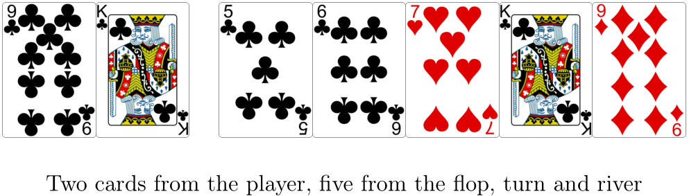Whilst we knew using a computational approach like this would be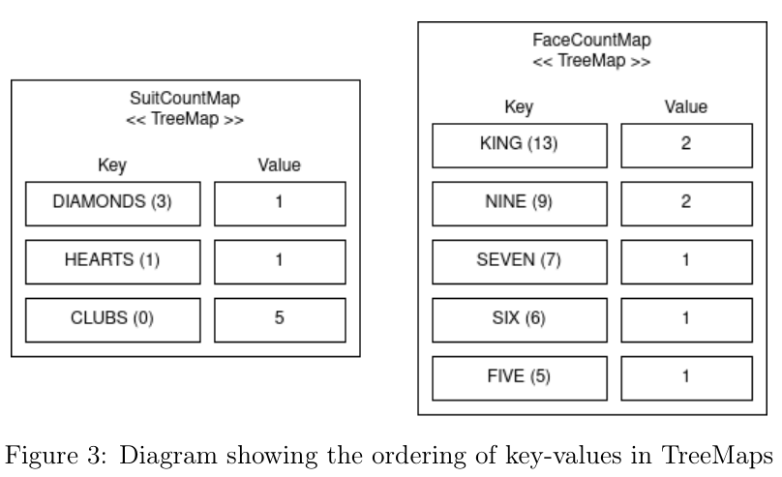 slower, we attempted to bring down the speed of the algorithm by processing commonly accessed attributes ahead of time.

From this array of unordered cards, we can use a TreeMap to store their faces (values) and suits which:

* Does not accept duplicate entries
* Orders its entries by key automatically
* Provides an easy method of counting its entries

This means that our cards are already sorted from most powerful to lowest in terms of value as they are entered into the TreeMap. This means we can easily check if a flush exists by accessing the first value of the map - which will be accessed in a time of O(1) - and checking if it has a value of 5 or more. Similarly, if we need to check if any three/four-of-a-kind or pairs exists, we can iterate through the map and we will have the most powerful hand if one exists.

*Show psuedocode*

# Implementation

## Project Requirements

Our requirements for the project were not particularly specific, however some core ones were defined in our vision and scope, as well as project proposal.

### Backend

**Functional**

* Written in Java / Kotlin
* Able to generate a result (e.g. 3 of a kind) from the players hand and table
* Abstracts elements of card-based games (i.e. hands, cards, faces, suits)

**Non-Functional**

* Unit-testable
* Small, portable

### Server

**Functional**

* Runs on Linux and Windows
* Handles the evaluation of games internally
* Utilizes TCP/IP

**Non-functional**

* Open-sourced
* Available for free download (source code and application)

### Application

**Functional**

* Ability to run on any JVM-compatible device
* Allows for connecting to servers via IP addresses

**Non-functional**

* Presents a simple, uncluttered interface for connecting/joining games
* Presents a simple game screen, with not too much clutter for games statistics
* Presents the users current chips for online matches
* Presents the users current chips within the game
* Presents a server browser for online matches

## Client

During development, we had to make multiple changes to the initial design of the client. Initially, we planned to make it solely an Android application, as this would provide a good opportunity to showcase dropouts. However, developing it as only an Android application made testing much more difficult. It was for this reason we opted to make it a terminal-based application that could be hooked into an application later.

Because we made this choice, the ability to instantly get a client/server connection running on the development machine was trivial, as a modern computer is able to do this very quickly compared to having to compile an Android application and run it either on an emulator or even slower on a physical device, let alone having to develop a build system to compile both the server and an Android application.

Furthermore, **we realised that** the client would need some form of identification, because we didn't want players whom hadn't been in the game to join back; this would annoy users of the system if they were to experience a dropout and could not join. Therefore, we opted to make a file that exists locally to identify the user and is created upon first launching the program.

**We arrived at this choice because the other approaches were not the most reliable or optimal def/ref?**. For example, we could have used the IP address of the user to identify them but using an IP address is extremely unreliable as they are very susceptible to change - especially after a dropout from the client’s internet provider. We could have also used a media-access control (MAC) address to identify them - which is tied to the devices network interface card (NIC) - but this is quite difficult to retrieve from a Java perspective, some devices may or may not return one reliably.

Therefore, we decided that **the most reliable option would be to use an approach that can be used on any device - be it a web browser, a mobile device or a desktop, and that would be using a file to identify the user ?**. While many devices may not support some network functions, it is almost **guaranteed** that a file can be created and read anywhere Java is used.

## Server

### Overview

As the target of delay tolerance implies, the server was a crucial part of the project. It also however took a lot of effort to coordinate with the client, as any changes made to the client would need to be synchronized with the server, and so development of both had to be done somewhat in parallel.

We had multiple challenges to overcome when developing the server, including: **(good)**

* Allowing multiple clients to connect
* Gracefully deal with disconnections
* Allow only those who have previously lost connection
* Find a suitable method for hosting the server

### Development

The server is written in Java as this means we can use compatible, standard Java networking libraries to communicate with the client counterpart. Furthermore, this makes it simple to port to new platforms to host on, particularly any operating system with a Java Virtual Machine.

This platform interoperability particularly came in useful when we needed to test external devices being able to connect and thus the delay tolerance of the network, as local hosted servers are typically hard to simulate delay or dropouts. We ran into the problem of restrictive network policies at student accommodation not allowing us to host the server so that we could attempt to connect from the internet, and as such we had to find another place to host the server to test delay and unexpected dropouts.

As we were able to simply compile the server and its dependencies into a JAR file, we decided to host an Amazon Web Services (AWS) EC2 instance - a small, Amazon-hosted Linux server - to test connections that originated over the internet. From here, we could simply push the file onto the server, configure the firewall to open a specified port, and test.

The server itself uses a thread pool to keep connections to clients alive, whereby each connection has its own thread and thus sequence of execution as previously discussed. A thread pool simply provides a way for each thread to get its time to execute (Oracle).

Furthermore, an array exists containing Player objects, which not only act as a "wrapper" for each of the connection threads but also provide connectivity data, such as if the player has unexpectedly disconnected or intentionally quit, as well as game data such as how many chips they have and what action they last took.

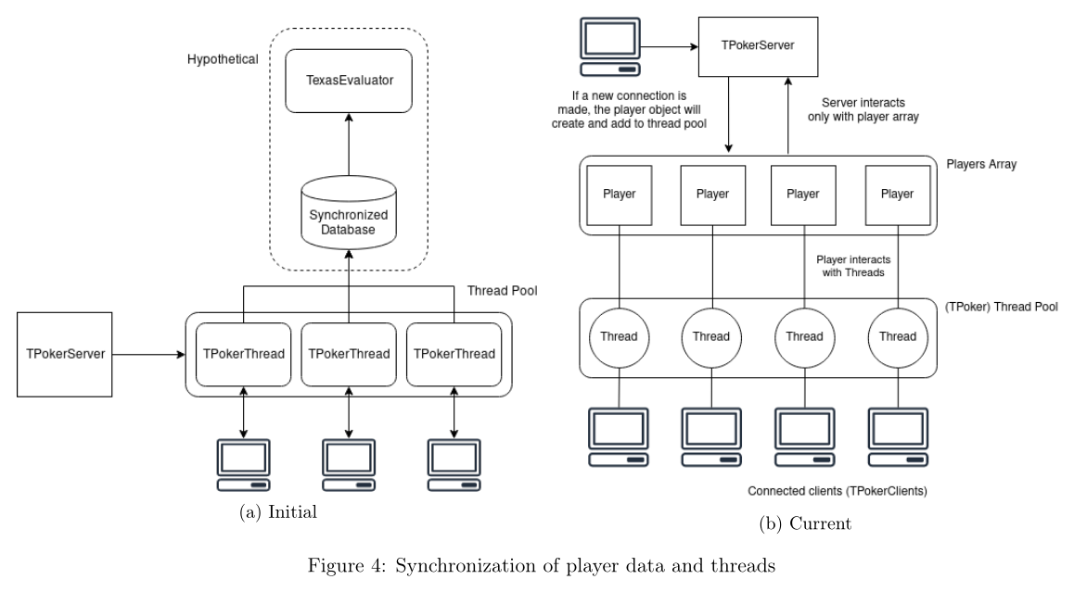

If we had proceeded with the initial synchronization method seen in Fig. 3(a) data integrity would also be kept, but there would still be the problem of sending messages to each thread/connection and communicating with them. Instead, the player class acts as an abstraction layer between the server and the client programs.

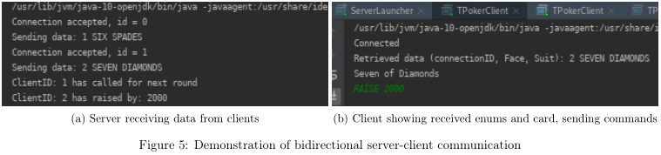

## Data Classes

### Overview

The data classes used in the project include cards comprised of faces and values, ranks including different outcomes of hands and more. When considering how we were going to design them, we needed to look at how they would be sent between the client and server, including using a object representation format such as JSON, XML or a built-in method.

We decided on using the built-in Serializable interface and the Object(Input/Output)Streams, as this did not require the need to built a serializer and deserializer for each object that we wanted to move over the network. Instead, we could build classes from enumerated and primitive (i.e. integers, strings) and then Java would serialize them for us. This does however have the impact that the server and client programs must have data classes built from the same source, otherwise there will be a version mismatch.

% show dataoutputstream/inputstream

### Face / Suit

For the Face and Suit part of the Card class (Queen, King, Ace, etc) it was best to use an enumerated type. This is because we can easily initialize & create them, both initially on creation of pulling a new Card, but they are inherently much easier to transfer over a network due to the default and final values associated with them.

This was chosen because it simplifies reading the code, but they can also easily define other values in their constructor. Enums can easily be transferred over a network via their value name or id. The code following shows this, as we can set a custom display value, e.g. "Three" and a value for the card. Later on, we can use these values to sort hands and make determining straights and other results much easier.

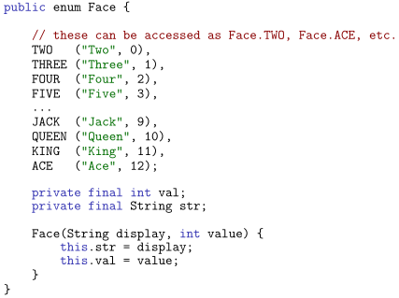

Because the Card class - which will be transferred over the network most frequently - is built from enumerated classes, sending a Card class itself can easily be done by implementing Java's serializable interface. This reduced the amount of code necessary for the server-client architecture.

## Build System

During our development we initially planned to just use the built-in IntelliJ IDE build function. However, we realised that the project requirements required that we open-sourced the code so that people could build upon it and make their own projects.

Therefore, we needed a build system that was reliable and would work on any system compatible with Java and the build system, as an IDE build configuration can be dependent on one’s computer and preferences. This is where we decided to use Gradle as a build system, because it is cross-platform and it is somewhat a solid foundation for building projects; it's the preferred build system of popular frameworks such as Android. (Google, 2020)

**The Gradle (ref)** build system provided solutions and time-saving measures that we did not anticipate during the beginning. As we previously discussed in implementing the client, we needed an identity file for each client so that we could identify them. During development, we used a JAR of the client which would create its own file in whatever folder it was located, and so we used a file structure which contained players 1 - 8.

% add file structure here

Gradle allowed us to JAR the client, and automatically deploy the JAR file into each of the environment folders.

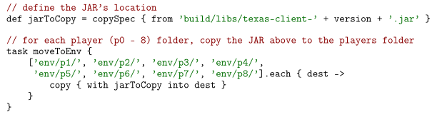

We realised that the server would need to be in a JAR format so that we were able to distribute the software; we found that in **Gradle**, it is possible to jar a certain class and its dependencies for use elsewhere, as shown below.

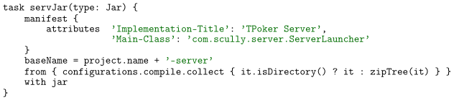

As we will discuss later in the evaluation section, we required that the server is hosted elsewhere than the client's device, to test delay and disconnect tolerance properly in a more suitable environment. Unbeknownst to us, **we found a Gradle plugin (ref?)** that supports us using Secure Shell (SSH) to move certain files to a remote server.

remotes {

withGroovyBuilder {

"create"("webServer") {

setProperty("host", "ec2-35-178-207-104.eu-west-2.compute.amazonaws.com")

setProperty("user", "ubuntu")

setProperty("identity", file('rekop.pem'))

}

}

}

FileTree myFileTree = fileTree(dir: 'build/libs/') // JAR files location

// example exec: $ ./gradlew deploy

task deploy {

doLast {

ssh.run {

session(remotes.webServer) {

// move JAR files to server

put from: myFileTree.asList(), into: '/home/ubuntu/'

// restart remote server; grab server output

execute '~/restart_server.sh'

}

}

}

}

This further saved time because the workflow typically went as follows: **(good)**

1. Develop a change to server/client
2. Build from Gradle
3. Gradle compiles client and server to a JAR
4. Gradle pushes the server JAR to the remote server
5. Gradle will execute a script on the AWS server to restart the server
6. Gradle grabs the terminal output of the server

Note that these can all be executed in sequence, so that we could press build Gradle or a Bash script, and it would run the tests, build the necessary components, push them to the remote server, get that servers output (so we can see connections and what the server is doing) and then connect.

This was possibly the most insightful part of the project, as the power of time-consuming or complicated setup can make development and testing a breeze; on a custom Arch Linux install, we were able to launch multiple terminals spawning multiple clients, as shown below.

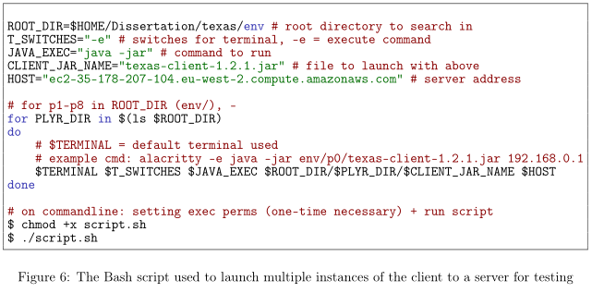

# Evaluation

## Unit Testing

Unit testing was crucial in the development of the back end, as writing and designing algorithms for this ahead of time is quite difficult due to the amount of edge cases that can crop up when there are many outcomes of a poker hand.

**Table (test_numer pass/fail) ? Examples?**

It also showed how testing cannot just be used to verify that a program is working properly, but to drive its development forward. This constant feedback of cases that needed to be tested helped spot bugs and allowed each part of the evaluator to work together flawlessly. Because most edge cases had been ironed out in isFlush and isStraight functions, implementing whether a hand was a straight flush was a somewhat simple procedure.

Furthermore, tests that would have been somewhat cumbersome to perform were suddenly much easier to; the Deck that we use to pull cards contains, as normal, 52 cards in an array. We needed to test that no two cards came out the same, and that pulling 52 cards resulted in an error being thrown.

## Testing Over a Network

Testing network code is much more different than testing typical single-threaded, local code. Due to the blocking nature of network calls - that is, they halt execution until data has been received - when we hosted the server and client on the same computer, it became difficult even with a debugger to root down the cause of the issues as we didn't always know what the client or server was waiting for.

%(?) complex to setup;possible etc.

Whilst it is possible to unit-test network code, it can **be tedious** and complex to set-up, and not all errors can easily be detected. We opted to use a logging system **(good)**, whereby we constantly printed what was being sent on both sides of the network to the console to see if there was delay, a block of execution or simply crashed. We found this to be the most effective way, as debuggers were often awkward to use when working with multiple threads and when a bug was unpredictable.

Furthermore, when we tested the server remotely via AWS, we did not have the opportunity for a debugger and thus all debugging had to be done using the console. This meant that we had to resort to a normal logger being used to print output to the screen, with each small action the server is taken being noted. **Examples? Diagrams/screenshots etc?**

***Show log messages and transact.***

# Summary and Reflections

## Management

To help me manage what needs to be done in the project and primarily drive development, GitLab issues tracker have been made for various tasks that need to be completed. These are easy to read via the use of labels and offer reminders through email. In addition to this, branches are created for each issue to manage changes to code.

In the initial design stages, I focused on the vision and scope whereby outlining the ideal product but also the essentials for the project. Working under agile principles, I focused on getting a usable algorithm for evaluating poker hands as this gives us early ideas from where to go next or problems that would arise; once we had this to a good state, research for how the server will handle sending these objects or communicating became easier.

Appendix 7.1 and 7.2 show the old and the new Gantt charts. Upon developing the backend, I realised that no databases and thus database classes were needed in this part. Later, during the end stages of the server’s development, databases will be used for online play, and can be removed at this stage. Therefore, server tasks as well as implementing them into the Android application have been brought forward, as these are critical.

## Contributions and Reflections

### Build System

Whilst not directly related to the project at hand, I believe that the build system was a massive help and achievement in its own right in driving development forward; it has shown that it is often overlooked in terms of its power and ability to save time.

It would be estimated that for each change, to manually move the server JAR file to the remote server would take a minute or two and then to get multiple clients connected would take another. For each small change, this can add up to a lot of time wasted during setup; the addition of Gradle scripts made it almost instantaneous as to the setup and allowed us to rapidly test the network.

### Data Classes

An area that could have been improved would have been the data classes. Whilst the built-in option of packing and unpacking data, if we needed to make a small change to a data class even so much so as a tiny change in calculating something, we would have to recompile and deploy the server / client executables again.

If we had proceeded with the JSON/XML approach, we would not have issues with different versions providing compatibility issues. This would be because we could recreate the object independently, particularly with the use of a factory pattern.

### Conclusion

Overall, I am quite satisfied with the personal gains made from this project, as I have learned much about not only creating a network and implementing tolerance but the development of a project overall. Prior to this undertaking I had not much work regarding networking or concurrency as a topic, which requires a different shift in thinking compared to sequential, single threaded programming like most projects.

I think some areas could have been improved, namely implementing a suitable and fun user interface or front-end so that it could be presented to actual players but the framework to do so is somewhat there itself and could be picked up by anyone in the future. Moreover I think time management could have gone a lot better on this project, but the demands of other project-based modules on the course limited my undivided attention on this; there was a lot of context switching involved when transferring from one module back to this project.

I also think that more work could have been done on the network side to make it more robust, potentially adding in a lander thread or configuration options, so that we could set timeouts for disconnections and a method of reliably detecting that the user has disconnected rather than using a certain Java exception type to detect what has happened; which is quite flimsy.

# References

Beck, K. (2000). Preface. In K. Beck, *Test-Driven Development: By Example* (pp. ix - x).

Beck, K., Beedle, M., Bennekum, A. v., Cockburn, A., Cunningham, W., Fowler, M., . . . Thomas, D. (2001, January 1). *Agile Principles.* Retrieved from Agile Manifesto: https://agilemanifesto.org/principles.html

Durst, R. C., Feighery, P., & Scott, K. L. (1999). Why not use the Standard Internet Suite for the Interplanetary Internet. *InterPlanetary Networking Special Interest Group (IPNSIG)*, 4-6.

Gilpin, A., & Sandholm, T. (2006). A Texas Hold'em poker player based on automated abstraction and real-time equilibrium computation. *International Joint Conference on Autonomous Agents and Multiagent Systems (AAMAS)*, 2. Retrieved from https://www.cs.cmu.edu/~sandholm/texas_demo.aamas-06.pdf

Google. (2020, Feburary 1). *Android Documentation.* Retrieved from Android: https://developer.android.com/studio/releases/gradle-plugin

id Software. (1997, December 23). *id-Software / DOOM: d_ticcmd.h*. Retrieved from GitHub: https://github.com/id-Software/DOOM/blob/master/linuxdoom-1.10/d_ticcmd.h

Kleiman, S., Shah, D., & Smaalders, B. (1996, 01 01). *Programming with Threads.* Retrieved from http://www.cs.ioc.ee/yik/lib/2/Kleiman1pre.html

Oracle. (n.d.). *Thread Pools.* Retrieved from Java Documentation: https://docs.oracle.com/javase/tutorial/essential/concurrency/pools.html

Ramsey, T., & Hawaii, U. o. (2005, January 2). *5 Card Poker Hands: Probability.* Retrieved from http://www.math.hawaii.edu/~ramsey/Probability/PokerHands.html

Serrador, P., & Pinto, J. (2015). Does Agile work? - A quantitive analysis of agile project success. *Internation Journal of Project Management*, 1047. Retrieved from https://people.eecs.ku.edu/~saiedian/Teaching/Sp19/811/Papers/Agility/does-agile-work.pdf#s0055

Teófilo, L. F., Reis, L. P., & Cardoso, H. L. (2013). Speeding-Up Poker Game Abstraction Computation. *Computer Poker and Imperfect Information*, 60.

World Series of Poker. (2019, October 25). *2019 World Series of Poker Europe.* Retrieved from World Series of Poker: https://www.wsop.com/tournaments/updates/?aid=4&grid=1628&tid=17580&dayof=8298&rr=5

# Appendix

## 7.1 Old Gantt Chart – these both need updating

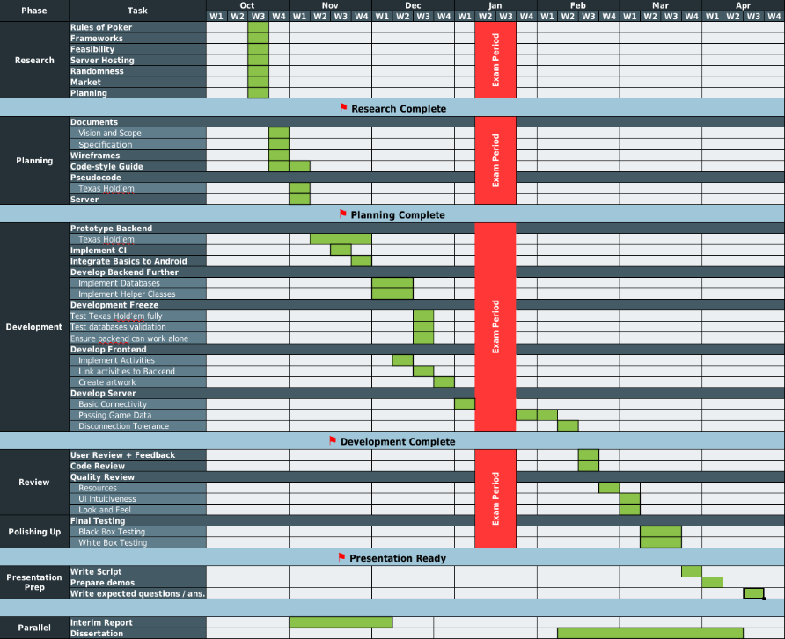

## 7.2 New Gantt Chart

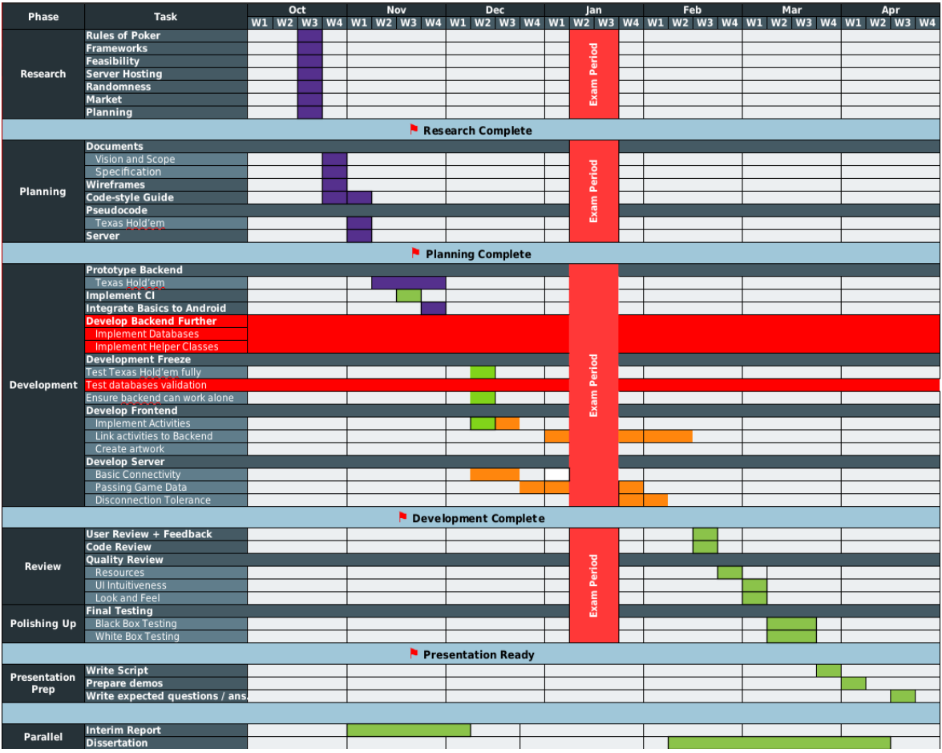

## 8.6 Server-client sequence diagram

## 8.8 Poker Evaluation Algorithm

