**Create Function App on Azure**

**Create Function In Visual Studio**

Open VS2019

File -> New Project

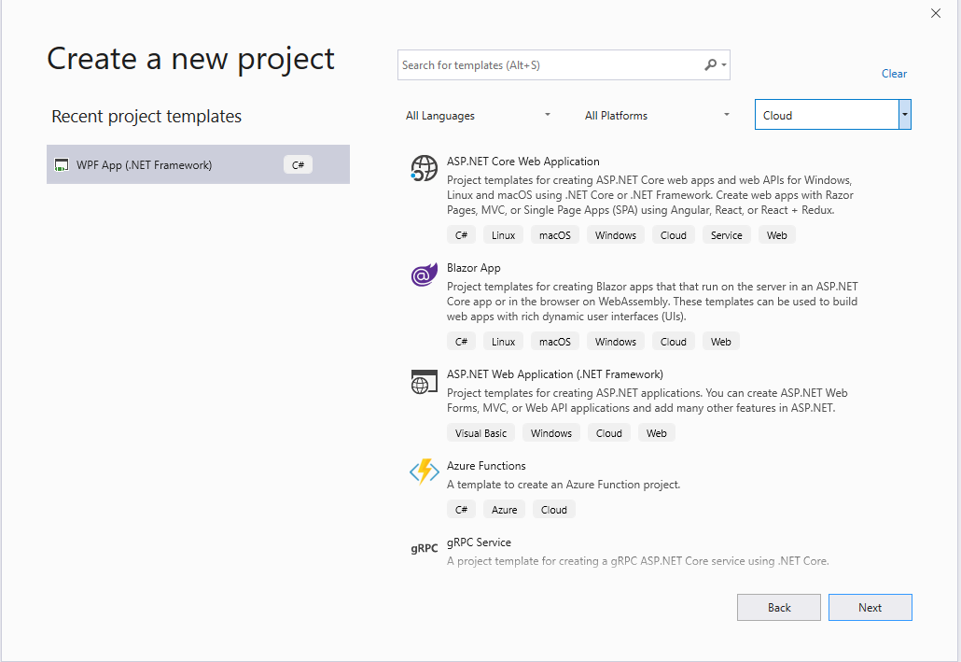

Select Azure Functions

Give it a name. I put on .CS to know that it is a C# project

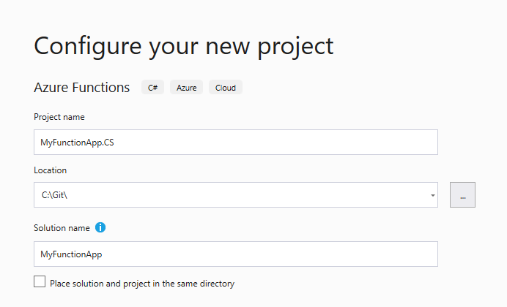

Pick your Trigger. I picked Timer

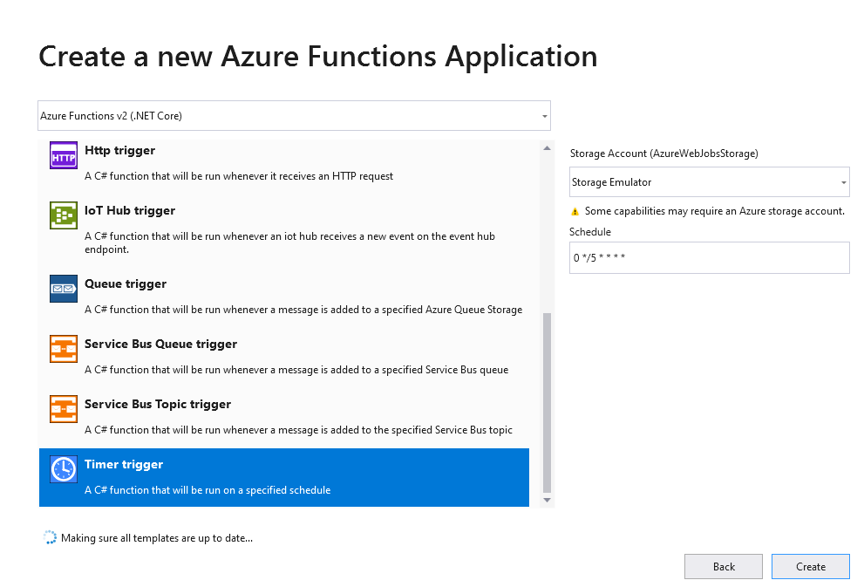

Visual Studio creates the solution and project.

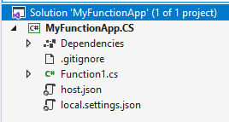

Build It

Add new Project to Solution

Pick F# Class Library (.NET Core)

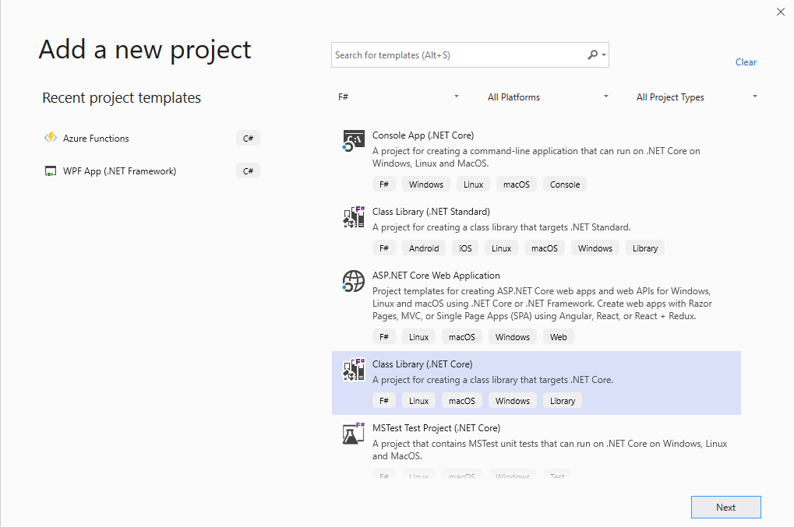

Give it a name (I use a .FS suffix)

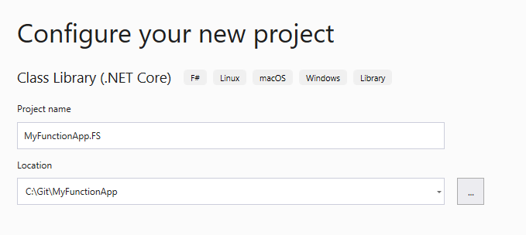

Visual Studio creates the project

Build the project

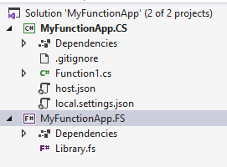

Rename Library1 to Function2



Add in the host.json and the local.settings.json from the CSharp project to the FSharp project (Add -> Existing Item)

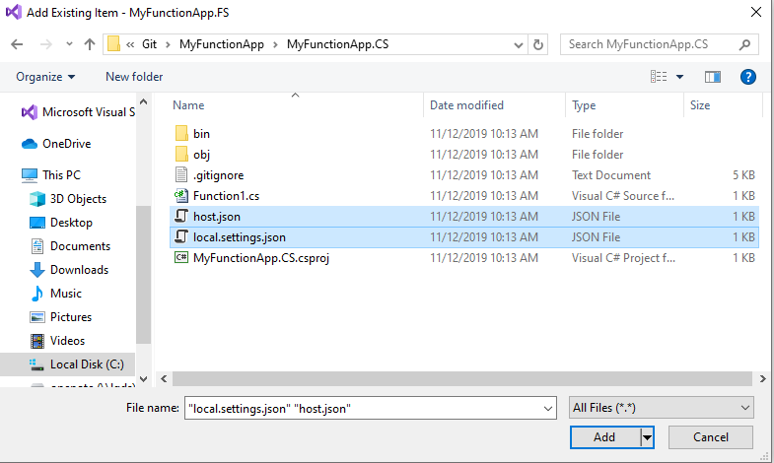

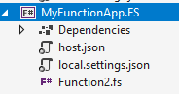

Open the MyFunctionApp.FS project and replace the content with this:

<Project Sdk="Microsoft.NET.Sdk">

<PropertyGroup>

<TargetFramework>netcoreapp2.1</TargetFramework>

<AzureFunctionsVersion>v2</AzureFunctionsVersion>

</PropertyGroup>

<ItemGroup>

<PackageReference Include="Microsoft.NET.Sdk.Functions" Version="1.0.28" />

</ItemGroup>

<ItemGroup>

<None Update="host.json">

<CopyToOutputDirectory>PreserveNewest</CopyToOutputDirectory>

</None>

<None Update="local.settings.json">

<CopyToOutputDirectory>PreserveNewest</CopyToOutputDirectory>

<CopyToPublishDirectory>Never</CopyToPublishDirectory>

</None>

</ItemGroup>

<ItemGroup>

<Compile Include="Function2.fs" />

</ItemGroup>

<ItemGroup />

</Project>

Open Up Function2.fs and replace the code with this:

namespace MyFunctionApp.FS

open System

open Microsoft.Azure.WebJobs

open Microsoft.Extensions.Logging

module Function2 =

[<FunctionName("Function2")>]

let run ([<TimerTrigger("0 */5 * * * *")>]myTimer:TimerInfo, log:ILogger) =

log.LogInformation("F# Timer trigger function executed at:" + DateTime.Now.ToString())

**Deploy Functions**

Right Click on FS Project -> Publish

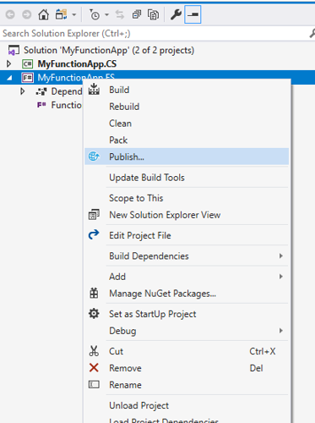

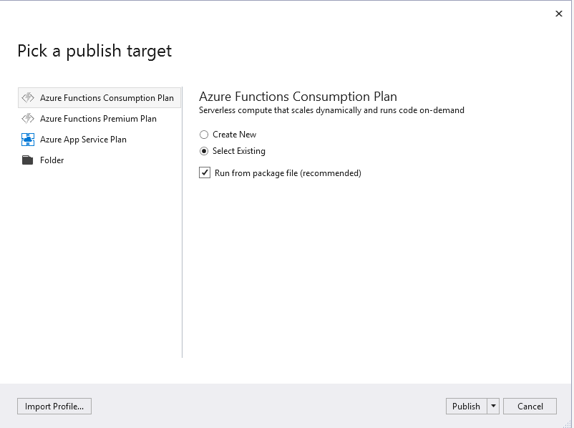

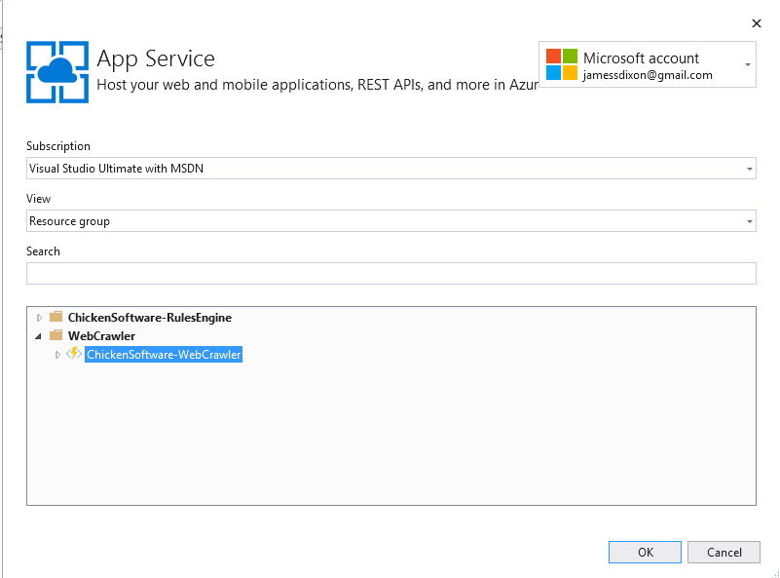

Go to the Azure Portal to Test

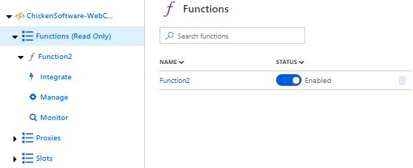

Press “Run”

