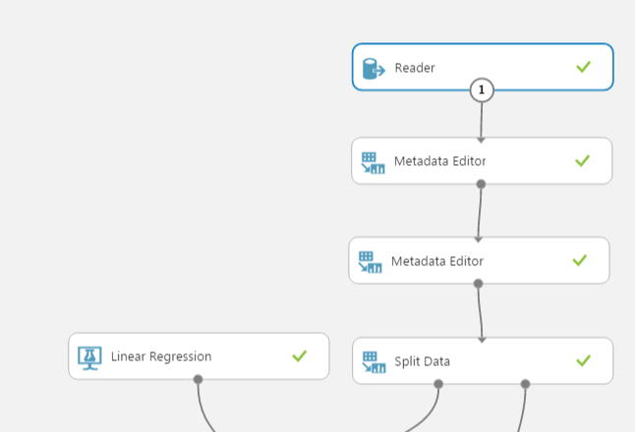

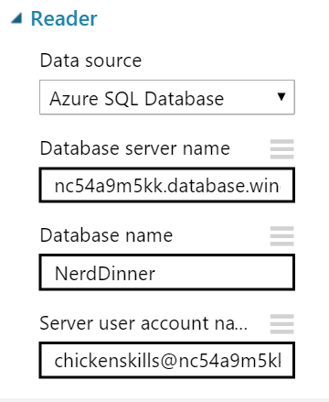

Select

HostedById as HostId,

DATEPART (weekday,EventDate) as DayOfWeek,

Count(RSVPID) as Attendance

from [dbo].[Dinners] as d

Inner join [dbo].[RSVPs] as r

on d.DinnerID = r.DinnerID

Group By HostedById, EventDate

